
Design and Analysis of an Isolated Single-Stage Bidirectional V2V EV

Charging Converter

School of Electrical Engineering, Vellore Institute of Technology, Chennai

OBJECTIVES
Develop a bidirectional isolated converter model [1].
Analyse both V2V charging directions.
Determine suitable open-loop operating points.
Compare PI, ISMC and fuzzy logic control.
Evaluate efficiency and semiconductor losses.

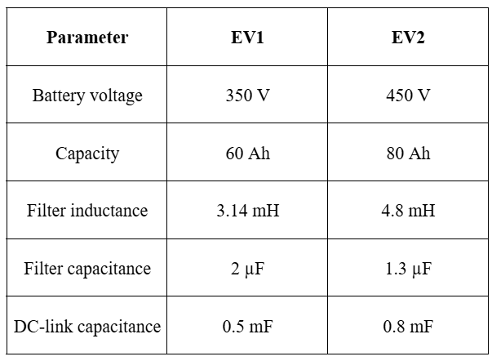
OVERVIEW
This project investigates an isolated, single-stage bidirectional converter for transferring energy between two electric vehicles using their onboard charging interfaces. MATLAB/Simulink is used to analyze power flow in both directions and evaluate closed-loop control strategies.
SYSTEM SPECIFICATIONS

Switching Frequency : 25 kHz
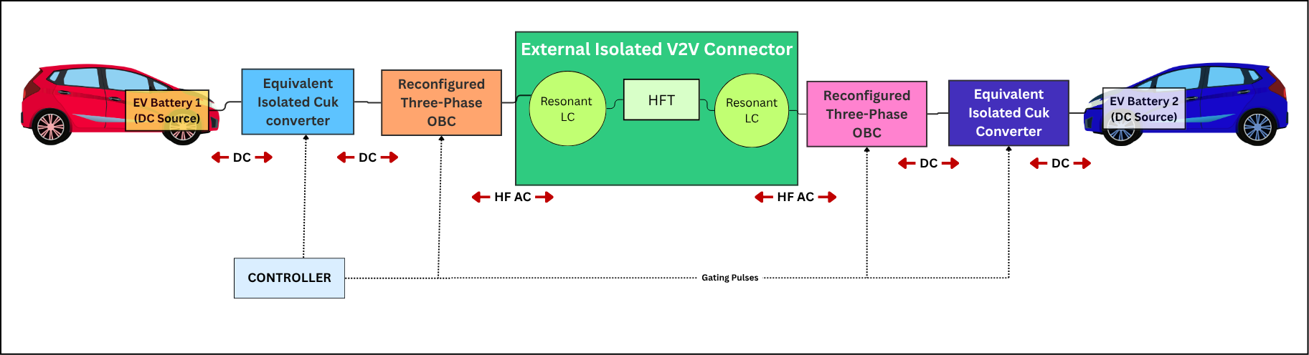
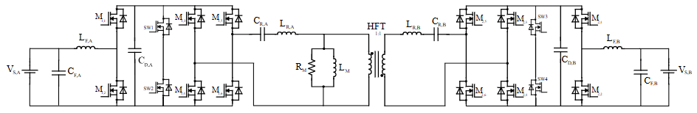
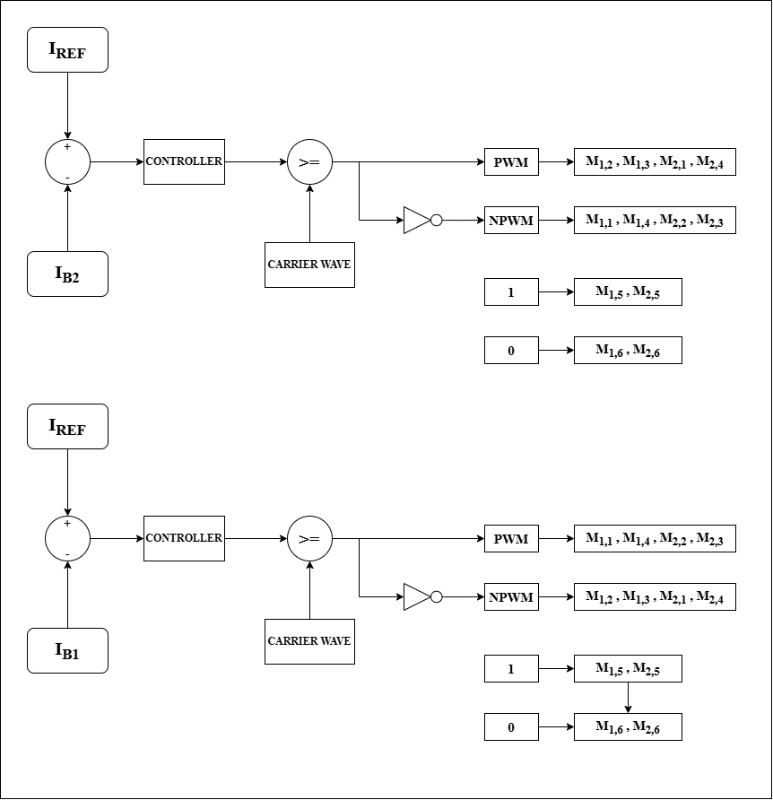
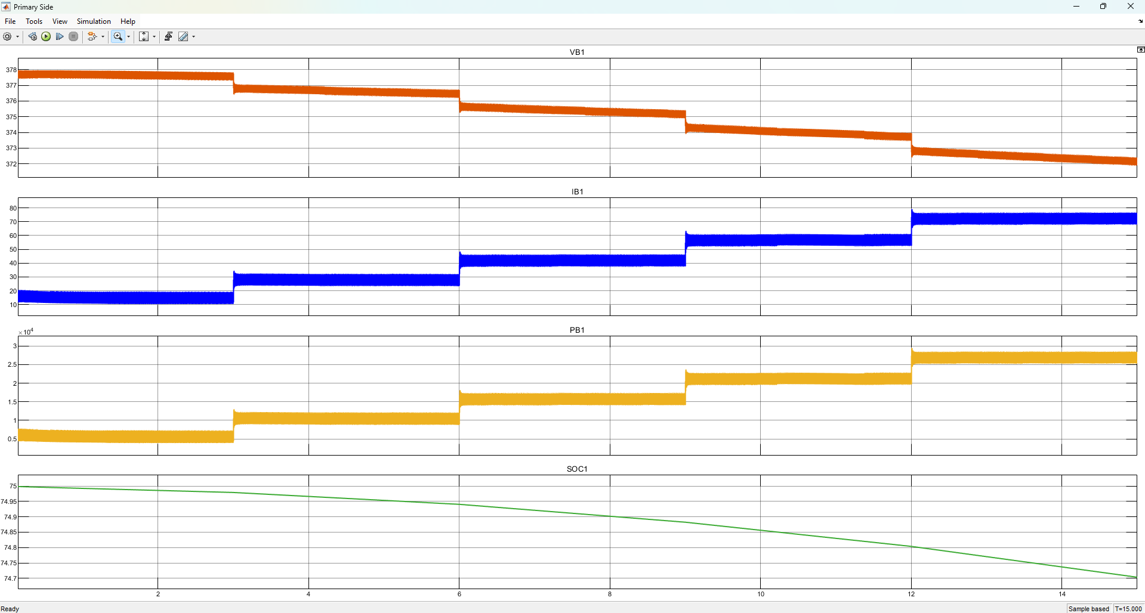
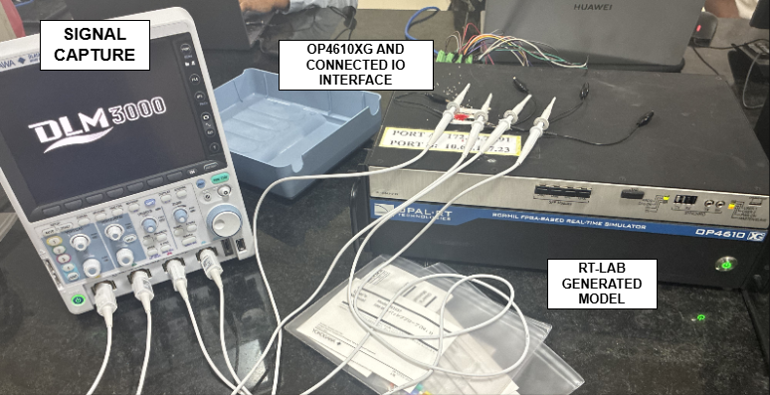
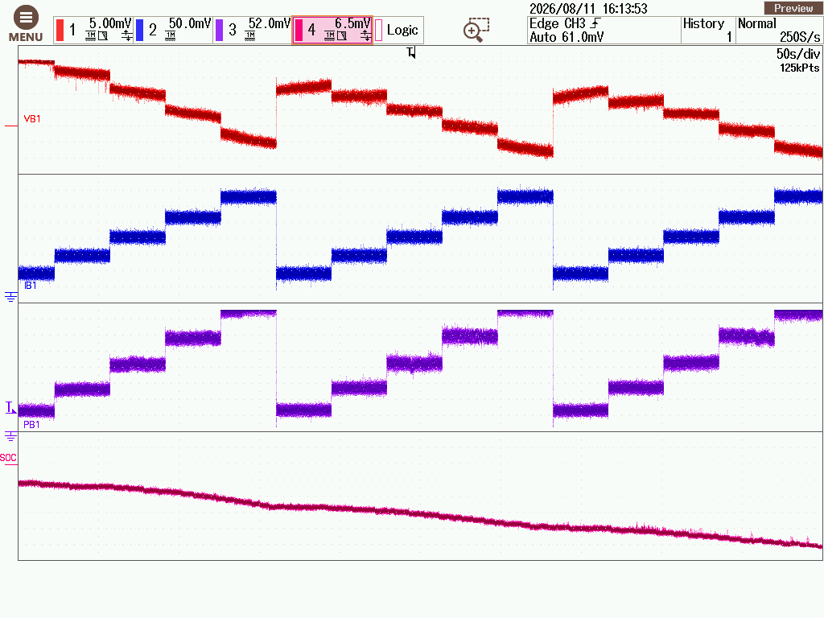
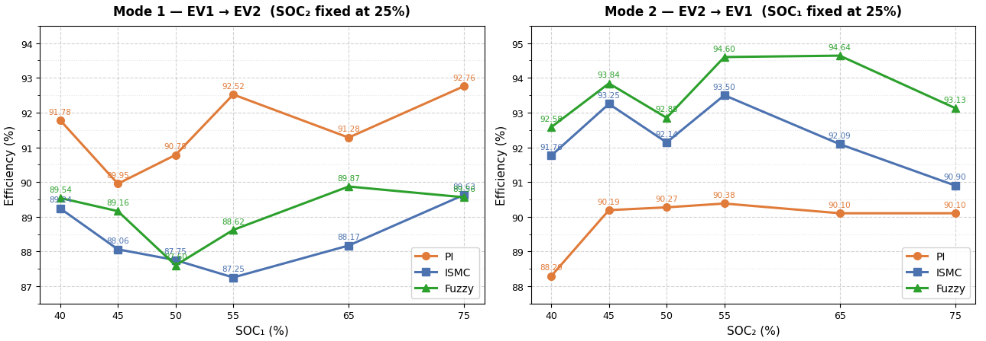
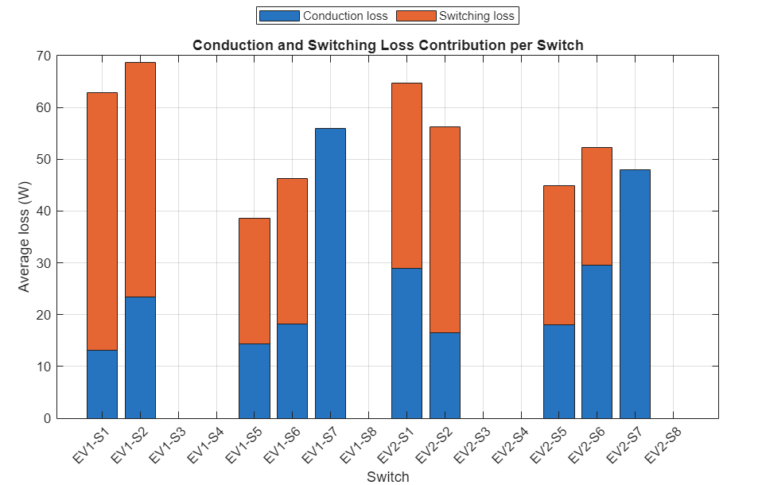
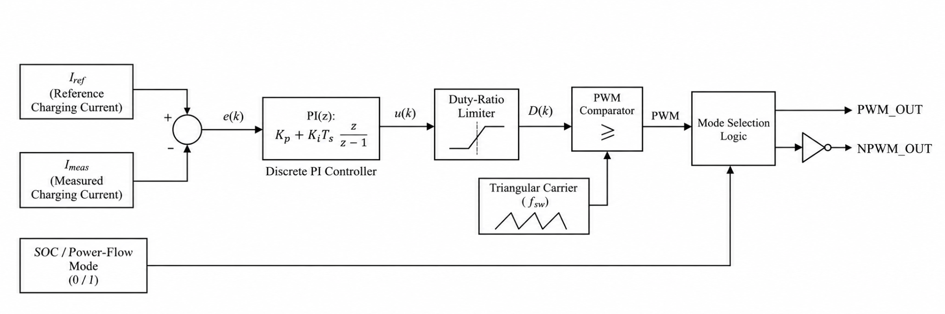
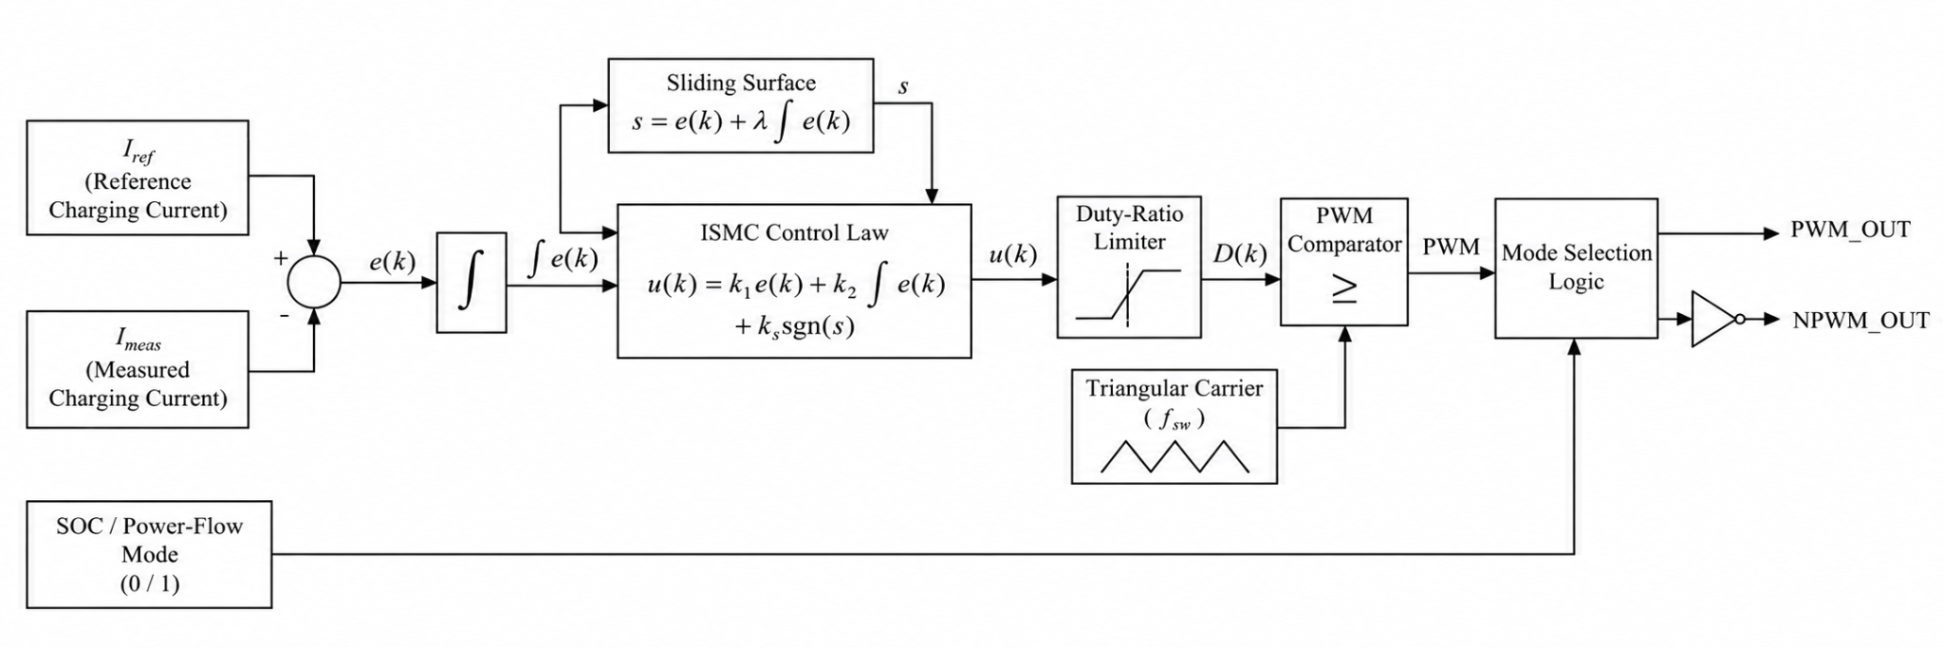
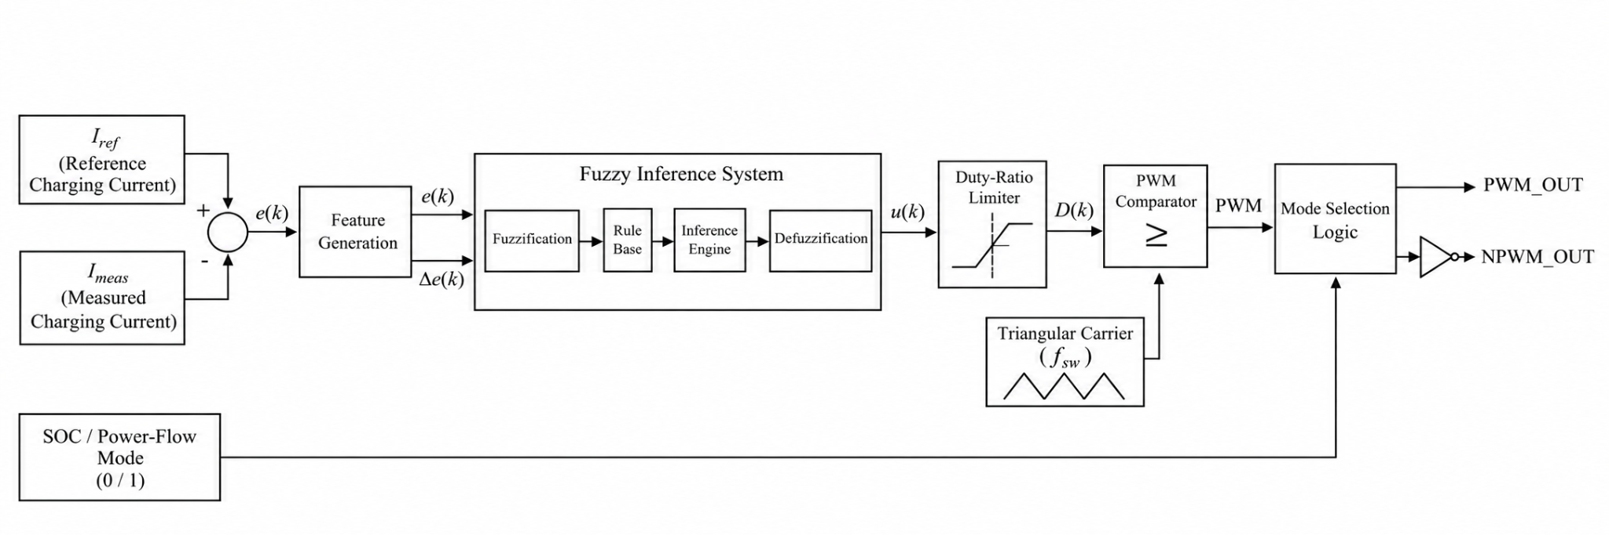

REFERENCES:

[1] R. Zhou, B. Chong, B. Labaleine, J. Arnett, and L. Zhang, "A novel isolated connector for bidirectional direct V2V charging using onboard chargers," e-Prime – Nexus of Electrical, Electronic, and Intelligent Engineering, vol. 17, Art. no. 201193, Sep. 2026, doi: 10.1016/j.eprime.2026.201193.

TANUKASREE R – 23BEE1160
N SUBRAMANIAN – 23BEE1115
SAHAS VISHANTH M V – 23BEE1119

SUBMITTED BY:

GUIDE : Dr. KANIMOZHI G
BLOCK DIAGRAM

PROPOSED CONVERTER & CONTROLLER

RESULTS
1. Controller Performance: PI, ISMC and fuzzy controllers were compared for bidirectional current tracking and transient response.
2. Efficiency & Losses: Controller efficiency was compared - fuzzy was the best among the 3 converters estimated semiconductor losses were 272.19 W (EV1) and 266.13 W (EV2).
3. OPAL-RT Validation: The converter model was evaluated using MATLAB/Simulink and OPAL-RT SIL, establishing a basis for future HIL and hardware testing.
MATLAB/Simulink & OPAL-RT VALIDATION

EFFICIENCY AND LOSS RESULTS

PI, ISMC, FUZZY CONTROLLERS

