Comparative Evaluation of PI, Integral Sliding-Mode and Fuzzy Logic Current Control for an Isolated Single-Stage Bidirectional Vehicle-to-Vehicle Charger Built on Onboard-Charger Bridges
G. Kanimozhi¹ · N. Subramanian² · Sahas Vishanth M. V.² · Tanukasree R.²
¹ Centre for Smart Grids and Technology, Vellore Institute of Technology, Chennai, Tamil Nadu, India
² School of Electrical Engineering, Vellore Institute of Technology, Chennai, Tamil Nadu, India
Corresponding author: name and e-mail · E-mails: subramanian.aadhi2006@gmail.com; sahasvishanthmv@gmail.com; sreetanuka0628@gmail.com; < mam e-mail >
Abstract
Vehicle-to-vehicle (V2V) charging allows an electric vehicle (EV) with surplus stored energy to charge another EV where fixed charging infrastructure is unavailable. A converter for this purpose must transfer power in both directions between batteries of different voltages, regulate the charging current and, for safety, provide galvanic isolation. This study evaluates three charging-current controllers, a proportional–integral (PI) controller, an integral sliding-mode controller (ISMC) and a Mamdani fuzzy logic controller (FLC), on an isolated single-stage bidirectional V2V converter that reuses the onboard-charger bridges of both vehicles and couples them through an external series-resonant connector with a 1:1 high-frequency transformer. A 24 kW model linking a 350 V and a 450 V battery was built in MATLAB/Simulink, its duty-ratio operating points were identified in open loop, and the controllers were compared under a stepped 10–50 A constant-current reference in both power-flow directions. With the gains used, only the ISMC held the regulated current within about 0.5 A of the reference in both directions; the PI loop showed an offset of about 10 A in one direction and the FLC in both. ISMC and FLC reduced the start-up current peak by about 62% and settled three to eight times faster than PI. Average efficiency over the tested state-of-charge range was 88.4–91.5% for EV1-to-EV2 transfer and 89.9–93.6% for EV2-to-EV1 transfer, but the ranking partly reflects the different delivered currents. Semiconductor-loss estimates and software-in-the-loop execution on an OPAL-RT real-time simulator complete the evaluation; hardware validation remains future work.
Keywords Vehicle-to-vehicle charging · Isolated bidirectional DC–DC converter · Onboard charger · Integral sliding-mode control · Fuzzy logic control · Real-time simulation
1 Introduction
The transport sector is a major source of greenhouse-gas emissions, and electrifying road vehicles is one of the principal measures for meeting climate targets (United Nations 2021). Research on and adoption of electric vehicles (EVs) have grown rapidly (Haghani et al. 2023), but public charging infrastructure has not kept pace: fast-charging stations are expensive, need space and grid capacity, and remain sparse outside urban corridors (Gümrükcü et al. 2023; Ucer et al. 2021). A driver whose battery is nearly depleted far from a charger, or during an emergency, may therefore have no practical way to recover range.
Vehicle-to-vehicle (V2V) charging addresses this problem by transferring energy directly from one EV battery to another. It belongs to the family of bidirectional vehicle–energy interactions that also includes grid-to-vehicle (G2V), vehicle-to-grid (V2G) and vehicle-to-home (V2H) operation (Tran et al. 2022; Yilmaz and Krein 2013). Because many EVs already contain a bidirectional power stage in their onboard charger (OBC), reusing that hardware for V2V transfer is attractive: it avoids a separate charger and keeps the added equipment to a cable or connector (Shafiqurrahman et al. 2023; Taghizadeh et al. 2020).
A V2V converter has to meet several requirements at once. It must move power in either direction with the same hardware; match batteries whose nominal voltages differ, typically within 250–800 V (Ucer et al. 2021); regulate the charging current of the receiving battery, normally in constant-current (CC) mode followed by constant-voltage (CV) mode (Noh et al. 2019); and, for safety, separate the two vehicles galvanically. Each additional conversion stage lowers efficiency, so it is also desirable to perform voltage matching and isolation in as few stages as possible.
Zhou et al. (2026) recently proposed an isolated connector for direct V2V charging that satisfies these requirements with a single conversion stage. The OBC bridges of both vehicles are reconfigured into high-frequency bridges, and an external connector containing a series-resonant tank on each side and a 1:1 high-frequency transformer (HFT) provides galvanic isolation. Together with the battery-side filters, the arrangement behaves as an isolated Ćuk-type converter whose gain is set by the duty ratio. The charging current in that work was regulated with a conventional PI controller.
PI control is simple and widely used, but its fixed gains are tuned around one operating point, whereas a V2V converter operates in two directions with different gate-signal mappings and with battery voltages that drift with state of charge (SOC). Integral sliding-mode control (ISMC) and fuzzy logic control (FLC) have been applied to isolated bidirectional converters to obtain more robust regulation (Chitra Devi et al. 2026; Shivakumar et al. 2026; Sun et al. 2020), but their behaviour on the OBC-based isolated V2V topology has not been reported. In particular, it is not known whether a controller that performs well in one power-flow direction also performs well in the other.
This study addresses that question. Its contributions are as follows:
•A consolidated analytical and simulation model of the isolated OBC-based V2V converter for 350 V and 450 V batteries, including the mode-wise gate-signal assignment, the idealized voltage-gain relation and the open-loop duty-ratio operating points in both directions.
•The design of PI, ISMC and FLC charging-current controllers that share one mode-selection and pulse-width-modulation structure, so that only the control law differs between them.
•A quantitative comparison of the three controllers in both power-flow directions, covering start-up transients, steady-state current tracking, efficiency across source-battery SOC and switch-level semiconductor losses.
•Execution of all three controllers in software-in-the-loop (SIL) form on an OPAL-RT OP4610XG real-time simulator.
Section 2 reviews the related literature. Section 3 describes the converter and its operating modes, Section 4 the converter design and Section 5 the controllers. Section 6 explains the simulation methodology, Section 7 presents and discusses the results, Section 8 states the limitations and Section 9 concludes the paper. The abbreviations and symbols used are listed in Table 1.
Table 1 Abbreviations and symbols
Symbol | Description | Symbol | Description
CC / CV | Constant current / constant voltage | V_{S,A}, V_{S,B} | Battery voltages of EV1 (port A) and EV2 (port B) (V)
DAB | Dual active bridge | v₁, v₂ | HFT primary and secondary voltages (V)
FLC | Fuzzy logic controller | v_{CD} | DC-link capacitor voltage (V)
HFT | High-frequency transformer | v_{CR} | Resonant capacitor voltage (V)
HIL / SIL | Hardware-in-the-loop / software-in-the-loop | i_{LF}, i_{LR} | Filter and resonant inductor currents (A)
ISMC | Integral sliding-mode controller | L_{F}, C_{F} | Battery-side filter inductance (H) and capacitance (F)
MSO | Mixed-signal oscilloscope | L_{R}, C_{R} | Resonant (leakage) inductance (H) and capacitance (F)
NPWM | Complement of the PWM signal | C_{D} | DC-link capacitance (F)
OBC | Onboard charger | L_{M}, R_{M} | HFT magnetizing inductance (H) and core-loss resistance (Ω)
PI | Proportional–integral | R_{sw} | Sum of conducting switch resistances (Ω)
PWM | Pulse-width modulation | D | Duty ratio of the PWM signal
SOC | State of charge | f_{S}, f_{R} | Switching and resonant frequencies (Hz)
V2V, V2G | Vehicle-to-vehicle, vehicle-to-grid | I_{ref}, I_{meas} | Reference and measured charging currents (A)
G2V, V2H | Grid-to-vehicle, vehicle-to-home | e, Δe | Current-tracking error and its change (A)
EV1, EV2 | Source-side and receiving-side vehicles in Mode 1 | s, λ, φ | Sliding surface, surface coefficient, boundary-layer width
M_{x,1}–M_{x,6} | Bridge switches of vehicle x ∈ {1, 2} | η | Efficiency (%)

2 Literature Review
2.1 EV Charging Architectures and Vehicle-Side Energy Exchange
EV chargers are classified as onboard or off-board according to where the power converter is located (Yilmaz and Krein 2013). Onboard chargers are limited by the size, weight and cost the vehicle can carry and therefore have modest power ratings, whereas off-board chargers can deliver much higher power. Chargers are further divided into unidirectional and bidirectional types. Unidirectional non-isolated high-gain DC–DC converters have been studied extensively for DC fast charging, with comparisons of voltage gain, voltage stress, component count, power rating and efficiency (Venugopal et al. 2023); however, a unidirectional stage cannot serve V2V transfer, in which either vehicle may act as source or receiver.
Bidirectional power flow enables G2V, V2G, V2H and V2V modes. Tran et al. (2022) proposed a universal magnetic power plug to connect vehicles, homes and the grid through a common interface, and Shah and Payami (2023) integrated G2V, V2G and DC/V2V charging into the drive-train converter of a switched-reluctance-motor EV. At the system level, Gümrükcü et al. (2023) developed a decentralized energy-management concept for urban charging hubs with several V2G aggregators. These works show the value of flexible, bidirectional vehicle energy exchange but do not address the converter-level control of isolated direct V2V charging.
2.2 Non-Isolated and Onboard-Charger-Based V2V Converters
Several studies reuse or extend the OBC for V2V transfer. Shafiqurrahman et al. (2023) connected the DC links of two vehicles through the active-rectifier switches of their existing on-board converters, so that the onboard DC–DC stages transfer energy directly; this reduces the number of conversion stages and was verified experimentally, but provides no galvanic isolation between the batteries. Taghizadeh et al. (2020) added a V2V charging-assistance capability to a multifunctional single-phase OBC; the energy passes through a multistage chain, and the reported efficiency was about 87%. Ucer et al. (2021) analysed and compared single-, two- and three-phase interleaved bidirectional buck–boost V2V chargers for batteries between 250 V and 800 V, quantifying the effect of interleaving on current ripple, inductance, efficiency and size; these converters are efficient and compact but again non-isolated.
2.3 Single-Stage Versus Multistage Conversion
Multistage V2V chains, for example AC/DC followed by DC/DC conversion in each vehicle, offer flexibility in voltage matching but incur the losses of every stage. Up to four conversion stages appear in OBC-based schemes (Shafiqurrahman et al. 2023; Taghizadeh et al. 2020). A single-stage converter that performs voltage regulation and isolation together removes intermediate stages and their losses, provided that current regulation and isolation are not compromised.
2.4 Isolated Bidirectional and Resonant Converters
Galvanic isolation separates two circuits so that no conductive path exists between them; in an EV charger this improves safety and allows the source and load sides to operate at different potentials. Isolation is usually provided by a high-frequency transformer whose core material, flux density and insulation are chosen for the application. Fan and Li (2011) analysed HFT-isolated bidirectional DC–DC modules for a 20 kVA solid-state transformer and showed that bridge design, transformer design, soft switching and the frequency-dependent core and winding losses all determine efficiency. Veerakgoundar and Subramaniam (2025) proposed a voltage feed-forward dual-active-bridge (DAB) bidirectional converter for onboard EV chargers.
Resonant topologies such as LLC and CLLC converters use inductor–capacitor tanks to shape current and voltage and to obtain zero-voltage or zero-current switching, but their benefits depend strongly on the choice of tank components and operating point; poorly chosen tank parameters lead to high circulating currents and losses (Deshmukh et al. 2022). All of these converters provide isolation through a dedicated isolated stage; the connector of Zhou et al. (2026) instead obtains isolation from an external resonant link while reusing the vehicles’ own bridges.
2.5 Charging-Current Control of Bidirectional Converters
Battery charging is commonly carried out in a CC phase followed by a CV phase (Noh et al. 2019), so the converter controller must regulate current accurately over a range of battery voltages. PI control is the usual baseline and was used by Zhou et al. (2026). Sun et al. (2020) combined adaptive integral sliding-mode control with a radial-basis-function network for a DAB converter and reported improved robustness to model uncertainty and load variation, together with better transient response than non-integral sliding-mode control. Shivakumar et al. (2026) compared fuzzy logic and PI control of an EV DAB converter in simulation and found that fuzzy control regulated the DC voltage better. Chitra Devi et al. (2026) adjusted the duty cycle of a bidirectional DC–DC converter in a hybrid photovoltaic–battery system with a fuzzy controller tuned by the Fire Hawk search algorithm.
2.6 Research Gap
Table 2 summarizes the reviewed approaches. Isolated converters with advanced control exist, and an isolated single-stage V2V connector that reuses OBC bridges has been demonstrated with PI control, but no study has compared PI, sliding-mode and fuzzy current control on that topology in both power-flow directions, or examined how the choice of controller affects efficiency and losses. The present study addresses this gap through simulation and real-time SIL execution.
Table 2 Summary of the reviewed approaches relevant to isolated V2V charging
Study | Approach | Isolation | Limitation for direct V2V use
Taghizadeh et al. (2020) | Single-phase multifunctional OBC with V2V assistance | —ª | Multistage chain; ≈87% efficiency
Ucer et al. (2021) | Interleaved bidirectional buck–boost V2V chargers, 250–800 V | No | Dedicated non-isolated charger
Shafiqurrahman et al. (2023) | DC links coupled through existing on-board converters | No | No galvanic isolation between batteries
Fan and Li (2011) | HFT-isolated DAB modules for a 20 kVA solid-state transformer | Yes | Dedicated isolated stage; not V2V-specific
Veerakgoundar and Subramaniam (2025) | Voltage feed-forward DAB for onboard chargers | Yes | Dedicated isolated stage
Sun et al. (2020) | Adaptive ISMC with RBF network on a DAB | Yes | Not applied to V2V or OBC reuse
Shivakumar et al. (2026) | Fuzzy logic versus PI control of an EV DAB | Yes | Voltage regulation of a dedicated DAB
Chitra Devi et al. (2026) | Fuzzy control tuned by Fire Hawk search | —ª | PV–battery hybrid system, not V2V
Zhou et al. (2026) | Isolated single-stage V2V connector reusing OBC bridges | Yes | Current control examined with PI only
This study | Topology of Zhou et al. with PI, ISMC and FLC compared in both directions | Yes | Simulation and SIL only
ª Isolation is not a focus of the cited study

3 System Description
3.1 Architecture
Fig. 1 shows the V2V charging system. Each vehicle contributes its battery, which acts as source or sink depending on the power-flow direction, and its three-phase OBC bridge, whose legs are reconfigured into a boost/buck leg and a single-phase high-frequency H-bridge. Together with the battery-side inductor, these elements form an equivalent isolated Ćuk converter on each side, which regulates the battery voltage and sets the voltage gain through the duty ratio. The external V2V connector contains a series-resonant LC tank at each end and a 1:1 HFT; the transformer isolates the two vehicles, while the tanks support efficient power transfer. A common controller generates the gate signals for both vehicles, so the same hardware serves EV1-to-EV2 and EV2-to-EV1 transfer without modifying the vehicle interfaces.
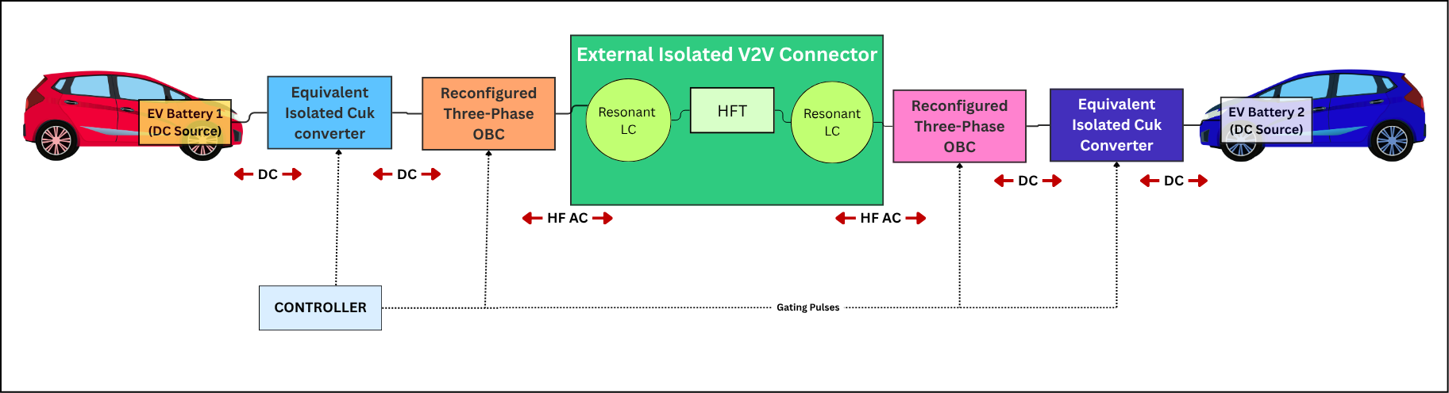
Fig. 1 Block diagram of the V2V charging system: battery, equivalent isolated Ćuk converter and reconfigured OBC bridge in each vehicle, external isolated connector with resonant LC tanks and HFT, and common controller
3.2 Converter Topology and Components
Fig. 2 shows the converter, which follows Zhou et al. (2026). On the source side (port A), the battery V_{S,A} is connected through the filter capacitor C_{F,A} and filter inductor L_{F,A} to the bridge leg M_{1,1}–M_{1,2}, which together with the DC-link capacitor C_{D,A} forms the gain stage. The legs M_{1,3}–M_{1,6} form the high-frequency H-bridge that drives the connector. In the connector, the resonant capacitor C_{R,A} and the transformer leakage inductance L_{R,A} form a series tank; the HFT model includes the magnetizing inductance L_{M} and a core-loss resistance R_{M}. The receiving side (port B) mirrors this arrangement. All switches conduct in both directions, so either port can act as source. Table 3 lists the role of each component.
The topology has four characteristic features. It is single-stage, because voltage regulation and galvanic isolation are obtained in one converter rather than in the AC/DC and DC/DC stages of conventional OBC-based V2V schemes (Taghizadeh et al. 2020). It is isolated, because the HFT removes the direct battery connection of non-isolated schemes (Shafiqurrahman et al. 2023). It is bidirectional, because every switch conducts in both directions. Finally, it reuses the existing OBC hardware, so no additional converter is required in either vehicle.
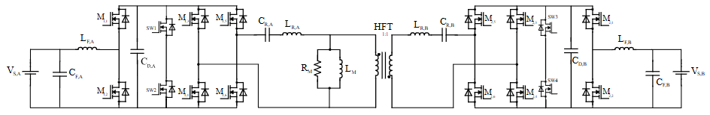
Fig. 2 Isolated single-stage bidirectional V2V converter formed by the reconfigured OBC bridges of EV1 (left) and EV2 (right) and the external resonant HFT connector (topology after Zhou et al. (2026))
Table 3 Components of the converter and their functions
Symbol | Component | Function in the converter
V_{S,A} | Source-side battery (port A) | Supplies energy in Mode 1 and receives energy in Mode 2
C_{F,A} | Source-side filter capacitor | Suppresses battery-voltage ripple and supplies high-frequency ripple current
L_{F,A} | Source-side filter inductor | Limits current ripple; stores and releases energy in each switching interval
M_{1,1}–M_{1,6} | Source-side OBC bridge switches | Operate as inverter or active rectifier depending on the power-flow direction; generate high-frequency excitation
C_{D,A} | Source-side DC-link capacitor | Holds the DC-link voltage nearly constant and absorbs switching transients
C_{R,A}, L_{R,A} | Source-side resonant capacitor and leakage inductance | Form the series-resonant tank that shapes the current and supports soft switching
HFT (L_{M}, R_{M}) | High-frequency transformer (1:1) | Provides galvanic isolation and couples energy magnetically; L_{M} and R_{M} model magnetization and core loss
C_{R,B}, L_{R,B} | Receiving-side resonant capacitor and leakage inductance | Receive resonant energy from the HFT and pass it to the receiving bridge
M_{2,1}–M_{2,6} | Receiving-side OBC bridge switches | Active rectifier in Mode 1, inverter in Mode 2
C_{D,B} | Receiving-side DC-link capacitor | Reduces DC-link ripple and buffers energy before the battery
L_{F,B}, C_{F,B} | Receiving-side filter | Smooth the charging current and voltage of the receiving battery

3.3 Operating Modes
In each mode the controller produces a pulse-width-modulated signal (PWM) with duty ratio D and its complement (NPWM) with duty ratio 1 − D, and both stages of a mode occur within one switching period. Table 4 lists the switches driven by each signal; the legs M_{x,5}–M_{x,6} are held in a fixed state, with M_{x,5} on and M_{x,6} off. Fig. 3 shows how the controller output is routed to the switches in each mode.
Table 4 Gate-signal assignment
Signal | Mode 1 (EV1 → EV2) | Mode 2 (EV2 → EV1)
PWM (D) | M_{1,2}, M_{1,3}, M_{2,1}, M_{2,4} | M_{1,1}, M_{1,4}, M_{2,2}, M_{2,3}
NPWM | M_{1,1}, M_{1,4}, M_{2,2}, M_{2,3} | M_{1,2}, M_{1,3}, M_{2,1}, M_{2,4}
Constant 1 | M_{1,5}, M_{2,5} | M_{1,5}, M_{2,5}
Constant 0 | M_{1,6}, M_{2,6} | M_{1,6}, M_{2,6}

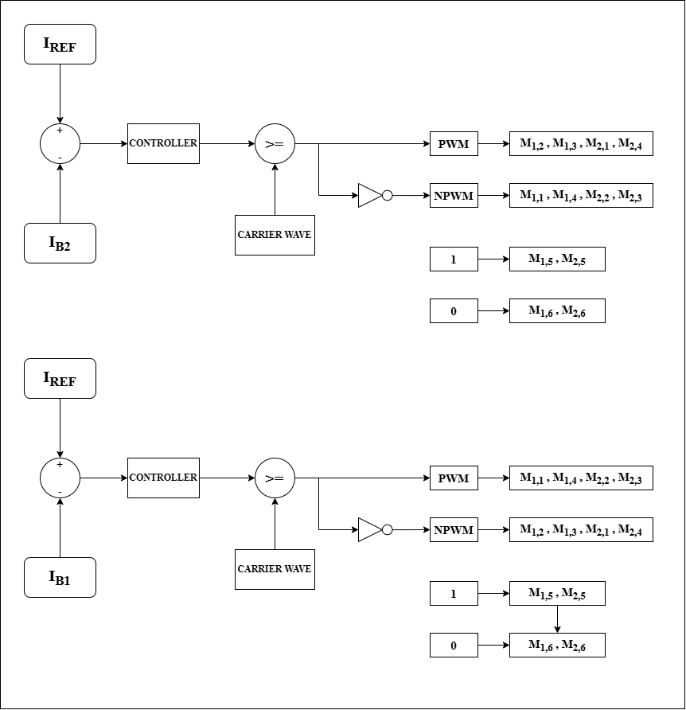
Fig. 3 Gate-signal generation with the controller: Mode 1 (top) regulates I_{B2} and Mode 2 (bottom) regulates I_{B1}; the controller output is compared with a carrier to form PWM and NPWM
Mode 1 (EV1 charges EV2). During the PWM interval (stage 1), battery A stores energy in L_{F,A} through M_{1,2} while C_{R,A} discharges through the resonant network; the HFT couples this energy to the receiving side, where L_{F,B} releases its stored energy into battery B. During the NPWM interval (stage 2), the energy stored in L_{F,A} is released, together with energy from the source, into the DC link, and the source-side bridge recharges the resonant tank; the resonant energy is again transferred through the HFT, and L_{F,B} is charged while battery B continues to charge (Fig. 4a, b).
Mode 2 (EV2 charges EV1). The PWM and NPWM assignments are exchanged (Table 4), so that the roles of the two sides are reversed: L_{F,B} stores energy, and the HFT delivers energy to battery A in both stages (Fig. 4c).

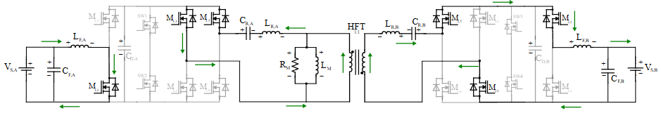
(a)
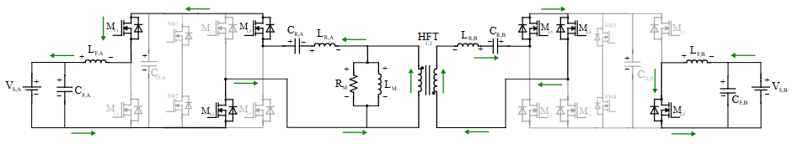
(b)
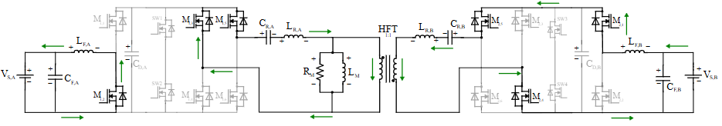
(c)
Fig. 4 Current paths (arrows): a Mode 1, stage 1 (PWM interval); b Mode 1, stage 2 (NPWM interval); c Mode 2
3.4 Theoretical Waveforms
Fig. 5 shows the idealized waveforms in each mode. The PWM and NPWM signals are high for DT_{S} and (1 − D)T_{S}, respectively, where T_{S} is the switching period. The filter-inductor currents are triangular, rising during the energy-storage interval and falling during the energy-release interval. The bridge voltages are unipolar pulses, and the transformer windings carry bipolar square-wave voltages of amplitude V_{P} on the primary and V_{S} on the secondary, which are equal for the 1:1 HFT. The receiving-side inductor current is also triangular, with slopes set by the corresponding charging and discharging intervals.

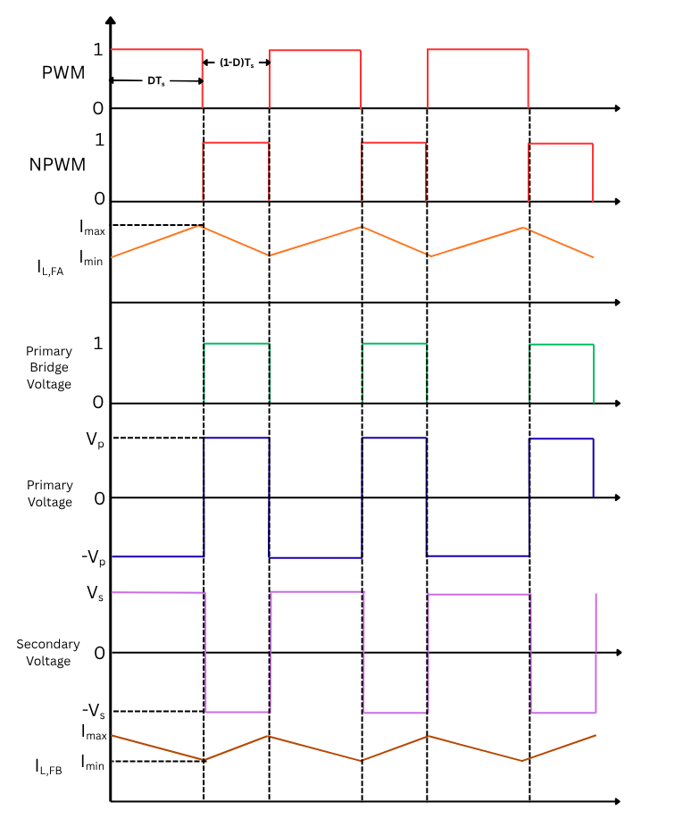
(a)
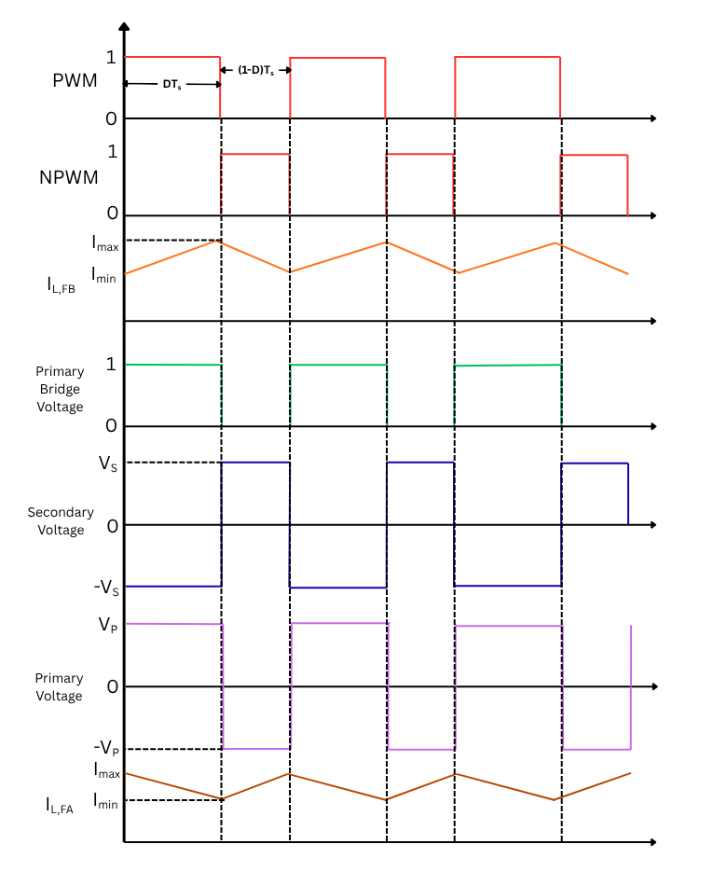
(b)
Fig. 5 Theoretical waveforms: a Mode 1 (EV1 charges EV2); b Mode 2 (EV2 charges EV1)
3.5 Voltage Gain
Applying Kirchhoff’s voltage law to the source-side filter loop and to the resonant branch gives
$V_{S,A} = L_{F,A}\frac{di_{LF,A}}{dt} + v_{CD,A}$ (1)
$v_{CD,A} = v_{CR,A} + i_{LR,A}R_{sw} + L_{R,A}\frac{di_{LR,A}}{dt} + v_{1}$ (2)
and, on the receiving side,
$v_{2} = v_{CR,B} − i_{LR,B}R_{sw} − L_{R,B}\frac{di_{LR,B}}{dt}$ (3)
$V_{S,B} = v_{CD,B} − L_{F,B}\frac{di_{LF,B}}{dt}$ (4)
where v₁ and v₂ are the HFT primary and secondary voltages and R_{sw} is the sum of the conducting switch resistances. To obtain the steady-state gain, the switch resistances and the resonant-tank voltage drop are neglected and the series tank and 1:1 HFT, operated near resonance, are treated as the energy-transfer path of a Ćuk converter with average transfer voltage V_{T}. Volt–second balance on L_{F,A} over one switching period gives
$DV_{S,A} + \left(1 − D\right)\left(V_{S,A} − V_{T}\right) = 0 ⇒ V_{T} = \frac{V_{S,A}}{1 − D}$ (5)
and on L_{F,B}
$D\left(V_{T} − V_{S,B}\right) − \left(1 − D\right)V_{S,B} = 0 ⇒ V_{S,B} = DV_{T}$ (6)
which combine into the Ćuk-type gain of Mode 1,
$\frac{V_{S,B}}{V_{S,A}} = \frac{D}{1 − D}$ (7)
and, by exchanging the PWM and NPWM roles, the gain of Mode 2,
$\frac{V_{S,A}}{V_{S,B}} = \frac{1 − D}{D}$ (8)
Equations (7) and (8) are idealized relations that assume lossless components, unity tank gain and continuous inductor current. They are used to locate the operating region; the actual operating points are identified by simulation in Sect. 7.1.
4 Converter Design
The design starts from the battery voltages, the desired charging current and the requirement for bidirectional power transfer. The converter links a 350 V, 60 Ah battery (EV1) and a 450 V, 80 Ah battery (EV2) and is rated at 24 kW.
4.1 Battery-Side Filters
The filter inductor limits the battery-current ripple and the filter capacitor limits the battery-voltage ripple. They were sized for a 5% current ripple at D = 0.57 using
$L_{F} = \frac{V_{L}D}{ΔI_{L}f_{S}}$ (9)
$C_{F} = \frac{ΔI}{8f_{S}ΔV}$ (10)
with f_{S} = 20 kHz, where ΔI_{L} is the permitted current ripple and ΔV the permitted voltage ripple. For EV1 (I_{L} = 63.5 A, V_{L} = 350 V), (9) gives L_{F,A} = (350 × 0.57)/(0.05 × 63.5 × 20 × 10³) = 3.14 mH, and with C_{F,A} = 2 µF, (10) gives a battery-voltage ripple of about 2.8%. For EV2 (I_{L} = 52.9 A, V_{L} = 450 V), L_{F,B} = 4.8 mH, and C_{F,B} = 1.3 µF gives the same ripple of about 3%.
4.2 Resonant Tank and Transformer
Each side uses C_{R} = 0.21 mF and L_{R} = 0.3015 µH, the latter representing the transformer leakage inductance, so the resonant frequency
$f_{R} = \frac{1}{2π\sqrt{L_{R}C_{R}}} ≈ 20 kHz$ (11)
coincides with the switching frequency and defines the soft-switching region. The HFT provides a 1:1 voltage ratio and galvanic isolation; its magnetizing inductance and core-loss resistance are included in the model.
4.3 Specifications and Equivalent Loads
Table 5 lists the parameters used in all simulations. For the open-loop studies, the receiving battery was represented by the resistance that absorbs the rated power at its nominal voltage,
$R_{L} = \frac{{V_{nom}}^{2}}{P_{rated}}$ (12)
which gives 450²/24 000 = 8.4375 Ω for EV2 in Mode 1 and 350²/24 000 = 5.1042 Ω for EV1 in Mode 2.
Table 5 Converter specifications and design parameters
Parameter | Value
EV1 battery | 350 V, 60 Ah
EV2 battery | 450 V, 80 Ah
Rated power | 24 kW
L_{F,A} / L_{F,B} | 3.14 mH / 4.8 mH
C_{F,A} / C_{F,B} | 2 µF / 1.3 µF
C_{D,A} / C_{D,B} | 0.5 mF / 0.8 mF
C_{R} (each side) | 0.21 mF
L_{R} (each side) | 0.3015 µH
HFT turns ratio | 1:1
f_{S} | 20 kHz
Switch model | IKWH75N65EH7 IGBT

5 Controller Design
5.1 Common Control Structure
All three controllers regulate the charging current of the receiving battery. As shown in Fig. 6, the controller subsystem receives the load current, the source current, a mode signal and the current reference, and outputs the PWM and NPWM signals. A mode-selection block chooses the regulated current and gate mapping according to the power-flow direction: the EV2 current I_{B2} in Mode 1 and the EV1 current I_{B1} in Mode 2. The tracking error is
$e = I_{ref} − I_{meas}$ (13)
The controller output is limited to a valid duty ratio, compared with a triangular carrier to produce the PWM signal, and inverted to produce NPWM (Fig. 7). Only the control law differs between the three controllers. The carrier is generated from a counter by the function listed in Appendix A.
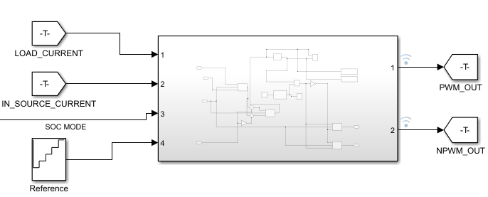
Fig. 6 Top-level controller subsystem with its inputs (load current, source current, SOC mode, reference) and outputs (PWM, NPWM)
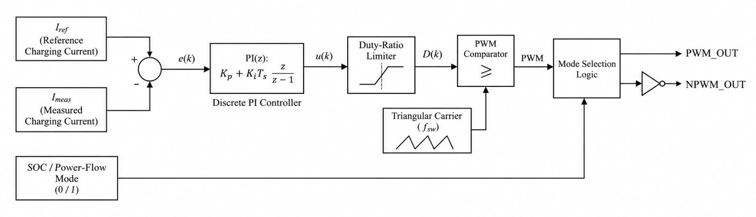
Fig. 7 Current loop shown with the discrete PI controller, duty-ratio limiter, PWM comparator with triangular carrier and mode-selection logic
5.2 Proportional–Integral Controller
The PI controller implements
$u\left(t\right) = K_{p}e\left(t\right) + K_{i}\int_{0}^{t}{}e\left(τ\right)dτ$ (14)
in discrete form, where the proportional term responds to the instantaneous error and the integral term accumulates it to reduce steady-state deviation. The gains were obtained with the Ziegler–Nichols method as K_{p} = 0.0001 and K_{i} = 0.015 and were used unchanged for both power-flow directions. Fig. 8 shows the Simulink implementation, in which the error is formed after mode selection and the PI output is compared with the carrier.
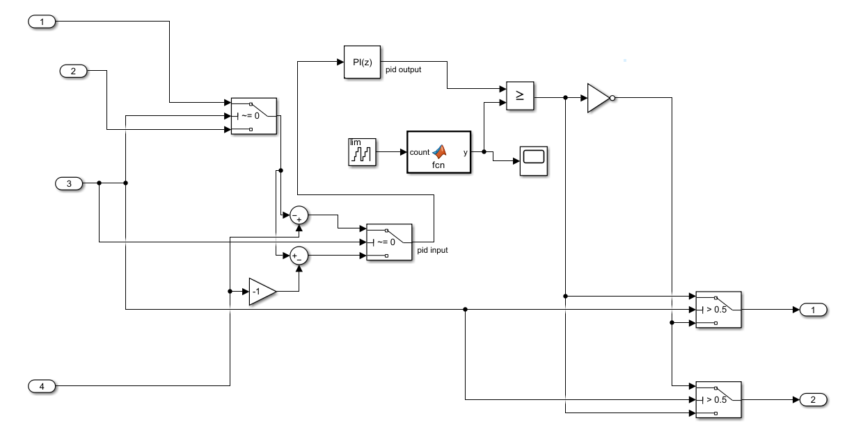
Fig. 8 Simulink implementation of the PI current controller with mode-dependent feedback selection, carrier comparison and PWM/NPWM routing
5.3 Integral Sliding-Mode Controller
The ISMC uses the integral sliding surface
$s\left(t\right) = e\left(t\right) + λ\int_{0}^{t}{}e\left(τ\right)dτ$ (15)
and the boundary-layer control law
$D_{cmd} = D_{0} + k sat\left(\frac{s}{φ}\right)$ (16)
where D₀ is the nominal duty ratio, k the correction gain and φ the boundary-layer width. The integral term in (15) removes steady-state error, and the saturation function replaces the discontinuous sign function of conventional sliding-mode control to limit chattering. In the implementation (Fig. 9), the error is integrated by a discrete-time integrator, weighted by λ, added to the instantaneous error, scaled by 1/φ, saturated, multiplied by k and added to D₀. The parameters λ = 2, φ = 0.5, k = 0.005 and D₀ = 0.5 were selected by simulation; the saturation limits, duty-ratio constraints and feedback sign were checked so that the correction acts in the correct direction in both modes.
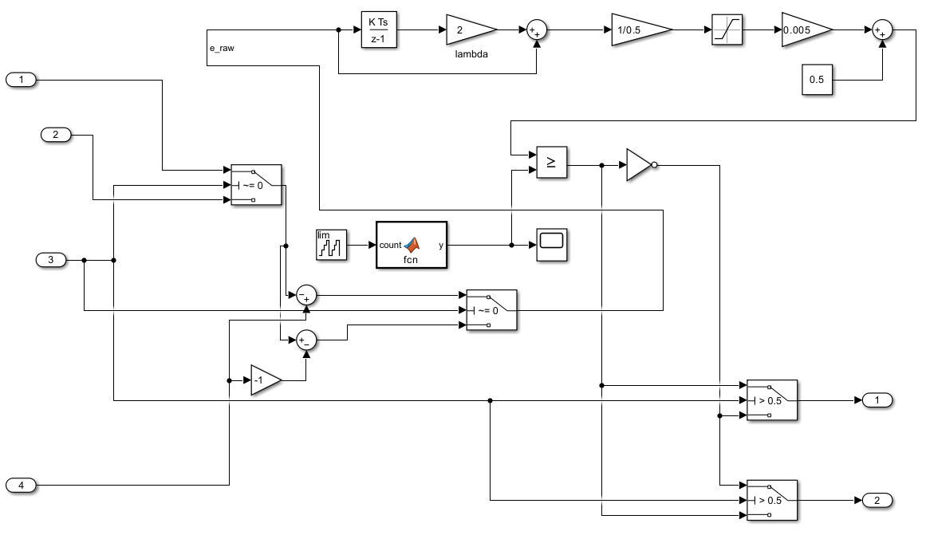
Fig. 9 Simulink implementation of the integral sliding-mode controller: integral sliding surface (λ = 2), boundary layer (1/φ), saturation, gain k = 0.005 and nominal duty ratio 0.5
5.4 Fuzzy Logic Controller
The FLC (Fig. 10) is a Mamdani system with two inputs, the normalized error e(k) and its change
$Δe\left(k\right) = e\left(k\right) − e\left(k − 1\right)$ (17)
where k is the sampling instant. Each input has five triangular membership functions, Negative Big (NB), Negative Small (NS), Zero (Z), Positive Small (PS) and Positive Big (PB), and the output, a duty-ratio command on [0, 1], has three (Table 6). The overlapping input functions allow several rules to fire for one input combination and give smooth transitions between control actions, while the narrow output functions keep the command near the nominal duty ratio of 0.5. The 25 rules in Table 7 are evaluated with the minimum operator for AND and implication and the maximum operator for aggregation, and the crisp command is obtained by centroid defuzzification:
$u^{*} = \frac{\int_{0}^{1}{}uμ_{agg}\left(u\right)du}{\int_{0}^{1}{}μ_{agg}\left(u\right)du}$ (18)
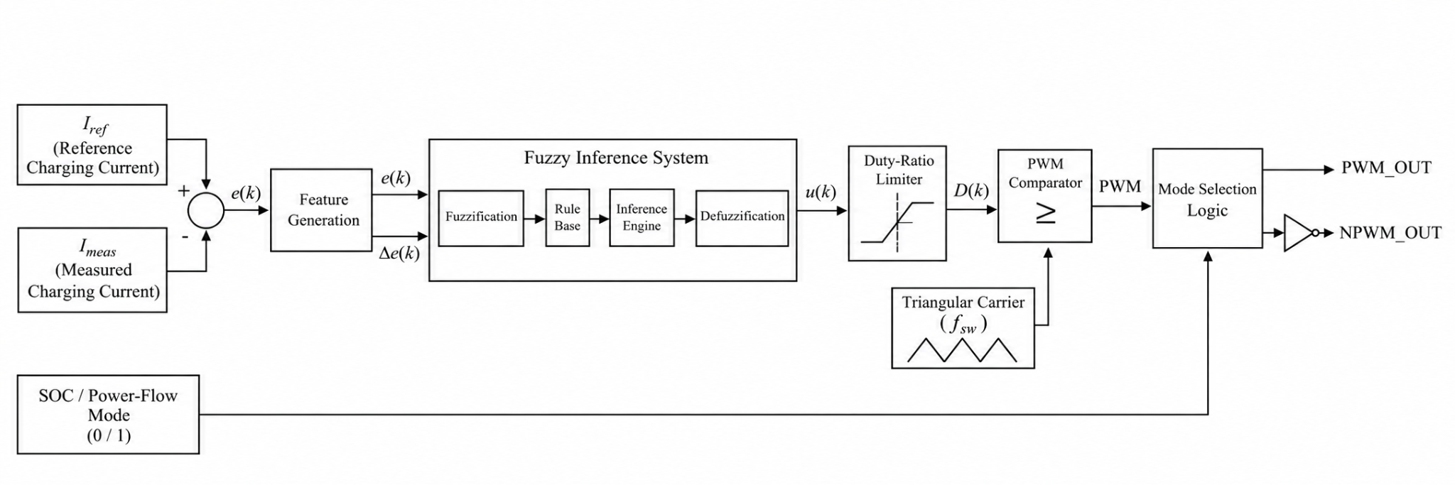
Fig. 10 Fuzzy logic current controller: error and change-of-error inputs, Mamdani fuzzy inference system, duty-ratio limiter, PWM comparator and mode-selection logic
Fig. 11 shows the Simulink implementation of the FLC, and Table 8 summarizes the parameters of all three controllers.
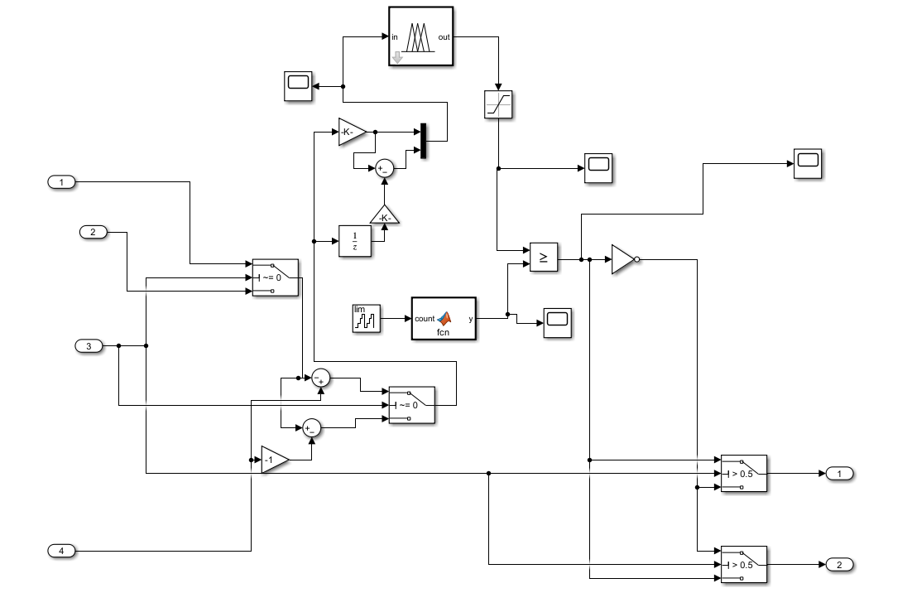
Fig. 11 Simulink implementation of the fuzzy logic controller

Table 6 Membership functions of the fuzzy logic controller (triangular, parameters [a, b, c])
Variable | Range | Labels and parameters
Error e and change of error Δe | [−1, 1] | NB [−1, −1, −0.5]; NS [−1, −0.5, 0]; Z [−0.25, 0, 0.25]; PS [0, 0.5, 1]; PB [0.5, 1, 1]
Output (duty command) | [0, 1] | Low [0.30, 0.40, 0.50]; Medium [0.45, 0.50, 0.55]; High [0.50, 0.60, 0.70]

Table 7 Fuzzy rule base (L Low, M Medium, H High)
e \ Δe | NB | NS | Z | PS | PB
NB | H | H | H | M | M
NS | H | H | M | M | L
Z | H | M | M | M | L
PS | M | M | M | L | L
PB | M | L | L | L | L

Table 8 Controller parameters
Controller | Parameter | Value
PI | K_{p}, K_{i} | 0.0001, 0.015
ISMC | λ, φ, k, D₀ | 2, 0.5, 0.005, 0.5
FLC | Inference; defuzzification | Mamdani; centroid
 | AND, OR, implication | min, max, min
 | Inputs; output; rules | 2 × 5 MFs; 3 MFs; 25

6 Methodology
6.1 Workflow
Fig. 12 summarizes the workflow. The converter and battery models were first built in MATLAB/Simulink R2024a with the parameters of Table 5. Open-loop simulations then identified duty ratios for stable power transfer in both directions. Closed-loop CC charging was implemented first with the PI controller and then with the ISMC and FLC, and the three were compared in transient response, steady-state tracking, efficiency and semiconductor losses. Finally, the model was executed in real time on an OPAL-RT simulator.
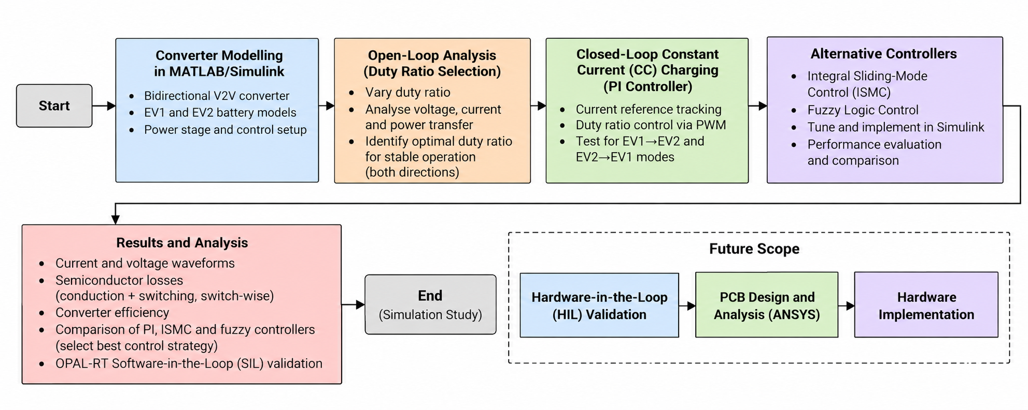
Fig. 12 Workflow of the study, from converter modelling and open-loop duty-ratio selection to closed-loop control, controller comparison and real-time validation, with hardware steps identified as future work
6.2 Simulation Models
Fig. 13 shows the open-loop model, in which the EV1 battery is the source and EV2 is represented by the resistance of Sect. 4.3, and Fig. 14 the closed-loop model with battery models on both sides and the controller subsystem. Table 9 lists the simulation durations used for the different studies.
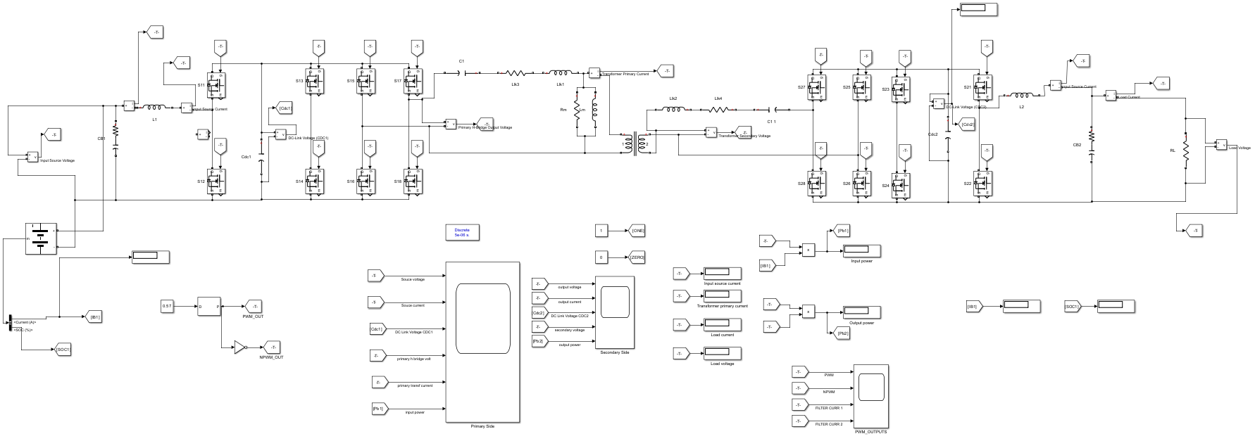
Fig. 13 Open-loop simulation model (EV1 battery as source, EV2 represented by an equivalent resistance)
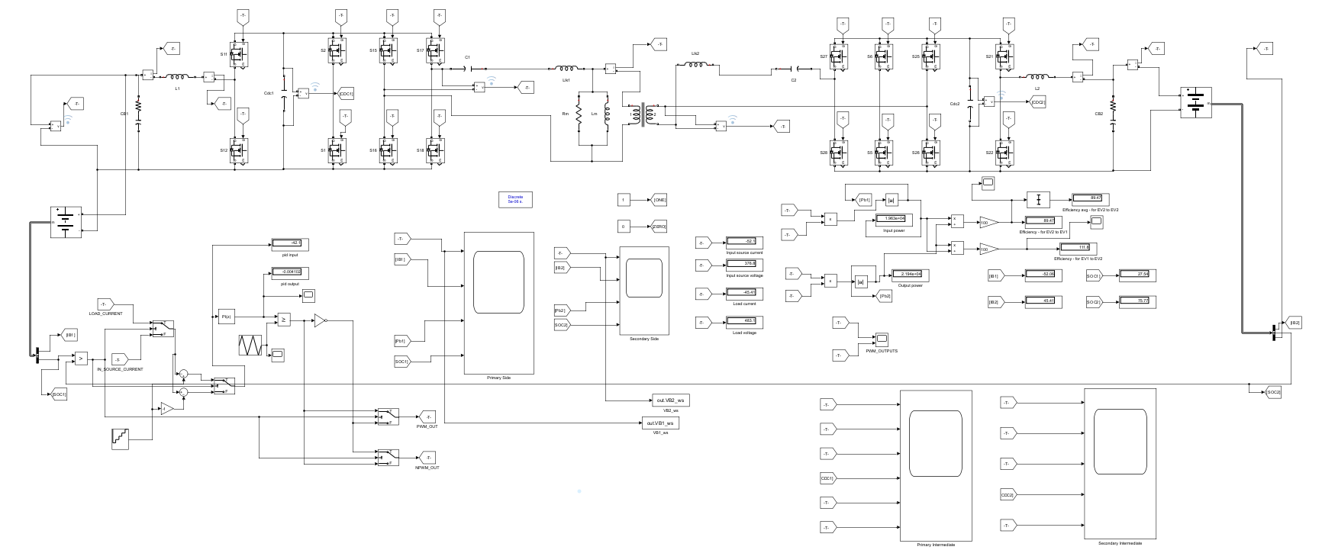
Fig. 14 Closed-loop simulation model with battery models on both sides and the PI controller subsystem
Table 9 Simulation durations
Study | Stop time
Steady-state operation (stepped reference) | 15 s
Start-up transient | 0.2 s
Real-time SIL | Continuous

6.3 Test Cases
•Open loop. With the source battery as a DC source and the receiving battery replaced by the equivalent resistance, the duty ratio was swept from 0.40 to 0.60 in both modes.
•Closed loop. With battery models on both sides, the charging-current reference was stepped from 10 A to 50 A in 10 A increments every 3 s, for each controller and each mode.
•Efficiency. Efficiency was evaluated at source-battery SOCs of 40–75% with the receiving battery at 25% SOC, for each controller and each mode.
•Semiconductor losses. Conduction and switching losses of each switch were estimated with datasheet-based look-up tables for the ISMC in Mode 2.
•Real-time SIL. The model was partitioned and executed on an OPAL-RT OP4610XG with a 5 µs time step, and its analog outputs were recorded on a mixed-signal oscilloscope.
6.4 Performance Metrics
Efficiency was computed as
$η = \frac{P_{out}}{P_{in}} × 100\%$ (19)
Transient performance was quantified by the peak excursion of each battery current and voltage and by the settling time, defined as the last instant at which a signal lies outside a tolerance band around its final value (±2% for voltages, ±20 A for currents, whose final values are close to zero). Steady-state tracking was quantified by the mean regulated current within each reference step, averaged between 0.6 s and 2.8 s after the step, and by its peak-to-peak ripple. These quantities were extracted from the recorded simulation waveforms; the resolution of each extraction is stated with the corresponding table.
7 Results and Discussion
7.1 Voltage Gain and Operating Points
Fig. 15a shows the simulated voltage gain as a function of duty ratio and of the ratio between switching and resonant frequency, and Fig. 15b fixes D = 0.5. The gain is highest at f_{S}/f_{R} = 1 and falls as the switching frequency moves away from resonance, while a larger duty ratio raises the gain at a given frequency ratio. Operating at resonance is therefore necessary for effective power transfer.

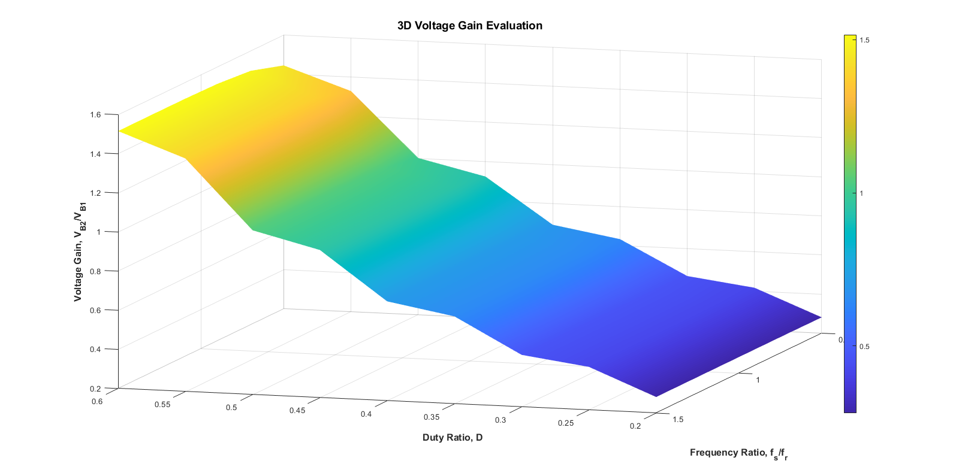
(a)
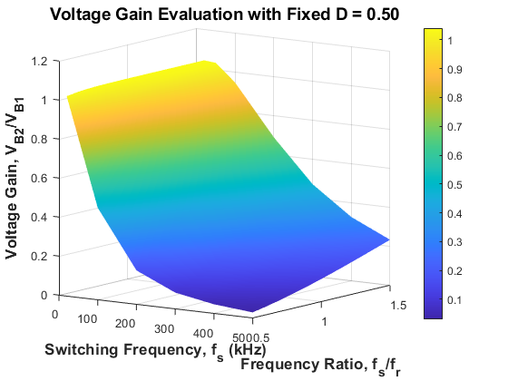
(b)
Fig. 15 Simulated voltage gain: a as a function of duty ratio and frequency ratio f_{S}/f_{R}; b at a fixed duty ratio of 0.5 as a function of switching frequency and frequency ratio
Fig. 16 shows the receiving-battery voltage as the duty ratio is swept. In Mode 1 the output voltage rises with D and reaches the 450 V nominal voltage of EV2 at D = 0.5724; in Mode 2 it falls with D and reaches the 350 V nominal voltage of EV1 at D = 0.5710. Table 10 compares these operating points with the idealized gains (7) and (8). The simulated voltages differ from the ideal values by less than 4%, which is consistent with the neglected switch, tank and transformer effects. These duty ratios were used as initial operating points for closed-loop control.
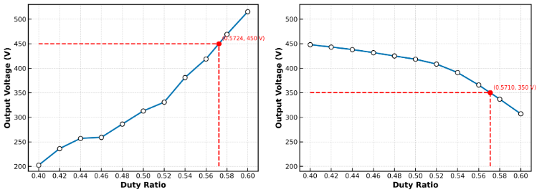
Fig. 16 Receiving-battery voltage versus duty ratio in open loop: Mode 1 (left, target 450 V) and Mode 2 (right, target 350 V); the marked points are the selected operating duty ratios
Table 10 Open-loop operating points
Mode | Target (V) | D | Ideal (V) | Deviation
1 | 450 | 0.5724 | 468.5 | −3.9%
2 | 350 | 0.5710 | 338.1 | +3.5%

7.2 Open-Loop Waveforms
Fig. 17 shows the Mode 1 filter-inductor current with the complementary PWM and NPWM signals: the current is triangular, as predicted in Fig. 5a. Fig. 18 shows the Mode 1 waveforms at the rated operating point. On the source side, the 350 V battery supplies a current of about 94 A with a ripple of roughly ±3 A, the DC-link voltage is about 936 V, the primary H-bridge produces unipolar pulses of about 950 V, and the transformer primary current oscillates between about −250 A and +300 A. On the receiving side, the load voltage is about 446 V with a ripple of about ±2 V and the load current about 52.9 A. The input power is about 33.1 kW and the output power about 23.6 kW, an open-loop efficiency of about 71% at this operating point.
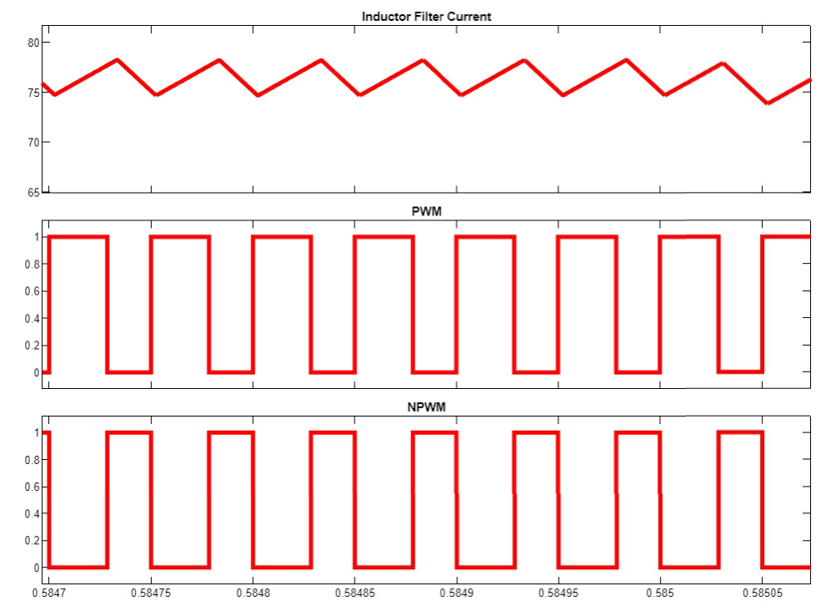
Fig. 17 Mode 1 filter-inductor current with the complementary PWM and NPWM signals

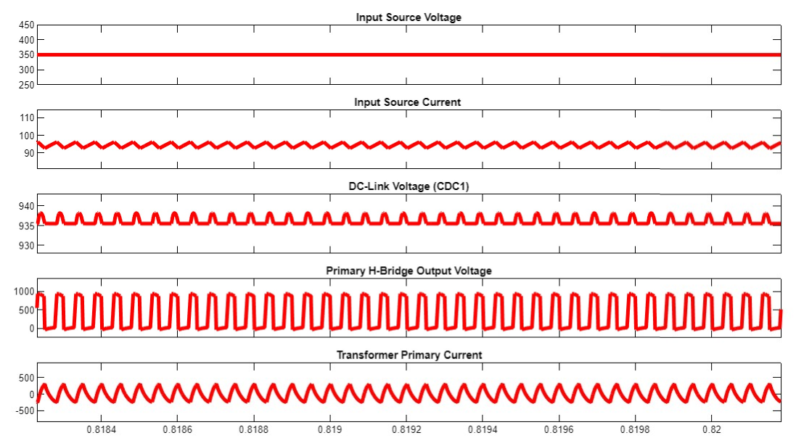
(a)
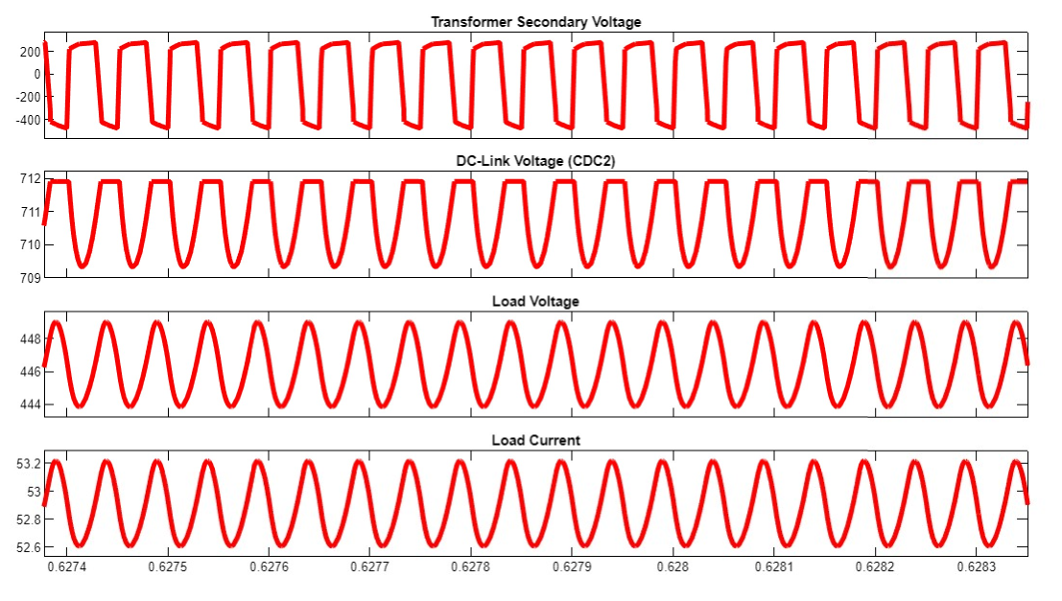
(b)
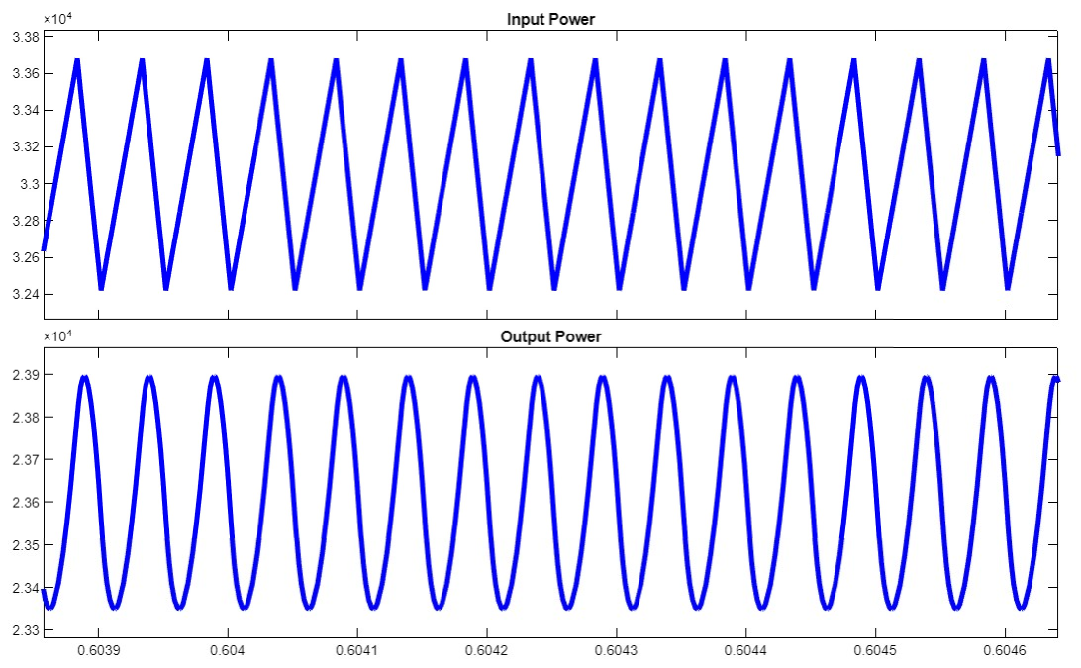
(c)
Fig. 18 Mode 1 open-loop waveforms at the rated operating point: a source side (battery voltage and current, DC-link voltage, primary bridge voltage, primary current); b receiving side (secondary voltage, DC-link voltage, load voltage and current); c input and output power
Figs. 19 and 20 show the corresponding Mode 2 waveforms at the operating point recorded. The 450 V EV2 battery supplies about 47.8 A, the DC-link voltage is about 786 V, the transformer carries ±400 V square-wave voltages with a primary current between about −50 A and +100 A, and the load receives about 63.3 A at about 322 V. The input power is about 21.5 kW and the output power about 20.4 kW, an efficiency of about 95%. The much smaller circulating current explains the higher efficiency in this direction. In both modes the DC-link voltage exceeds the 650 V rating of the IGBT model used for loss estimation, a point taken up in Sect. 8.

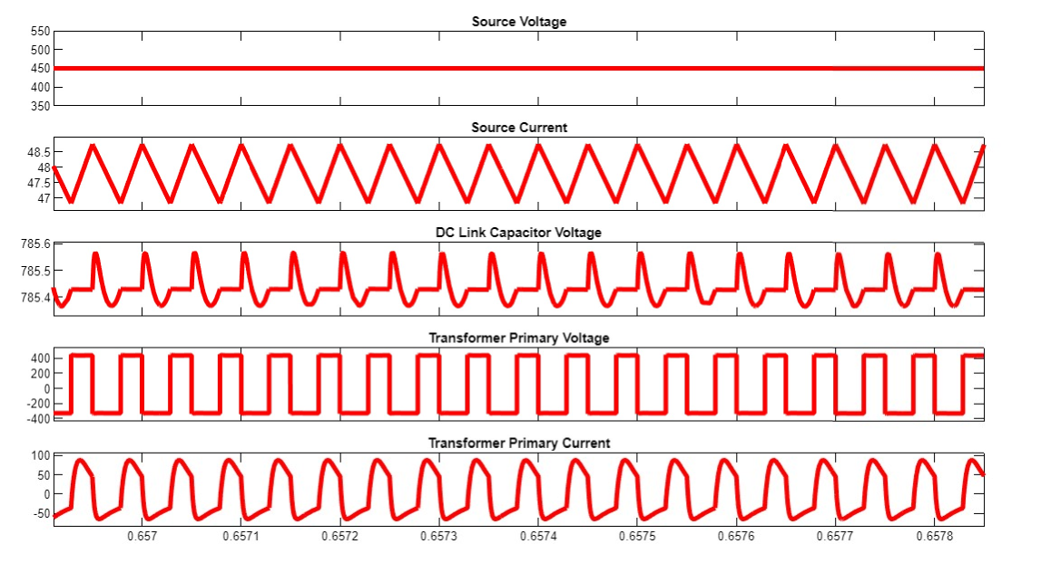
(a)
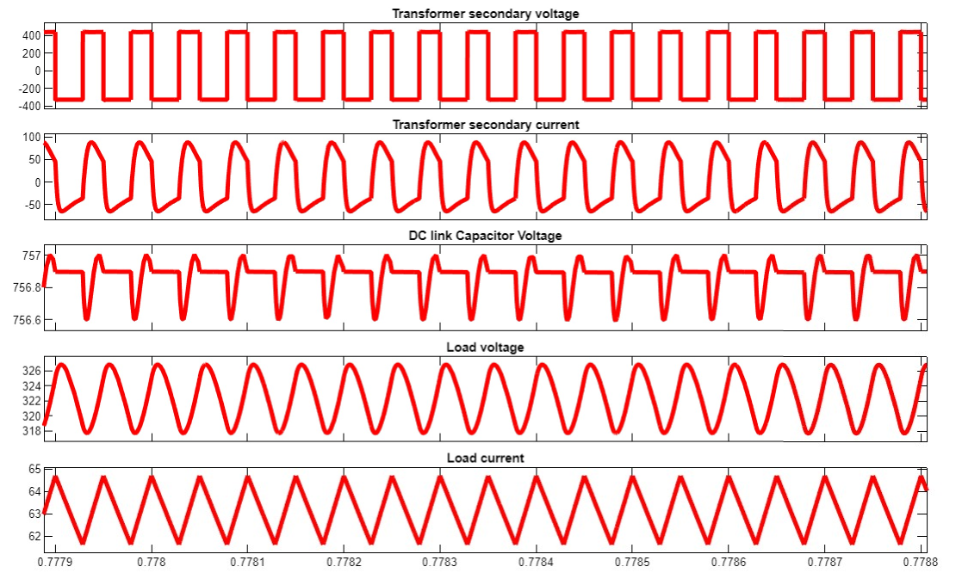
(b)
Fig. 19 Mode 2 open-loop waveforms: a source side (EV2 battery voltage and current, DC-link voltage, transformer primary voltage and current); b receiving side (transformer secondary voltage and current, DC-link voltage, load voltage and current)

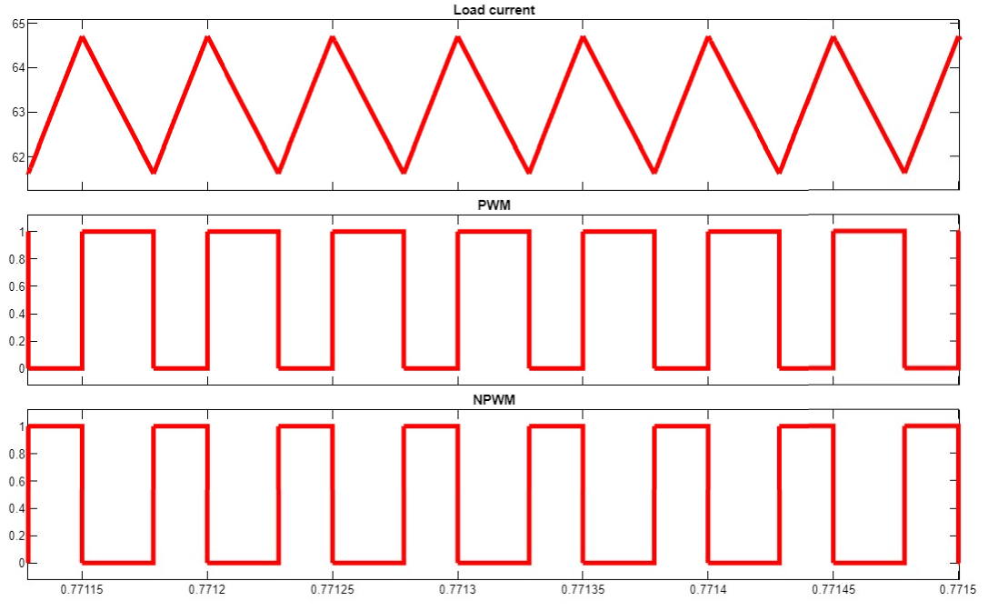
(a)
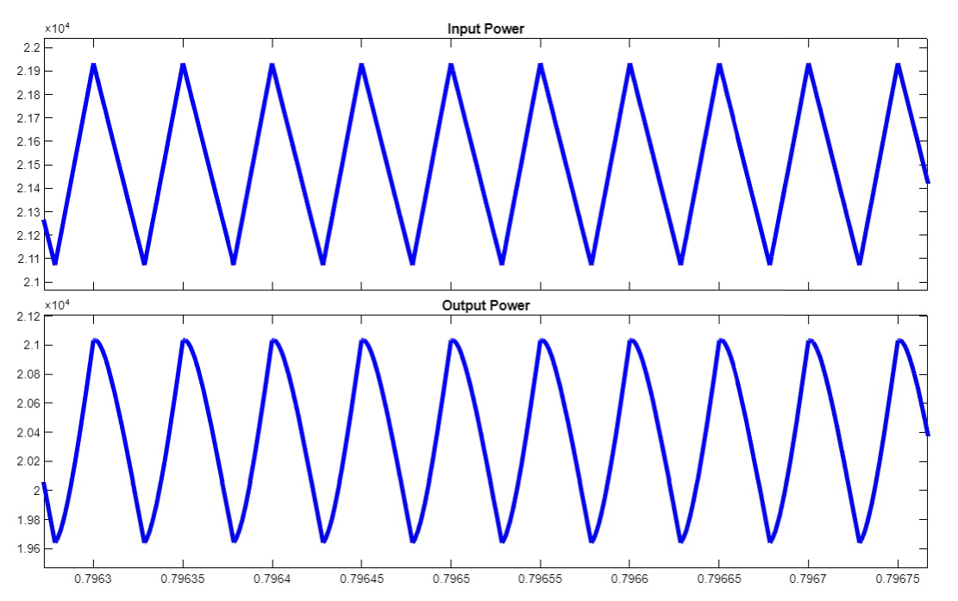
(b)
Fig. 20 Mode 2 open-loop waveforms: a load current with the PWM and NPWM signals; b input and output power
7.3 Closed-Loop Operation with Each Controller
Figs. 21–26 show the closed-loop responses of the three controllers to the stepped reference. For each controller, one figure shows Mode 1 and one shows Mode 2, with the voltage, current, power and SOC of EV1 (panel a) and EV2 (panel b). The initial SOCs differ between some runs, so the absolute SOC values are not directly comparable between controllers.
PI controller
In Mode 1 (Fig. 21), EV1 supplies power in steps as the reference increases, its voltage and SOC decrease, and the EV2 voltage and SOC increase. In Mode 2 (Fig. 22) the power flow reverses: EV1 charges and EV2 discharges. The responses settle within each 3 s step, but, as quantified in Sect. 7.4, the regulated current in Mode 1 remains about 10 A below the reference.

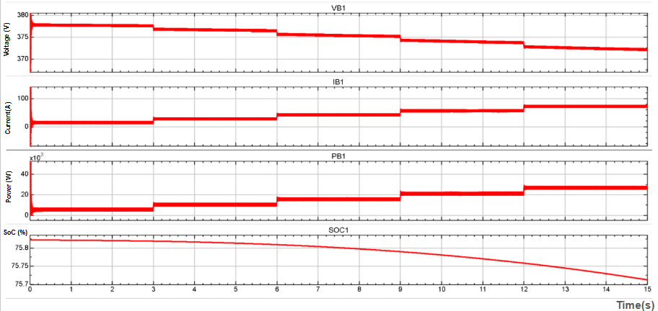
(a)
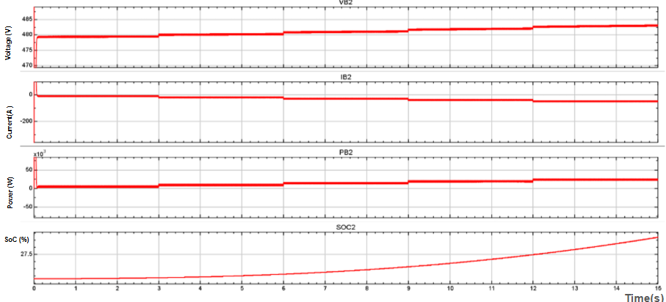
(b)
Fig. 21 Closed-loop response with the PI controller in Mode 1 (EV1 → EV2) under the stepped 10–50 A reference (voltage, current, power and SOC): a EV1; b EV2

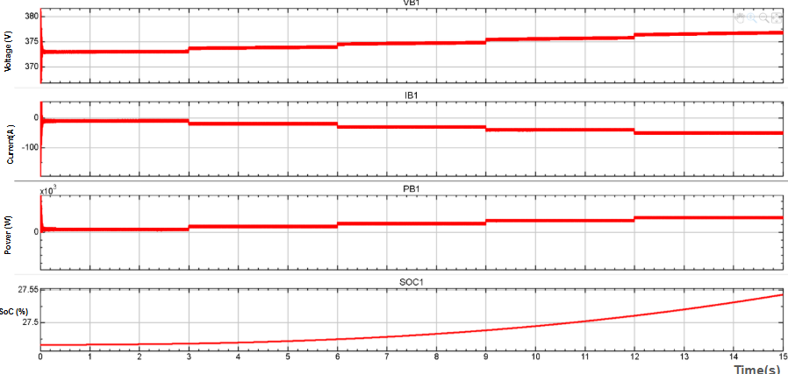
(a)
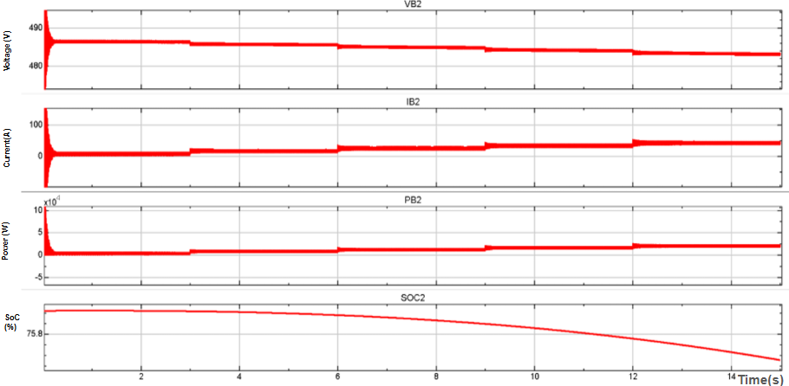
(b)
Fig. 22 Closed-loop response with the PI controller in Mode 2 (EV2 → EV1): a EV1; b EV2
Integral sliding-mode controller
Figs. 23 and 24 show the ISMC responses. The currents step cleanly with the reference in both modes, and the SOC trends confirm the intended power-flow direction. In Mode 2 the regulated EV1 current converges slowly after the 10–20 A step, taking roughly 2 s (Fig. 24a); the other steps settle quickly.

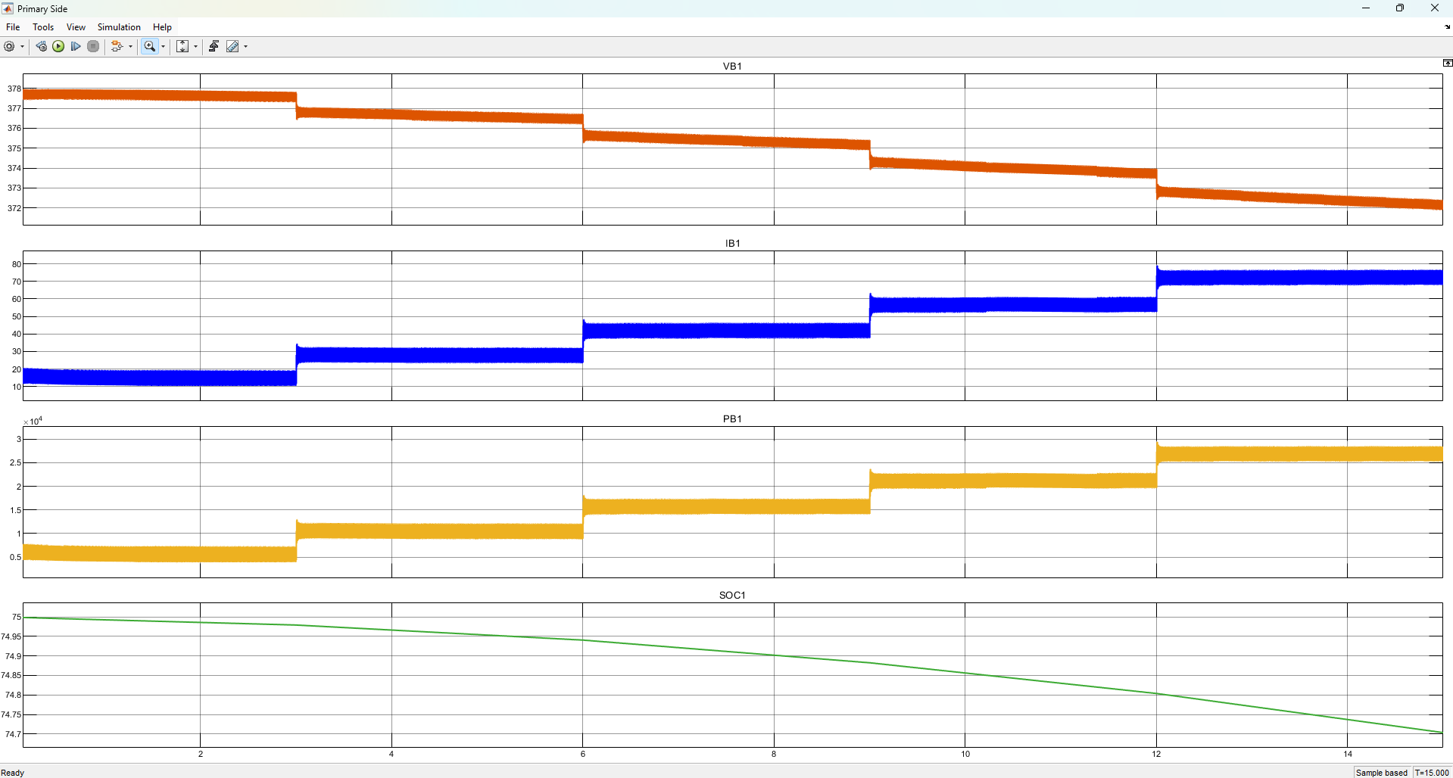
(a)
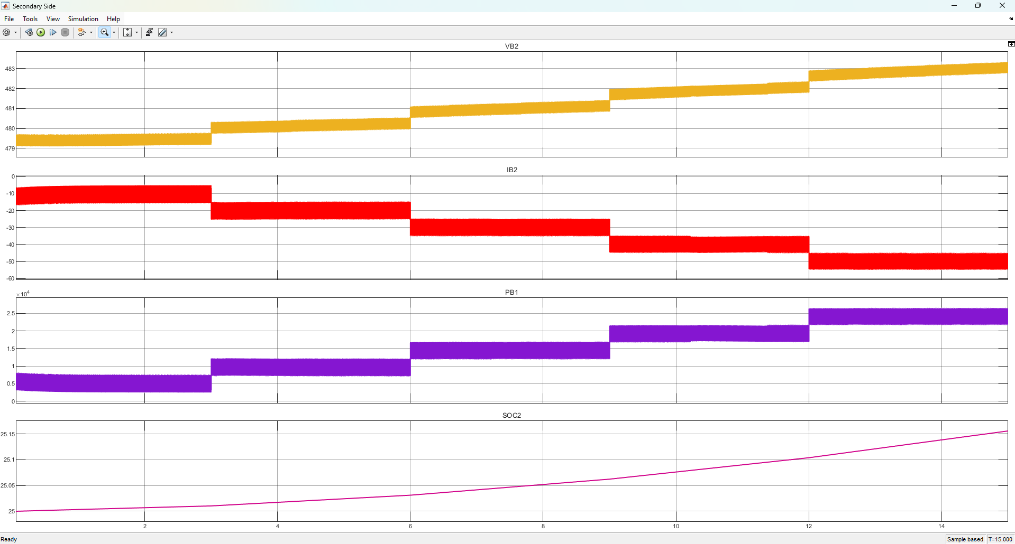
(b)
Fig. 23 Closed-loop response with the ISMC in Mode 1 (EV1 → EV2): a EV1; b EV2

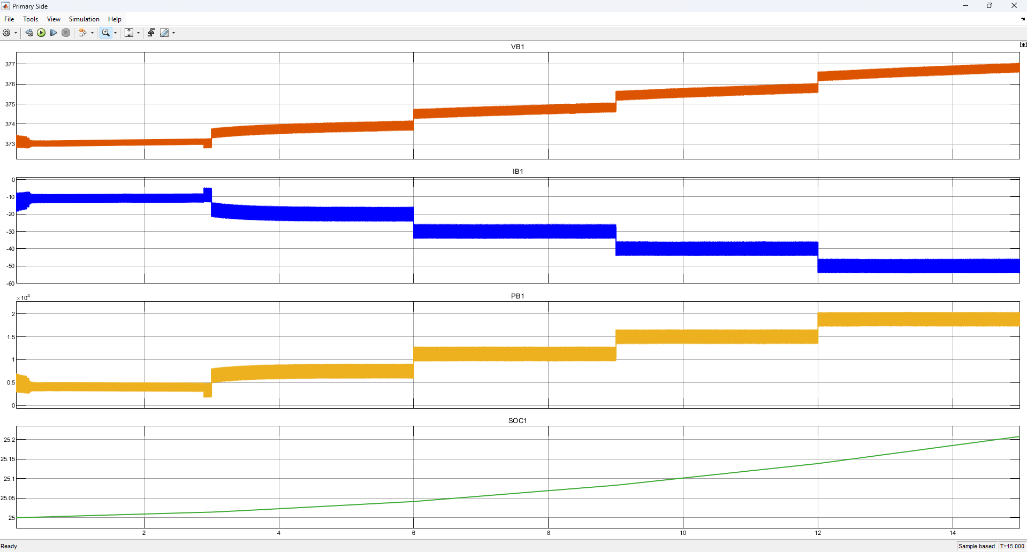
(a)
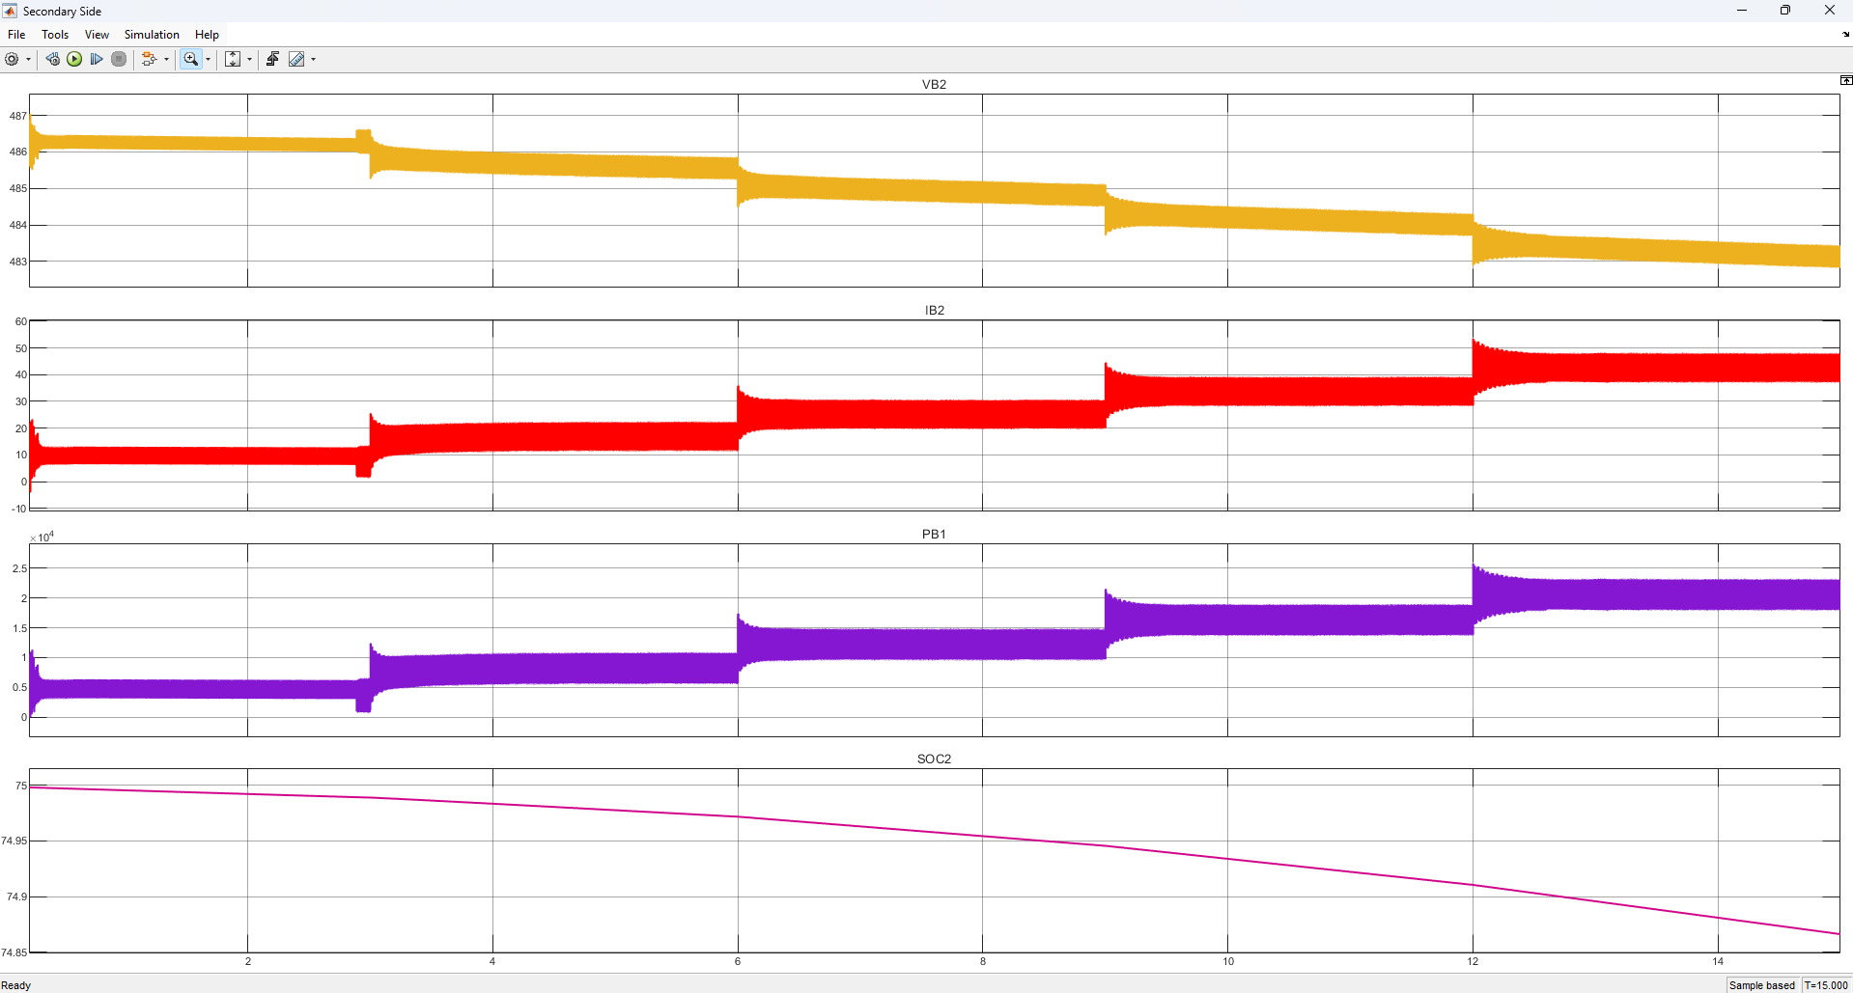
(b)
Fig. 24 Closed-loop response with the ISMC in Mode 2 (EV2 → EV1): a EV1; b EV2
Fuzzy logic controller
Figs. 25 and 26 show the FLC responses. Bidirectional operation is again confirmed, with smooth stepwise changes in current and power; however, the regulated current settles below the reference in both modes (Sect. 7.4).

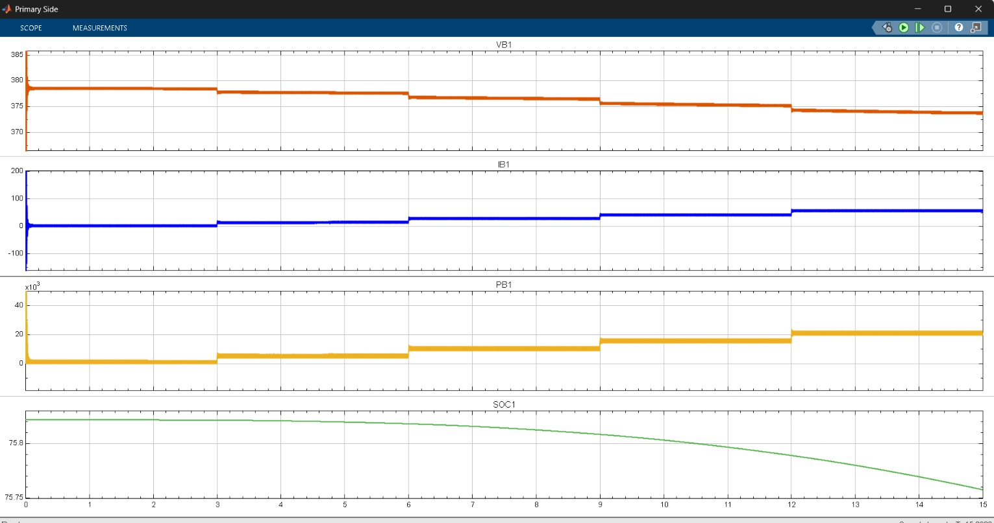
(a)
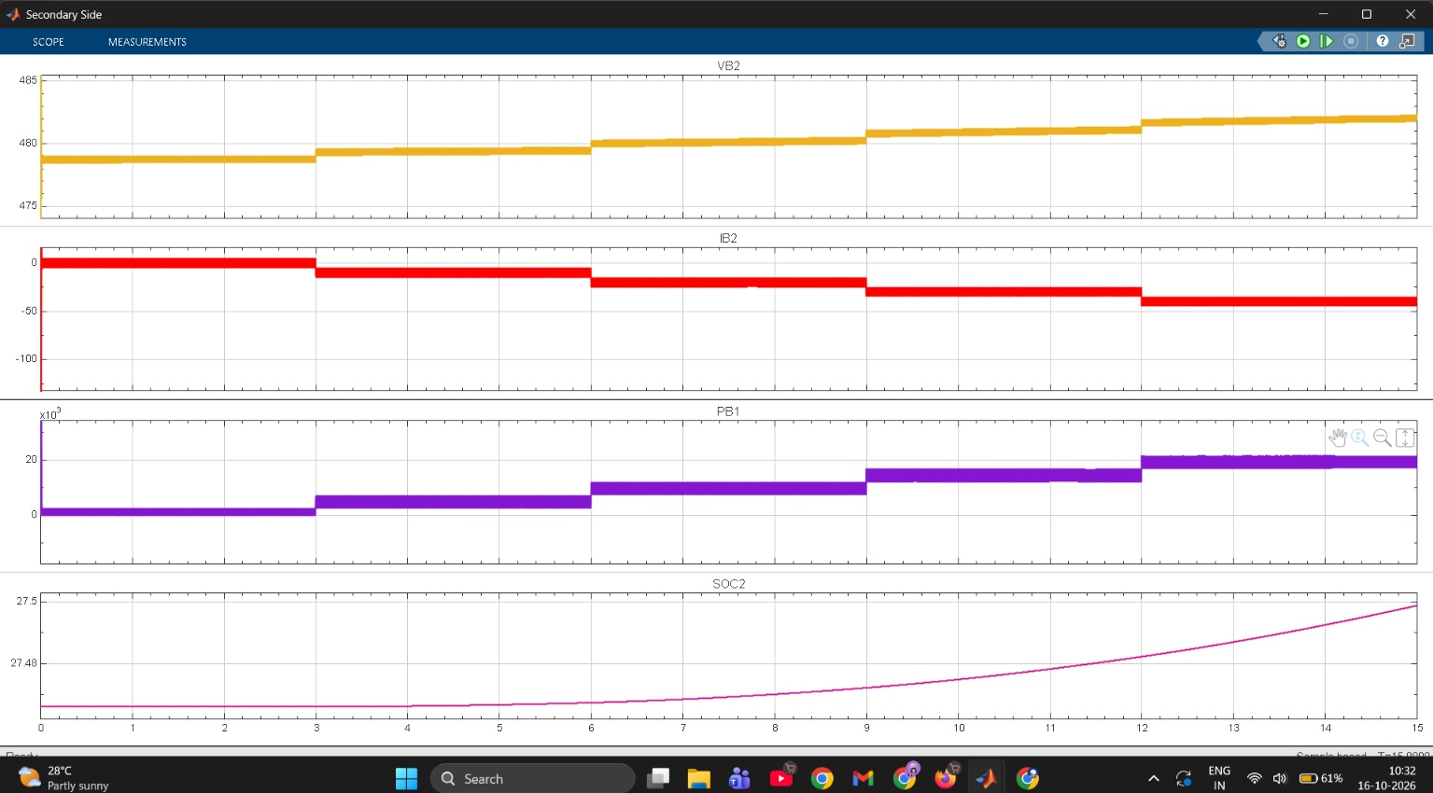
(b)
Fig. 25 Closed-loop response with the FLC in Mode 1 (EV1 → EV2): a EV1; b EV2

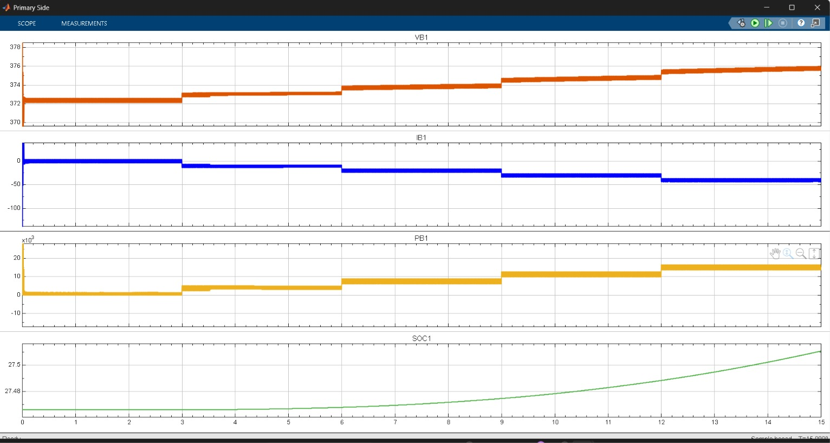
(a)
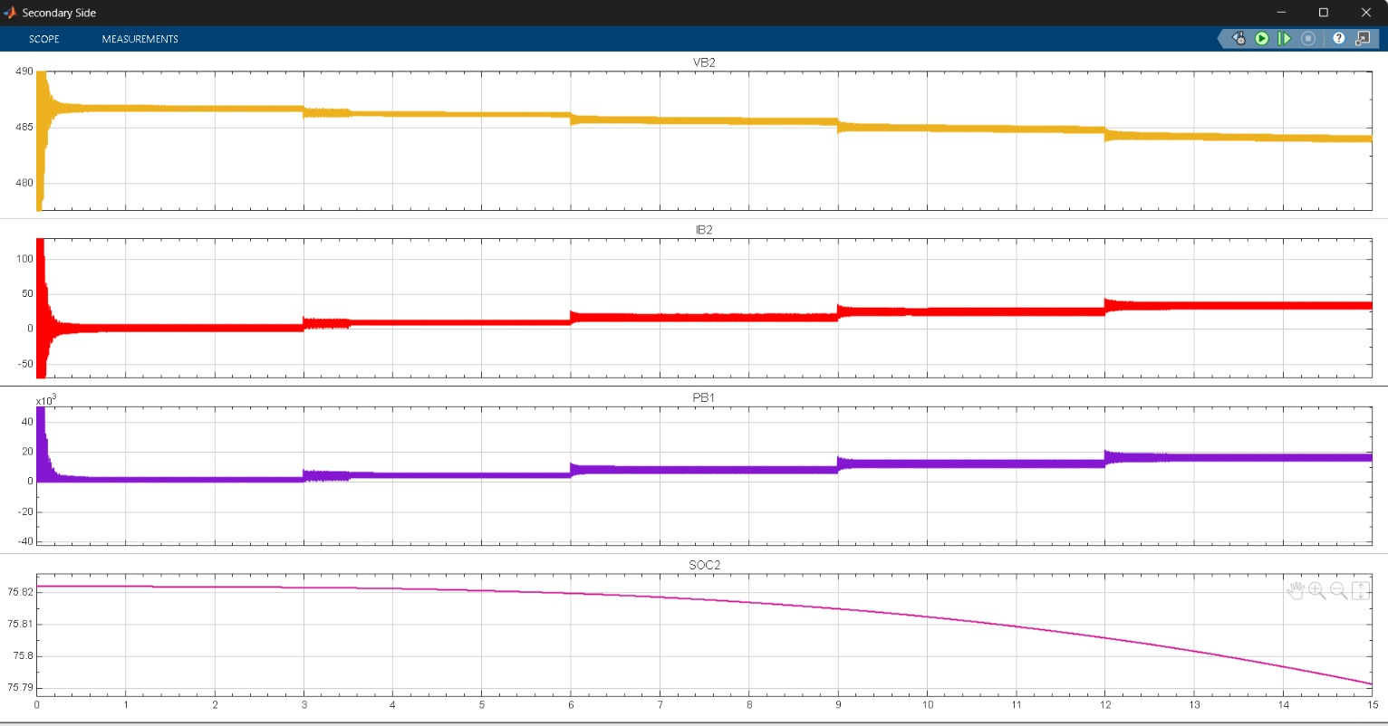
(b)
Fig. 26 Closed-loop response with the FLC in Mode 2 (EV2 → EV1): a EV1; b EV2
7.4 Steady-State Current Tracking
Table 11 lists the mean regulated current within each reference step, and Fig. 27 compares the battery currents of the three controllers in Mode 1. The ISMC held the regulated current within about 0.5 A of the reference in every step of both modes. The PI controller tracked the reference in Mode 2 but delivered about 10 A less than the reference in every step of Mode 1; at the 10 A step this means almost no charging current. The FLC delivered 8–11 A less than the reference in both modes; in Fig. 27 its trace lies beneath the PI trace, which is why it is not visible. The peak-to-peak ripple of the regulated current was about 9–11 A for all controllers.
These offsets show that, with the gains and rule base used here, the integral action of the PI loop in Mode 1 and of the FLC in both modes was not sufficient to remove the steady-state error within a 3 s step. The FLC has no explicit integral state, and its narrow output membership functions limit the duty-ratio correction to about ±0.1 around the nominal value; the PI gains were derived once and not retuned for the second direction. The results therefore characterize the tuned controllers rather than the PI and fuzzy structures in general.

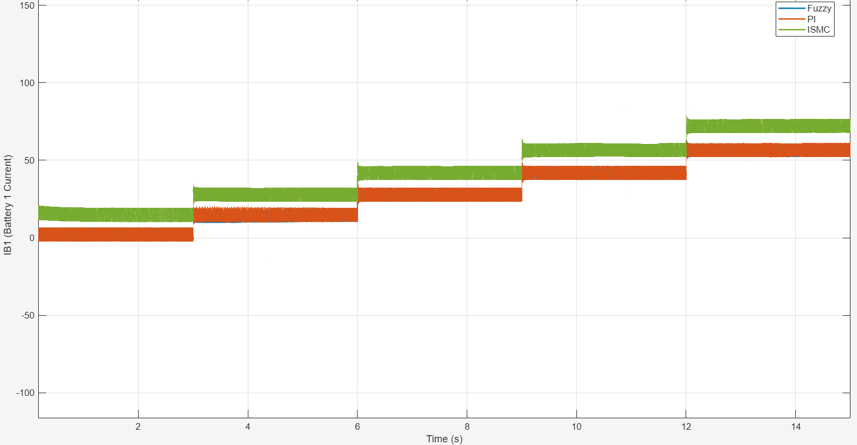
(a)
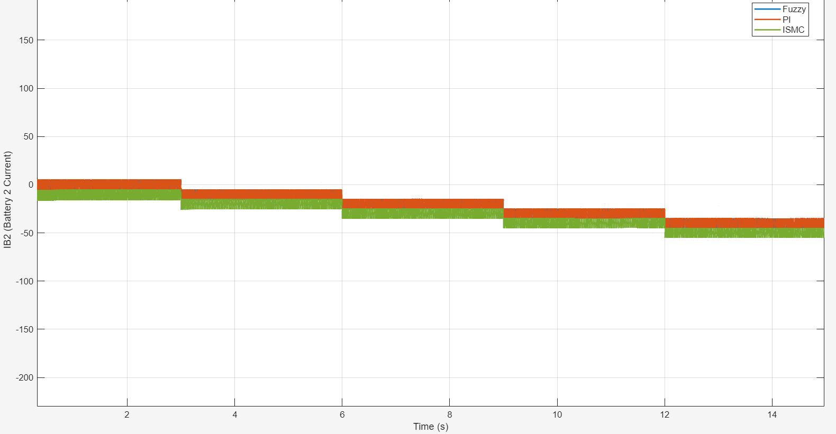
(b)
Fig. 27 Steady-state comparison in Mode 1 under the stepped reference: a EV1 battery current I_{B1}; b EV2 battery current I_{B2} (negative values denote charging); the FLC trace lies beneath the PI trace
Table 11 Mean regulated current in each reference step (A)
Reference (A) | 10 | 20 | 30 | 40 | 50 | Resolution
Mode 1, |I_{B2}|
PI | ≈0 | 9.4 | 19.2 | 29.1 | 39.3 | ±0.6
ISMC | 10.2 | 19.8 | 29.7 | 39.5 | 49.7 | ±0.6
FLC | ≈0 | 10 | 19 | 29 | 39 | ±1.5
Mode 2, |I_{B1}|
PI | 10 | 21 | 31 | 40 | 51 | ±3
ISMC | 9.9 | 20^{b} | 29.8 | 39.8 | 49.7 | ±0.5
FLC | ≈0 | 12 | 21 | 31 | 42 | ±2
ª Means between 0.6 s and 2.8 s after each step, extracted from the recorded waveforms (Figs. 21–27); the resolution reflects the plot scale. ^{b} Converges slowly within the step, from about 17 A to 22 A

Figs. 28 and 29 compare the battery power, voltage and SOC in Mode 1. The ISMC transfers more power at every step than the PI controller, consistent with its higher delivered current; the battery voltages change by only a few volts over the 15 s run, and the EV2 SOC rises fastest with the ISMC.

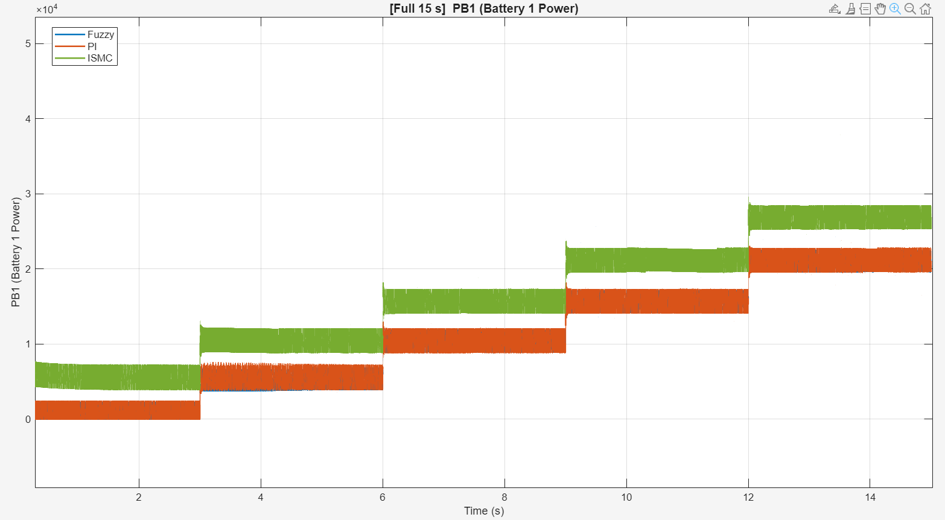
(a)
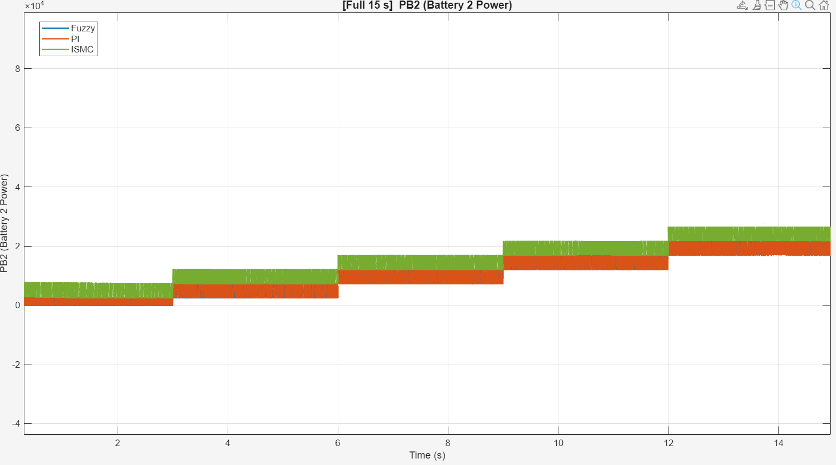
(b)
Fig. 28 Steady-state comparison of the battery power with the three controllers in Mode 1: a EV1 power; b EV2 power

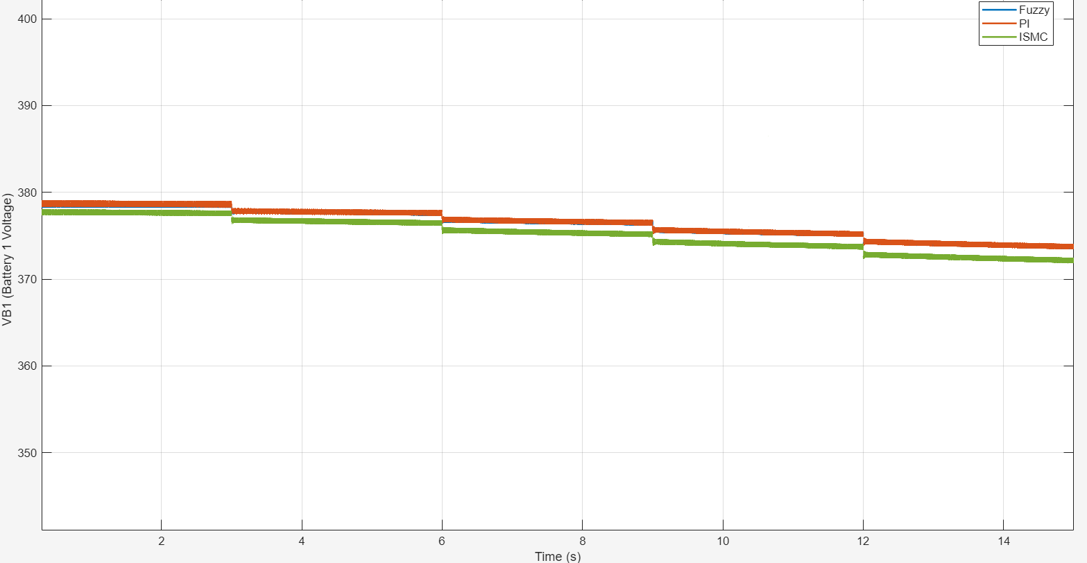
(a)
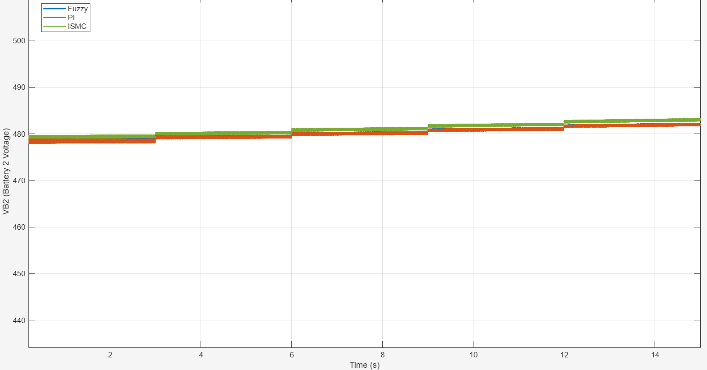
(b)
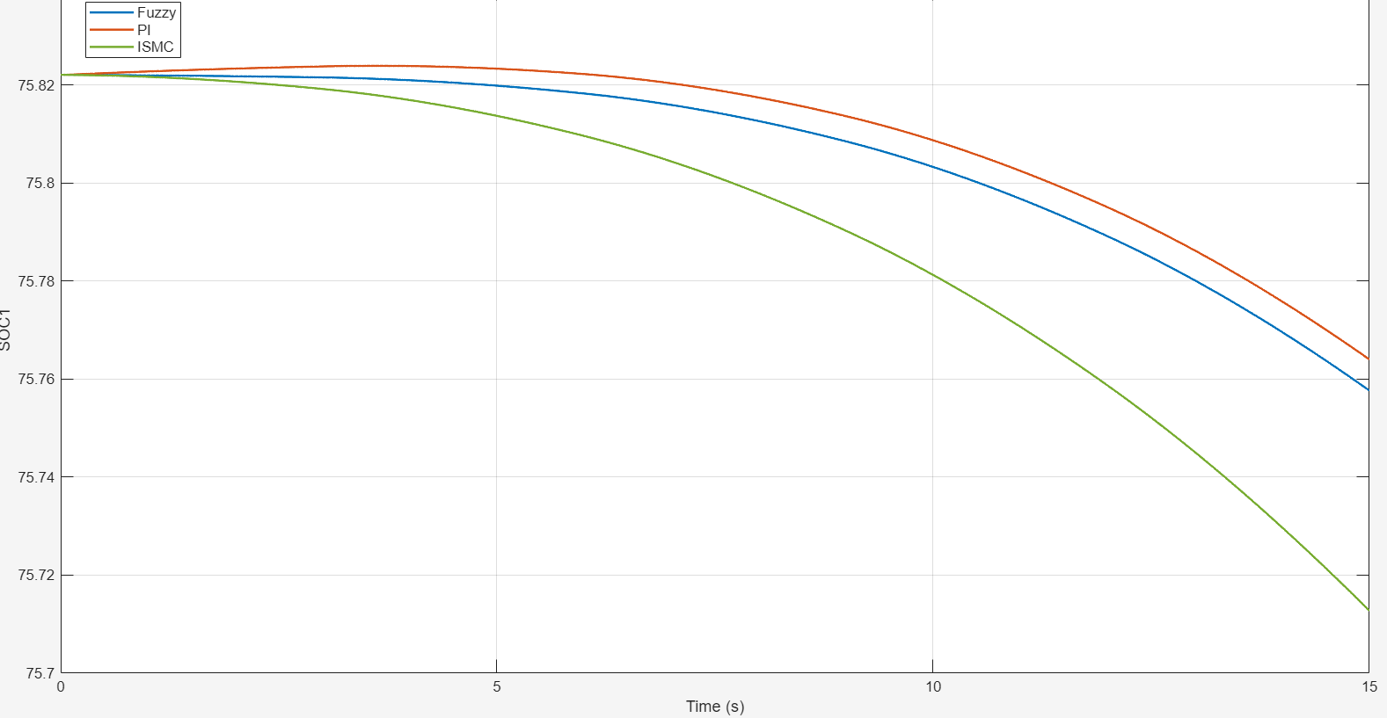
(c)
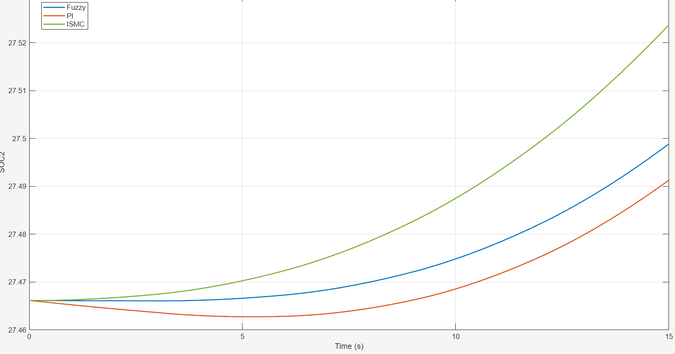
(d)
Fig. 29 Steady-state comparison of the battery voltage and SOC in Mode 1: a EV1 voltage; b EV2 voltage; c EV1 SOC; d EV2 SOC
7.5 Start-Up Transient
Figs. 30 and 31 compare the three controllers during the first 0.1 s of a Mode 1 run, and Table 12 summarizes the extracted metrics. With the PI controller, the EV2 current reached a peak of about 1567 A and the EV2 voltage dipped by about 86 V, and the battery voltages settled only after 71–74 ms. With ISMC and FLC, the EV2 current peak was about 594 A and the voltage dip about 34 V, reductions of about 62% and 60%, and the battery voltages settled within 8.6 ms (EV2) and 22 ms (EV1), three to eight times faster than with PI. Fig. 32 shows the same behaviour in the EV1 power. The two nonlinear controllers behaved almost identically in this interval. Although large, these start-up peaks occur within the first few milliseconds and would in practice be limited by soft-start and protection functions, which were not modelled.

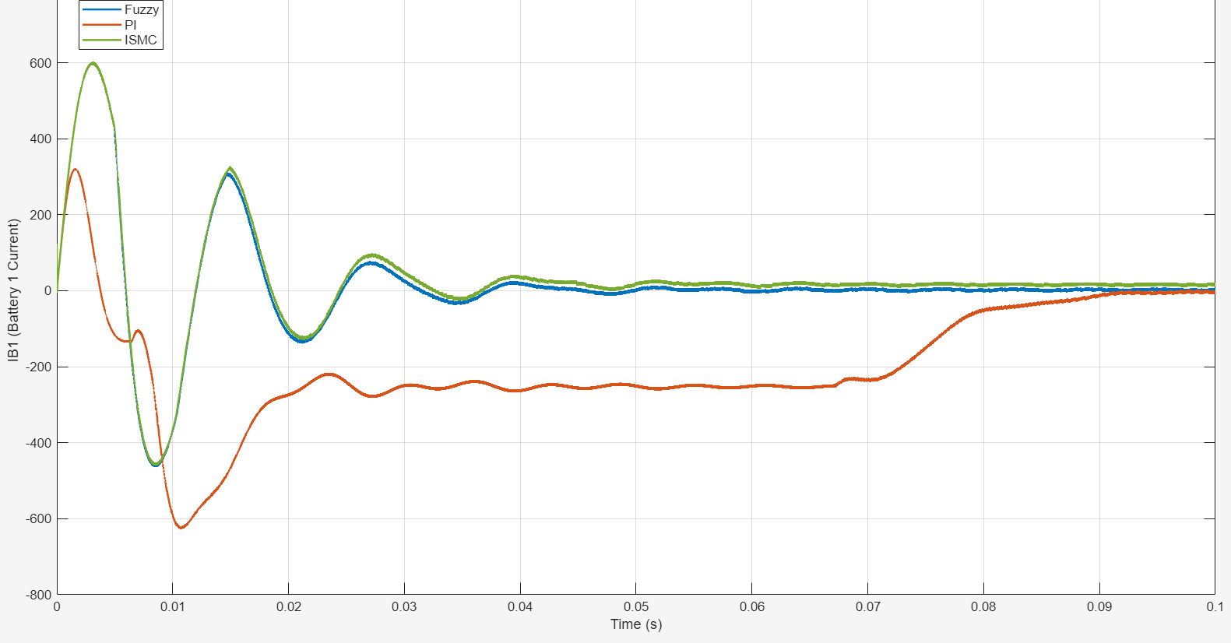
(a)
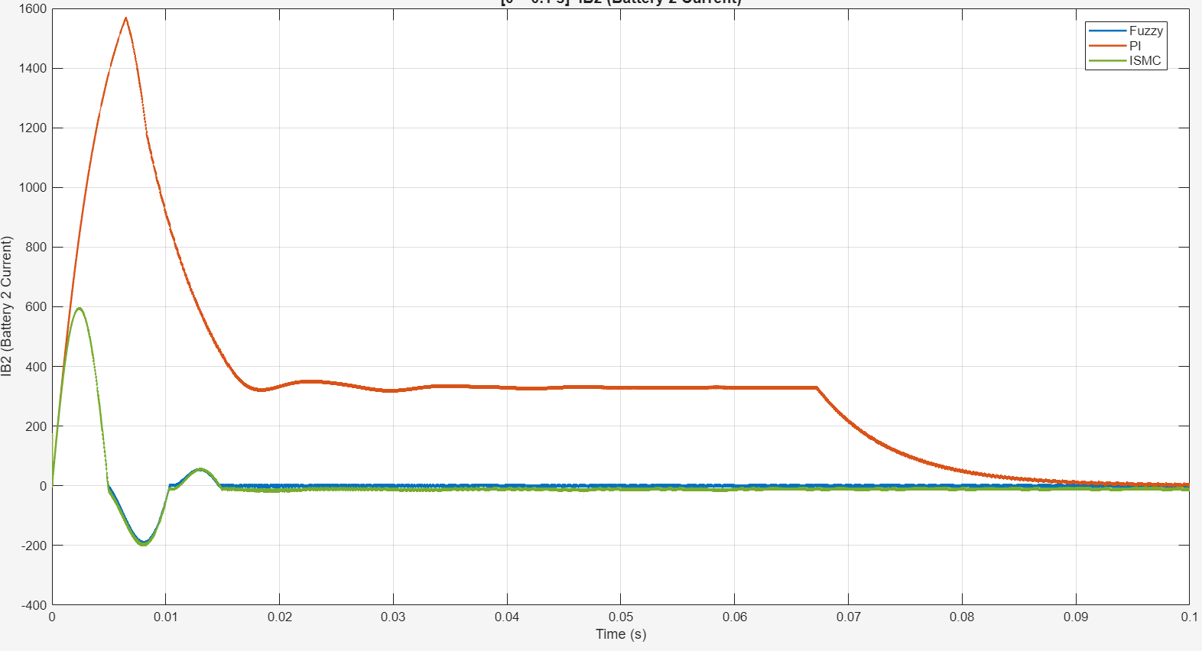
(b)
Fig. 30 Start-up transient of the battery currents with PI, ISMC and FLC in Mode 1: a EV1 current I_{B1}; b EV2 current I_{B2}

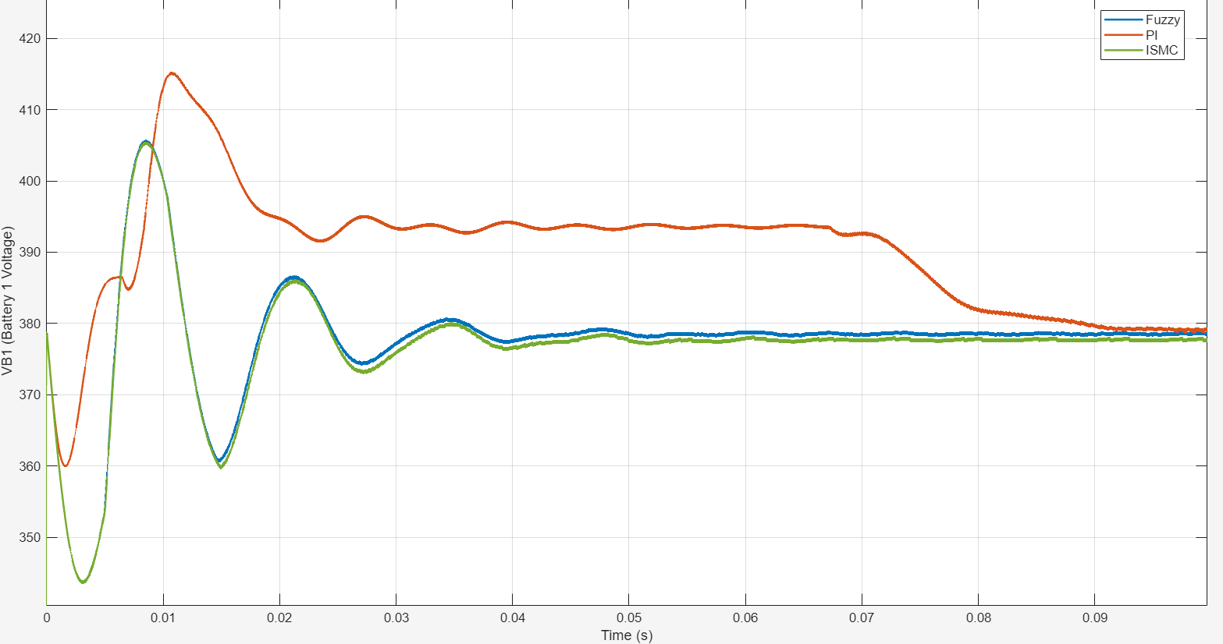
(a)
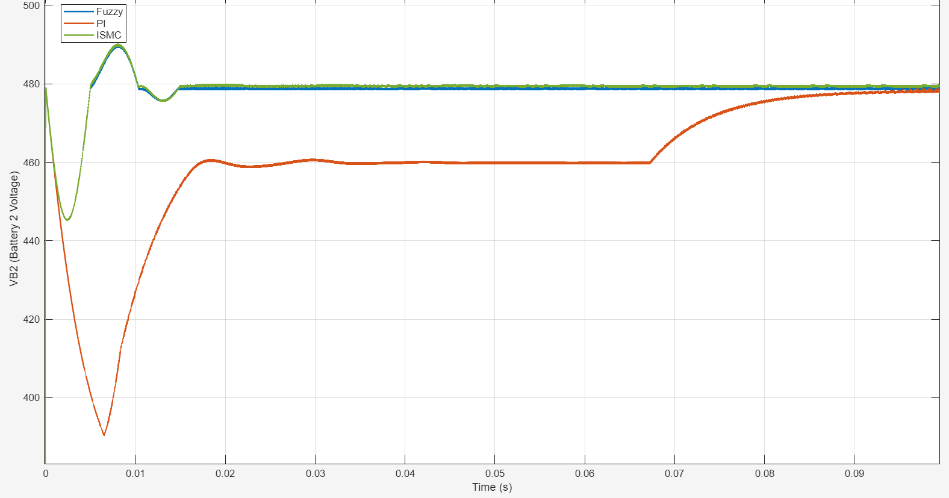
(b)
Fig. 31 Start-up transient of the battery voltages with PI, ISMC and FLC in Mode 1: a EV1 voltage V_{B1}; b EV2 voltage V_{B2}
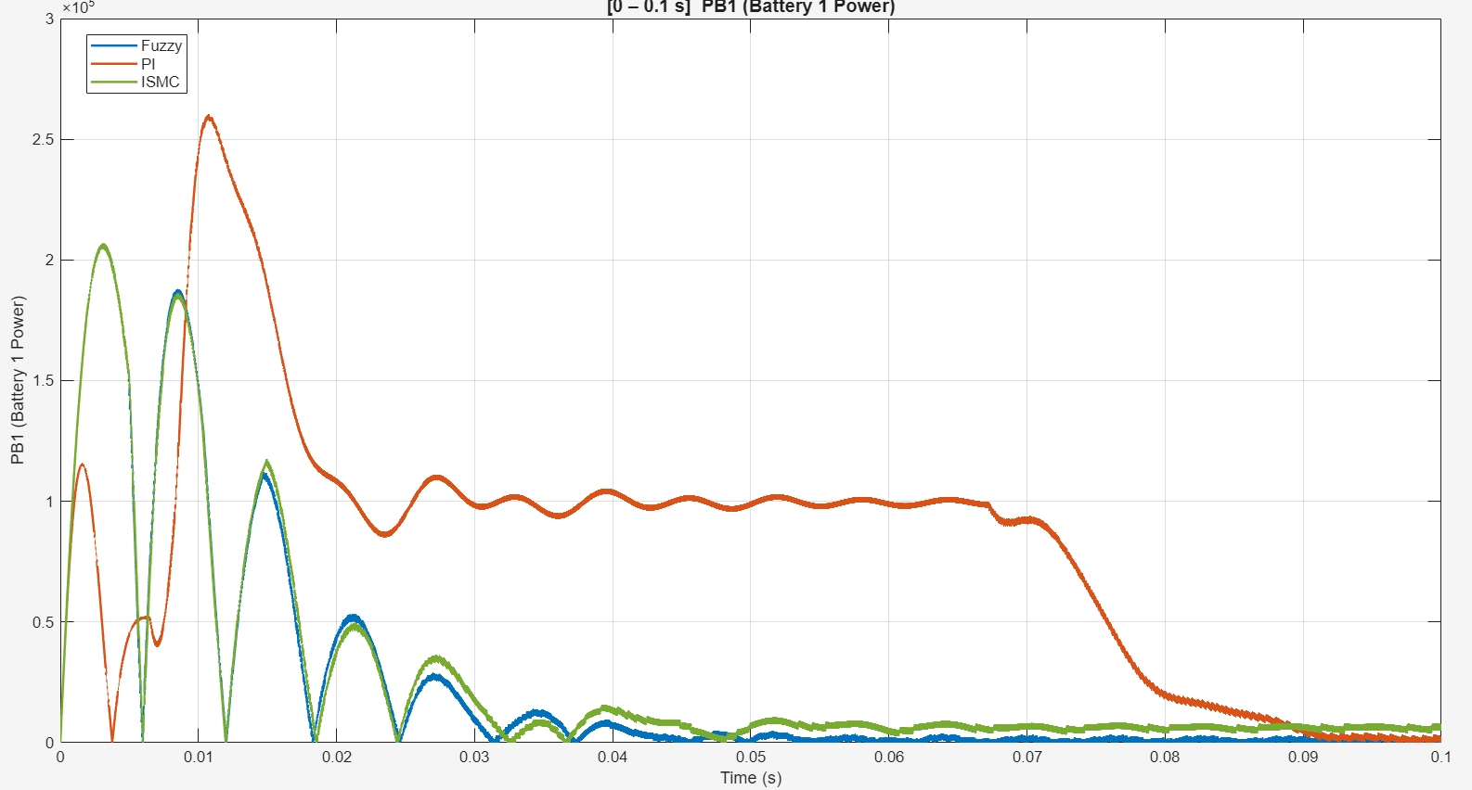
Fig. 32 Start-up transient of the EV1 battery power with the three controllers (Mode 1)
Table 12 Start-up transient metrics in Mode 1
Controller | Peak |I_{B1}| (A) | Peak |I_{B2}| (A) | Max ΔV_{B2} (V) | t_{s}, V_{B1} (ms) | t_{s}, V_{B2} (ms) | t_{s}, I_{B2} (ms)
PI | 625 | 1567 | 86.2 | 74.3 | 70.6 | 84.5
ISMC | 600 | 594 | 34.1 | 22.1 | 8.6 | 14.5
FLC | ≈600ª | ≈594ª | ≈34ª | 21.8 | 8.6 | 14.2
t_{s}: settling time to ±2% of the final value for voltages and ±20 A for currents. Extraction resolution ≈ ±2.5 A, ±0.15 V and ±0.07 ms. ª The FLC trace coincides with the ISMC trace during the first 5 ms

7.6 Efficiency
Fig. 33 and Table 13 give the efficiency at source-battery SOCs of 40–75% with the receiving battery at 25% SOC. In Mode 1, the PI controller gave the highest efficiency at every SOC, 90.0–92.8% (mean 91.5%), compared with means of 89.1% for FLC and 88.3% for ISMC. In Mode 2 the order was reversed: FLC gave 92.6–94.6% (mean 93.6%), ISMC 92.3% and PI 89.9%.
These results must be read together with Table 11. In each direction, the most efficient controller was also one that delivered about 10 A less than the reference: PI in Mode 1 and FLC in Mode 2. Because conduction and switching losses grow with current, part of the efficiency difference is likely to reflect the different delivered currents rather than the control law itself. The 2.4-point advantage of ISMC over PI in Mode 2, where both tracked the reference, is not affected by this confounding and indicates a genuine influence of the controller on the switching pattern and losses. A comparison at equal delivered power would be needed to separate the two effects.
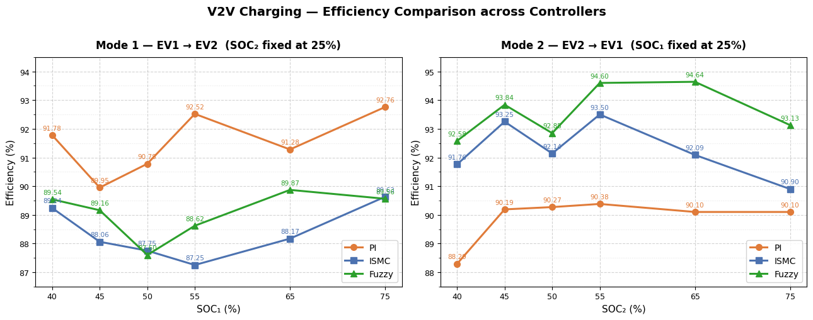
Fig. 33 Efficiency of the three controllers versus source-battery SOC: Mode 1, EV1 → EV2, with EV2 at 25% SOC (left), and Mode 2, EV2 → EV1, with EV1 at 25% SOC (right)
Table 13 Efficiency (%) versus source-battery SOC (receiving battery at 25% SOC)
Controller | 40% | 45% | 50% | 55% | 65% | 75% | Mean
Mode 1
PI | 91.78 | 89.95 | 90.78 | 92.52 | 91.28 | 92.76 | 91.51
ISMC | 89.24 | 88.06 | 87.75 | 87.25 | 88.17 | 89.62 | 88.35
FLC | 89.54 | 89.16 | 87.60 | 88.62 | 89.87 | 89.58 | 89.06
Mode 2
PI | 88.29 | 90.19 | 90.27 | 90.38 | 90.10 | 90.10 | 89.89
ISMC | 91.76 | 93.25 | 92.14 | 93.50 | 92.09 | 90.90 | 92.27
FLC | 92.58 | 93.84 | 92.85 | 94.60 | 94.64 | 93.13 | 93.61

7.7 Semiconductor Losses
Conduction losses were computed from the collector-current-dependent saturation voltage of the IGBT model (Infineon Technologies AG 2023) as
$P_{cond} = V_{CE,sat}\left(I_{C}\right)I_{C}$ (20)
and switching losses from the datasheet turn-on and turn-off energies, accumulated at every detected gate transition over the measurement interval:
$P_{sw} = \frac{∑E_{on} + ∑E_{off}}{t_{end} − t_{start}}$ (21)
Fig. 34 shows the Simulink subsystem used for each switch: look-up tables map the collector current to V_{CE,sat} and to the switching energies, gate transitions are detected, and the event energies are accumulated. The average losses were computed with the script in Appendix B. Fig. 35 and Table 14 give the results for the ISMC in Mode 2 over 0.2–1.5 s. The total semiconductor loss was 272.2 W on the EV1 side and 266.1 W on the EV2 side. Switching loss dominated in the switched legs (for example EV1-S1 and EV1-S2), whereas the switches held permanently on (EV1-S7 and EV2-S7) incurred conduction loss only; switches without activity in this interval show no loss. Because the interval lies in the first reference step, the losses correspond to a low transferred power and should not be expressed as a fraction of the rated power.
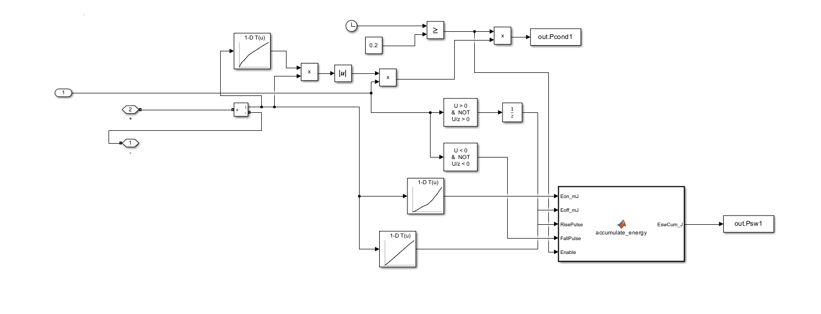
Fig. 34 Simulink subsystem that estimates the conduction and switching loss of each switch from datasheet look-up tables
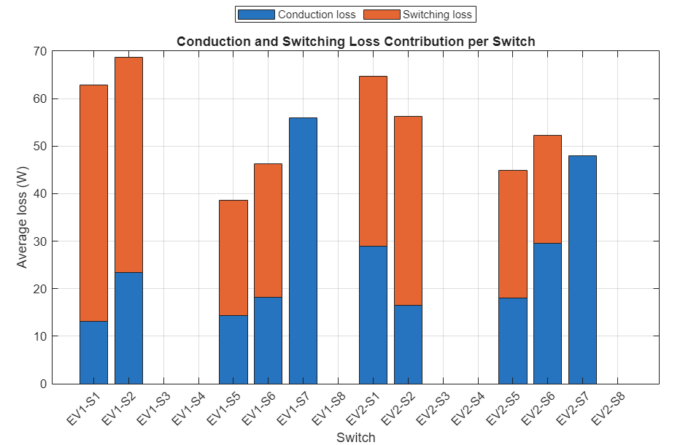
Fig. 35 Estimated conduction and switching loss of each switch for the ISMC in Mode 2
Table 14 Estimated semiconductor losses (ISMC, Mode 2)
Side | Conduction (W) | Switching (W) | Total (W)
EV1 | 124.96 | 147.23 | 272.19
EV2 | 140.95 | 125.19 | 266.13
Total | 265.91 | 272.42 | 538.32

7.8 Real-Time Software-in-the-Loop Execution
For real-time execution, the model was configured for the OPAL-RT OP4610XG simulator (Fig. 36a) and partitioned into a computation subsystem containing the converter and batteries and a supervisory subsystem (Fig. 37a). The two exchange eleven signals: the voltage, current, power and SOC of each battery and the input, feedback and reference signals (Fig. 37b). The model was executed with a 5 µs time step, and the analog outputs were captured on a mixed-signal oscilloscope (Fig. 36b).

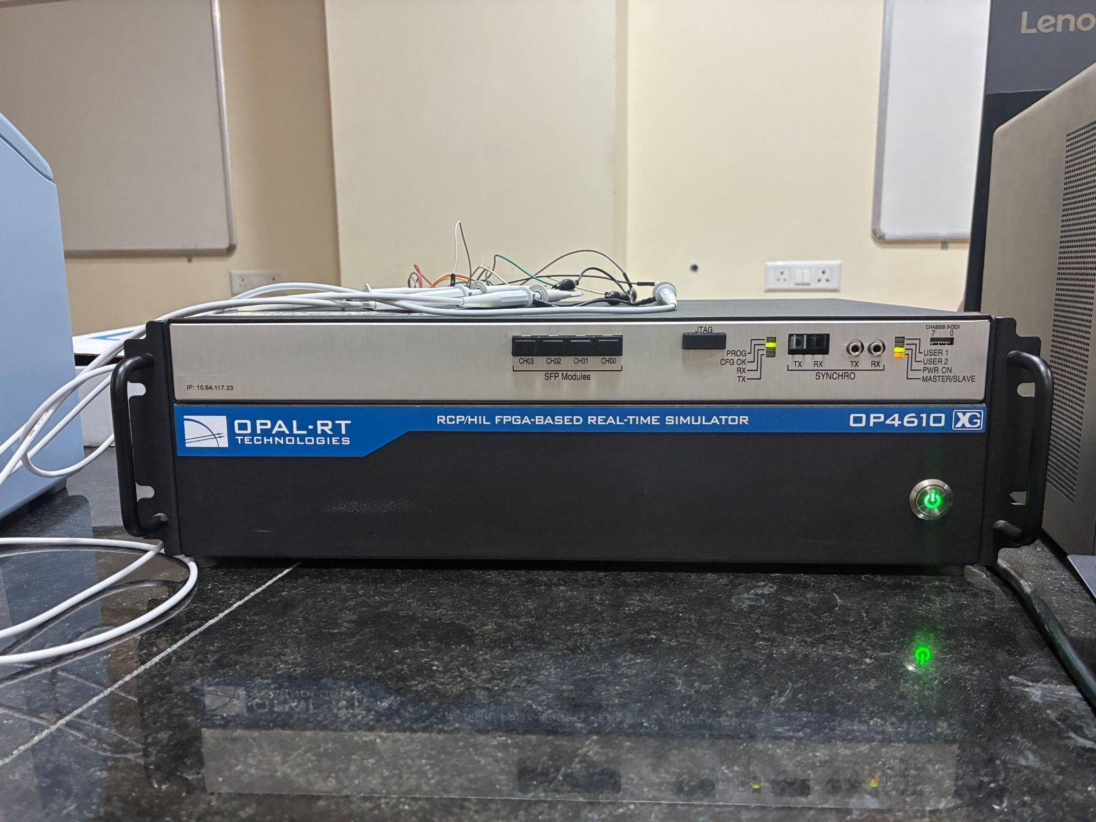
(a)
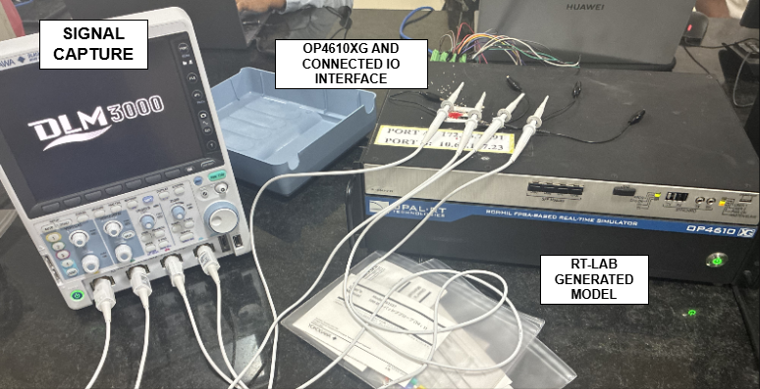
(b)
Fig. 36 Real-time SIL setup: a OPAL-RT OP4610XG simulator; b simulator with analog interface and oscilloscope

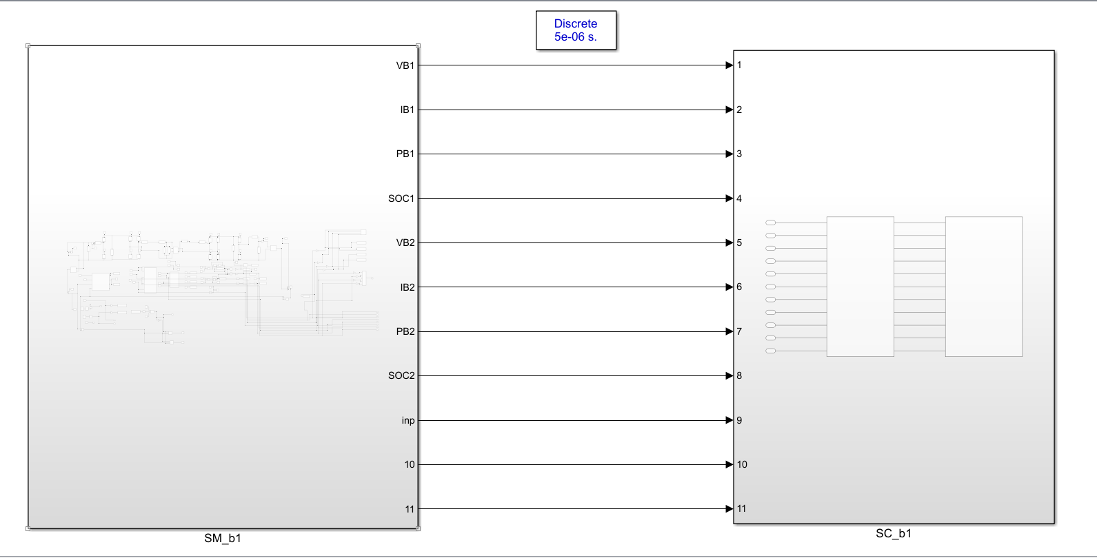
(a)
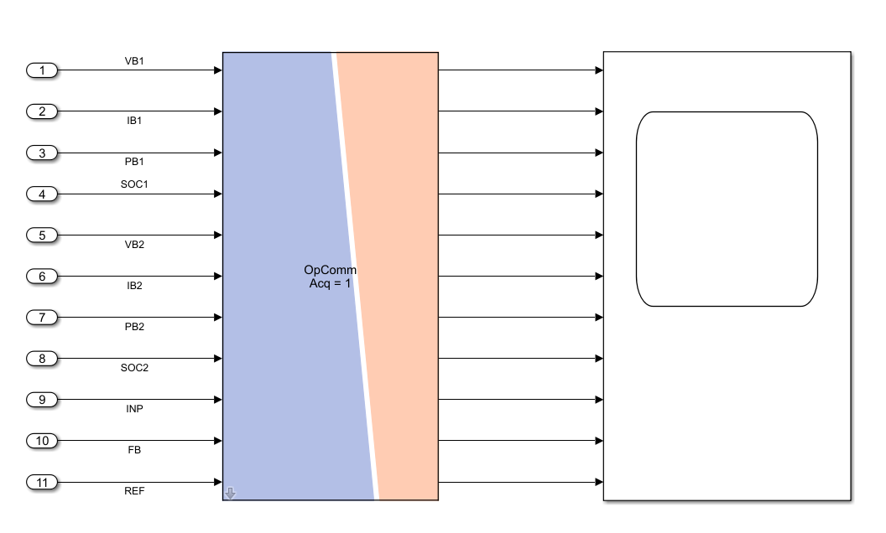
(b)
Fig. 37 Model partitioning for real-time execution: a computation (SM) and supervisory (SC) subsystems; b the eleven signals exchanged between them
Figs. 38–43 show the oscilloscope captures of the battery voltage, current, power and SOC for each controller in both modes. In all cases the signals change in steps with the reference and the SOC changes monotonically, matching the offline results. Because the converter itself is simulated, these results confirm that the three controllers execute in real time with the converter model; they do not constitute hardware validation. For the FLC in Mode 2, only the EV1-side capture is available.

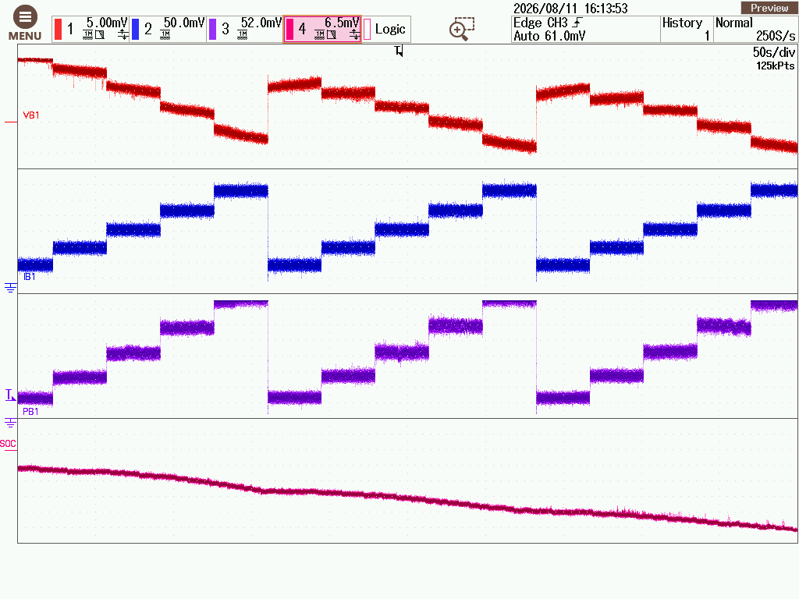
(a)
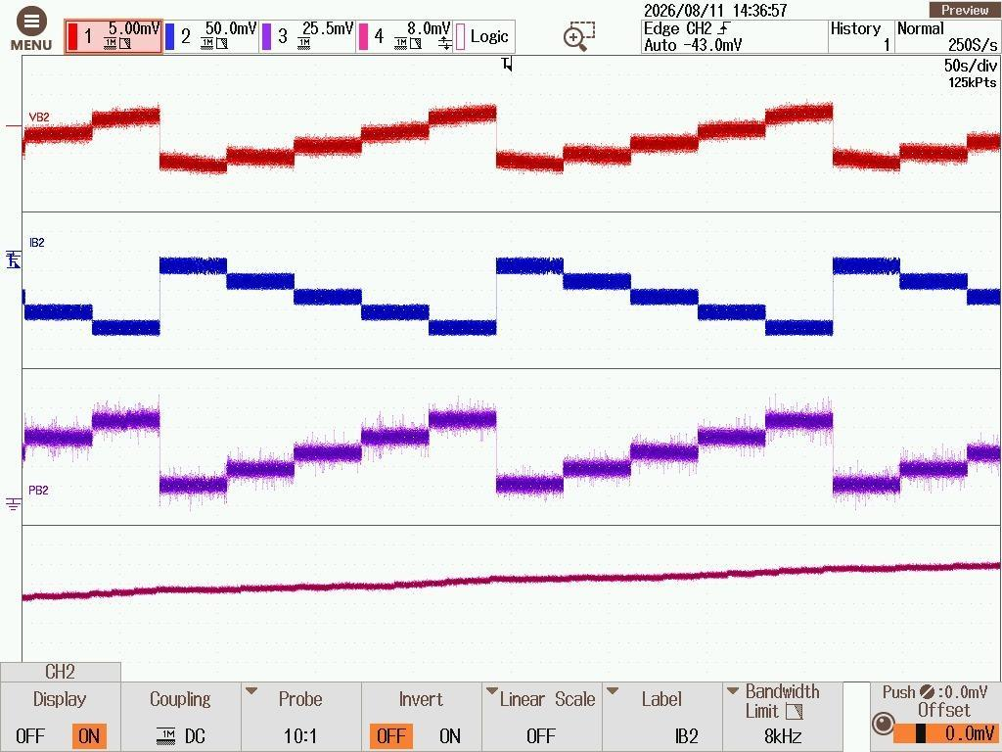
(b)
Fig. 38 Real-time SIL captures with the PI controller in Mode 1 (EV1 → EV2): a EV1 voltage, current, power and SOC; b EV2 voltage, current, power and SOC

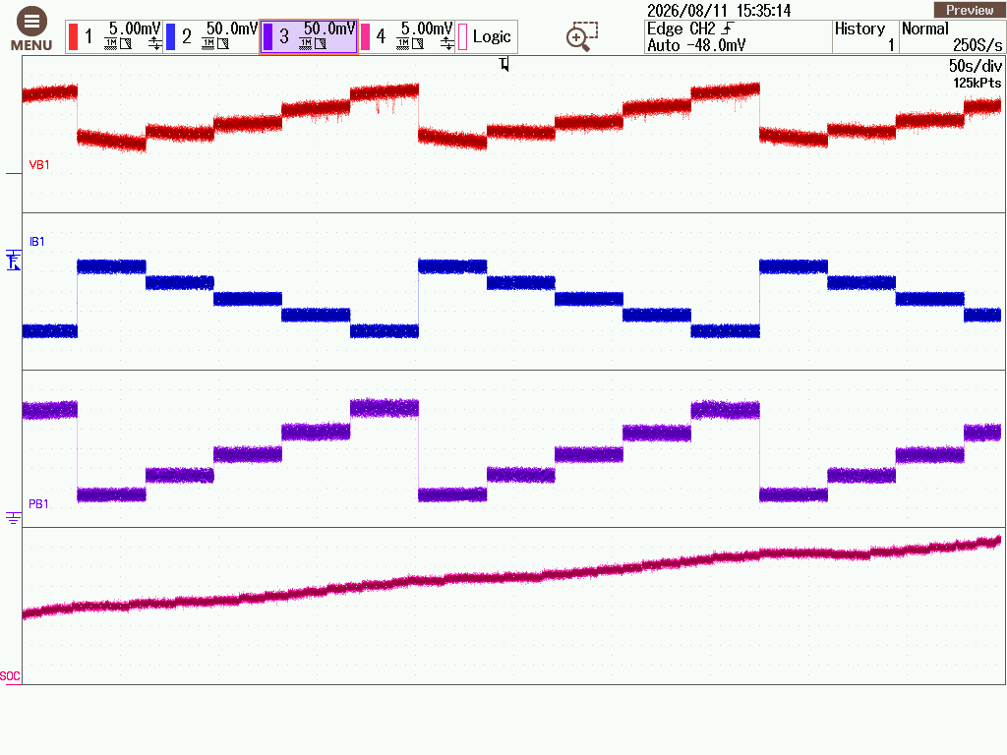
(a)
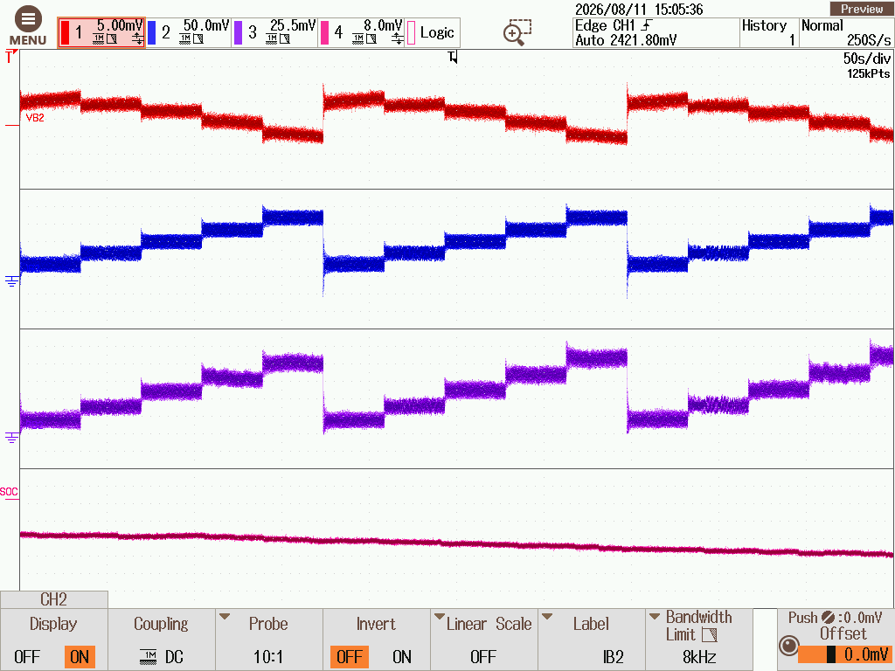
(b)
Fig. 39 Real-time SIL captures with the PI controller in Mode 2 (EV2 → EV1): a EV1; b EV2

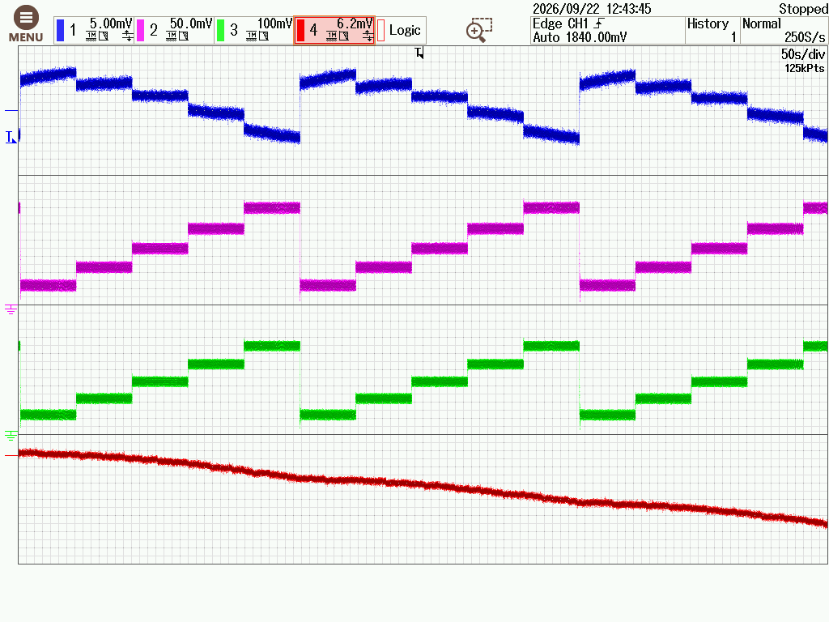
(a)
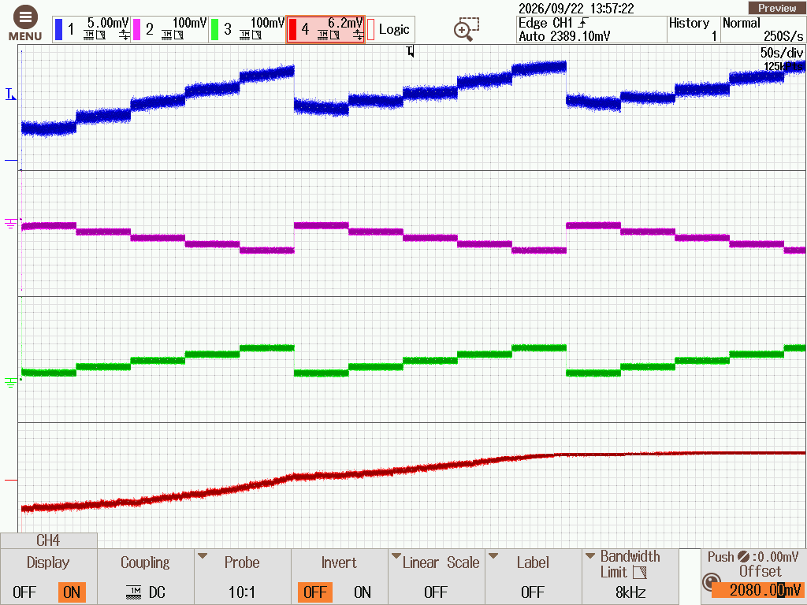
(b)
Fig. 40 Real-time SIL captures with the ISMC in Mode 1: a EV1; b EV2

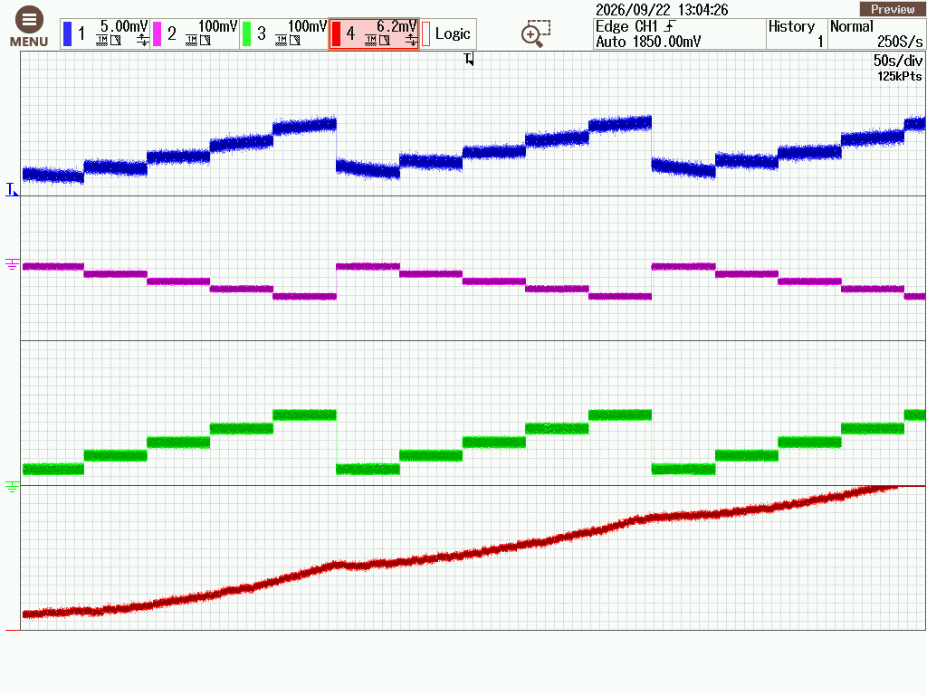
(a)
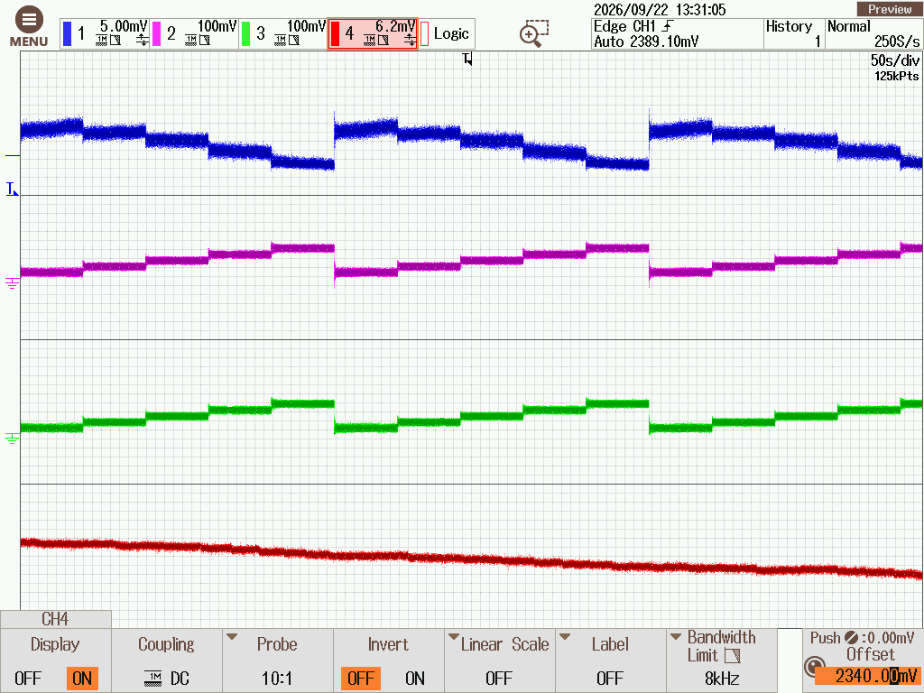
(b)
Fig. 41 Real-time SIL captures with the ISMC in Mode 2: a EV1; b EV2

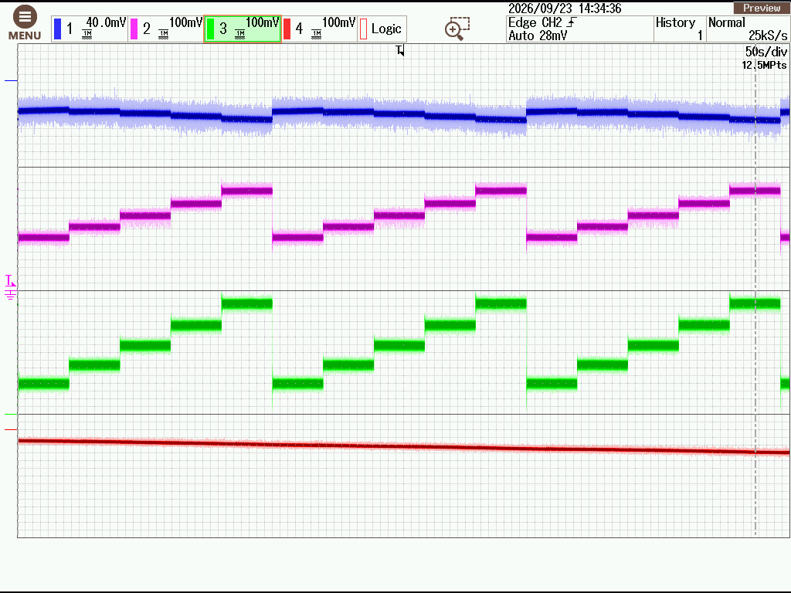
(a)
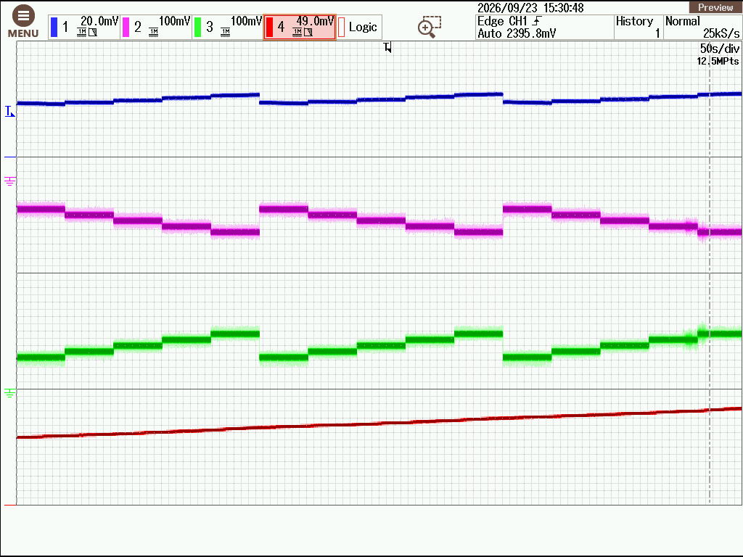
(b)
Fig. 42 Real-time SIL captures with the FLC in Mode 1: a EV1; b EV2
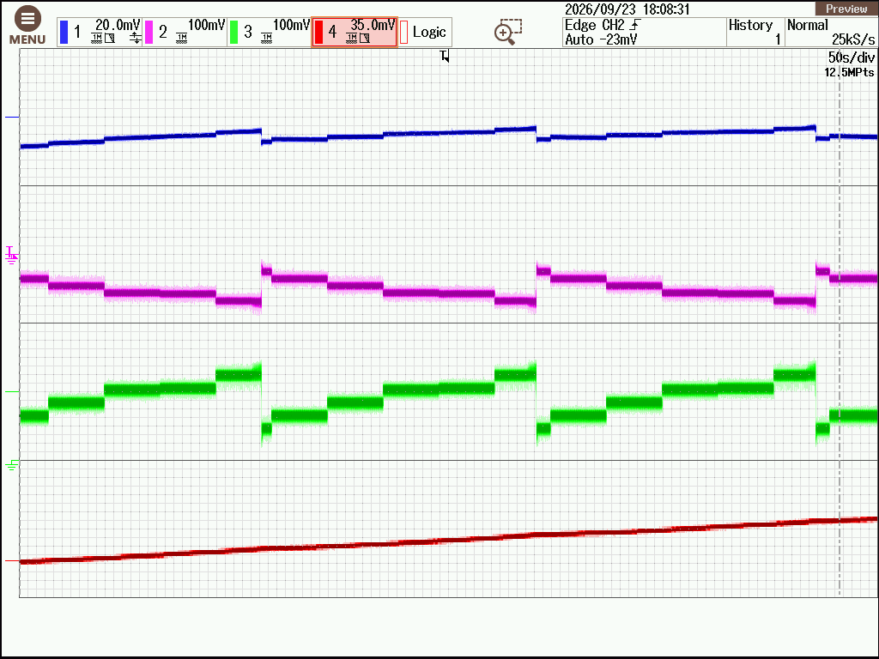
Fig. 43 Real-time SIL capture with the FLC in Mode 2 (EV1 voltage, current, power and SOC)
7.9 Discussion
Three findings stand out. First, controller performance depended on the power-flow direction. The ISMC was the only controller that tracked the reference in both directions; the PI controller tracked in Mode 2 only, and the FLC tracked in neither with the present rule base. Because a V2V converter must operate in both directions with one set of hardware, a controller tuned for one direction cannot be assumed to perform well in the other.
Second, the nonlinear controllers improved the start-up behaviour markedly. ISMC and FLC reduced the current peak by about 62% and the settling time by a factor of three to eight. This agrees with the reported robustness of integral sliding-mode control on isolated converters (Sun et al. 2020) and with the better regulation of fuzzy control over PI reported for a DAB converter (Shivakumar et al. 2026). In the present study, however, the fuzzy controller’s advantage was limited to the transient, and its steady-state offset shows that a model-free rule base still requires careful tuning of its output range.
Third, efficiency comparisons between current controllers are meaningful only at equal delivered power. The controllers that under-delivered current were also the most efficient in their respective directions, whereas the comparison between ISMC and PI in Mode 2 showed a genuine advantage of about 2.4 points for ISMC. The open-loop results add a direction-dependent effect of the topology itself: at the recorded operating points the circulating current, and hence the loss, was much larger in Mode 1 than in Mode 2. Combining the fast and accurate ISMC with direction-specific tuning, and re-evaluating efficiency once all controllers track the reference, appears to be the most promising route for this topology.
Table 15 brings together the main quantitative results for the three controllers.
Table 15 Summary of the controller comparison
Criterion | PI | ISMC | FLC
Steady-state tracking, Mode 1 | Offset ≈ 10 A | Within ≈ 0.5 A | Offset ≈ 10 A
Steady-state tracking, Mode 2 | Within ≈ 1 A (±3 A resolution) | Within ≈ 0.5 A; slow convergence in one step | Offset 8–11 A
Start-up peak |I_{B2}|, Mode 1 | 1567 A | 594 A | ≈594 A
Settling time of V_{B2}, Mode 1 | 70.6 ms | 8.6 ms | 8.6 ms
Mean efficiency, Mode 1 | 91.51% | 88.35% | 89.06%
Mean efficiency, Mode 2 | 89.89% | 92.27% | 93.61%
Real-time SIL execution | Both modes | Both modes | Both modes
Main limitation observed | Gains not valid for Mode 1 | Slow convergence after one step in Mode 2 | No integral action; narrow output range
Efficiency means are over source-battery SOCs of 40–75%; they are affected by the different delivered currents (Sect. 7.6)

7.10 Implications for Design
The results suggest several practical guidelines for this class of converter. First, the current controller should be designed and verified for both power-flow directions, because the mode-dependent gate mapping changes the plant seen by the controller; in this study a single set of PI gains tracked in one direction but not the other. Second, an explicit integral state, as in the ISMC, is valuable for removing the steady-state error of the regulated current; a fuzzy controller without one, or with a narrow output range, may leave a persistent offset. Third, controller comparisons should be made at equal delivered current or power, otherwise efficiency differences reflect the operating point as much as the control law. Fourth, the resonant link and the switching devices should be rated for the DC-link voltage and circulating current observed in simulation, which here exceeded the ratings of the device model used for loss estimation. Finally, soft-start and current limiting are needed to contain the start-up excursions, which reached several hundred amperes for all three controllers.
8 Limitations and Future Work
The study has several limitations. The evaluation is based on simulation and SIL execution only; hardware-in-the-loop testing and a physical prototype are needed to confirm the results. The controllers were tuned once, and the steady-state offsets of the PI controller (Mode 1) and FLC (both modes) show that further tuning, for example an integral term in the FLC or retuned PI gains, is required before their efficiency can be compared fairly. Several runs started from different SOCs, and the transient and steady-state metrics were extracted from recorded waveforms with the resolutions stated; re-extracting them from logged data would reduce this uncertainty.
The device model also needs revision. The simulated DC-link voltage was about 936 V in Mode 1 and 786 V in Mode 2, and the primary current reached about 300 A in Mode 1, whereas the IGBT used for the loss model is rated at 650 V and 75 A. A practical design would require devices of higher voltage and current rating, such as 1200 V silicon-carbide MOSFETs, and the loss figures reported here should be regarded as indicative. The open-loop efficiency of about 71% in Mode 1 at rated power also indicates high circulating current in the resonant link, which merits further optimization of the tank design and operating point. Finally, thermal behaviour, electromagnetic interference, protection, inter-vehicle communication and compatibility with commercial OBC interfaces were outside the scope of this work. Future work will address hardware-in-the-loop validation, a comparison of Si and SiC devices, PCB design and a hardware prototype with a dedicated communication link between the vehicles.
9 Conclusions
This study compared PI, integral sliding-mode and fuzzy logic charging-current control of an isolated single-stage bidirectional V2V converter that reuses the OBC bridges of both vehicles and couples them through an external resonant HFT connector. Open-loop simulation identified duty ratios of 0.5724 and 0.5710 for EV1-to-EV2 and EV2-to-EV1 transfer between 350 V and 450 V batteries, within 4% of the idealized Ćuk-type gain. In closed loop, the ISMC was the only controller that held the regulated current within about 0.5 A of the reference in both directions; with the gains used, the PI controller showed an offset of about 10 A in EV1-to-EV2 transfer and the FLC an offset of 8–11 A in both directions. ISMC and FLC reduced the start-up current peak by about 62% and settled three to eight times faster than PI. Mean efficiencies over the tested SOC range were 88.4–91.5% for EV1-to-EV2 and 89.9–93.6% for EV2-to-EV1 transfer, but the ranking is partly confounded by the different delivered currents. All three controllers executed in real time on an OPAL-RT simulator. The results indicate that ISMC is the most suitable of the three controllers for this topology, provided the device ratings and resonant-link stress are addressed in a hardware design.
Appendix A: Triangular Carrier Generator
The PWM carrier is generated from a limited counter (0–7) by the following MATLAB function block:
function y = fcn(count)
%#codegen
% count: uint8 from Counter Limited (0 to 7); y: double in [0, 1]
N = uint8(8);
HALF_N = uint8(4);
c = uint8(count);
if c < HALF_N
y = double(c) / double(HALF_N);
else
y = double(N - c) / double(HALF_N);
end

Appendix B: Average Loss Computation
The average loss of each switch was obtained from the logged instantaneous loss by trapezoidal integration over the selected window:
t = tout(:);
p = Pcond(:);
idx = t >= 0.2 & t <= 10;
t_seg = t(idx);
p_seg = p(idx);
if numel(t_seg) < 2
error('Insufficient samples in the selected time window.');
end
Pavg = trapz(t_seg, p_seg) / (t_seg(end) - t_seg(1));
fprintf('Average conduction loss = %.4f W\n', Pavg);

Acknowledgements The authors thank the School of Electrical Engineering, Vellore Institute of Technology, Chennai, for access to the OPAL-RT real-time simulation laboratory.
Author Contributions
Funding No funding was received for conducting this study.
Data Availability The simulation models and data are available from the corresponding author on reasonable request.
Declarations
Conflict of interest The authors declare that they have no conflict of interest.
Ethical approval Not applicable; the study involved no human participants or animals.
Consent to participate and for publication Not applicable.
References
Chitra Devi S, Ramkumar A, Rajesh K (2026) Optimized bidirectional power flow in hybrid systems using fuzzy logic and Fire Hawk search: an electric vehicle perspective. Iran J Sci Technol Trans Electr Eng 50:573–590. https://doi.org/10.1007/s40998-025-00859-6
Deshmukh S, Iqbal A, Islam S, Khan I, Marzband M, Rahman S, Al-Wahedi AMAB (2022) Review on classification of resonant converters for electric vehicle application. Energy Rep 8:1091–1113. https://doi.org/10.1016/j.egyr.2021.12.013
Fan H, Li H (2011) High-frequency transformer isolated bidirectional DC–DC converter modules with high efficiency over wide load range for 20 kVA solid state transformer. IEEE Trans Power Electron 26(12):3599–3608
Gümrükcü E, Klemets JRA, Suul JA, Ponci F, Monti A (2023) Decentralized energy management concept for urban charging hubs with multiple V2G aggregators. IEEE Trans Transp Electrific 9(2):2367–2381
Haghani M, Sprei F, Kazemzadeh K, Shahhoseini Z, Aghaei J (2023) Trends in electric vehicles research. Transp Res Part D Transp Environ 123:103881
Infineon Technologies AG (2023) IKWH75N65EH7: high speed and low saturation voltage 650 V TRENCHSTOP IGBT7. Datasheet. https://www.infineon.com/
Noh K, Zhang M, Sánchez-Sinencio E (2019) A unified amplifier-based CC-CV linear charger for energy-constrained low-power applications. IEEE Trans Circuits Syst II Express Briefs 66(3):377–381
Shafiqurrahman A, Umesh BS, Al Sayari N, Khadkikar V (2023) Electric vehicle-to-vehicle energy transfer using on-board converters. IEEE Trans Transp Electrific 9(1):1263–1272
Shah V, Payami S (2023) Integrated converter with G2V, V2G, and DC/V2V charging capabilities for switched reluctance motor drive-train based EV application. IEEE Trans Ind Appl 59(3):3837–3850
Shivakumar R, Dhivya A, Rathnakannan K (2026) Comparison of fuzzy logic and PI controlled dual active bridge bidirectional converter for electrical vehicle applications. In: Shrivastava V, Bansal JC, Panigrahi BK (eds) Power engineering and intelligent systems. Lecture Notes in Electrical Engineering, vol 1459. Springer, Singapore, pp 441–452. https://doi.org/10.1007/978-981-96-9716-8_35
Sun J, Qiu L, Liu X, Fang Y (2020) Adaptive integral sliding mode control based radial basis function network for bidirectional isolated dual active bridge converter. In: Proceedings of the 23rd International Conference on Electrical Machines and Systems (ICEMS), pp 1312–1316. https://doi.org/10.23919/ICEMS50442.2020.9291235
Taghizadeh S, Hossain MJ, Poursafar N, Lu J, Konstantinou G (2020) A multifunctional single-phase EV on-board charger with a new V2V charging assistance capability. IEEE Access 8:116812–116823
Tran VT, Islam MR, Muttaqi KM, Farrok O, Kiran MR, Sutanto D (2022) A novel universal magnetic power plug to facilitate V2V/V2G/G2V/V2H connectivity for future grid infrastructure. IEEE Trans Ind Appl 58(1):951–961
Ucer E, Buckreus R, Haque ME, Kisacikoglu M, Sozer Y, Harasis S, Guven M, Giubbolini L (2021) Analysis, design, and comparison of V2V chargers for flexible grid integration. IEEE Trans Ind Appl 57(4):4143–4154
United Nations (2021) The Sustainable Development Goals report 2021. Department of Economic and Social Affairs, United Nations, New York. https://unstats.un.org/sdgs/report/2021/Goal-13/
Veerakgoundar V, Subramaniam S (2025) An efficient and compact voltage feed-forward DAB-based bidirectional DC–DC converter for onboard EV charger. Comput Electr Eng 122:109979. https://doi.org/10.1016/j.compeleceng.2024.109979
Venugopal R, Chandrasekar B, Savio AD, Narayanamoorthi R, Aboras KM, Kotb H, Ghadi YY, Shouran M, Elgamli E (2023) Review on unidirectional non-isolated high gain DC–DC converters for EV sustainable DC fast charging applications. IEEE Access 11:78299–78338
Yilmaz M, Krein PT (2013) Review of battery charger topologies, charging power levels, and infrastructure for plug-in electric and hybrid vehicles. IEEE Trans Power Electron 28(5):2151–2169
Zhou R, Chong B, Labaleine B, Arnett J, Zhang L (2026) A novel isolated connector for bidirectional direct V2V charging using onboard chargers. e-Prime Nexus Electr Electron Intell Eng 17:201193. https://doi.org/10.1016/j.eprime.2026.201193

