DESIGN AND ANALYSIS OF AN ISOLATED SINGLE-STAGE BIDIRECTIONAL V2V EV CHARGING CONVERTER

A PROJECT REPORT
submitted in partial fulfillment of the requirements
for the award of the degree of

BACHELOR OF TECHNOLOGY
in
ELECTRICAL AND ELECTRONICS ENGINEERING
by
N SUBRAMANIAN (23BEE1115)
SAHAS VISHANTH M V (23BEE1119)
TANUKASREE R (23BEE1160)

under the guidance of
Dr. G Kanimozhi


SCHOOL OF ELECTRICAL ENGINEERING
VIT CHENNAI
NOVEMBER 2026




ABSTRACT

This project presents the design and analysis of an isolated, single-stage bidirectional DC–DC converter for electric vehicle-to-vehicle (V2V) charging, utilizing a high-frequency transformer for galvanic isolation. The proposed topology reuses existing onboard charger (OBC) bridges with switch reduction to minimize switching hardware. MATLAB/Simulink is used to analyse bidirectional power transfer, voltage gain and open-loop performance.
Closed-loop current regulation is investigated using PI, integral sliding mode control (ISMC) and fuzzy logic controllers. Initial PI-controlled simulations achieved a peak efficiency of 92.7% at 75% SOC for EV1-to-EV2 charging and 90.4% at 55% SOC for EV2-to-EV1 charging, under 25% load. The three controllers will be compared based on transient response and efficiency, with Software-in-the-Loop (SIL) validation planned for the PI controller. The study aims to evaluate controller performance and converter efficiency while establishing a foundation for future real-time implementation.
Keywords: V2V Charging, Bidirectional DC–DC Converter, Onboard Charger, Switch Reduction, PI Control, ISMC, Fuzzy Logic Control, MATLAB/Simulink.

TABLE OF CONTENTS
LIST OF TABLES vii
LIST OF FIGURES viii
ABBREVIATIONS AND NOMENCLATURE xi
CHAPTER I 1
1. INTRODUCTION 1
1.1 GENERAL INTRODUCTION 1
1.1.1 Motivation 2
1.1.2 Problem Statement 2
1.1.3 Objectives 3
1.1.4 Scope of the Work 4
CHAPTER II 5
2. LITERATURE REVIEW 5
2.1 LITERATURE REVIEW 5
2.2 RESEARCH GAP 11
2.3 ORGANIZATION OF THESIS 12
CHAPTER III 15
3. PROJECT DESCRIPTION 15
3.1 OVERVIEW OF THE PROPOSED SYSTEM 15
3.2 PROPOSED V2V CHARGING SYSTEM 15
3.2.1 System Block Diagram 15
3.2.2 Converter Topology And Component Overview 17
3.2.3 Modes of Operations 19
3.2.4 Theoretical Waveforms 22
3.2.5 Gain Equation Derivation 24
3.3 PROJECT METHODOLOGY AND WORKFLOW 26
3.4 TASKS AND MILESTONES 27
CHAPTER IV 28
4. DESIGN OF CONTROLLERS 28
4.1 PI CONTROLLER DESIGN AND TUNING 28
4.2 INTEGRAL SLIDING MODE CONTROLLER (ISMC) DESIGN 30
4.3 FUZZY LOGIC CONTROLLER DESIGN 33
CHAPTER V 37
5. DESIGN OF PROPOSED V2V CHARGING CONVERTER 37
5.1 DESIGN EQUATIONS AND CALCULATIONS 37
5.1.1 Tank Circuit and Transformer 38
5.1.2 Filter Design 38
5.2 CONVERTER SPECIFICATIONS AND DESIGN PARAMETERS 39
CHAPTER VI 41
6. SIMULATION RESULTS 41
6.1 CONVERTER MODELLING IN MATLAB/SIMULINK 41
6.2 OPEN-LOOP ANALYSIS 41
6.2.1 Simulation Setup 42
6.2.2 Duty Cycle Variation and Voltage Gain Analysis 43
6.2.3 EV1-to-EV2 Results 45
6.2.4 EV2-to-EV1 Results 48
6.3 CLOSED-LOOP ANALYSIS 50
6.3.1 PI Controller Results 52
6.3.2 Integral Sliding Mode Controller (ISMC) Results 54
6.3.3 Fuzzy Logic Controller Results 56
6.4 COMPARISON OF CONTROLLERS 58
6.4.1 Transient Response Comparison 58
6.4.2 Steady State Response Comparison 61
6.4.3 Efficiency Comparison 64
6.5 SEMICONDUCTOR LOSSES 65
CHAPTER VII 68
7. OPAL-RT SOFTWARE-IN-LOOP VALIDATION 68
7.1 OPAL-RT SETUP 68
7.2 OPAL-RT RESULTS 70
7.2.1 Hardware-Synchronized Results in MSO – PI CONTROLLER 70
7.2.2 Hardware-Synchronized Results in MSO – ISMC CONTROLLER 72
7.2.3 Hardware-Synchronized Results in MSO – FUZZY CONTROLLER 74
CHAPTER VIII 76
8. CONCLUSION 76
8.1 CONCLUSION 76
8.2 LIMITATIONS OF THE PROPOSED SYSTEM 77
8.3 FUTURE SCOPE 78
REFERENCES 79
APPENDIX 81
CURRICULUM VITAE 85

LIST OF TABLES

Table No. | Title | Page
Table 3.1 | List of Components and Functions | 18
Table 3.2 | Gating Signal Assignment for Mode 1 (EV1 Charging EV2) | 20
Table 3.3 | Gating Signal Assignment for Mode 2 (EV2 Charging EV1) | 21
Table 3.4 | Project Milestones | 27
Table 4.1 | PI Controller Objectives | 30
Table 4.2 | ISMC Controller Parameters | 32
Table 4.3 | Fuzzy Logic Controller (FLC) Parameters | 34
Table 4.4 | Output Membership Function | 35
Table 5.1 | Parameter and Converter Specifications | 39
Table 5.2 | Simulation Stop Time Setup | 39
Table 6.1 | Transient Response Comparison of PI, ISMC and Fuzzy Logic Controllers | 59
Table 6.2 | Steady-State Response Comparison of PI, ISMC and Fuzzy Logic Controllers | 62

LIST OF FIGURES

Figure No. | Title | Page
Figure 3.1 | Block Diagram of the Implemented System | 16
Figure 3.2 | Proposed Isolated Bidirectional V2V Charging Topology | 17
Figure 3.3 | Stage 1 Mode 1 Power Flow | 20
Figure 3.4 | Stage 2 Mode 1 Power Flow | 21
Figure 3.5 | Mode 1 Gating Signal Assignment (with Controller) | 21
Figure 3.6 | Mode 2 Stages 1 & 2 Power Flow | 22
Figure 3.7 | Mode 2 Gating Signal Assignment (with Controller) | 22
Figure 3.8 | Theoretical Waveforms when EV1 Charges EV2 | 23
Figure 3.9 | Theoretical Waveforms when EV2 Charges EV1 | 24
Figure 3.10 | Project Methodology and Workflow | 26
Figure 4.1 | Top Level Controller | 28
Figure 4.2 | PI Controller (Block Diagram) | 29
Figure 4.3 | Inner PI Controller View (Simulation Setup) | 30
Figure 4.4 | ISMC Controller Block Diagram | 31
Figure 4.5 | Inner ISMC Controller View | 33
Figure 4.6 | Fuzzy Logic Controller Block Diagram | 33
Figure 4.7 | Inner Fuzzy Logic Controller View | 36
Figure 6.1 | Open-loop Simulation Setup (EV1-Battery & EV2-R Load) | 41
Figure 6.2 | Voltage Gain 3D Plots | 43
Figure 6.3 | Duty Cycle Variation – Mode 1 and Mode 2 | 44
Figure 6.4 | Inductor Filter Current – Mode 1 | 45
Figure 6.5 | Mode 1 – EV1 Open-loop Results | 45
Figure 6.6 | Mode 1 – EV2 Open-loop Results | 46
Figure 6.7 | Mode 1 – Power Open-loop Results | 46
Figure 6.8 | Inductor Filter Current – Mode 2 | 47
Figure 6.9 | Mode 2 – EV1 Open-loop Results | 47
Figure 6.10 | Mode 2 – EV2 Open-loop Results | 48
Figure 6.11 | Mode 2 – Power Open-loop Results | 48
Figure 6.12 | Closed-loop Simulation Setup – PI Controller | 50
Figure 6.13 | Mode 1 EV1 Parameter (Battery Voltage, Battery Current, Power, SOC%) | 51
Figure 6.14 | Mode 1 EV2 Parameters using PI Controller | 51
Figure 6.15 | Mode 2 EV1 Parameters using PI Controller | 52
Figure 6.16 | Mode 2 EV2 Parameters using PI Controller | 52
Figure 6.17 | Mode 1 EV1 Parameters using ISMC Controller | 53
Figure 6.18 | Mode 1 EV2 Parameters using ISMC Controller | 53
Figure 6.19 | Mode 2 EV1 Parameters using ISMC Controller | 54
Figure 6.20 | Mode 2 EV2 Parameters using ISMC Controller | 54
Figure 6.21 | Mode 1 (EV1) using Fuzzy Controller | 55
Figure 6.22 | Mode 1 (EV2) using Fuzzy Controller | 55
Figure 6.23 | Mode 2 (EV1) using Fuzzy Controller | 56
Figure 6.24 | Mode 2 (EV2) using Fuzzy Controller | 56
Figure 6.25 | Battery Current Transient Comparison | 57
Figure 6.26 | Battery Power Transient Comparison | 57
Figure 6.27 | Battery SOC % Transient Comparison | 58
Figure 6.28 | Battery Voltage Transient Comparison | 59
Figure 6.29 | Battery Current Steady-State Comparison | 60
Figure 6.30 | Battery Power Steady-State Comparison | 61
Figure 6.31 | Battery SOC Steady-State Comparison | 61
Figure 6.32 | Battery Voltage Steady-State Comparison | 62
Figure 6.33 | Overall Efficiency Comparison | 63
Figure 6.34 | Subsystem Calculating the Loss for Each Switch | 65
Figure 6.35 | Semiconductor Losses – Graphical Result | 66
Figure 7.1 | OPAL-RT OP4610XG Real-Time Simulation Platform | 67
Figure 7.2 | MATLAB/Simulink Model Partitioning into Simulation and Control | 68
Figure 7.3 | Signal Interface between Converter Simulation Model and Supervisory | 68
Figure 7.4 | Apparatus Setup | 68
Figure 7.5 | Mode 1 – PI Controller – OPAL-RT Results | 69
Figure 7.6 | Mode 2 – PI Controller – OPAL-RT Results | 70
Figure 7.7 | Mode 1 – ISMC Controller – OPAL-RT Results | 71
Figure 7.8 | Mode 2 – ISMC Controller – OPAL-RT Results | 72
Figure 7.9 | Mode 1 – Fuzzy Controller – OPAL-RT Results | 73
Figure 7.10 | Mode 2 – Fuzzy Controller – OPAL-RT Results | 74

ABBREVIATIONS AND NOMENCLATURE
List of abbreviations used are given below
Abbreviation | Full Form
AC | Alternating Current
CC | Constant Current
CF | Filter Capacitor (battery-side)
CR | Resonant Capacitor
CV | Constant Voltage
DC | Direct Current
EV | Electric Vehicle
EV1 | Source-side Electric Vehicle
EV2 | Receiver-side Electric Vehicle
FLC | Fuzzy Logic Controller
G2V | Grid-to-Vehicle
HFT | High Frequency Transformer
HIL | Hardware-in-the-Loop
IEEE | Institute of Electrical and Electronics Engineers
ISMC | Integral Sliding Mode Controller
KVL | Kirchhoff's Voltage Law
LF | Filter Inductor (battery-side)
LR | Resonant Inductor
MATLAB | Matrix Laboratory
MSO | Mixed Signal Oscilloscope
NPWM | Non-Pulse Width Modulation  (complementary gate signal)
OBC | On-Board Charger
PI | Proportional-Integral
PWM | Pulse Width Modulation
SIL | Software-in-the-Loop
SOC | State of Charge
V2G | Vehicle-to-Grid
V2H | Vehicle-to-Home
V2V | Vehicle-to-Vehicle

List of Symbols used are given below

Symbol | Description | Units
D | Duty Cycle | —
V₁ | Primary (source-side) voltage | V
V₂ | Secondary (receiver-side) voltage | V
V_{S,A} | Source-side voltage | V
v_{CD,A} | Source-side DC-link capacitor voltage | V
v_{CR,A} | Source-side resonant capacitor voltage | V
v_{CR,B} | Receiver-side resonant capacitor voltage | V
v₁ | HFT primary voltage | V
v₂ | HFT secondary voltage | V
i_{LR,A} | Source-side resonant inductor current | A
i_{LR,B} | Receiver-side resonant inductor current | A
L_{F,A} | Source-side filter inductance | H
L_{R,A} | Source-side resonant inductance | H
L_{R,B} | Receiver-side resonant inductance | H
C_{F} | Battery-side filter capacitance | F
C_{R} | Resonant capacitance | F
C_{D,A} | Source-side DC-link capacitance | F
C_{D,B} | Receiver-side DC-link capacitance | F
R_{SW} | Sum of conducting switch resistances | Ω
I_{REF} | Reference charging current | A
I_{MEAS} | Measured charging current | A
e(k) | Discrete-time current-tracking error | A
Δe(k) | Change in error between samples | A
s(t) | Sliding surface | —
λ | ISMC sliding surface parameter | —
M_{1,1}–M_{1,8} | EV1 switches | —
M_{2,1}–M_{2,8} | EV2 switches | —
n | HFT turns ratio | —
f_{S} | Switching frequency | Hz
f_{R} | Resonant frequency | Hz

CHAPTER I

1. INTRODUCTION

1.1 GENERAL INTRODUCTION
The increasing adoption of electric vehicles (EVs) has created a need for flexible and reliable charging solutions that can improve energy accessibility beyond conventional charging stations. Vehicle-to-vehicle (V2V) charging enables direct energy transfer between two EVs, allowing a vehicle with sufficient available energy to support another vehicle with a low state of charge (SOC). This capability can be particularly useful in emergency situations and locations where charging infrastructure is limited.
Bidirectional DC–DC converters play a key role in V2V charging by enabling controlled power transfer in both directions. However, the converter must accommodate different battery voltage levels while maintaining stable current regulation and ensuring electrical isolation where required. A high-frequency transformer can provide galvanic isolation between the two vehicle-side electrical systems.
This project investigates the design and analysis of an isolated, single-stage bidirectional V2V charging converter that utilizes existing onboard charger (OBC) interfaces. The converter is modelled in MATLAB/Simulink to study its operating modes, voltage-gain characteristics and open-loop performance for EV1-to-EV2 and EV2-to-EV1 charging. A reduced-switch configuration is also examined to evaluate the possibility of minimizing switching hardware while maintaining the required bidirectional operation.
Furthermore, closed-loop charging-current regulation is investigated using three control strategies: proportional–integral (PI) control, integral sliding mode control (ISMC) and fuzzy logic control. Plant modelling and frequency-domain analysis support the controller-design process, while comparative simulations are used to evaluate transient response and efficiency. The PI-controlled system is additionally considered for Software-in-Loop (SIL) validation, providing a basis for further real-time implementation and hardware development.

1.1.1 Motivation
Conventional EV charging systems primarily depend on dedicated charging infrastructure, which may not always be accessible during emergencies or in remote locations. V2V charging provides an alternative by enabling energy transfer between EVs, potentially improving charging flexibility and energy utilization.
The motivation for this project is to develop an isolated bidirectional converter that supports energy transfer between EVs with different battery voltage levels while utilizing existing OBC interfaces. Reducing the number of active switches compared with a typical OBC-based arrangement is investigated as a means of simplifying the converter configuration and potentially reducing switching-related losses.
In addition, the dynamic behaviour of the converter depends on the effectiveness of its control strategy. Conventional PI control provides a reference approach for charging-current regulation, while ISMC and fuzzy logic control offer alternative strategies for investigating transient performance and robustness. A comparative study of these controllers can help identify suitable control approaches for bidirectional V2V charging.

1.1.2 Problem Statement
An isolated bidirectional V2V charging converter must transfer power reliably between two EV batteries in both directions despite differences in battery voltage, SOC and operating conditions. The converter must maintain appropriate charging-current regulation while accounting for the dynamics of its inductors, capacitors, transformer and switching network.
The use of multiple power switches can increase circuit complexity and switching losses, motivating an investigation into switch reduction while retaining the required operating modes. Furthermore, open-loop operation alone cannot adequately regulate the charging current against variations in operating conditions. An effective closed-loop controller is therefore required.
The problem addressed in this project is the design and simulation-based evaluation of an isolated, single-stage bidirectional V2V charging converter with a reduced-switch configuration and effective charging-current regulation. The study investigates PI, ISMC and fuzzy logic controllers, compares their transient responses and efficiencies, and considers SIL validation of the PI-controlled system.

1.1.3 Objectives
The major objectives of this project are:
1. To model and analyse an isolated, single-stage bidirectional DC–DC converter for V2V charging using existing OBC interfaces and a high-frequency transformer for galvanic isolation.
2. To investigate switch reduction in the converter topology and evaluate its influence on converter performance and efficiency.
3. To derive the converter gain relationship, establish the component design parameters and analyse open-loop operation for EV1-to-EV2 and EV2-to-EV1 charging.
4. To develop a plant model and investigate its dynamic characteristics using transfer-function analysis and frequency-domain tools, including Bode plots and applicable stability-analysis methods.
5. To design and implement PI, integral sliding mode control and fuzzy logic control for closed-loop charging-current regulation.
6. To compare the three controllers in terms of rise time, settling time, overshoot, steady-state error, current ripple and converter efficiency under consistent simulation conditions.
7. To investigate SIL validation of the PI-controlled system and establish a foundation for future real-time and hardware implementation.

1.1.4 Scope of the Work
The scope of this project covers the modelling, analysis and simulation-based evaluation of an isolated bidirectional V2V charging converter in MATLAB/Simulink. The work considers two operating modes: EV1 supplying power to EV2 and EV2 supplying power to EV1. The converter design includes the high-frequency transformer, resonant network, battery-side filters and associated switching stages.
Open-loop analysis is performed to study duty-cycle variation, voltage gain and converter behaviour in both power-flow directions. A reduced-switch configuration is investigated, and its performance is compared with the original topology under equivalent operating conditions where applicable.
The closed-loop study focuses on three controllers: PI, ISMC and fuzzy logic control. The controller designs are evaluated using common simulation conditions to assess transient response, current regulation and efficiency. Plant transfer-function modelling and frequency-domain analysis are included where the converter model supports a meaningful linearized representation.
The validation scope includes the PI-controlled system using the planned SIL setup. Real-time validation of ISMC and fuzzy logic control, hardware implementation, and further optimization of the converter and control strategies are considered future extensions unless completed within the present project.

CHAPTER II

2. LITERATURE REVIEW

2.1 LITERATURE REVIEW

2.2.1 Introduction to EV Charging and Vehicle-to-Vehicle Energy Transfer

There has been an increase in demand for electric cars because there is need for an alternative source of cars apart from those powered by internal combustion engines. Efficient operation of the car can be done through effective charging of the vehicles with appropriate voltage and currents. This can be done using power electronic converters in charging the vehicles through the regulation of energy transfer, voltage and charging and discharging process.

The charging system of the vehicle can be categorized either as on board or off board charger depending on the location of the power converter. On board charger refers to the charger which is within the car and is limited by things like size, weight and cost while the off-board charger is the charger that is outside the car hence having higher power rating. Charging systems can further be grouped based on the direction of energy transfer during the process of charging to unidirectional and bidirectional chargers. Unidirectional chargers refer to the chargers the one direction energy transfer while bidirectional chargers have two direction energy.

The availability of charging infrastructure may not be assured in situations when the electric vehicles have low state of charge. In addition, there are challenges of costs and integration of charging infrastructure with the grid that are associated with the deployment of charging infrastructure. These issues have led to the development of energy transfer methods, which will improve the flexibility of charging while optimizing the use of energy in the batteries of electric vehicles. [4], [8],[16]. V2V charging is an energy transfer method where electrical energy is transferred from one electric vehicle to another. The traditional charging process requires either charging infrastructure or the grid to provide electrical energy. However, V2V charging enables the electrical energy in one electrical energy in one electric vehicle to be used by the other.

The battery and power grid also have a bidirectional connection, and the following interactions can be referred to this king of connections: Grid to Vehicle (G2V), Vehicle to Vehicle (V2V), and Vehicle to Home (V2H). The G2V interaction is related to the charging process of the battery from the power grid, while V2G process is related to the discharging of the battery to the power grid. The V2H technology gives energy to the electricity network of the house, while the V2V technology allows for the exchange of energy between two vehicles [7],[16].

Therefore, the development of the energy transfer circuit which would be able to work with batteries with different voltages and allow for energy transfer control between two batteries is necessary. Consequently, the necessity of changing the direction of energy transfer and isolation of the circuit under certain conditions arises.

2.2.2 Charging Station System Architecture and Bidirectional DC-DC Converter topologies

Choice of power converter is one of the key aspects during design of EV charging stations as it affects multiple parameters such as voltage conversion, efficiency, number of components used, control system complexity and costs. There are different power converters topologies that can be found in literature.

2.2.3 Unidirectional and Bidirectional Converters

Unidirectional nature of the energy transferring process in DC-DC converters has found a wide implementation when it comes to battery charging through a constant source. As can be seen in [3], the converters have been analysed to consider them for high gain DC to DC conversion. In their article, they compared different families of converters for fast charging of sustainable electric vehicles in terms of voltage gain, voltage stress, number of components, power rating, and efficiency.

Even though all these converters feature efficient voltage conversion, the unidirectional converter does not meet the fundamental principle of V2V charging, which implies bidirectional energy transfer from or to any vehicle that acts as a source or a receiver. Thus, it becomes necessary to use the bidirectional converter mode to implement the concept of V2V charging. It should also be noted that operation mode, battery voltage, and charging current should be considered in the control algorithm.

2.2.3 Types of Bidirectional Converters- Isolated and Non-Isolated

Bidirectional converters can be classified into isolated and non-isolated topologies. Non isolated converters have quite a simple configuration of power transfer, and such converters may demonstrate quite high efficiency in small dimensions. However, the galvanic isolation between two parts is absent, thus, it is possible to apply the converters in cases when electrical isolation of battery systems is necessary.

The study in paper [8] aimed at the analysis of single phase, two phases and three phases interleaved bidirectional buck boost converters for V2V charging, in particular, the process of battery work with voltage in the range of 250 to 800 volts was considered. The influence of the interleaving approach in the current ripple, inductance, efficiency and size of converters was taken into consideration.

The energy transfer method utilizes V2V technology and an already installed on board charger is developed in paper [6]. As stated by the model created in paper [6], there is connection between DC buses of the cars through active rectifier switches in such a way that on board DC-DC converters help to transfer energy. Thus, the suggested method reduces the number of energy converting stages but still cannot provide galvanic isolation for the batteries. However, it should be pointed out that in all of the research discussed above, there is a focus on the significance of the bidirectional non isolated converter because it operates more efficiently than other converters. Nevertheless, in order to implement the isolated V2V system, the high frequency transformer is required.

2.2.4 Single Stage vs Multistage Conversion
Multistage conversion consists of various conversion methods to produce the receiver battery. In the system, one can see the level of flexibility in terms of voltage conversion, but some conversion losses might occur. The important thing about single stage conversion is that the process involves a smaller number of conversions throughout the entire process.

According to the research done in paper [6], the efficiency of on-board charger system is far better than that of the multistage V2V system. According to the research done in paper [7], it is based on the feasibility study of V2V through single-phase on-board charger.

According to the above descriptions, it is important to ensure that unnecessary conversions do not occur. However, issues regarding isolation and current and regulation should not be overlooked.

2.2.5 Isolated Bidirectional Converter Topologies

A variety of different isolated bidirectional converter topologies has been used for battery charging in electric vehicles and other systems. There are several isolated bidirectional converter topologies such as DAB, CLLC converters. Paper [11] examines isolated bidirectional converter topologies operating at high frequencies that provide transformer isolation and are based on dual bridge topologies. In this study, DAB converter topology, switching operations, transformers, ability of soft switching and efficiency were analysed.

CLLC resonant converter topologies consist of inductors and capacitors providing the shape of current and voltage profiles. Taking into account certain operational conditions, the application of resonant operation allows zero voltage switching and zero current switching reducing switching losses in the system. However, it should be noted that the application of resonant converters requires careful selection of components [13].

In conclusion it can be stated that there is always a compromise between efficiency, isolation, components, switching, and operational conditions which can be seen in the literature. These considerations provide the basis for studying the isolated single stage bidirectional converter adopted in this project.

2.2.6 Galvanic Isolation and Transformer- Based Converters

Galvanic isolation refers to the insulation between two circuits of the power conversion circuit without any conductive connection between them. In the case of an EV charger, galvanic isolation helps improve the safety level while allowing the source and the load sides to operate at different potentials using DC. The level of safety depends on the insulations in the transformer, converter design and protection system.

The High Frequency Transformer (HFT) is widely employed in isolated DC/DC converters since the HFT works at much higher frequency compared to the traditional AC supply. Knowing the material of the core, the flux density, and the insulations, the magnetic part of the transformer can be designed specifically for the application.

Transformers and resonant circuits are the primary components of the isolated resonant converter. Depending on the converter design, the resonant inductance will be the leakage inductance of the transformer or an external inductor. The resonant frequency formula of the idea series resonant circuit involves resonant inductance, resonant capacitance. The formula is,
$f=\frac{1}{2π\sqrt{LC}}$ …(2.1)
The values of the aforementioned parameters define the resonant current, transients, and even the level of soft switching. Right application of the resonant operation could lead to reduced stress and increased efficiency of the process. However, the advantages would highly depend on the operating point, the level of the load, switching technology etc. Wrong choice of the parameters of the resonant circuit would lead to high levels of the circulating currents and losses.

Paper [11] analysed the influence of the design and inductance of the transformer on the work of bidirectional isolated converters. In particular, the authors considered the core losses, winding resistances and the frequency of switching on the total losses of such converters. These observational results showed that in addition to the electrical design of the converter one should consider the design of the transformer. These considerations are relevant to the isolated V2V converter investigated in this project, in which the HFT serves as a galvanic isolation between the two sides while the resonant network supports energy transfer.

2.2.7 Critical Review of Selected Research Papers

The literature survey will be divided into four categories namely EV charging architecture, non-isolated V2V converters, Isolated bidirectional converters and Energy management techniques. Literature survey regarding EV battery charging architectures, operating range of chargers along with infrastructure requirements can be done based on the analysis done in paper [5]. A design of single-phase charger with multi-functional capacity able to transfer energy in the V2V manner has been done in paper [7], making efficiency claim of it about 87%. The concept of direct energy transfer in the V2V manner with the help of existing on-board chargers has been explored in paper [6]. This paper has analysed the power transfer in V2V by using the converters located in the vehicle itself, without using any conversion process.

Furthermore, they have analysed the performance of this technology with the help of an experimental setup. But paper 8 deals with the analysis of bidirectional interleaved buck boost converters to reduce the current ripples and the number of passive elements. But the non-isolation property of the power converter topology does not meet the galvanic isolation requirements between two vehicles. On the other hand, paper [11] have analysed bidirectional DC-DC converters with high frequency transformer isolation that can be utilized in solid state transformers. It includes design issues such as bridges, transformer design, soft switching technique and power losses.

Furthermore, resonant converter analysis [13] gives the bidirectional power transfer capability, soft switching techniques, and design issues of resonant tank and variable frequency operations. The design methodology used in this research [1] is isolated single stage V2V charging system with high frequency transformer. The research of the integrated converter [9],[10] concerns precisely the same hardware used in G2V, V2G, and V2V charging stations. Besides, literature sources [12],[14] contain the data on charger design, magnetic coupling and control.

Summarizing the findings of literature review, one should state that the possibility of integrating hardware and unifying functionality in the stage of power transfer is possible. But there are certain difficulties associated with galvanic isolation, bidirectional power transfer, reduction of devices amount and simplicity of control system. The explanation of such an opinion lies in further research of isolated V2V charging station design.

2.2 RESEARCH GAP

Electric cars are being developed faster than electric cars charging stations can be developed. It is difficult for the development of such stations to keep up pace with the development of electric cars due to financial constraints of building such stations [16]. In addition, it is costly to build DC fast chargers and there are problems of lack of space and grid constraints [8]. Other options for electric cars recharging include the Vehicle to Vehicle (V2V), where an electric car charges another electric car through its battery since all electric cars contain some energy in the battery [7],[16]. For this to be achieved, the converter used for connection between the two batteries should have features like bi-directional energy transfer, current regulation and electrical isolation.

Isolation, Single stage, Bidirectional V2V Conversion together with current regulation" is one of the significant criteria in the literature. But it is not mandatory to make the converter unique in this particular project. This particular conversion technique is derived from the base paper [1]. The objectives of the project identified from the research gap are:
- To design an isolated, single stage, bidirectional V2V conversion using onboard charger and galvanic isolation through high-frequency transformer;
- To examine the performance of the converter under different loads and source conditions; and
- To design the PI controller for bidirectional charging (EV1->EV2 & EV2->EV1) under different states of charge.

It can be stated definitely that all above-mentioned problems will be resolved due to selected topology and approach.
- Isolation: Isolation will be achieved via LC-HFT-LC resonant coupling where the electric connection will be established between two batteries. Thus, it is possible to overcome the isolation problem mentioned in [6] and [8].
- Number of Stages: Existing number of stages in the converters of on-board chargers and only one isolated stage between them rather than multiple stages of ac chain (for example, four stages in [6], [7]) will improve efficiency. It should be proved by means of simulations.
- Voltage mismatch: It can be calculated that the formula for the gain is
$\frac{V_{S,B}}{V_{S.A}}=\frac{α}{1-α}$ …(2.2),
thus the ratio will depend on the duty cycle. It is necessary to simulate it for voltages 350V and 450V and different state of charge.
- Bidirectional Control: Two modes of control using the same converter but different gate signal mapping and switching feedback loop.
- Modelling and validation: Modelling and validation in MATLAB/Simulink both for open loop and closed loop.

2.3 ORGANIZATION OF THESIS
This thesis is organized into eight chapters, presenting the design, modelling, control, simulation, and validation of an isolated single-stage bidirectional vehicle-to-vehicle (V2V) charging converter.
- Chapter I – Introduction: Presents the background and motivation for bidirectional V2V charging in electric vehicles. It defines the problem statement, objectives, and scope of the work.
- Chapter II – Literature Review: Reviews existing research on EV charging systems, bidirectional DC–DC converters, isolated and non-isolated converter topologies, single-stage conversion, and high-frequency transformer-based converters. It identifies the research gap and establishes the motivation for the proposed study.
- Chapter III – Project Description: Describes the proposed V2V charging system, system block diagram, converter topology, major components, operating modes, theoretical waveforms, and voltage-gain equation derivation. It also presents the project methodology, workflow, and milestones.
- Chapter IV – Design of Controllers: Explains the design and implementation of PI, integral sliding mode control (ISMC), and fuzzy logic controllers for closed-loop charging-current regulation. It discusses the control equations, tuning parameters, and MATLAB/Simulink implementation of each controller.
- Chapter V – Design of the Proposed V2V Charging Converter: Presents the converter design equations, component calculations, filter design, resonant tank configuration, high-frequency transformer specifications, and other design parameters used in the proposed system.
- Chapter VI – Simulation Results: Presents the MATLAB/Simulink converter model and open-loop analysis for both EV1-to-EV2 and EV2-to-EV1 power transfer. It evaluates closed-loop performance using PI, ISMC, and fuzzy logic controllers, compares their transient and steady-state responses, analyses converter efficiency, and examines semiconductor losses.
- Chapter VII – OPAL-RT Software-in-the-Loop Validation: Describes the OPAL-RT setup, simulation model configuration, signal interfacing, and validation methodology. It presents the hardware-synchronized results for the PI, ISMC, and fuzzy logic controllers, as applicable to the implemented validation.
- Chapter VIII – Conclusion: Summarizes the major findings of the project, highlights the outcomes of converter design and controller performance evaluation, discusses the limitations of the proposed system, and outlines future scope for further optimization, real-time validation, and hardware implementation.

CHAPTER III

3. PROJECT DESCRIPTION

3.1 OVERVIEW OF THE PROPOSED SYSTEM
Electric batteries of an electric vehicle can run out of energy even when a car does not reach the charging station due to various reasons such as emergency situations and lack of charging stations in some areas. The mentioned issue is solved by means of V2V charging because of the ability to exchange energy between two electric vehicles without charging stations [1]. There are several V2V technologies based on OBC; they include the direct battery charging with no galvanic isolation and IEC problems [6], as well as multi-conversion system that is not efficient [7]. V2V charging systems are very effective, although they are costly [8].

3.2 PROPOSED V2V CHARGING SYSTEM ARCHITECTURE
The current project is based on the designing and analysis of the isolated single stage bi-directional V2V charging converter based on the base paper [1]. The converter:
- Uses the existing OBC (onboard charger) of each vehicle. In this converter the OBC is changed into H-bridge topology at higher frequency and hence no extra converter is required for each car;
- Implements the isolation in the external V2V connector. There is resonant LC tank on both sides along with the 1:1 High Frequency Transformer (HFT). It results in the formation of galvanic isolation between the two batteries;
- Regulates the voltage and also provides isolation in the same conversion stage. The conversion ratio in this converter is Cuk type: (refer equation 1.2)
- Operates in two ways of power flow (EV1 to EV2 and EV2 to EV1) in the same hardware configuration but with different gate signals.

3.2.1 Block Diagram of the System
The energy exchange mechanism in the proposed system is going to occur with respect to energy exchange between the two electric vehicles (EV1) and (EV2). This is going to be achieved by means of an isolated V2V connection since this system uses the onboard charger of both the electric vehicles; therefore, there will be no need for making any change in the interface of both the vehicles. The Block Diagram of the energy exchange system is shown in Figure 3.1. The process of energy exchange will take place as follows:
- Vehicle battery (DC source/sink): The battery of both the electric vehicles can be used as either a source or a sink of energy depending upon the flow of energy.
- Equivalent Isolated Čuk Converter: The battery of both the electric vehicles, along with the inductor of battery side and reconfigurable bridge legs of OBC, acts as an equivalent Čuk converter. This stage regulates the battery voltage and also determines the voltage gain depending upon the duty cycle.
- Reconfigurable three-phase OBC: Reconfiguring the bridge legs of OBC into a single-phase H-bridge.
- External V2V Isolated Connector: Here there are LC tanks which are resonant at both ends, and along with this, there is also 1:1 High Frequency Transformer (HFT). Even though the 1:1 HFT can isolate the two cars, the LC tanks help to ensure that there is efficient transfer of power.
- Controller: The Common Controller helps to control the switching of the converters of the two vehicles. It helps to charge the batteries in both ways.

The symmetry of the design helps us to use the same hardware for both EV1 to EV2 and EV2 to EV1 scenarios.
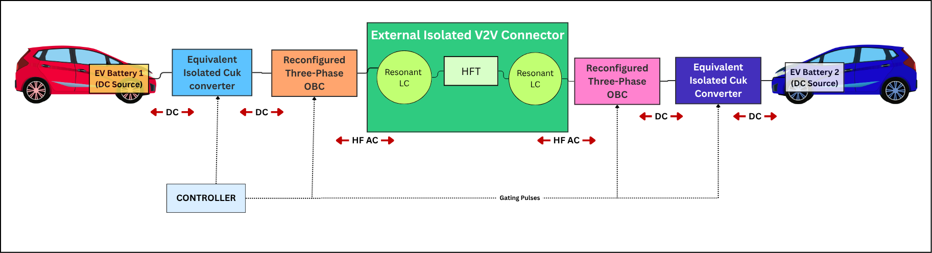

Figure 3.1 : Block Diagram of the implemented system

3.2.2 Converter Topology and Components

The Isolated and Single Stage Two Directional DC-DC Converter for V2V Charging, which has been discussed in the base paper [1], is the topology of the proposed system (see Figure 3.2). Below are the components that will be used in the proposed system:
- Battery Side Filter (L_{F}, C_{F}): It is very helpful to filter the battery current.
- Boost/Buck Bridge Leg (M_{1,1}-M_{1,2} for EV1 and M_{2,1}-M_{2,2} for EV2) along with DC Link Capacitance (C_{D}). In this case, the bridge leg is the voltage gain stage.
- High Frequency AC H-Bridge (M_{1,3}-M_{1,6} and M_{2,3}-M_{2,6} with switches SW1-SW4): High frequency AC coupling is achieved by the DC link.
- Series Resonant Tank (C_{R}, L_{R}, L_{R} = Leakage inductance of HFT)
- HFT with magnetizing inductance L_{M} and core loss resistance R_{M}

Characteristics of the topology are:
- Single stage conversion: Since, voltage regulation and galvanic isolation can be performed by only one converter whereas in case of conventional OBC based V2V converters two conversions are required i.e., AC/DC and DC/DC respectively [7].
- Galvanic isolation: Galvanic isolation is provided by the transformer working on high frequency and therefore, eliminates the need for direct battery connections as in case of non-isolated converters [6] thus resolving safety issues related to IEC standards.
- Bidirectional energy flow: All the switches utilized are bidirectional.
- Sharing of hardware: No additional converter is required in any vehicle as the
- OBC hardware is already available.
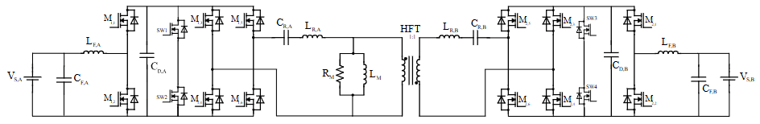

Figure 3.2 : Proposed isolated bidirectional V2V charging topology
The various components (in the Figure 3.2) its purpose and its respective function in the converter is listed in the table 3.1
Table 3.1 : List of components and function

Symbol | Component | Purpose | Function in the Converter
V_{S,A} | Source-side Battery (Port A) | Input DC power source | Supplies electrical energy during EV1→EV2 charging and receives energy during reverse power flow.
C_{F,A} | Source-side Filter Capacitor | Input voltage filtering | Suppresses voltage ripple, stabilizes the battery terminal voltage, and supplies high-frequency ripple current.
L_{F,A} | Source-side Filter Inductor | Current filtering & temporary energy storage | Reduces current ripple and alternately stores and releases magnetic energy during switching intervals.
M_{1,1} - M_{1,6} | Source-side Power MOSFETs (Three-Phase OBC Bridge) | Bidirectional switching | Operate as an inverter or active rectifier depending on the direction of power flow and generate high-frequency excitation.
C_{D,A} | Source-side DC-Link Capacitor | DC-link stabilization | Maintains a nearly constant DC-link voltage by absorbing transient power fluctuations caused by switching.
C_{R,A} | Source-side Resonant Capacitor | Resonant energy transfer | Forms the resonant tank with transformer leakage inductance to facilitate efficient power transfer and soft switching.
L_{R,A} | Source-side Resonant (Leakage) Inductor | Resonant current shaping | Represents the primary leakage inductance, limits current rise, stores magnetic energy, and participates in resonance.
HFT | High-Frequency Transformer | Isolation & energy transfer | Provides galvanic isolation, transfers energy through magnetic coupling, and allows voltage matching through its turns ratio.
R_{M} | Magnetizing Resistance | Core-loss modelling | Represents hysteresis and eddy-current losses in the transformer core.
L_{M} | Magnetizing Inductance | Magnetization of transformer core | Produces magnetic flux required for transformer operation and represents the magnetizing current path.
L_{R,B} | Receiver-side Resonant (Leakage) Inductor | Resonant current shaping | Secondary leakage inductance that forms the resonant network and transfers energy to the receiving side.
C_{R,B} | Receiver-side Resonant Capacitor | Resonant energy transfer | Receives resonant energy from the transformer and transfers it to the receiving bridge.
M_{2,1} - M_{2,6} | Receiver-side Power MOSFETs (Three-Phase OBC Bridge) | Active rectification / inversion | Operate as an active rectifier during EV1→EV2 charging and as an inverter during reverse power flow.
C_{D,B} | Receiver-side DC-Link Capacitor | DC-link stabilization | Reduces DC-link voltage ripple and buffers transient energy before delivery to the battery.
L_{F,B} | Receiver-side Filter Inductor | Output current filtering | Smooths the charging current supplied to the receiving battery and alternately stores/releases magnetic energy.

3.2.3 Operating Modes and Power-Flow Directions

Both operation modes and two stages of each mode can be realized within the switching period of the controller. That is, in both cases the controller provides PWM and NPWM signals generation with duty ratios D and 1-D respectively.

- Mode 1: Charging EV2 with EV1

In this case EV1 acts as a power source and EV2 acts as a load. The order of switching is given in the table 3.2 (also see figure 3.5) and its power flow direction is shown in figures 3.3 and 3.4:

Table 3.2 : Gating signal assignment for Mode 1 (EV1 charging EV2)

Signals | Switches driven
PWM | M_{1,2}, M_{1,3}, M_{2,1}, M_{2,4}
NPWM | M_{1,1}, M_{1,4}, M_{2,2}, M_{2,3}
Constant 1 | M_{1,5}, M_{2,5}
Constant 0 | M_{1,6}, M_{2,6}

Stage 1 (High PWM):
- Battery 1 is switched ON, where magnetic energy storage occurs in the L_{F,A} through M_{1,2}
- Capacitor C_{R,A} is discharged by the resonant circuit.
- HFT allows the energy transfer through magnetic coupling and galvanic insulation.
- EV2 withdraws the energy from the resonant circuit and L_{F,B} discharges the
stored energy to Battery 2.
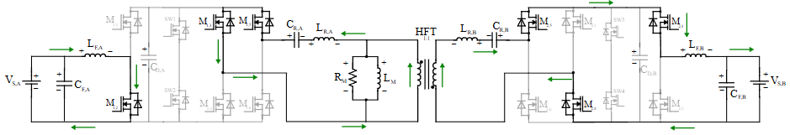

Figure 3.3 : Stage 1 Mode 1 Power Flow

Stage 2 (NPWM = high)
- The energy stored in L_{F,A} is released together with the source energy in the DC-link. The resonant capacitor and inductor are charged by the source side bridge circuit.
- Resonant energy is transferred to the output side through HFT.
- If the system is EV2, then L_{F,B} is charged while Battery 2 is getting charged.

Figure 3.4 : Stage 2 Mode 1 Power Flow
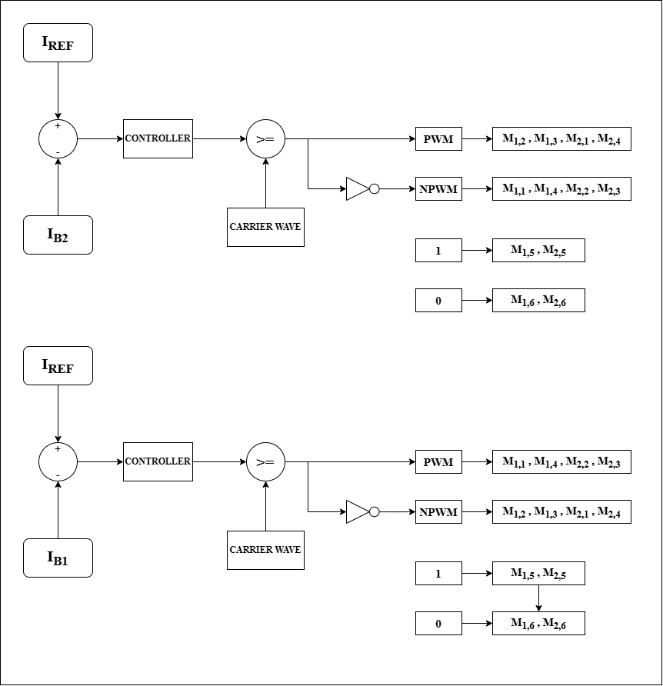
Figure 3.5 : Mode 1 Gating Signal Assignment (with controller)

- Mode 2: EV2 Charging EV1

In this case EV2 acts as a power source and EV1 acts as a load. The order of switching is given in table 3.3 (also see figure 3.7) and power flow direction is shown in figure 3.6

Table 3.3 : Gating signal assignment for Mode 2 (EV2 charging EV1)

Signals | Switches driven
PWM | M1,1, M1,4, M2,2, M2,3
NPWM | M1,2, M1,3, M2,1, M2,4
Constant 1 | M1,5, M2,5
Constant 0 | M1,6, M2,6

Mode 2 entails the power flow reversal process where EV2 will supply the power source while EV1 is used as the load. In this mode, the switching position of PWM and NPWM will be changed hence PWM switches will control the M_{1,1}, M_{1,4}, M_{2,2}, and M_{2,3} switches while NPWM switches will control the M_{1,2}, M_{1,3}, M_{2,1}, and M_{2,4} switches. M_{1,5} and M_{2,5} switches will be turned ON while M_{1,6} and M_{2,6} switches will be turned OFF. As it has been discussed in Mode 1, in both the two stages, L_{F,B} will store energy while HFT will give out energy to EV1 in Stage 1 and Battery 1 in Stage 2.

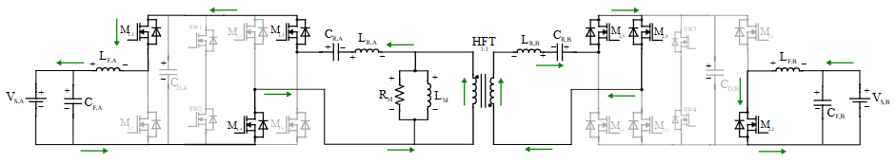

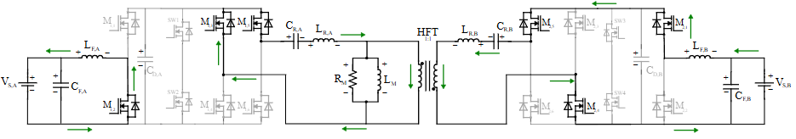

Figure 3.6 : Mode 2 Stages 1 & 2 Power Flow

Figure 3.7 : Mode 2 Gating Signal Assignment (with controller)

3.2.4 Theoretical Waveforms
The theoretical waveforms for each operating mode of the proposed converter are illustrated in Figures 3.8 and 3.9. The Pulse Width Modulation (PWM) and complementary Non-Pulse Width Modulation (NPWM) signals represent the gate pulses applied to the switches, with $DT_{S}$ and $(1-D)T_{S}$ denoting their respective high-state durations. The filter inductor currents ($I_{L,FA}$ and $I_{L,FB}$) exhibit triangular waveforms, increasing linearly during the energy-storage interval and decreasing during the energy-release interval. The bridge voltages exhibit unipolar pulse waveforms under NPWM operation. The primary and secondary transformer winding voltages exhibit bipolar square waveforms, switching between $+V_{P}$ and $-V_{P}$ on the primary side and $+V_{S}$ and $-V_{S}$ on the secondary side, assuming a 1:1 transformer turns ratio. Similarly, the receiver-side filter inductor current exhibits a triangular waveform, with its rising and falling slopes determined by the corresponding charging and discharging intervals.

A) Charging From EV1 TO EV2:

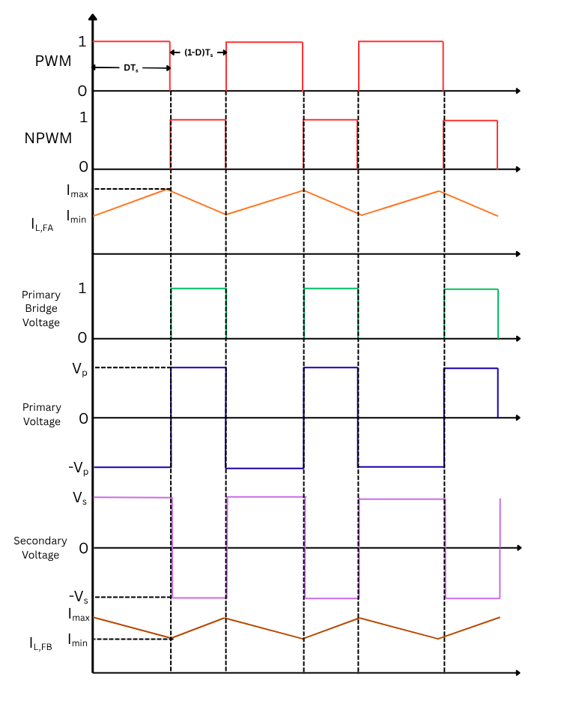

Figure 3.8 : Theoretical waveforms when EV1 charges EV2

B) Charging from EV2 TO EV1:

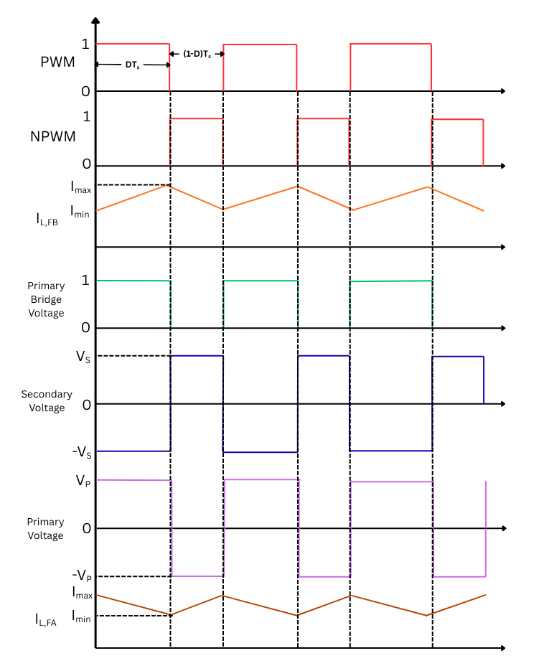

Figure 3.9 : Theoretical waveforms when EV2 charges EV1

3.2.5 Derivation of the Gain Equation

Since HFT has a 1:1 ratio and the resonant tank passes the bridge voltage with a gain close to one at the operating frequency, the voltage of the DC link on one side gets transferred to that on the other side with unity gain. The total gain equals the multiplication of the boost gain at the source side and buck gain at the load side. Denote α the duty ratio, V_{S,A} the battery voltage of EV1 and V_{S,B} the battery voltage of EV2.

Phase A: Loop 1 – KVL: $V_{S,A}=L_{F,A}\frac{di_{LF,A}}{dt}+v_{CD,A}$ … (3.1)

Loop 2 – KVL: $v_{CD,A}=v_{CR,A}+{i_{LR,A}R_{sw}+L_{R,A}\frac{di_{LR,A}}{dt}+v_{1}}_{}$ … (3.2)

Where v₁ is the HFT primary voltage, R_{sw} is the sum of conducting switch’s resistance

Phase B – KVL: $v_{2}=v_{CR,B}-{i_{LR,B}R_{sw}-L_{R,B}\frac{di_{LR,B}}{dt}}_{}$… (3.3)
$v_{CD,B}=v_{CR,B}-{L_{R,B}\frac{di_{LR,B}}{dt}}_{}$… (3.4)
$V_{S,B}=v_{CD,B}-{L_{F,B}\frac{di_{LF,B}}{dt}}_{}$… (3.5)

Mode 1 – After recombining, neglecting the switch resistance and L_{R} drop, equations (3.1 - 3.5),

$\frac{di_{LF,A}}{dt}|_{Mode 1}=\frac{V_{S,A}-v_{CD,A}}{L_{F,A}}$ … (3.6)
$\frac{di_{LF,B}}{dt}|_{Mode 1}=\frac{v_{CD,B}-V_{S,B}}{L_{F,B}}$ … (3.7)
$\frac{di_{LF,B}}{dt}|_{Mode 2}=\frac{V_{S,A}-v_{CD,A}-v_{CR,A}-v_{1}}{L_{F,A}}$ $\frac{di_{LF,B}}{dt}|_{Mode 1}=\frac{v_{CR,B}+V_{S,B}-v_{CD,B}}{L_{F,B}}$ … (3.8)

Phase A – KVL
$V_{S,A}=L_{F,A}\frac{di_{LF,A}}{dt}+v_{CD,A}+v_{CR,A}+L_{R,A}\frac{di_{LR,A}}{dt}+v_{1}$ … (3.9)

Phase B – KVL
$V_{S,B}=v_{CD,B}+{L_{R,B}\frac{di_{LR,B}}{dt}{-v}_{CR,B}-{L_{F,B}\frac{di_{LF,B}}{dt}}_{}}_{}$… (3.10)

Mode 2 – combining equations (3.9) & (3.10)

$\frac{di_{LF,B}}{dt}|_{Mode 2}=\frac{V_{S,A}-v_{CD,A}-v_{CR,A}-v_{1}}{L_{F,A}}$ $\frac{di_{LF,B}}{dt}|_{Mode 1}=\frac{v_{CR,B}+V_{S,B}-v_{CD,B}}{L_{F,B}}$ … (3.11)

L_{F,A} balance over T: (equations in 3.8)

$δ(V_{S,A}-v_{CD,A})+(1-δ)(V_{S,A}-v_{CD,A}-v_{CR,A}-v_{1})=0$
${⇒V}_{S,A}-v_{CD,A}=(1-δ)(v_{CR,A}+v_{1})$ …(3.12)

L_{F,B} balance over T: (equations in 3.11)

$δ(v_{CD,B}-V_{S,B})+(1-δ)(v_{CR,B}+V_{S,B}-v_{CD,B})=0$
$⇒δ(v_{CD,B}-V_{S,B})=(1-δ)(-v_{CR,B}-V_{S,B}+v_{CD,B})$
$⇒v_{CD,B}-V_{S,B}=(1-δ)v_{CR,B}$ …(3.13)

$\frac{V_{S,B}}{V_{S,A}}=\frac{δ}{1-δ}$ — (Gain Equation) …(2.2)

3.3 PROJECT METHODOLOGY AND WORKFLOW

The project methodology begins with open-loop simulation of the proposed bidirectional V2V converter in MATLAB/Simulink to identify suitable duty ratios for stable power transfer in both EV1-to-EV2 and EV2-to-EV1 charging modes. Subsequently, a closed-loop constant-current (CC) charging strategy is implemented using a PI controller. The control strategy is then extended to Integral Sliding-Mode Control (ISMC) and fuzzy logic control, and their performances are compared using current-tracking error, settling time, overshoot, output-voltage regulation, semiconductor losses, and converter efficiency. Conduction and switching losses are estimated using device characteristics and switching-energy data, enabling a switch-wise assessment of semiconductor losses. Finally, OPAL-RT-based real-time simulation, software-in-the-loop (SIL) and hardware-in-the-loop (HIL) validation, PCB design, and physical hardware implementation are identified as future extensions of the present simulation study.
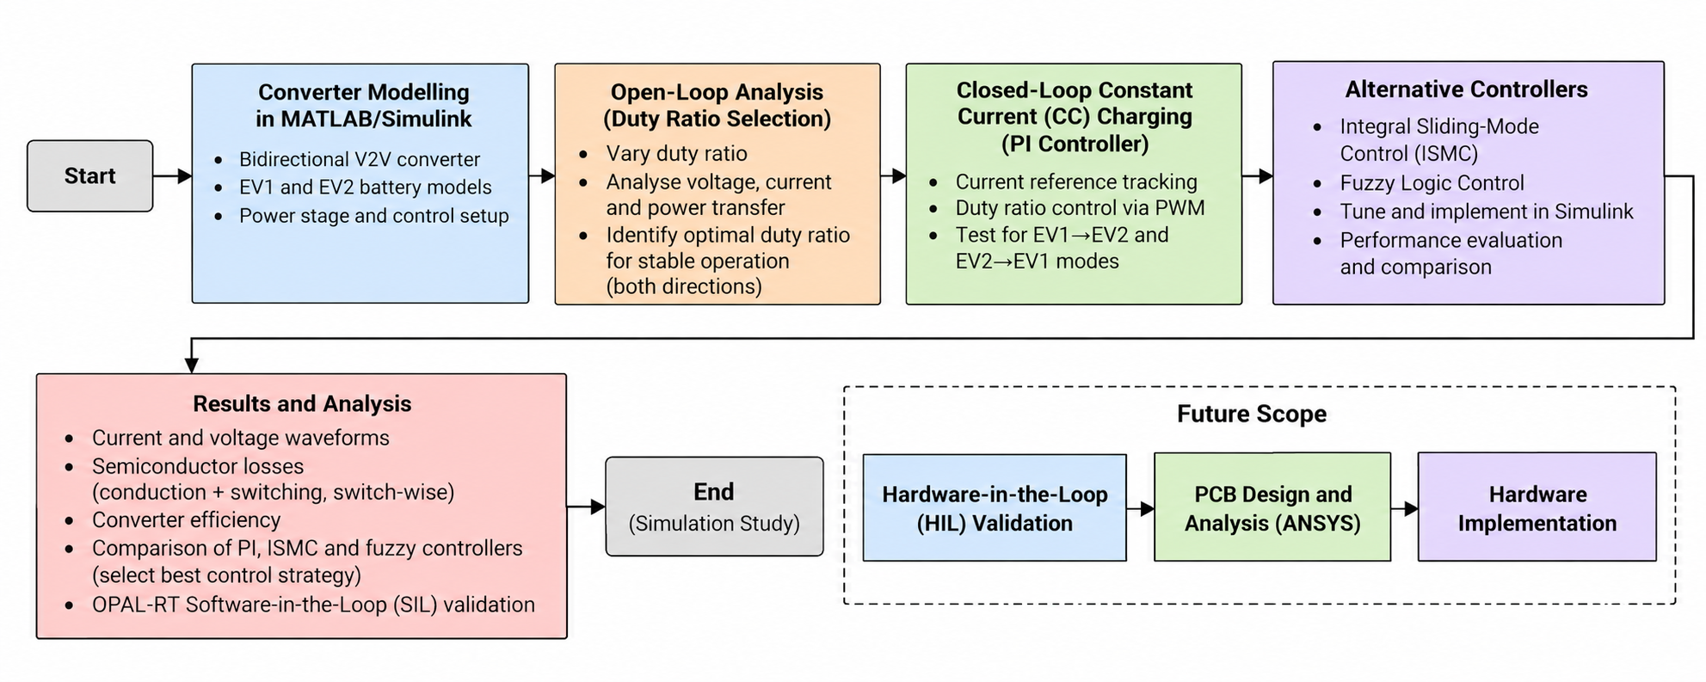
Figure 3.10 : Project Methodology and Workflow

3.4 TASKS AND MILESTONES

The project is organised into four major milestones corresponding to the scheduled project reviews. The activities progress from project selection and literature review to converter analysis, controller development, semiconductor-loss estimation, and preliminary real-time validation.
Table 3.4: Project Milestones
Milestone | Major Tasks
Review 0 –  Project Initiation  (Apr 2026) | Finalisation of the project guide, selection of the project domain, and preliminary identification of the problem area.
Review 1 –  Topic Finalisation and Open-Loop Analysis  (Jun – Aug 2026) | Finalisation of the project topic, literature review, identification of the research gap, converter modelling in MATLAB/Simulink, open-loop analysis in both power-transfer directions, and duty-ratio variation.
Review 2 – PI-Based Closed-Loop Control  (Aug, Sept 2026) | Implementation and tuning of a PI controller for constant-current (CC) charging, followed by analysis of current tracking, transient response, and bidirectional operation.
Final Review – Advanced Control and Loss Analysis  (Sept, Oct 2026) | Implementation and comparison of ISMC and fuzzy logic controllers, semiconductor conduction- and switching-loss estimation, and OPAL-RT Software-in-the-Loop (SIL) implementation and validation.

CHAPTER IV

4. DESIGN OF CONTROLLERS

The top-level controller architecture of the proposed bidirectional V2V charging converter is illustrated in Figure 4.1. The controller receives four inputs: load current, source current, SOC mode, and reference current. These signals are processed within the controller subsystem to determine the appropriate switching commands based on the operating conditions and the selected power-transfer direction. The SOC mode input enables mode-dependent control, while the reference current provides the desired charging-current value for regulation. The controller generates two outputs, PWM_OUT and NPWM_OUT, which are used to produce the required gate signals for the converter switches. These complementary switching signals facilitate controlled power transfer between EV1 and EV2 in both charging modes. The top-level architecture integrates the input signals, control logic, and switching outputs into a unified subsystem for closed-loop operation in MATLAB/Simulink.

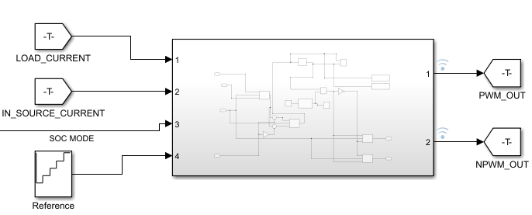
Figure 4.1 : Top level Controller

4.1 PI CONTROLLER DESIGN AND TUNING

A Proportional–Integral (PI) controller is implemented for closed-loop constant-current (CC) charging of the proposed bidirectional V2V converter. The controller regulates the charging current by adjusting the converter's duty ratio according to the deviation between the reference current and the measured current.
As shown in the block diagram (Figure 4.2), the reference and current feedback signals are processed through mode-selection logic according to the operating condition and direction of power transfer. The resulting control error is supplied to the discrete PI controller, represented by the PI(z) block. The controller generates the control output, which is compared with the modulation signal to generate the PWM switching command. The associated control logic generates the corresponding NPWM output and selects the appropriate switching signals for bidirectional operation.
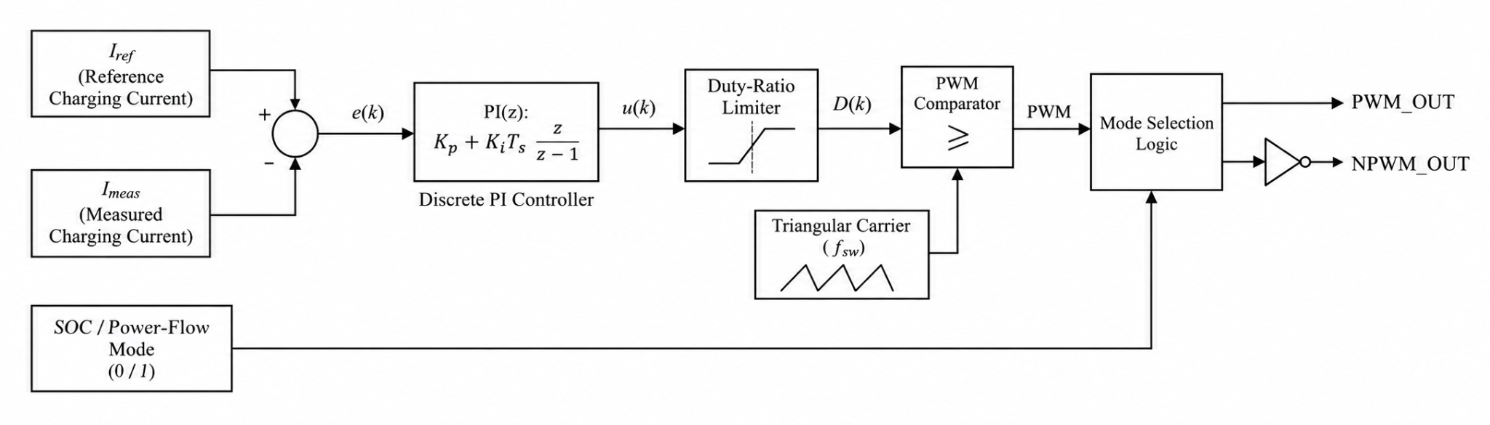
Figure 4.2 : PI Controller (Block Diagram)
The PI controller parameters are tuned using the Ziegler–Nichols (ZN) tuning method. The proportional gain determines the response to the instantaneous current error, while the integral gain accumulates the error to reduce steady-state tracking deviation. The selected gains are incorporated into the discrete PI controller in MATLAB/Simulink and evaluated under both EV1-to-EV2 and EV2-to-EV1 charging conditions. The simulation setup of the same is shown in figure 4.3
The continuous-time PI controller is expressed as,
$C(s) = K_{P}+\frac{K_{i}}{S}$ …(4.1)
where K_{P} is the proportional gain and K_{i} is the integral gain. The corresponding control action is given by,
$u(t) = K_{p}e(t)+K_{i}\int_{0}^{t}{}e(t)dt$ …(4.2)
where e(t) denotes the current-tracking error and u(t) represents the controller output.

Table 4.1 : PI Controller Objectives
Parameter | Value | Description
Tuning method | Ziegler–Nichols (ZN) | Controller gain tuning
Proportional gain, (K_{p}) | 0.0001 | Proportional response to current error
Integral gain, (K_{i}) | 0.015 | Integral action for reducing steady-state error
Control objective | Constant-current charging | Charging-current reference tracking

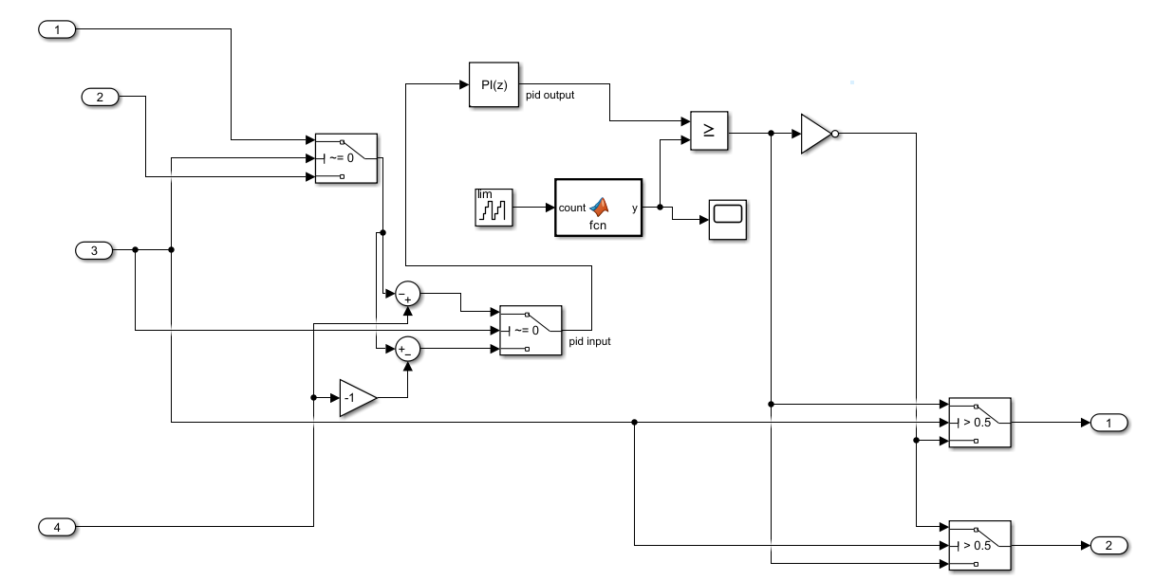
Figure 4.3 : Inner PI Controller view (Simulation Setup)

4.2 INTEGRAL SLIDING MODE CONTROLLER (ISMC) DESIGN

An Integral Sliding-Mode Controller (ISMC) is implemented as an alternative to the PI controller to regulate the charging current of the proposed bidirectional V2V converter. The controller incorporates an integral sliding surface to account for the accumulation of current-tracking error, together with a saturation function to generate the control correction (Block Diagram shown in figure 4.4). The controller is implemented in MATLAB/Simulink and integrated with the existing mode-selection logic and PWM generation subsystem.
The current-tracking error, e(t), is processed through a discrete-time integrator and combined with the instantaneous error to construct the sliding surface:
$s(t)=e(t)+λ\int_{0}^{t}{}e(t)dt$ …(4.3)
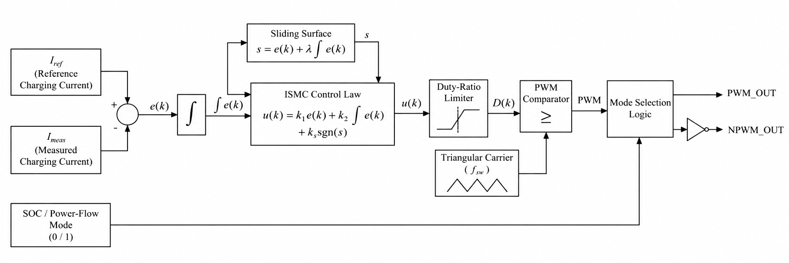
Where λ determines the contribution of the integral error to the sliding surface. In the implemented model, (λ=2). The resulting sliding variable is scaled by the boundary-layer parameter and passed through a saturation function to produce a bounded control action. This approach provides a practical approximation to the discontinuous switching action of conventional sliding-mode control and can help reduce chattering.

Figure 4.4 : ISMC Controller Block Diagram
The controller output is formed by adding the scaled saturation-function output to a nominal duty-ratio bias. Based on the implemented Simulink block diagram (see figure 4.5), the control relation can be expressed as
$D_{cmd}=D_{0}+k sat\left(\frac{s}{ϕ}\right)$ …(4.4)
where D₀ is the nominal duty-ratio bias, k is the control correction gain, and φ represents the boundary-layer scaling parameter. The generated control command is processed through the switching and mode-selection logic to obtain the appropriate gate signals for the selected power-transfer direction.
Table 4.2: ISMC Controller Parameters
Parameter | Value | Function
Sliding-surface coefficient | 2 | Weights the integral error
Boundary-layer parameter | 0.5 | Scales the sliding variable before saturation
Control correction gain | 0.005 | Scales the saturation-function output
Nominal duty-ratio bias | 0.5 | Provides the nominal control operating point
Saturation function | Simulink Saturation block | Limits the sliding-mode control action

The controller parameters are selected through simulation-based tuning to obtain suitable current-tracking behaviour and stable converter operation. The ISMC response is evaluated under both EV1-to-EV2 and EV2-to-EV1 charging conditions and compared with the PI controller using current-tracking error, transient response, output-voltage regulation, and estimated semiconductor losses.
The performance of the ISMC controller depends on the selected sliding-surface coefficient, control correction gain, boundary-layer parameter, and discrete-time implementation. The saturation limits, duty-ratio constraints, and feedback sign are therefore verified to ensure that the controller correction acts in the appropriate direction and that the generated switching signals remain compatible with the converter operating mode.
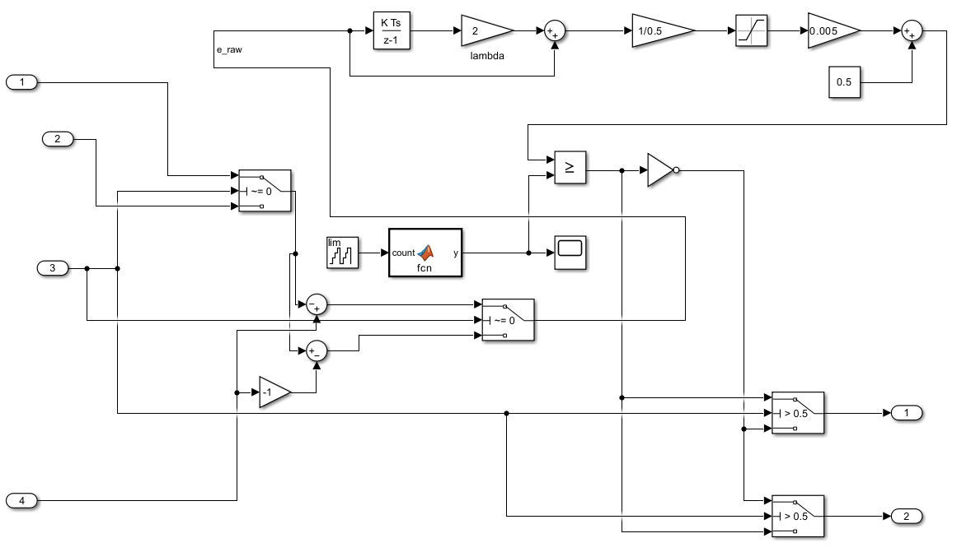
Figure 4.5 : Inner ISMC Controller view

4.3 FUZZY LOGIC CONTROLLER DESIGN

A fuzzy logic controller (FLC) is implemented as an alternative control strategy for regulating the charging current of the proposed bidirectional V2V converter. Unlike the PI controller, which relies on fixed proportional and integral gains, the FLC determines its control action using linguistic variables, membership functions, and a rule-based inference mechanism (see figure 4.6, block diagram). The controller is designed using a Mamdani-type fuzzy inference system (FIS) and implemented in MATLAB/Simulink using the fis configuration file.
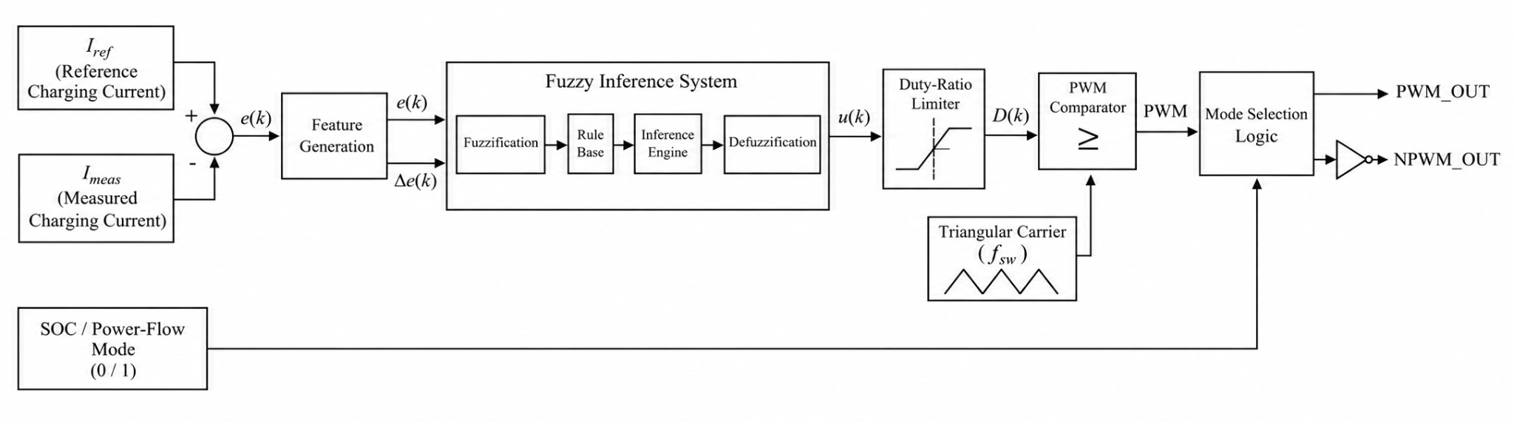
Figure 4.6 : Fuzzy Logic Controller Block Diagram
The FLC uses two inputs: the current-tracking error and its change between successive samples. These inputs provide information about both the magnitude of the deviation from the reference and its direction of change. The output is a control command used by the switching-control subsystem to regulate the converter operation. The current-tracking error is defined as,
$e(k)=I_{ref}(k)-I_{meas}(k)$…(4.5)
where I_{ref} is the reference charging current and I_{meas} is the measured current. The change in error is calculated as,
$Δe(k)=e(k)-e(k-1)$…(4.6)
Table 4.3 : FLC Parameters
Parameter | Design value | Parameter | Design value
Fuzzy inference system | Mamdani | Output range | ([0,1])
Number of inputs | 2 | Output membership functions | 3
Input variables | Error and change in error | Output membership function type | Triangular (trimf)
Input range | ([-1,1]) for both inputs | Output linguistic labels | Low, Medium, High
Membership functions per input | 5 | Number of rule entries specified | 25
Input membership function type | Triangular (trimf) | AND operator | Minimum
Input linguistic labels | NB, NS, Z, PS, PB | OR operator | Maximum
Number of outputs | 1 | Implication method | Minimum
Output variable | Control

Where k denotes the discrete sampling instant. If the change in error is implemented as a time derivative instead, it is calculated by dividing this difference by the sampling time T_{S}. The inputs are represented by five linguistic membership functions: Negative Big (NB), Negative Small (NS), Zero (Z), Positive Small (PS), and Positive Big (PB). The
The input membership functions partition the error signals into overlapping linguistic regions. The overlap enables the controller to activate multiple rules for a given input combination, providing a smooth transition between control actions. The output variable, named control, has a range of [0,1] and uses three triangular membership functions: Low, Medium, and High.
The membership-function breakpoints are defined in the FIS configuration file. For the error and change-in-error inputs, the NB and PB functions represent the extreme negative and positive regions, while NS and PS represent smaller deviations. The Z function represents an error close to zero. The output membership functions are defined by the following breakpoints:
Table 4.4 : Output Membership Function
Output membership function | Triangular parameters
Low | [0.30, 0.40, 0.50]
Medium | [0.45, 0.50, 0.55]
High | [0.50, 0.60, 0.70]
These output functions concentrate the control command around the nominal operating region while allowing the command to vary according to the active fuzzy rules. The controller evaluates the two inputs against their respective membership functions. Each rule associates an input combination with an output linguistic label. The minimum operator is used to determine the rule firing strength, while the maximum operator combines the implications of the active rules. The resulting aggregated fuzzy output is converted into a crisp control command through centroid defuzzification. The centroid method is expressed as,
u* = $\frac{\int_{0}^{1}{}uμ_{agg}(u)du}{\int_{0}^{1}{}μ_{agg}(u)du}$ …(4.7)
where u(k) is the defuzzified controller output, y is the output-domain variable, μ_{agg} is the aggregated output membership function. This operation produces a numerical control command that can be used by the converter's PWM and mode-selection logic.
The FLC is integrated into the existing MATLAB/Simulink model (See figure 4.7) while retaining the required operating-mode selection and bidirectional gate-signal generation. The controller is evaluated for EV1-to-EV2 and EV2-to-EV1 charging operation. Its performance is assessed using current-reference tracking, transient response, output-voltage regulation, and estimated semiconductor conduction and switching losses. The results are compared with those obtained using the PI and ISMC controllers under equivalent operating conditions to evaluate the relative performance of the control strategies.
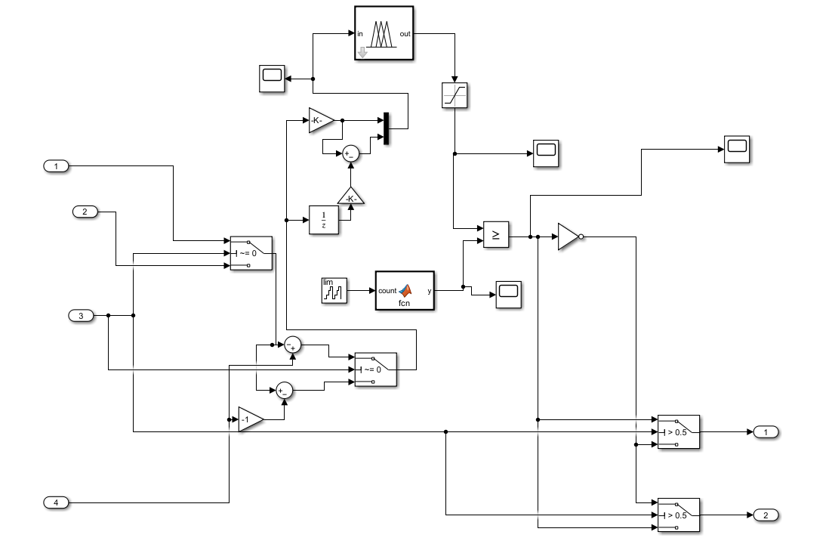
Figure 4.7 : Inner Fuzzy Logic Controller view

CHAPTER V

5. DESIGN OF THE PROPOSED V2V CHARGING CONVERTER

5.1 DESIGN EQUATIONS AND CALCULATIONS
The design of the proposed isolated single-stage bidirectional V2V charging converter is based on the voltage requirements of the two EV battery systems, the desired charging current, and the requirements for bidirectional power transfer. The design process involves defining the converter specifications and operating parameters, deriving the theoretical voltage-gain relationship, and establishing the relevant design equations for component selection and parameter calculation. These design parameters provide the foundation for developing the MATLAB/Simulink model and evaluating the converter under open-loop and closed-loop operating conditions in both EV1-to-EV2 and EV2-to-EV1 power-transfer modes.
5.1.1 Filter Design

Inductor in the battery side circuit acts as the ripple in the battery current filter, and the capacitor in the filter serves as the ripple in the battery voltage filter:

L = (V_{L} · D) / (ΔI_{L} · f_{S}) …(5.1)
C = ΔI / (8 · f_{S} · ΔV) …(5.2)

where ΔI_{L} is the maximum value of the ripple current, and ΔV is the maximum allowable ripple in the battery voltage. Ripple in the battery current of 5% is assumed for the duty ratio of 0.57.

Side EV1
(I_{L,rated} = 63.5 A, V_{L} = 350 V):
L_{F,A} = (350 × 0.57) / (0.05 × 63.5 × 20×10³) = 3.14 mH …(5.3)
C_{F,A} = 2 µF; the ripple in the battery voltage is equal to
ΔV = 0.05 × 63.5 / (8 × 20×10³ × 2×10⁻⁶ × 350) ≈ 2.8% ≈ 3% …(5.4)

Side EV2
(I_{L,rated} = 52.9 A, V_{L} = 450 V):
L_{F,B} = (450 × 0.57) / (0.05 × 52.9 × 20×10³) = 4.8 mH …(5.5)
C_{F,B} = 1.3 µF; the ripple in the battery voltage is equal to
ΔV = 0.05 × 52.9 / (8 × 20×10³ × 1.3×10⁻⁶ × 450) ≈ 2.8% ≈ 3% …(5.6)

Thus from (5.4) and (5.6), the ripple in the battery voltage is the same (3%) on both sides of the converter.

5.1.2 Tank circuit and transformer

For both schemes, C_{R} = 0.21 mF, L_{R} = 0.3015 µH. Resonant frequency is calculated as follows:

$f=\frac{1}{2π\sqrt{L_{R}C_{R}}}=25 kHz$ …(5.7)
and sets a range of soft switching for the converter. HFT is used to implement 1:1 voltage transformation and galvanic isolation. Also magnetizing inductance and resistance of magnetic core L_{M} and R_{M} are incorporated into HFT.

5.2 CONVERTER SPECIFICATIONS AND DESIGN PARAMETERS
This section presents the general specifications and design parameters of the proposed isolated bidirectional V2V charging converter. The parameters include the EV battery ratings, filter and resonant components, DC-link capacitances, and switching frequency, which form the basis for converter modelling and simulation in MATLAB/Simulink. The simulation stop times are also specified according to the requirements of steady-state, transient, and software-in-the-loop analyses.

Table 5.1 : Parameter and Converter Specifications

Parameter | Value
EV1 battery pack capacity | 60 Ah
EV2 battery pack capacity | 80 Ah
EV1 battery pack nominal voltage | 350 V
EV2 battery pack nominal voltage | 450 V
Filter inductance A | 3.14 mH
Filter inductance B | 4.8 mH
Filter capacitance A | 2 µF
Filter capacitance B | 1.3 µF
Resonant capacitors A and B | 0.21 mF each
Resonant (leakage) inductors A and B | 0.3015 µH each
DC-link capacitor A | 0.5 mF
DC-link capacitor B | 0.8 mF
Switching frequency | 25 kHz

Table 5.2 : Simulation Stop time Setup

Simulation objective | Stop time
Steady-state operation | 15 s
Transient operation | 0.2 s
OPAL-RT software-in-the-loop (SIL) simulation | inf

CHAPTER VI

6. SIMULATION RESULTS

6.1 CONVERTER MODELLING IN MATLAB/SIMULINK
The proposed isolated single-stage bidirectional V2V charging converter is modelled in MATLAB/Simulink using the selected circuit topology and design parameters. The model incorporates the two EV battery systems, switching devices, high-frequency transformer, resonant components, and associated electrical elements. The switching and control signals are configured to facilitate bidirectional power transfer between EV1 and EV2. The developed model serves as the basis for open-loop duty-ratio analysis, closed-loop constant-current control, and comparative evaluation of different controller strategies.

6.2 OPEN-LOOP ANALYSIS
Open-loop analysis is performed to investigate the operating characteristics of the proposed bidirectional V2V charging converter without closed-loop feedback control. The duty ratio is varied systematically to study its influence on voltage gain, charging current, and power transfer between the two EV battery systems. Simulations are conducted for both EV1-to-EV2 and EV2-to-EV1 operating modes to identify suitable operating points and establish a baseline for subsequent closed-loop controller design.

6.2.1 Simulation Setup

The given below figure shows the open-loop simulation setup done in the MATLAB/Simulink 2024.a
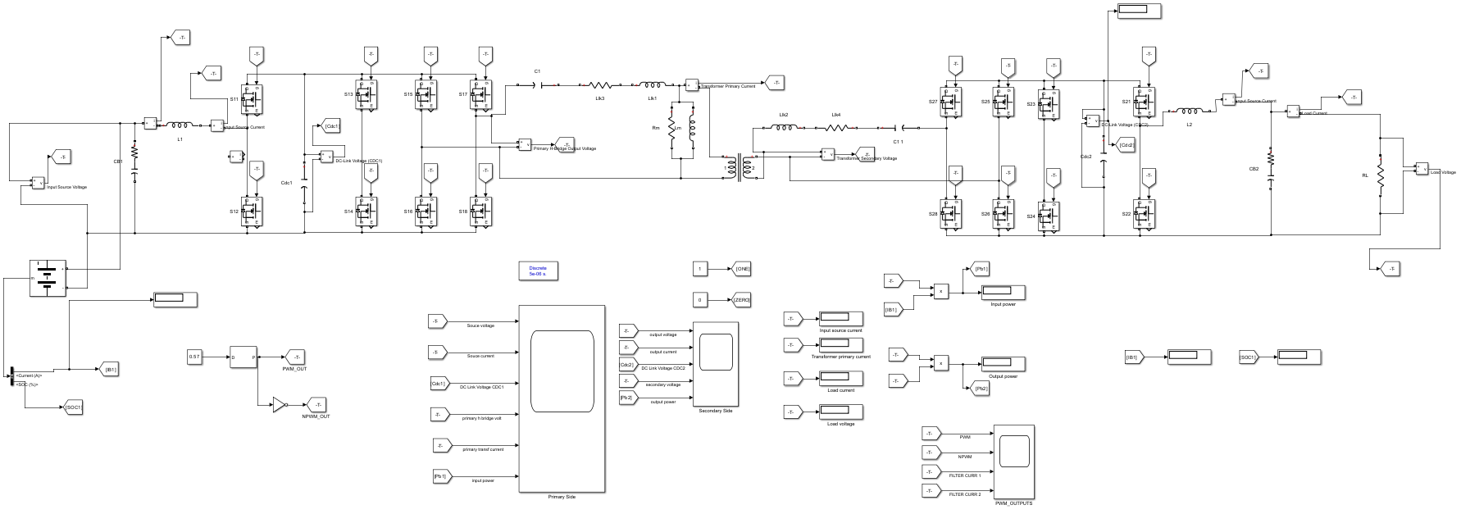

Figure 6.1 : Open-loop Simulation Setup (EV1-Battery & EV2-R Load)
Equivalent Resistance Modelling

- EV2 as a R-Load: Source battery (EV1) (350V 60Ah) is taken as a DC Voltage source. Load Battery (EV2) (450V 80Ah) is taken as a Resistive load. Assuming the rated power of the converter with charging capability up to 24kW. We know that,
Power = (Voltage)²/Resistance …(6.1)
R_{LOAD, EV2} = 450²/24000 = 8.4375 Ω …(6.2)

- EV1 as a R-Load: Source battery (EV2) (450V 80Ah) is taken as a DC Voltage source. Load Battery (EV1) (350V 60Ah) is taken as a Resistive load. Assuming the rated power of the converter with charging capability up to 24kW. From equation 5.1
R_{LOAD, EV1} = 350²/24000 = 5.1042 Ω …(6.3)

6.2.2 Duty Cycle Variation and Voltage Gain Analysis
Open-loop parametric analysis is performed to investigate the influence of duty ratio and resonant frequency matching on the voltage gain of the proposed V2V charging converter. (Refer equations 2.1, 2.2)
The frequency ratio is defined by f_{S}/f_{R} = Switching / Resonant frequency. Two three-dimensional voltage-gain plots are used to examine the converter characteristics. The first plot illustrates the combined influence of duty ratio and frequency ratio on voltage gain. It enables the operating region to be assessed across different duty-ratio and resonance conditions. The second plot fixes the duty ratio at (D=0.50) and examines the variation in voltage gain with switching frequency and frequency ratio, thereby isolating the influence of resonant frequency matching from changes in duty ratio.

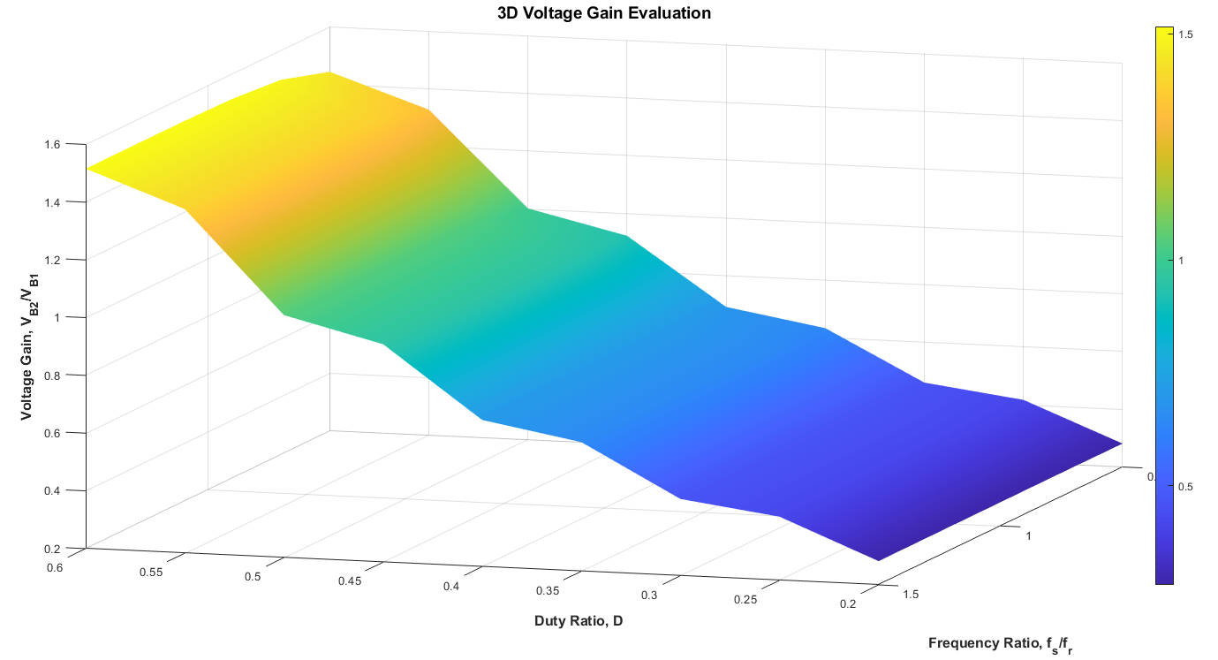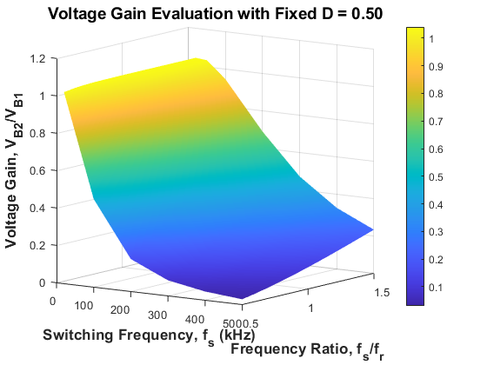
Figure 6.2 : Voltage Gain 3D Plots
The resulting graph reports (in Figure 6.2) that voltage gain reaches its maximum when (f_{S}/f_{R}=1), corresponding to matching the switching frequency with the resonant frequency. The gain decreases as the frequency ratio deviates from unity, while increasing the duty ratio generally increases the voltage gain at a given frequency ratio. These observations highlight the importance of selecting suitable duty-ratio and resonant-circuit parameters for effective power transfer.
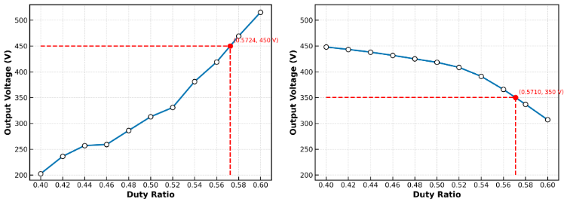
The duty-ratio analysis is also performed separately for both power-transfer directions to identify operating points at which the converter output voltage matches the nominal voltage of the receiving EV battery. The resulting duty ratios provide initial operating points for subsequent closed-loop controller development.

Figure 6.3 : Duty Cycle Variation – Mode 1 and Mode 2

The duty ratio is varied from 0.40 to 0.60 to identify suitable operating points for both power-transfer directions. During EV1-to-EV2 operation, the output voltage increases with duty ratio, reaching the target voltage of 450 V at (D=0.5724). During EV2-to-EV1 operation, the output voltage decreases as the duty ratio increases, reaching 350 V at (D=0.5710). Figure 6.3 shows these results graphically. These operating points correspond to the nominal voltage requirements of the receiving EV battery in each mode and are selected as initial duty-ratio values for subsequent closed-loop controller analysis. Since the analysis is performed in an open loop, the identified values represent simulated voltage-matching operating points rather than guaranteed regulation under varying operating conditions.
6.2.3 EV1-to-EV2 Results
The simulation results for EV1-to-EV2 power transfer demonstrate the operation of the proposed bidirectional V2V charging converter in the forward power-flow mode. The input source voltage remains approximately constant, while the filter current exhibits periodic ripple. The PWM and NPWM signals provide complementary switching commands to the converter bridge, producing high-frequency voltage pulses at the transformer primary. The corresponding primary current and transformer secondary voltage waveforms illustrate the transfer of energy through the high-frequency transformer. On the receiving side, the DC-link voltage, load voltage, and load current exhibit periodic variations associated with converter switching and resonant operation. The input and output power waveforms also show periodic fluctuations, indicating the dynamic nature of power transfer.
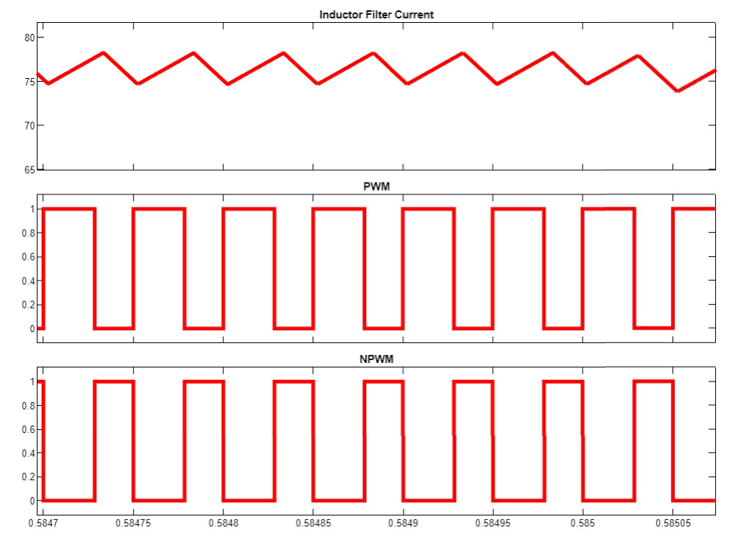
Current (A)
Voltage (V)
Voltage (V)
Time (s)
Figure 6.4 : Inductor Filter Current - Mode 1
Voltage (V)
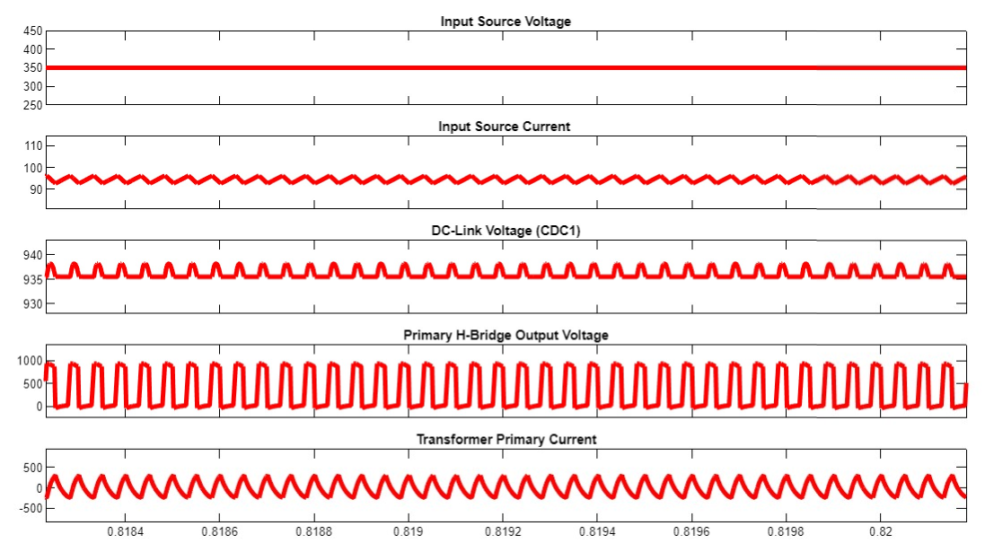
Current (A)
Current (A)
Time (s)
Voltage (V)
Voltage (V)
Figure 6.5 : Mode 1 - EV1 Open-loop Results
Time (s)
Time (s)

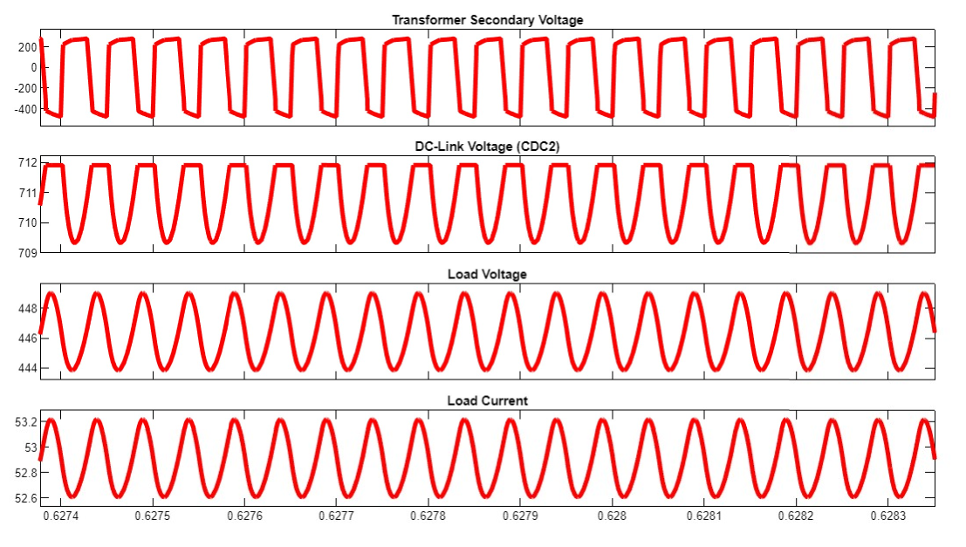
Time (s)
Current (A)
Voltage (V)
Voltage (V)
Voltage (V)
Figure 6.6 : Mode 1 - EV2 Open-loop Results

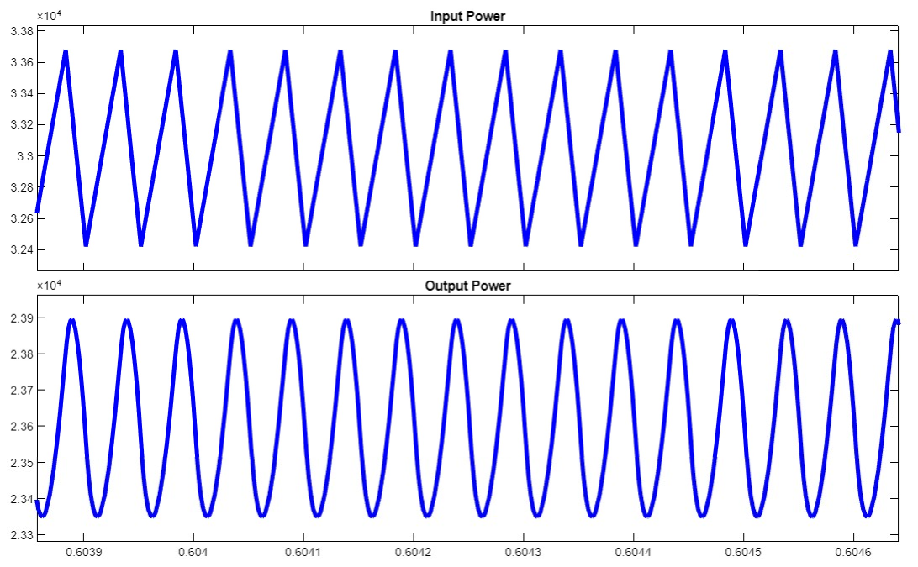
Power (W)
Power (W)
Time (s)
Figure 6.7 : Mode 1 - Power Open-loop Results

Figure 6.4 confirms periodic inductor-current ripple and complementary PWM/NPWM switching. Figures 6.5 and 6.6 demonstrate stable periodic electrical waveforms across both EV sides during open-loop operation. Figure 6.7 indicates oscillatory input and output power, highlighting periodic energy transfer between the vehicles.

6.2.4 EV2-to-EV1 Load Results

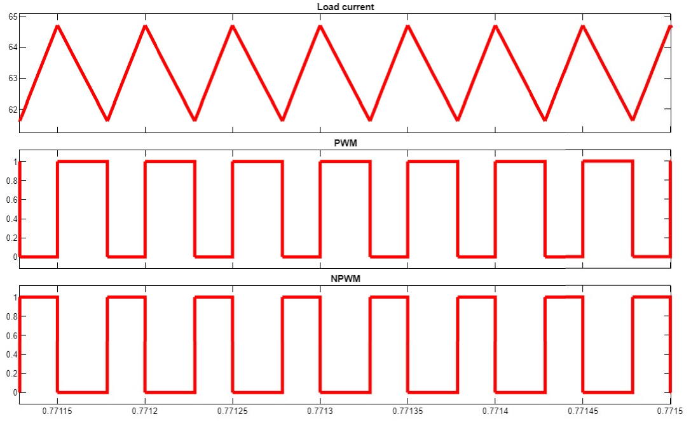
Time (s)
Voltage (V)
Current (A)
Voltage (V)
Figure 6.8 : Inductor Filter Current - Mode 2
Voltage (V)
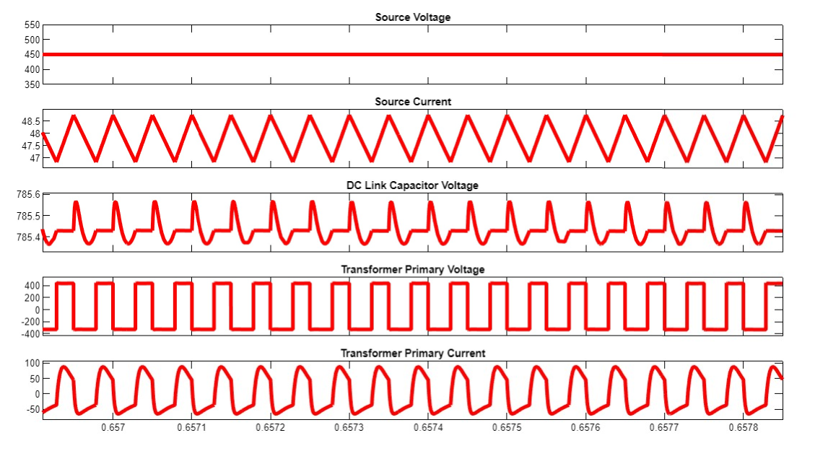
Time (s)
Voltage (V)
Voltage (V)
Current (A)
Current (A)
Figure 6.9 : Mode 2 - EV1 Open-loop Results

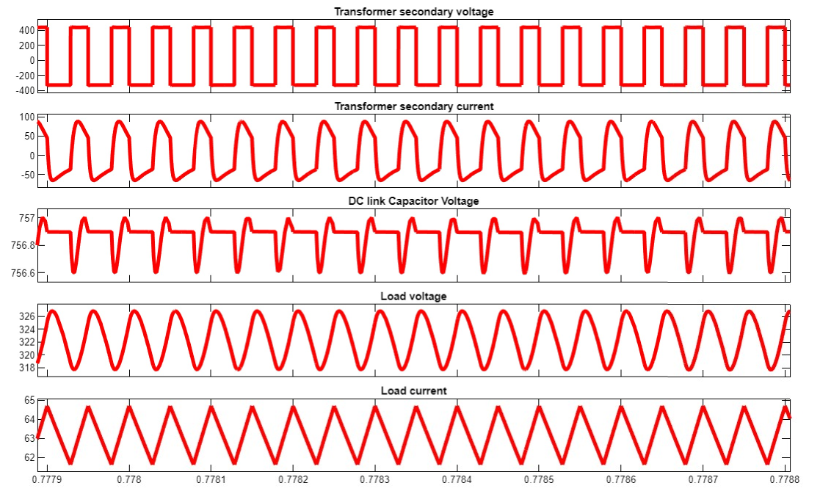
Current (A)
Voltage (V)
Voltage (V)
Current (A)
Time (s)
Voltage (V)
Figure 6.10 : Mode 2 - EV2 Open-loop Results

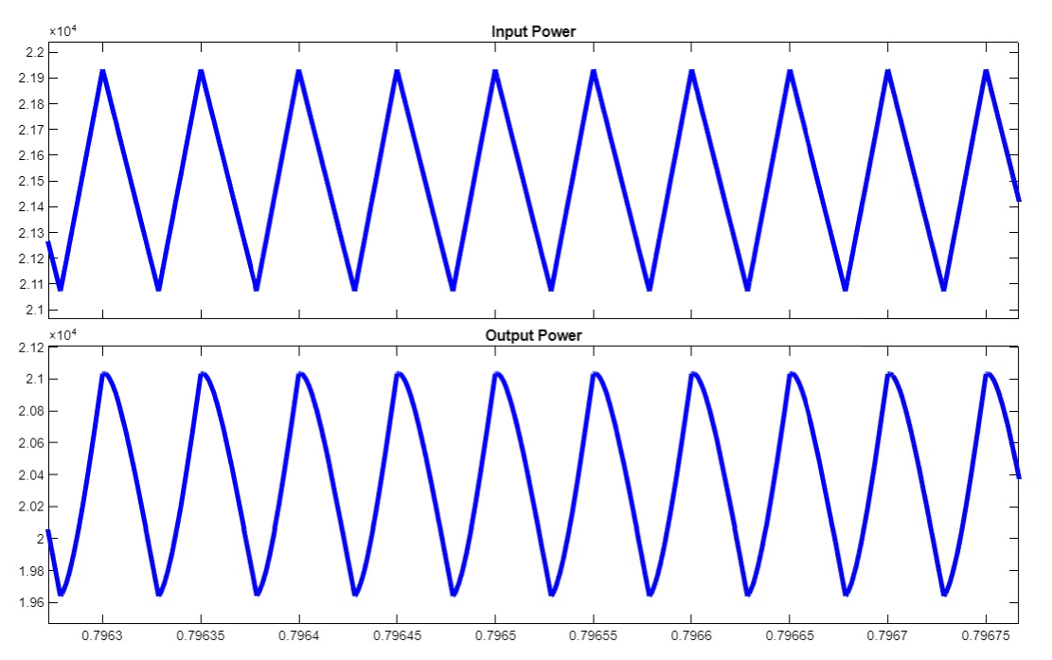
Power (W)
Time (s)
Power (W)
Figure 6.11 : Mode 2 - Power Open-loop Results

Figure 6.8 shows periodic filter inductor current ripple with complementary PWM/NPWM switching during Mode 2. Figures 6.9 and 6.10 demonstrate periodic voltage and current waveforms and oscillatory power transfer during Mode 2. The results indicate sustained bidirectional converter operation, with periodic variations in current and power.
6.3 CLOSED-LOOP ANALYSIS

Closed-loop analysis is carried out to evaluate the current-regulation performance of the proposed bidirectional V2V charging converter using feedback-based control. Unlike open-loop operation, where the duty ratio is fixed at a selected operating point, the closed-loop controller adjusts the control command based on the deviation between the reference charging current and the measured current.
The PI controller is initially implemented for constant-current (CC) charging, with the controller output used to regulate the PWM switching signals. The system is evaluated in both EV1-to-EV2 and EV2-to-EV1 power-transfer modes to examine current tracking, transient response, DC-link voltage behaviour, load voltage and current, and input/output power characteristics. The resulting waveforms are used to assess the converter's operation under feedback control.
Subsequently, the PI controller is considered as the baseline for comparison [1] with the Integral Sliding-Mode Controller (ISMC) and fuzzy logic controller. The controllers are evaluated under equivalent operating conditions using current-tracking error, settling time, overshoot, voltage regulation, and estimated semiconductor conduction and switching losses. This comparative analysis is intended to identify the relative performance and limitations of the different control strategies during bidirectional charging operation.

The given below figure shows the closed-loop (implementing PI Controller) simulation setup done in the MATLAB/Simulink 2024.a

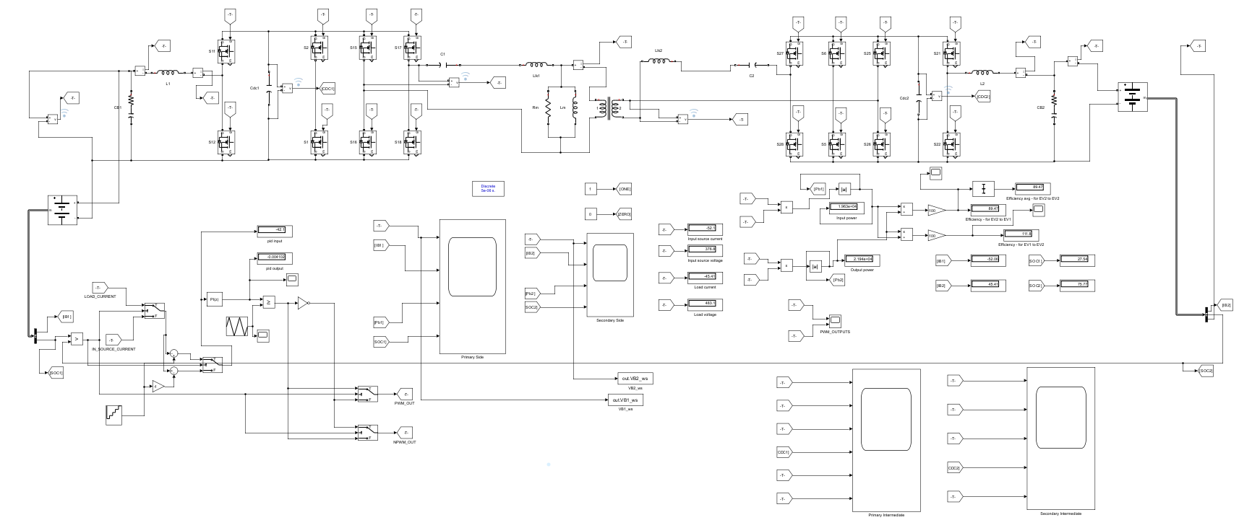

Figure 6.12 : Closed-loop Simulation Setup – PI Controller

6.3.1 PI Controller Simulation Results

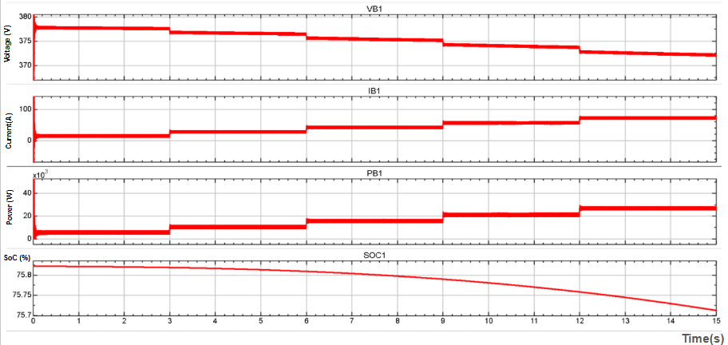
The PI controller is evaluated under both EV1-to-EV2 and EV2-to-EV1 charging modes using a stepwise constant-current (CC) reference. The charging-current reference is increased in increments of 10 A at 3 s intervals, from 10 A to 50 A, to investigate the converter response under varying charging conditions.

Figure 6.13 : Mode1 EV1 Parameter (Battery Voltage, Battery Current, Power, SOC%)
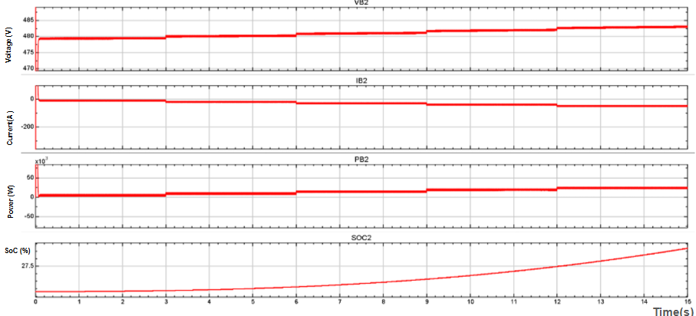

Figure 6.14 : Mode 1 EV 2 Parameters using PI Controller
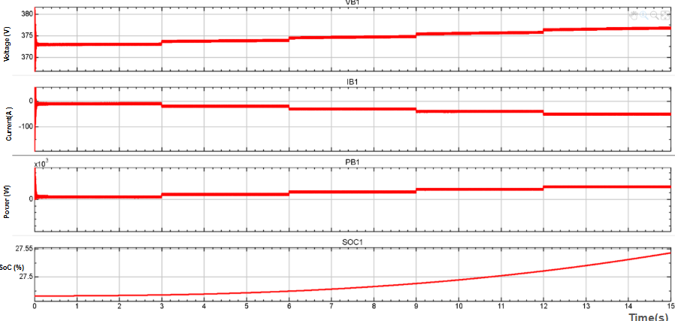

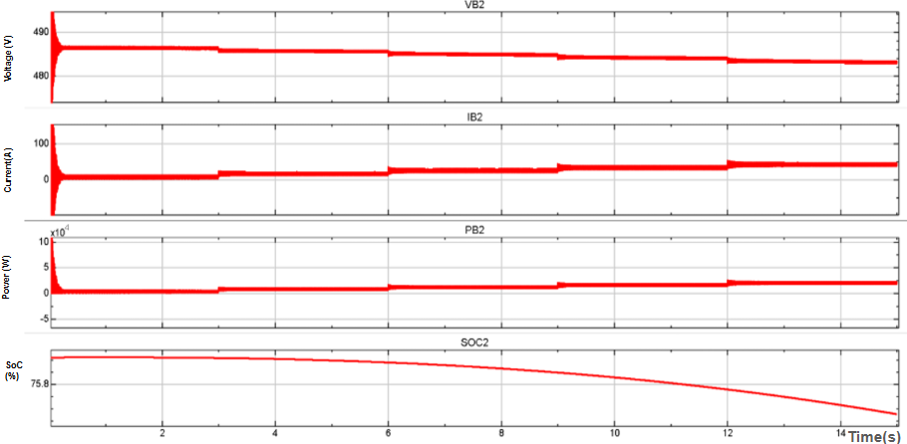
Figure 6.15 : Mode 2 EV 1 Parameters using PI Controller

Figure 6.16 : Mode 2 EV 2 Parameters using PI Controller

Figures 6.13 and 6.14 show increasing charging current and SOC in EV2, while EV1 supplies power during Mode 1. Figures 6.15 and 6.16 illustrate the reverse power flow in Mode 2, with EV1 charging and EV2 discharging. The results demonstrate PI-based current regulation and bidirectional energy transfer through corresponding changes in battery voltage, current, power, and SOC.

6.3.2 ISMC Controller Simulation Results
The ISMC controller is evaluated under both EV1-to-EV2 and EV2-to-EV1 charging modes using a stepwise constant-current (CC) reference. The charging-current reference is increased in increments of 10 A at 3 s intervals, from 10 A to 50 A, to investigate the converter response under varying charging conditions.
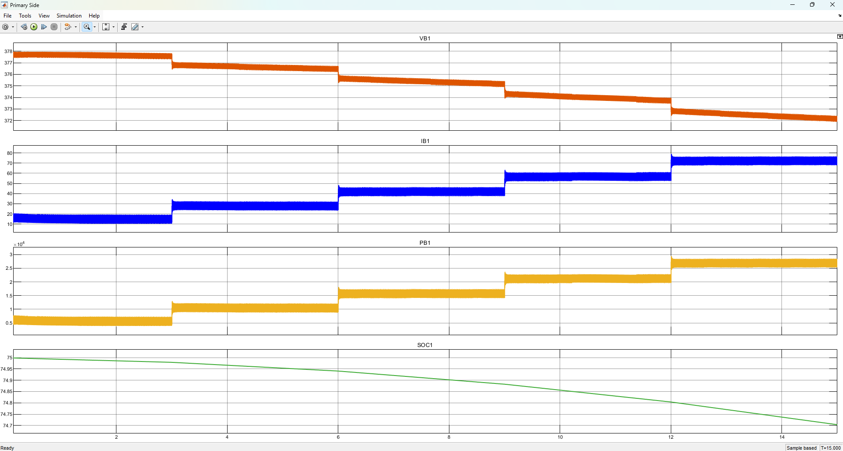
Figure 6.17 : Mode 1 EV 1 Parameters using ISMC Controller

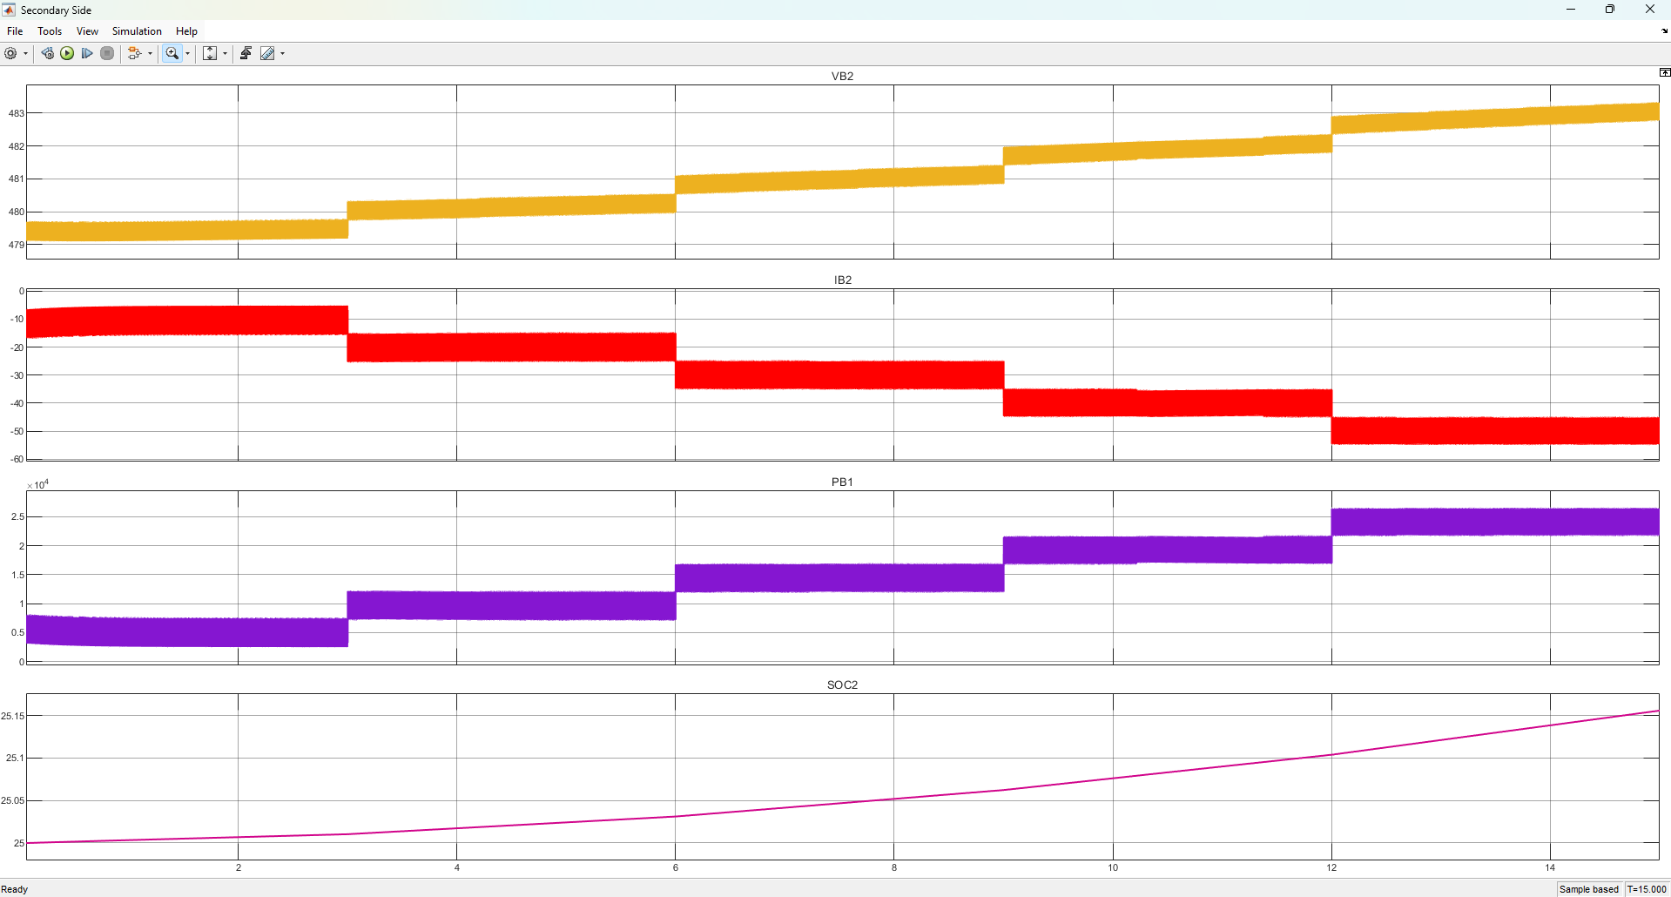
Figure 6.18 : Mode 1 EV 2 Parameters using ISMC Controller

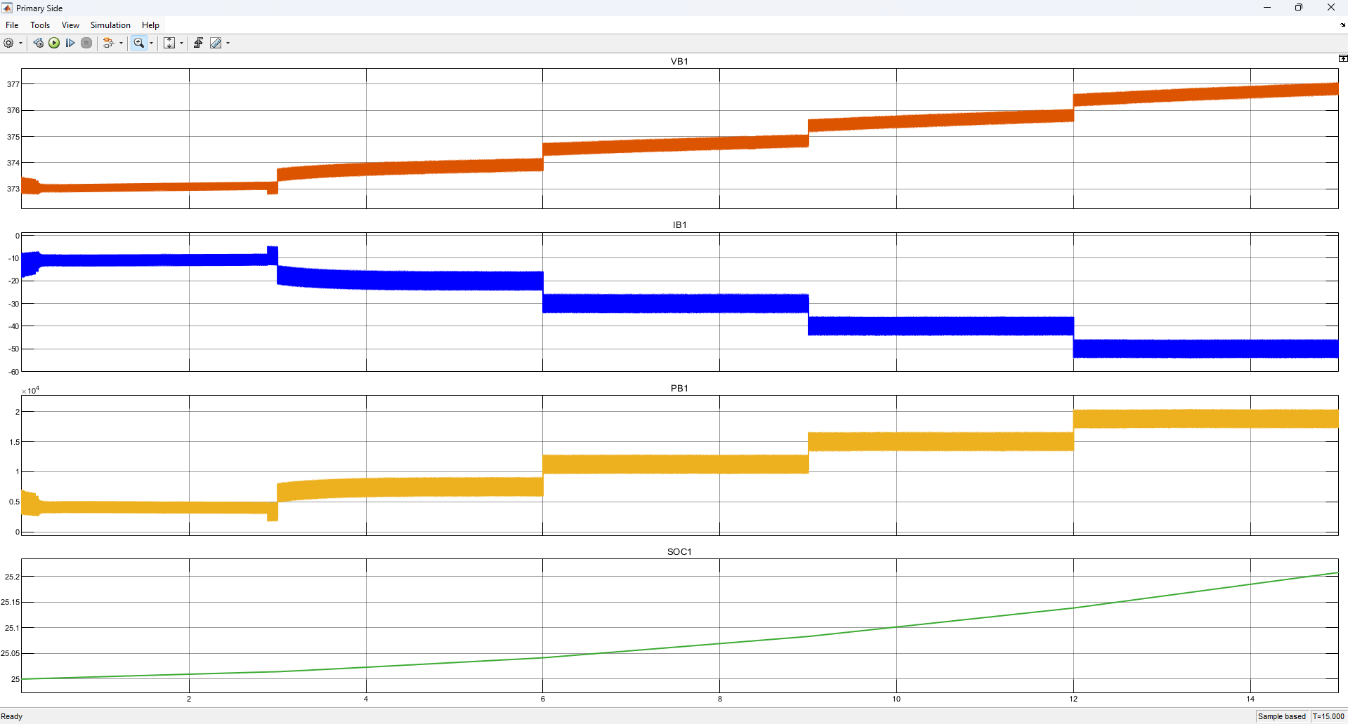
Figure 6.19 : Mode 2 EV 1 Parameters using ISMC Controller

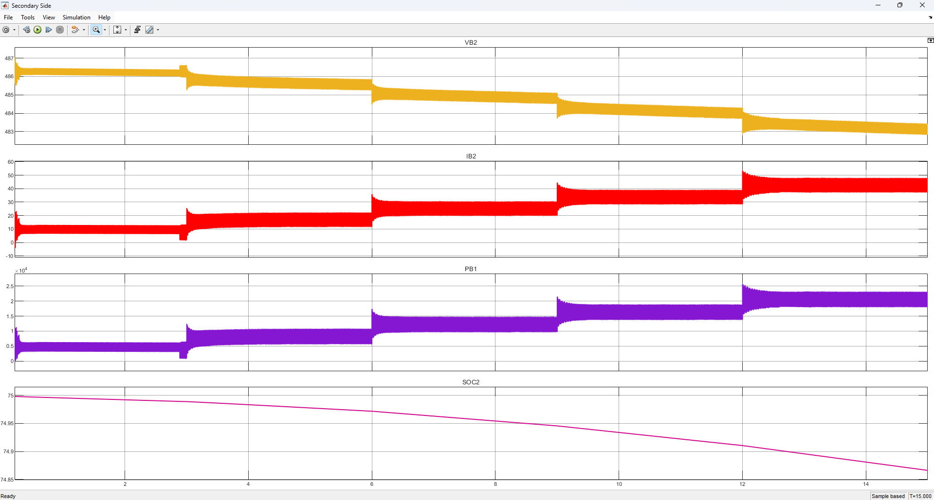
Figure 6.20 : Mode 2 EV 2 Parameters using ISMC Controller

Figures 6.17 and 6.18 show the ISMC response during Mode 1, with EV1 supplying power to EV2 as the charging-current reference increases. Figures 6.19 and 6.20 illustrate Mode 2 operation, where power flow reverses, EV1 charges, and EV2 discharges. The results demonstrate bidirectional operation with stepwise current and power responses and corresponding changes in battery SOC.
6.3.3 Fuzzy Controller Simulation Results
The Fuzzy controller is evaluated under both EV1-to-EV2 and EV2-to-EV1 charging modes using a stepwise constant-current (CC) reference. The charging-current reference is increased in increments of 10 A at 3 s intervals, from 10 A to 50 A, to investigate the converter response under varying charging conditions.

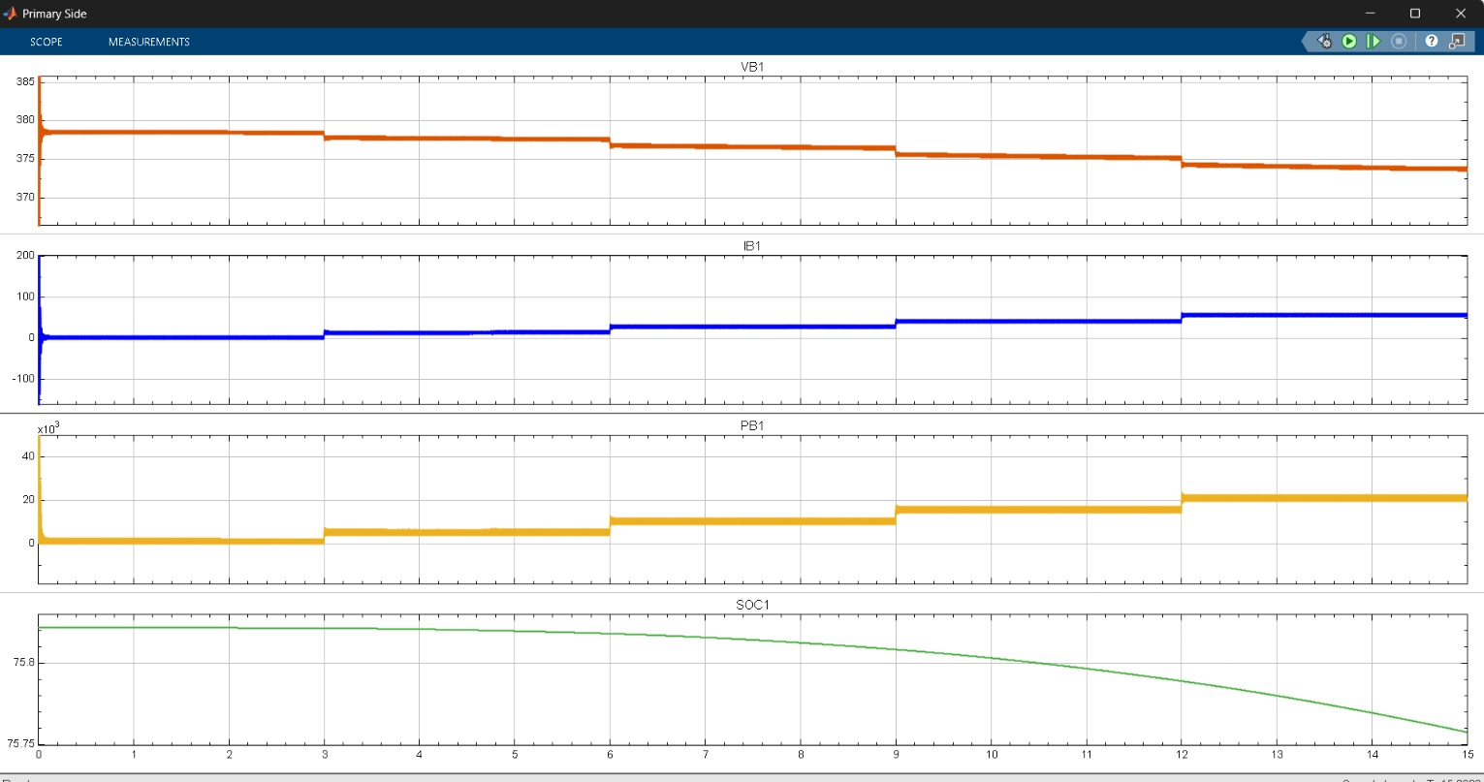
Figure 6.21 : Mode 1 (EV1) using Fuzzy Controller

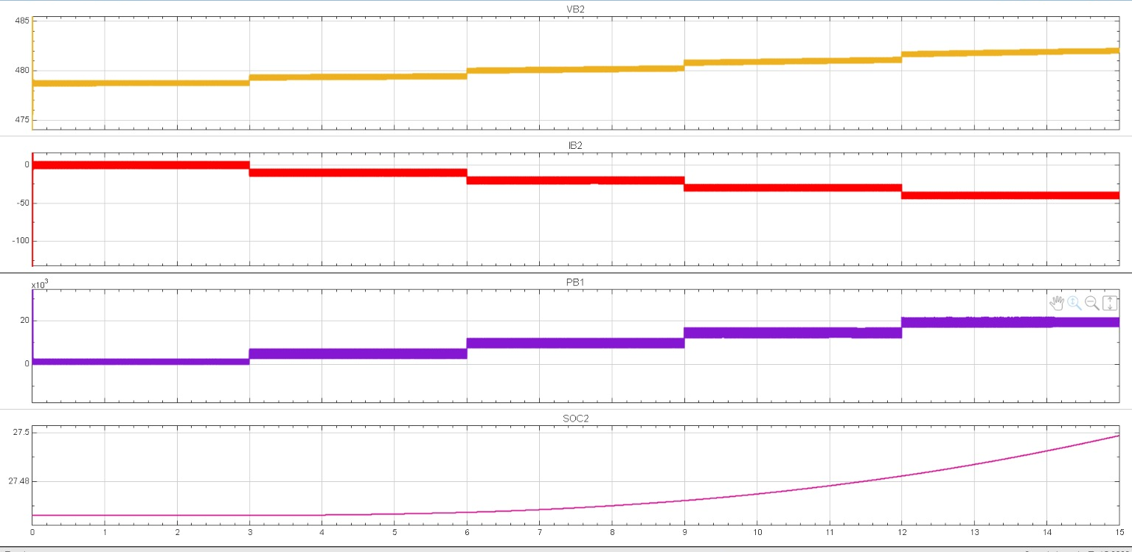
Figure 6.22 : Mode 1 (EV2) using Fuzzy Controller
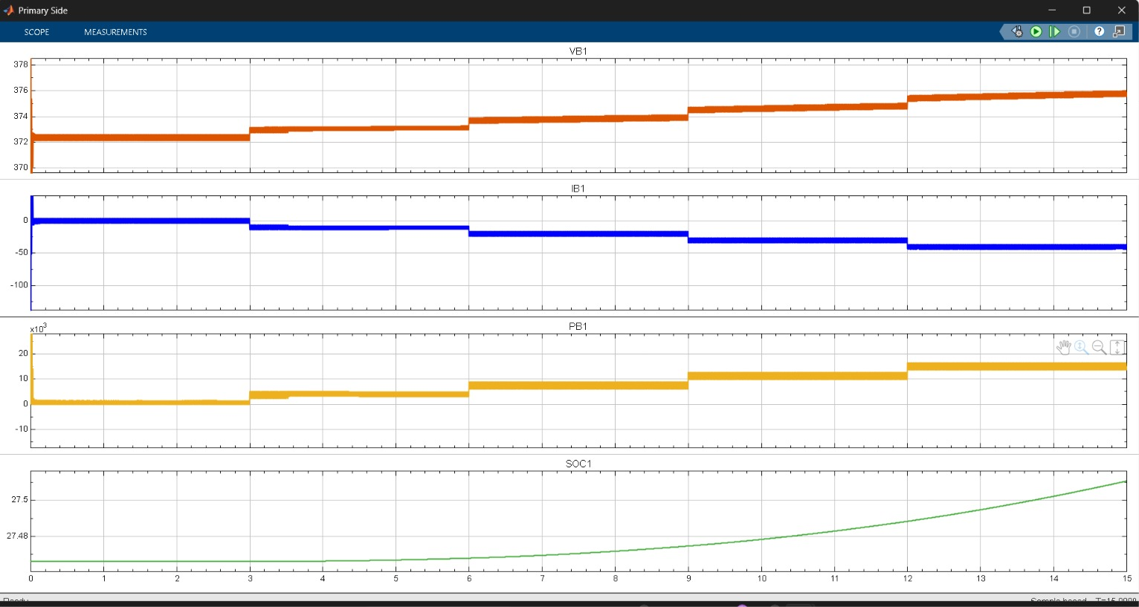
Figure 6.23 : Mode 2 (EV1) using Fuzzy Controller

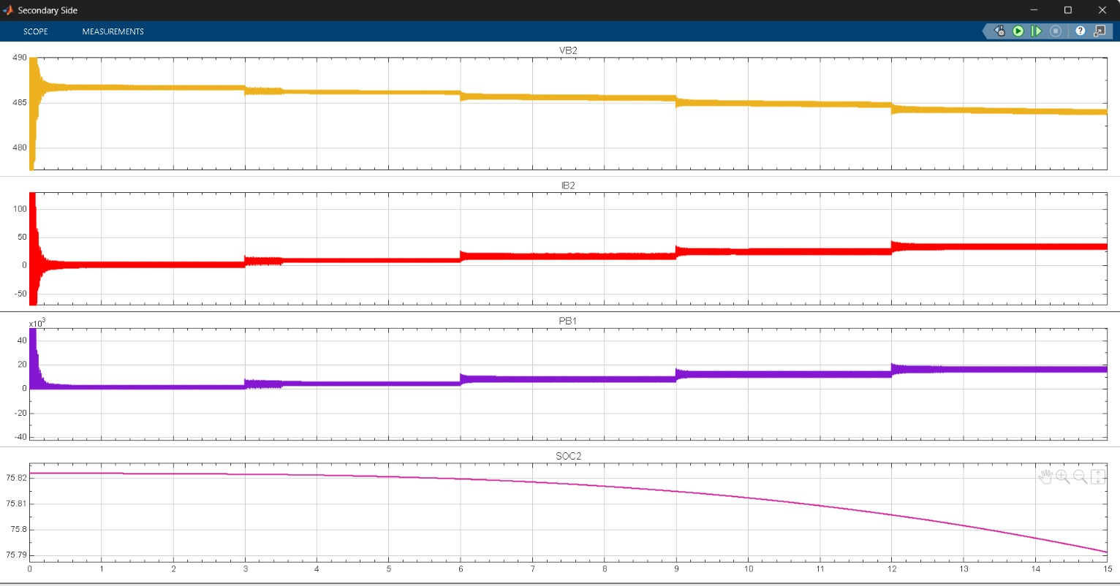
Figure 6.24 : Mode 2 (EV2) using Fuzzy Controller

Figures 6.21 and 6.22 show fuzzy-controller operation in Mode 1, with EV1 supplying power to EV2 as the charging-current reference increases. Figures 6.23 and 6.24 illustrate Mode 2, demonstrating reverse power flow from EV2 to EV1 with corresponding changes in current, power, and SOC. The results indicate that the fuzzy controller supports bidirectional operation and responds to stepwise changes in the charging-current reference.

6.4 COMPARISON OF CONTROLLERS

6.4.1 Transient Response Comparison
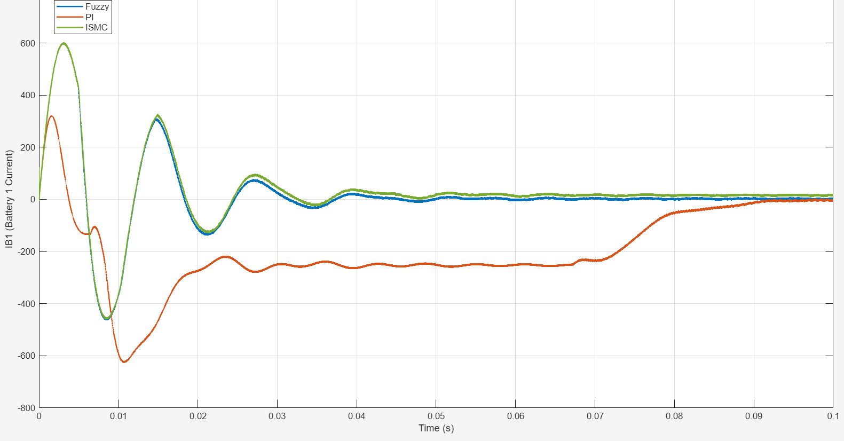
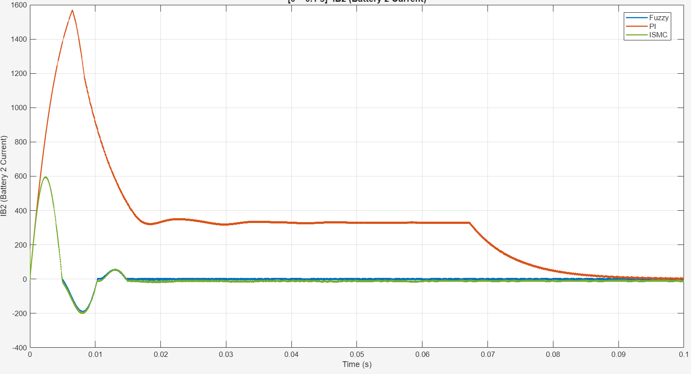
Figure 6.25 : Battery Current Transient Comparison
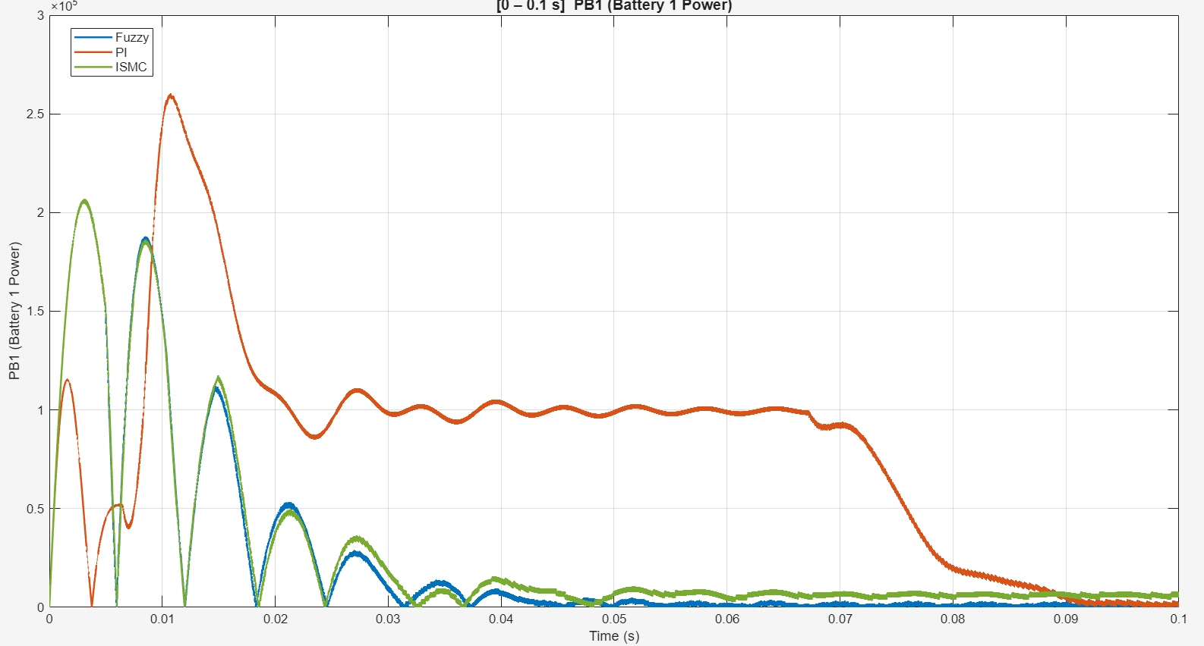
Figure 6.26 : Battery Power Transient Comparison
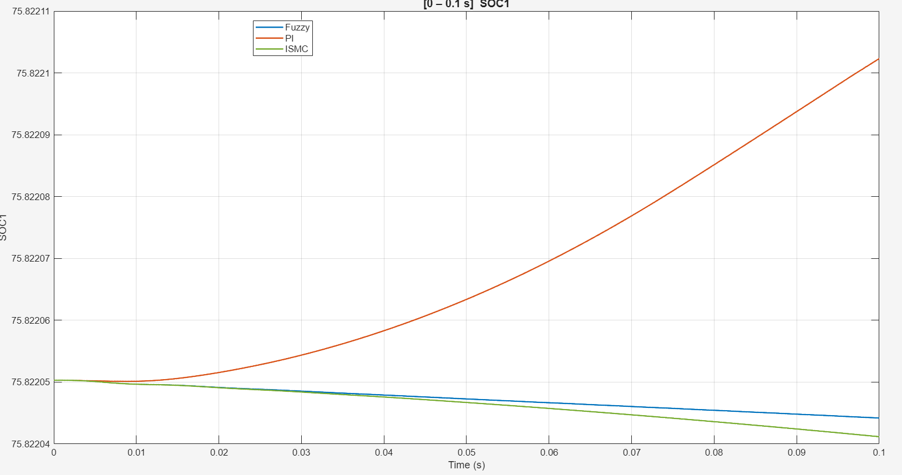
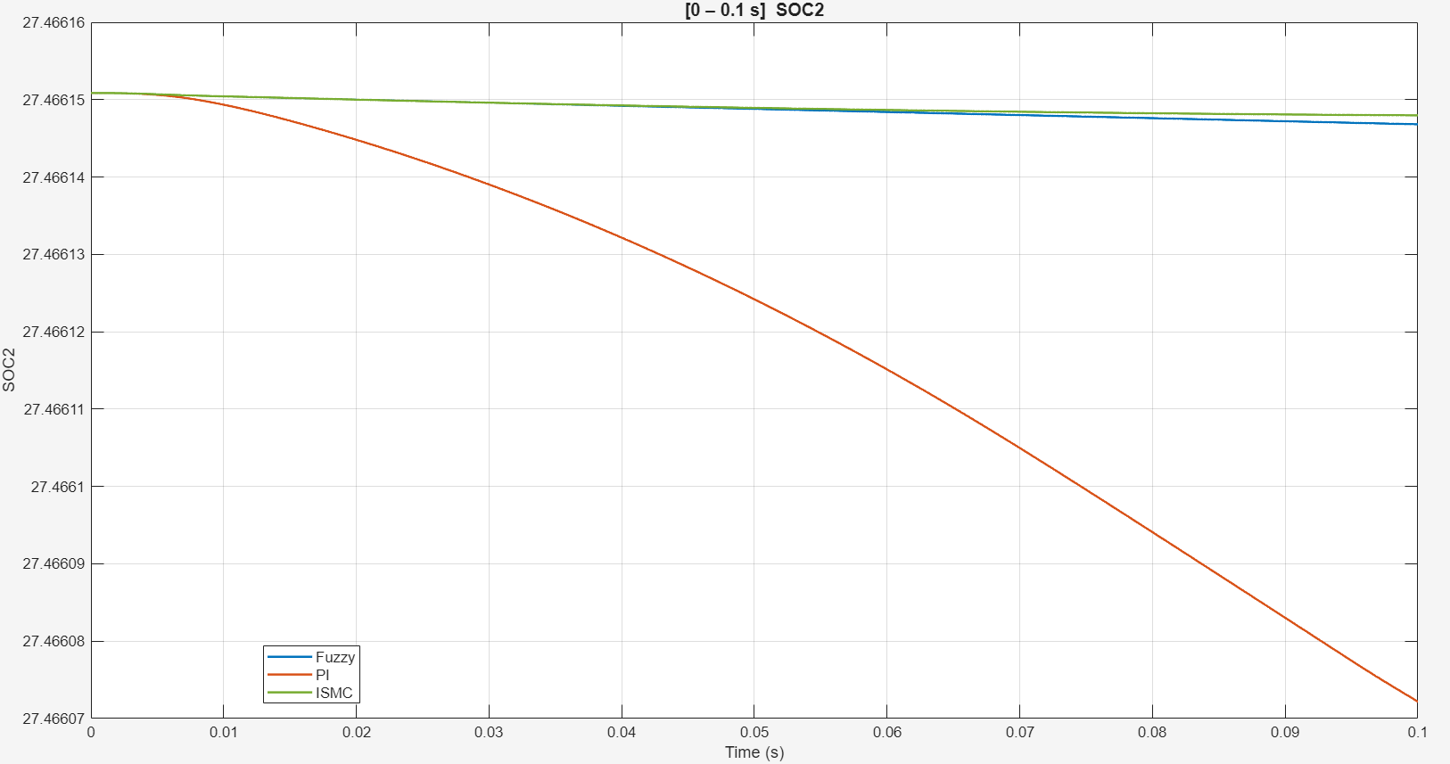
Figure 6.27 : Battery SOC % Transient Comparison

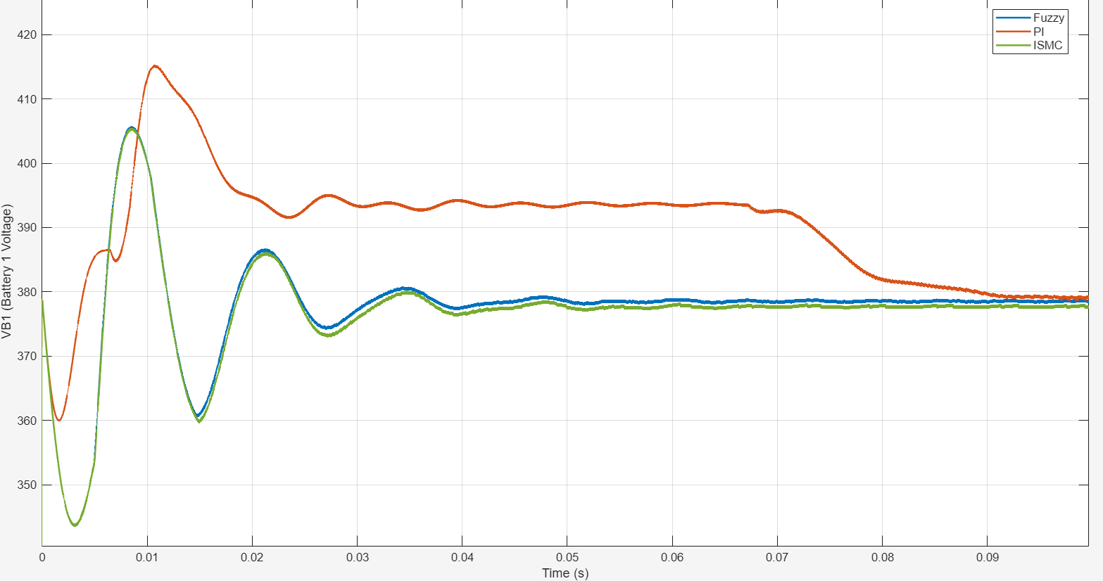
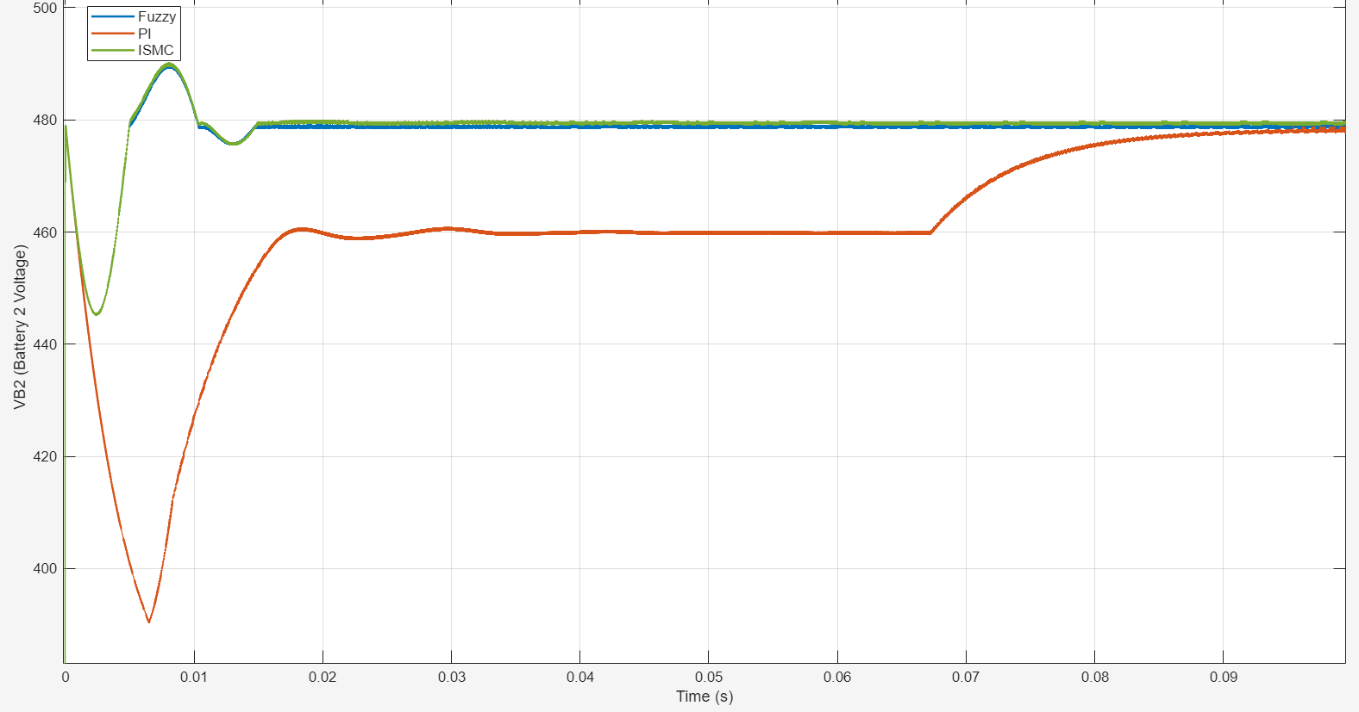
Figure 6.28 : Battery Voltage Transient Comparison

Table 6.1 : Transient Response Comparison of PI, ISMC and Fuzzy Logic Controllers

Performance parameter | PI controller | ISMC controller | Fuzzy logic controller
Initial transient deviation | Large voltage dip | Moderate voltage dip | Moderate voltage dip
Peak voltage response | Pronounced undershoot, followed by recovery | Overshoot followed by damped oscillations | Overshoot followed by damped oscillations
Oscillations | More pronounced and slower recovery | Rapidly damped | Rapidly damped
Settling behaviour | Slower; some variables recover near the end of the plotted interval | Settles relatively quickly | Settles relatively quickly
Steady-state voltage tracking | Reaches the target more slowly | Tracks close to the target | Tracks close to the target
Overall transient response | Slower recovery and larger deviation | Fast response with some initial oscillation | Fast response with some initial oscillation

6.4.2 Steady State Response Comparison
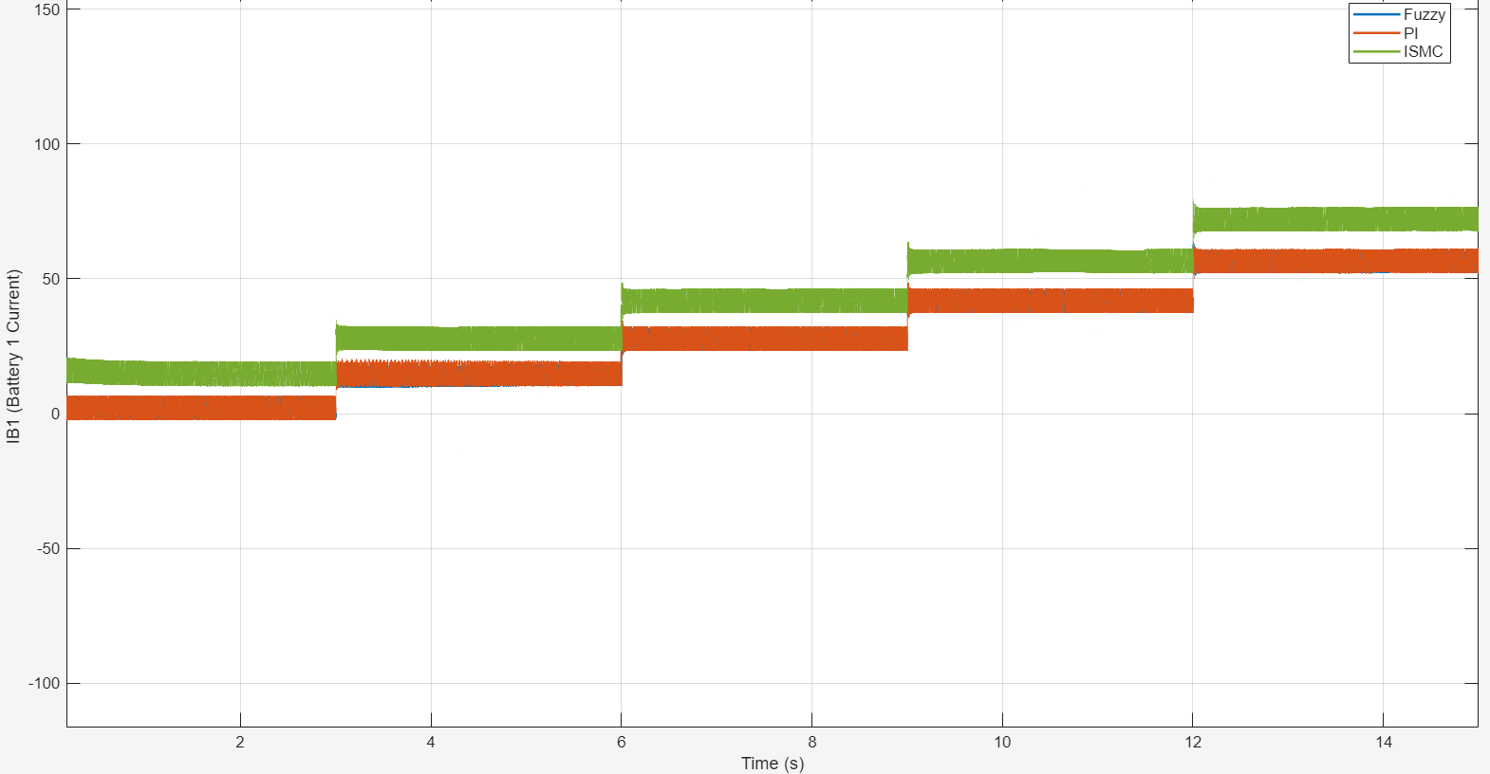
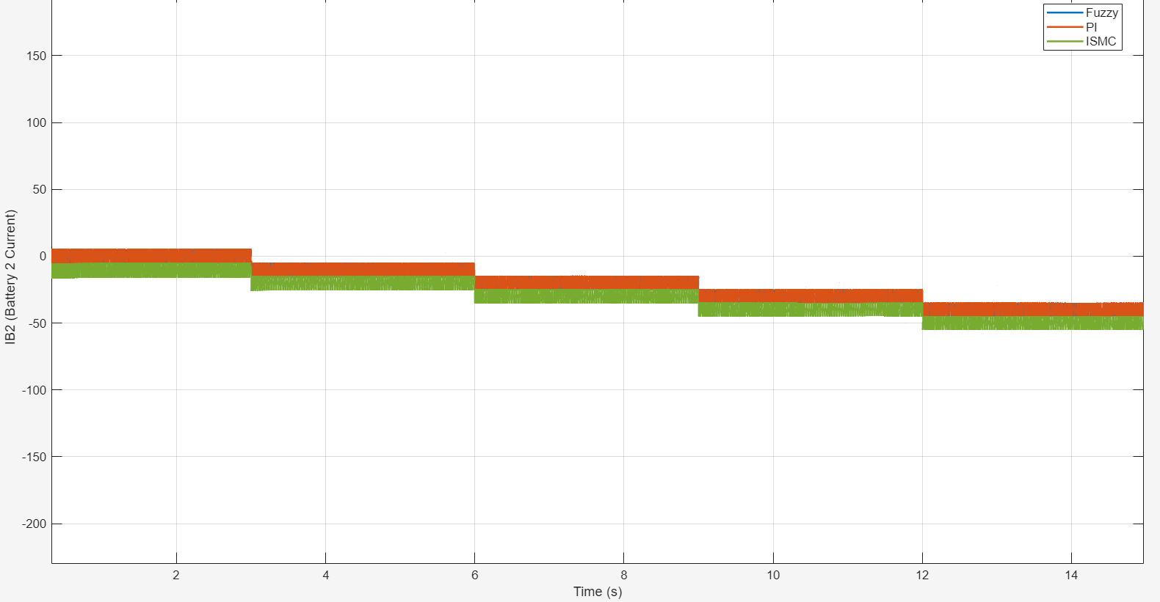
Figure 6.29 : Battery Current Steady-State Comparison

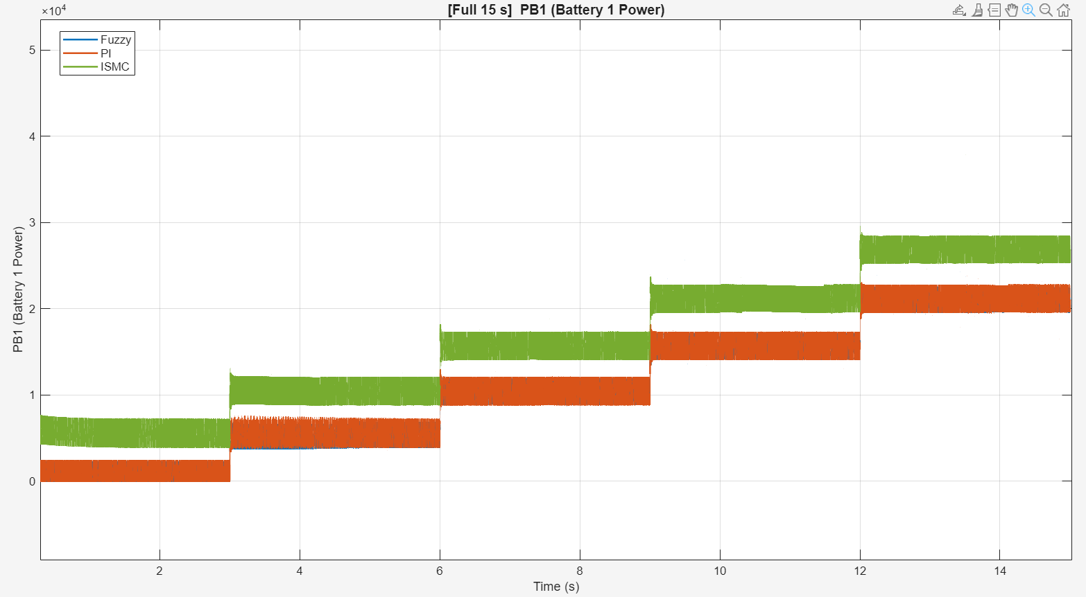
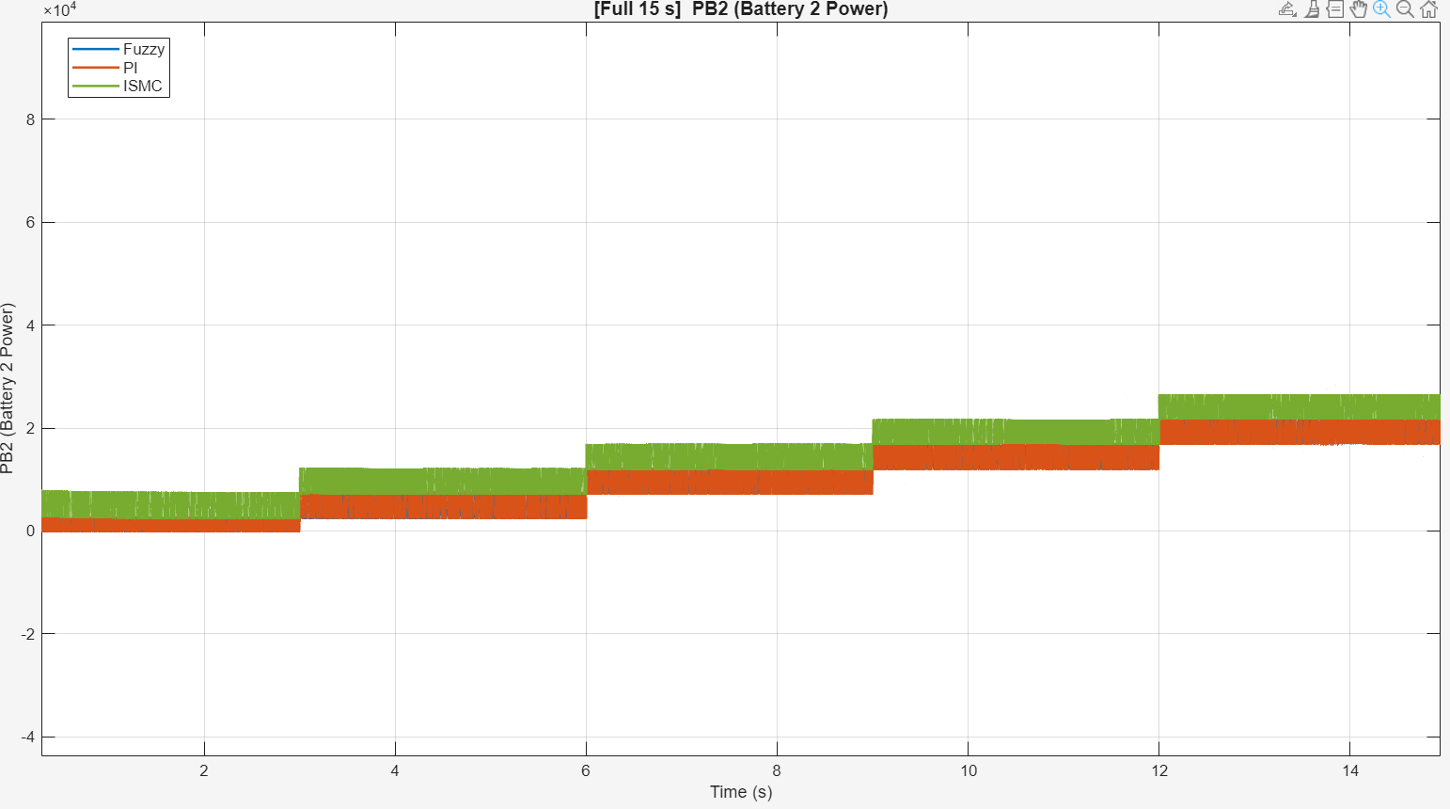
Figure 6.30 : Battery Power Steady-State Comparison
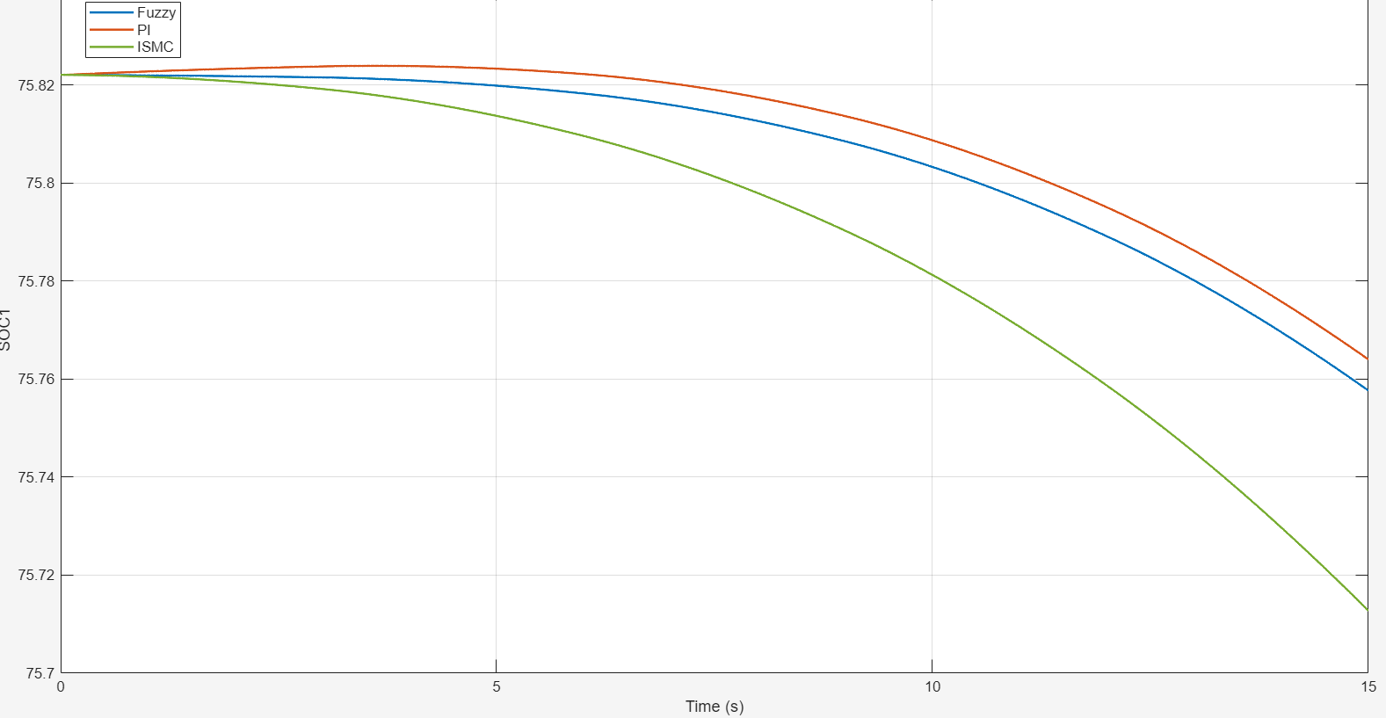
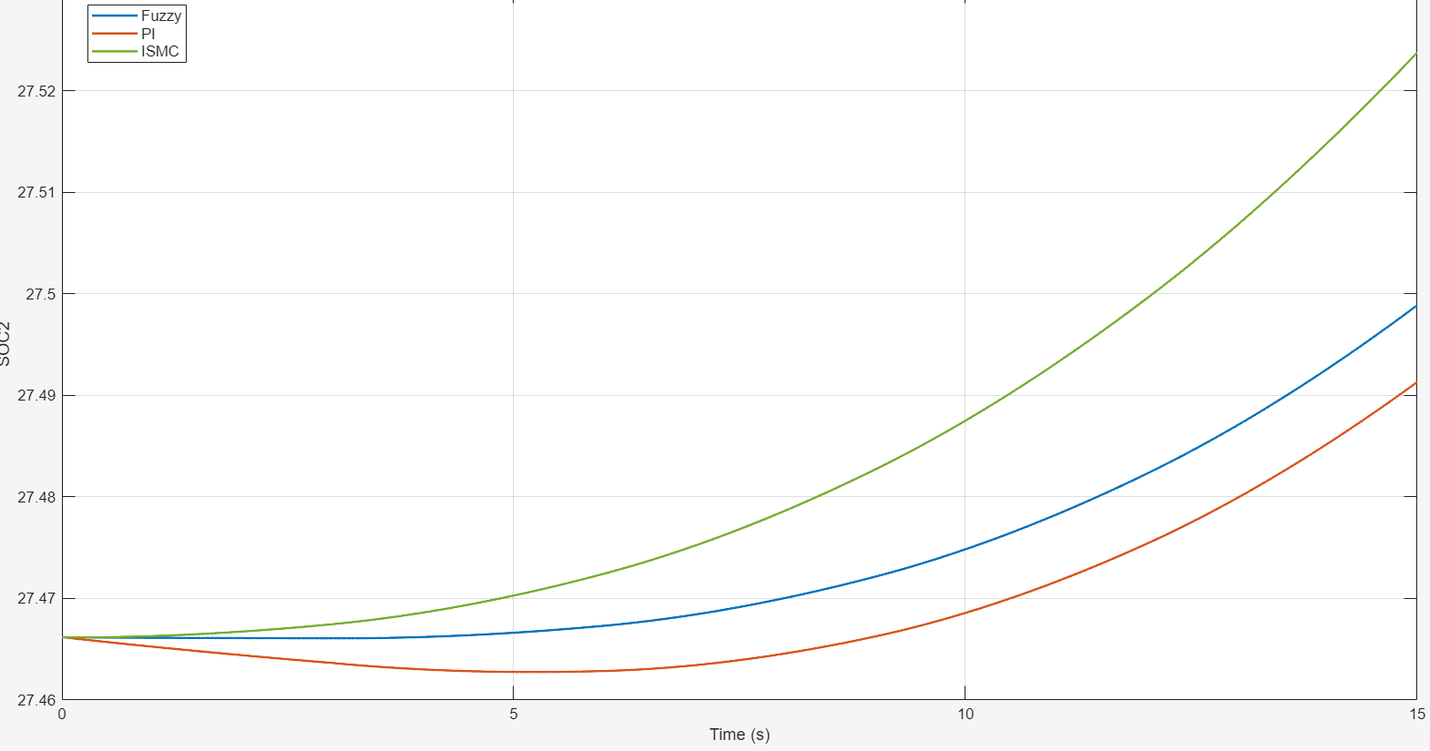
Figure 6.31 : Battery SOC Steady-State Comparison

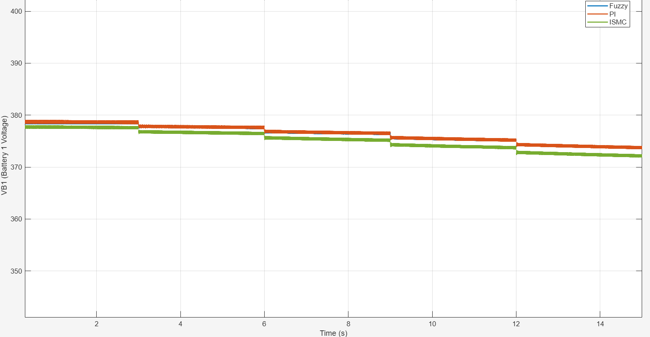
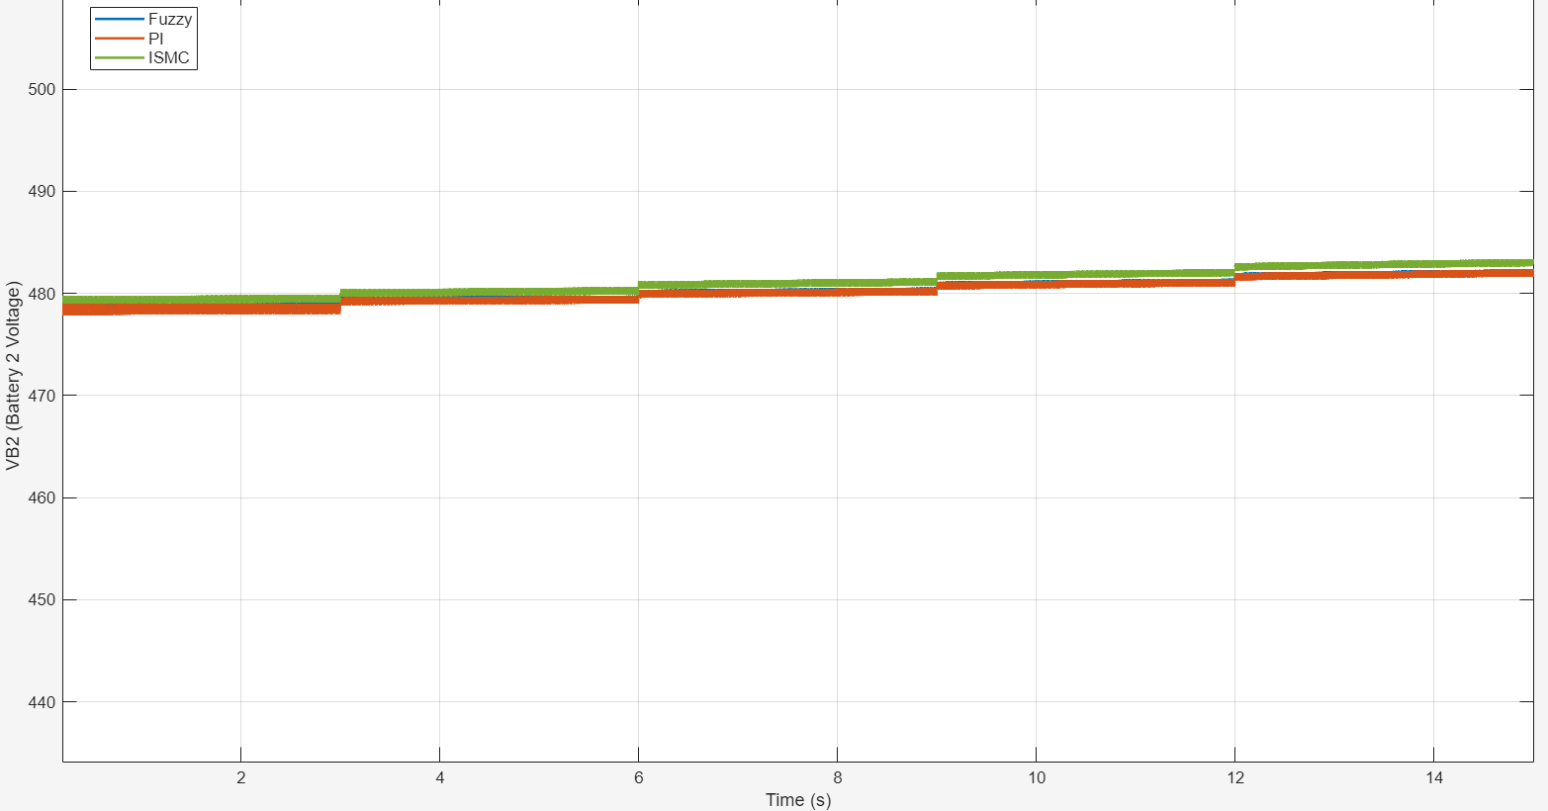
Figure 6.32 : Battery Voltage Steady-State Comparison

Table 6.2 : Steady-State Response Comparison of PI, ISMC and Fuzzy Logic Controllers

Performance parameter | PI controller | ISMC controller | Fuzzy logic controller
Battery current | Tracks the stepped reference at comparatively lower current levels | Higher current levels in the plotted results | Higher current levels in the plotted results
Battery power | Increases with successive reference steps | Higher power levels | Higher power levels
Source battery SOC | Decreases during discharge | Shows a comparatively larger decrease | Shows an intermediate decrease
Receiving battery SOC | Increases during charging | Shows a comparatively larger increase | Shows an intermediate increase
Source battery voltage | Gradually decreases | Gradually decreases | Gradually decreases
Receiving battery voltage | Gradually increases | Gradually increases | Gradually increases
Overall response | Stable, with comparatively lower power transfer | Stable, with higher observed power transfer | Stable, with higher observed power transfer than PI

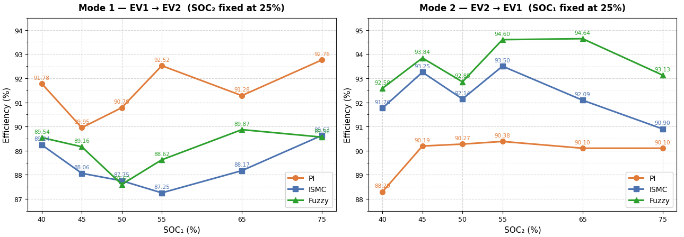
6.4.3 Efficiency Comparison

Figure 6.33 : Overall Efficiency Comparison

The steady-state results indicate that all three controllers support bidirectional power transfer, with the source battery SOC decreasing and the receiving battery SOC increasing in the respective charging modes. The transient plots show that ISMC and fuzzy logic control exhibit faster recovery and smaller sustained deviations than the PI controller, although both display initial oscillations. The efficiency comparison further highlights the influence of controller choice and power-transfer direction. In Mode 1 (EV1 → EV2), the PI controller achieves approximately 89–93% efficiency, while ISMC and fuzzy logic show comparatively lower or similar efficiency depending on SOC. In Mode 2 (EV2 → EV1), fuzzy logic achieves the highest efficiency across the plotted SOC points, reaching approximately 94–95%, while ISMC gives intermediate results and PI has the lowest efficiency, around 88–90%. Overall, the results suggest that fuzzy logic offers the strongest efficiency performance in reverse power transfer, whereas controller selection should consider transient response, steady-state regulation and efficiency together. These findings are specific to the simulated operating conditions and should not be generalised to all SOC and load conditions.

6.5 SEMICONDUCTOR LOSSES
Semiconductor losses in the proposed bidirectional V2V charging converter are classified into two main categories: conduction losses and switching losses. Conduction losses occur when current flows through a conducting semiconductor device, whereas switching losses arise during turn-on and turn-off transitions due to the simultaneous presence of voltage and current. Conduction loss estimation: The conduction losses of individual IGBTs are estimated using their collector-current characteristics obtained from the device datasheet. A lookup table is constructed from the V_{CE,SAT} versus collector-current curve to estimate the on-state voltage for the simulated current. The instantaneous conduction loss is calculated as,
P_{COND} = V_{CE,SAT}(I_{C}) * I_{C} …(6.1)
The resulting power signal is recorded in MATLAB/Simulink, and its average is calculated over the selected measurement interval from 0.2 s to 1.5 s.
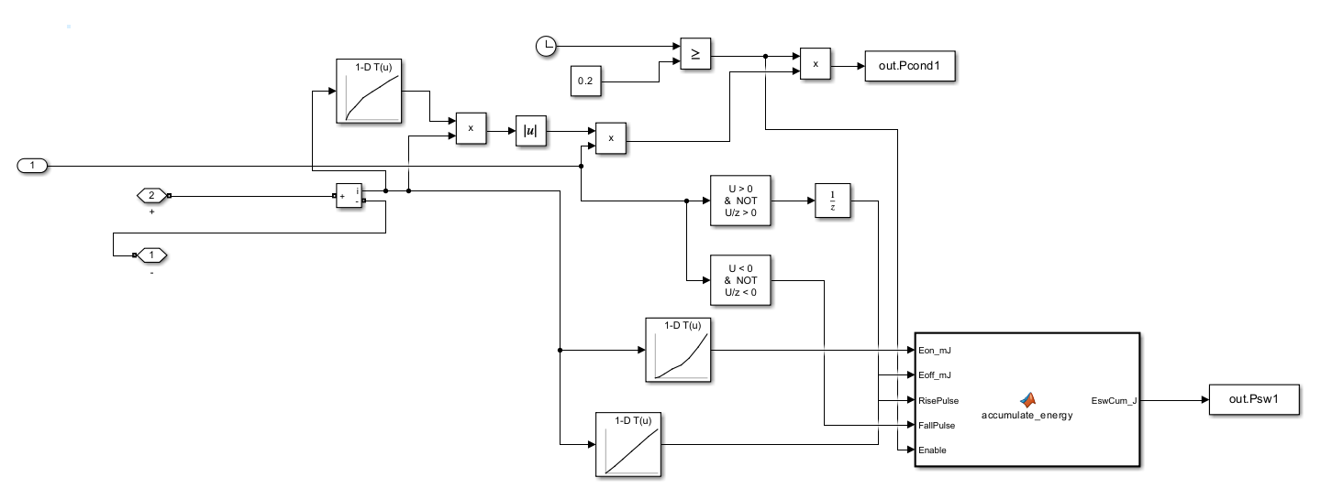
Figure 6.34 : Subsystem calculating the loss for each switch

Switching loss estimation: Switching losses are estimated using the turn-on energy E_{ON} and turn-off energy E_{OFF} characteristics obtained from the device datasheet [16]. Lookup tables relate the collector current at each switching event to the corresponding switching energy. Gate-signal transitions are detected, and the associated event energies are accumulated over the measurement interval. The average switching loss is calculated as,
$P_{SW}=\frac{\sum{}E_{ON}+\sum{}E_{OFF}}{t_{end}-t_{start}}$…(6.2)
The conduction and switching losses are evaluated separately for the individual switches on both EV sides. Their sum provides the estimated total semiconductor loss for each device.
The estimated conduction and switching losses exhibit different distributions across the converter switches. For EV1, the total conduction loss is approximately 124.96 W and the total switching loss is 147.23 W. For EV2, the corresponding values are approximately 140.95 W and 125.19 W. Thus, the estimated combined semiconductor losses are 272.19 W for EV1 and 266.13 W for EV2. Switches with no conduction or switching activity during the measurement interval show zero estimated loss, while a switch that remains conducting can exhibit conduction loss without recurring switching loss.
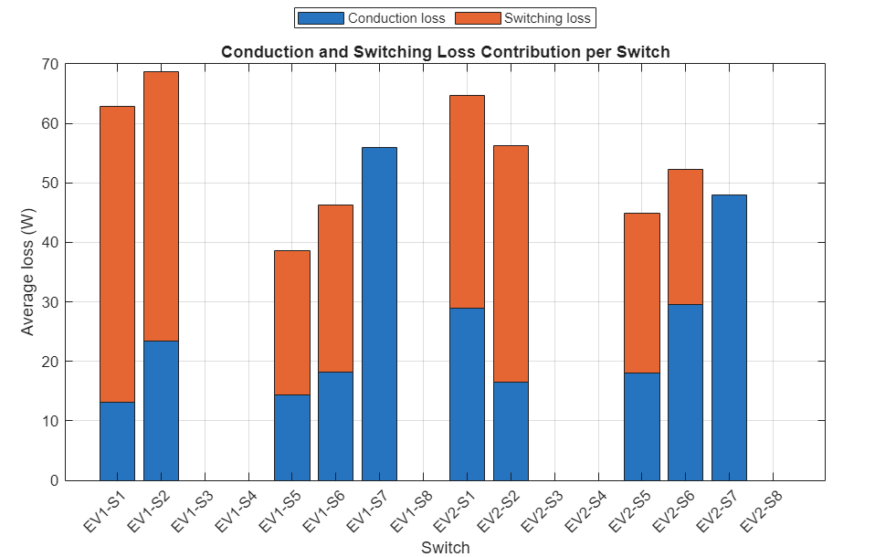
Figure 6.35 : Semiconductor Losses – Graphical Result

CHAPTER VII

7. OPAL-RT SOFTWARE-IN-LOOP VALIDATION

7.1 OPAL-RT SETUP

The proposed V2V charging converter model is configured for software-in-the-loop (SIL) simulation using the OPAL-RT OP4610XG (Figure 7.1) real-time simulator. The platform is intended to support real-time execution of electrical and control-system models, enabling controller implementation and evaluation in a real-time simulation environment.
The MATLAB/Simulink model is organised into two principal subsystems: the simulation model (SM_b1) and the supervisory control subsystem (SC_b1) (Figure 7.2). The simulation subsystem provides the converter and battery signals, while the control subsystem receives these signals for processing and control-system integration.
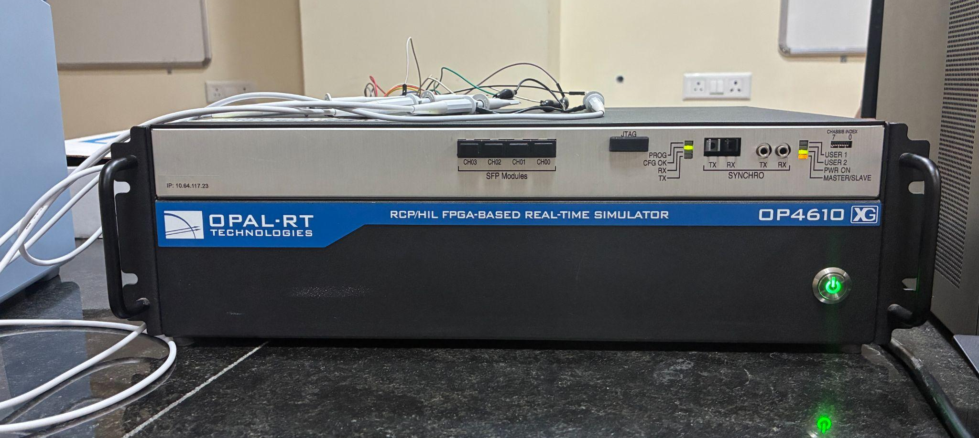
Figure 7.1 : OPAL-RT OP4610XG real-time simulation platform

The interface includes eleven signals: EV1 battery voltage, current, power and state of charge; EV2 battery voltage, current, power and state of charge; and the input, feedback and reference signals. These signals establish the interface between the converter model and the control subsystem. A discrete sample time of 5 µs is specified in the model configuration, subject to verification against the final simulation settings. The model is developed in MATLAB/Simulink R2024. (Figure 7.3) Compatibility with the installed OPAL-RT RT-LAB software must be verified before execution, as support depends on the specific RT-LAB release. The OPAL-RT setup provides a foundation for evaluating the proposed control strategies in a real-time simulation environment. Hardware-in-the-loop (HIL) testing and physical hardware implementation are considered future extensions of the project.
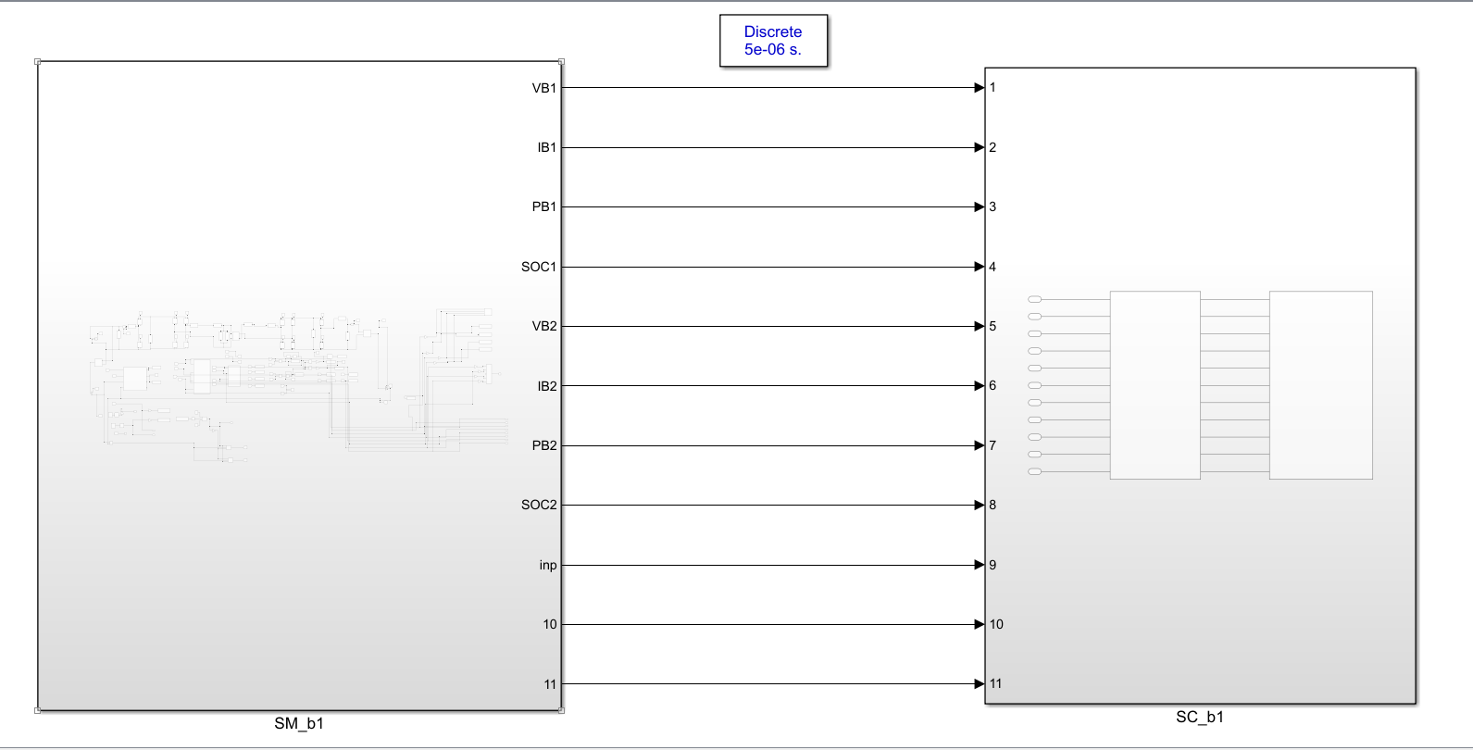
Figure 7.2 : MATLAB/Simulink model partitioning into simulation and control subsystems.
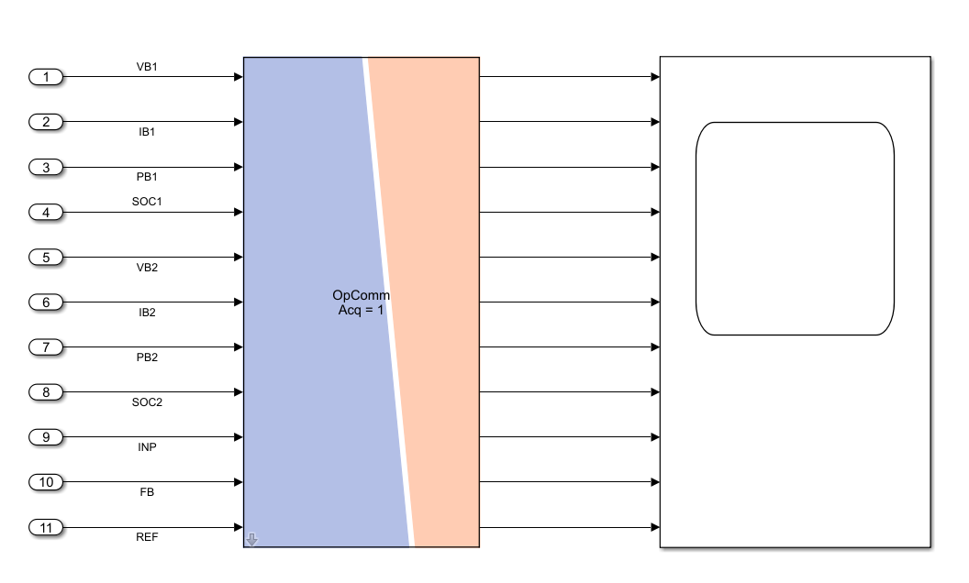
Figure 7.3 : Signal interface between the converter simulation model and supervisory control subsystem.
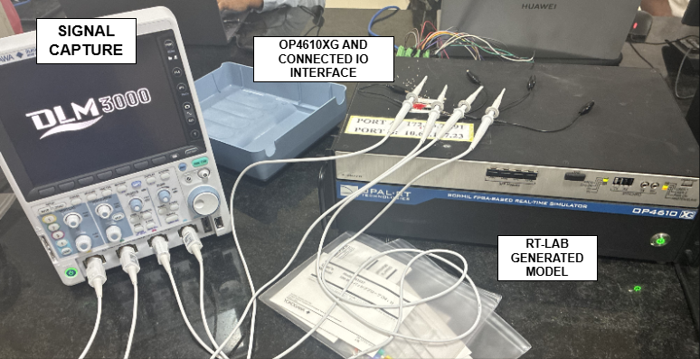
Figure 7.4 : Apparatus Setup

7.2 OPAL-RT RESULTS

7.2.1 Hardware-Synchronized Results in MSO – PI CONTROLLER

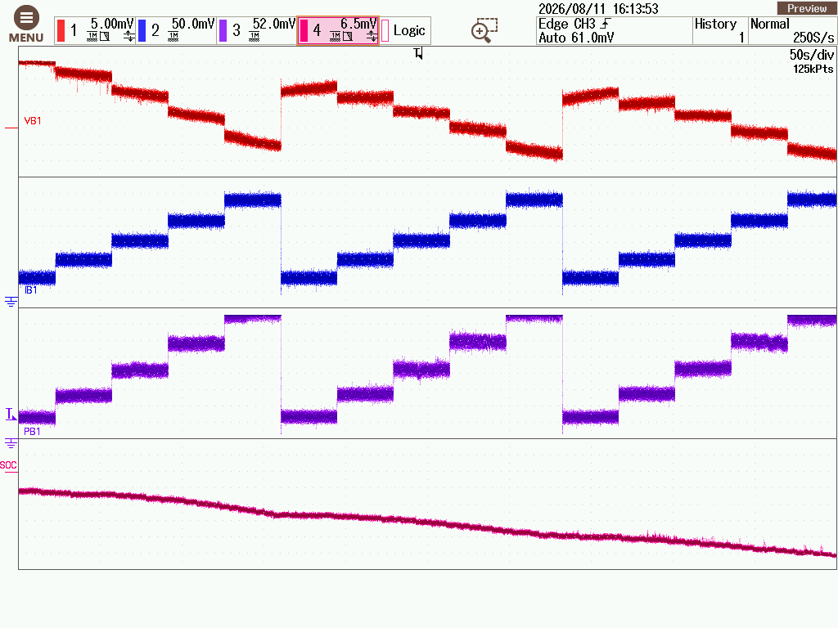
- Mode 1 - EV1 Charging EV2 - EV1 Parameters
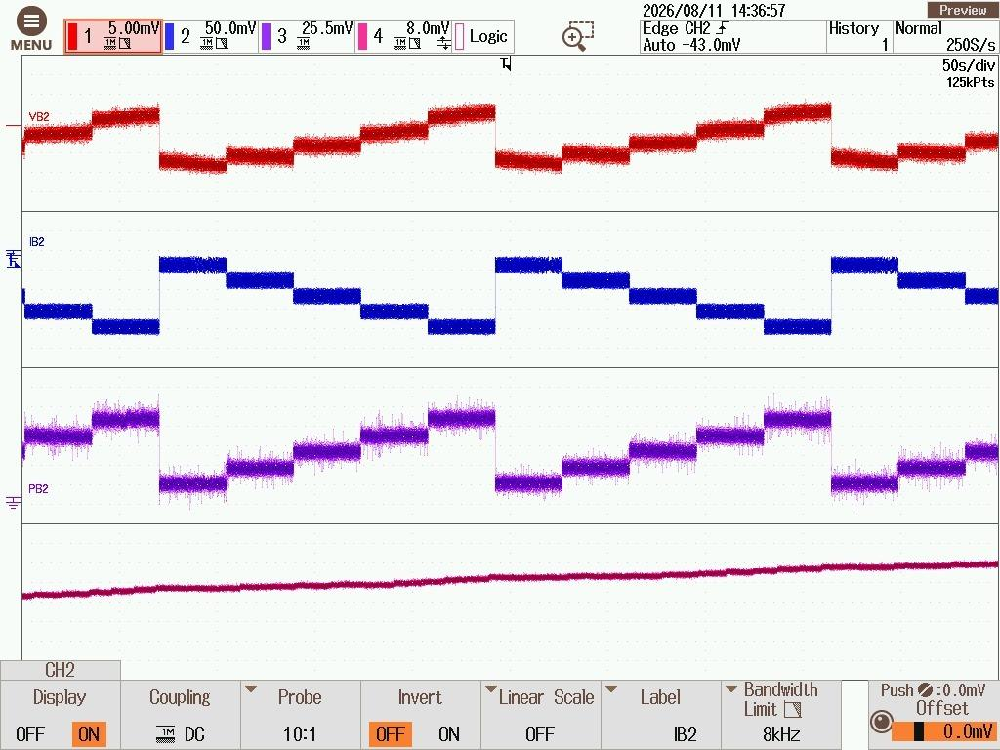
- Mode 1 - EV1 Charging EV2 - EV2 Parameters

Figure 7.5 : MODE 1 - PI CONTROLLER - OPAL RT RESULTS

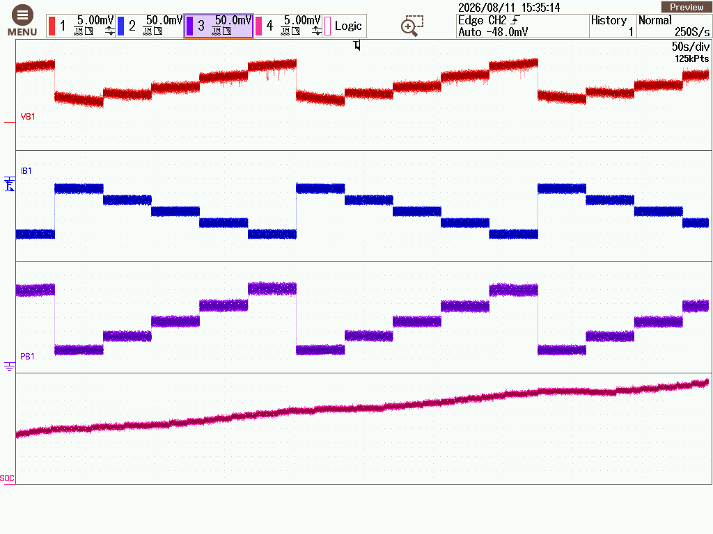
- Mode 2 - EV2 Charging EV1 - EV1 Parameters
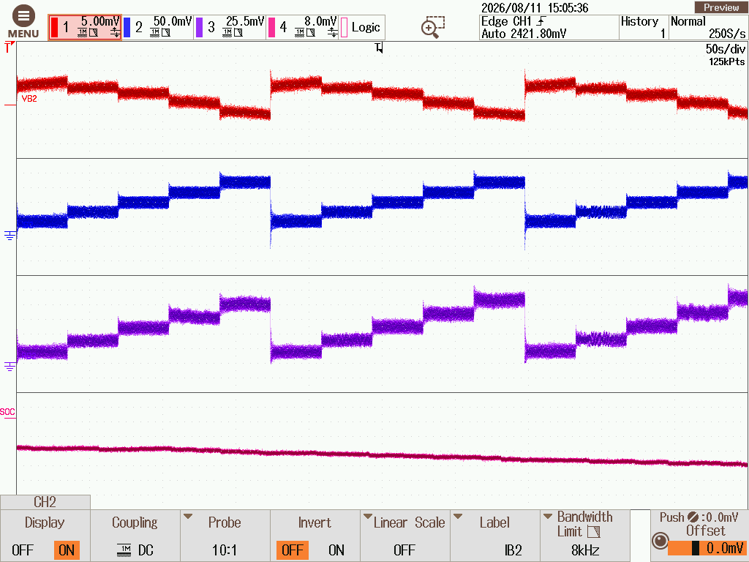
- Mode 2 - EV2 Charging EV1 - EV2 Parameters

Figure 7.6 : MODE 2 - PI CONTROLLER - OPAL RT RESULTS

Figure 7.5 shows OPAL-RT results for Mode 1, confirming stepwise changes in EV1 and EV2 parameters during charging. Figure 7.6 demonstrates Mode 2 operation, with power flow reversed from EV2 to EV1. The synchronized waveforms show consistent variations in voltage, current, power, and SOC with changing operating conditions. These results support the real-time simulation validation of PI-controlled bidirectional V2V charging.
7.2.2 Hardware-Synchronized Results in MSO – ISMC CONTROLLER

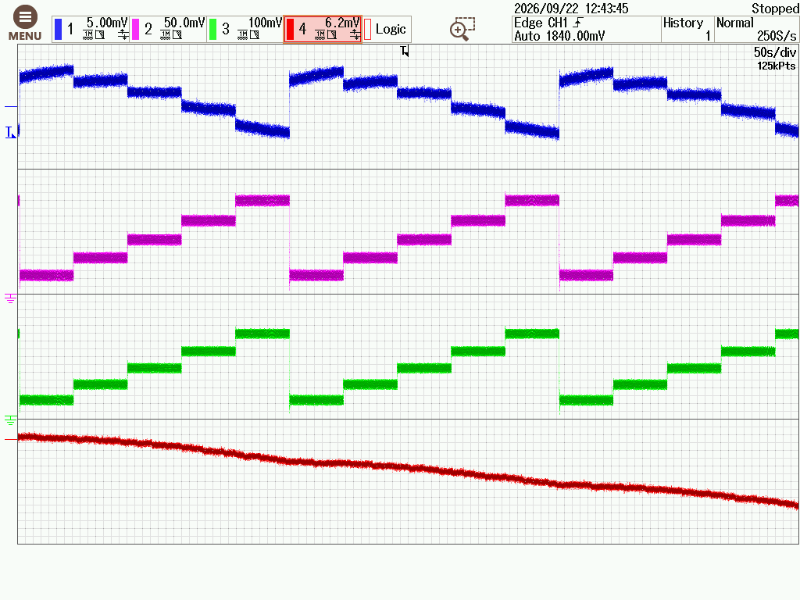
- Mode 1 - EV1 Charging EV2 - EV1 Parameters
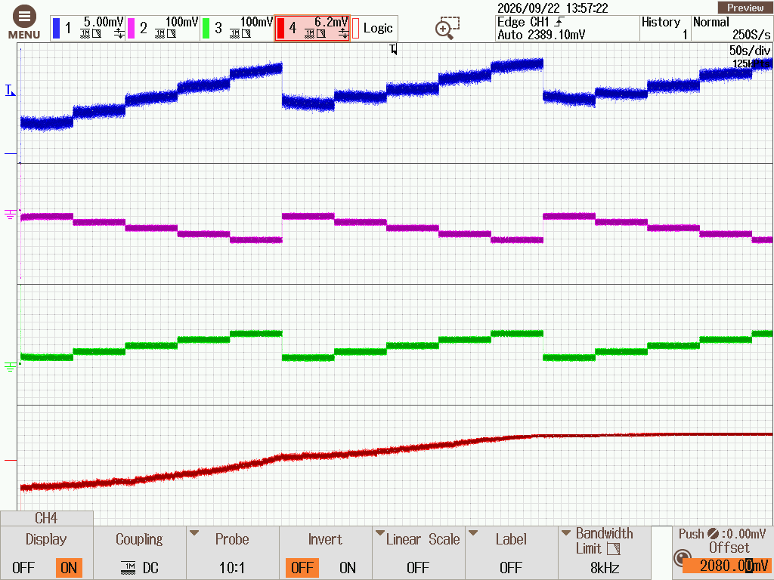
- Mode 1 - EV1 Charging EV2 - EV2 Parameters

Figure 7.7 : MODE 1 - ISMC CONTROLLER - OPAL RT RESULTS

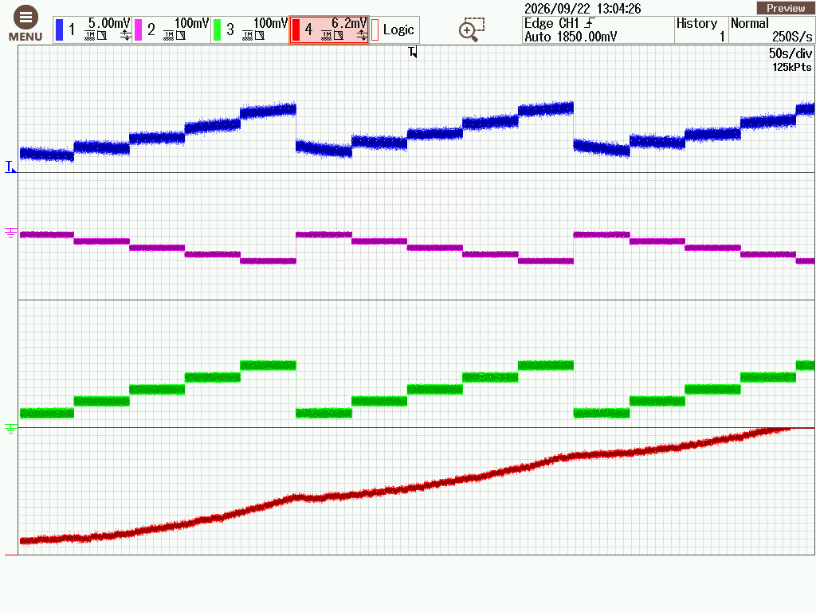
- Mode 2 - EV2 Charging EV1 - EV1 Parameters
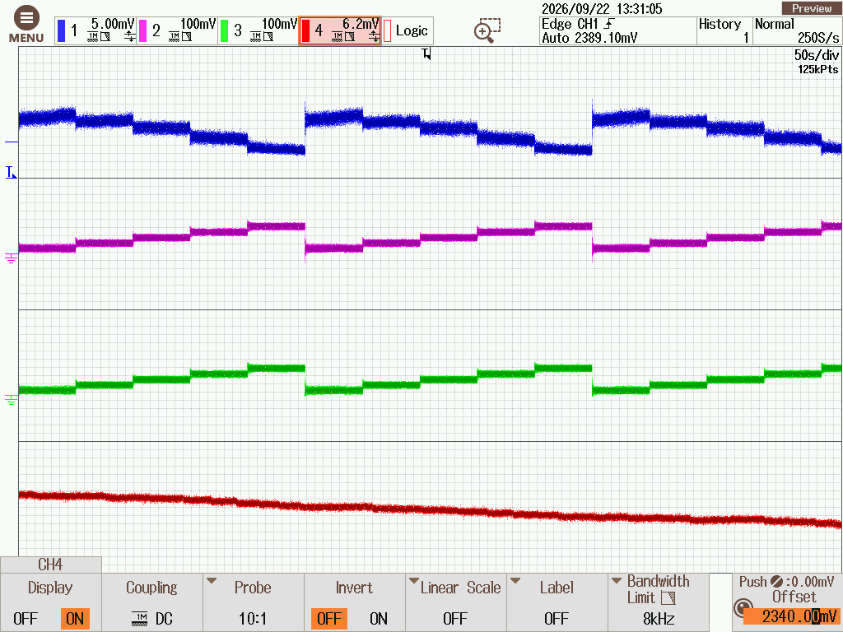
- Mode 2 - EV2 Charging EV1 - EV2 Parameters

Figure 7.8 : MODE 2 - ISMC CONTROLLER - OPAL RT RESULTS

Figure 7.7 shows the OPAL-RT results for ISMC-controlled Mode 1, demonstrating stepwise variations in EV1 and EV2 parameters during charging. Figure 7.8 presents Mode 2 operation, confirming the reversal of power flow from EV2 to EV1. The synchronized waveforms exhibit consistent parameter trends corresponding to changes in the charging-current reference. These results demonstrate the feasibility of ISMC-based bidirectional control under real-time simulation conditions.
7.2.3 Hardware-Synchronized Results in MSO – FUZZY CONTROLLER

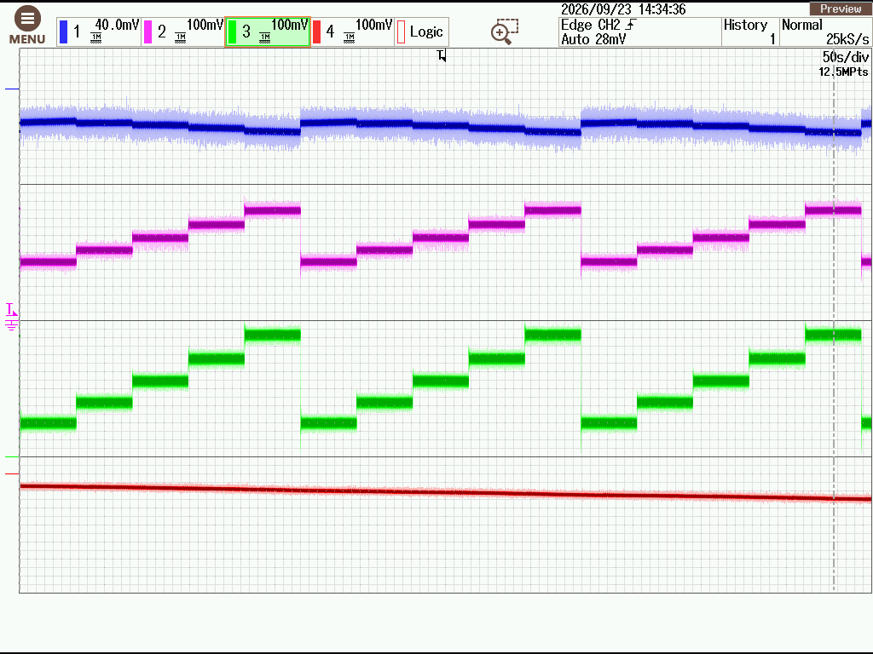
- Mode 1 - EV1 Charging EV2 - EV1 Parameters
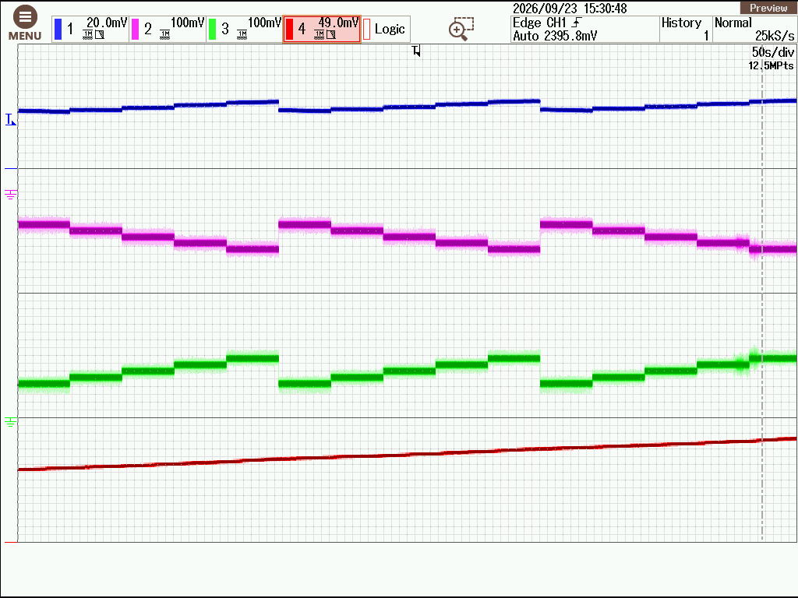
- Mode 1 - EV1 Charging EV2 - EV2 Parameters

Figure 7.9 : MODE 1 - FUZZY CONTROLLER - OPAL RT RESULTS

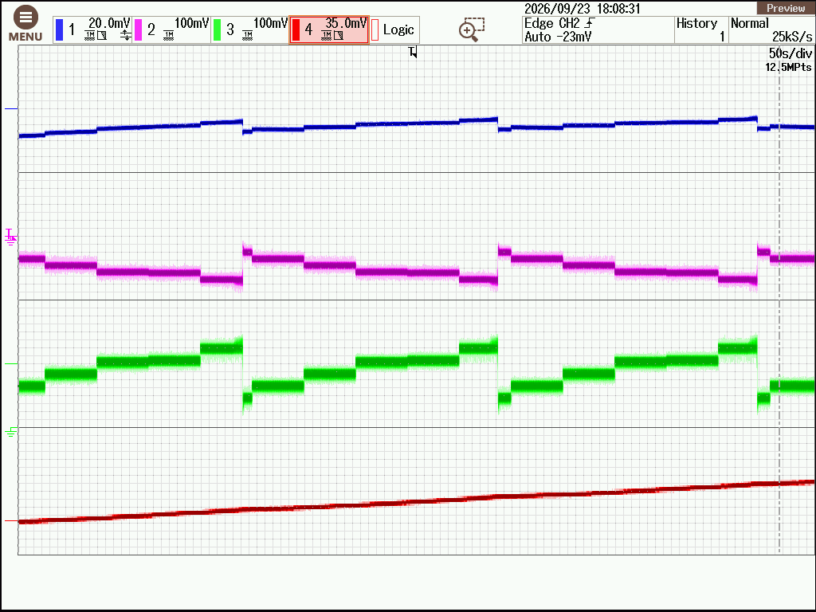
- Mode 2 - EV2 Charging EV1 - EV1 Parameters
- Mode 2 - EV2 Charging EV1 - EV2 Parameters

Figure 7.10 : MODE 2 - FUZZY CONTROLLER - OPAL RT RESULTS

Figure 7.9 & 7.10 presents the OPAL-RT results for fuzzy-controlled Mode 1 & 2 respectively, showing stepwise variations in EV1 and EV2 parameters during charging. These results support the feasibility of fuzzy logic control for bidirectional V2V charging under real-time simulation conditions.

CHAPTER VIII

8. CONCLUSION
8.1 CONCLUSION
This work presents the design and Software-in-the-Loop (SIL) validation of an isolated, single-stage bidirectional Vehicle-to-Vehicle (V2V) charging converter using existing onboard chargers (OBCs) and a resonant high-frequency transformer (HFT) link for galvanic isolation. The key objectives and contributions are summarised below:
- Utilisation of Existing OBCs: The proposed V2V charging architecture leverages the existing onboard chargers of both electric vehicles, reducing the need for dedicated charging infrastructure and extensive vehicle-side hardware modifications.
- Isolated Bidirectional Converter Design: An isolated, single-stage bidirectional converter incorporating a resonant HFT link is designed to facilitate power transfer between EV1 and EV2 in both directions while providing galvanic isolation.
- SIL Validation Using OPAL-RT: The system is modelled and validated using the OPAL-RT OP4610XG platform. Its performance is evaluated under varying load, supply, and state-of-charge (SOC) conditions to assess the stability and effectiveness of bidirectional charging and discharging.
- Comparative Controller Evaluation: PI, Integral Sliding Mode Control (ISMC), and Fuzzy Logic controllers are implemented and compared based on dynamic response, voltage/current regulation, and charging/discharging performance. Fuzzy Logic demonstrates the best overall response in the evaluated scenarios, while ISMC and Fuzzy Logic provide favourable bidirectional control performance.
- Power Loss Analysis: Switching losses and conductor losses are calculated to evaluate converter losses and assess their impact on overall power-conversion efficiency.
The study establishes a simulation-based framework for validating an isolated bidirectional V2V charging system that utilises existing OBCs. The results demonstrate the potential of advanced closed-loop control strategies to achieve stable bidirectional power transfer, with Fuzzy Logic exhibiting the best overall response among the evaluated controllers. Future work will focus on hardware-in-the-loop testing, experimental validation, controller optimisation, and further improvement of converter efficiency and practical implementation.

8.2 LIMITATIONS OF THE PROPOSED SYSTEM
- Simulation-Based Validation: The converter performance was primarily evaluated using MATLAB/Simulink simulations and OPAL-RT software-in-the-loop (SIL) analysis. Physical hardware testing and hardware-in-the-loop (HIL) validation remain outside the current project scope.
- Operating Conditions: The analysis considered selected battery voltage, state-of-charge (SOC), load and power-transfer conditions. Further testing under a wider range of battery conditions and operating scenarios would help establish the converter's performance more comprehensively.
- Controller Performance: PI, integral sliding mode control (ISMC), and fuzzy logic control were investigated for closed-loop operation. Their performance depends on controller parameters, operating conditions and tuning; further optimization could improve current tracking and transient response.
- Semiconductor Loss Estimation: Conduction and switching losses were estimated using datasheet-based lookup curves in the simulation environment. These estimates may differ from actual device losses due to operating temperature, switching behaviour and practical circuit parasitics.
- Efficiency Evaluation: The estimated converter efficiency depends on the accuracy of the simulated power measurements and loss models. Experimental measurements under identical operating conditions would provide stronger validation of the calculated efficiency.
- Hardware Implementation: Practical implementation aspects, including PCB design, thermal management, component tolerances, electromagnetic interference and protection mechanisms, require further investigation before hardware deployment.

8.3 FUTURE SCOPE
- Hardware-in-the-Loop (HIL) Validation: Validate the proposed converter and control strategies using HIL testing on the OPAL-RT platform to assess real-time performance under practical operating conditions.
- Si vs. SiC Switch Loss Analysis: Perform a comparative analysis of silicon (Si) and silicon carbide (SiC) switching devices to evaluate switching losses, conduction losses, and overall converter efficiency.
- Hardware Implementation: Develop a practical prototype incorporating manufacturer-compatible OBC interfaces, switch-level control, and a dedicated communication link for secure and coordinated bidirectional V2V charging.

REFERENCES
[1] R. Zhou, B. Chong, B. Labaleine, J. Arnett, and L. Zhang, "A novel isolated connector for bidirectional direct V2V charging using onboard chargers," e-Prime – Nexus of Electrical, Electronic, and Intelligent Engineering, vol. 17, Art. no. 201193, Sep. 2026, doi: 10.1016/j.eprime.2026.201193.
[2] United Nations Department of Economic and Social Affairs, The Sustainable Development Goals Report 2021, United Nations, New York, 2021. [Online]. Available: https://unstats.un.org/sdgs/report/2021/Goal-13/
[3] R. Venugopal, Balaji Chandrasekar, A. Dominic Savio, R. Narayanamoorthi, Kareem M. Aboras, Hossam Kotb, Yazeed Yasin Ghadi, Mokhtar Shouran, Elmazeg Elgamli, “Review on unidirectional non-isolated high gain DC–DC converters for EV sustainable DC fast charging applications,” IEEE Access 11 (2023) 78299–78338.
[4] Milad Haghani, Frances Sprei, Khashayar Kazemzadeh, Zahra Shahhoseini, Jamshid Aghaei, “Trends in electric vehicles research,” Transp. Res. Part D: Transp. Environ. 123 (2023) 103881.
[5] Murat Yilmaz, Philip T. Krein, “Review of battery charger topologies, charging power levels, and infrastructure for plug-in electric and hybrid vehicles,” IEEE Trans. Power Electron., 28 (5) (2013) 2151–2169.
[6] Azizulrahman Shafiqurrahman, B.S. Umesh, Naji Al Sayari, Vinod Khadkikar, “Electric vehicle-to-vehicle energy transfer using on-board converters,” IEEE Trans. Transp. Electrification 9 (1) (2023) 1263–1272.
[7] Seyedfoad Taghizadeh, M. Jahangir Hossain, Noushin Poursafar, Junwei Lu, Georgios Konstantinou, “A multifunctional single-phase EV on-board charger with a new V2V charging assistance capability,” IEEE Access 8 (2020) 116812–116823.
[8] Emin Ucer, Ramona Buckreus, Md Ehsanul Haque, Mithat Kisacikoglu, Yilmaz Sozer, Salman Harasis, Mustafa Guven, Luigi Giubbolini, “Analysis, design, and comparison of V2V chargers for flexible grid integration,” IEEE Trans. Ind. Appl. 57 (4) (2021) 4143–4154.
[9] Viet T. Tran, Md. Rabiul Islam, Kashem M. Muttaqi, Omar Farrok, Mahbubur Rahman Kiran, Danny Sutanto, “A novel universal magnetic power plug to facilitate V2V/V2G/G2V/V2H connectivity for future grid infrastructure,” IEEE Trans. Ind. Appl. 58 (1) (2022) 951–961.
[10] Vaibhav Shah, Saifullah Payami, “Integrated converter with G2V, V2G, and DC/V2V charging capabilities for switched reluctance motor drive-train based EV application,” IEEE Trans. Ind. Appl. 59 (3) (2023) 3837–3850.
[11] Haifeng Fan, Hui Li, “High-frequency transformer isolated bidirectional DC–DC converter modules with high efficiency over wide load range for 20 kVA solid state transformer,” IEEE Trans. Power Electron. 26 (12) (2011) 3599–3608.
[12] Kyoohyun Noh, Minglei Zhang, Edgar Sánchez-Sinencio, “A unified amplifier based CC-CV linear charger for energy-constrained low-power applications,” IEEE Trans. Circuits Syst. II: Express Briefs 66 (3) (2019) 377–381.
[13] S. Deshmukh (Gore), A. Iqbal, S. Islam, I. Khan, M. Marzband, S. Rahman, and A. M. A. B. Al-Wahedi, “Review on classification of resonant converters for electric vehicle application,” Energy Reports, vol. 8, pp. 1091–1113, 2022, doi: 10.1016/j.egyr.2021.12.013.
[14] V. Veerakgoundar and S. Subramaniam, “An efficient and compact voltage feed-forward DAB-based bidirectional DC–DC converter for onboard EV charger,” Computers and Electrical Engineering, vol. 122, Art. no. 109979, 2025, doi: 10.1016/j.compeleceng.2024.109979.
[15] Erdem Gümrükcü, Jonatan Ralf Axel Klemets, Jon Are Suul, Ferdinanda Ponci, Antonello Monti, “Decentralized energy management concept for urban charging hubs with multiple V2G aggregators,” IEEE Trans. Transp. Electrification, 9 (2) (2023) 2367–2381.
[16] Infineon Technologies AG, “IKWH75N65EH7: High speed and low saturation voltage 650 V TRENCHSTOP™ IGBT7 technology,” Datasheet, Nov. 15, 2023. [Online]. Available: https://www.infineon.com/

APPENDIX

MATLAB Functions & Codes

A - Triangular Wave Generator using Counter Input

function y = fcn(count)
%#codegen
% Triangle wave - original working version
% count: uint8 from Counter Limited (0 to 7)
% y: double [0,1]

N = uint8(8);
HALF_N = uint8(4);
c = uint8(count);

if c < HALF_N
y = double(c) / double(HALF_N);
else
y = double(N - c) / double(HALF_N);
end

B - Semiconductor loss Calculation

t = tout(:);
p = Pcond(:);

idx = t >= 0.2 & t <= 10;

t_seg = t(idx);
p_seg = p(idx);

if numel(t_seg) < 2
error('Insufficient samples in the selected time window.');
end

Pavg = trapz(t_seg, p_seg) / (t_seg(end) - t_seg(1));

fprintf('Average conduction loss = %.4f W\n', Pavg);

C - Workspace Plot – Comparison

figure;
plot(out_pi.vb1_pi.Time, out_pi.vb1_pi.Data, 'b', 'LineWidth', 2);
hold on;
plot(out_ismc.vb1_ismc.Time, out_ismc.vb1_ismc.Data, 'r--', 'LineWidth', 2);
grid on;
xlabel('Time (s)');
ylabel('Voltage (V)');
legend('PI', 'ISMC', 'Location', 'best');
title('EV1 Voltage Comparison: PI vs ISMC');

D - FIS Fuzzy

[System]
Name='ev_v2v'
Type='mamdani'
Version=2.0
NumInputs=2
NumOutputs=1
NumRules=25
AndMethod='min'
OrMethod='max'
ImpMethod='min'
AggMethod='max'
DefuzzMethod='centroid'

[Input1]
Name='error'
Range=[-1 1]
NumMFs=5
MF1='NB':'trimf',[-1 -1 -0.5]
MF2='NS':'trimf',[-1 -0.5 0]
MF3='Z':'trimf',[-0.25 0 0.25]
MF4='PS':'trimf',[0 0.5 1]
MF5='PB':'trimf',[0.5 1 1]

[Input2]
Name='del_error'
Range=[-1 1]
NumMFs=5
MF1='NB':'trimf',[-1 -1 -0.5]
MF2='NS':'trimf',[-1 -0.5 0]
MF3='Z':'trimf',[-0.25 0 0.25]
MF4='PS':'trimf',[0 0.5 1]
MF5='PB':'trimf',[0.5 1 1]

[Output1]
Name='control'
Range=[0 1]
NumMFs=3
MF1='Low':'trimf',[0.3 0.4 0.5]
MF2='Medium':'trimf',[0.45 0.5 0.55]
MF3='High':'trimf',[0.5 0.6 0.7]

[Rules]
1 1, 3 (1) : 1
1 2, 3 (1) : 1
1 3, 3 (1) : 1
1 4, 2 (1) : 1
1 5, 2 (1) : 1
2 1, 3 (1) : 1
2 2, 3 (1) : 1
2 3, 2 (1) : 1
2 4, 2 (1) : 1
1 5, 1 (1) : 1
3 1, 3 (1) : 1
3 2, 2 (1) : 1
3 3, 2 (1) : 1
3 4, 2 (1) : 1
3 5, 1 (1) : 1
4 1, 2 (1) : 1
4 2, 2 (1) : 1
4 3, 2 (1) : 1
4 4, 1 (1) : 1
4 5, 1 (1) : 1
5 1, 2 (1) : 1
5 2, 1 (1) : 1
5 3, 1 (1) : 1
5 4, 1 (1) : 1
5 5, 1 (1) : 1

CURRICULUM VITAE
(Short Bio-data of the student)

Name : N Subramanian
Date of Birth : 7th February 2006
Email : subramanian.n2023@vitstudent.ac.in
Address for Communication : subramanian.aadhi2006@gmail.com
Education : B.Tech EEE, VITCC
Interests : EV, Underwater Communication, Maths

CURRICULUM VITAE
(Short Bio-data of the student)

Name : Sahas Vishanth M V
Date of Birth : 3rd February 2006
Email : sahasvishanth.mv2023@vitstudent.ac.in
Address for Communication : sahasvishanthmv@gmail.com
Education : B.Tech EEE, VITCC
Interests : Robotics, FPGA, ML

CURRICULUM VITAE
(Short Bio-data of the student)

Name : Tanukasree R
Date of Birth : 28th June 2005
Email : tanukasree.r2023@vitstudent.ac.in
Address for Communication : sreetanuka0628@gmail.com
Education : B.Tech EEE, VITCC
Interests : Digital Electronics, Semiconductor, Physics

