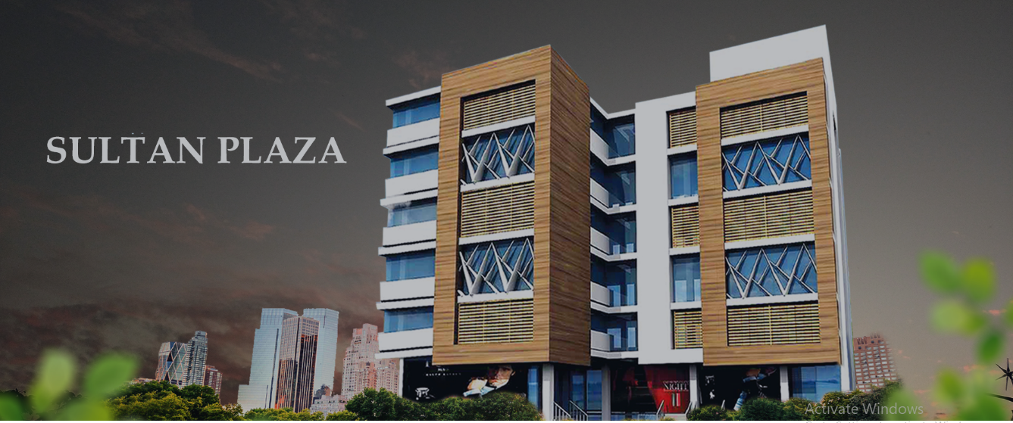

**Sultan Plaza**

**A place for your business and leisure**

Sultan Plaza is located at a prime location on DHA Phase-5 Expressway. It is developed with a vision and objective of delivering a truly unique venture. It is home to shops, boutiques, stores, and office workspaces. It is a sublime project by the Sultan Group of Companies for all sorts of businesses, investors, and retailers alike.

SULTAG MARKEING

Project Proposal

|  |
| --- |
|  |

**Property**

|  |  |  |  |
| --- | --- | --- | --- |
| Floor | Unit | Size |  |
|  |  |  |  |

**Payments**

|  |  |  |  |  |
| --- | --- | --- | --- | --- |
| Rate | Total Price (Size x Rate) |  | Remaining  70 % | Installment  4 |
|  |  |  |  |  |