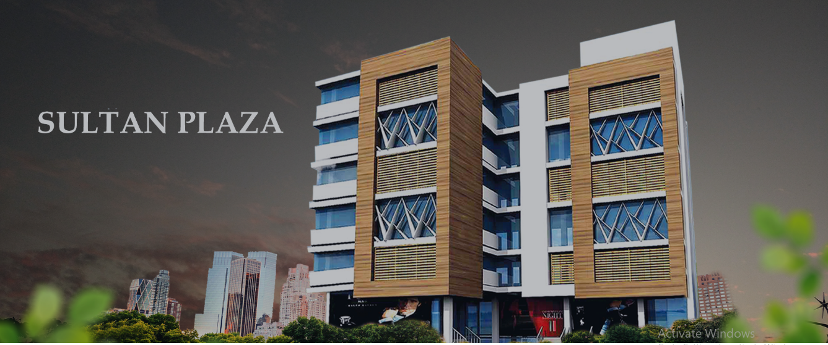

**Sultan Plaza**

**A place for your business and leisure**

Sultan Plaza is located at a prime location on DHA Phase-5 Expressway. It is developed with a vision and objective of delivering a truly unique venture. It is home to shops, boutiques, stores, and office workspaces. It is a sublime project by the Sultan Group of Companies for all sorts of businesses, investors, and retailers alike.

SULTAN MARKEING

PROJECT PROPOSAL

|  |
| --- |
|  |

**Client**

|  |
| --- |
| **Riaz ul Hassan** |
| **Rawalpindi , 0334-4132 940** |

**Product Information**

|  |  |
| --- | --- |
| **Project Name** | **Sultan Plaza** |
| **Product Plan** | **1 Year Installments – 30 % Downpayment  70% 4 x quarterly installment** |
| **Product Type** | **Installment** |
| **Product Code** | **SPZ-2G** |

**Unit Details**

|  |  |
| --- | --- |
| **Unit Type** | **Commercial Shop-2G** |
| **Floor** | **Ground** |
| **Sq ft.** | **228.00** |

**Payment Details**

|  |  |
| --- | --- |
| **Rate Sq ft. (Rs)** | **85,000/-** |
| **Total Amount** | **11,938,000/-** |
| **Down Payment (30 %)** | **1,3800,000/-** |
| **Quarterly installment  (4 installments)** | **435,000/-** |
| **Possession 0%** | **0/-** |