JuryRigged
Unified Text-First Courtroom Streaming UI Specification
Design direction based on the dark classic viewer + broadcast overlay concepts, adapted for a React asset and streaming-text experience.
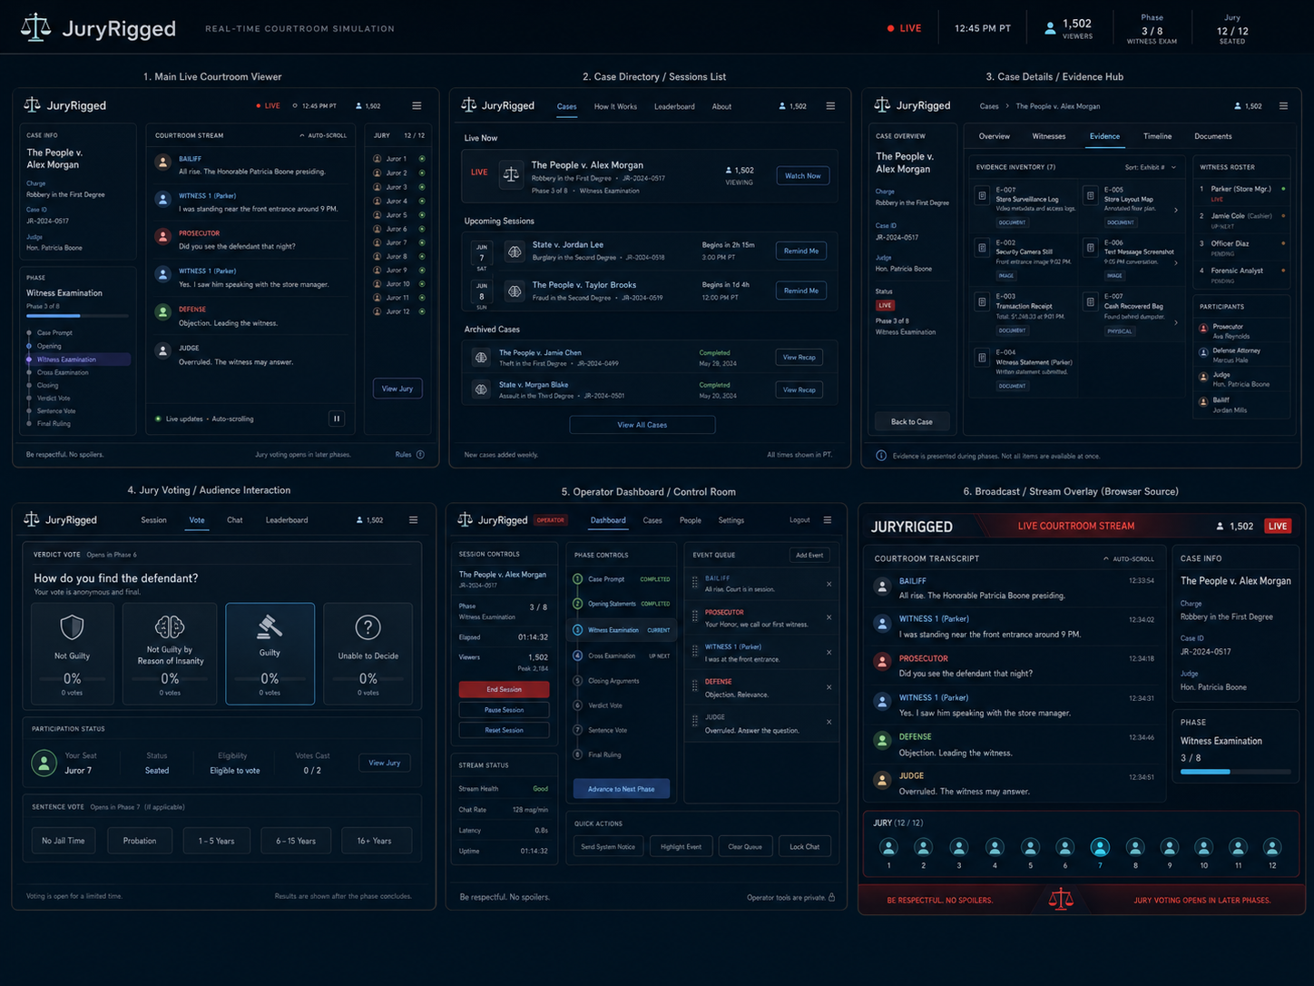

Product intent: JuryRigged is a real-time courtroom simulation where multi-agent roles stream testimony and procedural dialogue through SSE. The interface should feel like a live legal broadcast without relying on video: typography, transcript rhythm, evidence cards, juror state, phase progression, and lightweight React animations carry the drama.

1. Product Context
- Core experience: a live courtroom stream composed of agent dialogue, phase events, evidence presentation, audience actions, and jury voting.
- Primary constraint: no video feed. The UI must treat text, avatars, icons, cards, progress, and motion as the broadcast medium.
- Technical reality: backend streams live events via Server-Sent Events; React views consume the same event timeline across viewer, overlay, and operator pages.
- Visual goal: merge the restrained “Dark Classic” app shell with the sharper “Broadcast / Stream Overlay” treatment into one coherent site.
Design principles
Principle | Meaning in UI | Avoid
Text is the footage | Transcript is large, legible, paced, and visually differentiated by speaker role. | Tiny logs that feel like admin output only.
Broadcast confidence | Live badge, viewer count, phase state, and jury status are always visible. | Hiding session state behind menus.
Courtroom hierarchy | Judge, counsel, witness, evidence, and jury each have stable visual roles. | Generic chat app styling.
Operator and viewer share DNA | Public pages and private controls use the same components/tokens. | Two unrelated apps stitched together.
Motion with restraint | Typewriter, objections, evidence reveal, vote pulses, and phase transitions add energy. | Constant animation that harms readability.

2. Site Map / Page Set
Page | Route | Audience | Purpose
Main Live Courtroom Viewer | /sessions/:id | Public viewers | Primary app view for following the case, transcript, phase, and jury status.
Broadcast Overlay | /overlay/:id | OBS / stream output | High-contrast browser-source layout optimized for Twitch/recording.
Case Directory | /cases | Public viewers | Live, upcoming, and archived sessions with watch/recap actions.
Case Details / Evidence Hub | /cases/:id | Public viewers | Structured case file: overview, evidence inventory, witnesses, timeline, documents.
Jury Voting / Audience Interaction | /sessions/:id/vote | Authenticated or anonymous jurors | Vote UI, eligibility, current seat, and phase-gated actions.
Operator Dashboard | /operator | Private operators | Session controls, phase advancement, queue management, stream health.
How It Works | /about | Public viewers | Explains agents, phases, audience commands, voting, and moderation.
Replay / Recap | /sessions/:id/recap | Public viewers | Archived transcript, key evidence, verdict, timeline, and shareable summary.

3. Visual System
The unified visual language should be dark, cinematic, and structured: navy courtroom UI, electric cyan status accents, restrained crimson live/error states, and small bronze/gold legal motifs.
Token | Value | Usage
--bg | hsl(210 42% 7%) | App background / OBS canvas
--surface | hsl(212 38% 10%) | Panels and cards
--surface-2 | hsl(212 34% 14%) | Nested blocks and hover states
--border | hsl(205 28% 23%) | Panel strokes and dividers
--text | hsl(205 40% 92%) | Primary text
--muted | hsl(207 18% 64%) | Metadata, timestamps, secondary labels
--cyan | hsl(190 92% 58%) | Live stream accents, progress, selected juror
--purple | hsl(260 75% 62%) | Current phase selection and rare UI emphasis
--red | hsl(3 89% 59%) | Live badge, danger controls, objection events
--gold | hsl(38 68% 60%) | Judge/legal iconography and verdict motifs
--green | hsl(145 64% 50%) | Healthy connection, seated jurors, success states
Typography
- Display / brand: compact grotesk or square sans such as Space Grotesk, Sora, or Archivo for headings and nav.
- Transcript: Inter, Atkinson Hyperlegible, or IBM Plex Sans for high readability at stream sizes.
- Monospace accent: JetBrains Mono or IBM Plex Mono for event IDs, timestamps, routes, and operator panels.
- Recommended base sizes: 14px app body, 16-18px transcript, 11-12px metadata, 22-28px page titles.
Layout grid
- Desktop viewer: 12-column grid, 16px gutters, 24px outer margin, max-width 1440px.
- Primary shell: left case/phase rail, center transcript stream, right jury/evidence panel.
- Broadcast overlay: 16:9 canvas, transcript dominant, right case/phase stack, bottom jury strip.
- Mobile: collapse side panels into tabs; transcript remains the default landing surface.

4. Page-Level Specifications

4.1 Main Live Courtroom Viewer
Region | Content | Behavior
Top bar | Logo, live badge, clock, viewer count, phase count, jury seated count, menu | Sticky. In compact mode, collapse secondary metrics into a status popover.
Case rail | Case title, charge, case ID, judge, current phase, phase timeline | Current phase highlighted. Completed phases use subtle check state.
Courtroom stream | Text-first transcript cards grouped by speaker turn | Auto-scroll by default; pause when user scrolls upward; resume affordance appears.
Jury rail | Juror list or compact juror dots | Shows seated, active, voted, disconnected, or pending states.
Footer notice | Rules, phase hint, moderation warning | Persistent but low-height; red accent during voting/objection spikes.

4.2 Broadcast / Stream Overlay
Region | Content | Behavior
Header band | JURYRIGGED wordmark, LIVE COURTROOM STREAM, viewers, live badge | Designed for OBS browser source; high contrast and large type.
Transcript body | Large role-stamped dialogue rows | No scrollbars visible on stream; newest line can animate in with typewriter or slide/fade.
Right stack | Case info and phase progress | Always visible for context when viewers join mid-session.
Bottom jury strip | 12 juror avatars/dots and selected seat highlight | Pulse juror during vote. Can collapse during non-voting phases.
Bottom ticker | Rules, command hints, voting status | Short rotating messages only; no long prose.

4.3 Case Directory / Sessions List
- Sections: Live Now, Upcoming Sessions, Archived Cases.
- Cards show case title, charge, phase, scheduled time, viewer count, and primary action: Watch Now, Remind Me, or View Recap.
- Use status chips for LIVE, starting soon, completed, paused, replay.

4.4 Case Details / Evidence Hub
- Tabs: Overview, Witnesses, Evidence, Timeline, Documents.
- Evidence cards include exhibit ID, title, type, availability status, and whether it has been presented.
- Witness roster separates live, pending, used, and unavailable witnesses.
- Timeline mirrors emitted event taxonomy so recap pages can reuse it later.

4.5 Jury Voting / Audience Interaction
- Verdict vote options: Not Guilty, Not Guilty by Reason of Insanity, Guilty, Unable to Decide.
- Sentence vote options are hidden until verdict phase resolves and only show if applicable.
- Eligibility block shows seat, status, vote count, and remaining phase window.
- Phase-gated disabled states must explain why a vote is unavailable.

4.6 Operator Dashboard / Control Room
- Private admin surface for starting/ending sessions, pausing, muting, advancing phases, clearing queue, and sending system notices.
- Event queue should show speaker, payload excerpt, age, and dismiss/edit controls.
- Stream health card should show SSE status, chat rate, latency, uptime, and error warnings.
- Danger controls require confirmation: End Session, Reset Session, Lock Chat.

5. Component Inventory
Component | Props / Data | Notes
AppShell | variant, liveState, viewerCount, sessionStatus | Shared across public pages and operator.
TopStatusBar | caseTitle, phaseIndex, phaseName, jurySeated, liveClock | Responsive metric grouping.
TranscriptStream | events[], autoScroll, paused, replayMode | Virtualize long sessions; preserve event order.
DialogueTurn | role, speakerName, text, timestamp, directive | Role color strip, avatar, optional typewriter.
PhaseTimeline | phases[], currentPhase, completedPhases | Vertical in app; horizontal in detail pages.
JuryPanel | jurors[], selectedJuror, voteState | List on desktop, dot strip on overlay/mobile.
EvidenceCard | exhibitId, title, type, status, revealedAt | Supports locked, available, presented, challenged.
VoteCard | option, icon, percent, disabled, selected | Large enough for touch interaction.
OperatorQueue | events[], controls | Use monospace metadata and role colors.
Ticker | messages[], severity | OBS-safe rotating short messages.

6. Interaction + Motion Rules
Event | Recommended motion | Sound / visual note
New dialogue turn | 150-250ms fade/slide; optional typewriter for highlighted speaker only | Do not typewriter every historical line.
Objection | Red flash border on transcript card; brief shake on overlay title band | Respect reduced motion.
Evidence presented | Evidence card expands from right rail; exhibit ID badge pulses | Can pin latest exhibit for 10-20 seconds.
Phase advanced | Timeline node fills; center toast announces new phase | Operator event is logged.
Vote opened | Jury strip glows cyan; vote panel becomes primary CTA | Show countdown/progress.
Connection issue | Live dot shifts to warning; sticky reconnect banner | Never silently fail the stream.
Accessibility requirements
- All role colors require text labels; never communicate role by color alone.
- Transcript region should be an aria-live log with polite announcements and manual pause support.
- Support prefers-reduced-motion by disabling shakes, flashes, and typewriter effects.
- Use minimum 4.5:1 contrast for body text and 3:1 for large UI text.
- Voting controls need keyboard focus states, disabled explanations, and confirmation feedback.

7. React Implementation Notes
- Create a shared design package or /components/ui folder before building page-specific features.
- Normalize incoming SSE events into a single timeline store: session, phase, dialogue, evidence, jury, system.
- Use CSS variables for tokens so OBS overlay, viewer, and operator can share theme values while overriding density.
- Use virtualization for transcript history, but keep the latest 20-50 events fully mounted for animations.
- Route overlay through a dedicated layout variant with fixed 16:9 sizing and browser-source safe defaults.
- Persist user auto-scroll preference and replay speed in local storage.
Suggested file | Responsibility
src/styles/tokens.css | Color, radius, shadow, typography, z-index variables.
src/components/AppShell.tsx | Unified shell frame and top status bar.
src/components/TranscriptStream.tsx | Streaming log, auto-scroll, grouped turns.
src/components/PhaseTimeline.tsx | Current/completed phase visualization.
src/components/JuryPanel.tsx | Juror list, dots, voting status.
src/components/EvidenceCard.tsx | Evidence hub and presented exhibit UI.
src/routes/session-viewer.tsx | Main live viewer page.
src/routes/overlay.tsx | OBS browser-source page.
src/routes/operator.tsx | Control room dashboard.

8. Data / Event Mapping
Event family | UI destination | Example presentation
session.created / session.updated | Header, case rail, directory cards | Case title, charge, status, viewer count.
phase.changed | Phase timeline, header metric, operator log | New phase toast and completed node.
dialogue.turn | Transcript stream and broadcast overlay | Role-stamped message card.
evidence.presented | Evidence hub, right rail, overlay reveal | Exhibit card expands and pins.
jury.vote.opened / jury.vote.cast | Voting page, jury strip, status bar | Eligible controls and dot state changes.
moderation.notice | Footer ticker, toast, operator log | Short warning or rules reminder.
replay.tick | Replay page, viewer timeline | Playback badge and speed control.

9. MVP Build Checklist
- Implement tokens.css and global app shell.
- Build Main Live Courtroom Viewer with mocked event data.
- Build Broadcast Overlay as a variant of the same components.
- Add Case Directory and Case Details skeletons.
- Add Jury Voting flow with phase-gated disabled states.
- Add Operator Dashboard with non-destructive controls first.
- Wire SSE timeline store and replace mocks incrementally.
- Add replay fixture mode for deterministic visual testing.
- Test in OBS browser source at 1920x1080 and 1280x720.
- Run accessibility pass for keyboard, color contrast, reduced motion, and screen reader transcript behavior.

