STUDENT TECHNICAL REPORT / SUBMISSION RECORD
Assignment 2 - Real-Time Data Processing with Pandas and NumPy
AITU Smart Classroom Energy Stream
This report records the implementation and evidence for the supplied synthetic classroom sensor stream. The calculations, plots, and test results referenced below are generated from the submitted project files.

1. Student and Submission Information
Required field | Student entry
Student full name | Amankos Danial Dauletuly
Student ID | 240260
Group / cohort | BDA-2405
Instructor | Serek Azamat
Submission date | 21.09.2026
Individual variant / task code | Not provided in the assignment file
Git repository / project link | Add after GitHub upload
Python / tool versions | Python 3.10.11; pandas 2.3.3; NumPy 2.3.3; Matplotlib 3.10.6; pytest 8.4.2

2. Work Record
Item | Student entry
Work start date | 21 September 2026
Work completion date | 21 September 2026
Main libraries / technologies | Python, Pandas, NumPy, Matplotlib, pytest
Source files / notebook | main.py
Test / experiment files | test_assignment2.py; evidence/calculation_check.json
Final repository commit/version | Add after GitHub upload

3. Report Structure

2.1 Data Quality and Cleaning
The raw sensor data contains three missing readings: temperature at 10:02, CO2 at 10:04, and occupancy at 10:07. I used the cleaning methods specified in the assignment. Temperature and CO2 are linearly interpolated, while occupancy is forward-filled.
Variable | Missing at | Method | Cleaned value | Reason
Temp_C | 10:02 | Linear interpolation | 21.9 | Between 21.7 and 22.1
CO2_ppm | 10:04 | Linear interpolation | 750 | Between 720 and 780 ppm
Occupancy | 10:07 | Forward fill | 29 | Most recent known occupancy
Required evidence | Student response / reference
Technical explanation | Required cleaning methods are applied only to the three columns with missing sensor values.
Code / file / function reference | main.py - missing_value_summary(), clean_data(), validate_cleaned_data()
Result / calculation / experiment evidence | cleaned_classroom_data.csv; evidence/main_output.txt
Student-specific decision or observation | After forward fill, Occupancy is converted back to integer because people are counted as whole values.

2.2 Streaming Window Statistics
I used a 3-row rolling window for temperature, CO2, and power. Since the data arrives once per minute, each complete window represents three consecutive minutes. The calculation uses min_periods=3, so rolling values begin at 10:02 when the first complete three-reading window exists.
Time | Temp mean | CO2 mean | Power mean
10:02 | 21.700 | 653.333 | 3.367
10:03 | 21.900 | 686.667 | 3.567
10:04 | 22.100 | 720.000 | 3.767
10:05 | 22.300 | 750.000 | 4.000
10:06 | 22.467 | 780.000 | 4.200
Required evidence | Student response / reference
Technical explanation | Each rolling value is the mean of the current row and previous two cleaned readings.
Code / file / function reference | main.py - add_rolling_statistics()
Result / calculation / experiment evidence | processed_classroom_data.csv; completed_tables.md; evidence/main_output.txt
Student-specific decision or observation | I require all three readings before reporting a rolling value instead of producing partial-window means.

2.3 Feature Engineering
Three required features are added after cleaning. Occupancy density measures the share of the 40-person room capacity in use. Energy per student normalizes power by occupancy. The comfort flag checks the assignment limits for CO2 and temperature.
Feature | Formula
occupancy_density | Occupancy / 40
energy_per_student | Power_kW / Occupancy
comfort_flag | CO2_ppm <= 1000 and 20 <= Temp_C <= 24
Time | Density | Energy/student | Comfort
10:03 | 0.600 | 0.1583 | True
10:06 | 0.725 | 0.1517 | True
10:09 | 0.825 | 0.1545 | True
10:11 | 0.925 | 0.1541 | True
Required evidence | Student response / reference
Technical explanation | The features convert raw sensor values into measures that are easier to interpret operationally.
Code / file / function reference | main.py - add_features()
Result / calculation / experiment evidence | processed_classroom_data.csv; completed_tables.md
Student-specific decision or observation | The comfort limits are inclusive, so exactly 24 C and 1000 ppm still count as comfortable.

2.4 Statistical Analysis
The statistical summary is calculated from the cleaned data. The highest-power time is selected with idxmax(), and Pearson correlation is calculated between occupancy and power.
Metric | Result
Temperature mean | 22.4833 C
Temperature median | 22.55 C
Temperature minimum | 21.5 C
Temperature maximum | 23.3 C
CO2 mean | 789.1667 ppm
CO2 maximum | 950 ppm
Highest power | 10:11 - 5.7 kW
Occupancy-power correlation | 0.9946
The correlation is very strong and positive in this synthetic sample. Higher occupancy is associated with higher power consumption. This is an association, not proof that occupancy alone causes the increase.
Required evidence | Student response / reference
Technical explanation | Pandas summary operations are used for central tendency, range, maximum-power selection, and correlation.
Code / file / function reference | main.py - calculate_statistics()
Result / calculation / experiment evidence | evidence/main_output.txt; evidence/calculation_check.json
Student-specific decision or observation | I report correlation as an association rather than a causal conclusion.

2.5 Visualization and Engineering Interpretation
The first plot shows the 3-minute rolling temperature and CO2 trends over time. The second plot compares occupancy and power, with a fitted line to make the relationship easier to see.
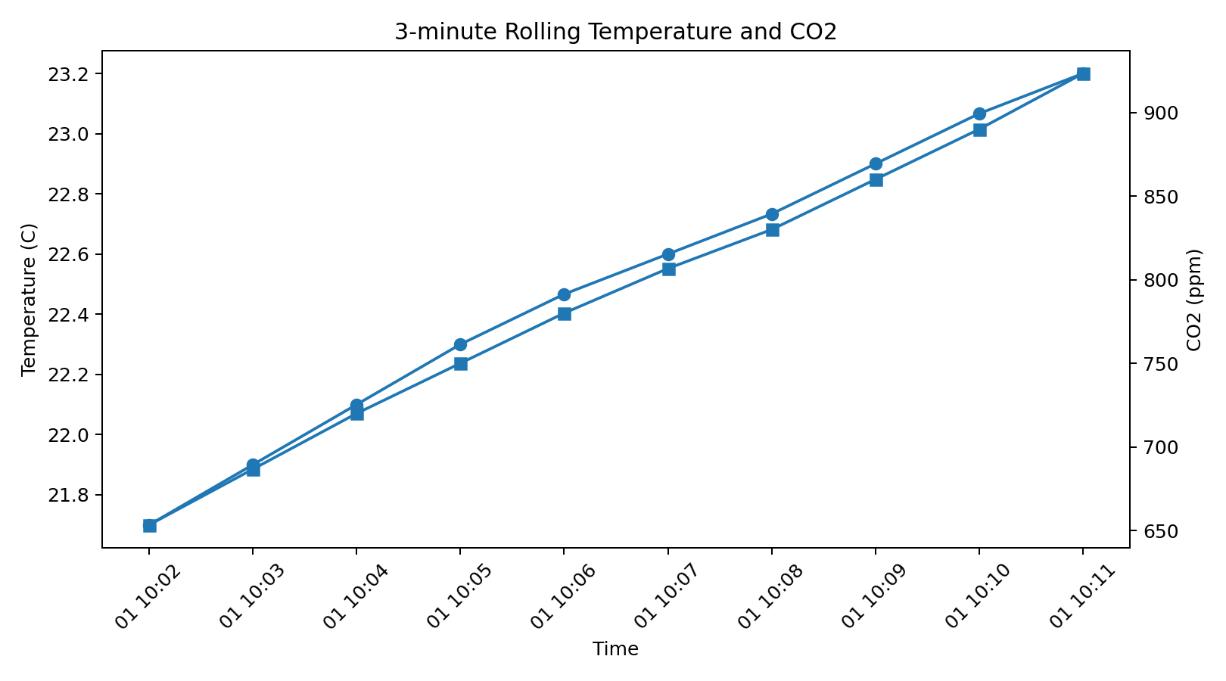
Figure 1. 3-minute rolling temperature and CO2.
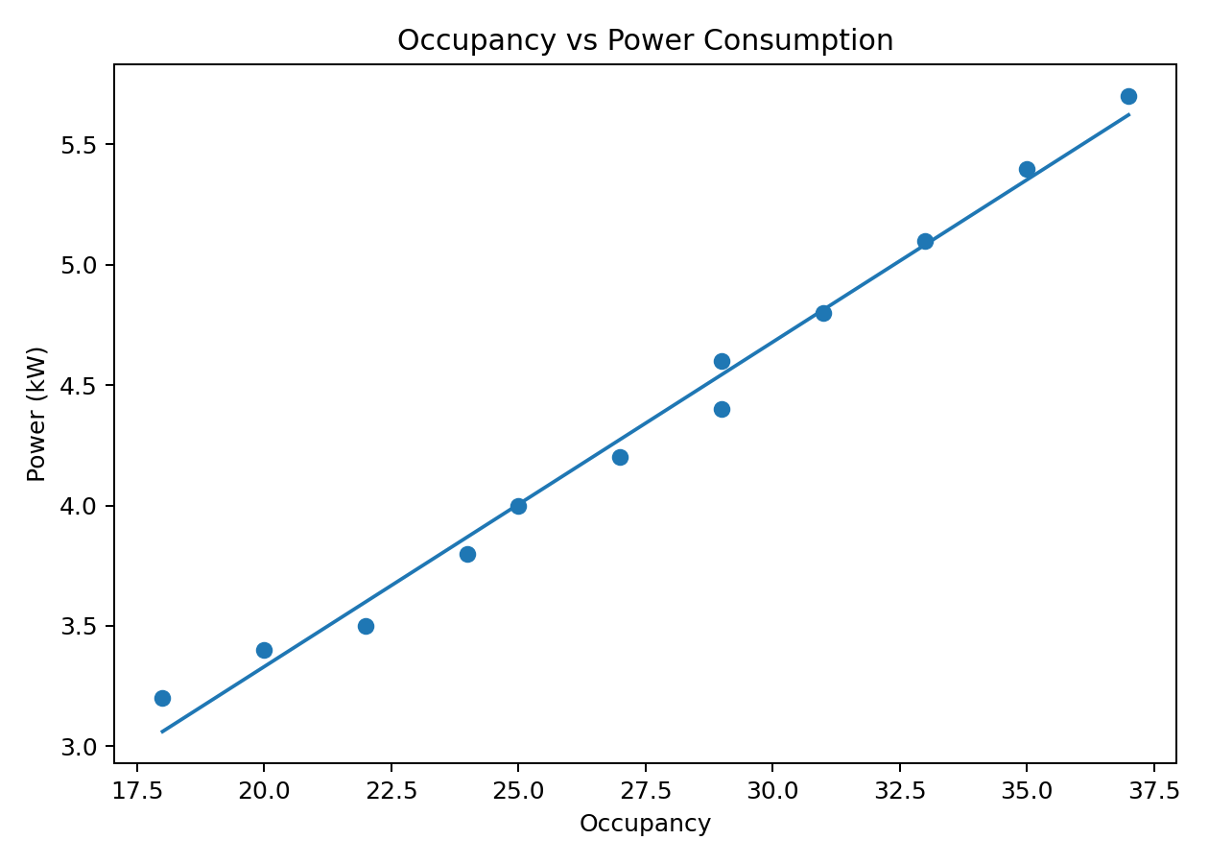
Figure 2. Occupancy versus power consumption.
Operational insight 1: Occupancy and power rise closely together. Occupancy-aware schedules or controls could help reduce energy use when a room is lightly occupied or empty.
Operational insight 2: Rolling temperature and CO2 rise through the class period. Facility staff could monitor the trend as an early signal to review ventilation or room-control settings.
Required evidence | Student response / reference
Technical explanation | The plots show time-based environmental change and the occupancy-power relationship.
Code / file / function reference | main.py - create_plots()
Result / calculation / experiment evidence | plots/rolling_temperature_co2.png; plots/occupancy_vs_power.png
Student-specific decision or observation | The rolling plot uses separate y-axes because temperature and CO2 have very different numerical scales.

2.6 Technical Reflection
A key processing decision was to use the exact missing-value methods specified in the task and to delay rolling statistics until a full three-reading window is available. One limitation is that the dataset contains only one room and twelve minutes, so the observed correlation should not be generalized to real AITU buildings. A realistic improvement would be to process multiple rooms over longer periods and compare patterns by room, time of day, and occupancy level.
Required evidence | Student response / reference
Technical explanation | Cleaning is completed before rolling and feature calculations so later results are based on a consistent dataset.
Code / file / function reference | main.py - main() processing order
Result / calculation / experiment evidence | cleaned_classroom_data.csv; processed_classroom_data.csv
Student-specific decision or observation | The current sample is useful for demonstrating the pipeline, but too small for broad operational conclusions.

4. Individual Work and Anti-Plagiarism Record
Individual evidence | Student entry
My unique technical/design decision | I use min_periods=3 so rolling statistics appear only after a complete three-minute window is available.
My own test/experiment | A boundary test checks that Temp_C = 24.0 and CO2_ppm = 1000 still produce comfort_flag = True.
Problem/bug I personally encountered and solved | After reading the CSV, Occupancy becomes float because the column contains a missing value. After forward fill, I convert it back to int so occupancy remains a whole-person count.
Exact code/repository/commit reference | main.py - clean_data(), add_rolling_statistics(), add_features(), calculate_statistics(), create_plots(); test_assignment2.py
One limitation of my implementation | The dataset contains only one room and twelve minutes of synthetic readings.
One improvement I propose | Extend the same pipeline to multiple rooms and longer streams, then compare room-level trends and alerts.

5. Evidence and Submission Checklist
☒ Technical report completed
☒ Source code submitted
☒ Required tables and calculations completed
☒ Required plots included
☒ Execution logs and reproducible calculation evidence included
☒ README and run instructions included
☒ Data files included
☒ Analytical results included
☐ Oral defense / demonstration completed

6. Student Declaration of Originality
I confirm that this submission represents my own work. I have not copied another student's source code, calculations, tables, architecture, plots, screenshots, logs, results, or written explanations. Any external material or reused code has been identified. I understand that the instructor may request a live demonstration, code modification, reproduction of calculations, or explanation of any submitted component.
Role | Name | Signature | Date
Student / Executor | Amankos Danial Dauletuly |  | 21.09.2026

Appendix - Reproducible Evidence
The following artifacts are included in the submission folder:
evidence/main_output.txt - cleaning, rolling, feature, analysis, and interpretation output
evidence/pytest_output.txt - automated test result
evidence/calculation_check.json - selected numeric checks
cleaned_classroom_data.csv - cleaned source fields
processed_classroom_data.csv - rolling statistics and engineered features
plots/rolling_temperature_co2.png - required rolling plot
plots/occupancy_vs_power.png - required occupancy-power plot

