TurnTable
Software Engineering Specification
Shared household coordination, responsibility rotation, expense settlement, and insight analytics

Architecture direction
API-first modular monolith with independently deployable backend API and worker, plus web and mobile clients. Source code lives in one monorepo to preserve shared contracts, tooling, and release discipline without coupling deployments.

Document field | Value
Status | Implementation-ready baseline
Version | 1.0
Technology verification date | 8 August 2026
Working product name | TurnTable (name/domain/trademark availability not validated)
Primary audience | Backend, web, mobile, QA, DevOps / platform engineers
Primary architecture | Modular monolith + asynchronous worker

Core product promise: answer two recurring shared-living questions reliably — “Whose turn is it?” and “Who owes whom?” — then surface trends that make household coordination easier and more transparent.

Engineering decision summary
Decision | Recommendation | Why
Backend separation | Yes: standalone REST API | Mobile and web consume the same business API; enables future clients and integrations.
Repository strategy | One pnpm/Turborepo monorepo; separate deployables | Avoid duplicated types/config while keeping runtime boundaries clean.
Backend architecture | Modular monolith | Simpler transactions and operations than microservices; clear module boundaries allow later extraction.
API style | REST + OpenAPI 3.1 | Stable tooling, generated clients, good cache/debug behavior. OpenAPI 3.2 is newer but 3.1 is the compatibility baseline.
Database | PostgreSQL 18 | Strong relational/transactional fit for assignments, expenses, and settlements.
Async work | Redis + BullMQ worker | Delayed reminders, retries, outbox processing, scheduled rollups.
Auth | Managed OIDC; Auth0 as reference | Do not build password/authentication infrastructure. Use OAuth/OIDC and PKCE.
Mobile | Expo SDK 57 / React Native 0.86 | Current Expo/RN baseline; production development builds for push notifications.
Web | Next.js 16.3 | Modern React web stack; keep business logic in shared API.
Observability | OpenTelemetry + error tracking | Vendor-neutral traces/metrics with production error diagnostics.

Contents
- 1. Product scope and requirements
- 2. Architecture and system boundaries
- 3. Technology baseline
- 4. Repository and module design
- 5. Domain model and business rules
- 6. API contract
- 7. Scheduling, swaps, and notifications
- 8. Expense and settlement engine
- 9. Analytics and visualization specification
- 10. Security and privacy
- 11. Testing strategy
- 12. CI/CD and environments
- 13. Observability and operations
- 14. Delivery phases and Definition of Done
- 15. Risks and future evolution
- Appendices: bootstrap, environment variables, source standards

Guiding principles
- Correctness before cleverness: task assignment and money movement are transactional business logic.
- API-first: clients never depend on database schema or backend implementation details.
- Explainable analytics: deterministic metrics and insight rules before any generative-AI narrative layer.
- Do not start with microservices. Extract a service only after an independently scaling or ownership boundary is demonstrated.
- Prefer managed infrastructure for undifferentiated concerns: authentication, databases, Redis, push routing, secrets, backups.
- UTC internally, IANA time zone at the household boundary; all recurrence behavior must be DST-safe.
- Store money as integer minor units and a currency code; never use binary floating point for financial amounts.

1. Product scope and requirements

1.1 Product definition
TurnTable is a shared-household operating app for roommates. It manages recurring responsibilities (cooking, cleaning, groceries, trash, bills), flexible turn swaps/covers, reminders, shared expenses, settlements, and analytics that explain workload and spending patterns.

1.2 Primary user journeys
1. Create a household, choose time zone/default currency, and invite roommates.
2. Create a recurring responsibility, define rotation members, schedule, and reminders.
3. See today’s assignment, mark it complete, request a swap, or ask another member to cover.
4. Add a shared expense, specify payer and split method, and immediately update balances.
5. Record a settlement and reduce net outstanding balances.
6. Open dashboards to see spending trends, category mix, member contributions, completion reliability, swaps, and workload balance.

1.3 MVP functional scope
Capability | MVP behavior | Phase 2+
Households | Create/join/invite; owner/member roles; default currency/time zone | Multiple household profiles, richer permissions
Responsibilities | Recurring and one-off tasks; round-robin/fixed assignment | Weighted rotation, dependency tasks, templates
Swaps/covers | Request, accept, decline, cancel; history | Open marketplace-style coverage, favor credits
Away periods | Exclude absent members from eligible generated occurrences | Configurable catch-up/fairness policies
Notifications | Push reminders and swap/expense events; preferences | Email/SMS fallback, adaptive reminders
Expenses | Equal/exact/percentage/share splits; categories; notes | Receipt OCR, recurring bills, multi-currency
Balances | Net household balances; suggested minimal transfers; settlements | Payment-provider deep links
Analytics | Expense and responsibility dashboards + rule-based insights | Budgets, forecasts, anomaly detection
Activity | Household activity stream for important mutations | Comments/reactions

1.4 Explicit non-goals for v1
- No banking, card, Venmo, or payment custody integration.
- No general household chat platform.
- No AI requirement for core scheduling or expense correctness.
- No microservices, Kafka, Kubernetes, event sourcing, or CQRS unless demonstrated scale justifies them.
- No cross-currency debt netting in MVP.

1.5 Non-functional targets
Area | Target / requirement
API latency | Typical authenticated read/write p95 < 300 ms excluding third-party identity/push latency under expected MVP load.
Consistency | ACID transactions for swaps, expense creation/editing, settlements, and invitation acceptance.
Reminder timing | Enqueue/send attempt within ±2 minutes of configured reminder time; deduplicate retries.
Availability | Design for stateless API horizontal scaling; managed database/Redis with backups.
Accessibility | Web target WCAG 2.2 AA; mobile controls labeled and usable with platform accessibility services.
Time correctness | All timestamps stored UTC; recurrence evaluated in household IANA time zone with DST tests.
Privacy | Collect minimum profile data; support export/deletion workflow; redact tokens and sensitive data from logs.
Auditability | Financial and assignment mutations emit immutable activity/audit events.

2. Architecture and system boundaries

2.1 Recommended shape
Recommendation
Keep the backend independently deployable and client-agnostic, exactly as proposed. The improvement is organizational: use one monorepo for API, worker, web, mobile, generated clients, and shared engineering configuration. This is not a “monolithic app”; it is a monorepo containing separately deployed applications.

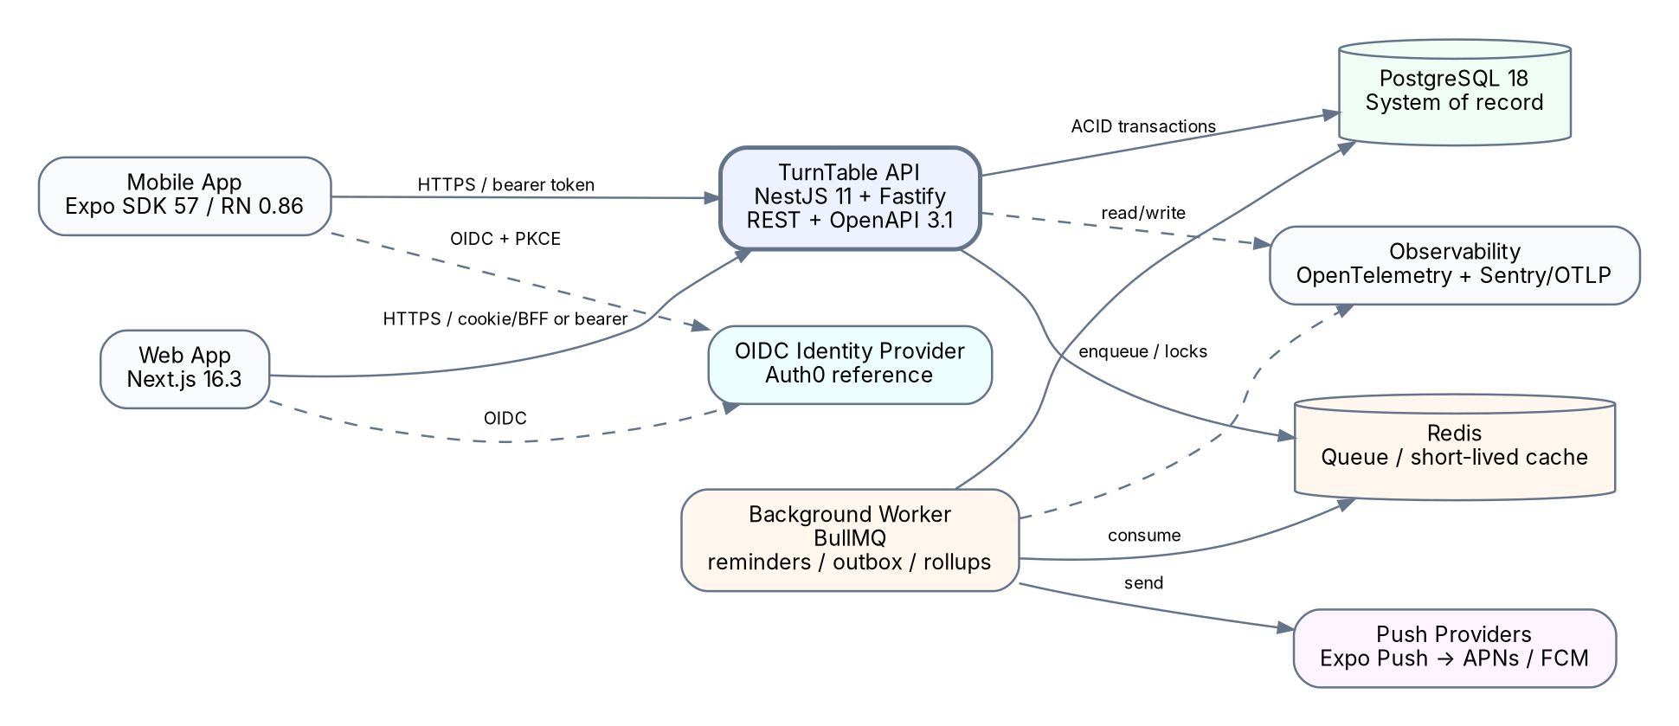
Figure 1. Target system architecture. Business state stays in PostgreSQL; reminders and asynchronous work run through a separate worker.

2.2 Why a modular monolith
- Household membership, task assignment, swaps, expenses, and settlements frequently cross domain boundaries and benefit from one ACID database transaction.
- Microservices would add distributed transactions, duplicated auth/telemetry, queue semantics, deployment coordination, and network failure modes before the product has scale evidence.
- NestJS modules provide explicit internal boundaries. If a module later needs independent scaling, isolate its public interface first, then extract it behind the same API/event contract.

2.3 Runtime components
Component | Responsibility | Scaling model
API | Synchronous business commands/queries, authz, OpenAPI | Stateless horizontal replicas
Worker | Delayed jobs, reminders, transactional-outbox dispatch, analytics rollups | Independent worker replicas; concurrency by queue
PostgreSQL | Authoritative relational state and transactions | Managed primary + backups/read replica later
Redis | BullMQ storage, short-lived locks/cache, rate-limit counters | Managed Redis; not source of truth
Web | Next.js UI; optional thin BFF/session boundary | CDN/serverless or Node runtime
Mobile | Expo/React Native iOS and Android app | App stores / EAS build pipeline
OIDC provider | Authentication, social login/passkeys/MFA as configured | Managed external service
Push provider | Device notification routing | Expo Push initially; adapter allows direct APNs/FCM later

2.4 API boundary rules
- Clients consume only documented API contracts; they never share ORM models or database entities.
- Generate the TypeScript API client from the checked OpenAPI document in CI. Generated code is versioned as a workspace package or generated during builds.
- Use `/v1` path versioning, cursor pagination, RFC 9457-style problem responses, ISO/RFC 3339 timestamps, and idempotency keys on retry-sensitive commands.
- Do not expose internal identifiers as authorization. Every household-owned object query must include membership authorization at the service/repository boundary.

3. Technology baseline (verified 8 August 2026)
Layer | Baseline | Engineering note
Runtime | Node.js 24 LTS | Use LTS in production. Node 26 is Current and does not enter LTS until October 2026.
Language | TypeScript, strict mode | Pin a stable version compatible with NestJS/Next.js; `strict`, no implicit any, exact optional semantics where practical.
Package/workspace | pnpm 11 + Turborepo | pnpm 12 is beta; do not use beta tooling for the production baseline.
Backend | NestJS 11 + Fastify adapter | Strong modular structure; latest LTS Node recommended by Nest.
API contract | REST + OpenAPI 3.1 | 3.2 is newer; 3.1 selected until the complete generator/validator/tool chain is proven with 3.2.
Database | PostgreSQL 18.x | Current supported PostgreSQL major; use managed service in production.
ORM/migrations | Prisma ORM 7 GA | Type-safe queries and migrations. Use GA features only; driver adapter is required for direct DB connections.
Queue | Redis + BullMQ | Delayed/retryable background jobs; Redis remains replaceable infrastructure, not business state.
Web | Next.js 16.3 + React | App Router; keep domain logic in API, not duplicated in server actions.
Mobile | Expo SDK 57 + React Native 0.86 | Use development/production builds; Expo Go is not the production push-notification environment.
Web E2E | Playwright | Cross-browser Chromium/WebKit/Firefox coverage.
Mobile E2E | Maestro via EAS Workflows | Supported Expo E2E workflow; track flakes and regressions.
Integration tests | Testcontainers for Node.js | Run tests against real PostgreSQL/Redis containers, not in-memory substitutes.
Observability | OpenTelemetry + OTLP exporter + Sentry-compatible error tracking | Vendor-neutral traces/metrics; correlate logs with trace/request IDs.
CI/CD | GitHub Actions + CodeQL + dependency review | Required PR checks; protected deployment environments.
Containers | Docker multi-stage builds | Non-root runtime images, pinned bases, health checks, SBOM/container scan.

3.1 Dependency policy
- Pin major versions and commit `pnpm-lock.yaml`; automated update PRs only after CI passes.
- Prefer GA/stable features. Preview/early-access dependencies require an explicit ADR and rollback plan.
- Enable pnpm supply-chain controls such as delayed acceptance/minimum release age where compatible with release workflow.
- Quarterly dependency/platform upgrade window; immediate security patching for high/critical advisories.

4. Repository and backend module design

4.1 Monorepo layout
turntable/
apps/
api/ # NestJS HTTP API
worker/ # NestJS standalone/BullMQ worker
web/ # Next.js application
mobile/ # Expo / React Native application
packages/
api-client/ # generated from OpenAPI; no handwritten domain logic
contracts/ # tiny cross-client enums/constants only when stable
eslint-config/
tsconfig/
observability/ # shared OTel bootstrap helpers
test-utils/
infra/
docker/
terraform/ # or OpenTofu modules when production infra is formalized
docs/
adr/
api/
runbooks/
.github/workflows/

Important boundary
Do not create a large “shared” package containing backend domain entities and client models. That silently couples every client to server internals. Share generated API DTO/types, design tokens, and truly universal utilities only.

4.2 Backend modules
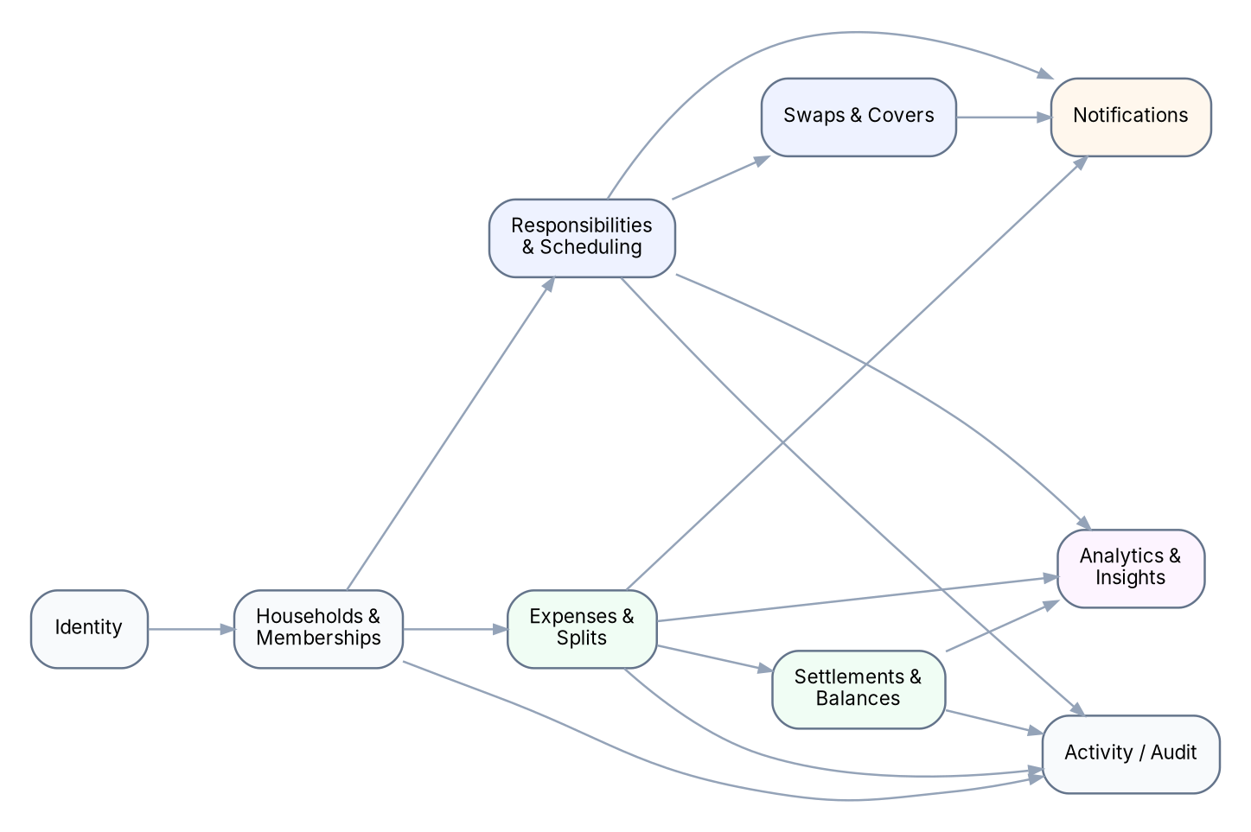
Figure 2. Recommended internal modular-monolith boundaries. Arrows indicate permitted high-level dependencies, not database foreign keys.
Module | Owns | Public services/events
Identity | local user projection, external subject mapping | resolveCurrentUser
Households | households, memberships, invitations, roles | membership checks; HouseholdCreated/MemberJoined
Responsibilities | tasks, rotations, occurrences, completion | schedule/query/complete occurrence
Swaps | swap/cover requests and assignment changes | request/accept/decline/cancel
Expenses | expenses, split validation, categories | create/update/archive expense
Settlements | settlement records, balance query/simplification | record settlement; compute balances
Notifications | preferences, device tokens, notification intent | enqueue notification intent
Analytics | aggregate queries, cache/rollups, insight rules | dashboard DTOs
Activity | append-only household activity entries | recordActivity

4.3 Layering inside each module
module/
api/ # controllers, request/response DTOs, guards
application/ # use cases / orchestration / transactions
domain/ # invariants, value objects, pure algorithms
infra/ # Prisma repositories, external provider adapters
tests/

- Controllers remain thin: validate/authorize/dispatch; no ORM calls directly from controllers.
- Domain algorithms (split arithmetic, balance simplification, rotation selection) are pure and exhaustively unit tested.
- Application services define transaction boundaries and emit outbox/activity records in the same database transaction.

5. Domain model and business rules
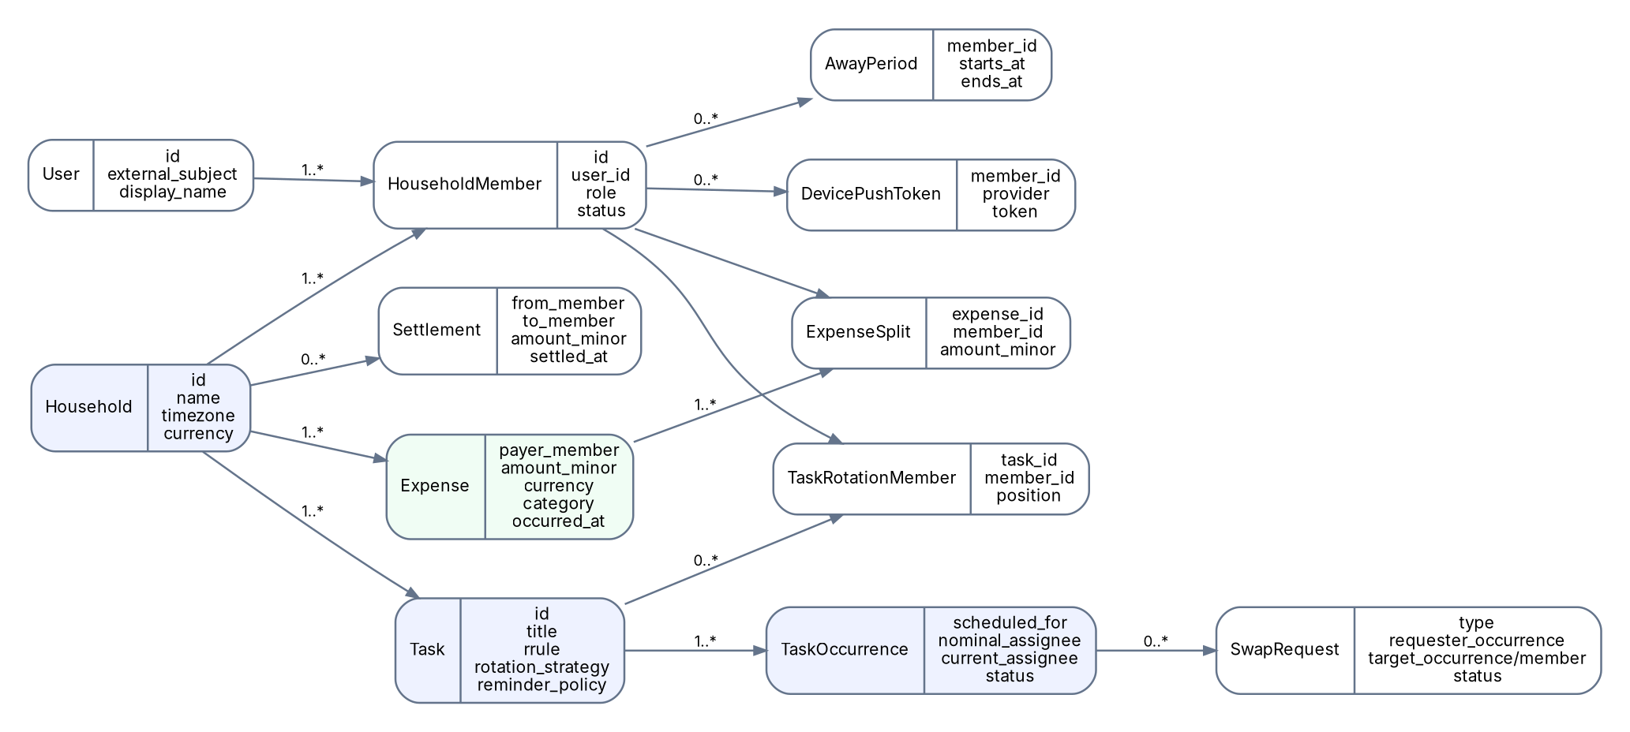
Figure 3. Core domain entities. The physical schema may add indexes, version columns, audit fields, and outbox records.

5.1 Global data conventions
Convention | Rule
IDs | Use UUID primary keys. Never treat unpredictability of an ID as an authorization control.
Audit columns | `created_at`, `updated_at`; add `created_by_member_id` where authorship matters.
Time | `timestamptz` in PostgreSQL; evaluate schedules in `household.timezone` (IANA identifier).
Money | `amount_minor BIGINT` + ISO 4217 `currency CHAR(3)`; household is single-currency in MVP.
Deletion | Prefer status/archive for financial/activity records; hard-delete transient tokens and privacy-requested personal projections where legally/operationally appropriate.
Concurrency | `version`/optimistic checks for normal edits; row locks/serializable transaction where accepting swaps or settling balances can race.

5.2 Responsibility model
A Task is the recurrence definition. A TaskOccurrence is the concrete responsibility on a specific date/time. This distinction is mandatory: swaps modify occurrences, not the recurring task definition.
Entity | Key fields / behavior
Task | household_id, title, description, recurrence_rule, timezone, assignment_strategy, due-time policy, reminder policy, weight
TaskRotationMember | ordered eligible members; active_from/active_until supports membership changes
TaskOccurrence | task_id, scheduled_for, nominal_assignee, current_assignee, status, completed_by, completed_at
AwayPeriod | member start/end; occurrence generator excludes ineligible members using defined away policy
SwapRequest | SWAP or COVER; source occurrence; target member/occurrence; state; expiration; request message

5.3 Rotation algorithm (MVP)
1. Expand recurrence in the household time zone for a rolling horizon (for example, the next 60 days).
2. For round-robin tasks, maintain deterministic ordered rotation membership and a cursor derived from prior nominal assignments.
3. Before assignment, filter members inactive or away at that occurrence time.
4. Assign the next eligible member. Persist both nominal and current assignee so swaps/covers preserve the base schedule history.
5. Swaps/covers never rewrite future occurrences unless the user explicitly edits the task rotation.
6. Extend the horizon daily and regenerate only missing future occurrences; never silently overwrite user-modified occurrences.
DST requirement
A task configured for “7:00 PM America/New_York” remains at 7:00 PM local wall-clock time across daylight-saving transitions. Do not model recurring local schedules as a fixed UTC interval.

5.4 Task lifecycle
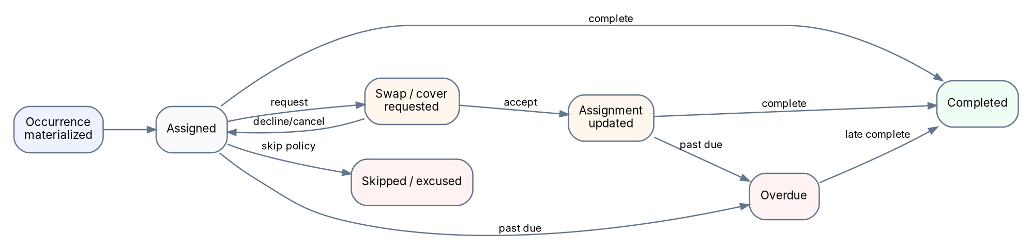
Figure 4. Task occurrence and swap lifecycle. Accepting a swap is a transactional state change with idempotency/concurrency protection.

5.5 Expense model
- One expense has exactly one payer in MVP, an amount, category, date, and one or more splits.
- Split rows must sum exactly to the expense amount in minor units. Equal splits distribute the remainder deterministically so cents are never lost.
- Supported split modes: equal, exact amount, percentage, and shares. Convert all modes to persisted exact minor-unit split rows at creation time.
- Editing a financial record emits an activity/audit event containing old/new metadata; do not rely on application logs as the audit trail.

5.6 Balance semantics
member_net = shared_amounts_paid
- shared_amounts_allocated_to_member
+ settlements_paid_to_others
- settlements_received_from_others
Positive net -> household owes this member.
Negative net -> this member owes the household.

Suggested transfers are derived from member net balances using a deterministic debtor/creditor matching algorithm. Suggestions are not themselves persisted debt; recorded settlements are persisted facts.

6. REST API contract

6.1 Protocol conventions
Concern | Convention
Base | `/v1`
Auth | OIDC access token for mobile/API clients; web may use a thin BFF/session boundary.
Content | JSON UTF-8; explicit content types.
Errors | Problem-details envelope with stable application error codes and request/trace ID.
Pagination | Cursor based: `?after=<opaque>&limit=50`; return `next_cursor`.
Filtering | Explicit documented query parameters; reject unknown filters for sensitive endpoints.
Idempotency | `Idempotency-Key` for create-expense, create-settlement, accept-swap and other retry-sensitive commands.
Concurrency | ETag/version or explicit `version` field for mutable resources where lost updates matter.
Dates | RFC 3339 strings; date-only fields documented as local calendar dates.
Money | integer minor units in API plus ISO currency; clients format for display.

6.2 Endpoint inventory
Area | Representative endpoints
Me | GET `/v1/me`; PATCH `/v1/me`; POST `/v1/me/push-tokens`; DELETE push token
Households | POST/GET `/v1/households`; GET/PATCH `/households/{id}`; membership/invite endpoints
Tasks | POST/GET/PATCH `/households/{id}/tasks`; GET `/task-occurrences?from=&to=`; POST occurrence complete/reopen
Swaps | POST `/occurrences/{id}/swap-requests`; POST `/swap-requests/{id}/accept|decline|cancel`
Availability | POST/GET/DELETE `/households/{id}/away-periods`
Expenses | POST/GET `/households/{id}/expenses`; GET/PATCH/DELETE `/expenses/{id}`
Balances | GET `/households/{id}/balances`; GET `/households/{id}/settlement-suggestions`; POST `/settlements`
Analytics | GET `/households/{id}/analytics/overview|expenses|responsibilities` with date range
Activity | GET `/households/{id}/activity`
Notifications | GET/PATCH notification preferences

6.3 Example: create expense
POST /v1/households/{householdId}/expenses
Idempotency-Key: 01J...opaque...
{
"description": "Costco groceries",
"amount_minor": 9000,
"currency": "USD",
"payer_member_id": "...",
"category": "GROCERIES",
"occurred_at": "2026-08-08T18:30:00-04:00",
"split": {
"mode": "EQUAL",
"member_ids": ["...", "...", "..."]
}
}

201 Created
{
"id": "...",
"amount_minor": 9000,
"currency": "USD",
"splits": [
{"member_id": "A", "amount_minor": 3000},
{"member_id": "B", "amount_minor": 3000},
{"member_id": "C", "amount_minor": 3000}
],
"created_at": "2026-08-08T22:30:01Z"
}

6.4 OpenAPI discipline
- OpenAPI document is produced in CI and diffed on pull requests; breaking changes require explicit review.
- Generate clients from the API contract; clients should not hand-maintain duplicate response interfaces.
- Contract tests validate that generated schema examples and representative endpoints agree with runtime behavior.
- Adopt OpenAPI 3.2 only after Nest/OpenAPI generation, validators, documentation UI, and client generator all pass a compatibility spike.

7. Scheduling, swaps, and notifications

7.1 Background job model
The HTTP API writes authoritative state and an outbox/event row in the same PostgreSQL transaction. A worker publishes/executes asynchronous side effects. This prevents “database committed but notification was never queued” failure windows.
API transaction:
1. validate authorization + invariant
2. mutate business tables
3. insert activity_event
4. insert outbox_event
COMMIT
Worker:
5. claim outbox_event idempotently
6. enqueue/send push notification
7. record delivery attempt/result
8. retry transient failures with backoff

7.2 Reminder scheduling
- Materialize occurrences ahead of time, then schedule reminder jobs referencing occurrence IDs rather than embedding mutable task details.
- At execution time, re-read the occurrence and current assignee. If it was swapped, completed, canceled, or rescheduled, suppress or recalculate the notification.
- Use a deterministic deduplication key such as `occurrence:{id}:reminder:{offset}`.
- Store per-user quiet hours and notification preferences. Critical swap acceptance/decline can bypass normal informational digest settings but not OS-level permissions.

7.3 Push implementation
Start with Expo Push for mobile routing. Keep a `PushProvider` interface so the worker can migrate high-volume traffic to direct APNs/FCM without changing business modules. Expo documentation notes that remote push notification testing requires a development build rather than relying on Expo Go on Android.

7.4 Swap acceptance transaction
1. Lock/read the swap request and relevant occurrence rows.
2. Verify request is still PENDING, target membership is active, and occurrences remain eligible.
3. Apply SWAP (exchange current assignees) or COVER (replace current assignee on source occurrence).
4. Mark request ACCEPTED and record actor/time.
5. Insert activity and notification outbox events.
6. Commit; duplicate accept request returns the existing accepted state rather than applying twice.

8. Expense and settlement engine

8.1 Split arithmetic
Mode | Server-side rule
Equal | Divide integer minor units by member count; assign remainder cents deterministically by stable member order.
Exact | Sum submitted amounts; must equal expense total exactly.
Percentage | Validate total = 100%; calculate exact minor units using deterministic largest-remainder allocation.
Shares | Validate positive shares; allocate proportionally using largest-remainder method.

8.2 Settlement simplification
Compute each member’s net position, partition into creditors and debtors, then greedily match the largest remaining debtor and creditor balances. This yields at most N-1 transfers for common cases, is deterministic when tie-breaking is stable, and is easy to explain. Do not mutate original expenses to “simplify debt.”
Example net balances:
Kushal +$50
Alex -$20
Sam -$30
Suggested transfers:
Alex -> Kushal $20
Sam -> Kushal $30

8.3 Financial integrity checks
- Database check constraints for non-negative expense amounts and valid status values.
- Application + database transaction validation that splits sum to total.
- Same-currency check across household expense/settlement records in MVP.
- A settlement cannot have same payer and receiver; amount must be positive.
- Expense and settlement writes require active household membership and object-level authorization.
- Use idempotency for mobile retries/offline resubmission.

9. Analytics and visualization specification
Principle
Every visualization must answer a user question. The backend returns semantic aggregates and insight facts; each client chooses a platform-appropriate chart library. Do not send raw database rows and force clients to rediscover financial/task logic.

9.1 Dashboard API shape
GET /v1/households/{id}/analytics/overview?from=2026-08-01&to=2026-08-31
{
"kpis": {...},
"expense_trend": [{"period":"2026-08","amount_minor":64800}],
"expense_categories": [...],
"member_financials": [...],
"responsibility_mix": [...],
"completion_status": [...],
"swap_trend": [...],
"balance_score": 91,
"insights": [{"code":"EXPENSE_MOM_UP","severity":"info","facts":{...}}]
}

9.2 Visualization catalog
Question | Visualization | Server aggregate / rule
How much are we spending over time? | Line chart | Daily/weekly/monthly bucket sum; compare previous equivalent period.
Where does shared money go? | Donut only for <=6 categories; otherwise horizontal bars | Category sum + share of total.
Who is fronting shared costs? | Grouped/horizontal bar | Paid vs allocated amount by member.
Who owes whom now? | Settlement cards/arrows, not a pie | Net balances + suggested transfers.
Is responsibility load balanced? | Stacked bar by person and task category | Completed/credited weighted task points.
Are tasks reliably completed? | Donut + count labels | On-time, late, skipped, overdue, covered.
Which days are overloaded? | Calendar heatmap | Occurrence count or weight by local date.
Are swaps increasing? | Line/column trend | Swap requests and acceptance rate by period/task.

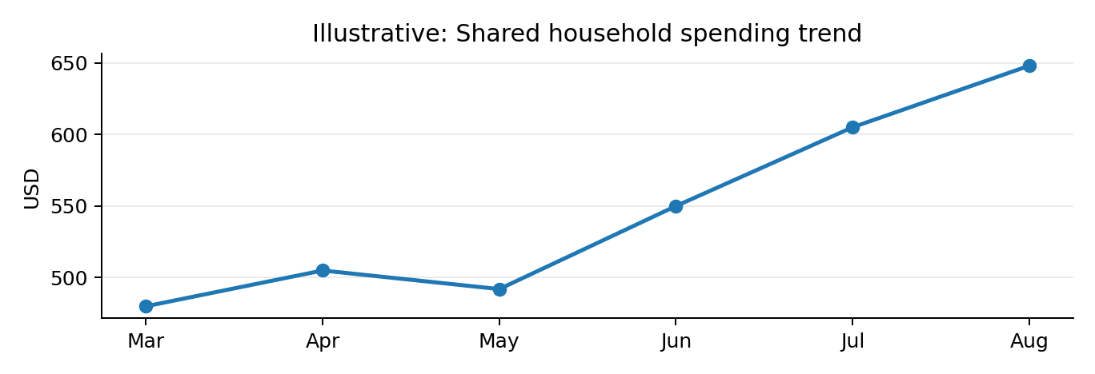
Figure 5. Example line chart: trend first, with period-over-period insight calculated on the server.
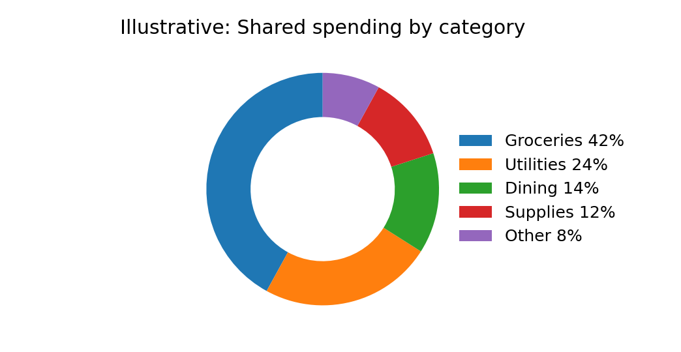
Figure 6. Example category share. Use a donut only when category count is small enough to compare accurately.
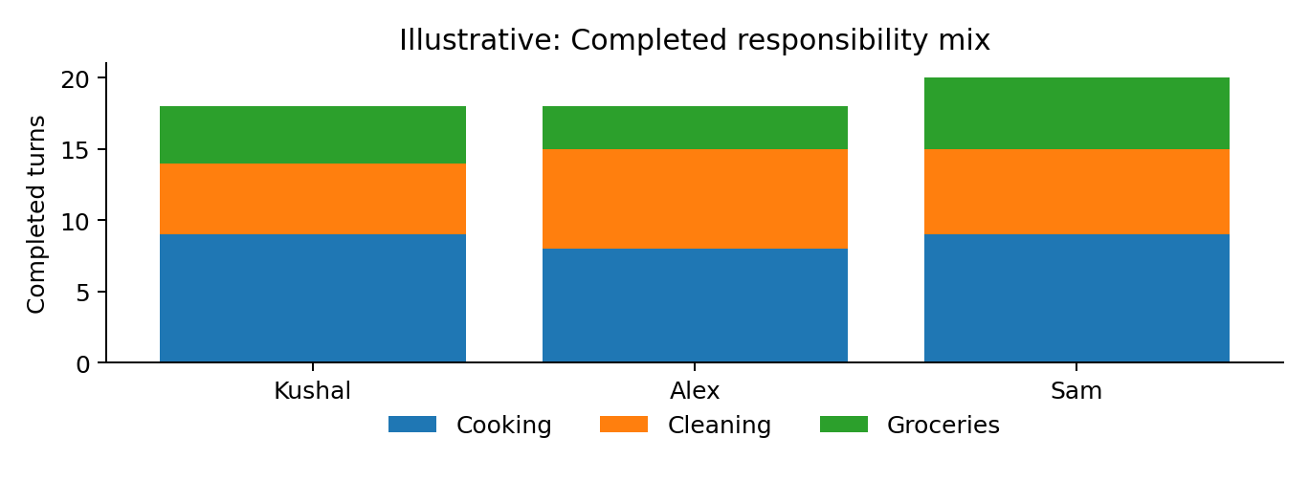
Figure 7. Example responsibility contribution mix. A stacked bar reveals whether apparently unequal totals are offset by different chore categories.

9.3 Balance/fairness metric
Avoid calling one person “unfair.” Present a neutral workload balance metric and always expose the underlying counts. An implementable score is 100 × (1 − normalized Gini coefficient) over completed task points for active members during the selected period. A perfectly even distribution is 100. If fewer than two members or too few completed occurrences exist, return `insufficient_data`.
Interpretation guardrail
The balance score is descriptive, not moral. Away periods, custom task weights, and household agreements can make unequal counts intentional. Always pair the score with per-member bars and an explanatory note.

9.4 Deterministic insight rules (initial)
Insight | Trigger example | UI message pattern
Spending increase | Current full period > prior period by >=20% and >= $50 equivalent | “Shared spending is up 24% vs last month, mainly groceries.”
Dominant category | One category >=40% of shared spend | “Groceries account for 42% of this month’s shared spending.”
Schedule friction | Task swap-request rate >=30% with >=5 occurrences | “Friday dinner is frequently swapped; consider changing its schedule.”
Coverage imbalance | One member performs >=25% more weighted points than household mean and sample >=10 | “Kushal covered more turns than the group average this period.”
Completion concern | Overdue/late rate >=20% with sample >=10 | “1 in 4 cleaning tasks finished late or remained overdue.”

9.5 Visualization implementation rules
- Bars start at zero unless an explicitly labeled analytical exception requires otherwise.
- Line charts are for ordered time series; do not connect unordered categories.
- Avoid 3D charts. Do not encode the same metric only by color; include labels/patterns/tooltips for accessibility.
- Show currency and time-zone context in chart metadata.
- Return both machine values and display-independent labels from analytics APIs; formatting remains client-side.
- Cache expensive household-period aggregates briefly, but invalidate after relevant expense/task writes or accept a documented short freshness window.

10. Security, authentication, authorization, and privacy

10.1 Authentication
- Use an external OIDC provider. Auth0 is the reference implementation; equivalent standards-compliant providers may be substituted.
- Mobile: Authorization Code flow with PKCE; store refresh/access material only in platform secure storage through supported SDKs.
- Web: prefer secure, HttpOnly, SameSite cookies via the provider/Next.js session layer or a thin BFF; avoid long-lived bearer tokens in `localStorage`.
- API validates issuer, audience, signature, expiration, and expected scopes/claims. Map external subject to local `User`.

10.2 Authorization model
Authorization is household-scoped RBAC plus object-level ownership checks. Roles should stay small: OWNER and MEMBER for MVP; add ADMIN only when a distinct capability is required.
Action | Owner | Member
View household/task/expense data | Yes | Yes
Create tasks/expenses/swaps | Yes | Yes
Change household settings | Yes | No
Invite members | Yes | Optional policy; default No
Remove members / transfer ownership | Yes | No
Record own settlement | Yes | Yes

OWASP priority
Broken object-level authorization is a leading API risk. Every endpoint that accepts a household-owned object ID must prove the current user is an active member of that object’s household before reading or mutating it.

10.3 API/security controls
- HTTPS only; HSTS at edge in production.
- Strict CORS allowlist; CSRF protection when cookies can authorize state-changing requests.
- Input validation with allowlisted DTO fields; reject mass-assignment of server-controlled fields.
- Per-user/IP rate limits on auth-sensitive, invite, and mutation endpoints; stronger throttling on invitation/token abuse paths.
- Secrets in managed secret store; never commit `.env` production values.
- Parameterized ORM queries; review raw SQL; least-privilege DB role for application.
- Log security-relevant events without access/refresh tokens, push tokens, or full sensitive payloads.
- CodeQL, dependency review, automated vulnerability updates, container/secret scanning in CI.

10.4 Privacy/data lifecycle
- Collect display name, identity subject, household membership, tasks, expenses, and optional receipt metadata only as needed.
- Provide account/household export and deletion paths before public launch.
- Financial activity should be retained consistently within a household; user deletion may pseudonymize historical authorship where deleting the fact would corrupt shared records.
- Define retention for notification delivery logs and expired invitation tokens; keep them much shorter than business records.

11. Testing strategy

11.1 Test pyramid
Level | Tooling | Required coverage
Pure domain unit | Jest/Vitest-compatible TypeScript runner selected per app | Rotation, recurrence edge cases, split arithmetic, Gini/balance score, settlement simplification, insight rules.
Backend integration | Testcontainers + PostgreSQL/Redis | Repositories, transactions, unique/check constraints, idempotency, worker/outbox, concurrency races.
API contract | Supertest + generated OpenAPI validation | Authz matrix, errors, pagination, API examples, backward-compatibility checks.
Web component/integration | React Testing Library | Important state transitions and accessibility behavior.
Web E2E | Playwright | Household onboarding, task swap, expense + settlement, analytics smoke flows.
Mobile unit/integration | Jest + React Native Testing Library | Screen/state behavior, offline/retry boundaries.
Mobile E2E | Maestro / EAS Workflows | Login, join household, notification-linked navigation, task completion, expense flow.

11.2 Mandatory edge-case suites
- DST spring-forward/fall-back, leap day, month-end, time-zone changes, user away across DST boundary.
- Three-way rotations, member removal mid-horizon, task edits after future occurrences exist, concurrent swap acceptance.
- Expense totals not divisible by member count, percentage rounding, large amounts, edit/delete after settlement, duplicate mobile retry.
- Authorization attempts using another household’s UUIDs for every resource class.
- Push provider timeout, token invalidation, duplicate job delivery, worker crash after side effect but before acknowledgment.

11.3 Quality gates
- No merge with lint/type/test failure.
- Changed backend modules require unit/integration tests for new invariants.
- Schema migration must be reviewed for lock/backfill risk.
- OpenAPI breaking-change check required on public API changes.
- Critical/high dependency vulnerabilities block release unless explicitly risk-accepted with expiration.

12. CI/CD, environments, and deployment
Figure 8. Recommended protected CI/CD path. Production promotion occurs only from a tested immutable artifact.

12.1 Environments
Environment | Purpose | Data
Local | Developer workflow via Docker Compose/Testcontainers | Synthetic/local only
Preview | Per-PR web preview and optional ephemeral API namespace | Seeded synthetic data
Staging | Production-like integration and E2E | Synthetic/anonymized; never copy raw production secrets
Production | Real users | Managed backups, monitoring, restricted access

12.2 Deployment topology
- Build API and worker as separate OCI images from the same commit SHA.
- Run database migrations as an explicit deployment step/job before or during a backward-compatible rollout.
- API uses rolling/blue-green deployment; worker deployment must be compatible with in-flight queued jobs.
- Production database and Redis are managed services. Do not run stateful production databases inside the app container platform.
- Infrastructure configuration is code (Terraform/OpenTofu) once production resources stabilize; environment differences are variables, not hand-edited consoles.

12.3 Migration discipline
1. Expand: add nullable/new structures first; old and new app versions can coexist.
2. Backfill asynchronously if required; measure lock/IO impact.
3. Deploy code that reads/writes the new shape.
4. Contract/remove old columns only in a later release.

13. Observability and operations

13.1 Telemetry
Signal | Minimum fields
Structured logs | timestamp, level, service, environment, request_id/trace_id, route, status, latency; no tokens.
Traces | HTTP spans, PostgreSQL calls, Redis/BullMQ jobs, external auth/push calls; propagate correlation ID into jobs.
Metrics | request count/error/latency, DB pool, queue depth/age/failures, reminder lag, push failures, worker throughput.
Product health | successful task completions, swap acceptance failures, expense write failures, analytics freshness.

13.2 Initial alerts
- API 5xx error-rate spike or sustained latency SLO breach.
- Database connection exhaustion or migration failure.
- Oldest queue job age above reminder tolerance.
- Push delivery failure rate spike or invalid-token surge.
- Outbox backlog growing without drain.
- Repeated settlement/split invariant failures (potential bug or abuse).

13.3 Health endpoints
GET /health/live -> process is alive; no dependency calls
GET /health/ready -> DB reachable, required migrations applied, Redis reachable
GET /health/build -> version/commit/runtime metadata; no secrets

13.4 Backups and recovery
- Enable managed PostgreSQL automated backups and point-in-time recovery before beta users depend on the app.
- Test restore procedure periodically; a backup that has never been restored is not a verified recovery mechanism.
- Redis queue loss should be recoverable from PostgreSQL outbox/business state for durable notification intents; do not rely on Redis as the only record of an obligation.

14. Delivery phases and Definition of Done

14.1 Recommended implementation order
Phase | Deliverable | Exit condition
0. Foundation | Monorepo, CI, API skeleton, DB/Redis local stack, OIDC, OpenAPI, telemetry | One authenticated `/me` request passes local + CI integration tests.
1. Household | Household/member/invite flows, authorization guard | Two users can join; cross-household access tests fail correctly.
2. Responsibilities | Task CRUD, recurrence, rotation, occurrence materialization, completion | DST/away/member-change suites pass.
3. Swaps + reminders | Swap/cover workflow, worker, outbox, push tokens/preferences | Accepting swap updates assignment once and notification jobs are idempotent.
4. Expenses | Expense CRUD, all split modes, categories, balances | Rounding/property tests and cross-household authz pass.
5. Settlements | Settlement recording + transfer simplification | Balances reconcile to zero after exact settlements.
6. Analytics | Overview, expense/task charts, deterministic insights | Dashboard numbers reconcile against raw test fixtures.
7. Beta hardening | E2E, rate limits, backups, runbooks, accessibility, app-store builds | Release checklist and restore drill complete.

14.2 Definition of Done for a backend feature
- Domain invariant documented and implemented.
- Authorization rule is explicit and tested.
- Migration reviewed; indexes/constraints included.
- OpenAPI request/response/error schema updated.
- Unit + integration tests cover success, validation, authorization, idempotency/concurrency where relevant.
- Activity/outbox event behavior defined.
- Telemetry added for failure-prone workflow.
- Generated client compiles; web/mobile can consume without handwritten API types.
- No unresolved high/critical dependency or code-scanning finding introduced.

14.3 First engineering tickets
1. Initialize pnpm 11 + Turborepo workspace and standard TypeScript/ESLint/formatting configs.
2. Create NestJS 11 API and worker apps with Node 24 LTS Dockerfiles and local Compose services for PostgreSQL 18 + Redis.
3. Configure Prisma 7, baseline migration, migration CI check, and Testcontainers integration harness.
4. Integrate OIDC provider and implement `CurrentUser` + household authorization guard.
5. Add OpenAPI 3.1 generation, API diff artifact, and generated TypeScript client package.
6. Implement Household/Membership/Invite module with end-to-end authorization tests.
7. Implement Task/Occurrence model and recurrence engine with DST tests before building UI.
8. Implement worker/outbox infrastructure before reminders so side-effect reliability is designed once.

15. Key engineering risks and future evolution
Risk | Why it matters | Mitigation
Time zones / DST | Recurring chores can fire at wrong local times | Household IANA zone; local recurrence expansion; dedicated DST tests.
Money rounding | Small inconsistencies destroy trust | Integer minor units; deterministic remainder allocation; property tests.
Object-level auth | UUIDs can be guessed/shared; household data is sensitive | Membership-scoped repository/service guards + negative tests.
Duplicate mobile requests | Retries/offline sync can create duplicate expenses or settlements | Idempotency keys + unique persistence record.
Notification drift | Queued reminder can become stale after swap/complete | Job references occurrence ID; worker revalidates current state before send.
Premature microservices | Adds failure modes and slows delivery | Modular monolith with explicit extraction boundaries.
Analytics mistrust | Misleading fairness/spend insights cause conflict | Explainable calculations, minimum sample sizes, expose underlying values.
Vendor lock-in | Auth/push/observability vendors can change price/API | Standards/adapters: OIDC, PushProvider, OTLP.

15.1 When to extract services
Do not extract a microservice because a module exists. Consider extraction only when at least one of these is measured: independent scaling pressure, isolation/security boundary, separate team ownership/release cadence, or a workload with materially different runtime characteristics. Notification delivery is the first likely candidate because the worker is already independently deployable.

15.2 Future-capability hooks worth preserving
- Receipt attachments/OCR through object storage and asynchronous processing.
- Recurring bills and household budgets.
- Multi-currency with explicit FX-rate snapshots rather than live implicit conversion.
- Calendar export/sync.
- Direct APNs/FCM and email channels.
- Household inventory/shopping list.
- Optional LLM-generated narrative summaries only after deterministic analytics facts exist; never let an LLM calculate balances or assignment truth.

Appendix A. Bootstrap checklist

A.1 Local prerequisites
- Node.js 24 LTS
- Corepack + pnpm 11
- Docker Engine/Desktop
- Git
- OIDC development tenant/application
- Expo/EAS account when mobile builds begin

A.2 Initial commands (illustrative)
corepack enable
corepack prepare pnpm@11 --activate
mkdir turntable && cd turntable
pnpm init
pnpm add -D turbo typescript eslint prettier
# Create apps with their official CLIs, then wire them into pnpm-workspace.yaml.
# Pin exact dependency versions in package.json/lockfile after the initial install.
docker compose up -d postgres redis
pnpm install
pnpm -r typecheck
pnpm -r test

A.3 Local Docker services
Service | Port (suggested) | Purpose
PostgreSQL 18 | 5432 | Primary local relational database
Redis | 6379 | BullMQ / cache / rate-limit counters
Mailpit (optional) | 8025 UI / 1025 SMTP | Local email preview if invite/email channel is added

Appendix B. Environment variable contract
Variable | Scope | Notes
DATABASE_URL | api, worker | PostgreSQL connection; secrets manager in production
REDIS_URL | api, worker | TLS managed Redis in production
OIDC_ISSUER_URL | api/web/mobile config | Trusted issuer
OIDC_AUDIENCE | api/mobile/web | API audience
EXPO_ACCESS_TOKEN | CI/mobile | EAS/Expo operations; CI secret only
PUSH_PROVIDER_* | worker | Provider credentials if direct APNs/FCM later
OTEL_EXPORTER_OTLP_ENDPOINT | api, worker | Telemetry collector/vendor endpoint
SENTRY_DSN | api/web/mobile/worker | Optional error tracking; environment-specific
APP_ENV | all | local/preview/staging/production
LOG_LEVEL | api, worker | Default info in prod; never debug by default

Appendix C. Indexing baseline
- `household_members (household_id, user_id)` unique; index active memberships by user.
- `task_occurrences (household_id, scheduled_for)` and `(current_assignee_member_id, scheduled_for)`.
- `expenses (household_id, occurred_at DESC)` and category/date composite if analytics queries warrant it.
- `expense_splits (expense_id)` and `(member_id, expense_id)`.
- `settlements (household_id, settled_at DESC)`.
- `swap_requests (household_id, status, created_at DESC)` plus relevant occurrence IDs.
- `outbox_events (status, available_at)` for efficient worker polling/claiming.
Do not add every conceivable index up front. Validate with `EXPLAIN (ANALYZE, BUFFERS)` using representative data and monitor slow queries in staging/production.

Appendix D. Technology and standards sources
The following official/primary sources were checked when preparing the 8 August 2026 baseline. Versions should still be pinned and re-verified when implementation starts or dependencies are upgraded.
• Node.js releases
• NestJS migration guide / Node requirements
• PostgreSQL versioning policy
• PostgreSQL current documentation
• Prisma ORM documentation / current GA
• pnpm 11 release notes
• Next.js documentation
• Expo SDK 57 changelog
• React Native releases
• Expo notifications
• Expo Maestro E2E workflows
• OpenAPI Initiative specifications
• OAuth 2.0 Security Best Current Practice - RFC 9700
• OpenID Connect Core
• OWASP API Security Top 10
• OWASP REST Security Cheat Sheet
• OpenTelemetry JavaScript
• Playwright documentation
• Testcontainers Node.js guide
• GitHub CodeQL
• GitHub dependency review

Appendix E. Architecture decision records to create
ADR | Decision
ADR-001 | API-first modular monolith; no microservices at MVP
ADR-002 | REST/OpenAPI 3.1 and generated client strategy
ADR-003 | OIDC provider and web/mobile token/session handling
ADR-004 | Recurrence/rotation and away-period semantics
ADR-005 | Money representation and debt simplification semantics
ADR-006 | Transactional outbox + BullMQ notification delivery
ADR-007 | Analytics metric definitions and fairness interpretation
ADR-008 | Production hosting/provider selection and recovery objectives

Final implementation directive
Start here
Implement Household -> Responsibility/Occurrence -> Swap/Notification -> Expense/Split -> Settlement -> Analytics in that dependency order. Build the backend contract first for each vertical slice, generate the client, then implement mobile/web UI against the same API. Avoid creating a second business backend in Next.js.

This document is a baseline, not a frozen architecture. Any deviation that changes API compatibility, financial semantics, authorization, data durability, or runtime topology should be captured in an ADR and accompanied by migration/rollback implications.

