TurnTable
Data Model & Database Specification
Physical persistence baseline, constraints, indexes, transactions, and lifecycle rules
Status: Coding handoff baseline
Version: 1.0
Baseline date: 8 August 2026
Product: TurnTable - shared household coordination, responsibilities, expenses, settlements, and analytics

1. Persistence principles
- PostgreSQL is the source of truth for business state; Redis is not authoritative.
- Use server-generated UUID primary keys. IDs are identifiers, never authorization controls.
- Use timestamptz for instants and DATE for away-period local dates; store IANA time zones explicitly.
- Use BIGINT integer minor units plus CHAR(3) ISO currency for money.
- Use database constraints for local invariants, application transactions for cross-row invariants, and integration tests for both.
- Use lifecycle states such as ARCHIVED, VOIDED, LEFT, REMOVED where history is part of correctness.
- Mutable aggregates vulnerable to lost updates carry version INTEGER NOT NULL DEFAULT 1.
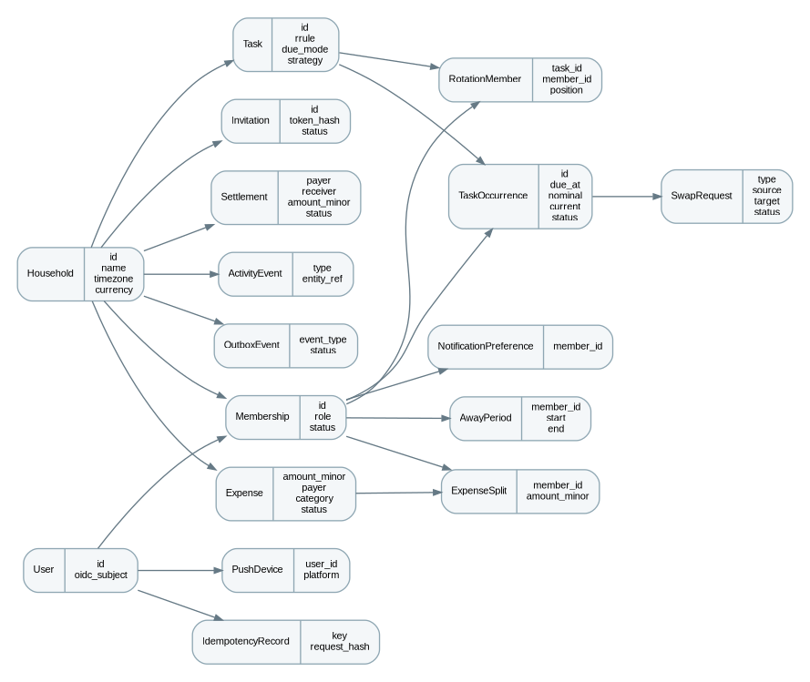
Figure 1. High-level relational model. Detailed entity fields below are normative.

2. Naming and column conventions
Convention | Rule
Tables | snake_case plural, e.g. task_occurrences.
Primary key | id UUID PRIMARY KEY.
Foreign keys | <entity>_id with explicit delete behavior; default RESTRICT for business history.
Audit timestamps | created_at on all business rows; updated_at on mutable rows.
Lifecycle | Constrained status field rather than physical deletion where history matters.
Optimistic lock | version increments on successful aggregate mutation.
JSON | jsonb only for variable metadata/event payloads, not as a substitute for core relational fields.

3. Entity data dictionary

3.1 users
Field | Type | Constraint | Notes
id | uuid | PK | Server-generated.
oidc_subject | text | UNIQUE NOT NULL | Stable external identity mapping.
email | text/citext | NULL | Convenience only; not immutable identity.
display_name | text | NOT NULL | User-visible name.
status | text | NOT NULL | ACTIVE, DELETED/PSEUDONYMIZED.
created_at | timestamptz | NOT NULL
updated_at | timestamptz | NOT NULL

3.2 households
Field | Type | Constraint | Notes
id | uuid | PK
name | text | NOT NULL | 1-120 chars.
timezone | text | NOT NULL | Validated IANA identifier.
currency | char(3) | NOT NULL | ISO 4217; changing after financial activity requires explicit workflow.
created_by_user_id | uuid | FK users | Audit convenience.
created_at | timestamptz | NOT NULL
updated_at | timestamptz | NOT NULL
version | integer | NOT NULL | Optimistic lock.

3.3 household_memberships
Field | Type | Constraint | Notes
id | uuid | PK
household_id | uuid | FK households NOT NULL
user_id | uuid | FK users NOT NULL
role | text | NOT NULL | OWNER, MEMBER.
status | text | NOT NULL | ACTIVE, LEFT, REMOVED.
joined_at | timestamptz | NOT NULL
left_at | timestamptz | NULL
created_at | timestamptz | NOT NULL
updated_at | timestamptz | NOT NULL
version | integer | NOT NULL

3.4 household_invitations
Field | Type | Constraint | Notes
id | uuid | PK
household_id | uuid | FK NOT NULL
created_by_member_id | uuid | FK memberships NOT NULL
token_hash | text | UNIQUE NOT NULL | Never store raw invite token.
invited_email | text | NULL | Optional binding/display.
status | text | NOT NULL | PENDING, ACCEPTED, REVOKED, EXPIRED.
expires_at | timestamptz | NOT NULL
accepted_by_user_id | uuid | FK users NULL
accepted_at | timestamptz | NULL
created_at | timestamptz | NOT NULL

3.5 tasks
Field | Type | Constraint | Notes
id | uuid | PK
household_id | uuid | FK NOT NULL
created_by_member_id | uuid | FK NOT NULL
title | text | NOT NULL | 1-120 chars.
description | text | NULL
status | text | NOT NULL | ACTIVE, ARCHIVED.
recurrence_rule | text | NULL | RFC 5545 RRULE without DTSTART; NULL for one-off.
start_local_date | date | NOT NULL | Recurrence anchor.
timezone | text | NOT NULL | IANA zone.
due_mode | text | NOT NULL | ALL_DAY, TIME.
due_local_time | time | NULL | Required for TIME.
assignment_strategy | text | NOT NULL | ROUND_ROBIN, FIXED.
fixed_assignee_member_id | uuid | FK memberships NULL | Required for FIXED.
rotation_cursor_position | integer | NULL | Server-managed.
weight | smallint | NOT NULL DEFAULT 1 | MVP UI fixed at 1.
reminder_offsets_minutes | integer[] | NOT NULL DEFAULT {} | 0-3 non-negative offsets.
created_at | timestamptz | NOT NULL
updated_at | timestamptz | NOT NULL
version | integer | NOT NULL

3.6 task_rotation_members
Field | Type | Constraint | Notes
task_id | uuid | FK tasks | Composite PK/unique pair with member.
member_id | uuid | FK memberships | Must belong to task household.
position | integer | NOT NULL | 0-based ordered rotation.
active_from | date | NULL | Optional future extension.
active_until | date | NULL | Optional future extension.

3.7 task_occurrences
Field | Type | Constraint | Notes
id | uuid | PK
task_id | uuid | FK NOT NULL
household_id | uuid | FK NOT NULL | Denormalized for safe scoped queries/indexes.
local_date | date | NOT NULL | Occurrence date in task zone.
due_at | timestamptz | NOT NULL | Resolved due instant.
nominal_assignee_member_id | uuid | FK NULL | Base assignment.
current_assignee_member_id | uuid | FK NULL | After swap/cover.
status | text | NOT NULL | SCHEDULED, COMPLETED, SKIPPED, CANCELED.
completed_by_member_id | uuid | FK NULL | Actual credited completer.
completed_at | timestamptz | NULL
skip_reason | text | NULL
is_user_modified | boolean | NOT NULL DEFAULT false | Protect from regeneration.
created_at | timestamptz | NOT NULL
updated_at | timestamptz | NOT NULL
version | integer | NOT NULL

3.8 away_periods
Field | Type | Constraint | Notes
id | uuid | PK
household_id | uuid | FK NOT NULL
member_id | uuid | FK memberships NOT NULL
start_date | date | NOT NULL | Inclusive local date.
end_date | date | NOT NULL | Inclusive; >= start_date.
reason | text | NULL
created_at | timestamptz | NOT NULL

3.9 swap_requests
Field | Type | Constraint | Notes
id | uuid | PK
household_id | uuid | FK NOT NULL
type | text | NOT NULL | SWAP, COVER.
source_occurrence_id | uuid | FK NOT NULL
target_occurrence_id | uuid | FK NULL | Required for SWAP.
target_member_id | uuid | FK memberships NOT NULL | Decision maker.
requested_by_member_id | uuid | FK memberships NOT NULL
status | text | NOT NULL | PENDING, ACCEPTED, DECLINED, CANCELED, EXPIRED.
message | text | NULL
expires_at | timestamptz | NOT NULL
decided_at | timestamptz | NULL
created_at | timestamptz | NOT NULL
version | integer | NOT NULL

3.10 expenses
Field | Type | Constraint | Notes
id | uuid | PK
household_id | uuid | FK NOT NULL
created_by_member_id | uuid | FK NOT NULL
payer_member_id | uuid | FK NOT NULL
description | text | NOT NULL | 1-200 chars.
amount_minor | bigint | NOT NULL | >0.
currency | char(3) | NOT NULL | Household currency.
category | text | NOT NULL | Fixed MVP enum.
occurred_at | timestamptz | NOT NULL
split_mode | text | NOT NULL | EQUAL, EXACT, PERCENTAGE, SHARES.
note | text | NULL
status | text | NOT NULL | ACTIVE, VOIDED.
voided_at | timestamptz | NULL
voided_by_member_id | uuid | FK NULL
created_at | timestamptz | NOT NULL
updated_at | timestamptz | NOT NULL
version | integer | NOT NULL

3.11 expense_splits
Field | Type | Constraint | Notes
expense_id | uuid | FK expenses | Composite PK with member_id.
member_id | uuid | FK memberships | Historical membership allowed on existing record.
amount_minor | bigint | NOT NULL | >=0; all splits sum to total.
input_value | numeric/text | NULL | Optional original percent/share; resolved amount is authoritative.

3.12 settlements
Field | Type | Constraint | Notes
id | uuid | PK
household_id | uuid | FK NOT NULL
payer_member_id | uuid | FK NOT NULL | Debtor.
receiver_member_id | uuid | FK NOT NULL | Creditor.
amount_minor | bigint | NOT NULL | >0.
currency | char(3) | NOT NULL | Household currency.
settled_at | timestamptz | NOT NULL
note | text | NULL
created_by_member_id | uuid | FK NOT NULL
status | text | NOT NULL | ACTIVE, VOIDED.
voided_at | timestamptz | NULL
voided_by_member_id | uuid | FK NULL
created_at | timestamptz | NOT NULL
version | integer | NOT NULL

3.13 notification_preferences
Field | Type | Constraint | Notes
member_id | uuid | PK/FK memberships | One per membership.
push_enabled | boolean | NOT NULL
task_reminders_enabled | boolean | NOT NULL
swap_events_enabled | boolean | NOT NULL
expense_events_enabled | boolean | NOT NULL
settlement_events_enabled | boolean | NOT NULL
quiet_hours_start | time | NULL | Household local time.
quiet_hours_end | time | NULL
updated_at | timestamptz | NOT NULL

3.14 push_devices
Field | Type | Constraint | Notes
id | uuid | PK
user_id | uuid | FK users NOT NULL
provider | text | NOT NULL | EXPO initially.
platform | text | NOT NULL | IOS, ANDROID.
token | text | NOT NULL | Treat as sensitive; encryption/secret handling per security policy.
active | boolean | NOT NULL
last_seen_at | timestamptz | NOT NULL
created_at | timestamptz | NOT NULL

3.15 activity_events
Field | Type | Constraint | Notes
id | uuid | PK
household_id | uuid | FK NOT NULL
actor_member_id | uuid | FK NULL | System event may be null.
event_type | text | NOT NULL | Stable application code.
entity_type | text | NOT NULL
entity_id | uuid | NULL
metadata | jsonb | NOT NULL DEFAULT {} | Redacted/display-safe.
created_at | timestamptz | NOT NULL | Immutable.

3.16 outbox_events
Field | Type | Constraint | Notes
id | uuid | PK
household_id | uuid | FK NULL
event_type | text | NOT NULL
aggregate_type | text | NOT NULL
aggregate_id | uuid | NOT NULL
payload | jsonb | NOT NULL | Minimal side-effect payload.
status | text | NOT NULL | PENDING, PROCESSING, PROCESSED, FAILED.
attempt_count | integer | NOT NULL DEFAULT 0
available_at | timestamptz | NOT NULL
processed_at | timestamptz | NULL
last_error_code | text | NULL | No secrets.
created_at | timestamptz | NOT NULL

3.17 idempotency_records
Field | Type | Constraint | Notes
id | uuid | PK
actor_user_id | uuid | FK users NOT NULL
operation_scope | text | NOT NULL | Normalized command/route.
idempotency_key | text | NOT NULL | Unique with actor+scope.
request_hash | text | NOT NULL | Reject same key with different request.
response_status | integer | NOT NULL
response_body | jsonb | NULL | Safe response snapshot or resource reference.
created_at | timestamptz | NOT NULL
expires_at | timestamptz | NOT NULL | Default 24 hours.

4. Required database constraints
Invariant | Implementation
Membership uniqueness | UNIQUE(household_id,user_id). Enforce exactly one ACTIVE OWNER per household via validated transaction plus partial unique/trigger approach appropriate to ORM/database.
Task shape | TIME requires due_local_time; FIXED requires fixed_assignee; ROUND_ROBIN forbids fixed_assignee.
Rotation | UNIQUE(task_id,member_id); UNIQUE(task_id,position); membership household must match task household.
Occurrence uniqueness | Use a recurrence-instance uniqueness key sufficient to prevent duplicate generation, e.g. task_id + local_date + due_at for MVP schedules.
Away period | CHECK(end_date >= start_date). Overlap may be allowed and normalized by service.
Pending swap | Partial UNIQUE(source_occurrence_id) WHERE status=PENDING.
Expense | CHECK(amount_minor>0); constrained status/category/split mode; household currency validated transactionally.
Expense splits | UNIQUE(expense_id,member_id); CHECK(amount_minor>=0); sum-to-total validated in same transaction.
Settlement | CHECK(amount_minor>0); CHECK(payer_member_id<>receiver_member_id).
Idempotency | UNIQUE(actor_user_id,operation_scope,idempotency_key).

5. Index baseline
Table | Indexes
household_memberships | UNIQUE(household_id,user_id); (user_id,status); (household_id,status,role).
tasks | (household_id,status); (fixed_assignee_member_id,status) where applicable.
task_occurrences | (household_id,due_at); (current_assignee_member_id,due_at); (task_id,local_date); partial SCHEDULED index.
away_periods | (member_id,start_date,end_date); (household_id,start_date,end_date).
swap_requests | (household_id,status,created_at DESC); (target_member_id,status,expires_at); occurrence refs.
expenses | (household_id,occurred_at DESC); (household_id,category,occurred_at DESC); (payer_member_id,occurred_at DESC).
expense_splits | (member_id,expense_id).
settlements | (household_id,settled_at DESC); payer/receiver time indexes.
activity_events | (household_id,created_at DESC).
outbox_events | (status,available_at), preferably partial for pending workload.
idempotency_records | Unique actor/scope/key; (expires_at) cleanup index.

6. Transaction boundaries
Command | Atomic scope
Accept swap/cover | Lock request + affected occurrences; revalidate; mutate assignees; mark accepted; insert activity + outbox; commit.
Create/edit/void expense | Validate membership/currency/splits; persist expense + resolved splits + activity + outbox + idempotency result; commit.
Record/void settlement | Recompute current net/suggestion under lock/appropriate isolation; validate; write settlement + activity/outbox; commit.
Accept invitation | Lock invitation; verify token/status/expiry; create/activate membership; mark accepted; activity/outbox; commit.
Task schedule edit | Update with version check; regenerate future untouched occurrences in same transaction or durable follow-up job depending on volume; preserve modified occurrences.

7. Query and authorization boundary
Critical rule
Household-owned repository/service reads must accept household context and constrain queries by household_id before returning data. Do not fetch by bare object ID and rely on a later authorization check.

8. Migration discipline
- Use Prisma Migrate for history and inspect generated SQL for production.
- Prefer expand/backfill/contract so old/new app versions coexist during rolling deployment.
- Avoid unsafe one-step NOT NULL/default backfills on large tables.
- Add indexes through provider-safe/concurrent methods when scale warrants it.
- Test migrations on clean install and upgrade fixtures.

9. Data lifecycle
Data | Lifecycle
Invite tokens | Revoke/delete after expiry + short operational window; raw tokens never persisted.
Idempotency | Default 24-hour TTL unless operation requires longer.
Notification attempts | Short retention such as 30-90 days; aggregate metrics may outlive raw attempts.
Activity/financial facts | Retain with household history unless privacy/legal workflow requires pseudonymization.
Deleted user | Pseudonymize profile while preserving factual shared records where deletion would corrupt others’ history.
Push tokens | Deactivate/delete on logout/device removal/permanent provider invalidation/account deletion.

10. Deterministic seed fixture
Local/staging seed data must include one three-person household, 90 days of task occurrences, 30-50 expenses across categories, multiple swaps/covers, an away period, and settlements. Stable non-production IDs make tests and dashboard screenshots repeatable.

