TurnTable
UX Flows & Screen Specification
Mobile-first interaction model, responsive web mapping, screen states, forms, and deep links
Status: Coding handoff baseline
Version: 1.0
Baseline date: 8 August 2026
Product: TurnTable - shared household coordination, responsibilities, expenses, settlements, and analytics

1. UX objective
The UI reduces household coordination to clear next actions. Home prioritizes “what do I need to do?” and “what is my balance?” before analytics detail. Visualizations answer concrete questions and never replace underlying values.
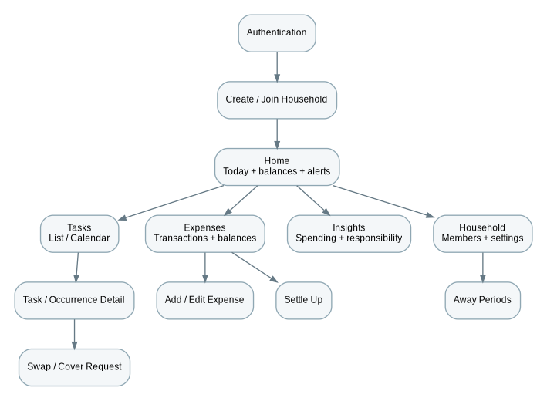
Figure 1. MVP information architecture and primary navigation.

2. Navigation and client-state rules
Area | Rule
Mobile navigation | Bottom tabs: Home, Tasks, Expenses, Insights, Household; stack/modal routes for details and creation.
Web navigation | Left sidebar with same five sections; route hierarchy mirrors mobile concepts.
Household switcher | Visible when user has multiple households. Switching clears/refetches household-scoped server state.
Server state | Use a query/cache library pattern; API remains source of truth. Cache keys always include household and relevant filters.
Local UI state | Keep form/modal/selection state local. Do not create a broad global store for server data.
Forms | Client validation improves UX but server validation is authoritative; preserve user input after recoverable errors.
Offline | Online-first MVP. Cached reads may display stale status; only explicitly idempotent supported mutations may retry automatically.

3. Screen catalog
ID | Screen | Purpose/data | Primary actions | Required states
S01 | Sign in | Managed OIDC authentication. | Sign in. | Provider error/cancel.
S02 | Create or join household | Choose create vs invite. | Create; accept invite. | No memberships; invalid/expired invite.
S03 | Create household | Name, time zone, currency. | Create. | Validation.
S04 | Home | Today assignments, requests, own net balance, household-today, one insight, recent activity. | Complete; swap/cover; add expense; settle. | Empty, loading, stale/offline, partial widget failure.
S05 | Tasks | Upcoming list/calendar with assignee and state. | Open; create; filter. | No tasks; date-range empty.
S06 | Task detail | Definition, rotation, reminders, upcoming occurrences/history. | Edit; archive; open occurrence. | Archived/permission-limited.
S07 | Create/Edit task | Recurrence, due mode/time, assignment, rotation/fixed member, reminders. | Save. | Invalid RRULE/fields; no eligible member.
S08 | Occurrence detail | Due, nominal/current assignee, state, swap history. | Complete; skip; swap/cover. | Completed; overdue; unassigned; stale version.
S09 | Request swap/cover | Type, target member, target occurrence for swap, message. | Send. | No eligible target; pending request exists.
S10 | Swap inbox | Received pending; sent/history tabs. | Accept; decline; cancel. | Expired/conflict.
S11 | Away periods | Own away dates; OWNER can manage members. | Add/remove. | Accepted-swap warning.
S12 | Expenses | Expense feed, filters, period total, balance summary. | Add; open; settle. | Empty/filter-empty/stale.
S13 | Add/Edit expense | Amount, payer, description, date, category, participants, split mode. | Save. | Split mismatch, inactive member, version conflict.
S14 | Expense detail | Payer, exact splits, status, note, audit context. | Edit/void if authorized. | VOIDED read-only presentation.
S15 | Balances & settle | Member nets and recommended transfers. | Partial/full settlement. | Settled-up; suggestion changed before submit.
S16 | Insights overview | KPI cards, selected expense/responsibility charts, deterministic insights. | Date range; drill-down. | Insufficient data.
S17 | Expense insights | Trend, category mix, fronted vs allocated, top expenses. | Filter/date range. | No spend.
S18 | Responsibility insights | Member/category bars, completion, swap trend, heatmap, balance score. | Filter period/task. | Insufficient sample.
S19 | Household | Members, invite, settings, activity. | Invite; settings; manage member. | Role differences.
S20 | Notification settings | Push/event toggles and quiet hours. | Save. | OS permission off.

4. Home screen hierarchy
Module | Behavior
Today | Current user actionable occurrences ordered by due time; task, due state, Complete and Swap/Cover actions.
Requests | Pending received swap/cover count plus most urgent request.
Balance | “You are owed $X”, “You owe $X”, or “Settled up”; link to balance detail.
Household today | Compact other-member assignment list; never label members as fair/unfair.
Insight | At most one high-value deterministic insight so operational content stays primary.
Activity | Latest 3-5 important events; full feed from Household.

5. Task creation/edit UX
- Enter title and optional description.
- Choose one-off or recurring. Offer friendly presets (daily, weekdays, weekly, custom) that serialize to RRULE.
- Choose ALL_DAY or TIME; TIME requires local due time.
- Choose Rotate among members or Always assign to one member.
- For rotation, select/reorder active members. For fixed, select one member.
- Choose up to three reminder offsets from presets/custom values.
- Preview the next five assignments before saving.
- When a schedule edit would preserve user-modified future occurrences, show a concise warning that some agreed swaps/covers will remain unchanged.

6. Expense entry UX
- Amount is visually primary and formatted in household currency.
- Description, payer, occurred date/time and category are required; note optional.
- Participants default to all active members but can be deselected.
- Split selector: Equal, Exact, Percentage, Shares. Display resolved amount per member live before Save.
- Disable Save until participant/input rules are satisfied. Server remains authoritative for final rounding.
- After Save, show a concise confirmation and updated balance link. Do not imply persistent pairwise debt beyond the household-net model.

7. Balance and settlement UX
- Lead with the current user’s net state and recommended transfers, not a dense debt graph.
- Allow partial amount up to current suggestion; show recipient and current maximum.
- Revalidate at submit. If balances changed, show updated suggestion and require review rather than silently changing the amount.
- Settlement history is separate from current suggestions and clearly labels voided records.

8. Visualization placement
Screen | Visual strategy
Home | At most one mini trend/insight; operational tasks/balance dominate.
Insights overview | 2-4 KPI cards, spending trend, category breakdown, responsibility mix, completion summary.
Expense insights | Line trend, category donut/bar, fronted vs allocated grouped bars, ranked top expenses.
Responsibility insights | Stacked member bars, completion distribution, swap trend, local-date heatmap, balance score with underlying counts.

9. Loading, empty, error and offline states
State | Required treatment
Loading | Skeletons for lists/cards after route shell; avoid full-screen spinner after initial successful load.
Empty | Explain missing data + one relevant action, e.g. “No tasks yet — create the first rotation.”
Error | Safe message + Retry; preserve entered values; optional trace/reference ID in diagnostics.
Offline/stale | Show cached reads with “May be outdated”. Disable unsupported mutations and explain connection requirement.
409 conflict | Refetch current state and ask user to review; never overwrite silently.
Permission denied | Hide known impossible actions but treat server 403 as authoritative.

10. Notification deep links
Notification | Destination
Task reminder | Occurrence detail.
Swap request | Specific swap request/inbox item.
Swap accepted/declined | Affected occurrence or request history.
Expense create/edit | Expense detail.
Settlement | Balances/settlement detail.
Unassigned occurrence owner alert | Occurrence detail with resolution action.

11. Accessibility and visual rules
- Web target WCAG 2.2 AA; mobile controls have accessible labels/roles and adequate touch targets.
- Charts include text summary/table-equivalent values; color is never the only encoding.
- Bars start at zero unless explicitly justified; no 3D charts; line charts only for ordered time series.
- Interactive points expose accessible labels/tooltips and keyboard/focus behavior on web where applicable.
- Respect reduced-motion preferences; animation is nonessential.
- Currency, selected date range and household time-zone context remain visible near analytics.

12. Responsive behavior
- Phone: single-column cards/charts and persistent bottom tabs.
- Tablet: two-column dashboard when legible; never shrink chart labels below usable size.
- Desktop: constrained content width with two/three-column analytics grid and data tables where useful.
- Core business capability must not exist only on one client unless explicitly documented; layouts may differ, semantics may not.

