TurnTable
Analytics & Visualization Specification
Exact metric definitions, chart contracts, deterministic insights, and reconciliation rules
Status: Coding handoff baseline
Version: 1.0
Baseline date: 8 August 2026
Product: TurnTable - shared household coordination, responsibilities, expenses, settlements, and analytics

1. Analytics principles
- Every chart answers a user question; no decorative visualization is required.
- Backend returns semantic aggregates and deterministic insight facts; clients render them appropriately for platform.
- Every metric defines population, formula, date/time-zone behavior, and exclusions.
- Charts expose underlying values and accessible text/table alternatives.
- Private personal finance is outside MVP; member-level financial metrics refer only to shared-household data.
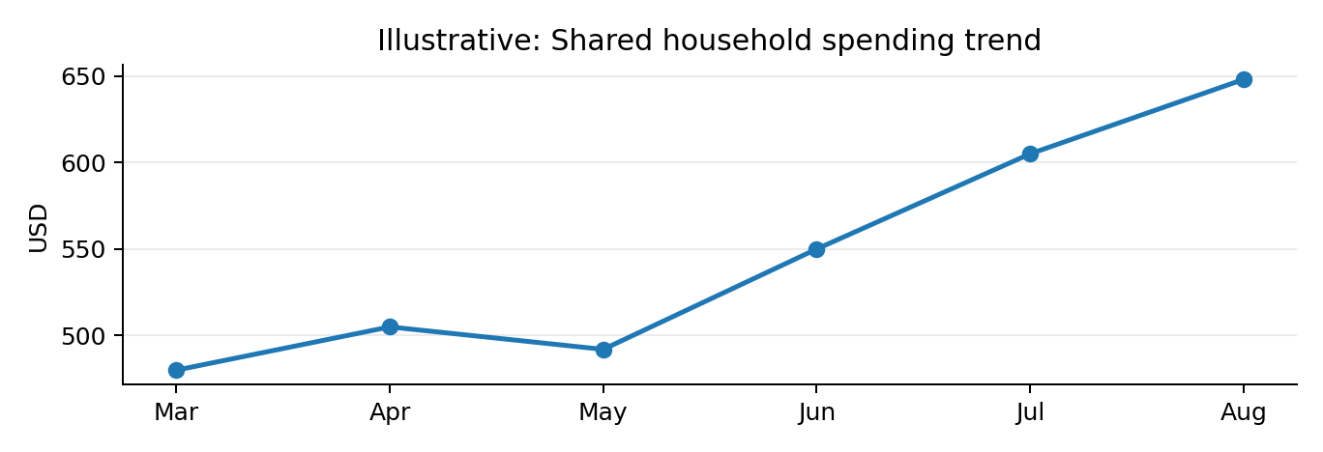
Figure 1. Shared-spending time trend.
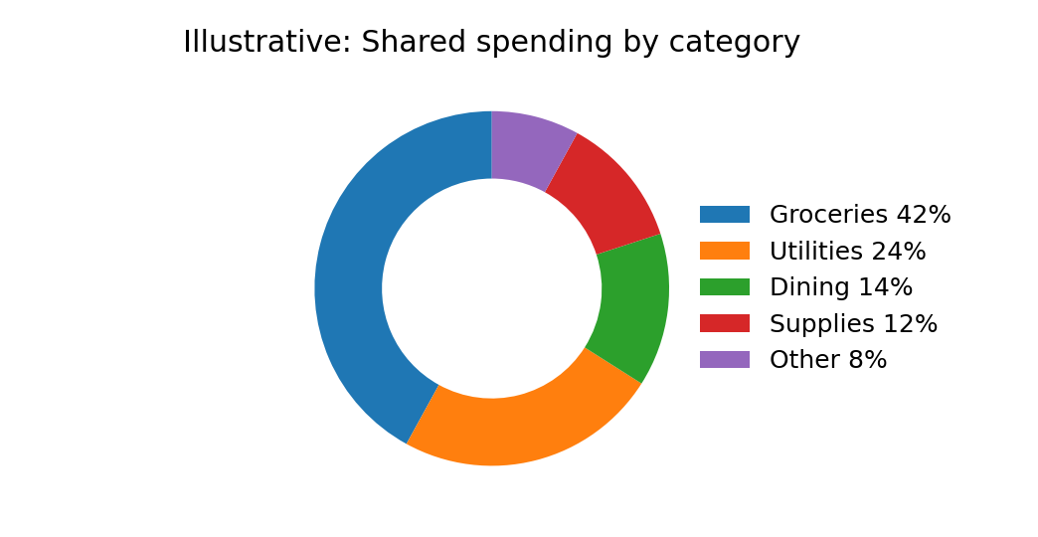
Figure 2. Category share; use donut only for a small category count.
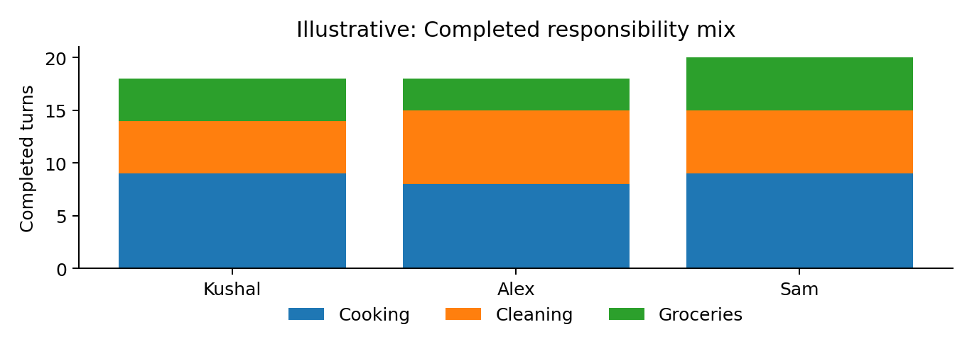
Figure 3. Responsibility contribution by member and category.

2. Date range and bucketing
Rule | Definition
Input | from/to are inclusive local calendar dates in household time zone.
Expense inclusion | ACTIVE expense whose occurred_at converted to household local date is within range.
Task inclusion | Occurrence local_date is within range, even if task is now archived.
Default expense range | Current household-local calendar month.
Trend bucket | <=31 days: day; 32-120: week; >120: month, unless a supported explicit bucket is requested.
Comparison | Immediately preceding equivalent span; UI labels exact compared dates.

3. Financial metrics
Metric | Formula | Included | Excluded | Usage
Household shared spend | SUM(expense.amount_minor) | ACTIVE expenses in range. | VOIDED. | Primary period total.
Category spend | SUM amount grouped by category | Same population. | VOIDED. | Category totals reconcile to shared spend.
Category share | category_spend / shared_spend | When total >0. | No-spend denominator. | Donut <=6 categories; otherwise horizontal bars.
Member fronted | SUM expense.amount where payer=member | ACTIVE expenses in range. | VOIDED. | “I paid” / who fronted costs.
Member allocated | SUM active expense_splits.amount for member | Splits of ACTIVE expenses in range. | VOIDED expense splits. | “My household spending/share”.
Member net current | paid - allocated + settlements_paid - settlements_received | All ACTIVE financial facts through as_of. | VOIDED facts. | Balance/settlement truth, normally not limited to dashboard period.
Period delta | current total - prior comparable total | Comparable prior span. |  | Show absolute and percent when prior >0.

4. Responsibility metrics
Metric | Formula | Included | Notes
Completed work count | COUNT completed occurrences credited to completed_by_member_id. | COMPLETED in range. | SKIPPED/CANCELED/SCHEDULED excluded.
Completed work points | SUM(task.weight) credited to completed_by. | COMPLETED. | MVP task weight=1.
On-time | completed_at <= due_at. | COMPLETED. | ALL_DAY due_at is local end-of-day.
Late | completed_at > due_at. | COMPLETED. | Descriptive, not moral judgment.
Overdue current | status=SCHEDULED AND due_at < now. | Current actionable state. | Derived, not stored.
Skip count | COUNT status=SKIPPED. | Occurrences in range.
Coverage count | Covered occurrence completed by current covering assignee. | COMPLETED covered occurrences. | Use assignment provenance/activity to distinguish cover from swap.
Swap request rate | requests / eligible task occurrences. | Task/period with sample threshold. | Used for schedule-friction insight.
Swap acceptance rate | accepted / (accepted+declined). | Decided requests. | Canceled/expired excluded from denominator.

5. Workload balance score
Compute completed work points per relevant active member in the selected period. Compute Gini coefficient G over non-negative totals, normalize for group size as implemented in a documented pure function, then score = 100 × (1 - normalized_G). Perfect equality = 100. If fewer than 2 relevant members or fewer than 10 completed occurrences total, return insufficient_data.
Interpretation guardrail
The score is descriptive, not moral. Away periods, household agreements, and task differences can make unequal counts intentional. Always pair the score with per-member bars and underlying values.

6. Visualization catalog
User question | Visualization | Server aggregate | Interpretation rule
How much are we spending over time? | Line | period bucket → amount_minor | Show period-over-period annotation.
Where does shared money go? | Donut <=6; else horizontal bar | category → amount/share | Sort descending; preserve raw values.
Who fronts vs consumes costs? | Grouped horizontal bars | member → fronted, allocated | Do not label fronting alone as “contribution”.
Who owes whom now? | Balance cards + transfer list/arrows | member nets + suggestions | Avoid pie/network clutter.
Is work balanced? | Stacked member/category bars | completed points | Show total and task-category composition.
Are tasks completed reliably? | Bar/donut with count labels | on-time, late, skipped, overdue | Keep current overdue concept distinct from historical completed counts.
Which days are overloaded? | Calendar heatmap | local date → occurrence count/weight | Household local date.
Are swaps increasing? | Line/column | period → request count + acceptance rate | Require sample before insight text.
What are largest expenses? | Ranked horizontal bars/table | expense → amount | Top N + link to full feed.

7. Deterministic insight rules
Code | Trigger | Message pattern | Facts
EXPENSE_PERIOD_UP | Current total >= prior ×1.20 and absolute increase meets configured materiality threshold. | Shared spending is up X% vs previous period, mainly CATEGORY. | current, prior, pct_change, top_driver.
CATEGORY_DOMINANT | One category >=40% of total and total>0. | CATEGORY accounts for X% of shared spending. | category, share, amount.
TASK_SWAP_FRICTION | Task swap request rate >=30% with >=5 eligible occurrences. | TASK is frequently swapped; consider changing its schedule. | task_id, rate, requests, occurrences.
WORKLOAD_IMBALANCE | One member points >= mean×1.25; >=10 completions; >=2 members. | One member covered more work than group average this period. | member_id, member_points, mean, sample.
COMPLETION_CONCERN | (late + current overdue)/relevant >=20% with >=10 occurrences. | A noticeable share of tasks finished late or remain overdue. | counts, rate.
ALL_SETTLED | Every member current net = 0. | Everyone is settled up. | as_of.

8. Analytics API payload rules
- Return machine values, stable IDs/codes, bucket labels, currency, selected date range, time zone, and as_of timestamp.
- If results are cached, include cached/freshness metadata or otherwise document freshness window.
- Insight objects return code + facts. Client-localized text may be generated from code/facts, but facts are authoritative.
- Clients must not receive raw rows and reimplement financial/task semantics independently.

9. Reconciliation invariants
Invariant | Required equality
Expense category totals | SUM(category amounts) = active household shared spend for same period.
Member allocations | SUM(member allocated) = active household shared spend for same period.
Member nets | SUM(all current member nets) = 0, absent a detected migration/data-integrity incident.
Settlement suggestions | Suggested outgoing total = total debtor magnitude = total creditor magnitude.
Completion composition | on_time + late = completed count for included occurrences.
Responsibility bars | SUM member completed points = total completed points in selected population.

10. Accessibility and visual integrity
- Every chart has a title, short takeaway, units, and accessible numeric alternative.
- Never encode debt/credit or status using color alone; pair sign/text/icon/labels.
- Bars start at zero; truncated axes require explicit analytical justification and annotation.
- No 3D charts; avoid more than six donut/pie slices.
- Tooltips cannot be the only location containing values; mobile needs tappable/focusable access or adjacent summaries.
- Keep member/category ordering consistent across views when possible.

11. Seed and test fixture
The deterministic development fixture must include at least 3 members, 90 days of task and expense history, one away period, accepted/declined swaps, covered tasks, on-time/late completions, voided financial records, and settlements. Automated analytics tests compare endpoint aggregates to expected fixture values, not screenshots.

