KhelGhar
A React E-Commerce Project for Sports Equipment
Project Documentation

Student Name: Prashant Subedi
NP Code: NP071178
College: Techspire College
Course: React JS
Instructor: Saman Thakuri
Submission Date: 27th September 2026

1. Project Introduction
KhelGhar is a small e-commerce site built for this course project — a sports-gear store where a visitor can look through a catalog, filter it down, add things to a cart, and walk through a checkout that doesn't actually charge anyone anything. The name is Nepali for “house of sports,” which felt like a better fit than calling it something generic.
I went with Option 5, the mini e-commerce catalog and cart, mainly because it forces almost every syllabus topic to interact with every other one in the same app. A to-do list exercises state and lists on their own; this exercises state, routing, forms, and conditional rendering all touching each other at once — the cart has to update from a button on one page and show up correctly on another, which is a more honest test of whether the concepts actually stuck.
The intended user is anyone browsing a small sports shop online. In practice the only person who will ever open this outside of grading is me, poking at it to see if the cart survives a refresh.

2. Objectives
What I was actually trying to get out of building this:
- Use functional components only, since that's what the course covered — no class components anywhere.
- Get the cart's state management right, especially since two separate pages need to read and change it.
- Use useEffect for something real instead of just to tick a box — here, a simulated fetch and a localStorage sync.
- Build one form properly, with controlled inputs, rather than faking it with an uncontrolled text box.
- Wire up React Router across more than one route.
- Render dynamic lists correctly, with keys that hold up across re-renders.
- Keep the layout usable on a phone screen and not just on my laptop.

3. Technologies Used
Everything below is something that's actually in package.json — nothing here is aspirational.
Technology | Purpose
React.js | Frontend UI — functional components and hooks
JavaScript (ES6+) | State, event handlers, and the filtering/cart logic
HTML (via JSX) | Page structure
Tailwind CSS | Styling and the responsive layout
React Router DOM | Navigation between the Catalog and Cart views
lucide-react | Icons
Vite | Dev server and production build
Git / GitHub | Version control and submission
No Axios or Fetch, because there's nothing real to call — the “loading” state on the catalog page is a setTimeout standing in for a network request, mostly so useEffect had a genuine job to do rather than an empty dependency array with nothing in the body. I also skipped the Context API on purpose; see Section 8 for why.

4. System Requirements

Software
- Windows, Linux, or macOS
- Node.js 18 or later
- npm (comes with Node)
- A code editor — I used VS Code
- A modern browser
- Git, for cloning and committing

Hardware
Nothing unusual — any laptop from the last several years handles the Vite dev server without trouble. 4 GB of RAM is enough; 8 GB makes the dev server and the browser feel less sluggish at the same time. Internet is only needed for the initial npm install and for the Google Fonts request in index.html; once those are cached, the app runs fine offline.

5. Project Features
- Product catalog laid out as a responsive card grid.
- Live search by product name.
- Category filter (Team Sports, Fitness, Outdoor, Footwear), combined with the search.
- A short simulated loading state before the catalog appears.
- Add to cart from any product card, with a brief ‘Added’ confirmation on the button.
- Quantity +/- and remove controls on the cart page.
- Live subtotal, flat shipping charge, and total.
- Cart persistence through localStorage, so a refresh doesn't wipe it.
- Separate empty states for ‘no search results’ and ‘cart is empty,’ plus a checkout confirmation screen.
- Layout that holds up from a phone width up to a desktop width.

6. Project Structure
khelghar/
├── index.html
├── package.json
├── tailwind.config.js
├── postcss.config.js
├── vite.config.js
├── README.md
└── src/
├── main.jsx
├── App.jsx
├── index.css
├── data/products.js
├── hooks/useLocalStorage.js
├── components/
│ ├── Navbar.jsx
│ ├── Footer.jsx
│ ├── SearchFilter.jsx
│ ├── ProductCard.jsx
│ ├── ProductGrid.jsx
│ └── CartItem.jsx
└── pages/
├── CatalogPage.jsx
└── CartPage.jsx

What lives where
components/ small pieces reused across pages — a navbar, a footer, a single product card, a single cart row.
pages/ the two things React Router actually renders — the catalog and the cart.
hooks/ one custom hook, useLocalStorage, used only for the cart.
data/ the mock product list that stands in for a real database.

7. Application Screens / UI
Replace each placeholder below with an actual screenshot from npm run dev before submitting.

Catalog page (“/”)

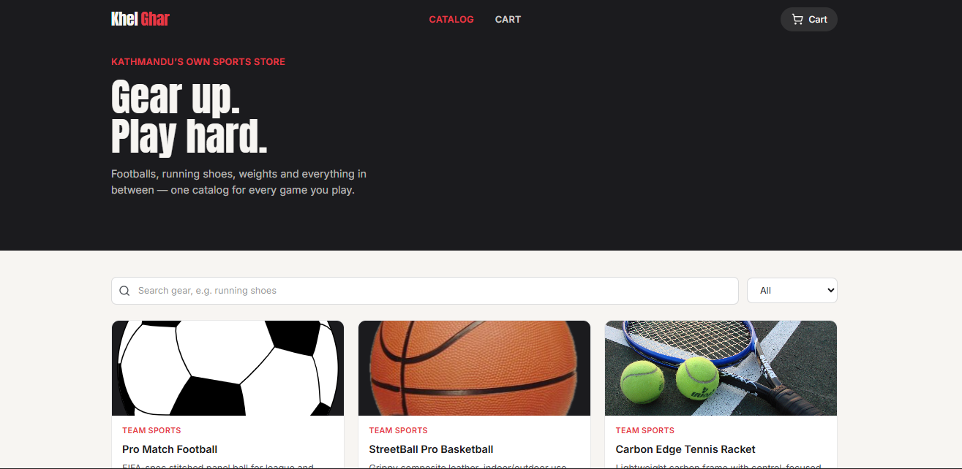

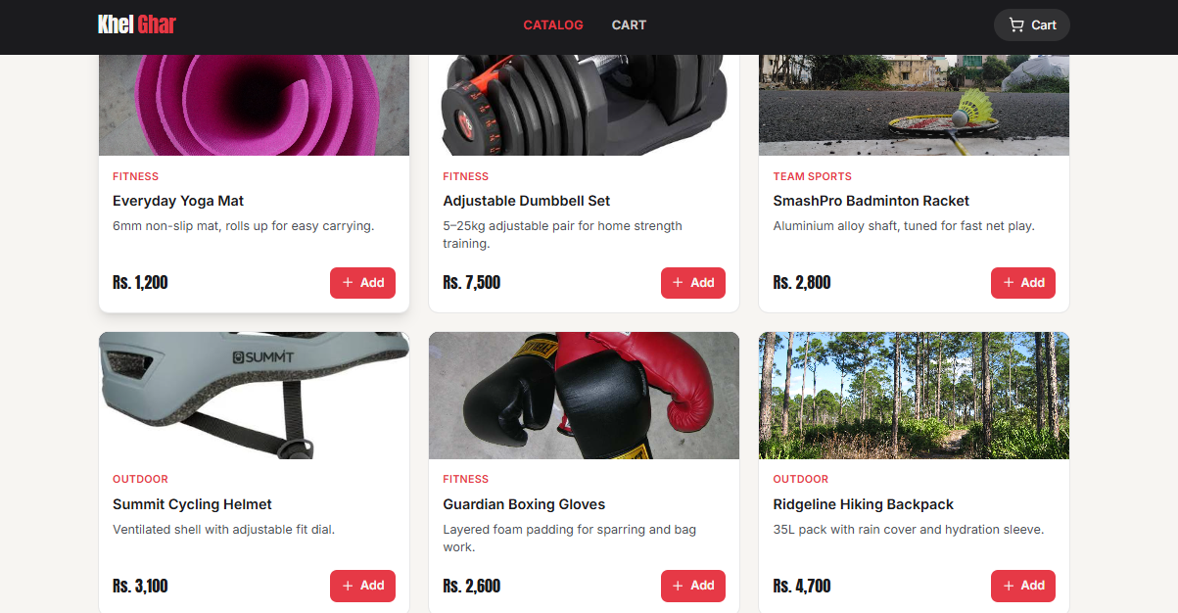
The hero banner, search bar and category dropdown, and the grid of product cards.

Cart page (“/cart”)
Each cart line with quantity controls and a remove button, next to the subtotal/shipping/total summary.
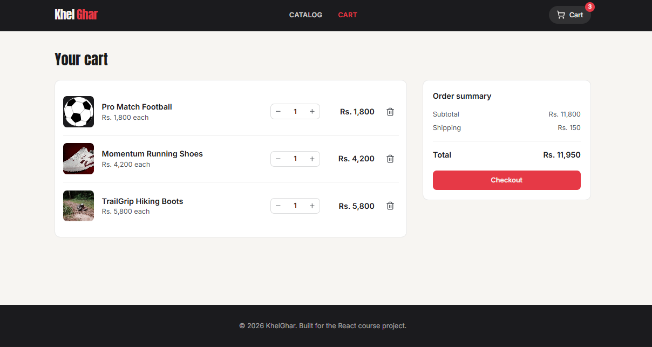

Empty cart
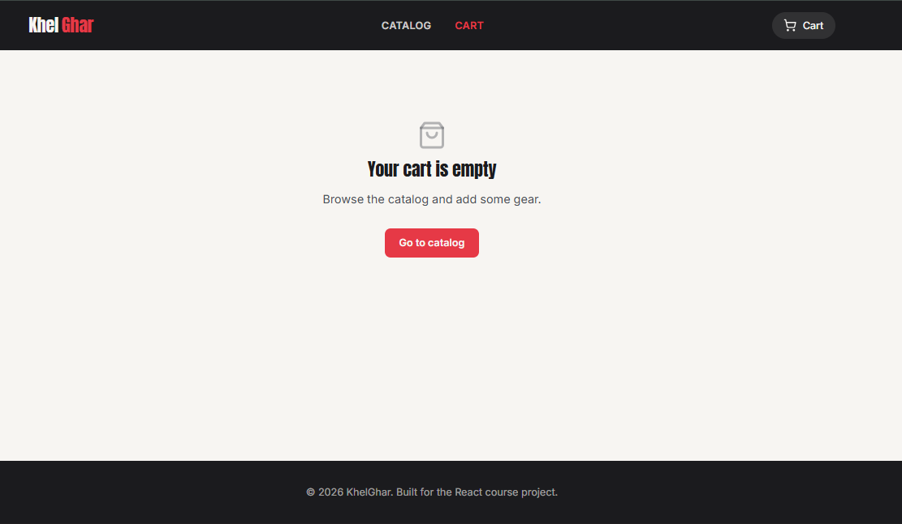What shows up when there's nothing in the cart yet.

Mobile width

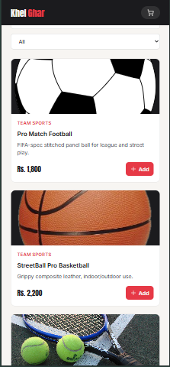
The same catalog page collapsed down to a single column.

8. React Concepts Used

Components
Eight functional pieces in total — Navbar, Footer, SearchFilter, ProductCard, ProductGrid, CartItem, and the two pages. Each one does roughly one thing: ProductCard only knows how to render a single product and report a click, ProductGrid only knows how to lay products out and show an empty state. That split is what makes ProductCard reusable once per product and CartItem reusable once per cart line, instead of one long file doing all of it.

Props
All parent-to-child data moves through props. App.jsx computes the cart items and hands down callback props — onAddToCart, onUpdateQuantity, onRemove — into the pages, which pass them further into the smaller components. No component reaches sideways into another one's state.

State
const [cart, setCart] = useLocalStorage("khelghar-cart", []);
cart is an array of { productId, quantity } objects. Local, page-only state uses plain useState instead — CatalogPage keeps its own searchTerm and category, for instance, since nothing outside that page needs them.

useEffect
useEffect(() => {
setIsLoading(true);
const timer = setTimeout(() => {
setProducts(PRODUCTS);
setIsLoading(false);
}, 500);
return () => clearTimeout(timer);
}, []);
This one fakes a network request on mount so there's an actual loading state to show. The other useEffect that matters is buried inside useLocalStorage — it writes the cart to localStorage every time it changes, which is the entire mechanism behind the cart surviving a refresh.

Context API
Deliberately not used. There's exactly one piece of shared state (the cart) and exactly two consumers of it (the two pages). Lifting that state to App.jsx and passing it down as props covers that case without adding a Provider and a custom hook for something this small. If the app grew to five or six pages all touching the cart, I'd probably reconsider.

React Router
<Routes>
<Route path="/" element={<CatalogPage onAddToCart={addToCart} />} />
<Route path="/cart" element={
<CartPage
cartItems={cartItems}
onUpdateQuantity={updateQuantity}
onRemove={removeFromCart}
/>
} />
</Routes>
Two routes, “/” and “/cart.” Navigation happens through Link and NavLink in the Navbar. I didn't need Outlet since the Navbar and Footer sit directly in App.jsx around <Routes> rather than behind a nested layout route.

Event handling
Button clicks (add, quantity up/down, remove, checkout) go through onClick handlers that call whichever callback prop was passed down. The search input and category select use onChange, updating state on every keystroke or selection so the filtering is live rather than waiting on a submit.

Forms
SearchFilter is controlled — both the text input and the select read their value from parent state and report changes back up. onSubmit is prevented from reloading the page, since there's nothing to submit; filtering already happens as you type.

9. Important Code Explanation

Adding an item to the cart
const addToCart = (productId) => {
setCart((prev) => {
const existing = prev.find((entry) => entry.productId === productId);
if (existing) {
return prev.map((entry) =>
entry.productId === productId
? { ...entry, quantity: entry.quantity + 1 }
: entry
);
}
return [...prev, { productId, quantity: 1 }];
});
};
If the product's already in the cart, its quantity goes up by one and everything else about that entry stays the same. If it isn't, a new entry gets appended. Using the callback form of setCart (prev => ...) matters here — without it, two quick clicks on the same product can both read the same stale cart value and only one increment actually sticks.

Updating quantity and removing
const updateQuantity = (productId, quantity) => {
if (quantity < 1) {
removeFromCart(productId);
return;
}
setCart((prev) =>
prev.map((entry) =>
entry.productId === productId ? { ...entry, quantity } : entry
)
);
};
const removeFromCart = (productId) => {
setCart((prev) => prev.filter((entry) => entry.productId !== productId));
};
That quantity < 1 check exists because I hit exactly that bug early on: clicking minus on a quantity of 1 dropped it to 0 and left a cart row sitting there showing “0” instead of disappearing. Routing anything below 1 into removeFromCart instead fixed it.

Persisting state with a custom hook
export function useLocalStorage(key, initialValue) {
const [value, setValue] = useState(() => {
const stored = window.localStorage.getItem(key);
return stored ? JSON.parse(stored) : initialValue;
});
useEffect(() => {
window.localStorage.setItem(key, JSON.stringify(value));
}, [key, value]);
return [value, setValue];
}
Wraps useState with a lazy initializer that reads whatever was saved last time, plus an effect that writes back on every change. Because it returns [value, setValue] just like the built-in hook, it drops in anywhere a persisted value is needed — here, just the cart.

Filtering the catalog
const filteredProducts = useMemo(() => {
return products.filter((product) => {
const matchesCategory = category === "All" || product.category === category;
const matchesSearch = product.name
.toLowerCase()
.includes(searchTerm.trim().toLowerCase());
return matchesCategory && matchesSearch;
});
}, [products, searchTerm, category]);
Both conditions have to hold, so a search term and a category filter narrow the list together rather than one overriding the other. useMemo just means this doesn't re-run on every keystroke of some unrelated state elsewhere on the page.

Conditional rendering
if (products.length === 0) {
return ( /* empty-state message */ );
}
return (
<div className="grid ...">
{products.map((product) => (
<ProductCard key={product.id} product={product} onAddToCart={onAddToCart} />
))}
</div>
);
ProductGrid bails out to an empty-state message before it ever tries to map an empty array, which is what makes the ‘no results’ message show up instead of a blank grid.

10. API Documentation
There isn't one. The catalog is static data in src/data/products.js, and the “fetch” in CatalogPage is a setTimeout, not a network call. No Axios, no fetch(), nothing hitting a server.
If I did wire up a backend later, the obvious place is exactly where that setTimeout sits now — swap it for a real fetch. A rough shape for what that backend might expose, purely for reference, not something this submission implements:
Method | Endpoint | Purpose
GET | /products | Replace the local mock catalog
GET | /products/:id | Single product detail
POST | /cart | Cart stored server-side instead of localStorage
PUT | /cart/:productId | Change one item's quantity
DELETE | /cart/:productId | Remove one item

11. Application Flow
User opens the app
↓
Catalog loads (fake fetch → loading spinner → grid)
↓
Search / filter narrows the list
↓
"Add" on one or more products
↓
Cart state updates in App.jsx, saved to localStorage
↓
Navigate to /cart via the navbar
↓
Adjust quantities or remove items
↓
"Checkout" → confirmation screen

12. Challenges Faced
The cart was the main source of friction, mostly because it's read and written from two places that don't share a parent any more specific than App.jsx. My first instinct was to reach for Context, but for one value with two consumers it seemed like more machinery than the problem needed, so I lifted the state instead and passed it down as props. That's held up fine so far.
Combining search and category filtering took a couple of tries to get right — my first version checked the category and, separately, re-ran the search filter on top of whatever the category filter had already produced, which worked but recalculated the array twice for no reason. Folding both checks into one .filter() call fixed that and reads more clearly besides.
The quantity bug mentioned in Section 9 (dropping to a visible “0” instead of disappearing) took longer to notice than to fix, since it only shows up if you decrease from exactly 1 rather than clicking remove directly.
Getting useEffect into the project honestly, rather than for the sake of the requirement, meant accepting that there's no real API to call. A fake timeout felt slightly artificial while I was writing it, but it does exercise the actual pattern — mount, fetch, update state, clean up — which is the point.
The last one wasn't really technical: most e-commerce course projects default to the same rounded-card, soft-shadow look, so I picked a charcoal/crimson palette and a condensed display font up front, before writing any components, specifically so KhelGhar wouldn't look identical to every other student's version of the same assignment.

13. Testing
No automated tests — everything below was checked by hand in the browser.
- Adding the same product twice increments its quantity instead of creating a duplicate row.
- Decreasing quantity to zero removes the item (see the bug note in Section 9).
- Search and category filter work separately and together, including the empty-results state.
- Refreshing the page keeps the cart, confirming localStorage actually persists it.
- Checked the layout at phone, tablet, and desktop widths in the browser's device toolbar.
- npm run build finishes with no errors or warnings that matter.

14. Limitations
- Product data is local and static, not a real backend.
- Checkout is a confirmation screen only — no payment processing.
- No accounts; the cart belongs to a browser, not a person, so it won't follow you to another device.
- No automated tests.
- Error handling is thin, since there are no real network requests that could actually fail.

15. Future Enhancements
- Swap the mock data for a real backend or public product API.
- Add accounts and a per-user order history.
- A dedicated product-detail route.
- Sorting and pagination on the catalog.
- A real payment flow (test mode) behind the checkout button.
- At least a handful of automated tests around the cart logic, since that's the part most likely to break silently.

16. Conclusion
KhelGhar ended up covering everything the assignment asked for — catalog browsing, search and filtering, a persistent cart, and navigation between two views — without needing anything outside what the course actually taught. The part that took the most iteration wasn't any single hook, it was getting the cart's state to behave correctly across two pages without over-building the solution.
If I had another week, I'd probably try rebuilding the cart around the Context API just to check whether it's actually cleaner than prop drilling for two consumers. My guess going in is that it wouldn't be, for something this small, but I'd rather confirm that than assume it.

17. References
- React documentation — https://react.dev/
- React Router documentation — https://reactrouter.com/
- Tailwind CSS documentation — https://tailwindcss.com/
- lucide-react — https://lucide.dev/
- Vite documentation — https://vitejs.dev/

18. GitHub Repository
Repository:
It contains:
- The project structure shown in Section 6
- README.md with setup instructions
- Full source
- package.json / package-lock.json
- .gitignore excluding node_modules, dist, and any .env file
No .env files, keys, or credentials are in the repository — there's nothing here that calls an external service that would need them.

