**Create database db_churn**

-**Data Exploration--- Check Distinct Values-----% distribution of distinct values-----**

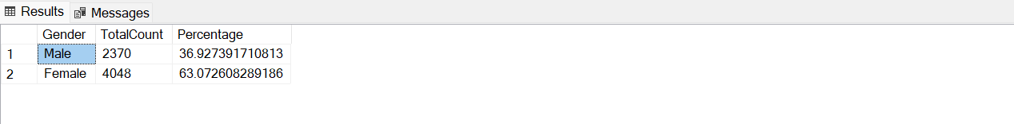

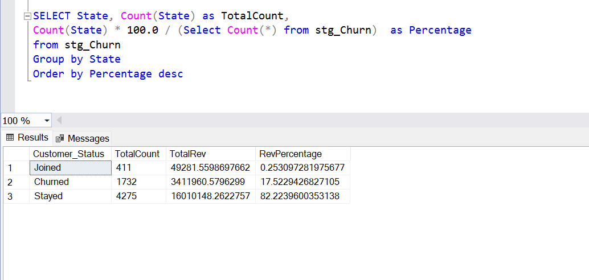

**Check Null values------**

**











**Remove null and insert the new data into Prod table**

**Create view**

