**SQL Query to categorize products based on their price**

**SQL statement to join dim_customers with dim_geography to enrich customer data with geographic information**

**Query to clean whitespace issues in the ReviewText column**

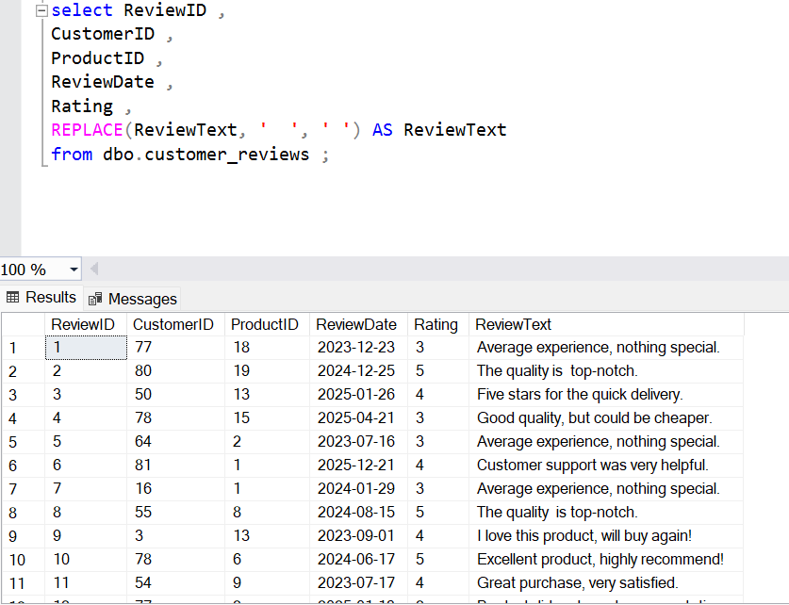

**Query to clean and normalize the engagement_data table**

**How do you clean and deduplicate customer journey data using SQL CTEs and window functions?**