BizTwin AI: An Adaptive Multi-Agent Decision Intelligence Engine for Small and Medium Business Operations
Ms. D. Brindha
Assistant Professor
Dept. of Artificial Intelligence and Data Science
Dr. N.G.P Institute of Technology
Coimbatore, India
brindha.d@drngpit.ac.in
Pranesh S
UG Student
Dept. of Artificial Intelligence and Data Science
Dr. N.G.P Institute of Technology
Coimbatore, India
23ad080@drngpit.ac.in
Sanjai M
UG Student
Dept. of Artificial Intelligence and Data Science
Dr. N.G.P Institute of Technology
Coimbatore, India
23ad094@drngpit.ac.in
Shri Subeesesh V K
UG Student
Dept. of Artificial Intelligence and Data Science
Dr. N.G.P Institute of Technology
Coimbatore, India
23ad120@drngpit.ac.in
Abstract—Small and medium-sized enterprises (SMEs) run point-of-sale, inventory, finance, supplier and customer systems that do not reason jointly, so decisions in one function ignore constraints in another. We present BizTwin AI, an implemented multi-agent control tower that maintains a business digital twin, monitors it for anomalies, and coordinates nine domain agents through an Adaptive Multi-Agent Decision Intelligence Engine (AMDIE). AMDIE weights agents by a learned reliability score passed through a temperature-controlled softmax, trains that score with a quantile (pinball) loss at an owner-chosen service level, and fuses recommendations by a constrained linear program whose optimum we show to be a weighted median. We evaluate replenishment decisions in a simulated retailer across three scenarios (adequate budget, tight budget, volatile demand and supply) with 10 held-out instances each, against operations-research baselines, single agents and unweighted ensembles. AMDIE outperforms the agent mean by 3.0 percentage points (pp) of profit in the baseline and volatile scenarios ($p_{\text{Holm}}<0.02$) and learns within four weeks to place 70–80% of its weight on the most reliable agent. It does not outperform a correctly specified newsvendor policy or that best agent alone, and ablation shows that two components (median-type LP fusion and an outlier penalty) bias it toward under-ordering. We report these results, and the corrections they imply, as guidance for multi-agent decision support in SMEs.
Keywords— multi-agent systems, decision fusion, business digital twin, inventory control, explainable AI, small and medium enterprises

Introduction
SMEs typically run several independent tools—POS terminals, inventory, accounting, CRM and supplier management—that were never designed to interoperate [1]. A reorder placed without the cash position, a price change made without the stock position, or a promotion launched without fulfilment capacity are each locally reasonable and jointly harmful. Adoption studies identify limited budgets, skills and data quality as the main barriers to analytics in this segment [2], so a useful system must coordinate functions without requiring a data-science team.
Two research lines suggest a design. Digital twins keep a synchronised virtual representation of a system for monitoring, prediction and what-if analysis, and have been extended from physical assets to business processes [3], [4]. Multi-agent systems decompose decisions among specialised agents, and recent work, including large language model (LLM) agents, argues that such systems need an explicit coordination layer rather than emergent coordination [5], [6]. What remains open is how that layer should combine agents whose recommendations conflict, and whether doing so actually improves business outcomes.
This paper makes four contributions:
- An implemented control-tower architecture (business twin, monitoring, forecasting, nine agents, explanations, copilot, and a human-in-the-loop automation policy) in which every decision type is scoped to the agents that answer on its axis (Sec. III).
- AMDIE, a coordination method combining reliability-weighted softmax weighting, service-level-aware outcome learning via pinball loss, and constrained LP fusion, with a characterisation of the fused decision as a weighted median (Sec. IV).
- A reproducible evaluation of replenishment decisions through the production code path: 510 paired simulation runs over three scenarios, operations-research and ensemble baselines, ablations and Holm-corrected tests (Secs. V–VI).
- An analysis of where adaptive multi-agent fusion helps and where it does not, including two components that measurably hurt (Sec. VII).

Related Work
SME analytics and digital twins. ERP and BI tools record and report history but rarely support cross-functional, forward-looking decisions; reviews of data-driven process management in micro, small and medium enterprises report benefits alongside persistent resource and skill barriers [1], [2]. Digital twins combine models with live operational data for monitoring and simulation [3]; the business-process manifesto of [4] identifies data integration and keeping the twin current as key open problems. Our twin is a database-backed snapshot updated by transactions rather than a process-mining model.
Multi-agent and LLM-based decision making. Surveys cover rule-based, game-theoretic, reinforcement-learning and LLM-based cooperation [5]; enterprise orchestration work emphasises explicit planning, policy and state management layers [6]. LLM multi-agent frameworks such as AutoGen [7] coordinate agents through conversation. InvAgent [8] applies zero-shot LLM agents to multi-echelon inventory and reports that reinforcement-learning baselines often achieve lower cost, trading performance for explainability and no training. OptiGuide [9] keeps a combinatorial solver in the loop and uses an LLM to answer what-if questions about its output. AMDIE likewise keeps numerical optimisation in the loop, but coordinates several heterogeneous agents instead of explaining one solver.
Inventory control. Periodic-review order-up-to (base-stock) policies are optimal for many single-item settings, and the newsvendor critical ratio sets the service level that balances underage and overage cost [10]. Deep reinforcement learning can match strong heuristics on lost-sales and multi-echelon problems but needs costly tuning [11], [12]. We use the classical policies as reference baselines.
Combining experts. Weighted combination of forecasts dates to Bates and Granger [13]; the “forecast combination puzzle” shows that simple averages often beat estimated weights because of weight-estimation error [14]. Exponential-weights algorithms such as Hedge [15] weight experts by a softmax of cumulative performance; our temperature-controlled weighting is of this form. Quantile (pinball) loss [16] is the proper loss for newsvendor-type decisions, which motivates our outcome scoring.
Explainability. Explanations that name contributing factors and counterfactual alternatives are a requirement for non-technical decision makers [17], [18], and conversational access lowers the adoption barrier for SMEs [19]. These motivate our per-agent traces and the copilot.

System Architecture
Fig. 1 shows the implemented system (FastAPI backend, SQL database, React frontend).
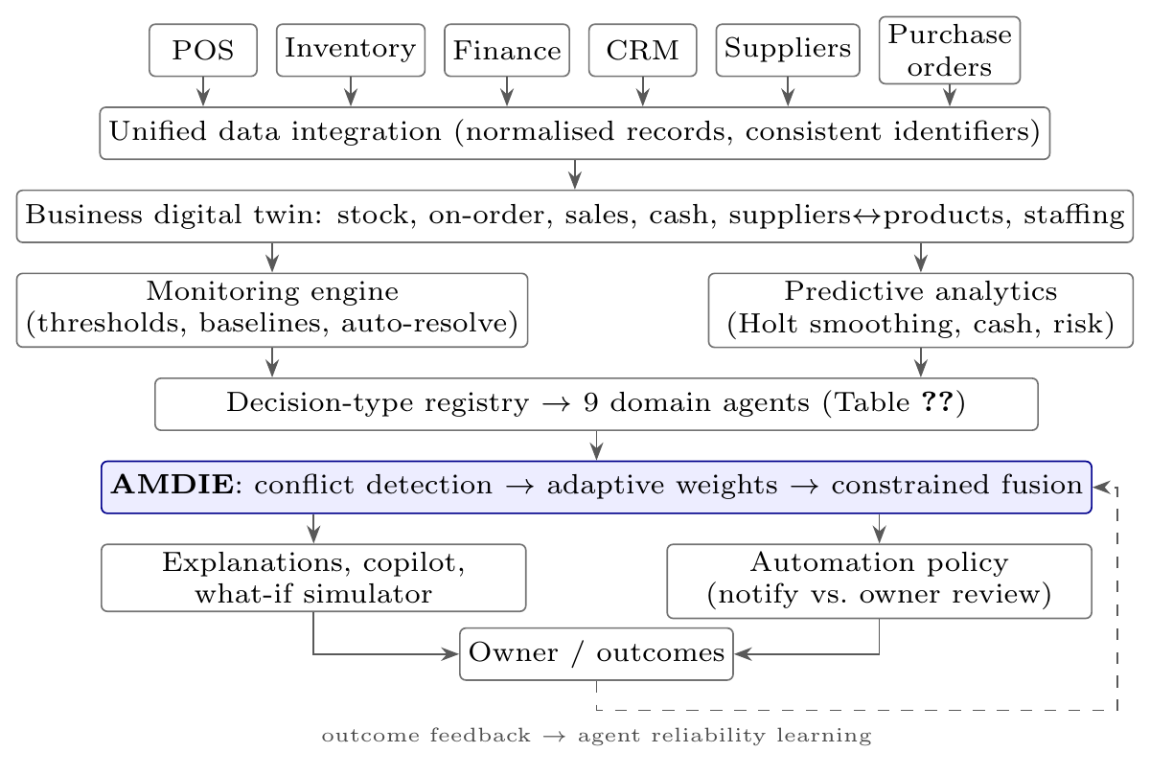
BizTwin AI architecture as implemented. Stock events from the monitoring engine trigger AMDIE automatically; realised outcomes update agent reliability.
Twin, monitoring and forecasting. The twin is a read-only snapshot over the operational database, including on-order stock from open purchase orders and supplier-to-product links. A scheduler scans all tenants every five minutes for stock depletion, cash shortfall, sales spikes relative to a 14-day baseline, and unreliable suppliers; events close automatically when the condition clears, and stock events trigger an AMDIE reorder cycle. Demand is forecast with Holt’s additive-trend exponential smoothing on the 90 preceding complete days [20].
Decision types and agents. Each decision type has a registered set of agents and a single numeric axis (Table I); agents that serve several types (Sales, Finance, Marketing) project their view onto the axis of the decision at hand, so fusion never mixes units. Signed axes (price, staffing) allow negative recommendations. A Risk agent acts as a modifier under a risk-averse goal rather than as a voter.
Decision registry: participating agents and decision axis
Decision type | Agents | Axis
Reorder quantity | Inventory, Sales, Finance, Procurement | units $≥0$
Price adjustment | Pricing, Sales (+ Risk modifier) | price $Δ$ (signed)
Promotion | Marketing, Finance | discount $∈[0,1]$
Staffing | HR, Sales, Finance | hours $Δ$ (signed)
Customer retention | Customer mgmt., Sales, Marketing | level $∈[0,1]$
Explanation and automation. Each decision is logged with every agent’s recommendation, rationale, weight components and solver trace; the explanation endpoint and the copilot answer from this log and from the twin. Autonomous decisions pass an automation policy: reorders below a cost limit are dispatched as notifications, while pricing, staffing and costly actions wait for owner approval. A what-if simulator re-applies the forecasting models to an in-memory copy of the state and reports its assumptions (e.g. an elasticity estimated from the product’s own price history).

AMDIE: Adaptive Multi-Agent Decision Fusion
For a decision of type $k$ on product $p$, each registered agent $i$ returns a recommendation $r_{i}$ on the axis of $k$, a confidence $c_{i}∈[0,1]$, a risk score $ρ_{i}∈[0,1]$, a rationale, and optionally a hard cap ${\overset{‾}{u}}_{i}$ (e.g. Finance’s affordable quantity).
Conflict detection. The conflict score is
$$κ=min\left(1,\max_{i<j}\frac{|r_{i}−r_{j}|}{max(|r_{i}|,|r_{j}|,1)}\right),$$
and a conflict is flagged when $κ>τ_{c}=0.3$; it is reported to the owner and recorded for audit.
Adaptive weights. Each agent receives the score
$$s_{i}=w_{1}R_{i}+w_{2}c_{i}+w_{3}H_{i}+w_{4}C_{i}−w_{5}ρ_{i}−w_{6}D_{i},$$
where $R_{i}$ is an exponentially smoothed reliability, $H_{i}$ the mean historical accuracy, $C_{i}$ the cosine similarity between a sentence embedding [21] of the decision context and the agent’s domain description, and $D_{i}=min(1,|r_{i}−\tilde{r}|/max(|\tilde{r}|,1))$ the deviation from the median recommendation $\tilde{r}$. Weights are
πi=exp(si/T)j​exp(sj/T).
Because $s_{i}$ lies in a narrow range, $T=1$ yields nearly uniform weights; a small $T$ makes the scheme an exponential-weights rule over reliability [15].
Service-level-aware outcome learning. When a decision’s outcome $y$ is known (for replenishment, the ex-post order quantity that would have exactly covered demand), each agent’s accuracy is scored with the pinball loss at level $q$:
$$a_{i}=1−\frac{q (y−r_{i})^{+}+(1−q) (r_{i}−y)^{+}}{max(q,1−q) max(|r_{i}|,|y|,1)}.$$
For $q=0.5$ this is the symmetric relative error; for $q>0.5$ under-ordering (lost sales) is penalised more than over-ordering, which is the newsvendor optimality condition [10], [16]. $q$ is an owner-level service target. Reliability is updated as $R_{i}←0.3 a_{i}+0.7 R_{i}$, and after 30 outcomes the coefficients $w_{1..6}$ are refitted by non-negative least squares of $a_{i}$ on the score components, per tenant and decision type.
Constrained fusion. The fused decision solves the LP (HiGHS [22])
maxx, u &i​πiui − λcx + λtmin(x,d)s.t. &ui≤1−|x−ri|/σi, 0≤ui≤1,&ℓk≤x≤min(Uk,miniui), unit cost⋅x≤B,
with triangular utilities of half-width $σ_{i}=(0.4|r_{i}|+δ)/c_{i}$, axis bounds $[ℓ_{k},U_{k}]$, budget $B$, and goal-dependent cost and turnover terms $λ_{c},λ_{t}$ (zero under profit maximisation).
Proposition 1. If $λ_{c}=λ_{t}=0$ and the optimum lies within every agent’s utility support, the solution of (5) is a weighted median of $\{r_{i}\}$ with weights $π_{i}/σ_{i}$, clipped to the feasible interval.
Proof. [Sketch] At the optimum $u_{i}=1−|x−r_{i}|/σ_{i}$, so the objective is i​πi−i​(πi/σi)|x−ri|, a convex piecewise-linear function of $x$ minimised at the weighted median; feasibility constraints clip it. $▫$ The fused value therefore never lies outside the range of agent recommendations, and, because $σ_{i}$ grows with $|r_{i}|$, agents recommending larger values receive proportionally less influence. Algorithm 1 summarises one cycle.
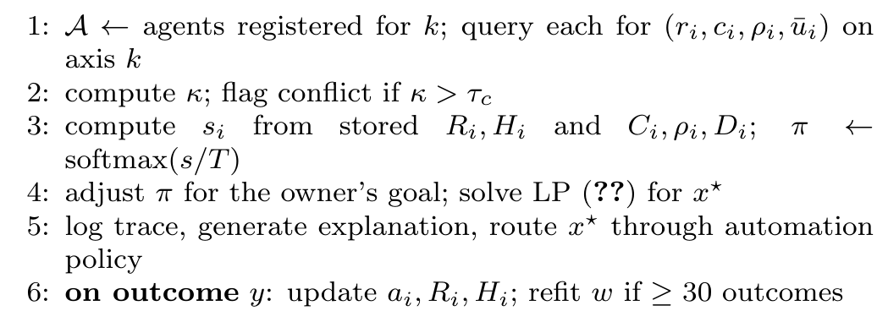
Algorithm 1: One AMDIE cycle for decision type $k$

Experimental Setup
Only replenishment has an objective, simulable ground truth, so we evaluate AMDIE on reorder quantity. Pricing, promotion, staffing and retention decisions are executed by the same pipeline but would require field data or controlled experiments to evaluate.
Environment. A seeded retailer with 8 products, 120 days of history and a 140-day test horizon reviewed weekly (20 cycles). Daily demand is $d_{t}∼N(μ_{t},(vμ_{t})^{2})$, rounded and floored at zero, with $μ_{t}=b(1+g t/365)(1+0.25sin\frac{2πt}{7})(1+asin(\frac{2πt}{365}+ϕ))$ and product-specific $b,g,a,ϕ,v$. Lead times are stochastic per order. Unmet demand is lost; holding cost is 25% of unit cost per year; each order line costs 15; orders are paid on placement and truncated to a shared weekly purchase budget and available cash. Only censored sales are recorded, as a POS would. Three scenarios vary the conditions: baseline (budget 1.5$×$ expected cost of goods, $v∈[0.2,0.4]$), tight budget (0.8$×$), and volatile ($v∈[0.4,0.7]$, a 3-week demand surge or drop for half the products, doubled lead-time variance, 30% unreliable suppliers).
Same code path. Agent policies call the production agents and AMDIE calls the API’s decision function against the simulator’s database; orders are written as purchase orders, so agents see on-order stock. After each order’s protection interval, the ex-post quantity is fed back as the outcome, as the outcome endpoint does in deployment.
Policies. Newsvendor and base-stock (95% cycle service) order-up-to policies on observed sales [10]; each single agent; the unweighted mean and median of the four agents; AMDIE; seven ablations; and a perfect-foresight order-up-to reference that knows future demand and lead times (not an upper bound, since it holds no buffer for the next order’s lead time).
Protocol. Policies run on identical instances (common random numbers), so comparisons are paired. The softmax temperature $T∈\{1,0.2,0.05,0.02\}$ and service level $q∈\{0.5,0.9\}$ were selected on four development seeds per scenario ($T=0.05$, $q=0.9$); all reported results use 10 different held-out seeds per scenario (510 runs). The primary metric is profit (revenue minus purchases, holding and ordering cost, plus the change in inventory value) relative to base-stock on the same instance. We report means with 95% CIs and paired $t$-tests across seeds with Holm correction within each scenario; product-level Wilcoxon tests agree in direction. An AMDIE decision takes 0.26 s on a desktop CPU.

Results
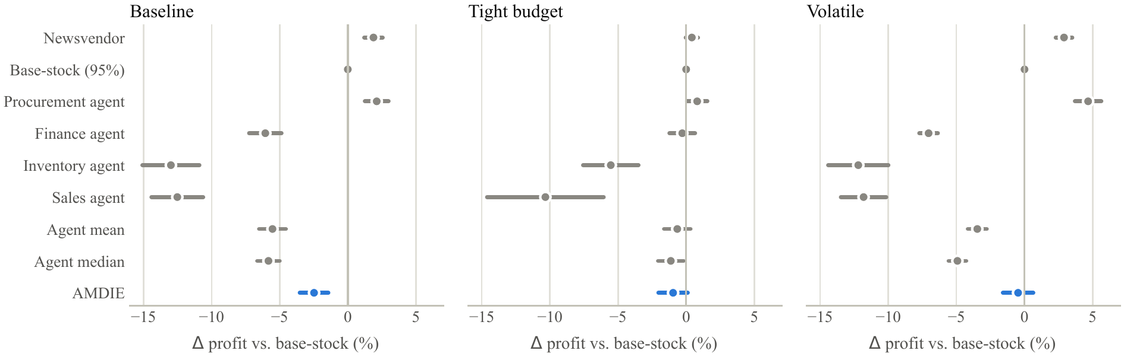
Profit relative to the base-stock policy on the same instance (mean and 95% CI over 10 held-out instances per scenario).
 | Baseline |  | Tight budget |  | Volatile
2-3(lr)4-5(l)6-7 Method | $Δ$ profit | Fill | $Δ$ profit | Fill | $Δ$ profit | Fill
Newsvendor order-up-to | $+1.88$ [$+1.20$, $+2.57$] | 0.970 | $+0.42$ [$−0.04$, $+0.87$] | 0.735 | $+2.90$ [$+2.29$, $+3.51$] | 0.928
Base-stock (95% service) | 0 | 0.951 | 0 | 0.733 | 0 | 0.900
Procurement agent only | $+2.12$ [$+1.25$, $+3.00$] | 0.972 | $+0.81$ [$+0.06$, $+1.56$] | 0.737 | $+4.67$ [$+3.69$, $+5.64$] | 0.947
Finance agent only | $−6.06$ [$−7.25$, $−4.86$] | 0.894 | $−0.29$ [$−1.23$, $+0.66$] | 0.729 | $−7.04$ [$−7.73$, $−6.36$] | 0.836
Inventory agent only | $−12.99$ [$−15.09$, $−10.89$] | 0.827 | $−5.53$ [$−7.57$, $−3.50$] | 0.699 | $−12.20$ [$−14.42$, $−9.99$] | 0.792
Sales agent only | $−12.52$ [$−14.42$, $−10.61$] | 0.824 | $−10.34$ [$−14.62$, $−6.05$] | 0.664 | $−11.82$ [$−13.49$, $−10.15$] | 0.791
Agent mean | $−5.53$ [$−6.52$, $−4.54$] | 0.900 | $−0.65$ [$−1.63$, $+0.32$] | 0.728 | $−3.47$ [$−4.16$, $−2.77$] | 0.871
Agent median | $−5.83$ [$−6.65$, $−5.00$] | 0.896 | $−1.13$ [$−2.07$, $−0.19$] | 0.725 | $−4.93$ [$−5.58$, $−4.28$] | 0.857
AMDIE | $−2.48$ [$−3.53$, $−1.42$] | 0.927 | $−0.96$ [$−2.04$, $+0.12$] | 0.726 | $−0.47$ [$−1.59$, $+0.65$] | 0.899
Perfect-foresight reference | $−3.07$ [$−4.67$, $−1.47$] | 0.924 | $+0.05$ [$−1.04$, $+1.14$] | 0.731 | $−5.90$ [$−8.06$, $−3.75$] | 0.848
Table II and Fig. 2 summarise the comparison.
Against naive multi-agent aggregation. AMDIE outperforms the unweighted agent mean by $+3.05$ pp (baseline, 9/10 instances, $p_{\text{Holm}}=0.006$) and $+2.99$ pp (volatile, 10/10, $p_{\text{Holm}}=0.014$), and the agent median by $+3.35$ and $+4.45$ pp ($p_{\text{Holm}}≤0.002$). It also outperforms the Finance, Inventory and Sales agents in both scenarios ($p_{\text{Holm}}<0.01$).
Against strong baselines. AMDIE does not reach the best single agent or the newsvendor policy. In the baseline scenario it trails base-stock by $2.48$ pp, newsvendor by $4.36$ pp and the Procurement agent by $4.60$ pp (all $p_{\text{Holm}}<0.01$). In the volatile scenario it is statistically indistinguishable from base-stock ($−0.47$ pp, $p_{\text{Holm}}=0.73$) but trails newsvendor and Procurement. Under the tight budget, truncation by the budget dominates every policy (fill rates 0.66–0.74, 30–38% of orders truncated), and no AMDIE comparison except against Procurement ($−1.77$ pp) and the two weakest agents is significant after correction.
Learned trust. Fig. 3 shows that AMDIE starts by trusting the Sales agent (high self-reported confidence) and, as outcomes arrive, shifts 70–80% of its weight to Procurement—the agent with the best realised profit—within four review cycles; the same pattern holds in all three scenarios. Agents disagreed on 99% of decisions ($κ>0.3$), so the conflict flag is not informative at the current threshold.
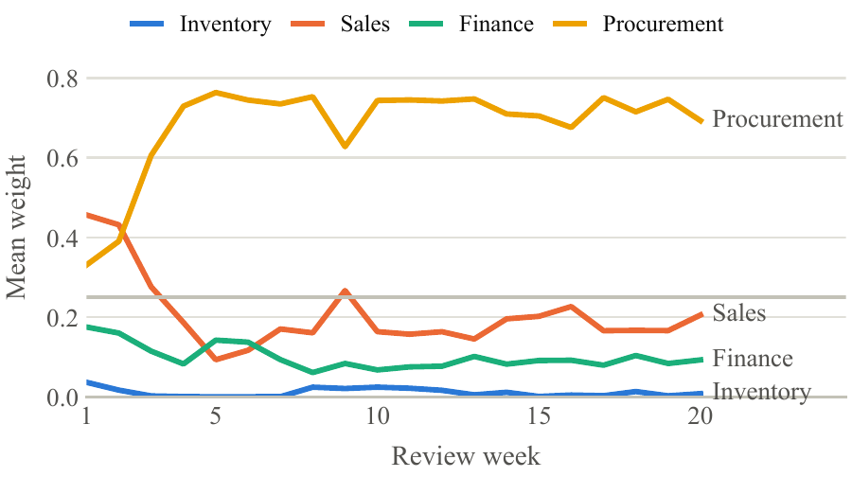
Mean AMDIE weight per agent over the review cycles (baseline scenario, 10 instances). Grey line: uniform weight.
Ablation. Table III removes one component at a time. Adaptive weighting and outcome learning are essential: equal weights cost 2.9 and 5.1 pp, freezing reliability 1.6 and 2.5 pp, and the untuned configuration ($T=1$, $q=0.5$) is as poor as equal weights, confirming that a flat softmax neutralises the weighting. Two components hurt: replacing the LP by a weighted average gains $+2.2$ and $+2.4$ pp, and removing the divergence penalty gains $+1.9$ and $+1.4$ pp. Context relevance and Finance’s hard cap have no measurable effect in this setting, because the shared budget, not the per-product cap, is binding.
Ablation: change in profit (pp of base-stock profit) when a component is removed; $​^{*}$ $p_{\text{Holm}}<0.05$
Removed component | Baseline | Tight | Volatile
Tuning ($T=1$, $q=0.5$) | $−{2.78}^{*}$ | $+0.55$ | $−{4.85}^{*}$
Adaptive weights (equal) | $−{2.92}^{*}$ | $+0.77$ | $−{5.10}^{*}$
Outcome learning | $−{1.64}^{*}$ | $+0.50$ | $−{2.52}^{*}$
LP fusion (weighted average) | $+{2.23}^{*}$ | $+0.75$ | $+{2.38}^{*}$
Divergence penalty | $+{1.89}^{*}$ | $+0.97$ | $+{1.40}^{*}$
Context relevance | $−0.34$ | $+0.37$ | $−0.58$
Finance hard cap | $0.00$ | $0.00$ | $0.00$

Discussion and Limitations
Why AMDIE helps. The four agents differ by up to 15 pp in profit, and which one is best is not known in advance. Exponential weighting over a service-aware reliability signal identifies the strongest agent from operational outcomes alone, which is why AMDIE recovers most of the gap between the naive ensembles and the best agent, consistent with the online-learning view of expert combination [15].
Why it falls short. The remaining gap has an identifiable cause. By Proposition 1, the LP returns a weighted median with weights $π_{i}/σ_{i}$, and $σ_{i}$ grows with $|r_{i}|$; the divergence penalty likewise down-weights agents far from the median. The best agent in this domain is the one that holds the most safety stock, so both mechanisms pull the decision toward the more conservative agents: AMDIE’s fill rate (0.927) lies between the ensemble (0.900) and Procurement (0.972). Removing either mechanism improves profit, which points to a weighted-average fusion without the outlier penalty as the next version. Because this was observed on the test instances, it must be confirmed on fresh instances before being claimed. The newsvendor policy is the right model for this simulated environment by construction; AMDIE’s value lies in combining heterogeneous agents across decision types with an auditable trace, not in beating a correctly specified single-item policy. Our results also echo the forecast-combination literature: estimated weights help only when agents differ substantially [14], as the tight-budget scenario illustrates.
Limitations. The evaluation is simulated, covers one decision type, and uses synthetic demand, so field validation with SME data remains necessary. An LLM decision-maker baseline is implemented but was not completed within free-tier API limits. No user study of the explanations or copilot has been conducted. The conflict threshold needs calibration per decision type. The twin consolidates sensitive financial and customer data; the implementation uses role-based access and encrypted cost fields, but a full governance assessment is outside our scope.

Conclusion
BizTwin AI implements a business control tower in which nine domain agents are coordinated by AMDIE. In 510 paired simulation runs, adaptive, outcome-trained weighting clearly beats unweighted agent aggregation and matches a base-stock policy under volatile conditions, while two fusion components introduce a conservative bias that keeps it below the best single agent and the newsvendor policy. Future work will (i) validate weighted-average fusion without the outlier penalty on fresh instances, (ii) complete the LLM-agent baseline, (iii) evaluate pricing and staffing decisions with field data, and (iv) study explanation quality with SME owners. This work supports UN Sustainable Development Goal 8 (decent work and economic growth).

References
[1] G. Garcı́a-Vidal, A. Sánchez-Rodrı́guez, L. Guzmán-Vilar, R. Martı́nez-Vivar, and R. Pérez-Campdesuñer, “Exploring MSME owners’ expectations of data-driven approaches to business process management,” Systems, vol. 13, no. 4, p. 265, 2025, doi: 10.3390/systems13040265.
[2] P. Maroufkhani, M.-L. Tseng, M. Iranmanesh, W. K. W. Ismail, and H. Khalid, “Big data analytics adoption: Determinants and performances among small to medium-sized enterprises,” International Journal of Information Management, vol. 54, p. 102190, 2020.
[3] F. Tao, H. Zhang, A. Liu, and A. Y. C. Nee, “Digital twin in industry: State-of-the-art,” IEEE Transactions on Industrial Informatics, vol. 15, no. 4, pp. 2405–2415, 2019.
[4] F. Fornari et al., “Digital twins of business processes: A research manifesto,” Internet of Things, vol. 30, p. 101477, 2025, doi: 10.1016/j.iot.2024.101477.
[5] W. Jin, H. Du, B. Zhao, X. Tian, B. Shi, and G. Yang, “A comprehensive survey on multi-agent cooperative decision-making: Scenarios, approaches, challenges and perspectives.” arXiv:2503.13415, 2025.
[6] A. Adimulam, R. Gupta, and S. Kumar, “The orchestration of multi-agent systems: Architectures, protocols, and enterprise adoption.” arXiv:2601.13671, 2026.
[7] Q. Wu et al., “AutoGen: Enabling next-gen LLM applications via multi-agent conversation.” arXiv:2308.08155, 2023.
[8] Y. Quan and Z. Liu, “InvAgent: A large language model based multi-agent system for inventory management in supply chains,” in AAAI 2025 workshop on advancing LLM-based multi-agent collaboration, 2025.
[9] B. Li, K. Mellou, B. Zhang, J. Pathuri, and I. Menache, “Large language models for supply chain optimization.” arXiv:2307.03875, 2023.
[10] P. H. Zipkin, Foundations of inventory management. Boston, MA: McGraw-Hill, 2000.
[11] J. Gijsbrechts, R. N. Boute, J. A. Van Mieghem, and D. J. Zhang, “Can deep reinforcement learning improve inventory management? Performance on lost sales, dual-sourcing, and multi-echelon problems,” Manufacturing & Service Operations Management, vol. 24, no. 3, pp. 1349–1368, 2022.
[12] R. N. Boute, J. Gijsbrechts, W. van Jaarsveld, and N. Vanvuchelen, “Deep reinforcement learning for inventory control: A roadmap,” European Journal of Operational Research, vol. 298, no. 2, pp. 401–412, 2022.
[13] J. M. Bates and C. W. J. Granger, “The combination of forecasts,” Operational Research Quarterly, vol. 20, no. 4, pp. 451–468, 1969.
[14] J. Smith and K. F. Wallis, “A simple explanation of the forecast combination puzzle,” Oxford Bulletin of Economics and Statistics, vol. 71, no. 3, pp. 331–355, 2009.
[15] Y. Freund and R. E. Schapire, “A decision-theoretic generalization of on-line learning and an application to boosting,” Journal of Computer and System Sciences, vol. 55, no. 1, pp. 119–139, 1997.
[16] R. Koenker and G. Bassett, “Regression quantiles,” Econometrica, vol. 46, no. 1, pp. 33–50, 1978.
[17] M. Mersha, K. Lam, J. Wood, A. AlShami, and J. Kalita, “Explainable artificial intelligence: A survey of needs, techniques, applications, and future direction,” Neurocomputing, vol. 599, p. 128111, 2024.
[18] S. Dandl, C. Molnar, M. Binder, and B. Bischl, “Multi-objective counterfactual explanations,” in Parallel problem solving from nature – PPSN XVI, in Lecture notes in computer science, vol. 12269. Springer, 2020.
[19] U. Radhakrishnan, “Documenting SME processes with conversational AI: From tacit knowledge to BPMN.” arXiv:2512.05122, 2025.
[20] R. J. Hyndman and G. Athanasopoulos, Forecasting: Principles and practice, 3rd ed. Melbourne, Australia: OTexts, 2021.
[21] N. Reimers and I. Gurevych, “Sentence-BERT: Sentence embeddings using Siamese BERT-networks,” in Proc. Conf. Empirical methods in natural language processing (EMNLP), 2019, pp. 3982–3992.
[22] Q. Huangfu and J. A. J. Hall, “Parallelizing the dual revised simplex method,” Mathematical Programming Computation, vol. 10, no. 1, pp. 119–142, 2018.

