TRIBHUVAN UNIVERSITY
INSTITUTE OF ENGINEERING
PULCHOWK CAMPUS

CONNECTHUB: A MULTI-CLIENT LAN CHAT AND FILE SHARING APPLICATION

A PROJECT REPORT
SUBMITTED IN PARTIAL FULFILLMENT OF THE REQUIREMENTS FOR THE DEGREE OF BACHELOR OF ENGINEERING IN ELECTRONICS AND COMPUTER ENGINEERING

Submitted by:  Prabesh BC (080BCT054)  Saroj Rawal (080BCT076)  Subesh Yadav (080BCT084) | Submitted to:  Department of Electronics &  Computer Engineering  Pulchowk Campus, IOE  Tribhuvan University, Nepal

August, 2026

Abstract
ConnectHub is a working multi-client LAN chat and file-sharing application written entirely in plain C. It uses nothing beyond the C standard library and standard POSIX calls — no external frameworks, no third-party libraries. Every part of the system, from the network layer to the terminal interface, is built from scratch using system calls taught in the undergraduate curriculum: socket, bind, listen, accept, pthread_create, select, read, and write.
The application follows a classic client–server design. A single multithreaded server manages all connected users, chat rooms, and file transfers. Each client gets its own POSIX thread on the server, and shared data is protected by mutexes. On the client side, a single select() loop watches both the keyboard and the network at the same time, so the terminal stays responsive even during a file upload.
All messages follow a custom text-based protocol — pipe-delimited, newline-terminated lines — that is easy to read and debug with any terminal tool. The system supports room-based chat, private messaging, typing indicators, join/leave notifications, room history, SHA-256 password authentication, and bidirectional file transfer with token-based access control.
Keywords: TCP sockets, POSIX threads, select(), concurrent server, LAN chat, file transfer, custom protocol, C programming, SHA-256

Acknowledgements
We thank the Department of Electronics and Computer Engineering, Pulchowk Campus, for giving us the opportunity to undertake this project as part of our Bachelor's program.
We are grateful to our project supervisor for the guidance and feedback provided throughout the design and implementation phases. The advice received at key decision points significantly shaped the final outcome.
We also acknowledge the faculty members whose lectures on systems programming, computer networking, and operating systems laid the conceptual foundation for this work. The understanding we gained from those courses directly informed every design choice in ConnectHub.
Finally, we thank the authors of the references listed at the end of this report, whose published work served as an essential guide.

Table of Contents

1. Introduction 1
1.1 Background 1
1.2 Motivation 1
1.3 Scope 2
2. Problem Statement 3
3. Objectives 4
3.1 Main Objective 4
3.2 Specific Objectives 4
4. Literature Review 5
4.1 Theoretical Background 5
4.2 Related Works 5
4.3 Gap Analysis 6
5. System Design and Architecture 7
5.1 System Overview 7
5.2 Server Architecture 8
5.3 Client Architecture 9
5.4 Wire Protocol Design 9
5.5 Data Structures 10
5.6 Module Structure 11
6. Implementation 12
6.1 Technology Stack 12
6.2 Module Breakdown 12
6.3 Authentication 13
6.4 Room Management 13
6.5 Messaging 14
6.6 File Transfer 14
6.7 Build System 15
7. Testing and Validation 16
7.1 Integration Testing 16
7.2 Concurrency and Stress Testing 16
7.3 Wire-Level Verification 17
8. Results and Discussion 18
9. Conclusion and Future Work 19
9.1 Conclusion 19
9.2 Future Work 19
10. References 20

List of Figures
Figure 1 LAN Deployment Topology 7
Figure 2 Two-Tier Client–Server Architecture 7
Figure 3 Server Thread Model and Locking Strategy 8
Figure 4 File Transfer Sequence 14
Figure 5 Module Dependency Map 11

List of Tables
Table 1 Gap Analysis Summary 6
Table 2 Client → Server Protocol Messages 9
Table 3 Server → Client Protocol Messages 10
Table 4 Server Shared Data Structures 10
Table 5 Codebase Module Breakdown 11
Table 6 ConnectHub Technology Stack 12
Table 7 Concurrency and Stress Test Results 16
Table 8 Project Objectives Outcome 18

List of Abbreviations
Abbreviation | Meaning
API | Application Programming Interface
CLI | Command-Line Interface
DM | Direct Message
FD | File Descriptor
I/O | Input/Output
IRC | Internet Relay Chat
LAN | Local Area Network
POSIX | Portable Operating System Interface
SHA | Secure Hash Algorithm
TCP | Transmission Control Protocol
TUI | Terminal User Interface
TU | Tribhuvan University
IOE | Institute of Engineering

1. Introduction

1.1 Background
Chat applications look simple to users, but building one from scratch requires solving real problems in networking, concurrency, and protocol design. ConnectHub is the result of doing exactly that — a multi-client LAN chat and file-sharing application written entirely in plain C, without any external library doing the heavy lifting.
The server handles multiple simultaneous clients using POSIX threads. The client is a lightweight terminal program that uses select() to watch both the keyboard and the network socket at the same time. Every part of the system — the wire format, the thread model, the locking strategy, the file transfer flow — is visible in the source code and directly corresponds to concepts covered in the undergraduate systems-programming and networking curriculum.

1.2 Motivation
Modern chat and file-sharing tools like WhatsApp or Discord require internet access and rely on remote proprietary servers. In closed environments such as a computer lab or an offline classroom, these tools simply do not work. Beyond the connectivity issue, commercial applications hide all the networking mechanics behind high-level abstractions, so they offer no educational value for someone learning how protocols, sockets, and threads actually work.
ConnectHub was built to address both of these problems:
- It works fully offline, within a LAN. Every device only needs to reach the same router or switch — over WiFi or Ethernet. No internet connection, no external server, no subscription.
- It is transparent by design. Every design decision is visible in the source code. The wire protocol can be read with netcat. The thread model can be studied in server.c. There are no black boxes.

1.3 Scope
ConnectHub is scoped to a trusted academic LAN environment. It includes:
- A concurrent TCP server supporting up to 128 simultaneous clients using POSIX threads and mutexes
- A terminal-based, single-threaded client driven by one select() loop
- A custom human-readable text protocol for all client–server communication
- Room-based public chat and private direct messaging
- Real-time typing indicators and join/leave presence notifications
- Per-room message history (last 50 lines replayed on join)
- Token-guarded, base64-chunked file transfer routed through the server
- An admin interface for managing users, rooms, and server statistics
The application does not implement transport encryption. This is a deliberate scope decision for a trusted LAN teaching project and is discussed further in Section 8.

2. Problem Statement
ConnectHub addresses five specific gaps:
- No offline LAN communication tool. Most chat and file-sharing tools require internet access. No lightweight, self-hosted option exists for closed LAN environments like computer labs or offline classrooms.
- Black-box protocols. Commercial messaging applications do not expose their wire format. Students cannot inspect or learn from them.
- Teaching examples stop at one client. Standard beginner socket tutorials handle only a single client at a time. They deliberately skip multi-client concurrency — the most important part from a systems-programming perspective.
- Chat and file transfer are taught separately. Existing course exercises cover either chat or file transfer in isolation. No standard teaching example integrates both into one coherent application.
- Terminal clients block on one input. Simple client examples block on either keyboard input or network data, but not both. Non-blocking select()/poll()-based clients are rarely demonstrated in practice.
ConnectHub closes all five gaps in a single, working, C-only application.

3. Objectives

3.1 Main Objective
To design and implement a complete, multi-client LAN chat and file-sharing application in plain C using only standard POSIX APIs, demonstrating applied understanding of socket programming, concurrent server design, protocol engineering, and systems-level I/O multiplexing.

3.2 Specific Objectives
- Design a lightweight, text-based wire protocol for all client–server communication.
- Implement a concurrent TCP server using POSIX threads with mutex-protected shared state.
- Build a single-threaded terminal client using select() for simultaneous keyboard and network I/O.
- Support room-based public messaging and private direct messaging.
- Implement password authentication using a SHA-256 implementation written from scratch.
- Enable bidirectional file transfer between clients, routed through the server in base64-encoded chunks with per-transfer token validation.
- Provide typing indicators and user presence notifications.
- Build an admin interface for user and room management.
- Validate correctness through integration tests, concurrency stress tests, and wire-level inspection.

4. Literature Review

4.1 Theoretical Background
ConnectHub draws on three main areas of systems-programming theory.
TCP/IP socket programming. The BSD socket API — socket(), bind(), listen(), accept(), connect(), send(), recv() — is the backbone of virtually all networked software [4]. TCP guarantees ordered, reliable delivery, which is essential for a chat and file transfer application where messages must arrive in sequence [5]. In the UNIX model, a socket is simply a file descriptor, which means the same read()/write() calls used for files work for network connections too [3].
Concurrent server design. A server that needs to handle many clients at once typically spawns one POSIX thread per accepted connection [3, 6]. Threads within the same process share memory — including the user list, room tables, and transfer state — and all shared data must be protected by mutexes to prevent race conditions and deadlocks.
I/O multiplexing. The select() system call lets a single-threaded program monitor multiple file descriptors at once and react to whichever is ready first [4]. ConnectHub uses this on the client to watch both stdin and the server socket simultaneously, eliminating the need for a second thread. For the protocol itself, line-delimited text formats (as used by IRC [7]) are simple to implement, human-readable, and easy to debug — a natural fit for an educational project.

4.2 Related Works
A review of existing chat implementations in the literature and standard course material shows a consistent pattern of partial solutions:
- Basic socket tutorials [8] teach TCP connection setup and echo servers, but stop at one client. No concurrency, no rooms, no file transfer.
- Multi-threaded chat demos add per-client threads and broadcasting, but typically support only a single channel with no private messaging or room management [6].
- IRC [7] is a well-documented, production-grade line-based protocol that has channels and private messages. It served as a primary design reference for ConnectHub's own protocol, though ConnectHub's version is considerably simpler.
- Standard course exercises — echo servers, concurrent TCP servers, select()-based clients — provide the individual building blocks that ConnectHub combines into one complete application [4].

4.3 Gap Analysis
Gap | ConnectHub's Answer
Single-client only examples | Concurrent server with up to 128 clients
No room/channel support in demos | Named rooms with access control and history
No private messaging in demos | Full DM system between any two users
Chat and file transfer taught separately | Integrated in one application
Blocking terminal clients | `select()`-based non-blocking client
Black-box protocols | Custom human-readable text protocol

5. System Design and Architecture

5.1 System Overview
ConnectHub follows a two-tier client–server design over TCP. The server is the single source of truth: it holds the connected-user list, registered accounts, active rooms, message history, and in-progress file transfers. Multiple client processes connect to it, authenticate, and then exchange messages and files through the server as an intermediary. There is no peer-to-peer component — all traffic flows through the server.
Figure 1 — LAN Deployment Topology. ConnectHub runs entirely on the local network. Devices may connect over WiFi or Ethernet; no internet connection is required at any point.
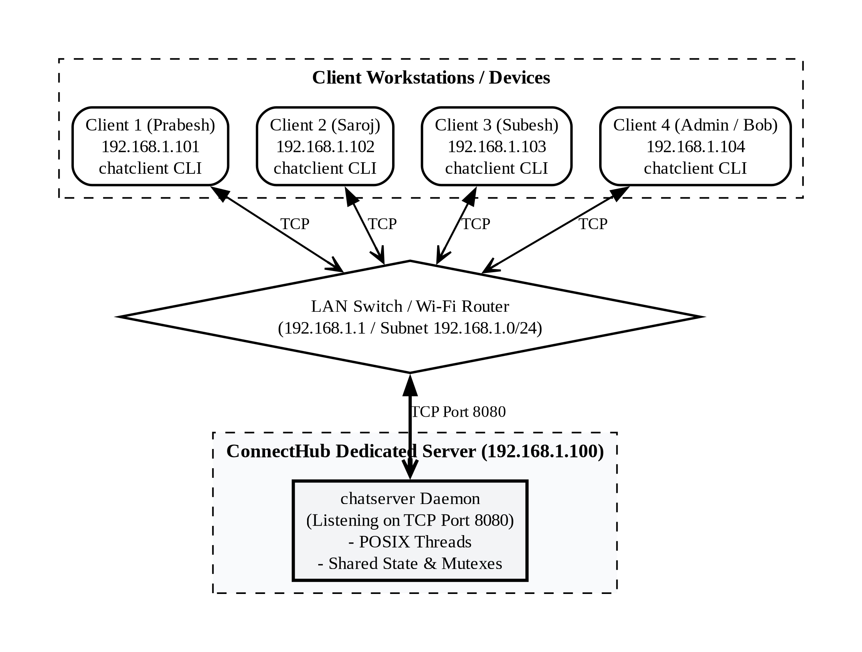
Figure 1: LAN Deployment Topology
Figure 2 — Two-Tier Client–Server Architecture. Every message travels to the server first; the server routes it to the intended recipient(s).
Figure 2: Client–Server Architecture

5.2 Server Architecture
The server (bin/chatserver) is a multithreaded TCP server. At startup it loads credentials, initializes subsystems (logger, room manager, user table, history), sets up signal handlers for graceful shutdown, binds a listening socket, and enters an accept loop driven by select() with a one-second timeout. On each accepted connection it spawns a new detached POSIX thread for that client. On timeout it does housekeeping: expiring stale upload slots and timed-out queue entries.
Figure 3 — Server Thread Model and Locking Strategy. One detached thread per client; all shared state behind dedicated mutexes.
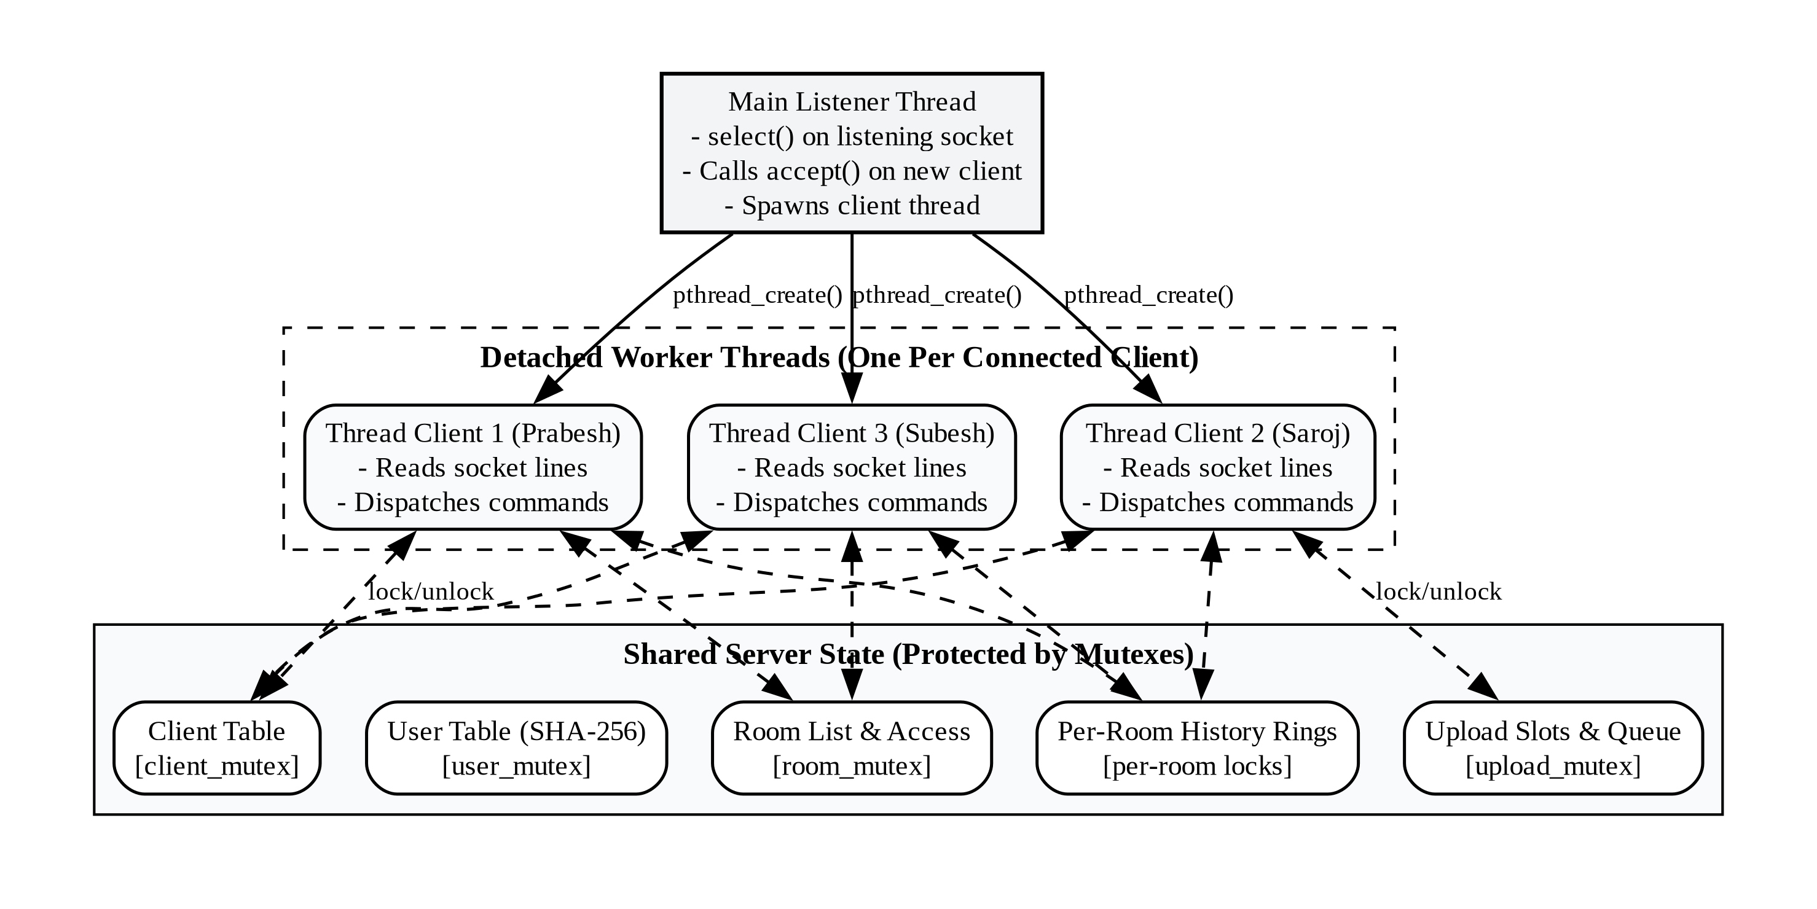
Figure 3: Server Thread Model
The design keeps the server deadlock-free and race-free through four rules:
- One mutex per data structure. The client list, user table, room table, upload slots/queue, and transfer list each have their own lock. Per-room history has its own lock so rooms can be written in parallel.
- Never hold `client_mutex` while broadcasting. Handlers copy what they need under the lock, release it, then send to other clients. This breaks the lock-ordering cycle that could cause deadlock.
- Snapshot under lock. Functions that route data copy the relevant record to a local variable before unlocking, so the caller never touches freed memory.
- Cleanup on disconnect. Every owned resource — upload slots, transfer offers, the client record itself — is released on disconnect, and remaining clients are notified.

5.3 Client Architecture
The client (bin/chatclient) is single-threaded by design. Its entire event model is one select() loop watching two file descriptors: stdin (keyboard) and the TCP socket. select() blocks until at least one descriptor is ready, so the client never gets stuck on either source.
The terminal is put into termios raw mode with ICANON and ECHO disabled. The screen is divided into four fixed regions drawn with ANSI escape codes on every loop iteration: a chat area (scrollback), a sidebar showing online users and rooms, a status bar, and an input line. This gives a responsive full-screen TUI without any curses library.

5.4 Wire Protocol Design
All communication uses a custom, lightweight text protocol. Every message is one ASCII line: fields separated by |, terminated by \n. The first field is always the message type.
LOGIN|prabesh|secret
LOGIN_OK|prabesh
PUBLIC|general|prabesh|Hello everyone!|02:30 PM
PRIVATE|saroj|prabesh|Hi saroj|02:30 PM
FILE_OFFER|saroj|report.pdf|204800|prabesh
This line-oriented, human-readable format is the same philosophy as IRC [7]. Because both sides build and parse the same lines, the protocol is fully debuggable with netcat or Wireshark without any special tooling. A full list of message types is given in the tables below.
Client → Server messages (key subset)
Message | Fields | Purpose
LOGIN | username, password | Authenticate
PUBLIC | text | Send message to current room
PRIVATE | recipient, text | Send private message
JOIN | room [, password] | Join a room
LEAVE | — | Return to #general
CREATE_ROOM | name, title, desc, password | Create a new room
FILE_REQUEST | filename, size, target | Offer a file to another user
FILE_DATA | filename, token, base64 | One file chunk
FILE_END | filename | End of transfer
FILE_ACCEPT | sender, filename | Accept incoming file offer
LOGOUT | — | Clean disconnect

Server → Client messages (key subset)
Message | Fields | Purpose
LOGIN_OK | username | Login accepted
LOGIN_FAIL | reason | Login rejected
PUBLIC | room, sender, text, timestamp | Room message
PRIVATE | sender, recipient, text, timestamp | Private message
NOTIFY | text [, timestamp] | System notification
TYPING | room, username | Typing indicator
FILE_GRANTED | sender, filename, token, size | Upload slot granted
FILE_OFFER | sender, filename, size, target | Incoming file notification
FILE_DATA | sender, filename, base64 | Forwarded file chunk
FILE_END | sender, filename | Transfer complete
ERROR | reason | Generic error

5.5 Data Structures
The server keeps the following structures in shared memory, each guarded by its own mutex:
Structure | Contents | Mutex
`clients[]` | sockfd, username, room, thread ID, active flag | `client_mutex`
`users[]` | username → SHA-256 digest | `user_mutex`
`rooms[]` | name, title, description, password hash, members | `room_mutex`
per-room history | linked list of last 50 messages | per-room lock
`upload_slots[2]` | token, sender, file, size, active flag | `upload_mutex`
`upload_queue` | FIFO of pending FILE_REQUESTs (cap: 16 entries, 1 MiB budget) | `upload_mutex`
`transfer_list` | sender, recipient, file, size (for routing FILE_DATA) | `transfer_mutex`
global counters | total_messages, total_privmsgs, total_files (admin /stats) | —

5.6 Module Structure
The codebase is organized into three directories: server/, client/, and shared/.
Figure 5 — Module Dependency Map.
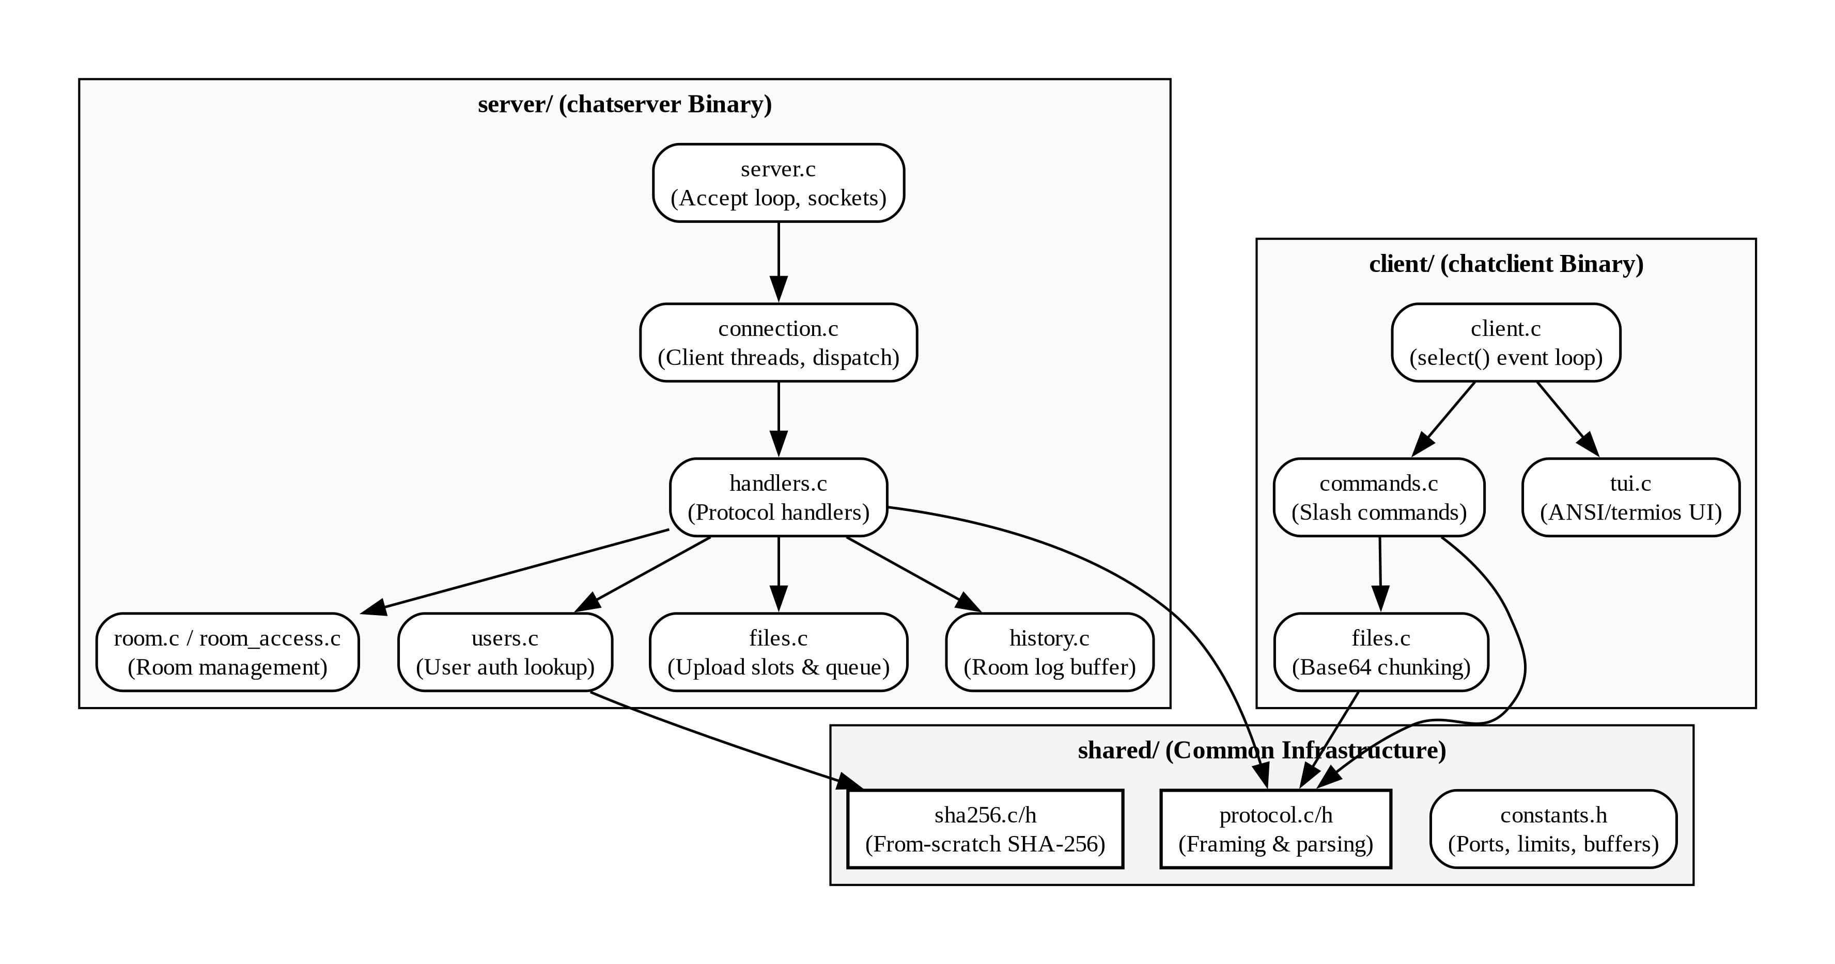
Figure 5: Module Dependency Map
Directory | File | Responsibility
server/ | server.c | Entry point, socket setup, accept loop
server/ | connection.c | Per-client thread, line reading, command dispatch
server/ | handlers.c | One handler function per protocol message type
server/ | room.c | Room data structures and management
server/ | room_access.c | Room access control (passwords, permissions)
server/ | users.c | User account loading and lookup
server/ | files.c | Server-side transfer state management
server/ | history.c | Per-room ring buffer of recent messages
server/ | logger.c | Event logging to logs/server.log
server/ | net.c | Low-level socket send helpers
client/ | client.c | Entry point, select() loop
client/ | commands.c | User command parser (/join, /msg, /sendfile, …)
client/ | tui.c | ANSI + termios terminal rendering
client/ | net.c | Connect and I/O helpers
client/ | protocol.c | Message builder/parser
client/ | files.c | Chunking, base64 encode/decode, reassembly
shared/ | protocol.c/h | Message-type definitions, framing
shared/ | sha256.c/h | SHA-256 implementation
shared/ | constants.h | Shared constants (port, buffer sizes, limits)

6. Implementation

6.1 Technology Stack
Concern | Choice
Language | C (C11), compiled with gcc
Networking | Berkeley sockets over TCP (`sys/socket.h`, `netinet/in.h`, `arpa/inet.h`)
Concurrency | POSIX threads; mutexes for shared-state protection (`-lpthread`)
I/O multiplexing | `select()` on both the server accept loop and the client event loop
Terminal I/O | `termios.h` raw mode; ANSI escape codes for the TUI
Hashing | SHA-256 implemented from scratch in `shared/sha256.c` — no OpenSSL
Build | Single GNU Makefile; objects in `build/`, binaries in `bin/`
External libraries | None

Key shared constants (shared/constants.h): default port 8080, MAX_CLIENTS 128, BUFFER_SIZE 4096, MAX_ROOMS 32, MAX_FILE_SIZE 64 MiB, FILE_CHUNK_SIZE 2048 bytes, ROOM_HISTORY_MAX 50, MAX_CONCURRENT_UPLOADS 2, MAX_QUEUE_DEPTH 16.

6.2 Module Breakdown
The codebase has three top-level directories. See Section 5.6 for the full role map.
- `server/` — The multithreaded server. server.c sets up the listening socket and the accept loop. connection.c runs the per-client thread: it reads lines from the socket and dispatches them. handlers.c contains one small handler function per protocol message type. room.c and room_access.c manage room state and access control. users.c loads and looks up accounts. files.c manages upload slots, the queue, and the transfer list. history.c maintains per-room message rings. logger.c writes logs/server.log. net.c provides socket write helpers.
- `client/` — The TUI client. client.c contains the main select() loop. commands.c translates user slash-commands into wire messages. tui.c renders the four-region terminal UI using raw mode and ANSI codes. files.c handles chunking, base64 encoding, and chunk reassembly. net.c manages the TCP connection. protocol.c builds and parses wire messages.
- `shared/` — Code used by both sides. protocol.c/h defines message types and framing. sha256.c/h is the from-scratch SHA-256 implementation. constants.h defines all shared limits and defaults.

6.3 Authentication
When a client connects, it immediately sends LOGIN|username|password. The server SHA-256-hashes the provided password and compares it to the stored digest. If they match, the client is marked active, placed in #general, and receives a replay of the room's recent history. All other connected clients receive an updated user list. If the credentials are wrong, the server replies with LOGIN_FAIL and closes the connection.
A username that is already online is rejected even with correct credentials. This prevents session conflicts without requiring per-session tokens.
Passwords are stored as SHA-256 hex digests in config/users.cred and config/admin.cred. The SHA-256 implementation is written from scratch in shared/sha256.c and follows the NIST FIPS 180-4 specification.

6.4 Room Management
On startup, #general is created as the default room. Users join it automatically after login. Users can create additional named rooms with an optional password. The room creator is the owner; only the owner or an admin can delete the room.
A JOIN command moves the user from their current room to the target room (after checking the password hash, if protected). Both the old room and the new room receive NOTIFY messages announcing the movement. On join, the server replays the last 50 lines of room history to give the new user context. A /leave command returns the user to #general.

6.5 Messaging
Public messages are sent with the PUBLIC command. The server timestamps the message, stores it in the room's history ring, and broadcasts it to all members of the sender's room except the sender themselves.
Private messages are sent with PRIVATE|recipient|text. The server delivers the message to the recipient and sends an echo copy back to the sender, so both sides have a consistent conversation record.
Typing indicators are sent as TYPING|room|username whenever a user types a character. The client shows "username is typing…" in the sidebar and clears it after a short timeout.

6.6 File Transfer
File transfer uses a server-mediated token scheme that prevents one client from injecting data into another client's transfer. The upload subsystem is rate-limited: a maximum of two concurrent uploads, a per-queue depth of 16, and a combined byte budget of 1 MiB.
Figure 4 — File Transfer Sequence.
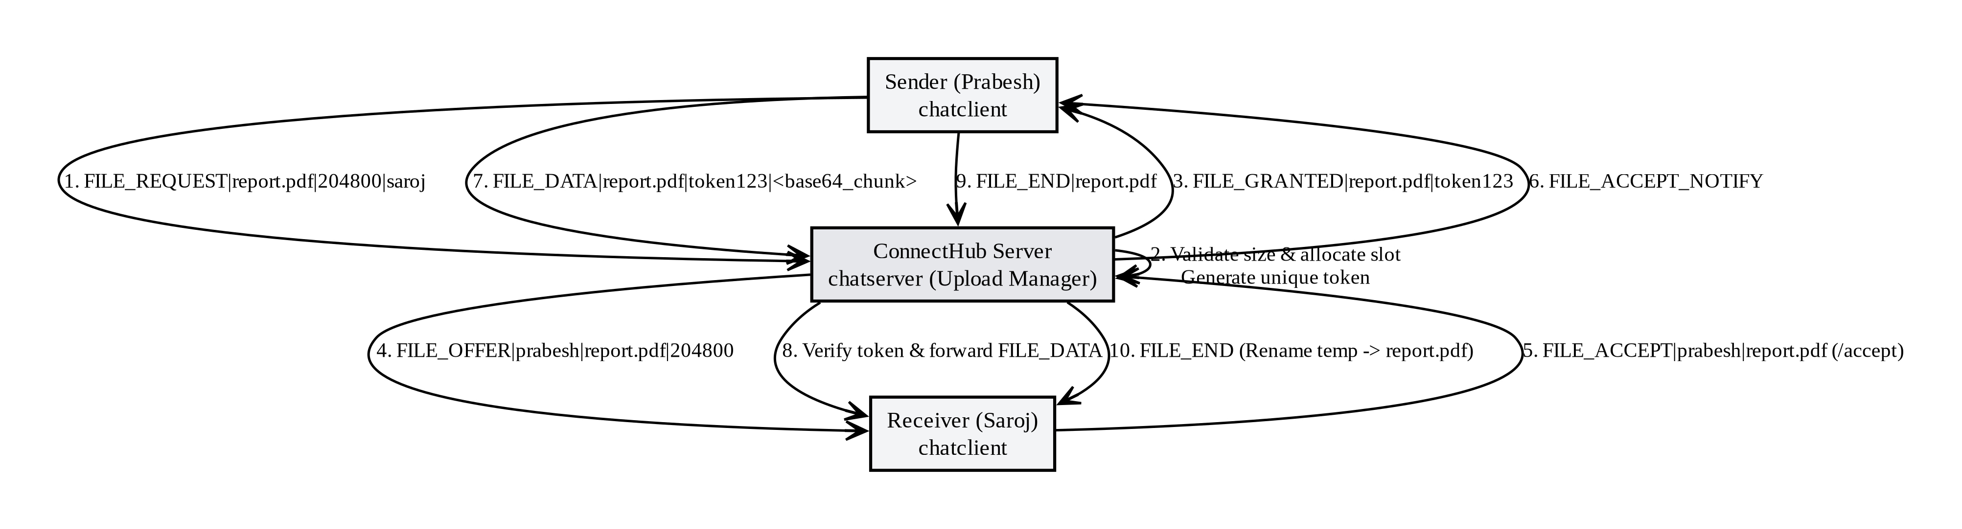
Figure 4: File Transfer Sequence
The steps are:
- The sender issues FILE_REQUEST|filename|size|target. The server validates that the file size is within the 64 MiB limit.
- The server mints a unique token, reserves an upload slot (or queues the request and replies FILE_WAIT), and replies FILE_GRANTED|sender|filename|TOKEN to the sender.
- The server sends FILE_OFFER|sender|filename|size|target to the recipient.
- The recipient runs /accept → FILE_ACCEPT|sender|filename. The server notifies the sender.
- The sender streams FILE_DATA|filename|TOKEN|base64_chunk messages. Each chunk is about 2 KB encoded in base64. The server verifies the token on every chunk before forwarding.
- The sender sends FILE_END|filename. The server frees the upload slot, forwards the end signal, and the recipient renames the temporary file to its final name.
If the recipient rejects the offer with /reject, the slot is released and both sides are notified. Received files are stored in the files/ directory. Duplicate filenames get a numeric suffix.

6.7 Build System
A single GNU Makefile builds both binaries:
- Object files go into build/, mirroring the source directory structure.
- chatclient links six client objects plus shared/protocol.o.
- chatserver links the server objects plus shared/sha256.o and -lpthread.
- Compile flags: -Wall -Wextra -O2 -g.
- make clean removes build/ and bin/.
make # build both binaries
./bin/chatserver 8080 # start server
./bin/chatclient 192.168.1.1 8080 # connect a client

7. Testing and Validation

7.1 Integration Testing
The project includes tests/smoke.py, a Python integration test that connects raw sockets to a freshly started server and drives the full system end-to-end. On a successful run it prints SMOKE TEST PASSED. The test covers:
- Authentication: valid credentials produce LOGIN_OK; wrong credentials produce LOGIN_FAIL.
- Public messaging: a message sent by one client is received by all others in the same room.
- Private messaging: a DM is delivered only to the intended recipient.
- Room lifecycle: create, join, and leave a room; verify that presence NOTIFY messages go to the right clients.
- File transfer: a file offered by one client is received intact by the accepter; the test compares SHA-256 digests to confirm byte-for-byte integrity.
- Disconnect: when a client disconnects, the remaining clients receive the correct presence notification.

7.2 Concurrency and Stress Testing
Multiple clients were connected simultaneously and driven to produce high message throughput concurrently. The following checks were performed:
Check | Result
No message duplication, dropping, or field corruption under concurrent load | Passed
No deadlock when multiple clients join/leave the same room simultaneously | Passed
Concurrent file transfers do not interfere with chat traffic | Passed
Clean resource cleanup (file descriptors, thread memory) on disconnect | Passed

No deadlocks, race conditions, or resource leaks were observed in extended sessions. The open file-descriptor count (checked via /proc/<pid>/fd) returned to baseline after each test.

7.3 Wire-Level Verification
tcpdump and Wireshark captures confirmed:
- All messages are framed as newline-terminated ASCII strings with no partial or misdelimited frames.
- File chunks arrive in order with intact base64 content.
- TCP connections close gracefully (FIN/ACK exchange) on /logout or Ctrl-C.
- The custom protocol is fully human-readable in the capture without any special dissector.

8. Results and Discussion
ConnectHub meets all of its stated objectives. The following summarizes what was achieved and where limitations exist.

What Was Achieved
Objective | Outcome
Concurrent multi-client server | Handles up to 128 simultaneous clients; no deadlock or state corruption observed
Room-based chat | Named rooms with passwords, history replay, and access control work correctly
Private messaging | DMs delivered only to the intended recipient; echo copy to sender
Typing indicators and presence | Notifications sent and cleared correctly
File transfer | Byte-for-byte integrity confirmed by SHA-256 digest comparison in tests
SHA-256 authentication | From-scratch implementation, no OpenSSL dependency
Admin interface | User creation/deletion, password reset, kick, announce, and stats all functional
Zero external dependencies | Builds and runs with only `gcc`, `make`, and a POSIX OS
Debuggable protocol | Protocol fully readable in `netcat` and Wireshark without any special tooling

Limitations
No transport encryption. Credentials and messages travel as plaintext over TCP. This is acceptable for a trusted offline LAN project, but TLS (via OpenSSL or mbedTLS) would be required for any deployment on an untrusted network.
No persistence. Rooms, users created at runtime, and message history all live in memory and are lost on server restart. Only the config/*.cred files survive. A persistent storage layer (SQLite or flat-file serialization) would be needed in a production setting.
These two limitations were known from the outset and are intentional scope decisions, not oversights. They are the most natural starting points for future work.

9. Conclusion and Future Work

9.1 Conclusion
ConnectHub shows that a fully functional, feature-rich, multi-client chat and file-sharing application can be built from first principles in plain C using nothing but standard POSIX APIs. The project integrates the core topics of the undergraduate systems-programming curriculum — TCP sockets, POSIX threads and mutexes, select()-based I/O multiplexing, custom protocol design, and cryptographic hashing — into one coherent, working system.
The text-based pipe-delimited protocol was simple to implement and easy to debug, confirming why line-oriented protocols have been the standard for text communication systems since IRC. The per-client-thread server model handled concurrent load without issues at the scale of an academic LAN. The single-threaded select()-based client was genuinely simpler and more responsive than a multi-threaded alternative would have been.
Building the system one feature at a time — starting with login and broadcast echo, then adding rooms, DMs, presence, and finally file transfer — kept complexity manageable and ensured each component was tested before the next one was added.

9.2 Future Work
- TLS/SSL encryption — adding OpenSSL or mbedTLS would make ConnectHub usable on untrusted networks by encrypting all traffic.
- Persistent storage — SQLite or flat-file serialization would preserve rooms, accounts, and history across server restarts.
- Thread pool with event queue — replacing the per-client-thread model would improve scalability at high connection counts.
- `epoll()` on the server — replacing select() in the accept loop would eliminate O(n) descriptor scanning at scale.
- Web or GTK front-end — a WebSockets bridge or GTK client would make the system accessible to non-terminal users; the shared protocol already supports it.
- End-to-end file encryption — AES encryption on file chunks would prevent the server from reading transferred content.
- Delivery acknowledgements — explicit ACKs would let clients detect dropped or failed deliveries.

10. References
- I. Sommerville, *Software Engineering*, 10th ed. Harlow, UK: Pearson, 2016.
- B. A. Forouzan, *Data Communications and Networking*, 5th ed. New York: McGraw-Hill, 2017.
- W. R. Stevens, *Advanced Programming in the UNIX Environment*, 3rd ed. Boston, MA: Addison-Wesley, 2013.
- W. R. Stevens, *UNIX Network Programming, Volume 1: The Sockets Networking API*, 3rd ed. Boston, MA: Addison-Wesley, 2003.
- J. F. Kurose and K. W. Ross, *Computer Networking: A Top-Down Approach*, 8th ed. Boston, MA: Pearson, 2021.
- D. R. Butenhof, *Programming with POSIX Threads*. Boston, MA: Addison-Wesley, 1997.
- J. Oikarinen and D. Reed, "Internet Relay Chat Protocol," IETF RFC 1459, May 1993.
- B. W. Kernighan and R. Pike, *The UNIX Programming Environment*. Englewood Cliffs, NJ: Prentice Hall, 1984.
*End of Report — ConnectHub Final Project Report, August 2026*

