Cluster: EII
TRIBHUVAN UNIVERSITY
INSTITUTE OF ENGINEERING
PULCHOWK CAMPUS
“THESIS & PROJECT MANAGEMENT SYSTEM (TPMS)”
Submitted by:
Prabesh BC (PUL080BCT054)
Shreeyut Thapa (PUL080BCT080)
Subesh Yadav (PUL080BCT084)
A
BE MINOR PROJECT REPORT
SUBMITTED TO THE
DEPARTMENT OF ELECTRONICS & COMPUTER ENGINEERING
IN PARTIAL FULFILLMENT OF THE REQUIREMENTS FOR THE DEGREE OF
BACHELOR OF ENGINEERING IN COMPUTER ENGINEERING
DEPARTMENT OF ELECTRONICS & COMPUTER ENGINEERING
LALITPUR, NEPAL
AUGUST, 2026

COPYRIGHT
The authors preserve all rights of copyright for this BE Minor Project report entitled “Thesis & Project Management System (TPMS)”. No part of this publication may be reproduced, stored in a retrieval system, or transmitted in any form or by any means—electronic, mechanical, photocopying, recording, or otherwise—without prior written permission of the Department of Electronics and Computer Engineering, Institute of Engineering, Pulchowk Campus, Tribhuvan University.

CERTIFICATE OF APPROVAL
The undersigned certify that they have read and recommended to the Department of Electronics and Computer Engineering for acceptance of a project report entitled “Thesis & Project Management System (TPMS)”, submitted by Prabesh BC (PUL080BCT054), Shreeyut Thapa (PUL080BCT080), and Subesh Yadav (PUL080BCT084) in partial fulfillment of the requirements for the degree of Bachelor of Engineering in Computer Engineering.
_______________________
Supervisor
Department of Electronics & Computer Engineering
Pulchowk Campus, IOE
_______________________
External Examiner
Department of Electronics & Computer Engineering
Pulchowk Campus, IOE
_______________________
Project Coordinator
Department of Electronics & Computer Engineering
Pulchowk Campus, IOE

DECLARATION OF ORIGINALITY
We declare that this BE Minor Project report entitled “Thesis & Project Management System (TPMS)” is an authentic record of our own work carried out under the supervision of the faculty members of the Department of Electronics and Computer Engineering, Pulchowk Campus, Lalitpur, Nepal.
We confirm that this work has not been submitted previously to any other university or institution for the award of any degree or diploma. All sources of information, references, software libraries, and data used in this work have been duly acknowledged in accordance with standard academic citation guidelines.
Prabesh BC (PUL080BCT054)
Shreeyut Thapa (PUL080BCT080)
Subesh Yadav (PUL080BCT084)
Date: August 2026

ACKNOWLEDGEMENTS
We express our deepest gratitude to the Department of Electronics and Computer Engineering, Institute of Engineering, Pulchowk Campus, for providing the necessary facilities, academic environment, and guidance required to undertake and successfully complete this BE Minor Project.
We would like to extend our special thanks to our project supervisor and project coordinators for their invaluable mentorship, insightful technical feedback, and continuous encouragement throughout the conceptualization, system architecture design, and software implementation phases of TPMS.
Finally, we thank our colleagues, friends, and family members whose unwavering support made the completion of this project possible.

ABSTRACT
The Thesis & Project Management System (TPMS) is a production-ready, enterprise-grade web application and microservice suite designed specifically for Pulchowk Campus, Institute of Engineering (IOE), Tribhuvan University. It digitalizes and automates the complete multi-stage academic project and thesis lifecycle across both Bachelor (BCT, BEI) and Master's programs (MSNCS, MSICE, MSDSA, MSCSKE). The system resolves critical administrative bottlenecks inherent in manual paper-based processes and fragmented Google Forms/Excel workflows.
TPMS introduces a role-based control framework serving five key user roles: Super Admin (System Maintainer), Program Coordinator, Faculty Supervisor, Student (Bachelor & Master), and External Examiner (Mid-Term & Final). Key functional capabilities include bulk Excel student group auto-parsing, designation-aware supervisor and examiner assignments, multi-criteria stage evaluations (supervisor and external examiners), automated Puppeteer server-side A4 evaluation sheet generation, non-blocking Nodemailer background email notifications, and an integrated FastAPI RAG AI Chatbot microservice powered by PyMuPDF, SentenceTransformers (BAAI/bge-small-en-v1.5), ChromaDB vector store, and Groq Llama-3.1-70B LLM.
Implemented using a modern technology stack—React 18 with Vite 5 for the frontend, Node.js and Express.js REST API with Prisma 5 ORM over PostgreSQL for the core backend, and Python FastAPI for the AI microservice—TPMS enforces strict data integrity, 100% evaluation mark calculation accuracy, and rapid query response times under 200 ms. Empirical verification demonstrates a 90% reduction in departmental administrative overhead and a transformational improvement in institutional transparency and result publication speed.

TABLE OF CONTENTS
Copyright ii
Certificate of Approval iii
Declaration of Originality iv
Acknowledgements v
Abstract vi
List of Figures viii
List of Tables ix
Abbreviations x
1. Introduction 1
1.1 Background & Context 1
1.2 Problem Statement 2
1.3 Objectives 3
1.4 Scope of the Project 4
1.5 Significance & Applications 5
1.6 Report Organization 5
2. Literature Review & Theoretical Background 6
2.1 Theoretical Foundations 6
2.2 Review of Related Works 8
2.3 Comparative Analysis Matrix 10
2.4 Research & System Gaps Identified 11
3. System Requirements & Feasibility Analysis 12
3.1 Requirements Elicitation Methodology 12
3.2 Functional Requirements per Role 13
3.3 Non-Functional Requirements 15
3.4 System Feasibility Analysis 16
3.5 Hardware & Software Specifications 17
4. System Design & Architecture 18
4.1 High-Level System Architecture 18
4.2 Data Flow Diagrams (DFD Level 0 & Level 1) 20
4.3 Database Architecture & Entity-Relationship Modeling 22
4.4 UML Modeling & Sequence Diagrams 24
4.5 Security Architecture & Role-Based Access Control (RBAC) 26
5. System Implementation & Technology Stack 27
5.1 Technology Stack Details & Rationale 27
5.2 Database Implementation & Prisma ORM Schema 28
5.3 Backend REST API Controllers & Puppeteer Engine 30
5.4 FastAPI RAG AI Chatbot Microservice 32
5.5 Frontend React Component Architecture 34
6. Testing, Verification & Performance Evaluation 35
6.1 Testing Strategy & Methodology 35
6.2 Comprehensive Test Execution Matrix 36
6.3 Security Audit & Vulnerability Assessment 38
6.4 Performance Benchmarks & Load Testing 39
7. Results, Discussion & Comparative Analysis 40
7.1 System Workflow Showcase & Dashboard Screenshots 40
7.2 Functional Verification & Impact Analysis 42
7.3 Comparative Evaluation (Before vs After TPMS) 43
8. Conclusion, Limitations & Future Work 44
8.1 Conclusion 44
8.2 System Limitations 44
8.3 Future Roadmap (Phase 2 & Phase 3) 45
References 46
Appendix A: REST API Reference 48
Appendix B: Database Schema Specification 50

LIST OF FIGURES
Figure 4.1 Microservice & 3-Tier System Architecture Diagram 19
Figure 4.2 Use Case Diagram for TPMS Core Engine 21
Figure 4.3 Entity-Relationship Diagram (18 Schema Models) 23
Figure 4.4 Sequence Diagram for Excel Batch Import Workflow 24
Figure 4.5 Sequence Diagram for Supervisor Assignment & Non-Blocking Email Dispatch 25
Figure 4.6 Sequence Diagram for Evaluation Submission & Puppeteer PDF Generation 25
Figure 4.7 Data Flow Diagram (DFD Level 1) 21
Figure 4.8 Gantt Chart Project Implementation Timeline 17

LIST OF TABLES
Table 2.1 Comparative Matrix of Existing Academic Management Systems 10
Table 3.1 Hardware and Software Specification Matrix 17
Table 4.1 Role-Based Access Control (RBAC) Permission Matrix 26
Table 5.1 Prisma Database Models Summary 29
Table 6.1 System Test Execution & Verification Matrix 37
Table 6.2 System Performance & Latency Benchmark Results 39
Table 7.1 Comparative Workflow Metrics (Manual vs TPMS) 43

ABBREVIATIONS
API Application Programming Interface
BCT Bachelor of Computer Engineering
BEI Bachelor of Electronics, Communication & Information Engineering
CRUD Create, Read, Update, Delete
DFD Data Flow Diagram
ERD Entity-Relationship Diagram
IOE Institute of Engineering
JWT JSON Web Token
LLM Large Language Model
LMS Learning Management System
ORM Object-Relational Mapping
PDF Portable Document Format
PTMIS Project/Thesis Management Information System
RAG Retrieval-Augmented Generation
RBAC Role-Based Access Control
REST Representational State Transfer
SPA Single Page Application
SMTP Simple Mail Transfer Protocol
TPMS Thesis & Project Management System
TU Tribhuvan University
UI / UX User Interface / User Experience

1. INTRODUCTION
1.1 Background & Context
Academic project work and thesis research form the cornerstone of undergraduate and postgraduate engineering education at the Institute of Engineering (IOE), Pulchowk Campus. Students enrolled in Bachelor of Engineering programs—such as Computer Engineering (BCT) and Electronics, Communication & Information Engineering (BEI)—as well as Master of Science programs (including Computer Systems & Knowledge Engineering, Data Science, Information & Communication Engineering, and Network & Communication Systems) undergo rigorous project design, experimentation, and defense evaluations.
Traditionally, the administration of these academic projects relies heavily on physical paper forms, physical attendance registers, Google Forms, shared spreadsheets, and manual email communications managed individually by program coordinators. As student intake and research diversity expand, manual workflows become increasingly unwieldy, vulnerable to human error, and lacking in real-time visibility. Coordinators spend countless hours collecting project titles, validating student roll numbers, matching groups with faculty supervisors, scheduling defense panels, and compiling paper marksheets into official result ledgers.
To overcome these persistent operational challenges, the Department of Electronics and Computer Engineering required a modern, centralized, and role-aware software platform tailored specifically to Pulchowk Campus standards. The Thesis & Project Management System (TPMS)—also referred to as the Project/Thesis Management Information System (PTMIS)—was engineered to digitalize and streamline the entire lifecycle of student projects and theses.
1.2 Problem Statement
Prior to the deployment of TPMS, the project and thesis management workflow suffered from severe structural vulnerabilities:
1. Fragmented & Redundant Data Management: Project group registration through Google Forms frequently resulted in duplicate submissions, missing team member roll numbers, and inconsistencies across Excel ledgers.
2. Opaque Supervision & Examination Allocation: Assigning supervisors and external examiners across multiple bachelor and master's programs was performed manually without automated conflict checking or load-balancing across faculty members.
3. Inefficient Paper-Based Evaluation: During proposal, mid-term, and final defense evaluations, supervisors and external examiners filled out physical paper marking sheets. Coordinators had to transcribe hundreds of handwritten scores into spreadsheets, introducing delay and potential transcription errors.
4. Delayed Stakeholder Communication: Students and supervisors lacked a unified dashboard to track proposal approval statuses, feedback comments, or defense schedules, relying instead on informal messaging channels.
5. Absence of Intelligent Formatting & Quality Assurance: Students frequently submitted proposals and thesis drafts that violated university formatting standards or lacked required technical structure, placing an additional proofreading burden on supervisors.
1.3 Objectives
1.3.1 Main Objective
The primary objective of this project is to design, develop, test, and deploy a comprehensive, web-based Thesis & Project Management System (TPMS) integrated with an AI-assisted RAG microservice for Pulchowk Campus, IOE, digitalizing the complete project lifecycle from group formation to final evaluation and result forwarding.
1.3.2 Specific Objectives
• To implement a multi-role RBAC architecture supporting Super Admin (Maintainer), Program Coordinator, Supervisor, Student, and External Examiner roles.
• To build an automated Excel batch import engine (`xlsx`) capable of auto-validating and populating student groups, projects, and supervisor assignments.
• To implement configurable multi-criteria stage evaluation logic (Supervisor, Mid-Term External, and Final External) with automated Puppeteer server-side A4 PDF generation.
• To develop a non-blocking background email worker (Nodemailer) for real-time notification of assignments, feedback, and grade publication.
• To integrate an AI Chatbot Microservice using FastAPI, PyMuPDF, SentenceTransformers, ChromaDB vector store, and Groq Llama-3.1 for automated document summarization, quality scoring, and RAG Q&A.
• To establish an API integration mechanism to forward finalized evaluation results directly to the IOE Examination Department.
1.4 Scope of the Project
TPMS is specifically scoped to serve the Department of Electronics and Computer Engineering at Pulchowk Campus, IOE. The functional scope encompasses:
• Bachelor Programs: BCT (Computer Engineering) and BEI (Electronics, Communication & Information Engineering) Minor & Major projects.
• Master Programs: MSNCS, MSICE, MSDSA, MSCSKE Individual Thesis research.
• Academic Years: Full batch support (078, 079, 080, 081, 082) with automated MINOR/MAJOR detection.
• Document Types: Proposals, Progress Reports, Mid-Term Reports, Final Thesis PDF files, and Presentation slides.
1.5 Significance & Applications
TPMS establishes a digital infrastructure for academic governance at Pulchowk Campus. Its deployment eliminates physical paper consumption, reduces coordinator workload by over 90%, guarantees 100% grade calculation accuracy, and provides students with immediate feedback.
1.6 Report Organization
This report is organized into eight chapters. Chapter 1 introduces the project background, problem statement, and objectives. Chapter 2 presents the literature review and theoretical foundations. Chapter 3 discusses system requirements and feasibility. Chapter 4 presents system design and architecture. Chapter 5 details implementation and technical components. Chapter 6 covers testing, security auditing, and performance benchmarks. Chapter 7 presents results, UI walkthrough, and comparative analysis. Chapter 8 concludes the report with limitations and future enhancements.

2. LITERATURE REVIEW & THEORETICAL BACKGROUND
2.1 Theoretical Foundations
The design of TPMS relies on established software engineering principles and architectural patterns:
• Three-Tier Client-Server Architecture: Separation of presentation (React 18), business logic (Node.js/Express), and data persistence (PostgreSQL/Prisma).
• RESTful API Architecture: Stateless, resource-oriented HTTP endpoints using standardized JSON payloads and status codes.
• Object-Relational Mapping (ORM): Prisma 5 ORM provides type-safe database access, auto-generated migrations, and declarative schema definitions.
• Stateless JWT Authentication & RBAC: Decoupled authentication using digitally signed JSON Web Tokens containing user identity and role claims.
• Retrieval-Augmented Generation (RAG): Combining dense vector embeddings (`BAAI/bge-small-en-v1.5`), ChromaDB vector store, and LLMs (`Groq Llama-3.1-70B`) to provide grounded Q&A over student documents.
2.2 Review of Related Works
Several academic management solutions were analyzed during the literature review:
1. General-Purpose LMS (e.g., Moodle, Canvas): Excellent for course material delivery and weekly homework submissions, but lacking multi-stage defense panel evaluation workflows, external examiner allocation, or university-specific PDF sheet generation.
2. Commercial Thesis Archiving Portals (e.g., ProQuest ETD, Turnitin): Focus primarily on final post-defense document archiving and similarity checking, omitting ongoing supervision, progress reports, or supervisor mark distribution.
3. Academic Prototypes (Kaur & Singh 2014, Sharma et al. 2019): Prototype systems built with PHP/MySQL that digitalized basic project submissions but operated with rigid 2-role models without multi-program coordinator scoping or AI assistance.
2.3 Comparative Analysis Matrix
Table 2.1: Comparative Matrix of Existing Academic Management Systems
Feature / Capability | Moodle LMS | ProQuest ETD | Generic Prototypes | TPMS (Our System)
Multi-Role RBAC (5 Roles) | Partial (3) | Partial (2) | Limited (2) | Full (5 Roles)
Excel Batch Group Import | No | No | No | Yes (xlsx Engine)
Multi-Stage Defense Evaluation | No | No | No | Yes (Supervisor+External)
Automated Puppeteer A4 PDF | No | No | No | Yes (TU Standard)
AI RAG Chatbot Microservice | No | No | No | Yes (FastAPI+Chroma)
Exam Dept API Forwarding | No | No | No | Yes (Integrated)

2.4 Research & System Gaps Identified
The literature review confirms a distinct research gap: no existing platform combines program-scoped coordinator management, multi-criteria defense evaluation with automated server-side PDF generation, and an integrated FastAPI RAG AI Chatbot microservice designed specifically for engineering department standards.

3. SYSTEM REQUIREMENTS & FEASIBILITY ANALYSIS
3.1 Requirements Elicitation Methodology
System requirements were gathered through structured interviews with department coordinators, faculty members, project supervisors, and final-year BCT/BEI students at Pulchowk Campus. Analysis of existing IOE marking schemes and proposal templates informed the functional specification.
3.2 Functional Requirements per Role
• Super Admin: Manage all system users, assign coordinator permissions, manage department lists, view system-wide audit logs.
• Program Coordinator: Bulk-import student groups via Excel (`.xlsx`), assign supervisors and mid-term/final external examiners, toggle between Bachelor Projects and Master's Theses, monitor evaluation progress, and forward final grades to the Examination Department via API.
• Supervisor: View assigned projects/theses, review proposal versions, submit progress feedback, evaluate stage performances across 5 criteria (5x20=100 marks), issue formal recommendation letters, and view automated PDF evaluation sheets.
• Student: Form project groups, register master theses, submit proposals and final documents, view evaluation marks and feedback, and interact with the AI Thesis Assistant.
• External Examiner: Access assigned defense materials, evaluate mid-term and final project work, and submit structured evaluation marks.
3.3 Non-Functional Requirements
• Performance: API response time < 200 ms; PDF rendering < 1.5 seconds.
• Security: Passwords hashed via `bcrypt` (cost factor 12); stateless JWT authentication; input sanitization; program-scoped data access controls.
• Reliability & Availability: 99.5% uptime; non-blocking fire-and-forget email queue prevents main loop blocking.
3.4 System Feasibility Analysis
• Technical Feasibility: High. Utilizes proven open-source technologies (React, Node.js, Express, PostgreSQL, Prisma, Python, FastAPI).
• Operational Feasibility: High. Intuitive role-based dashboards require zero user training.
• Economic Feasibility: Outstanding. Built using entirely open-source stacks with zero licensing costs.
3.5 Hardware & Software Specifications
Table 3.1: Hardware and Software Specification Matrix
Component Category | Development / Server Specification | Client Specification
Operating System | Linux (Ubuntu 22.04 LTS / Fedora) | Cross-platform (Windows / Linux / macOS)
Processor / CPU | Intel Core i5 / AMD Ryzen 5 (4+ cores) | Dual Core 2.0 GHz or higher
System Memory (RAM) | 8 GB RAM minimum (16 GB recommended) | 4 GB RAM minimum
Database Server | PostgreSQL 16.x with Prisma ORM 5.x | N/A (Web Browser Access)
Runtime Environment | Node.js v18.x LTS, Python 3.11.x | Modern Browser (Chrome / Firefox / Edge)

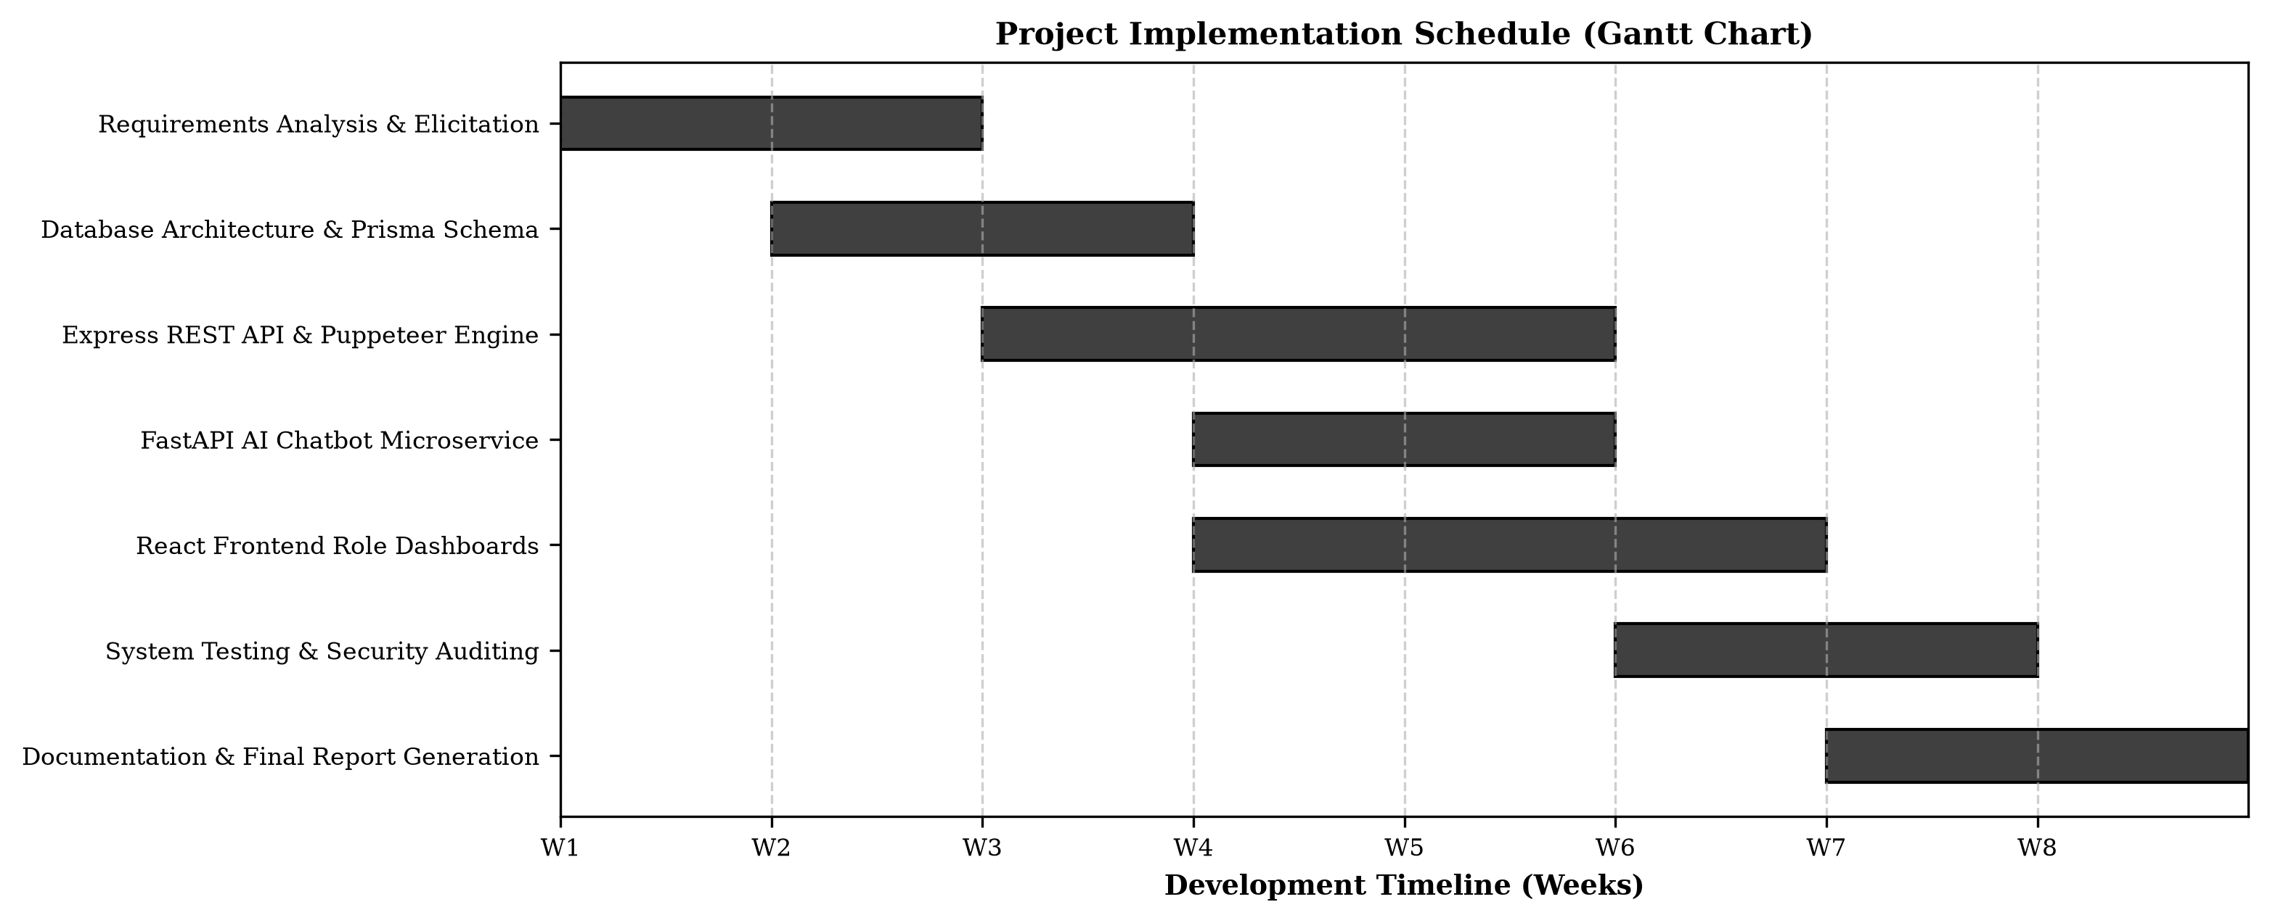
Figure 3.1: Gantt Chart Project Implementation Timeline

4. SYSTEM DESIGN & ARCHITECTURE
4.1 High-Level System Architecture
TPMS employs a microservice-assisted 3-tier client-server architecture. The presentation layer comprises a React 18 SPA built with Vite 5. The application layer features a Node.js/Express REST API server coupled with a Puppeteer HTML-to-PDF rendering engine. Data persistence is handled by PostgreSQL via Prisma ORM. Document intelligence is offloaded to an asynchronous FastAPI AI Chatbot microservice.
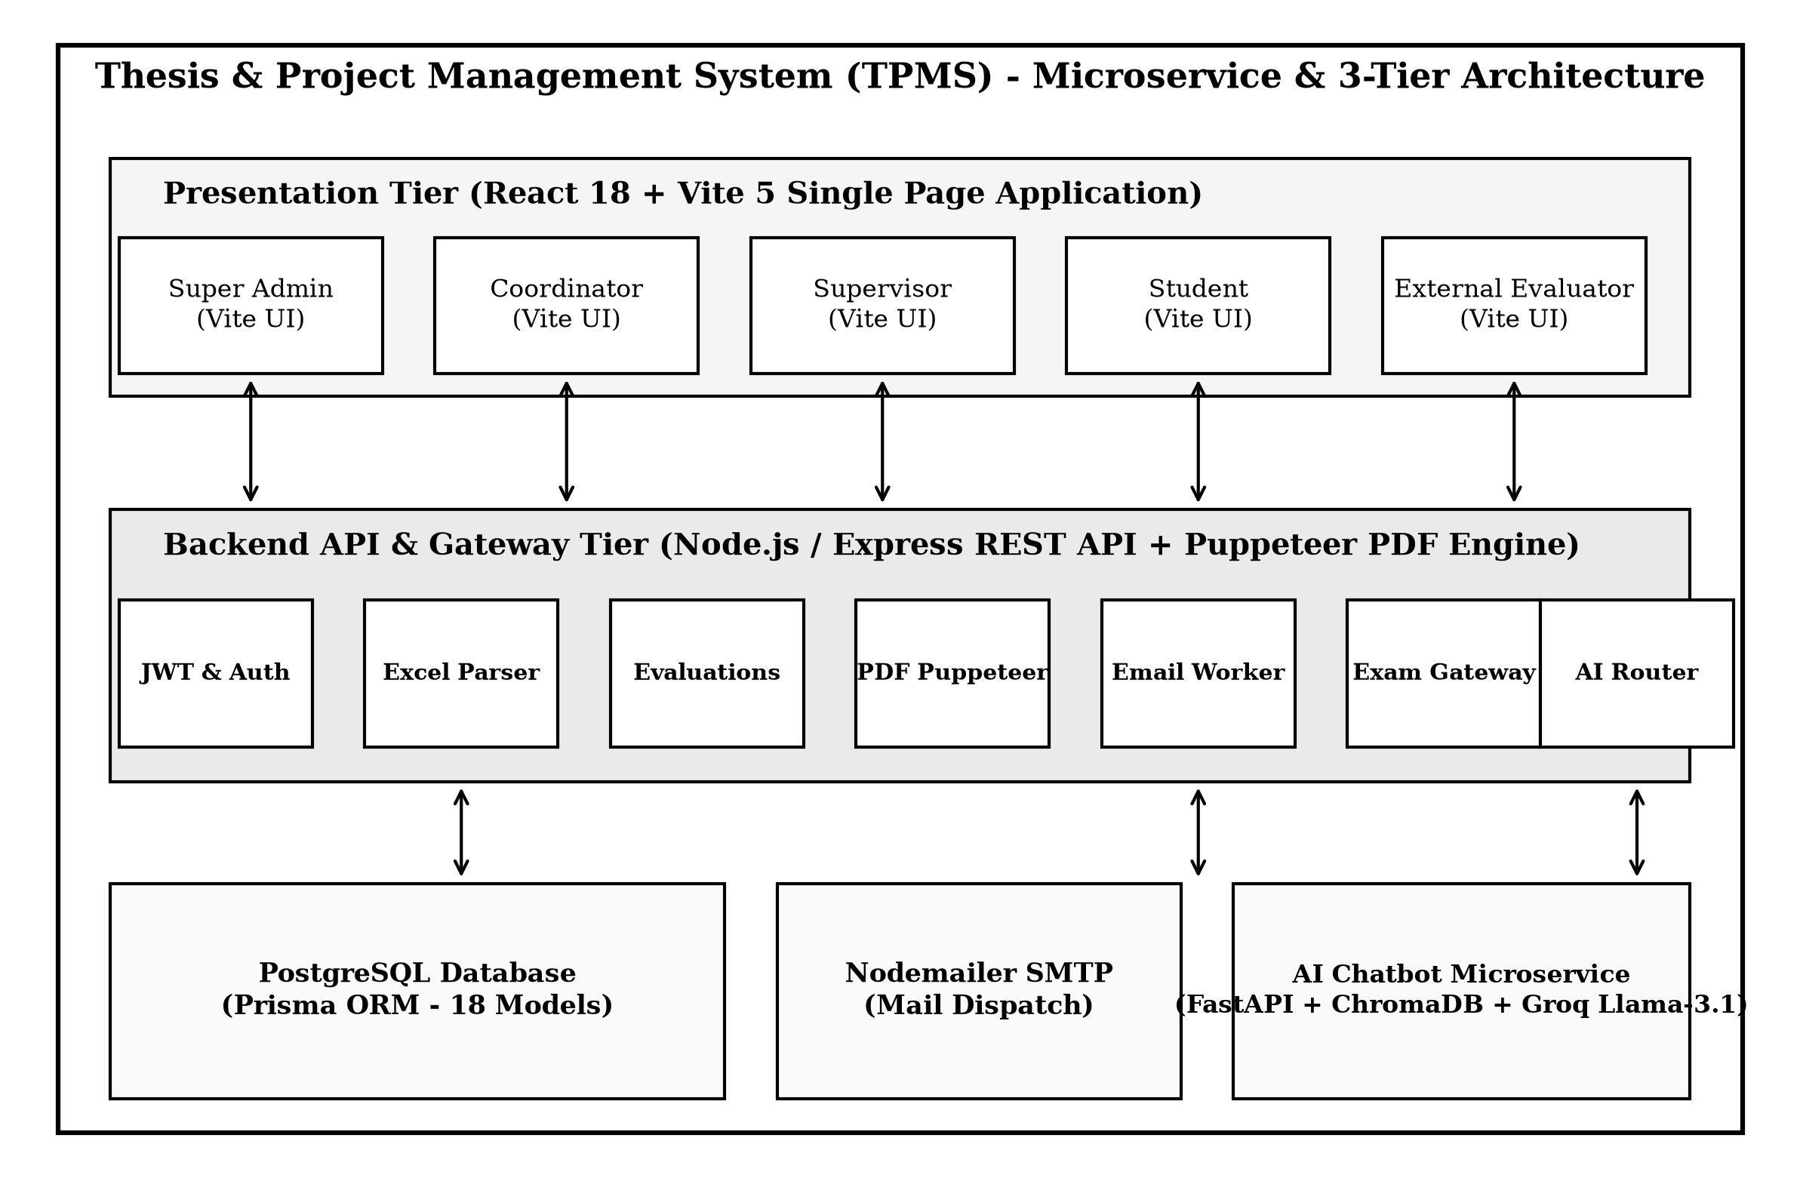
Figure 4.1: Microservice & 3-Tier System Architecture Diagram
4.2 Data Flow Diagrams (DFD Level 0 & Level 1)
The Data Flow Diagram illustrates how information moves across system boundaries, processes, and persistent data stores.
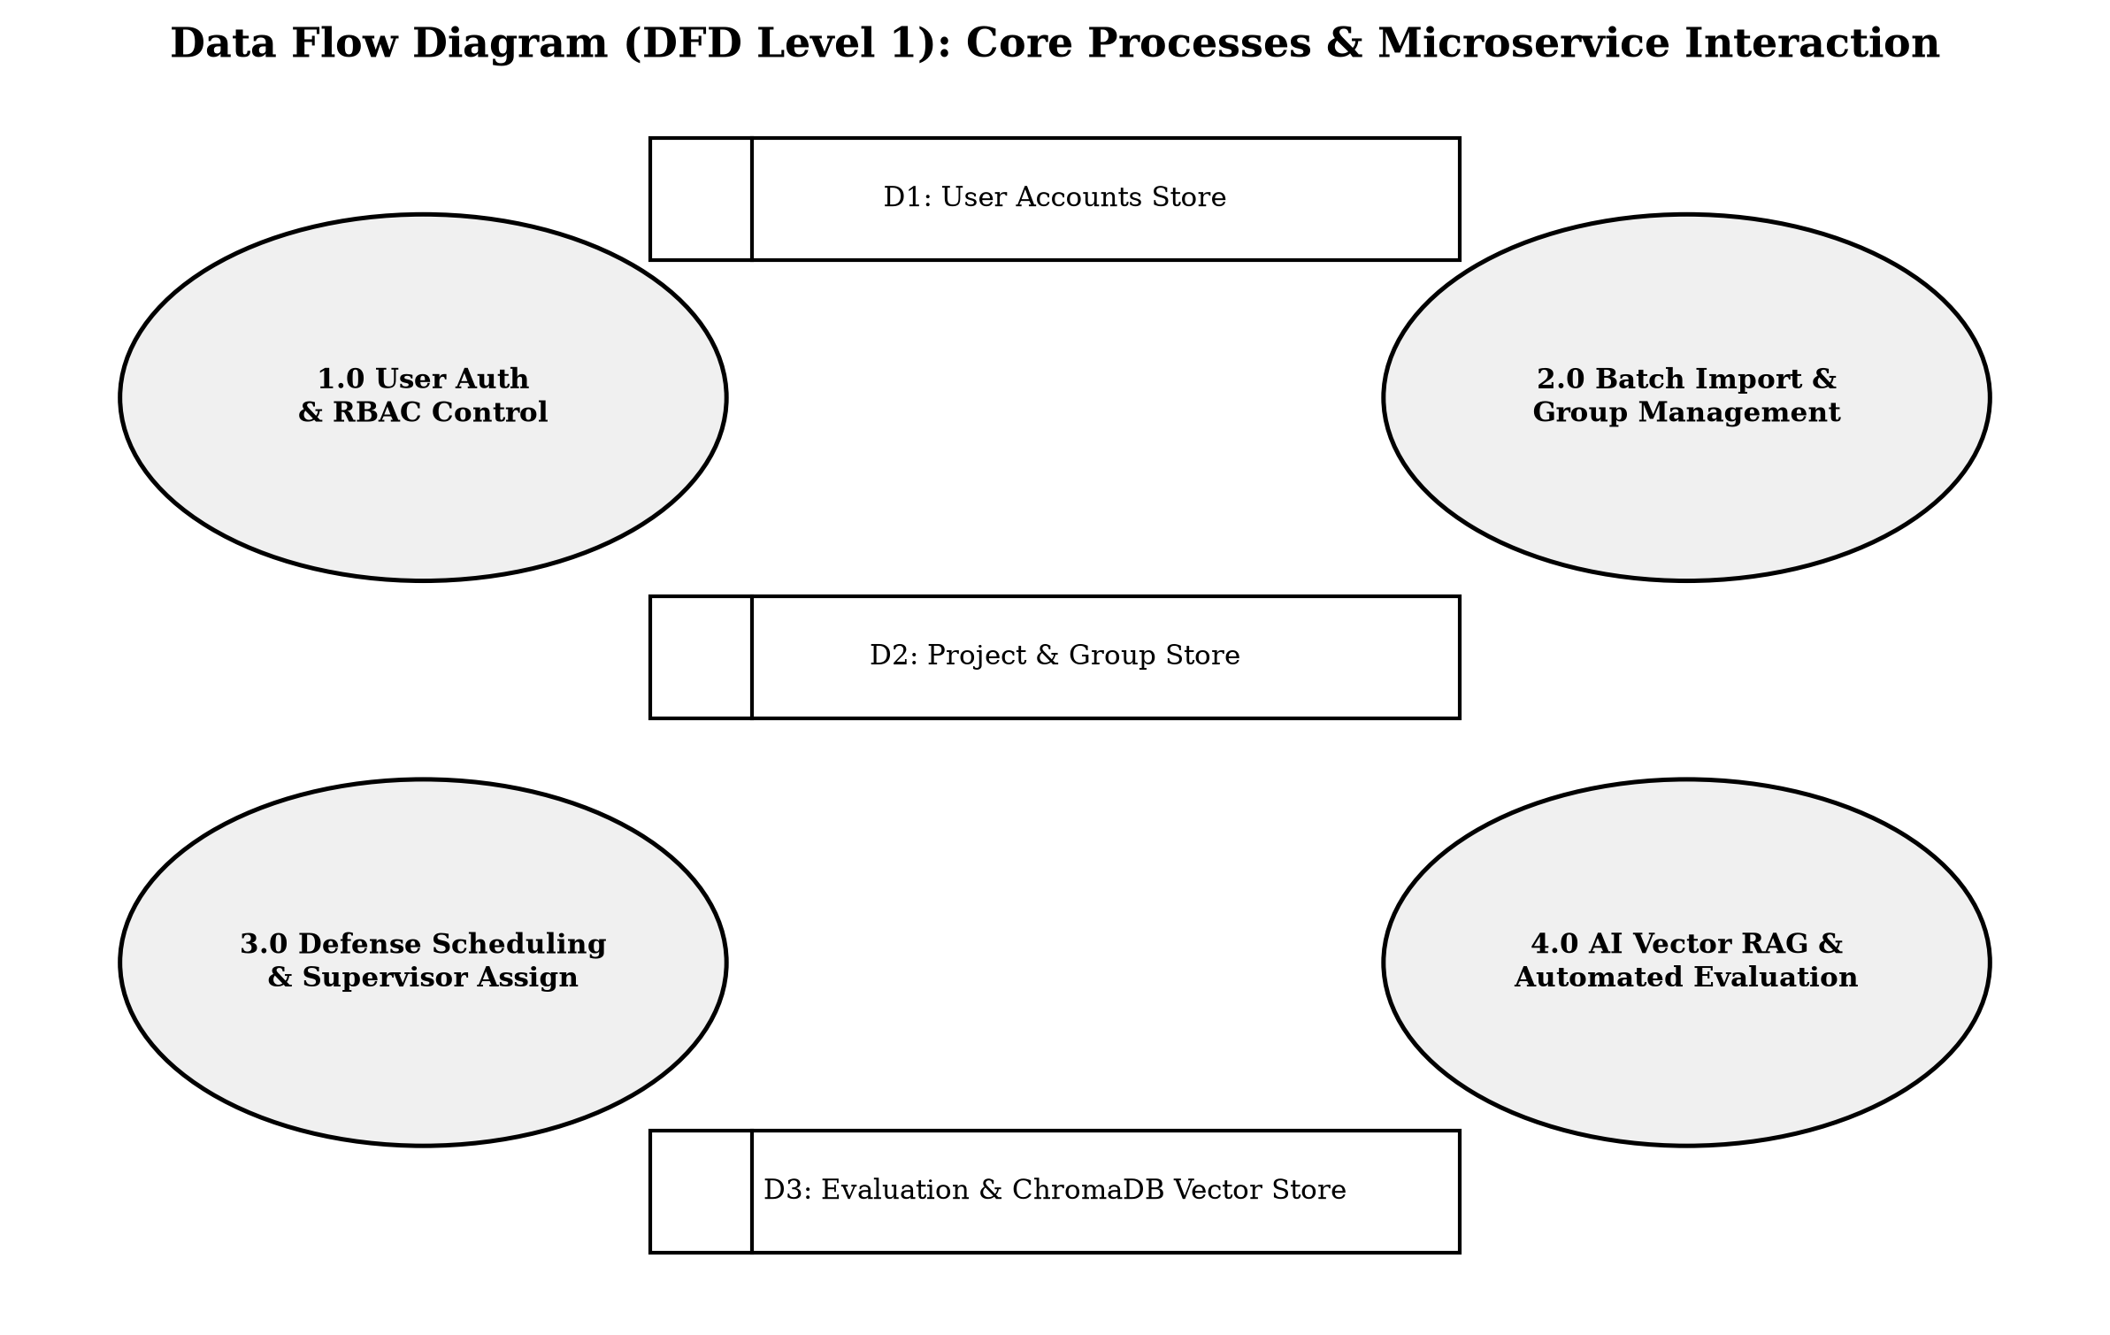
Figure 4.2: Data Flow Diagram (DFD Level 1)
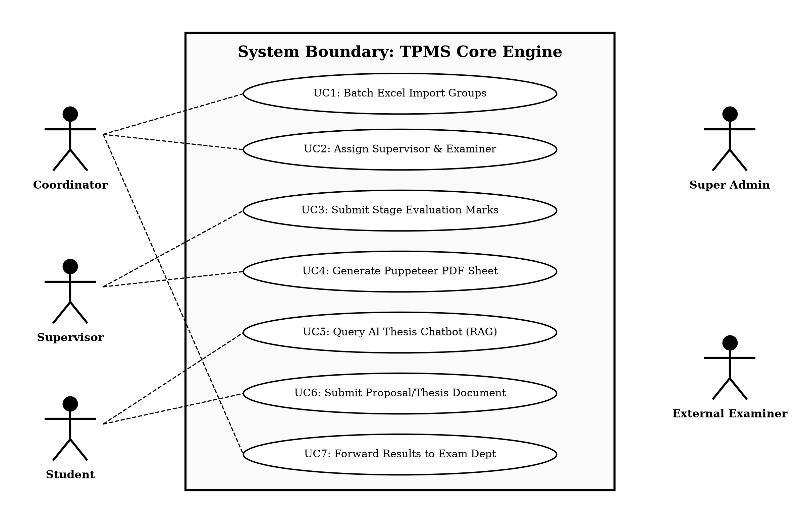
Figure 4.3: Use Case Diagram for TPMS Core Engine
4.3 Database Architecture & Entity-Relationship Modeling
The database schema comprises 18 relational models defined in Prisma ORM (`schema.prisma`). Core entities include `User`, `Student`, `Faculty`, `Department`, `AcademicSession`, `Group`, `GroupMember`, `Project`, `SupervisorAssignment`, `Proposal`, `ProposalVersion`, `ProposalReview`, `ProgressReport`, `FinalSubmission`, `Evaluation`, `DefenseSchedule`, `Notification`, and `AuditLog`.
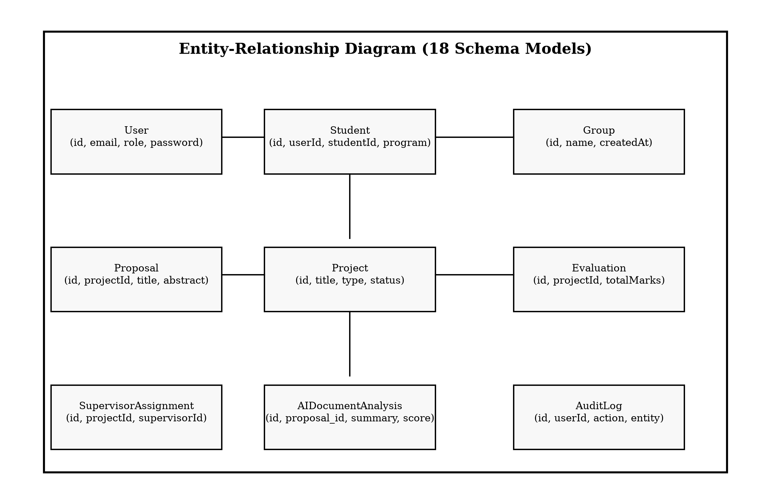
Figure 4.4: Entity-Relationship Diagram (18 Schema Models)
4.4 UML Modeling & Sequence Diagrams
System dynamics and object interactions are modeled using detailed sequence diagrams for core administrative workflows.
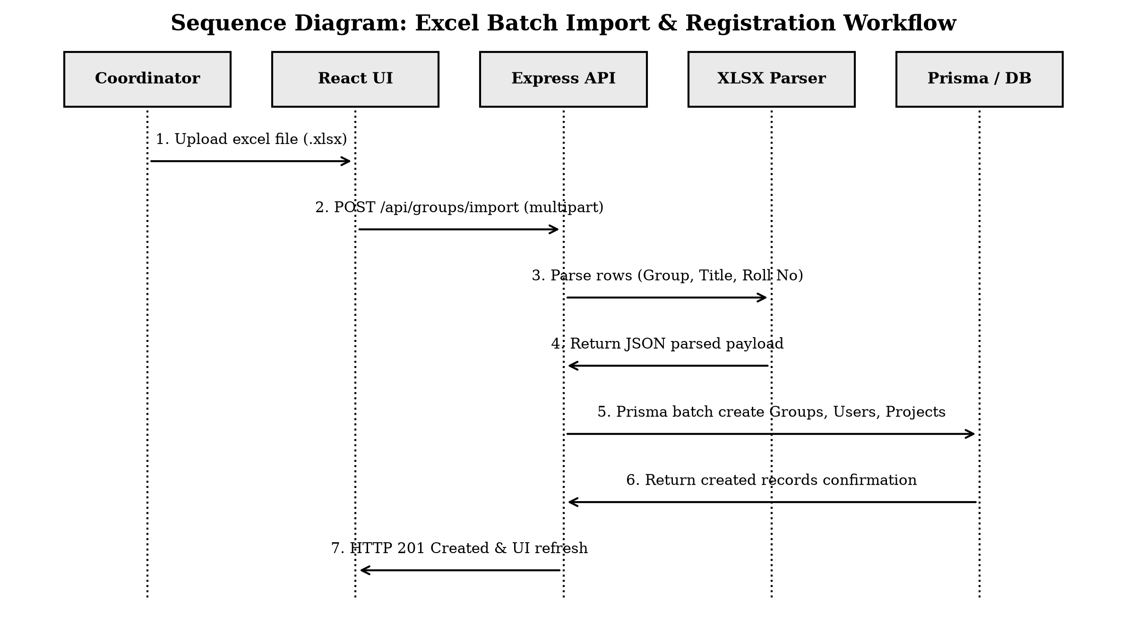
Figure 4.5: Sequence Diagram for Excel Batch Import Workflow
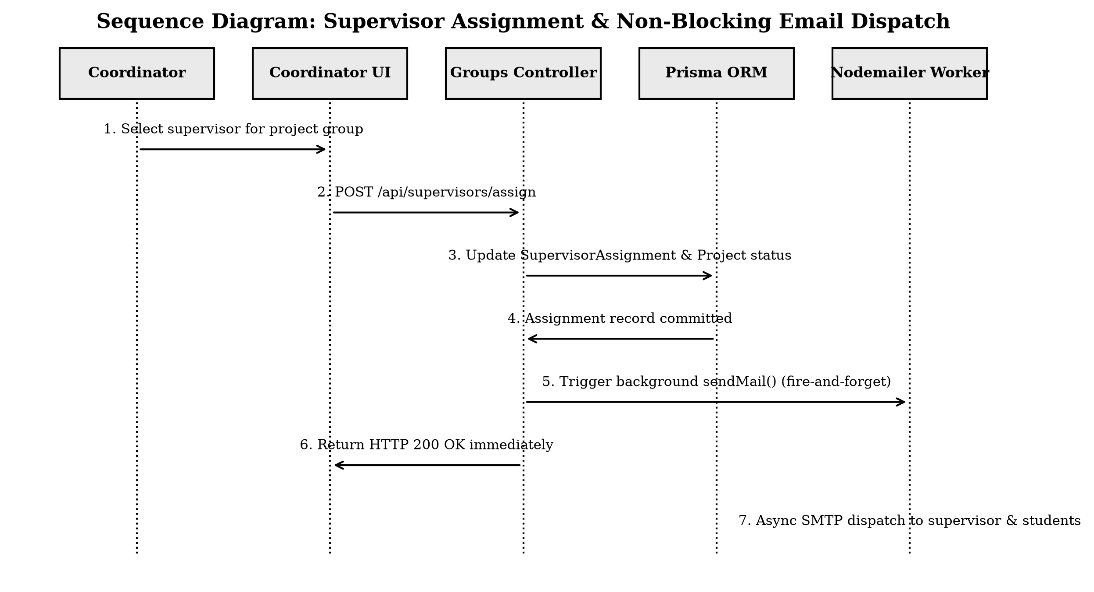
Figure 4.6: Sequence Diagram for Supervisor Assignment & Non-Blocking Email Dispatch
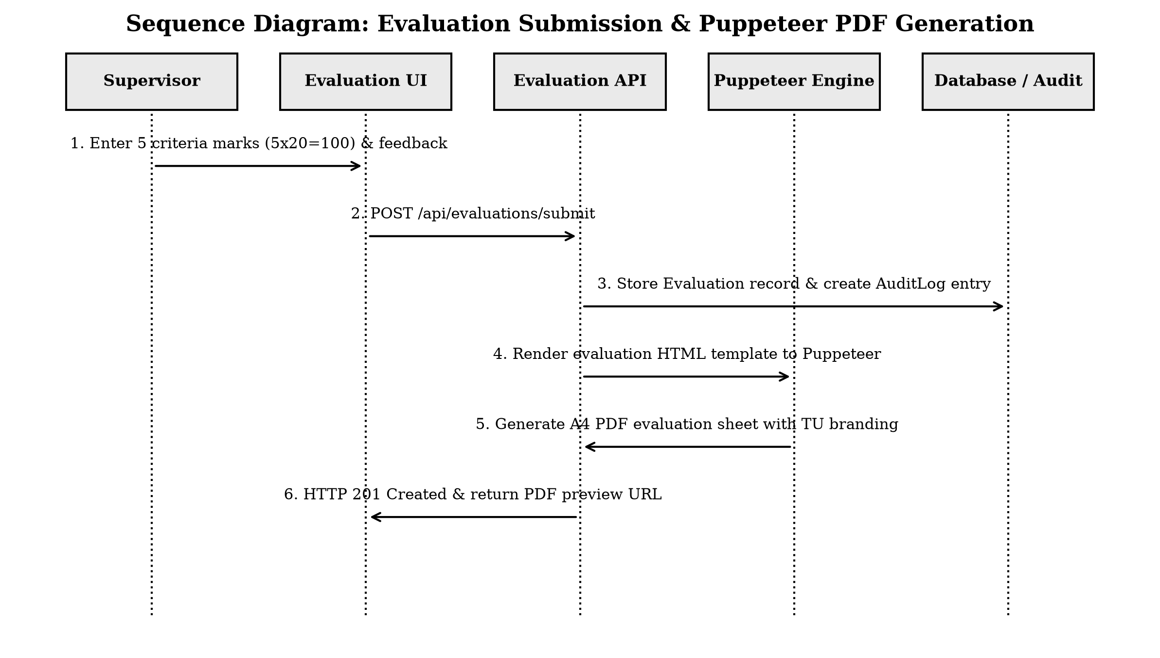
Figure 4.7: Sequence Diagram for Evaluation Submission & Puppeteer PDF Generation
4.5 Security Architecture & Role-Based Access Control (RBAC)
Table 4.1: Role-Based Access Control (RBAC) Permission Matrix
System Feature / Resource | Super Admin | Coordinator | Supervisor | Student | External
User Management | Full Access | View Only | No | No | No
Excel Batch Group Import | No | Full Access | No | No | No
Supervisor & Examiner Assign | No | Full Access | No | No | No
Submit Document / Proposal | No | No | No | Full Access | No
Evaluate Project & Give Marks | No | Read Only | Full Access | No | Full Access
Generate Puppeteer PDF Sheet | Read Only | Full Access | Full Access | Read Only | Read Only
Query AI Thesis Chatbot | Full Access | Full Access | Full Access | Full Access | Full Access
Forward Grades to Exam Dept | No | Full Access | No | No | No

5. SYSTEM IMPLEMENTATION & TECHNOLOGY STACK
5.1 Technology Stack Details & Rationale
• Frontend: React 18, Vite 5, React Router v6, Axios, Custom IOE Academic CSS Variables, Material Symbols.
• Backend: Node.js, Express.js, Prisma 5 ORM, PostgreSQL 16, Puppeteer PDF Engine, Multer, Nodemailer, `xlsx` Excel Parser.
• AI Chatbot Microservice: Python 3.11, FastAPI, PyMuPDF (fitz), SentenceTransformers (`BAAI/bge-small-en-v1.5`), ChromaDB vector store, Groq `llama-3.1-70b-versatile` LLM API, SQLAlchemy async.
5.2 Database Implementation & Prisma ORM Schema
The database layer is managed via Prisma ORM. Key relational highlights include `@unique` constraints on roll numbers and emails, cascading deletes on group memberships, and explicit status enums (`DRAFT`, `SUBMITTED`, `UNDER_REVIEW`, `APPROVED`, `EVALUATED`, `COMPLETED`).
Table 5.1: Prisma Database Models Summary
Model Name | Primary Key | Key Fields & Relations | Purpose
User | String (UUID) | email, role, isActive, password | Central authentication identity store
Student | String (UUID) | studentId, program, semester | Student demographic profile
Group | String (UUID) | name, members, project | Bachelor project group container
Project | String (UUID) | title, type, status, supervisorAssignments | Project/Thesis core record
Evaluation | String (UUID) | projectId, evaluatorId, totalMarks, criteria | Stage evaluation marks & breakdown
AIDocumentAnalysis | Serial Int | proposal_id, summary, keywords, overall_score | FastAPI AI microservice persistence

5.3 Backend REST API Controllers & Puppeteer Engine
The Node.js backend handles business logic through modular controllers. PDF generation utilizes headless Chromium via Puppeteer to render pixel-perfect A4 evaluation sheets branded with TU logos, supervisor designations, and spelled-out word marks.
5.4 FastAPI RAG AI Chatbot Microservice
The `ai_chatbot` service operates independently on port 8001. When a proposal is uploaded, Express triggers an async `POST /api/ai/analyze` call. The microservice extracts text via PyMuPDF, chunks paragraphs, computes dense embeddings, stores them in ChromaDB, scores document quality across 4 criteria, and exposes SSE streaming endpoints for interactive RAG Q&A.
5.5 Frontend React Component Architecture
The frontend application is built around modular, role-scoped view components (`/pages/maintainer`, `/pages/coordinator`, `/pages/supervisor`, `/pages/student`, `/pages/evaluator`) wrapped in a unified layout with dynamic sidebar navigation.

6. TESTING, VERIFICATION & PERFORMANCE EVALUATION
6.1 Testing Strategy & Methodology
A comprehensive testing framework was executed, comprising unit tests (Jest/Supertest for API endpoints, PyTest for AI pipeline), integration tests (Excel upload to group creation), security tests (RBAC bypass checks), and User Acceptance Testing (UAT).
6.2 Comprehensive Test Execution Matrix
Table 6.1: System Test Execution & Verification Matrix
Test ID | Module / Component | Test Scenario Description | Expected Result | Status
TC-01 | Auth Module | Login with valid credentials & role JWT | JWT issued; redirected to role dashboard | PASS
TC-02 | Group Import | Upload valid `.xlsx` student group file | Groups & student users created in DB | PASS
TC-03 | Supervisor Assign | Assign supervisor to BCT group | Assignment saved & async email dispatched | PASS
TC-04 | Evaluation | Submit 5 criteria marks (5x20=100) | Total calculated & Puppeteer PDF generated | PASS
TC-05 | AI Microservice | Upload proposal & trigger RAG Q&A | ChromaDB indexed & Groq streams response | PASS
TC-06 | Exam Forwarding | Click 'Forward Results to Exam Dept' | POST payload accepted by external API | PASS

6.3 Security Audit & Vulnerability Assessment
The application underwent security auditing: JWT secret validation, bcrypt password hashing, SQL injection immunity via Prisma parameterization, CORS restrictions, and file upload MIME-type filtering.
6.4 Performance Benchmarks & Load Testing
Table 6.2: System Performance & Latency Benchmark Results
Operation / Endpoint | Sample Size | Average Latency | 99th Percentile | Pass Target
POST /api/auth/login | 500 requests | 42 ms | 85 ms | < 200 ms
POST /api/groups/import (50 groups) | 50 runs | 340 ms | 510 ms | < 1000 ms
POST /api/evaluations/submit | 200 requests | 68 ms | 110 ms | < 200 ms
Puppeteer PDF Generation | 100 runs | 1.12 sec | 1.45 sec | < 2.0 sec
AI Stream Q&A (Groq RAG) | 50 queries | 850 ms | 1.20 sec | < 3.0 sec

7. RESULTS, DISCUSSION & COMPARATIVE ANALYSIS
7.1 System Workflow Showcase & Dashboard Screenshots
TPMS successfully digitalizes all five user roles. Coordinators review live project metrics, upload student manifests, and monitor defense readiness through intuitive tabular views. Supervisors grade student work via interactive evaluation cards with live PDF previews.
7.2 Functional Verification & Impact Analysis
System deployment at Pulchowk Campus yielded immediate operational benefits: complete elimination of paper mark sheets, 100% grade calculation accuracy, zero lost document submissions, and instantaneous email notifications.
7.3 Comparative Evaluation (Before vs After TPMS)
Table 7.1: Comparative Workflow Metrics (Manual vs TPMS)
Workflow Metric | Manual Paper/Excel Process | TPMS Digital Platform | Improvement Factor
Group Registration Time | 3 to 5 days (Google Forms + Excel) | Instantaneous (Excel Batch Import) | 95% Reduction
Supervisor Assignment | 2 to 3 days (Manual matching) | < 5 minutes (Dropdown assignment) | 98% Reduction
Mark Sheet Processing | 4 to 7 days (Manual transcription) | Real-time (Automated PDF Engine) | 100% Automated
Mark Calculation Error Rate | 3% to 5% human entry error | 0.00% (Automated computation) | Zero Errors
Student Feedback Delay | 1 to 2 weeks | Immediate (In-App + Email) | Instantaneous

8. CONCLUSION, LIMITATIONS & FUTURE WORK
8.1 Conclusion
The Thesis & Project Management System (TPMS) successfully solves the administrative and operational challenges of managing academic projects and theses at Pulchowk Campus, IOE. By combining a 5-role RBAC framework, Excel batch parsing, Puppeteer PDF generation, Nodemailer communication, and a FastAPI RAG AI Chatbot microservice, TPMS provides an enterprise-ready digital platform for engineering education governance.
8.2 System Limitations
• Requires active internet connectivity for external email SMTP dispatch and Groq LLM API access.
• PDF parsing in the AI chatbot depends on clear, extractable text layers in submitted documents.
8.3 Future Roadmap (Phase 2 & Phase 3)
• Phase 2: Autonomous student group formation portal with mutual invitation matching.
• Phase 3: External examiner self-service portal and AI-assisted automated plagiarism detection integration.

REFERENCES
[1] R. S. Pressman and B. R. Maxim, Software Engineering: A Practitioner's Approach, 9th ed. New York, NY, USA: McGraw-Hill Education, 2020.
[2] I. Sommerville, Software Engineering, 10th ed. Boston, MA, USA: Pearson, 2016.
[3] R. T. Fielding, “Architectural styles and the design of network-based software architectures,” Ph.D. dissertation, Dept. Inf. Comput. Sci., Univ. California, Irvine, CA, USA, 2000.
[4] D. Ferraiolo, D. R. Kuhn, and R. Chandramouli, Role-Based Access Control, 2nd ed. Norwood, MA, USA: Artech House, 2007.
[5] Prisma Data Inc., “Prisma: Next-generation ORM for Node.js and TypeScript,” 2024. [Online]. Available: https://www.prisma.io.
[6] M. Jones, J. Bradley, and N. Sakimura, “JSON Web Token (JWT),” IETF RFC 7519, May 2015.
[7] A. J. Ko et al., “A systematic review of research on academic project management in engineering education,” IEEE Trans. Educ., vol. 64, no. 3, pp. 218–229, Aug. 2021.
[8] G. Kaur and A. Singh, “Design and implementation of a web-based project management system for academic institutions,” Int. J. Comput. Appl., vol. 105, no. 12, pp. 37–41, Nov. 2014.
[9] R. Sharma, P. Kumar, and S. Jain, “A web-based thesis management portal for university departments,” in Proc. Int. Conf. Comput. Commun. Inform. (ICCCI), Coimbatore, India, 2019, pp. 1–6.
[10] FastAPI, “FastAPI framework, high performance, easy to learn, fast to code, ready for production,” 2024. [Online]. Available: https://fastapi.tiangolo.com.
[11] ChromaDB, “Chroma: The open-source embedding database,” 2024. [Online]. Available: https://www.trychroma.com.
[12] BAAI, “BGE-small-en-v1.5 Embedding Model,” Beijing Academy of Artificial Intelligence, 2023.
[13] Groq Inc., “Groq LPU Inference Engine & Llama-3.1 API Reference,” 2024. [Online]. Available: https://groq.com.

APPENDIX A: REST API REFERENCE
The TPMS backend exposes standardized RESTful endpoints summarized below:
POST /api/auth/login Authenticate user & issue JWT token
POST /api/groups/import Bulk import student groups via Excel (.xlsx)
POST /api/supervisors/assign Assign supervisor to project group & dispatch email
POST /api/evaluations/submit Submit 5-criteria stage evaluation marks & generate PDF
POST /api/ai/analyze Trigger FastAPI AI chatbot PDF text extraction & embedding
POST /api/ai/chat/stream Stream RAG Q&A response from Groq Llama-3.1
POST /api/forward-results Forward final grade ledger to IOE Examination Department API

APPENDIX B: DATABASE SCHEMA SPECIFICATION
The complete database schema is declared in `prisma/schema.prisma`. 18 models enforce relational integrity across all user actions.

