
TRIBHUVAN UNIVERSITY
INSTITUE OF ENGINEERING
PULCHOWK CAMPUS

A LAB REPORT
on

SUBMITTED TO:

Prakash Chandra Sir

Department of Electronics and Computer Engineering
SUBMITTED BY:

Name: Subesh Yadav
Roll: 080BCT084
Group: D
Lab No :2
Date: 1/6/2026

Assignment 1: Smart Calculator with History

Additional Constraints
● Handle invalid input (e.g., divide by zero)
● Use an array to store history

Problem Statement Design a calculator that:
● Performs basic arithmetic operations
● Stores last 5 calculations
● Displays calculation history dynamically
● Allows clearing history

- Problem Statement
The objective of this lab is to design a smart calculator using JavaScript that can perform basic arithmetic operations such as addition, subtraction, multiplication, and division. In addition to calculation, the system must store and display the last five calculations dynamically. The calculator should also handle invalid inputs such as division by zero and allow users to clear both the current input and calculation history.
- List of JavaScript Concepts Used
- Variables
- Functions & Arrays
- Dom Manipulation
- Event Handling
- Built-in Functions like eval
- Error handling
- Flow Diagram / Logic Steps
` a. Users click on the button for calculation, input values get appended on display.
b. When user clicks on ‘=’, first of all, error handling is done to check any possible errors, after which it executes using eval command, if there is still errors, it shows on screen.
c. The result is appended to history.
d. Similarly users can clear the history, display screen as well with respective button.

- Source Code

Index.html

<!DOCTYPE html>
<html>
<head>
<meta charset="utf-8">
<meta name="viewport" content="width=device-width, initial-scale=1">
<title>Calculator</title>
<link rel="stylesheet" type="text/css" href="style.css">
</head>
<body>

<div class="board" id='board'>
<input type="text" name="" id="box" disabled>

<div class="div" id="div">
<button class="button" onclick="reset()">CE</button>
<button class="button" onclick="removeOne()">X</button>
<button class="button" onclick="Display('%')">%</button>
<button class="button" onclick="Display('/')">/</button>
<button class="button" onclick="Display('7')">7</button>
<button class="button" onclick="Display('8')">8</button>
<button class="button" onclick="Display('9')">9</button>
<button class="button" onclick="Display('*')">*</button>
<button class="button" onclick="Display('4')">4</button>
<button class="button" onclick="Display('5')">5</button>
<button class="button" onclick="Display('6')">6</button>
<button class="button" onclick="Display('+')">+</button>
<button class="button" onclick="Display('1')">1</button>
<button class="button" onclick="Display('2')">2</button>
<button class="button" onclick="Display('3')">3</button>
<button class="button" onclick="Display('-')">-</button>
<button class="button" onclick="Display('0')">0</button>
<button class="button" onclick="Display('00')">00</button>
<button class="button" onclick="Display('.')"><strong>.</strong></button>

<button class="button" onclick="cal()">=</button>
</div>

</div>
<div class="history-board">
<h3>History (Last 5)</h3>
<ul id="historyList"></ul>
<button onclick="clearHistory()">Clear History</button>
</div>

<script type="text/javascript" src="script.js">

</script>
</body>
</html>

Style.css
* {
padding: 0;
margin: 0;
}

body {
background-color: black;
display: flex;
flex-direction: row;
align-items: center;
justify-content: center;
gap:20px;
}

.board {
margin-top: 50px;
width: 214px;
height: 351px;
display: flex;
flex-direction: column;
background-color: rgb(242, 243, 248);
border: 5px solid white;
box-sizing: border-box;
border-radius: 10px;
}

.div {
display: grid;
grid-template-columns: auto auto auto auto;
}

.button {
font-size: 17px;
margin: 3px;
border-radius: 100%;
box-shadow: 2px 1px 2px grey;
width: 45px;
height: 45px;
border: none;
display: flex;
justify-content: center;
align-items: center;
}

#box {
border-radius: 10px;
border: none;
font-size: 17px;
height: 100px;
transition: 0.5s;
position: relative;
}

.history-board {
width: 214px;
background-color: white;
padding: 10px;
border-radius: 8px;
color: black;
}

.history-board ul {
list-style: none;
font-size: 14px;
padding-left: 0;
}

.history-board li {
padding: 4px 0;
border-bottom: 1px solid #ccc;
}

.history-board button {
margin-top: 8px;
width: 100%;
padding: 5px;
}

Script.js

const box = document.getElementById('box');
const buttons = document.querySelectorAll(".button");

let calculation = '';
let history = [];
let lastCalculation=false;

function Display(value){
if(lastCalculation){
calculation='';
lastCalculation=false;
}
calculation += value;
box.value = calculation;
}

function cal(){
try {
if (calculation === "") return;

if (calculation.includes("/0")) {
throw new Error("Division by zero");
}

if (calculation.includes("**") || calculation.includes("//")) {
throw new Error("Invalid operator usage");
}

let result = eval(calculation);

if (!isFinite(result)) {
throw new Error("Invalid calculation");
}

addToHistory(calculation + " = " + result);

box.value = result;
calculation = result.toString();
lastCalculation=true;
} catch (err) {
alert("Invalid input: " + err.message);
reset();
}
}

function removeOne(){
calculation = calculation.slice(0, -1);
box.value = calculation;
}

function reset(){
calculation = '';
box.value = '';
}

function addToHistory(entry){
history.unshift(entry);

if (history.length > 5) {
history.pop();
}

renderHistory();
}

function renderHistory(){
const historyList = document.getElementById("historyList");
historyList.innerHTML = "";

history.forEach(item => {
const li = document.createElement("li");
li.innerText = item;
historyList.appendChild(li);
});
}

function clearHistory(){
history = [];
renderHistory();
}

- Output

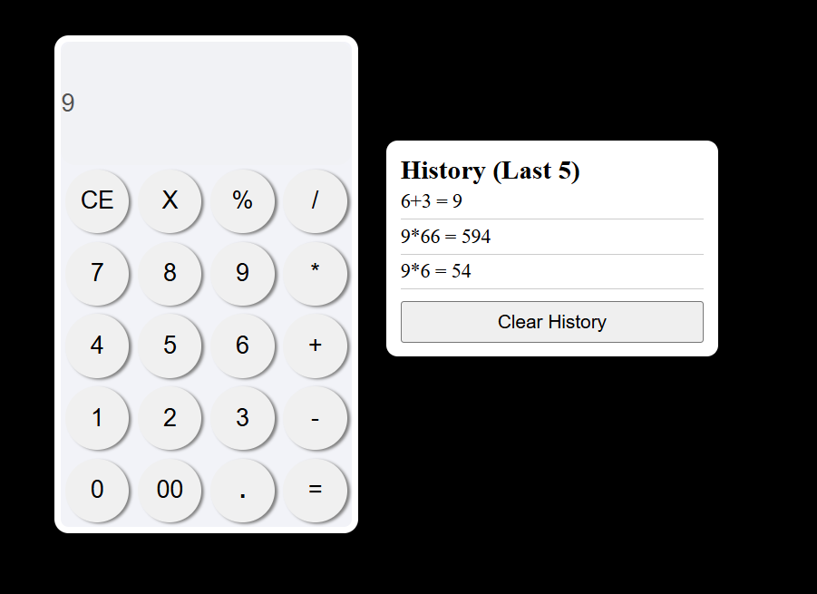

Assignment 2: Student Marks & Grade Analyzer
Problem Statement Create a system where:
● Student details are stored as objects
● Marks for multiple subjects are entered
● Total, percentage, and grade are calculated
● Result is displayed in a table
● Highlight pass/fail rows using CSS via JS

- Problem Statement
The objective of this lab is to develop a student result management system using JavaScript. Student details are stored as objects, and marks for multiple subjects are entered for each student. The system calculates the total marks, percentage, and grade for every student and displays the result in a tabular format. Students are categorized as pass or fail, and the corresponding rows are highlighted using CSS applied through JavaScript.
- List of JavaScript Concepts Used
- Objects & Array
- Array Methods like forEach, reduce
- Functions
- DOM Manipulations
- Conditional Statements

- Flow Diagram / Logic Steps
` a. Store student details and marks
b. Calculate total and percentage
c. Assign grade and pass/fail status
d. Display results in a table
e. Highlight pass/fail rows

- Source Code

Index.html
<!DOCTYPE html>
<html>
<head>
<title>Student Marks & Grade Analyzer</title>
<link rel="stylesheet" href="style.css">
</head>
<body>

<h2>Student Marks & Grade Analyzer</h2>

<table style="border: 1px solid black;" id="result-table">
<tr>
<th>Name</th>
<th>Marks</th>
<th>Total</th>
<th>Percentage</th>
<th>Grade</th>
<th>Result</th>
</tr>
</table>

<script src="script.js"></script>
</body>
</html>

Style.css

table {
border-collapse: collapse;
width: 80%;
}

th, td {
padding: 8px;
text-align: center;
}

.pass {
background-color: #c8f7c5;
}

.fail {
background-color: #f7c5c5;
}

Script.js

const table = document.getElementById("result-table");

const students = [
{
name: "Subesh",
marks: [75, 80, 70]
},
{
name: "Saroj",
marks: [45, 35, 30]
},
{
name: "Sangam",
marks: [90, 67, 92]
}
];

students.forEach(student => {
let total = student.marks.reduce((a, b) => a + b, 0);
let percentage = total / student.marks.length;
let grade = getGrade(percentage);
let result = percentage >= 40 ? "Pass" : "Fail";

let row = table.insertRow();
row.innerHTML = `
<td>${student.name}</td>
<td>${student.marks.join(", ")}</td>
<td>${total}</td>
<td>${percentage.toFixed(2)}%</td>
<td>${grade}</td>
<td>${result}</td>
`;

row.className = result === "Pass" ? "pass" : "fail";
});

function getGrade(percent) {
if (percent >= 80) return "A";
if (percent >= 60) return "B";
if (percent >= 40) return "C";
return "F";
}

- Output
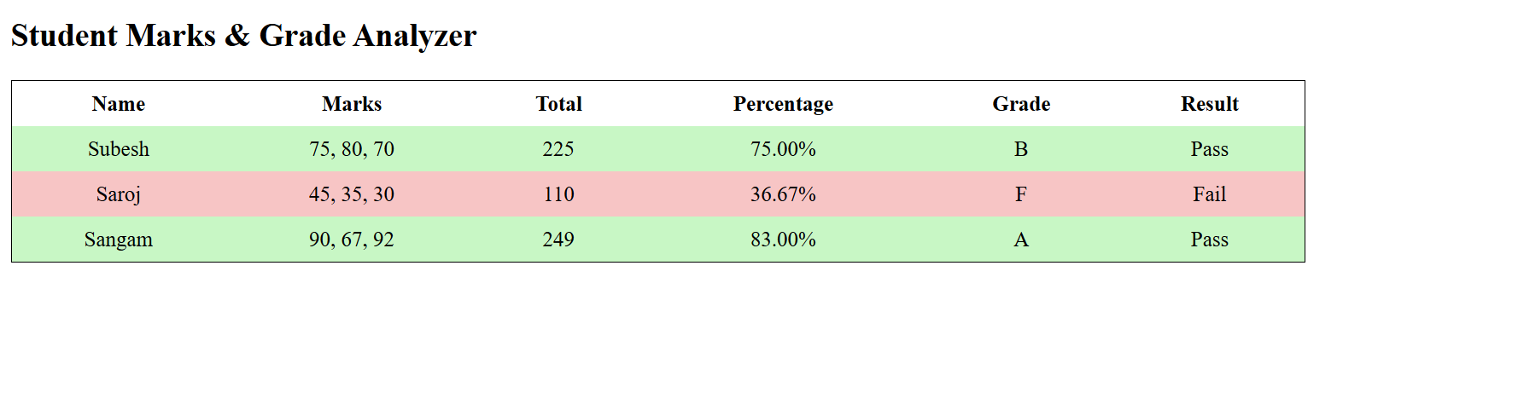

Assignment 3: Dynamic To-Do List with Status Filter
Problem Statement Build a To-Do app that:
● Adds, deletes, and marks tasks as completed
● Filters tasks (All / Completed / Pending)
● Displays count of completed tasks

- Problem Statement
The objective of this lab is to create a dynamic To-Do List application using JavaScript. The app allows users to add new tasks, delete existing tasks, and mark tasks as completed. It also provides a filtering feature to view all, completed, or pending tasks, and displays the count of completed tasks dynamically.
- List of JavaScript Concepts Used
- Objects & Array & Array Methods like forEach, reduce & Filter
- Functions
- DOM Manipulations & Event Handling
- Conditional Statements
- Template Literals
- Flow Diagram / Logic Steps
` a. Add task to the list
b. Mark task as completed or pending
c. Delete a task
d. Filter tasks (All / Completed / Pending)
e. Update and display count of completed tasks

- Source Code

Index.html
<!DOCTYPE html>
<html lang="en">
<head>
<meta charset="UTF-8">
<meta name="viewport" content="width=device-width, initial-scale=1.0">
<title>Dynamic To-Do List</title>
<link rel="stylesheet" href="style.css">
</head>
<body>

<h2>Dynamic To-Do List</h2>

<div class="todo-container">
<input type="text" id="taskInput" placeholder="Enter a task">
<button id="addTaskBtn">Add Task</button>
</div>

<div class="filters">
<button data-filter="all">All</button>
<button data-filter="completed">Completed</button>
<button data-filter="pending">Pending</button>
</div>

<p>Completed Tasks: <span id="completedCount">0</span></p>

<ul id="taskList"></ul>

<script src="script.js"></script>
</body>
</html>

Style.css
body {
font-family: 'Segoe UI', Tahoma, Geneva, Verdana, sans-serif;
background-color: #f4f7f9;
padding: 40px;
display: flex;
flex-direction: column;
align-items: center;
}

h2 {
color: #333;
margin-bottom: 20px;
}

.todo-container {
display: flex;
justify-content: center;
margin-bottom: 20px;
}

#taskInput {
width: 250px;
padding: 10px;
border: 2px solid #ddd;
border-radius: 8px 0 0 8px;
outline: none;
font-size: 16px;
transition: border-color 0.3s;
}

#taskInput:focus {
border-color: #007BFF;
}

#addTaskBtn {
padding: 10px 20px;
background-color: #007BFF;
border: none;
color: white;
font-weight: bold;
cursor: pointer;
border-radius: 0 8px 8px 0;
transition: background-color 0.3s;
}

#addTaskBtn:hover {
background-color: #0056b3;
}

.filters {
margin-bottom: 15px;
}

.filters button {
padding: 6px 15px;
margin: 0 5px;
border: none;
border-radius: 5px;
background-color: #ddd;
cursor: pointer;
transition: background-color 0.3s;
}

.filters button:hover {
background-color: #bbb;
}

ul {
list-style-type: none;
padding-left: 0;
width: 350px;
}

li {
background-color: white;
padding: 12px 15px;
margin-bottom: 8px;
display: flex;
justify-content: space-between;
align-items: center;
border-radius: 8px;
box-shadow: 0 2px 5px rgba(0,0,0,0.1);
transition: transform 0.2s;
}

li:hover {
transform: translateY(-2px);
}

.completed span {
text-decoration: line-through;
color: #28a745;
cursor: pointer;
}

.pending span {
color: #dc3545;
cursor: pointer;
}

li button {
background-color: #dc3545;
border: none;
color: white;
padding: 5px 10px;
border-radius: 5px;
cursor: pointer;
transition: background-color 0.3s;
}

li button:hover {
background-color: #a71d2a;
}

p {
font-weight: bold;
color: #333;
}

Script.js

const taskInput = document.getElementById("taskInput");
const addTaskBtn = document.getElementById("addTaskBtn");
const taskList = document.getElementById("taskList");
const completedCount = document.getElementById("completedCount");
const filterButtons = document.querySelectorAll(".filters button");

let tasks = [];

addTaskBtn.addEventListener("click", () => {
const text = taskInput.value.trim();
if (text === "") return;
tasks.push({ id: Date.now(), text: text, completed: false });
taskInput.value = "";
renderTasks();
});

function toggleTask(id) {
tasks = tasks.map(task => {
if (task.id === id) task.completed = !task.completed;
return task;
});
renderTasks();
}

function deleteTask(id) {
tasks = tasks.filter(task => task.id !== id);
renderTasks();
}

function renderTasks(filter = "all") {
taskList.innerHTML = "";
let filteredTasks = tasks;
if (filter === "completed") filteredTasks = tasks.filter(t => t.completed);
else if (filter === "pending") filteredTasks = tasks.filter(t => !t.completed);

filteredTasks.forEach(task => {
const li = document.createElement("li");
li.className = task.completed ? "completed" : "pending";
const span = document.createElement("span");
span.innerText = task.text;
span.onclick = () => toggleTask(task.id);
const delBtn = document.createElement("button");
delBtn.innerText = "Delete";
delBtn.onclick = () => deleteTask(task.id);
li.appendChild(span);
li.appendChild(delBtn);
taskList.appendChild(li);
});
completedCount.innerText = tasks.filter(t => t.completed).length;
}

filterButtons.forEach(btn => {
btn.addEventListener("click", () => renderTasks(btn.dataset.filter));
});

- Output

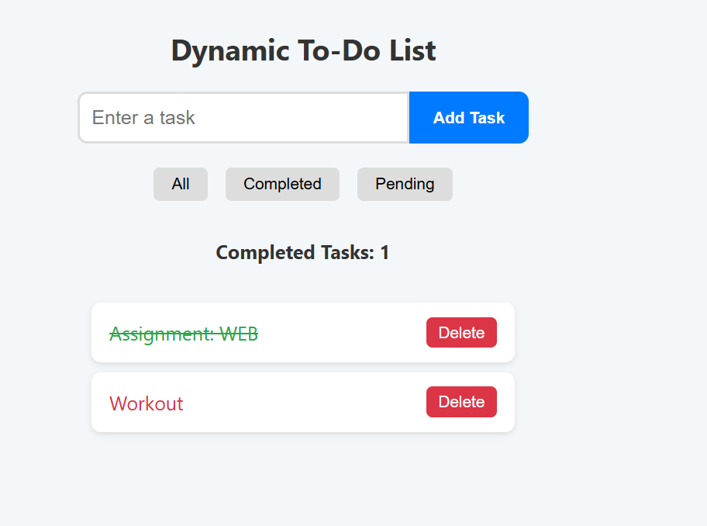

Assignment 3: Number Guessing Game with Score Tracking
Problem Statement Develop a game where:
● System generates a random number (1–100)
● User guesses the number
● Feedback is shown (High / Low / Correct)
● Score decreases on wrong attempts

- Problem Statement
The Number Guessing Game asks the computer to generate a random number between 1 and 100. The player tries to guess this number, and after each guess, the game provides feedback—telling the player if their guess is too high, too low, or correct. Each wrong guess reduces the player’s score, and the player can reset the game to start over. The goal is to guess the correct number with the highest score possible.

- List of JavaScript Concepts Used
- Objects & Array
- Functions
- DOM Manipulations & Event Handling
- Conditional Statements
- Template Literals
- Flow Diagram / Logic Steps
` a. Generate a random number between 1–100 and set the initial score.
b. User enters a guess and clicks submit.
c. Check if the guess is valid; show a warning if not.
d. Compare the guess to the random number: show “Too High”, “Too Low”, or “Correct”.
e. Reduce the score for wrong guesses and update the display.
f. User can reset the game to start over with a new number and full score.

- Source Code

Index.html
<!DOCTYPE html>
<html lang="en">

<head>
<meta charset="UTF-8">
<meta name="viewport" content="width=device-width, initial-scale=1.0">
<title>Number Guessing Game with Score Tracking</title>
<link rel="stylesheet" href="style.css">
</head>

<body>

<div id="game">
<h1 id="title">Guess the Number</h1>

<div id="inputSection">
<input type="number" id="userGuess" placeholder="Enter your guess (1-100)" min="1" max="100">
<button id="submitGuess">Submit Guess</button>
</div>

<div id="message">
<h1 id="feedback-title">Feedback:</h1>
<p id="feedback"></p>
</div>
<div>
<button id="reset">Reset</button>
</div>
</div>
<div id="score">
<h2>Score: <span id="scoreValue">100</span></h2>
</div>
<script src="script.js"></script>
</body>

</html>

Style.css
body {
font-family: 'Segoe UI', Tahoma, Geneva, Verdana, sans-serif;
background-color: #f4f7f9;
padding: 40px;
display: flex;
flex-direction: row;
align-items: center;
justify-content: center;
position: relative;
}

#score {
position: absolute;
top: 10px;
right: 10px;
font-size: 1.2em;
font-weight: bold;
color: #333;

}

#title {

color: #333;
margin-bottom: 0;
position: relative;
}

#title::after {
content: 'Win Against The Computer';
position: absolute;
display: block;
left: 100px;
font-size: 0.4em;
font-style: italic;
color: #666;
margin-top: -7px;
}

#game {
display: flex;
flex-direction: column;
align-items: center;
gap: 20px;
}

#inputSection {
margin-top: 50px;
}

#userGuess {
width: 200px;
padding: 7px;
border-radius: 5px;
}

#submitGuess {
padding: 7px 15px;
border-radius: 5px;
border: none;
background-color: #007BFF;
color: white;
font-weight: bold;
cursor: pointer;
transition: background-color 0.3s;
}

#submitGuess:hover {
background-color: #0056b3;
}

#message {
color: #333;
font-family: Arial, sans-serif;
font-style: italic;
padding: 5px;
border-radius: 8px;
background-color: #f0f0f0;
max-width: 400px;
box-shadow: 0 2px 6px rgba(0, 0, 0, 0.15);
display: none;
}

#feedback-title {
font-size: 0.7em;
color: #2f3640;
}

#feedback {
background-color: #a4b0b8;
color: #fff;
border-radius: 5px;
margin: 0;
padding: 2px;
}

#reset {

padding: 7px 15px;
border-radius: 5px;
border: none;
margin-top: 50px;
background-color: red;
color: white;
font-weight: bold;
cursor: pointer;
transition: background-color 0.3s;
}

Script.js

const userGuess = document.getElementById('userGuess');
const submitGuess = document.getElementById('submitGuess');
const scoreValue = document.getElementById('scoreValue');
const feedback = document.getElementById('feedback');
const message = document.getElementById('message');
const reset = document.getElementById('reset');

let score = 100;
let computerRandom = generateComputerGuess();
handleScore(score);

submitGuess.addEventListener('click', handleGuess);
reset.addEventListener('click', handleReset);

function generateComputerGuess() {
return Math.floor(Math.random() * 100) + 1;
}

function handleScore(score) {
scoreValue.innerText = score;
}

function showMessage(text) {
message.style.display = 'block';
feedback.innerText = text;
}

function handleGuess() {
const guess = Number(userGuess.value);

if (guess < 1 || guess > 100) {
showMessage("Invalid Guess: Guess Between 1 to 100");
return;
}

if (guess === computerRandom) {
showMessage("You Guessed it right!");
} else {
score = Math.max(score - 10, 0);
handleScore(score);

if (guess > computerRandom) {
showMessage("Guess Smaller Number than " + guess);
} else {
showMessage("Guess Larger Number than " + guess);
}
}

userGuess.value = '';
}

function handleReset() {
score = 100;
computerRandom = generateComputerGuess();
handleScore(score);
message.style.display = 'none';
userGuess.value = '';
}

- Output
