**SETUP Ansible HOST:**

* Provision a CENTOS 7 host using vagrant.
* Enable Password based authentication, by modifying the sshd_config file in /etc/ssh.

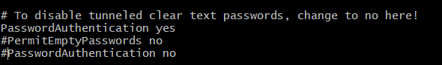

* Restart the system and login to the server using Putty/MOBA.

(default password for root/vagrant is : vagrant).

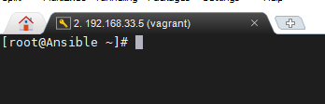

* Create the local user account (demo-adm).



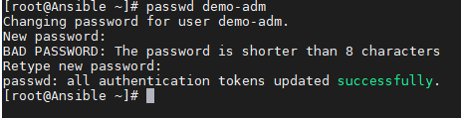

* Add the user to wheel group.



* Switch to local account and install epel-release first, followed by ansible.

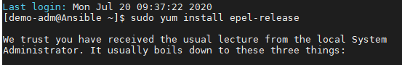

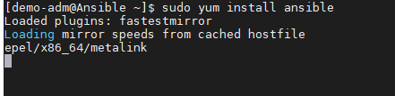

* Post install verification, execute the following command to confirm ansible is installed on local system.

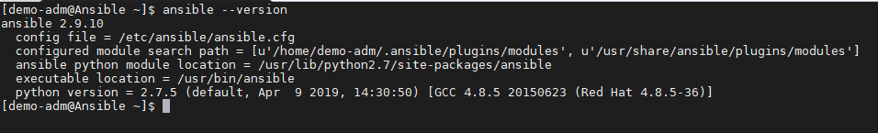

* Configure communication between Ansible and Target machines using SSH keys:

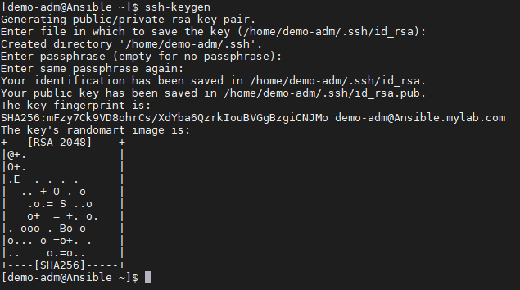

* Updating public key on remote host:

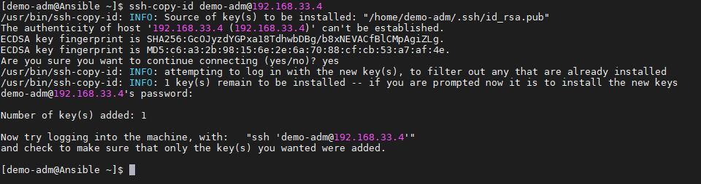

* Update the /etc/ansible/hosts file with the remote node IP address. (The hosts file is in git).
* Run ansible ping command to check the connectivity.

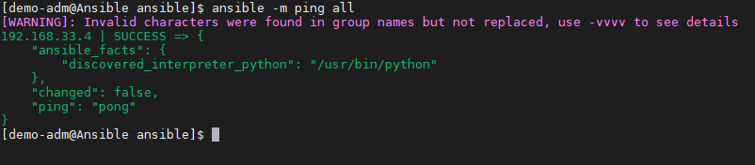

The same steps are to be performed to establish the connectivity between Ansible and other nodes.