**SETUP Kafka HOST:**

* Provision a CENTOS 7 host using vagrant.
* Enable Password based authentication, by modifying the sshd_config file in /etc/ssh.

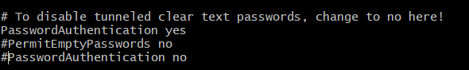

* Restart the system and login to the server using Putty/MOBA.

(default password for root/vagrant is : vagrant).



* Create the local user account (demo-adm).

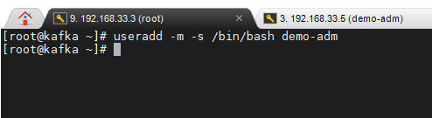

* Add the user to wheel group.

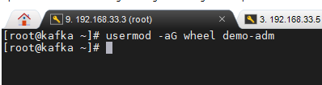

* Download Kafka binary and upload it to the host or run the following command if the node is connected to the internet:

wget <http://apache.mirror.amaze.com.au/kafka/2.5.0/kafka_2.12-2.5.0.tgz>

* Untar the package.

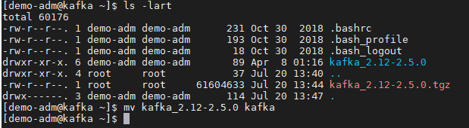

* JDK1.8 is mandatory for Kafka to run. Install JDK1.8

# yum install java -y

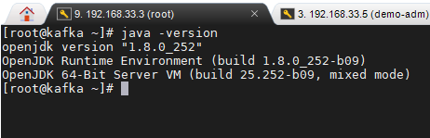

* Upload the services file from git/repo to /etc/system/system and reload the daemon.
* Start zookeeper and followed by kafka.

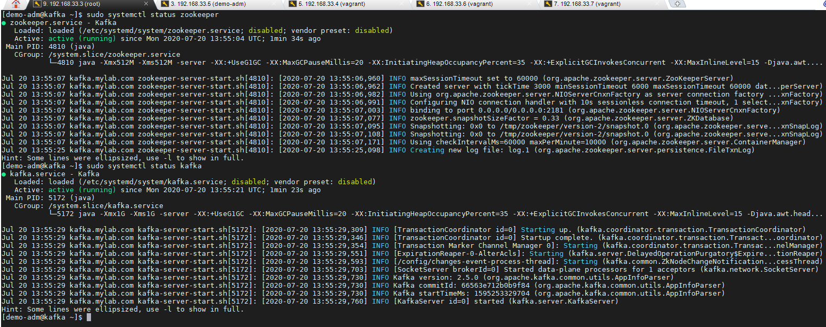

* Create a topic telegraf.

# cd /kafka/bin

# ./kafka-topics.sh --create --bootstrap-server 192.168.33.3:9092 --replication-factor 1 --partitions 1 --topic telegraf



* List Topics:

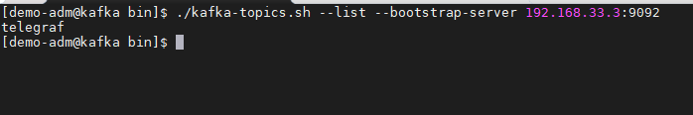

* Start the consumer on topic telegraf to verify telegraf agent data in Kafka:

# ./kafka-console-consumer.sh --bootstrap-server 192.168.33.3:9092 --topic telegraf --from-beginning

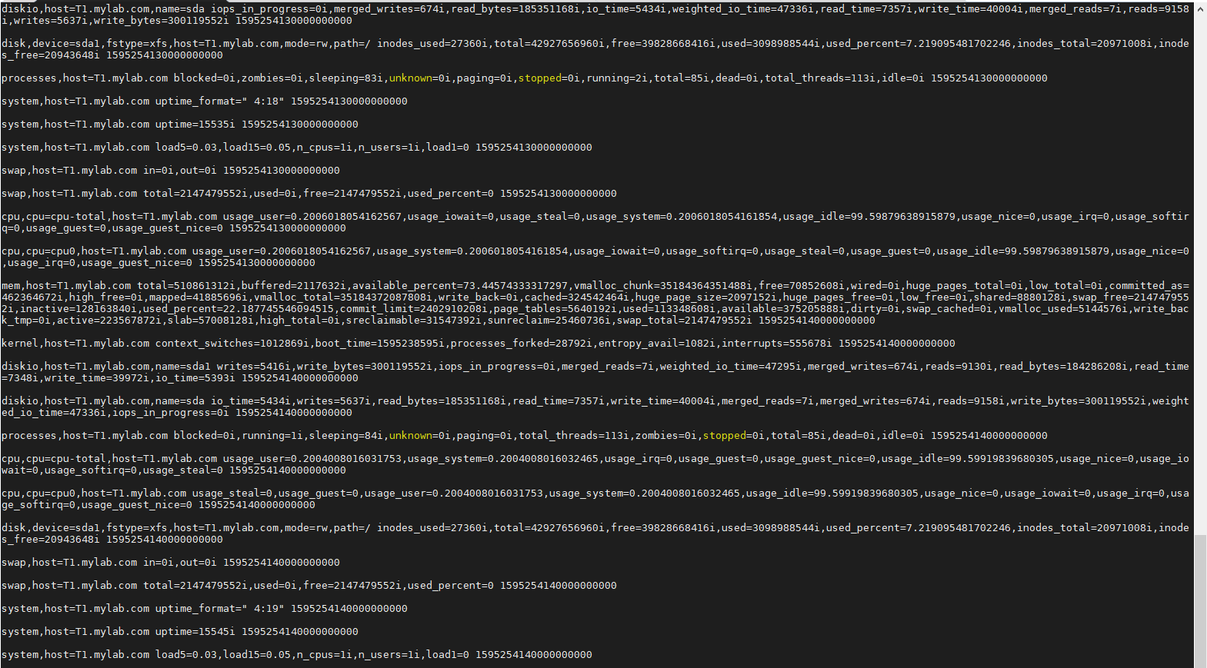

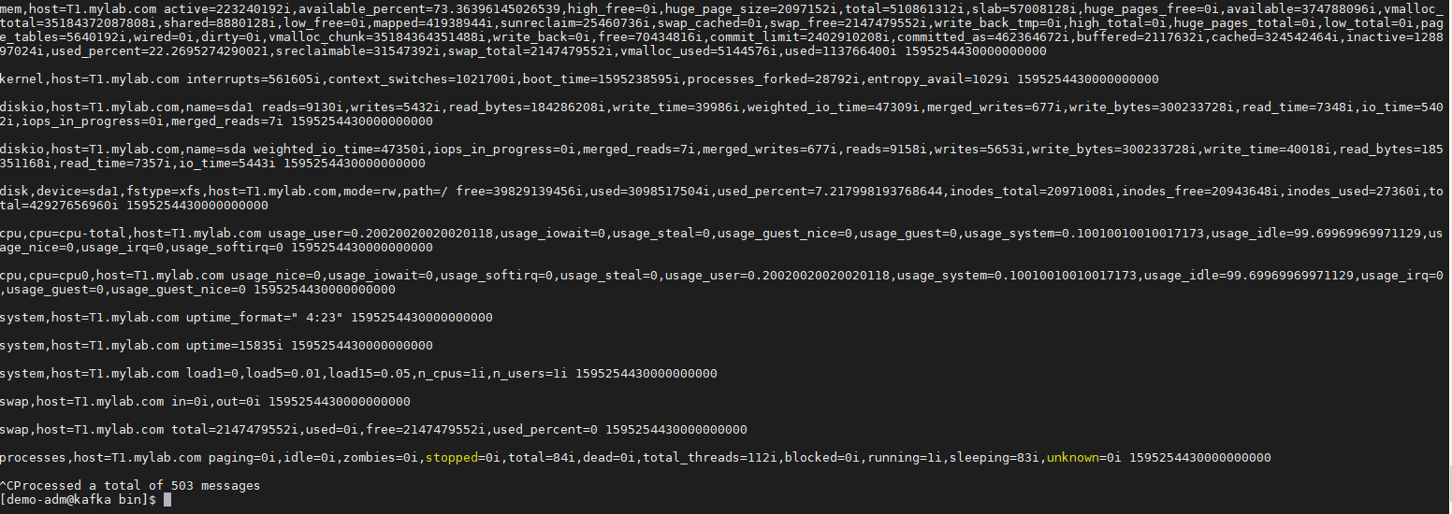

**Install Docker on Kafka Host:**

* Install yum utils:

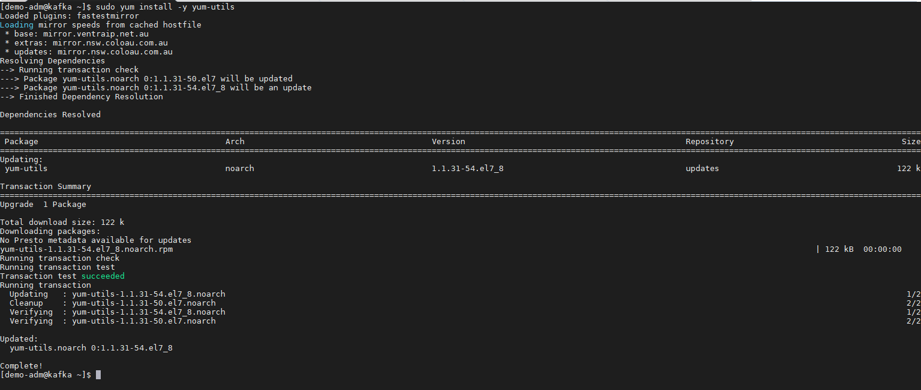

* Setup docker repo:

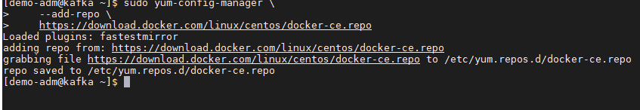

* Install docker:

# sudo yum install docker-ce docker-ce-cli containerd.io -y

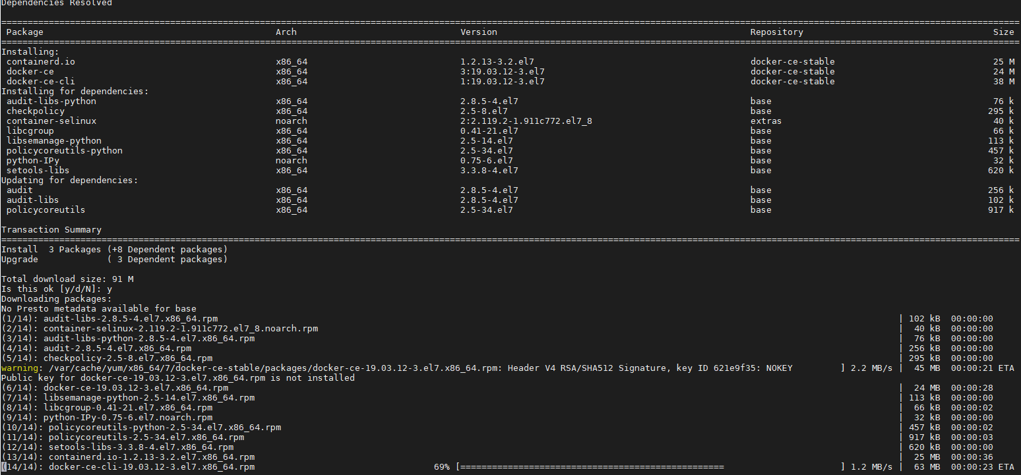

* Start, enable and verify Docker:

# sudo systemctl start docker

# sudo systemctl enable docker

# sudo docker

**Install Docker compose:**

* Download docker-compose from git:

# curl -L "https://github.com/docker/compose/releases/download/1.26.2/docker-compose-$(uname -s)-$(uname -m)" -o /usr/local/bin/docker-compose

* Change permission, create symlink and validate docker-compose version.

# chmod +x /usr/local/bin/docker-compose

# ln -s /usr/local/bin/docker-compose /usr/bin/docker-compose

# docker-compose –version

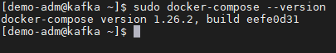

**Install Zoo navigator:**

Run the following docker-compose file:

# docker-compose -f zoonavigator-docker-compose.yml up -d

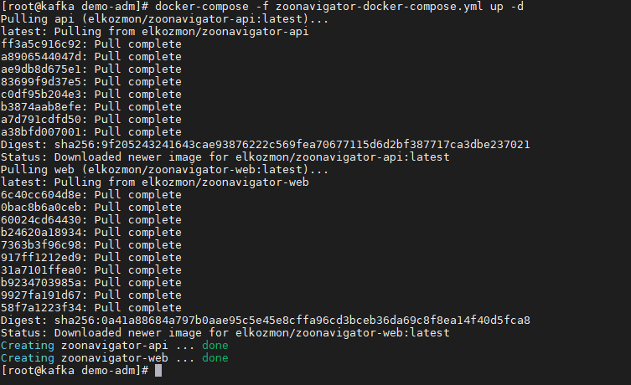

* Zoo navigator UI should be accessible on port 8001 now.

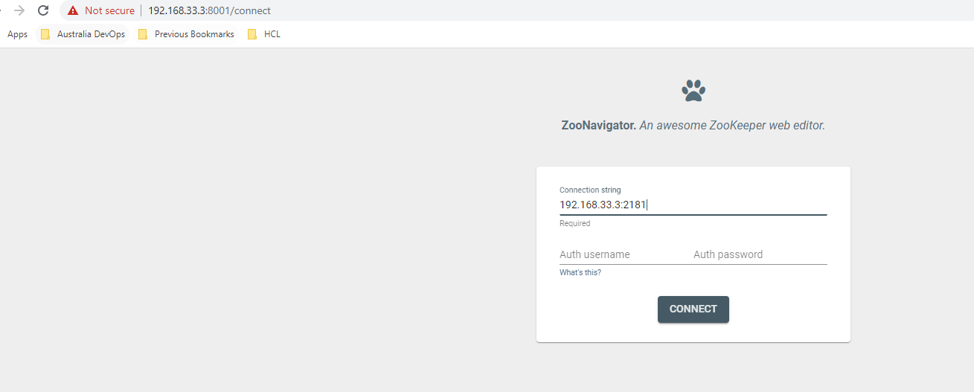

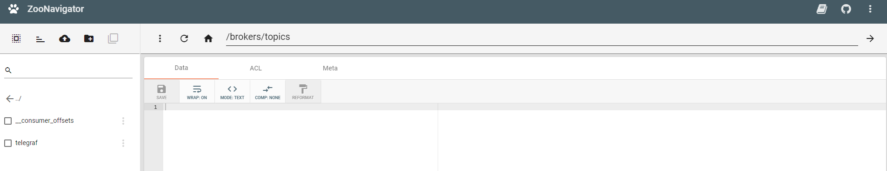

**Install Kafka Manager UI:**

* Run the following docker-compose file:

# docker-compose -f kafka-manager-compose.yml up -d

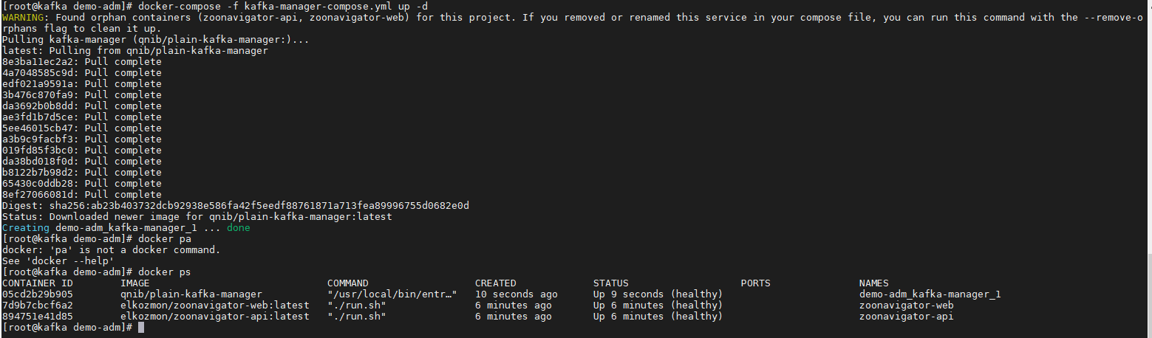

* Kafka manager UI is available on port 9000.

