Host JSON server in HEROKU

1. Cloning Repo to the System:

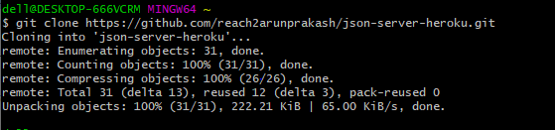

1. Modifying the db.json object

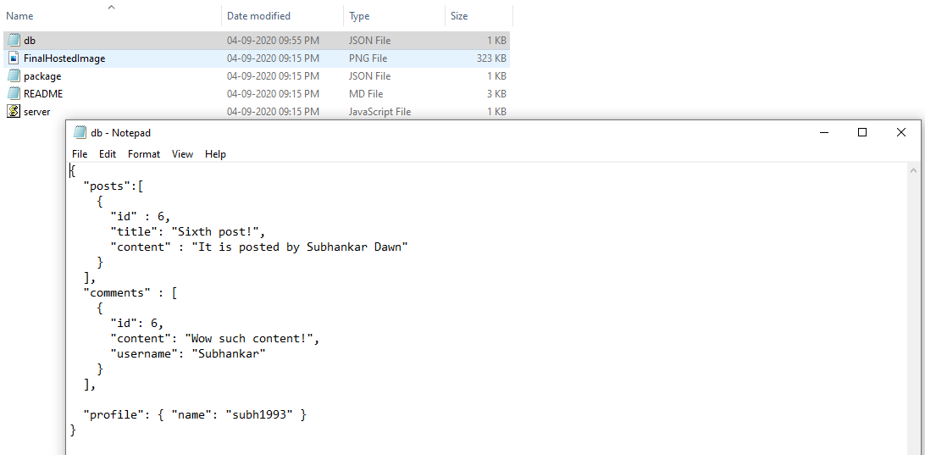

1. Click on stage Changed >> Select the file where changes are made>> Click on Commit after a commit messag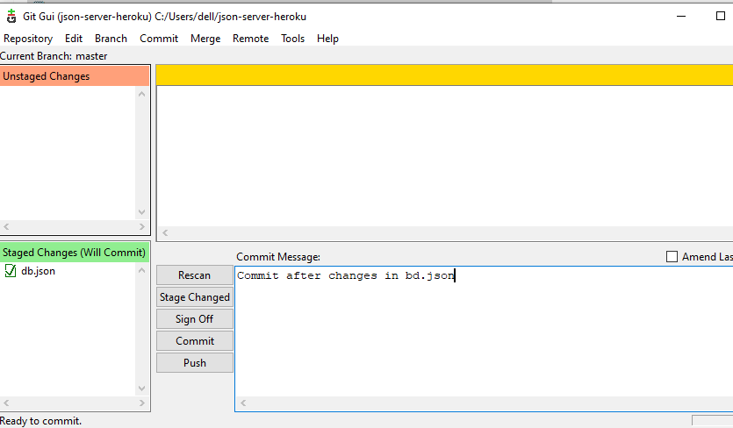e.
2. Open cmd after creating an account in Heroku and installing Heroku for Desktop

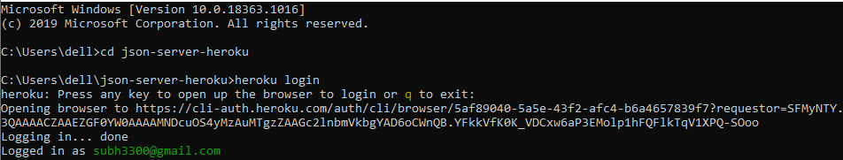

Cd to the cloned dir >> Log in to heroku “heroku login”>> enter credentials to log in

1. Create new server in heroku “heroku create <server-name>”



1. Add the remote repo which will be pushed in the git

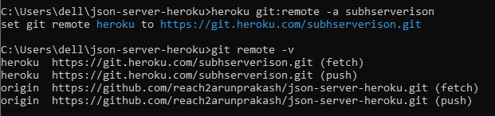

1. Push the repo to git

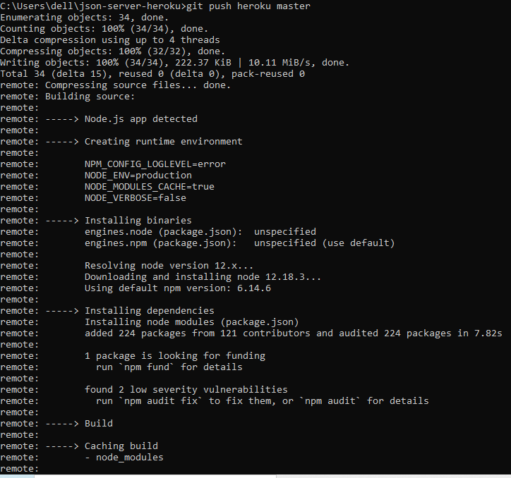

1. Type “heroku open” to view the deployed code

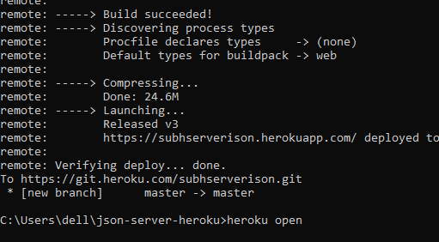

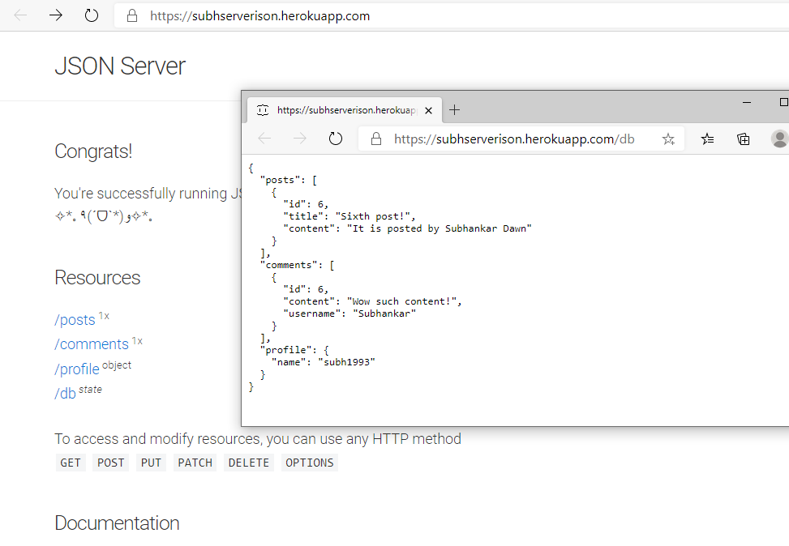

Here we can see the changes are reflected.