Fake Account Detection using Petri Net Analyzer in TINA

Introduction
Online Social Networks (OSNs) such as Twitter, Facebook, Instagram, and LinkedIn allow users to communicate and share information with others. Due to the increasing popularity of social networking platforms, fake accounts have become a major security concern. These fake accounts are often used for spamming, phishing, spreading misinformation, promoting advertisements, and distributing malicious links.
Fake account detection is an important security mechanism used to identify suspicious user profiles and protect genuine users from cyber threats. In this assignment, a Petri Net-based model is designed and simulated using the TINA tool to analyze Twitter account behavior and classify accounts as Genuine or Fake.

Objective
The main objectives of this assignment are:
- To study Twitter account characteristics.
- To identify important features used for fake account detection.
- To design a Petri Net model using TINA.
- To simulate the behavior of Twitter account analysis.
- To classify accounts as Genuine or Fake.
- To evaluate the performance of the proposed model.

Characteristics Analysis of Twitter Accounts
Twitter provides several features that help users communicate and interact with each other. These characteristics can be analyzed to detect suspicious behavior.

Tweets
Tweets are short messages posted by users. Genuine users generally post meaningful content, whereas fake users often post repetitive messages, advertisements, or spam content.

Analysis
    - High-quality tweets indicate genuine behavior.
    - Repetitive or automated tweets may indicate fake accounts.
    - Excessive promotional content is suspicious.

Followers
Followers are users who subscribe to another user's account.

Analysis
    - Genuine users usually have a balanced follower count.
    - Fake accounts generally have very few followers.
    - Sudden increases in followers may indicate suspicious activity.

Following
Following refers to the accounts that a user follows.

Analysis
    - Genuine users follow accounts based on interest.
    - Fake accounts often follow thousands of users in a short period.
    - Extremely high following count is a strong indicator of fake behavior.

Likes
Likes indicate appreciation of content.

Analysis
    - Genuine users like content based on interest.
    - Fake accounts may automatically like large numbers of tweets.

URLs
URLs are web links shared through tweets.

Analysis
    - Genuine users share useful links.
    - Fake users frequently share suspicious or malicious URLs.
    - Shortened URLs are commonly used in spam campaigns.

Retweets
Retweeting is reposting another user's content.

Analysis
    - Genuine users retweet useful information.
    - Fake users repeatedly retweet promotional content.

Feature Selection
Feature selection is the process of selecting important characteristics for detecting fake accounts.
The following features are selected:

Feature | Purpose
Followers Count | Measures account popularity
Following Count | Detects unusual following behavior
Total Tweets | Measures activity level
Likes Count | Measures engagement
URLs Shared | Detects suspicious links

Synthetic Twitter Dataset
Account | Followers | Following | Tweets | Likes | URLs | Result
User_A | 780 | 620 | 450 | 380 | 3 | Genuine
User_B | 25 | 1450 | 1900 | 12 | 28 | Fake
User_C | 1250 | 910 | 680 | 520 | 4 | Genuine
User_D | 42 | 1200 | 1650 | 18 | 24 | Fake
User_E | 610 | 540 | 390 | 275 | 2 | Genuine

6. Petri Net-Based Analyzer

Introduction
A Petri Net is a mathematical and graphical modeling tool used to represent system behavior and workflow.
In this assignment, Petri Net is used to model the process of Twitter account analysis.

Components of Petri Net
  - Place
A place represents a state in the system. Examples:
    - User Profile Loaded
    - Followers Checked
    - Following Checked
    - Tweets Checked
    - Likes Checked
    - URLs Checked
    - Behavior Analysis
    - Genuine User
    - Fake User

Transition
A transition represents an activity performed on the data. Examples:
    - Load Profile

Extract Followers
    - Extract Following
    - Analyze Tweets
    - Analyze Likes
    - Analyze URLs
    - Genuine Decision
    - Fake Decision

Token
A token represents a Twitter account being analyzed.
The movement of the token indicates the progression of the account through different analysis stages.

Arc
Arcs connect places and transitions.
They define the flow of information in the Petri Net model.

Petri Net Workflow
The designed Petri Net follows the sequence:

User Profile Loaded
↓

Followers Checked
↓

Following Checked
↓

Tweets Checked
↓

Likes Checked
↓

URLs Checked
↓

Behavior Analysis
↓

Genuine User / Fake User

Place | Description
P0 | User Profile Loaded
P1 | Followers Checked
P2 | Following Checked
P3 | Tweets Checked
P4 | Likes Checked
P5 | URLs Checked
P6 | Behavior Analysis
P7 | Fake User
P8 | Genuine User
- Petri Net Design in TINA

Places Used Transitions Used
Transition | Description
T0 | Load Profile
T1 | Extract Followers
T2 | Extract Following
T3 | Analyze Tweets
T4 | Analyze Likes
T5 | Analyze URLs
T6 | Genuine Decision
T7 | Fake Decision

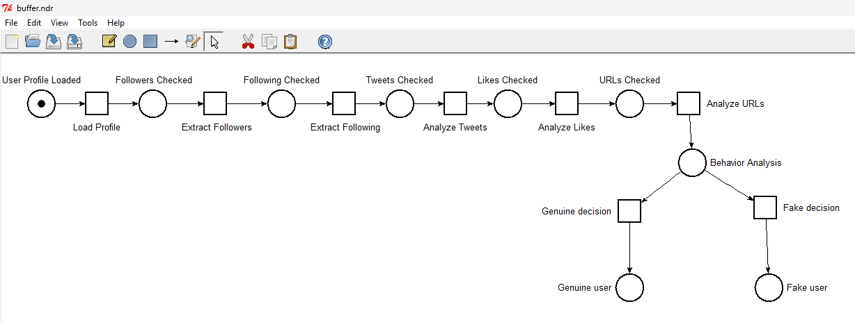

Petri Net Simulation
The Petri Net was simulated using TINA Interactive Simulator.

Simulation Steps Step 1
One token is placed in the "User Profile Loaded" state.

Step 2
The token moves to "Followers Checked" through the Load Profile transition.

Step 3
The token moves to "Following Checked".

Step 4
The token moves to "Tweets Checked".

Step 5
The token moves to "Likes Checked".

Step 6
The token moves to "URLs Checked".

Step 7
The token reaches "Behavior Analysis".

Step 8
Based on the selected features, the account is classified as:
- Genuine or Fake User

State Space Analysis
State Space Analysis was performed using TINA.
The generated output shows all reachable states and transitions.

Observations
- Number of Places = 9
- Number of Transitions = 8
- Number of States=9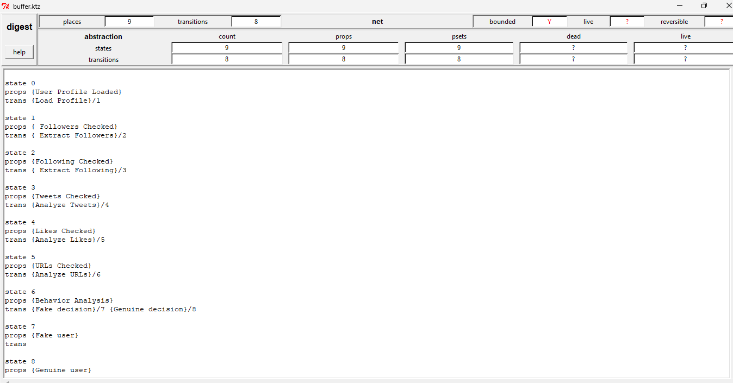
Performance Results

Account | Avg  Followers/Day | Avg  Following/Day | Avg Tweets/Day | Follower Ratio | Classification
User_A | 1.42 | 1.31 | 1.80 | 1.08 | Genuine
User_B | 0.20 | 23.33 | 0.50 | 0.009 | Fake
User_C | 1.90 | 1.74 | 2.40 | 1.09 | Genuine
User_D | 0.08 | 15.00 | 0.30 | 0.006 | Fake
User_E | 1.43 | 1.30 | 1.60 | 1.10 | Genuine

Analysis
- Genuine accounts have balanced follower-following ratios.
- Genuine accounts show regular activity.
- Fake accounts have very low followers and very high following counts.
- Fake accounts share more URLs and suspicious content.

Result
The Petri Net model was successfully implemented and simulated using TINA. The token moved through all analysis states and correctly classified Twitter accounts as Genuine or Fake based on the selected features.

Conclusion
This assignment presented a Petri Net-based approach for Twitter fake account detection. The model analyzed account characteristics such as followers, following, tweets, likes, and URLs. The Petri Net was successfully designed and simulated in TINA. State Space Analysis and Reachability Graph verified the correctness of the model. The results demonstrate that Petri Nets provide an effective method for modeling and analyzing fake account detection workflows in social networks.

