JADAVPUR UNIVERSITY
Kolkata – 700032
Faculty of Engineering and Technology – Department of Chemical Engineering
A PROJECT REPORT ON
DESIGN AND RATING OF A SHELL-AND-TUBE HEAT EXCHANGER
Debutanizer Condenser Debottlenecking Case Study using DWSIM
Submitted by
SUBHAMOY PANJA
B.E. Chemical Engineering (Roll No – 002310301114)
October 2026

ABSTRACT
This report presents the design and rating of a single-shell, two-tube-pass shell-and-tube heat exchanger operating as a debutanizer overhead condenser. Hydrocarbon vapour at 75 °C and 8 bar (15,000 kg/h) is cooled and condensed by 85,000 kg/h of cooling water entering at 30 °C. The exchanger was modelled in DWSIM using the Shell and Tubes Exchanger Rating option and the results were verified by independent hand calculations covering the energy balance, log-mean temperature difference (LMTD), required heat-transfer area, tube-side hydraulics and the overall heat-transfer coefficient.
The simulation gives a heat duty of 1,249.2 kW, an overall coefficient of 256.5 W/m²·K and an installed area of 160.6 m² against 155.4 m² required, i.e. a design margin of about 3.3 %. The shell-side film is the controlling resistance (about 78 % of the total). A screening estimate for a 15 % increase in hydrocarbon flow indicates a required area of about 184 m², roughly 14 % more than is installed; practical debottlenecking options are discussed.
Keywords: shell-and-tube heat exchanger, condenser, LMTD, heat-transfer area, fouling, debottlenecking, DWSIM.

1. INTRODUCTION

1.1 Background
Shell-and-tube exchangers are the most widely used heat-transfer equipment in refineries and chemical plants. In a debutanizer unit, the overhead vapour is condensed by cooling water in a shell-and-tube condenser. When plant throughput is increased, the existing condenser may no longer be able to remove the additional heat load, and the exchanger becomes a bottleneck. Assessing whether the installed area is sufficient, and how much additional area is needed, is a routine process-engineering task.

1.2 Problem statement
A shell-and-tube exchanger (debutanizer condenser) is to be simulated in DWSIM in which hot hydrocarbon vapour is condensed using cold cooling water. The objective is to determine whether a 15 % increase in vapour flow rate (from 15,000 kg/h to 17,250 kg/h) still results in complete condensation, by evaluating the vapour outlet fraction and outlet temperature of the hydrocarbon stream.

1.3 Objectives
- To simulate and rate the exchanger in DWSIM for the base-case operating conditions.
- To verify the simulation by hand calculation of heat duty, LMTD, required area, tube-side velocity, film coefficient, pressure drop and overall coefficient.
- To benchmark the predicted outlet temperatures against the published reference case study.
- To estimate the effect of a 15 % increase in hydrocarbon flow on the required heat-transfer area and to list possible debottlenecking measures.

1.4 Design basis
The operating data are given in Table 1. Both streams flow counter-currently; the cooling water is allocated to the tube side and the hydrocarbon to the shell side.
Table 1. Process design basis
Parameter | Hydrocarbon (shell side) | Cooling water (tube side)
Inlet temperature | 75.0 °C | 30.0 °C
Inlet pressure | 8.00 bar | 4.00 bar
Mass flow rate – base case | 15,000 kg/h (4.167 kg/s) | 85,000 kg/h (23.61 kg/s)
Mass flow rate – debottlenecking case | 17,250 kg/h (+15 %) | 85,000 kg/h
Flow arrangement | Counter-current | Counter-current

2. PROCESS SIMULATION IN DWSIM

2.1 Simulation set-up
The exchanger was represented by a single Heat Exchanger unit with the hydrocarbon vapour on the shell side and cooling water on the tube side. The calculation type was set to Shell and Tubes Exchanger Rating with Counter Current flow direction, and the geometry listed in Table 2 was entered in the Shell and Tube Exchanger Properties window (Figure 2). The flowsheet converged successfully; the resulting stream conditions and the Master Property Table are shown in Figure 1.
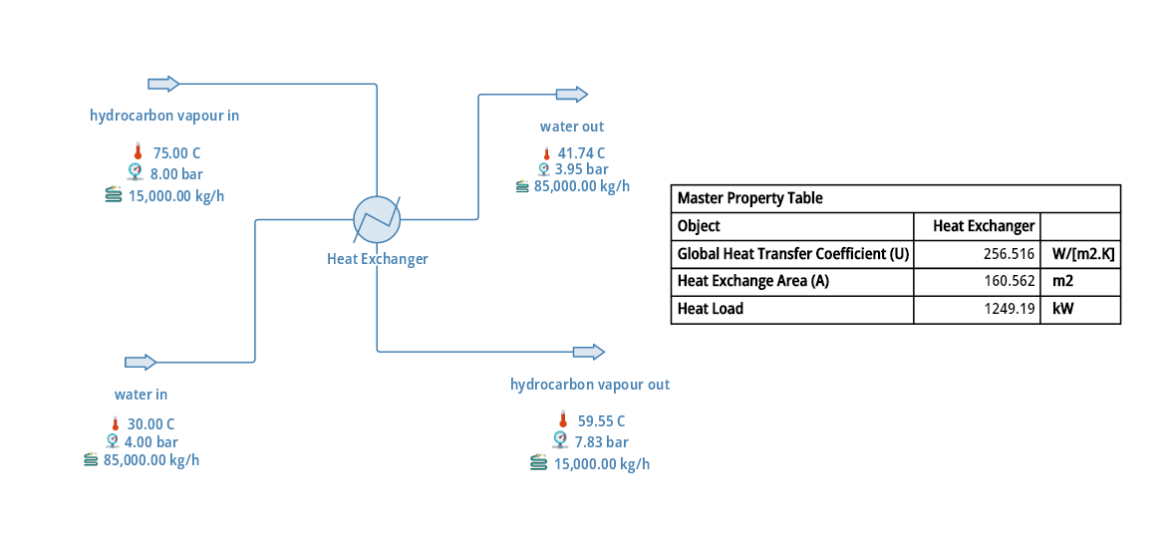
Figure 1. DWSIM flowsheet with stream conditions and Master Property Table

2.2 Exchanger geometry
Table 2. Geometry and mechanical data used in the rating model
Shell side | Value | Tube side | Value
Shells in series / passes | 1 / 1 | Tube ID / OD | 15.75 / 19.05 mm
Shell internal diameter | 600 mm | Tube length | 6.0 m
Shell fouling factor | 0.0002 m²·K/W | Passes per shell | 2
Baffle type / orientation | Single segmental / vertical | Tubes per shell | 450
Baffle spacing | 450 mm | Tube pitch / layout | 25 mm / triangular
Baffle cut | 25 % of diameter | Tube fouling factor | 0.0002 m²·K/W
Flow direction | Counter-current | Wall conductivity | 50 W/m·K
Fluid in tubes | Cold (cooling water) | Tube roughness | 0.05 mm
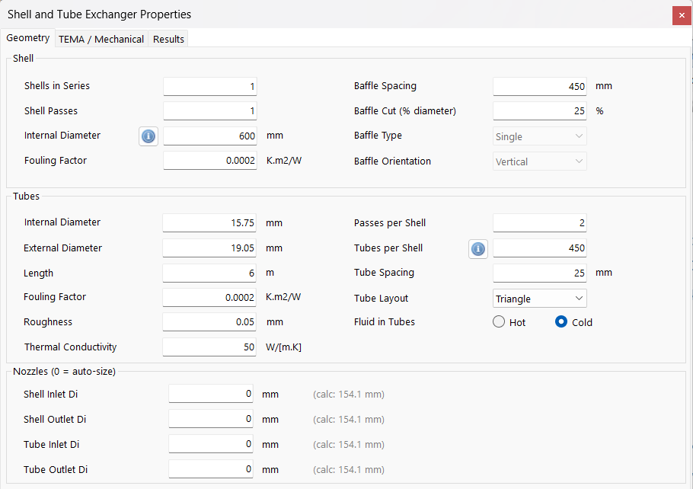

Figure 2. Shell and Tube Exchanger Properties window in DWSIM (geometry inputs)

2.3 Simulation results and validation
Table 3 compares the simulated outlet conditions with the reference case study. The outlet temperatures agree to within 0.15 °C, which confirms that the stream data and the exchanger model were specified correctly.
Table 3. Comparison of simulation results with the reference case
Quantity | This work | Reference case | Deviation
Water outlet temperature | 41.74 °C | 41.71 °C | +0.03 °C
Hydrocarbon outlet temperature | 59.55 °C | 59.40 °C | +0.15 °C
Hydrocarbon outlet pressure | 7.83 bar | 7.80 bar | +0.03 bar
Hydrocarbon pressure drop | 0.167 bar | 0.20 bar | –0.03 bar
Water-side pressure drop | 0.046 bar | – | –

3. THERMAL DESIGN CALCULATIONS

3.1 Heat duty
For steady, adiabatic operation the heat released by the hydrocarbon equals that absorbed by the cooling water (heat loss in DWSIM = 0 kW). The duty is evaluated from the cold stream, which is single-phase:
Q = ṁ_{c} c_{p,c} (T_{c,out} – T_{c,in}) (1)
With ṁ_{c} = 85,000/3600 = 23.611 kg/s and ΔT_{c} = 41.74 – 30.00 = 11.74 °C, and taking c_{p} = 4.18 kJ/kg·K:
Q_{hand} = 23.611 × 4.18 × 11.74 = 1,159 kW (2)
DWSIM reports Q = 1,249.19 kW, which is 7.2 % higher. The difference corresponds to a mean specific heat of about 4.50 kJ/kg·K in the simulator, and is attributed to the enthalpy basis of the property package used by DWSIM rather than to the exchanger model. As all subsequent calculations use the DWSIM duty together with the DWSIM temperatures, the area calculation remains internally consistent. On the hot side the duty corresponds to a specific enthalpy change of
Δh_{h} = Q/ṁ_{h} = 1,249.19/4.167 = 299.8 kJ/kg (3)
which is much larger than the sensible heat of a vapour cooled by 15.5 °C, showing that a major part of the duty is the latent heat of condensation, as expected for a condenser. The terminal temperatures are shown in Figure 3.
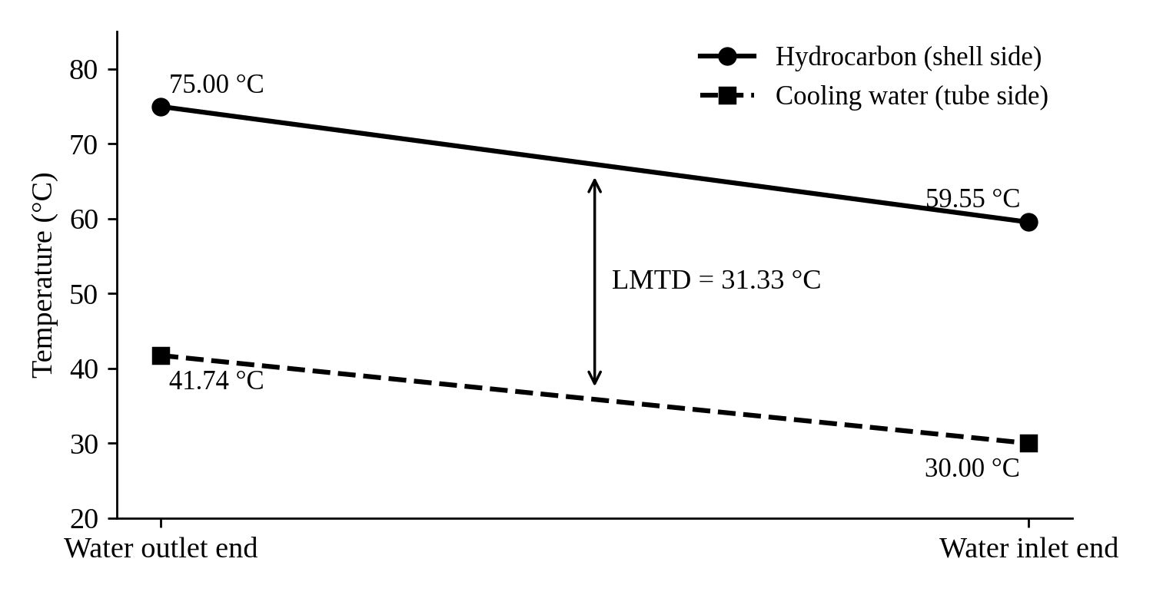
Figure 3. Terminal temperature diagram (profiles drawn as straight lines for illustration)

3.2 Log-mean temperature difference
For counter-current flow the terminal temperature differences are:
ΔT₁ = T_{h,in} – T_{c,out} = 75.00 – 41.74 = 33.26 °C (4)
ΔT₂ = T_{h,out} – T_{c,in} = 59.55 – 30.00 = 29.55 °C (5)
LMTD = (ΔT₁ – ΔT₂) / ln(ΔT₁/ΔT₂) = 31.37 °C (6)
DWSIM reports a target LMTD of 31.3314 °C, which agrees with the hand value to within 0.1 %. For a one-shell, two-tube-pass exchanger the correction factor F was checked using R = (T_{h,in} – T_{h,out})/(T_{c,out} – T_{c,in}) = 1.316 and P = (T_{c,out} – T_{c,in})/(T_{h,in} – T_{c,in}) = 0.261, which gives F ≈ 0.97 for a single-phase shell fluid (Bowman et al., 1940). Since the shell-side stream is condensing and nearly isothermal, F approaches unity and the counter-current LMTD is used without correction, consistent with the simulator.

3.3 Required heat-transfer area
A_{req} = Q / (U · LMTD) (7)
A_{req} = 1,249,190 / (256.516 × 31.3314) = 155.4 m² (8)
The area provided by the tube bundle, based on the tube outside diameter, is:
A = N_{t} π D_{o} L = 450 × π × 0.01905 × 6.0 = 161.6 m² (9)
DWSIM reports A = 160.562 m², differing by 0.6 % from the geometric value because of the internal tube-length and tube-count basis of the program. The design margin based on the DWSIM area is
Over-design = (A – A_{req})/A_{req} = (160.6 – 155.4)/155.4 = 3.3 % (10)
The installed area therefore covers the base-case requirement with a small margin of about 3 %, which is adequate for the present duty but leaves little allowance for increased throughput. The main thermal results are summarised in Table 4.
Table 4. Summary of thermal design results (base case)
Quantity | Symbol | Value | Unit
Heat duty | Q | 1,249.19 | kW
Overall coefficient (fouled) | U | 256.516 | W/m²·K
Log-mean temperature difference | LMTD | 31.33 | °C
Required area | A_{req} | 155.4 | m²
Installed area | A | 160.6 | m²
Design margin | – | 3.3 | %

4. MECHANICAL AND GEOMETRIC CONFIGURATION
The following dimensions were derived from the data in Table 2 to confirm that the tube bundle fits the shell and to obtain the shell-side flow parameters.
Pitch ratio P_{t}/D_{o} = 25/19.05 = 1.31 (11)
D_{b} = D_{o}(N_{t}/K₁)^{1/n1} = 19.05 (450/0.249)^{1/2.207} = 570 mm (12)
The bundle diameter of about 570 mm is smaller than the shell diameter of 600 mm, leaving a bundle-to-shell clearance of roughly 30 mm; the 450-tube layout therefore fits within the shell (K₁ = 0.249 and n₁ = 2.207 for two tube passes on a triangular pitch; Sinnott and Towler). The number of baffles is approximately L/B – 1 = 6000/450 – 1 ≈ 12. The shell cross-flow area, equivalent diameter and mass velocity are:
A_{s} = (P_{t} – D_{o}) D_{s} B / P_{t} = (5.95 × 600 × 450)/25 = 64,260 mm² = 0.0643 m² (13)
d_{e} = 1.10 (P_{t}² – 0.917 D_{o}²)/D_{o} = 16.9 mm (14)
G_{s} = ṁ_{h}/A_{s} = 4.167/0.0643 = 64.8 kg/m²·s (15)
The baffle spacing equals 75 % of the shell diameter, which lies within the usual range of 0.2 to 1.0 shell diameters. An illustrative tube layout and a schematic of the exchanger are given in Figures 4 and 5.
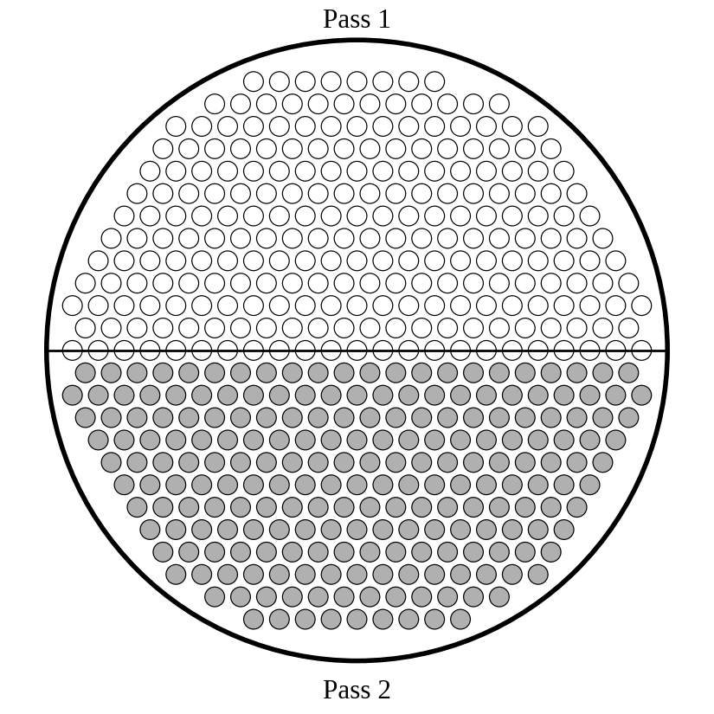
Figure 4. Illustrative tube layout (450 tubes, two passes, 25 mm triangular pitch)
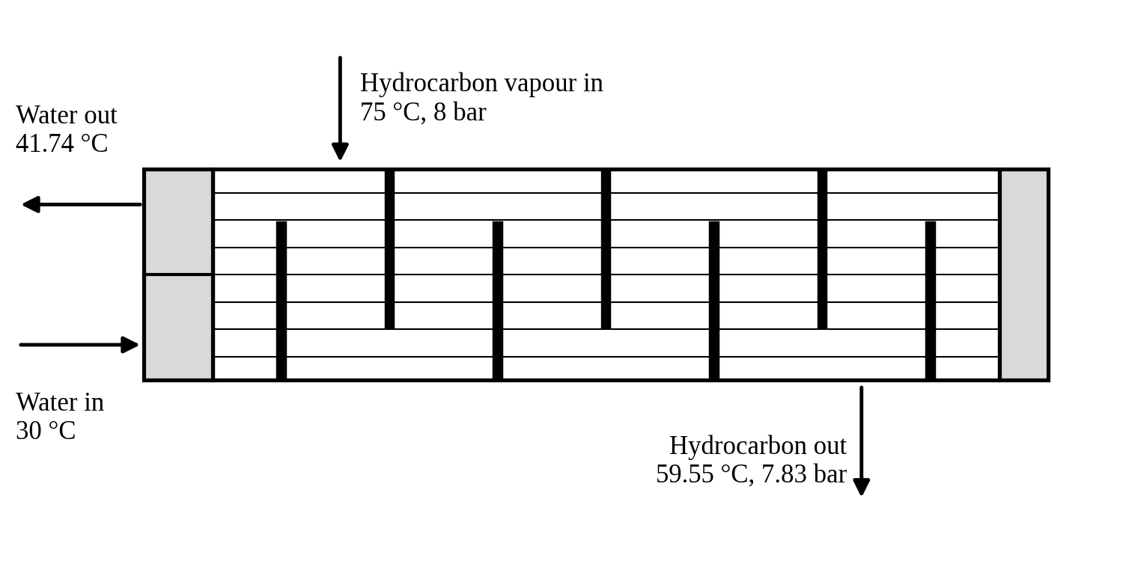
Figure 5. Schematic of the shell-and-tube exchanger (not to scale)

5. TUBE-SIDE THERMAL AND HYDRAULIC DESIGN
Cooling water flows inside the tubes. Properties were taken at the mean bulk temperature of about 35.9 °C: ρ = 994 kg/m³, μ = 0.70 mPa·s, k = 0.623 W/m·K and c_{p} = 4.18 kJ/kg·K.

5.1 Velocity and flow regime
With 450 tubes and two passes there are 225 tubes per pass, giving a flow area per pass of a = 225 × (π/4) × (0.01575)² = 0.04384 m².
v = (ṁ_{c}/ρ)/a = (23.611/994)/0.04384 = 0.54 m/s (16)
Re = ρ v D_{i}/μ = 994 × 0.542 × 0.01575/0.0007 = 12,119 (17)
Pr = μ c_{p}/k = 4.70 (18)
The flow is turbulent.

5.2 Tube-side film coefficient
The Dittus–Boelter correlation for heating of the fluid gives:
Nu = 0.023 Re^{0.8} Pr^{0.4} = 78.9 (19)
h_{i} = Nu · k/D_{i} = 78.9 × 0.623/0.01575 = 3,122 W/m²·K (20)
Referred to the outside area, h_{io} = h_{i} D_{i}/D_{o} = 2,581 W/m²·K.

5.3 Tube-side pressure drop
The Colebrook friction factor for ε/D_{i} = 0.0032 and Re = 12,119 is f = 0.0342, and the dynamic head is ρv²/2 = 146 Pa. Then:
ΔP_{friction} = f (L N_{p}/D_{i}) ρv²/2 = 0.0342 × (6 × 2/0.01575) × 146 = 3,802 Pa (21)
ΔP_{return} = 4 N_{p} ρv²/2 = 4 × 2 × 146 = 1,167 Pa (22)
ΔP_{tube} = ΔP_{friction} + ΔP_{return} = 0.050 bar (23)
The calculated pressure drop of 0.050 bar compares with 0.046 bar from DWSIM (a difference of 8 %). The water velocity of 0.54 m/s is below the 1.0–2.5 m/s normally recommended for cooling water, which increases the tendency for fouling and settling. Because the tube-side pressure drop is very small, there is ample hydraulic margin to raise the velocity, for example by providing four tube passes.

6. OVERALL HEAT-TRANSFER COEFFICIENT AND FOULING
The overall coefficient based on the outside tube area is obtained from the sum of the individual resistances:
1/U_{o} = 1/h_{o} + R_{f,o} + D_{o} ln(D_{o}/D_{i})/(2k_{w}) + R_{f,i} D_{o}/D_{i} + D_{o}/(D_{i} h_{i}) (24)
The DWSIM fouled coefficient is U = 256.5 W/m²·K. All resistances except the shell-side film are known from the geometry and the tube-side calculation, so the shell-side film resistance implied by DWSIM is obtained by difference (Table 5).
Table 5. Thermal resistances (outside-area basis)
Resistance | Expression | Value (m²·K/W) | Share
Tube-side film | D_{o}/(D_{i} h_{i}) | 3.874×10⁻⁴ | 9.9 %
Inner fouling | 0.0002 D_{o}/D_{i} | 2.419×10⁻⁴ | 6.2 %
Tube wall | D_{o} ln(D_{o}/D_{i})/2k_{w} | 3.624×10⁻⁵ | 0.9 %
Outer fouling | 0.0002 | 2.000×10⁻⁴ | 5.1 %
Shell-side film (by difference) | 1/U – Σ(above) | 3.033×10⁻³ | 77.8 %
Total | 1/U = 1/256.516 | 3.898×10⁻³ | 100 %

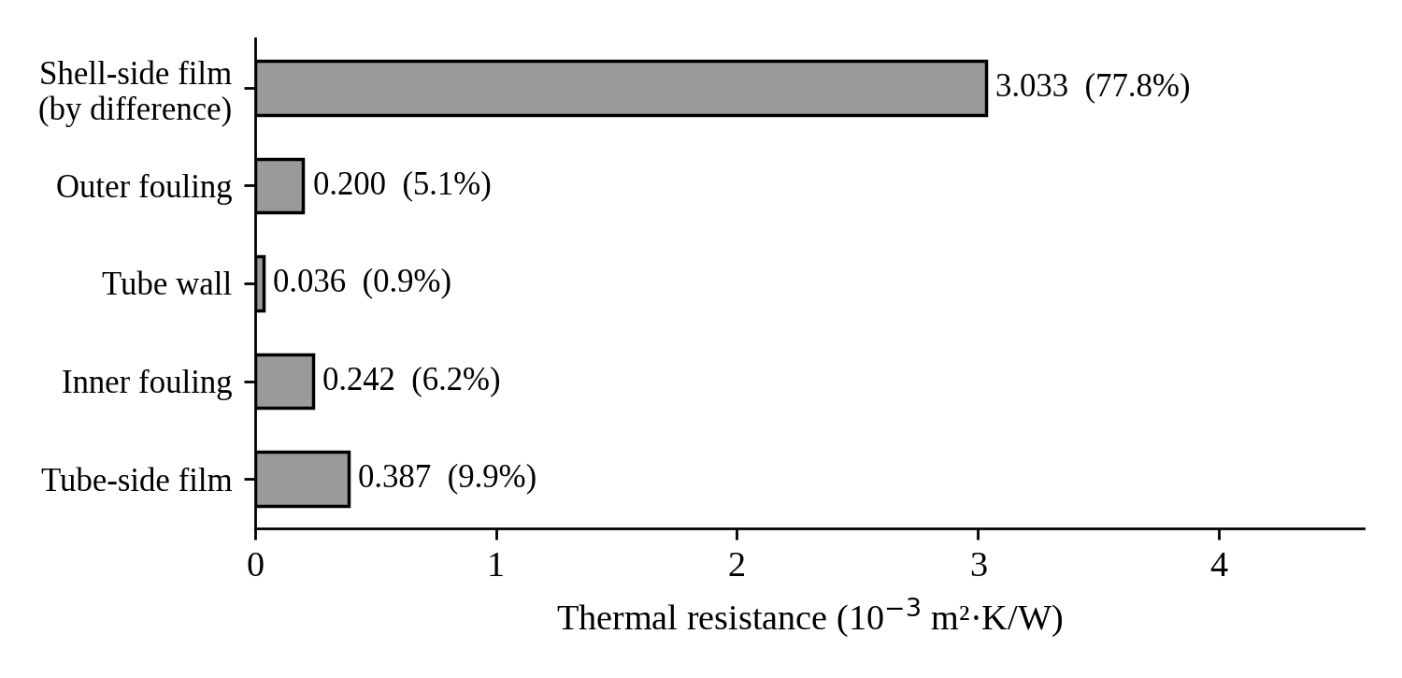
Figure 6. Contribution of individual resistances to the overall resistance
The implied shell-side coefficient is h_{o} = 1/3.033×10⁻³ ≈ 330 W/m²·K. Omitting the two fouling allowances, the clean coefficient is U_{c} = 289 W/m²·K, and the cleanliness factor is
CF = U/U_{c} = 256.5/289 = 0.89 (25)
The shell-side film contributes about 78 % of the total resistance, so the shell side controls heat transfer and improvements in baffle spacing, baffle cut or tube layout would be most effective. The two fouling allowances together account for 11 % of the resistance. The hot-side pressure drop of 0.167 bar is only about 2 % of the 8 bar operating pressure, so the condensing temperature is practically unaffected.

7. DEBOTTLENECKING AT +15 % HYDROCARBON FLOW
The hydrocarbon flow is increased from 15,000 to 17,250 kg/h while the cooling-water flow and inlet temperatures are unchanged. As a first screening estimate it is assumed that the duty per kilogram of hydrocarbon, the hydrocarbon outlet temperature (59.55 °C) and the overall coefficient remain the same as in the base case. These assumptions should be confirmed by re-running the DWSIM simulation.
Q_{new} = 1.15 × 1,249.19 = 1,436.6 kW (26)
ΔT_{c,new} = 1.15 × 11.74 = 13.51 °C, T_{c,out} = 43.51 °C (27)
LMTD_{new} = (31.49 – 29.55)/ln(31.49/29.55) = 30.51 °C (28)
A_{req,new} = 1,436,569/(256.5 × 30.51) = 183.5 m² (29)
The required area exceeds the installed 160.6 m² by 14.3 %. Figure 7 shows that, under these assumptions, the existing exchanger can accommodate an increase of only about 3 % in vapour flow before the available area is exhausted. The results are compared in Table 6.
Table 6. Comparison of base case and +15 % case
Case | Q (kW) | T_{c,out} (°C) | LMTD (°C) | A_{req} (m²) | A_{installed} (m²)
Base (15,000 kg/h) | 1,249 | 41.74 | 31.33 | 155.4 | 160.6
+15 % (17,250 kg/h) | 1,437 | 43.51 | 30.51 | 183.5 | 160.6

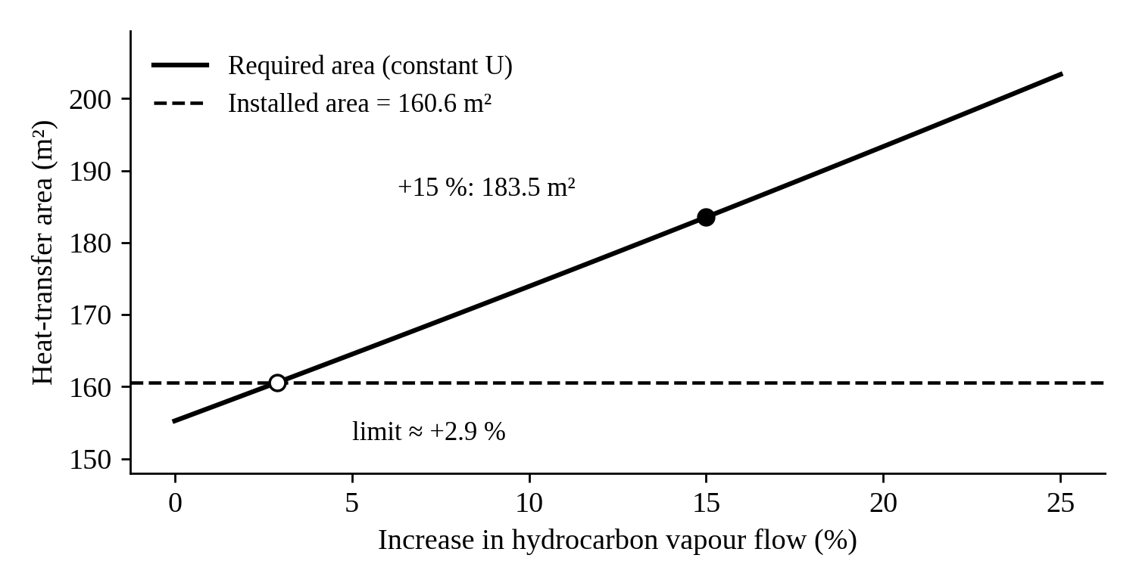
Figure 7. Required heat-transfer area as a function of increase in hydrocarbon flow

7.1 Debottlenecking options
- Longer tubes: re-tubing with tubes of about 6.9 m length (instead of 6 m) provides the required 184 m², subject to shell length and tube-pulling space.
- Second shell in series: an additional exchanger of about 23 m² can be added with minimal change to the existing unit.
- Higher cooling-water flow: increases the LMTD and the tube-side coefficient; the low tube-side pressure drop leaves hydraulic margin, subject to pump capacity and water availability.
- Shell-side improvement: closer baffle spacing or a different baffle cut raises h_{o}, at the cost of a higher shell-side pressure drop.
- Fouling control: maintaining fouling at or below the design value of 0.0002 m²·K/W preserves the fouling allowance in U.
To confirm the screening result, the hydrocarbon flow should be set to 17,250 kg/h in DWSIM and the rating calculation repeated; a vapour fraction of zero at the outlet indicates complete condensation.

8. RESULTS AND DISCUSSION
Table 7 compares the hand calculations with the simulation results.
Table 7. Verification of DWSIM results by hand calculation
Quantity | DWSIM | Hand calculation | Agreement
Heat duty | 1,249 kW | 1,159 kW (c_{p} = 4.18) | -7.2 %
LMTD | 31.33 °C | 31.37 °C | +0.11 %
Area | 160.6 m² (installed) | 155.4 m² (required) | 3.3 % margin
Tube-side pressure drop | 0.046 bar | 0.050 bar | +8 %
Outlet temperatures | 41.74 / 59.55 °C | Reference: 41.71 / 59.40 °C | within 0.15 °C

The simulation and the hand calculations agree closely for LMTD, area and tube-side pressure drop. The only appreciable difference, in heat duty, arises from the enthalpy basis of the simulator. The installed area of 160.6 m² is adequate for the base case but provides a margin of only about 3 %, and a 15 % increase in hydrocarbon flow is estimated to require about 184 m². The overall coefficient is controlled by the shell-side film, while the low tube-side velocity (0.54 m/s) is a possible fouling concern.

9. CONCLUSIONS
- A single-shell, two-tube-pass exchanger with 450 tubes (19.05 mm OD, 6 m long) in a 600 mm shell provides 160.6 m² of area against 155.4 m² required for a duty of about 1.25 MW, a design margin of about 3 %.
- The DWSIM rating model reproduces the reference outlet temperatures to within 0.15 °C and agrees closely with hand-calculated LMTD, area and tube-side pressure drop.
- The overall coefficient of 256.5 W/m²·K is controlled by the shell-side film (78 % of the total resistance); the clean coefficient is about 289 W/m²·K, giving a cleanliness factor of 0.89.
- At +15 % hydrocarbon flow the required area is estimated at 184 m², about 14 % above the installed area; the existing exchanger is therefore not sufficient without modification, subject to confirmation by simulation.
- The tube-side velocity is low (0.54 m/s); four tube passes would improve the film coefficient and reduce the fouling tendency at little hydraulic cost.

Scope for further work
The study may be extended by re-running the DWSIM model at 17,250 kg/h, by rigorous shell-side (Kern or Bell–Delaware) calculations once hydrocarbon properties are available, and by an economic comparison of the debottlenecking options.

NOMENCLATURE
Symbol | Description | Unit
A | Heat-transfer area | m²
a | Tube-side flow area per pass | m²
A_{s} | Shell cross-flow area | m²
B | Baffle spacing | m
c_{p} | Specific heat capacity | kJ/kg·K
D_{i}, D_{o} | Tube inside and outside diameter | m
D_{s}, D_{b} | Shell and bundle diameter | m
f | Darcy friction factor | –
h_{i}, h_{o} | Tube-side and shell-side film coefficients | W/m²·K
L | Tube length | m
ṁ | Mass flow rate | kg/s
N_{t}, N_{p} | Number of tubes, number of tube passes | –
P_{t} | Tube pitch | m
Q | Heat duty | kW
R_{f} | Fouling resistance | m²·K/W
Re, Pr, Nu | Reynolds, Prandtl and Nusselt numbers | –
T | Temperature | °C
U | Overall heat-transfer coefficient | W/m²·K
v | Velocity | m/s
ΔP | Pressure drop | Pa, bar
μ, ρ, k | Viscosity, density, thermal conductivity | Pa·s, kg/m³, W/m·K
LMTD | Log-mean temperature difference | °C

REFERENCES
[1] Kern, D. Q. (1950). Process Heat Transfer. McGraw-Hill, New York.
[2] Sinnott, R. K. and Towler, G. Chemical Engineering Design (Coulson and Richardson’s Chemical Engineering, Vol. 6). Butterworth-Heinemann, Oxford.
[3] Incropera, F. P., DeWitt, D. P., Bergman, T. L. and Lavine, A. S. Fundamentals of Heat and Mass Transfer. John Wiley and Sons.
[4] Bowman, R. A., Mueller, A. C. and Nagle, W. M. (1940). Mean temperature difference in design. Transactions of the ASME, 62, 283–294.
[5] Dittus, F. W. and Boelter, L. M. K. (1930). Heat transfer in automobile radiators of the tubular type. University of California Publications in Engineering, 2, 443–461.
[6] Tubular Exchanger Manufacturers Association. TEMA Standards.
[7] DWSIM – Open Source Chemical Process Simulator. https://dwsim.org

