**Site Url:** <http://codeigniter-development.com/hostelworld/>

**Agent Url:** <http://codeigniter-development.com/hostelworld/agent/>

**Agent Username:** [ashes.pal@webskitters.com](mailto:ashes.pal@webskitters.com)

**Agent Password:** 123456

**Admin Url:** <http://codeigniter-development.com/hostelworld/admin/>

**Admin Username:** [admin@admin.com](mailto:admin@admin.com)

**Admin Password:** 123456

1. Availability: How do you set availability? I can see a calendar but nothing else.

**WDC: When client book a property, the bookable date will will marked as pink color in the calendar of agent area. Please see below.**

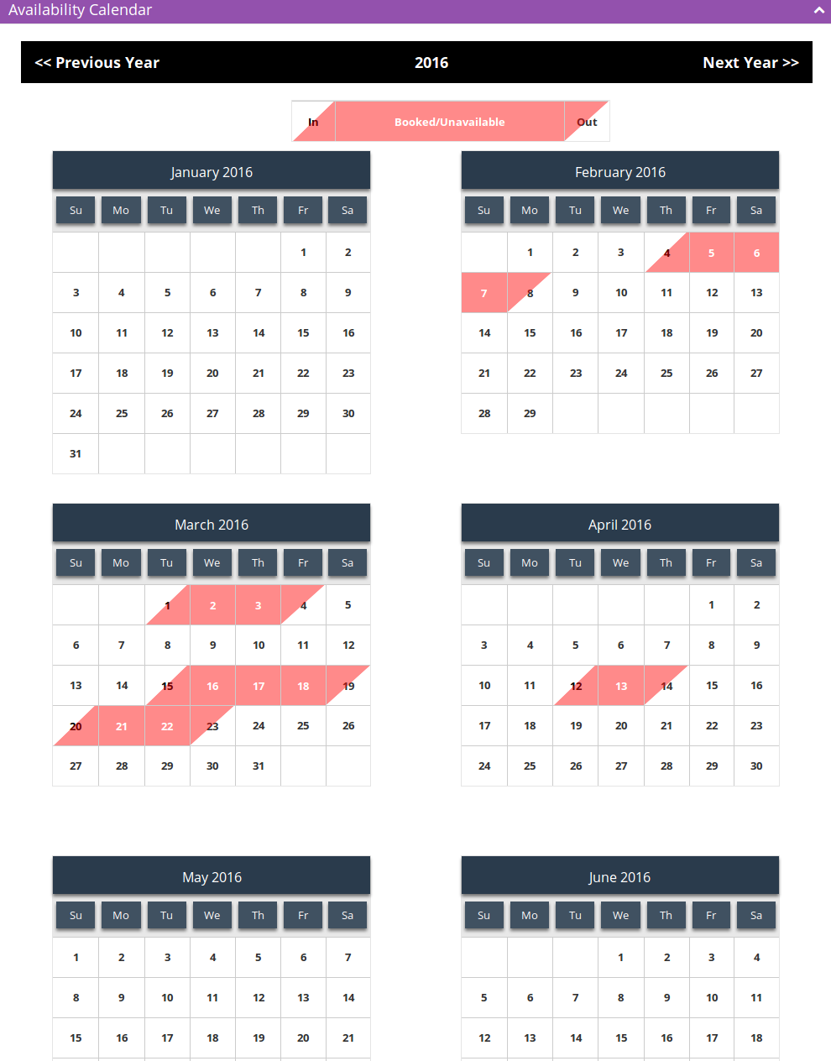

2. Agent allocate available nights.

**WDC: We did not get this point please explain this point and give some screen shot.**

3. Client needs to be able to book a bed

**WDC: From the property details page client can book a bed. First need to select date range from which user want to book then click “Check Availability” button. After that select guest from the drop down list. Then Book Now option will show.**

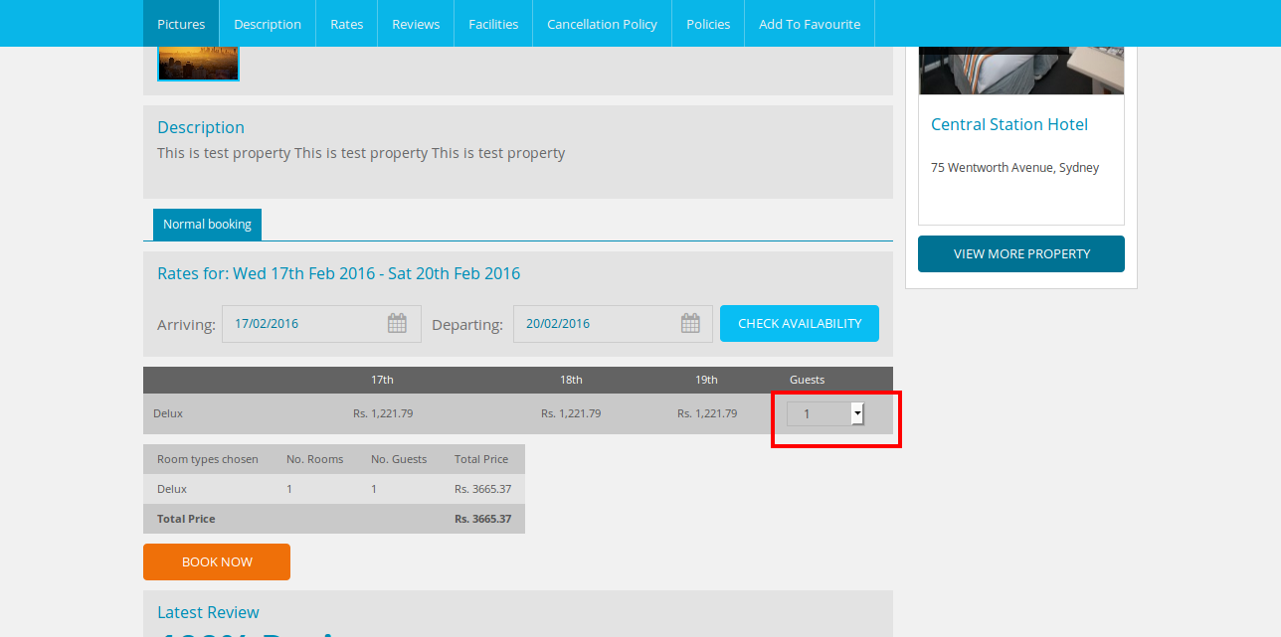

4. Booking must show under booking section

**WDC: All the booking is listed here. To view this booking listing First click on the “Property Setup” tab and then click on “Booking” tab.**

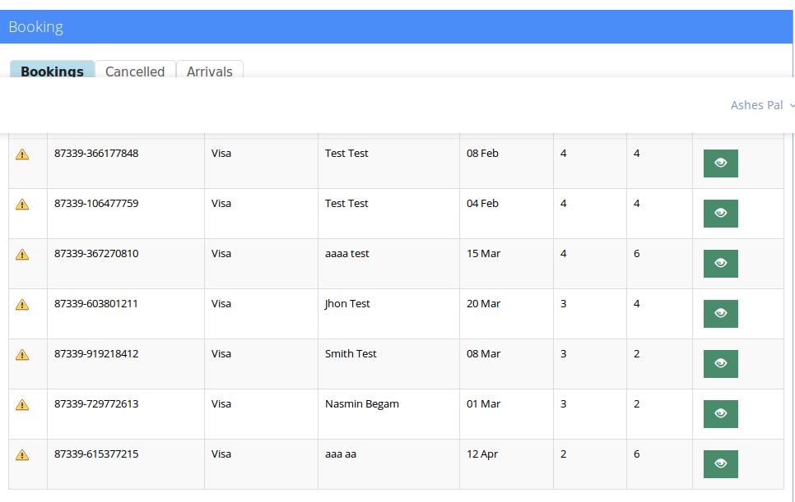

5. Booking must show under report section.

**WDC: Report is showing how many is booked from Website and how is booked from App.**

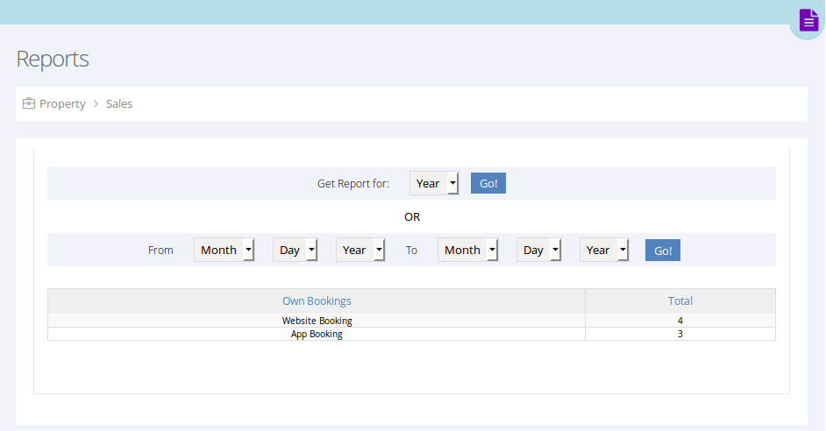

6. Client needs to be able to leave a review which can be accessed and see in agent section

**WDC: An email with a feedback link will be sent to the client when the check out date will be pass.**

**After getting the email client need to click on the link then the below page will be open.**

**And If a agent want to see the review, they need to click on “Property Setup” tab then click on the “Reports” tab then “Customer Ratings” tab.**

