**CONTENT PAGE**

1. **Introduction…………………………………………….……Page 2**
2. **Existence of Trade Unions among Youths…………….Page 2**
3. **Statistics of Young Union Members………………….Page 2-3**
4. **Reasons for Decline of Young Union Members……Page 3-6**

4.1 Low Awareness & Weak Branding of Trade Union’s role

4.2 Loss of Faith in Unions  
4.3 Passive Youths   
4.4 Existing Benefits

4.5 Influence of Social Media

**5. Ways to Increase Appeal of Unions to Youths...…...Page 6-7**

5.1 Link up with Youth Organizations  
 5.2 Campaigns and Roadshows

5.3 Use of Social Media

5.4 Added Benefits

5.5 Promote Young Union Leadership

**6. Conclusion…………………………………………………...Page 7   
7. References…………………………………………...………Page 8  
8. Appendices………………………………………………Page 9-11**

**1. Introduction**

A trade union is an organization of employees formed to secure a diverse range of benefits and aims to promote good industrial relations while increasing productivity for the benefit of workers, employees and economy.

**2. Existence of Trade Unions among Youths**

The existence of a powerful and recognized trade union is a pre-requisite to industrial peace. Decisions casted through collective bargaining and negotiations between employer and unions are more influential. However, globalization has weakened the power of unions. The composition of employment has shifted from highly unionized to traditionally non-union sectors and workers. Younger workers have shown less interest in unions.

**3. Statistics of Young Union Members**

In 2008, the rate among 15 to 25-year-olds was just under 8%. With more than 31%, the rate among over-45s was nearly four times as high as among young people. The Wall Street Journal ran an article about unions having increasing difficulty attracting young members. The article noted that in 1983, 39.6% of union members were between the ages of 16 and 34. This figure had fallen to just 24.6% in 2010. The graph below further substantiates the drop in trade union membership among youths in European countries.

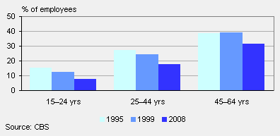

In Singapore’s context, the decline in labour force participation rate of young people between 15 and 24 years old slowed down the growth of young union memberships. Labour force participation rate declined from 25.3% in 1993 to 13% in 2003 for those aged 15 – 19 and declined from 80.2% to 71.6% for aged 20 – 24. This is due to longer periods that young people stay in the education system, which has been steadily improving over the years with better educational opportunities and economic growth. However, there are several other contributing factors that lead to the decline of young union membership, which will be discussed further.

**4. Reasons for Decline of Young Union Members**  
  
**4.1 Low Awareness and Weak Branding of Trade Union’s role**Everyone knows NTUC, but do they really know the true objective of the union besides it’s FairPrice supermarkets, Comfort Delgro taxi services, Income Insurance and lifestyle hubs? The main objective of unions has dwindled over the years. In the 1970s, NTUC began establishing various cooperatives in the name of providing welfare benefits to its members. With the intention of facilitating better labour management relations and promoting company loyalty, the Trade Union Act was amended in 1982. In order to make factors such as working hours, conditions of service and fringe benefits predictable, and thus making businesses sufficiently attractive for investors, trade unions were barred from promotion, transfer, employment, dismissal, retrenchment, and reinstatement negotiation matters.

The steadily declining union memberships since the late 1970s illustrates its complete ineffectiveness among workers. Only about 19% of Singapore’s 2.4 million workforce is represented by NTUC.

**4.2 Loss of Faith in Unions**The last strike in Singapore was in 1987 when an employees’ union had taken issue with a company for victimising their officials. NTUC even calls for workers’ wages to be negotiated in such a way that they can easily be cut whenever a company fails to make profits, such as in a downturn or recession, all under the guise of saving jobs.

In 2009, there were 187 unionised trade disputes referred for conciliation, a sharp increase from 103 in 2008. There were also five unionized trade disputes that were referred for arbitration, the highest number since 2005. Referring to MOM or IAC may reflect an inability of the union to convince the employer of its case. Thus, youths may choose not to join unions because they do not see it as a great advantage for them.

**4.3 Passive Youths**   
The Compulsory Education scheme channels young Singaporeans into either technical or academic education from young where employment prospects are good. Due to Singapore’s financial stability, it is becoming a norm to hold a degree. As a result, more qualified and professional graduates enter the labour workforce with ease as compared to the 1960s-1970s where general literacy rate was low and the need for union was high.

On average, younger workers who are retrenched take a shorter time to find another job compared to older workers as they have better qualifications. Generally, the young do not face serious unemployment problems due to the delayed entry of youths into the labour market. The table below illustrates findings from June 2003.

|  |  |
| --- | --- |
| Age | No. of weeks taken to find another job |
| 20-29 | 7.8 |
| 30-39 | 12.3 |
| 40-39 | 14.1 |
| 50-59 | 15.8 |

**4.4 Existing Benefits**

Employment contracts in Singapore are considered to be strict, as they have to follow statutory requirements by MOM. There are legal clauses that regulate employment contracts. For example, the maximum work hours required is 44 hours, 7 days of annual leave is given for first year of employment even though it is common practice for companies to give 12-14 days, well above the requirement by Singapore Employment Act. Female employees are also entitled to twelve weeks of maternity leave.

This is in contrast to the1960s-70s of political instability where standard of living was poor and education opportunities were limited, leading to low wages and poor working conditions. Many had to juggle more than one job and work overtime. Thus, the presence of unions during that time was more significant. Youths feel that there is no need for unions to fight so much for them as there are already requirements laid out by MOM.   
  
**4.5 Influence of Social Media**

The Internet usage trend among Singaporean tech-savvy youths has spiked throughout the years. Youths connect through various social platforms such as Facebook, Twitter, blogs, portals and forums. These channels act as an outlet for them to voice out and there is no need for unions to do it on their behalf. A simple post about unfair working conditions in their workplace on popular forums can go viral within minutes, along with the anonymity that social media permits. This snowball effect of online debates and making headlines on Internet news never fails to catch the attention of the community. This usually forces organizations to give a favorable public response to clear the air.

**5. Ways to Increase Appeal of Unions among Youths**Young NTUC, the youth wing, has a base of 150,000 members that aims to project a vibrant and youthful image while remaining relevant to the labour workforce.

There should be a rebranding of trade unions to move away from its traditional image that most youths have. Most think that unions are for the older generation and refrain from joining one due to peer pressure that being in a union is committing social taboo. Listed below are ways to attract more youth memberships.

**5.1 Link up with Youth Organizations**  
Unions can link up with youth organizations such as MCYS and NYC in the hosting of events and roadshows at popular youth hangouts such as \*SCAPE or Orchard Cineleisure. Dance competitions, Karaoke contests and Amazing races that sit well among youths can be organized to hike up memberships. For example, free union memberships can be given to participants.

**5.2 Campaigns & Roadshows**   
Campaigns should be held in tertiary institutions and popular youth hangouts to create awareness about unions among school leavers who are about to enter the labour workforce after graduating. Talks can be held to educate the purpose of trade unions and registration booths can be set up for fuss-free applications on the spot. Street interviews and surveys can be conducted to hear the voice of Singaporean Youths and let them know they are heard through the improvisation of schemes for the better.

**5.3 Use of Social Media**  
Unions should make use of social media for publicity. Social platforms include Facebook page, Twitter, blogs, forums and radio stations that help in engaging youths and hearing their voice.

**5.4 Added Benefits**More perks should be given to entice young union memberships. The current nEbO card already has a wide range of benefits for members. However, these benefits should be constantly updated and increased to retain and attract new members. Existing members should have additional perks or monetary rewards when they refer new members in. This tree branch effect will motivate them to introduce more friends to join the union.   
  
**5.5 Promote Young Union Leadership**Trade unions should create opportunities for young people to achieve their aspirations, contribute ideas and participate actively in making decisions to shape the future by sending them for training courses at the Ong Teng Cheong Institute Labour Studies. Selected young union members who have the potential to lead and are responsible or interested in industrial relations and human resource management should be enrolled in the courses offered, as it will provide in-depth knowledge on employment relations’ functions.

Holding regular dialogue sessions and forums can help strengthen bonds and networking among young and senior union leaders. This way, the young leaders will be more engaged and have a higher sense of belonging to the union.

**6. Conclusion**   
It is a challenge for trade unions in Singapore to stay relevant to the changing and increasingly diverse profile of young workers in knowledge-based economy. Strategies to retain and attract young union members should be well implemented and integrated into society. Youth development and employment must be placed high on governments’ agendas, as after all, the young are our future.

**7. References**  
Chew, Soon Beng (1991), Trade Unionism in Singapore, McGraw Hill, Singapore.

Chew, Soon Beng and Chew, Rosalind (2001), "Union membership trend in Singapore: the effectiveness of the innovative approach in increasing membership", Employment Relations Record, Vol. 1, No.1, pp. 99-109.

Johnson, L. and Ariff, M. (1998), "The determinants of trade union membership in Singapore and selected developed countries", Southeast Asian Economic Review, Vol. 9, No.1, pp. 17-22

Ministry of Manpower (2003), Singapore Yearbook of Manpower Statistics, Singapore.

National Trade Union Congress (1989), Agenda for the Nineties, Ordinary Delegates' Conference, Singapore, 24-25 November 1989.

National Trade Union Congress (1991), 30 Years On: Strong Union, Cultivated Workforce, Singapore.

Schmitt, John. 2008. “The Union Wage Advantage for Low-Wage Workers,” Center for Economic and Policy Research Briefing Paper.

|  |
| --- |
|  |

**8. Appendices   
  
Strike Statistics**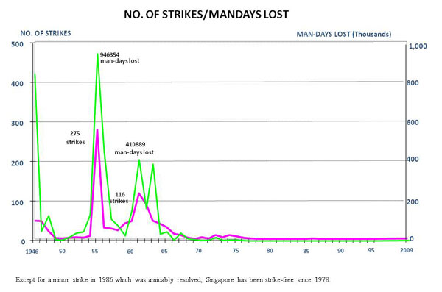 **Unionised Trade Disputes Referred For Conciliation (2000 - 2009)**

**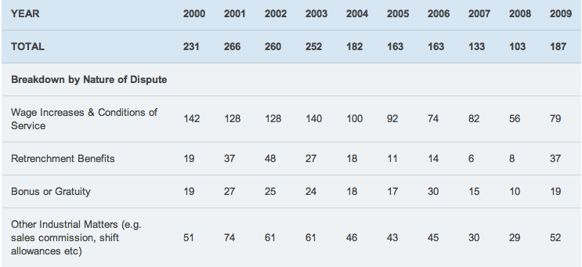**

**Unionised Trade Disputes Referred For Arbitration (2000 - 2009)**

**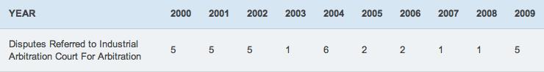**

**Ong Teng Cheong Institute Labour Studies Program**

**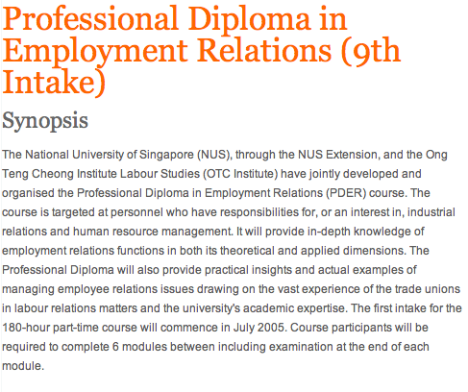Recent University Graduates – Singapore**

**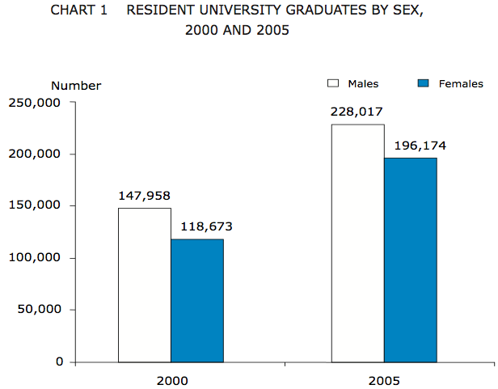**

**Decline in Young Union Memberships –Europe**

**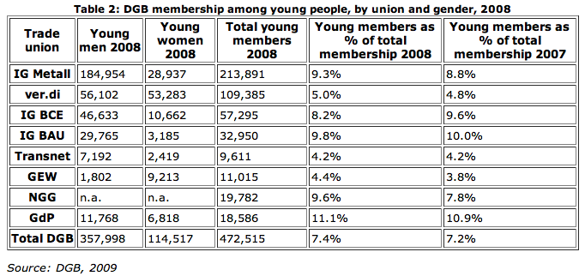**

|  |  |
| --- | --- |
| **ELECTRONIC ASSIGNMENT COVERSHEET** | Murdoch_land_RGB |

|  |  |
| --- | --- |
| Student Number | 32041865 |
| Surname | Tay |
| Given name | Serena Maybelle |
| Email | serenamtay@hotmail.com |
|  |  |
| Unit Code | BUS251 |
| Unit name | Employment Relations in Asia |
| Enrolment mode |  |
| Date | 7 November 2012 |
| Assignment number | Question 1 |
| Assignment name | Individual Essay |
| Tutor | Adrian Hoa |

|  |
| --- |
| Student’s Declaration:   * Except where indicated, the work I am submitting in this assignment is my own work and has not been submitted for assessment in another unit. * This submission complies with Murdoch University's academic integrity commitments. I am aware that information about plagiarism and associated penalties can be found at http://www.murdoch.edu.au/teach/plagiarism/. If I have any doubts or queries about this, I am further aware that I can contact my Unit Coordinator prior to submitting the assignment. * I acknowledge that the assessor of this assignment may, for the purpose of assessing this assignment:   + reproduce this assignment and provide a copy to another academic staff member; and/or   + submit a copy of this assignment to a plagiarism-checking service. This web-based service may retain a copy of this work for the sole purpose of subsequent plagiarism checking, but has a legal agreement with the University that it will not share or reproduce it in any form. * I have retained a copy of this assignment. * I will retain a copy of the notification of receipt of this assignment. If you have not received a receipt within three days, please check with your Unit Coordinator. |
| I am aware that I am making this declaration by submitting this document electronically and by using my Murdoch ID and password it is deemed equivalent to executing this declaration with my written signature. | |
| Optional Comments to Tutor:  E.g. If this is a group assignment, list group members here | |