1. **Introduction**

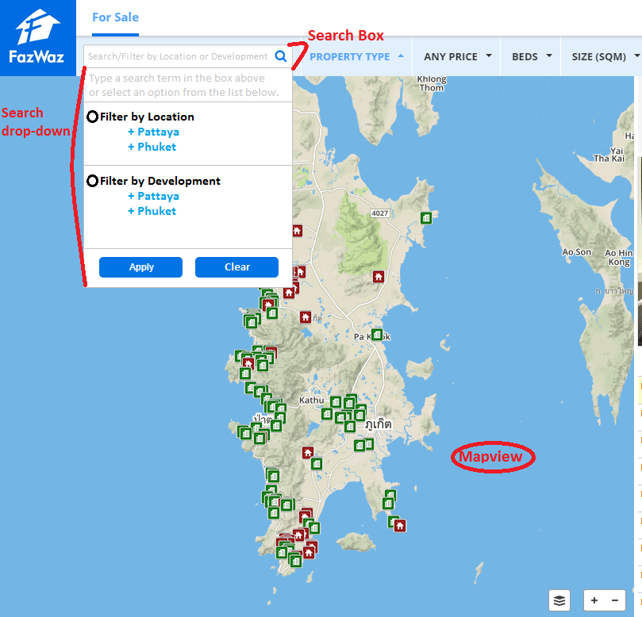

* 1. We want to update the search box with a drop-down menu option. It will allow users to select EITHER:
     1. Multiple locations from one region OR
     2. Multiple developments from one region

It will also allow users to see what developments they have set filter=”yes” on mapview

1. **Default view** (no filters yet applied through search box, search drop-down, or mapview)
   1. When user clicks on the search box, the search drop-down will be displayed.
   2. Same as before, user can type in a search term:
      1. Location, Region
      2. Development Name

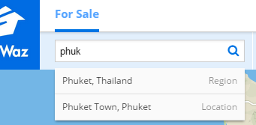If user types a term, the search drop-down should function as it does already:

* + 1. Selecting a region functionality will NOT change:
       1. Display region in mapview
       2. Do not check/uncheck ANY boxes
    2. Selecting a location functionality WILL change:
       1. Display location in mapview
       2. Next time search drop-down is opened, apply “Filter by Location” radio button, check this location’s box
    3. Also suggest development names when user is typing. On the right side (where it has “Region” or “Location” in gray) put the Region (“Pattaya”, “Phuket”, etc). Selecting a development functionality:
       1. Do not change current mapview
       2. Next time search drop-down is opened, apply “Filter by Development” radio button, check this development’s box

1. **Filter by Location**

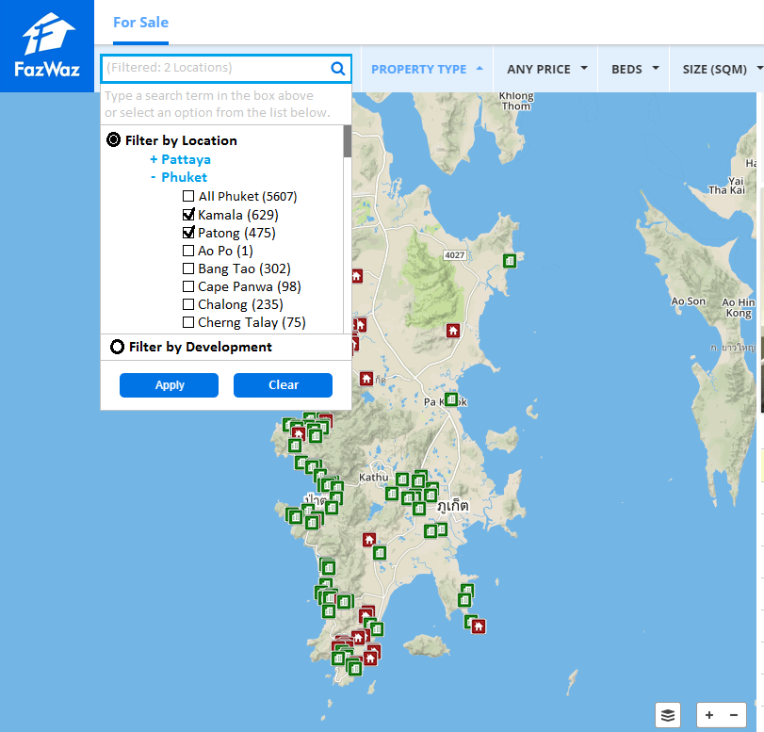

* 1. When user clicks “Filter by Location” radio button, push “Filter by Development” to bottom (hide “Phuket” and “Pattaya”).
  2. User can expand/hide “Pattaya” and “Phuket”, but only check boxes from one at a time:
     1. “All Pattaya” or “All Phuket” checkbox should always come first
     2. Remaining locations are sorted alphabetically
  3. Do NOT apply any filters until user clicks “Apply” button. If user clicks on another part of the screen (other than search box or search drop-down), we count this as clicking “Apply”.
  4. When search drop-down is closed, then re-opened:
     1. Auto-expand “Phuket” or “Pattaya” if they have locations with boxes checked.
     2. “All Pattaya” or “All Phuket” checkbox should always come first
     3. Next, any locations with boxes checked should be displayed alphabetically
     4. Finally, any locations with boxes NOT checked should be displayed alphabetically
  5. If user clicks “Filter by Development”, DO NOT uncheck the location boxes UNTIL “Apply” button is pressed (or user clicks outside of search box/search dropdown). The reason is that a user might accidentally click “Filter by Development” and then click back to “Filter by Location” without losing their filter options.
  6. If any location filters are “on”, put a thick blue border around the search box, and “(Filtered: # Locations)” in the search box, in light gray text. “# Locations” is the number of locations with their boxes checked.

1. **Filter by Development**

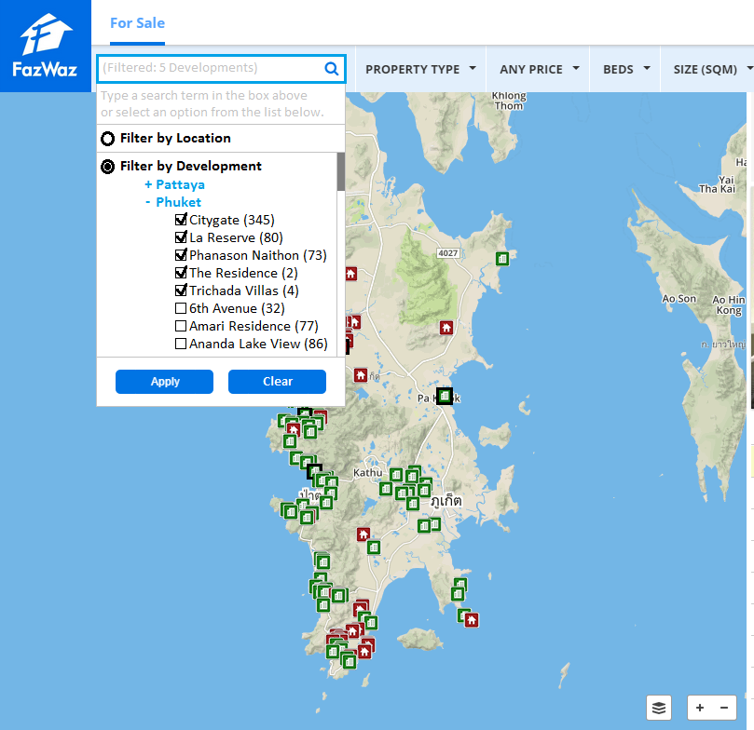

* 1. When user clicks “Filter by Development” radio button, push “Filter by Location” to top (hide “Phuket” and “Pattaya”).
  2. User can expand/hide “Pattaya” and “Phuket”, and check boxes from both at the same time, if they want to.
     1. Developments are sorted alphabetically
  3. Do NOT apply filters until user clicks “Apply”. If user clicks on another part of the screen (other than search box or drop-down), we count this as clicking “Apply”.
  4. When search drop-down is closed, then re-opened:
     1. Auto-expand “Phuket” or “Pattaya” if they have regions with boxes checked.
     2. “All Pattaya” or “All Phuket” checkbox should always come first (not pictured here, sorry)
     3. Next, any developments with boxes checked should be displayed alphabetically
     4. Finally, any developments with boxes NOT checked should be displayed alphabetically
  5. If user clicks “Filter by Location”, DO NOT uncheck the development boxes UNTIL “Apply” button is pressed (or user clicks outside of search box/search dropdown). The reason is that a user might accidentally click “Filter by Location” and then click back to “Filter by Development” without losing their filter options.
  6. If any development filters are “on”:
     1. Put a thick blue border around the search box, and “(Filtered: # Developments)” in the search box, in light gray text. “# Developments” is the number of developments with their boxes checked.
     2. (see next page)

1. **Filter by Development (continued)**

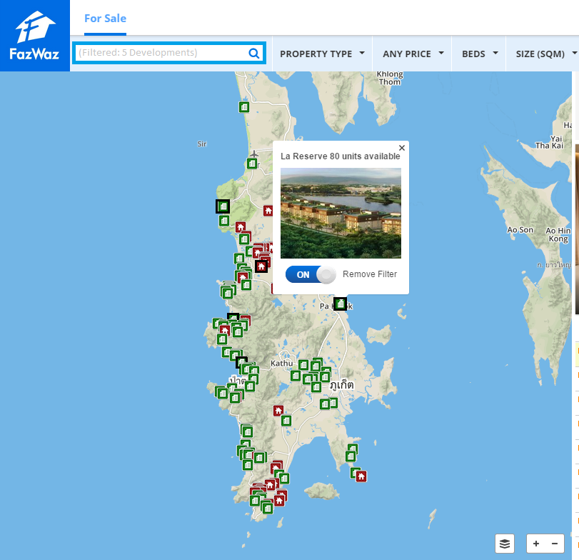

1. If any development filters are “on”: (continued)
2. Put a thick black border around the development icon on mapview.
3. These borders will be applied:
   * + 1. If user turns filter on from mapview
       2. If user turns filter on from search drop-down
4. The search drop-down boxes will be checked:
   * + 1. If user turns filter on from mapview
       2. If user turns filter on from search drop-down
5. If possible/easy, we want development icons with a black border to pop on TOP of the others (showing incorrectly here:)
6. **General / Other Requests**
   1. Only allow 1 option at a time:
      1. Filter by Location
      2. Filter by Development
   2. “Filter by Mapview”
      1. We currently have a functionality I will call “filter by mapview” (or FBM).
      2. Currently, FBM will adjust the units displayed in listview based on user’s current mapview. For example, if you zoom in very close on a single development, the listview on the right side of the page only displays units from this development.
      3. If we have any location or development filters applied in the search drop-down box, we want to turn OFF the FBM functionality.
      4. If user clicks “Clear” button in search drop-down (or “Reset Search” in the filter bar), we want to turn the FBM functionality ON again.