**Product Scheduling Calendar**

2. When in the admin or vendor admin and you click to update the number of places available the number appearing when you click to change the # of places is not correct see here <http://screencast.com/t/eEdodyDI2Y>

**WDC 8-12-15: Done**

**Mobile**

Whenever I click back page button or forward page button on my mobile device regardless what page I am on I get the below error which never happened before

**WDC 8-12-15: Please give the page name from where you have got this messages.**

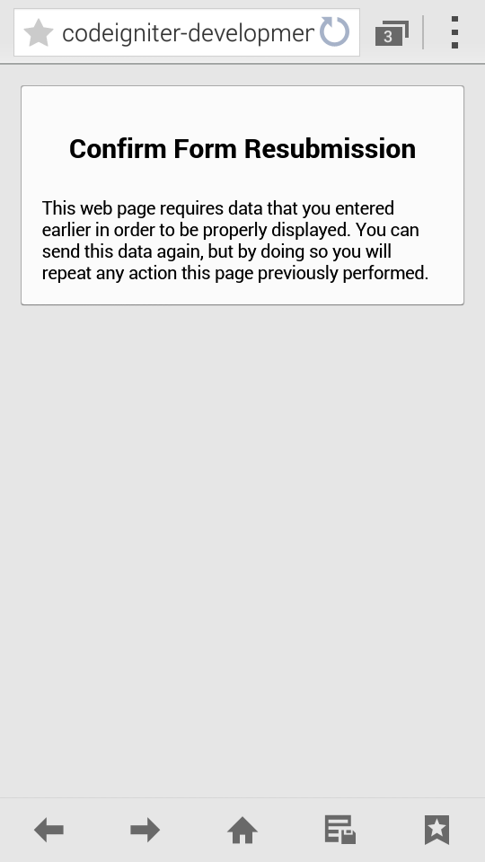

**Email Templates Website Admin**

I want to insert the name of the activity above the product name in some of the emails that customers gets. In the change date/time email templates in the admin i added

Activity Name: {{ACTIVITY_NAME}}

However, when the email goes to the customer it appears as below. What am I doing wrong here as the activity name is not appearing?

Order Number: 1448989984  
  
Vendor Name: PaddleCoach11  
  
Activity Name: {{ACTIVITY_NAME}}  
  
Product Name: this a new running test

**WDC 8-12-15: You can not add any extra variable from admin panel. If you want to add any variable please tell us because we need to add those variable in coding page. You can use only those variable which we have used for a single template.**

**Activity Profile Page**

**Desktop & Mobile**

13. Today is Nov 3rd, there is a time open for Nov 3rd, but Nov 3rd is not highlighted green as available on the calendar see here <http://screencast.com/t/MnC2npJRWf54b>

**WDC: R&D work**

Dcomments: This is very important to be fixed, as people will come to the site to book same day activities, so if today is December 5th and if activities are open on December 5th customer will see that there is no availability for December 5th as it currently shows as white and not green.

15. Date with no places assigned displaying on the calendar.

When you click on December 4th on http://codeigniter-development.com/dec/location/toronto/suplessonsmississauga/ on the calendar it allows you to select # of people. It should not do this, if there are no places available for a given date that date should not be selectable on the calendar

**WDC 8-12-15: Done**

**Check Out Page**

**Mobile Only**

1. If no CVV number is entered and user clicks on book now the "Please enter a number" prompt should appear just like it does for credit card number field.

**WDC 8-12-15: We have used same validation for both fields. Please give us screen-shots.**

**\***11. When you click on the back browser button on a mobile device is should bring the user back to the top of the activity profile page and not the bottom of it.

**Order Not Approved Within 24hs Customer Email**

1. Could you change the "Activity Cost" heading to "Total Cost" and for the amount show the cost of the activity + booking fee?

**WDC: 04-12-2015: Activity cost and total cost are showing separately in the declined mail.**

**Dcomments: I can't test until orders that have not been approved automatically move to decline status so this email can go out.**

**Website Admin Notification**

**\***10. How does the admin get notified of what the changes a vendor makes to their listing if the vendor edits a listing that is already approved and set live by the admin?

**WDC 15-10-15: Under Development.**

**WDC 27-10-2015 : 12 working days separately for the above point.**

Dcomments:   
As per our discussion today, you will build a section in the admin titled "Updated Activities" when the website administrator clicks on this section they will see all the activities updated by the vendor. When the admin clicks on the more info for each activity listed in this section they will only see the fields that the vendor has updated. The only sections from the vendor management section that are eligible for display in this section if any of the fields are updated are as follows:

My Account Page, Step 2, Step 3, Step 4

The website admin can then:  
  
1. Approve the changes, if approved the changes the vendor made will be moved to production and the new changes will be included within the activity profile information within the website admin and vendor management section and front end website going forward until other changes are made by the vendor.  
  
2. Decline the changes, if declined none of the changes the vendor made will be moved to production.

Please Ensure That ERICA tests this in full before telling me it's completed. Tech Guys will have to explain everything to Erica and what this functionality will touch on and what this might affect or break in the site, this is one section I do not and will not QA.

**Product Scheduling Website Admin & Vendor Management**

2. When you go to close an individual time slot with a date show the date under the red close button as "Tuesday, 15 October 2015" ohttp://screencast.com/t/nfnpcJ6K1Lr when you close a time slot with an individual date and time show the date and time under the red close button as "Tuesday, 15 October 2015 at 2:00PM" and if closing an "entire series" ensure the month is spelt in full i.e. Oct should be October.

**WDC: 04-12-2015: Fixed**

**Dcomments:**

You forgot to include the year. The year should appear when close a date with no time slot or a date with a time slot. See below for the close this time slot and close entire series the year does not appear.

For the close time slot/entire series examples below,

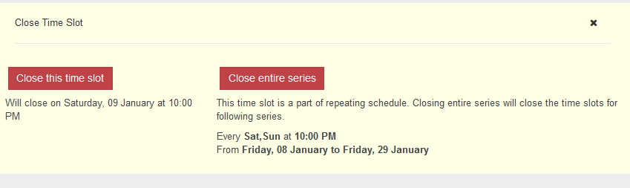

The year should be shown as

"Will close on Saturday, 09 January 2016 at 10:00 PM"

" From **Friday, 08 January 2016 to Friday, 29 January 2016**"

**WDC 8-12-15: Done**

**Website Admin Section**

3. The quick view functionality does not appear to be working in any of the admin sections.

4. Incorrect city name appearing in the website admin. I tested the new activity. I changed the city name in the vendor management view and the new city name chosen in the vendor management view is not appearing as the first city the website admin view that a look at http://codeigniter-development.com/dec/vendor_user/activity_edit/262 and <http://codeigniter-development.com/dec/admin/activity_master/edit_step2/262/0/>

**WDC: 02-12-2015: Fixed. Please check the below screen-shots.**

<http://awesomescreenshot.com/0755gang2d>

<http://awesomescreenshot.com/0155ganjbb>

Dcomments:

1. This is not fixed see here. I created a new activity to test this on http://screencast.com/t/qlVqbB4sq

2. Also when I was testing this activity, there were 2 cities assigned in the website admin, when I changed the city in the vendor admin, when I went back to the website admin and refershed the page, the 2nd city that was in the website admin was deleted and only the first city was displayed. I didn't have the video running to capture this.

This is has happened and reported to you at least 4 times in the past and it's still happening.

3. I am also getting an error message when I change cities in the vendor management area see here http://screencast.com/t/6J5ulaQvCiuD

Please get QA to test the whole functionality for adding cities, editing cities in vendor management and website admin for existing activities, new activities to existing vendors and new activities to new vendors. I want to see QA sign off on testing this tomorrow.

Issues with adding/editing cities have been an ongoing issues for 2 months and more at this stage.

**WDC: 04-12-2015: Fixed**

**Dcomments: Can Erica please provide me with the completed test case that she completed for this. I need to be 100% confident that each of the 3 issues above have been fixed as these has been an ongoing issue for months now and I need to ensure that this has been tested in full.**

**WDC 8-12-15: Done**

**Other Changes or Issues I noticed on checking the site today.**

1. Mobile: View Desktop link does not work when clicked on

3. What is the protocol for secure password creation i.e. Uppercase, lowercase, special character, number etc? Need to ensure that the passwords are secure.

**WDC: 04-12-2015: We have used an encrypted format for the password & storing into the database. This encrypted password can not be decrypted any more. So, it is a highly secure way for the password.**

**Dcomments: Can you confirm that you have not or the website system or database will not be storing customers credit card numbers?**

**6. Vendor Registration** [**http://codeigniter-development.com/dec/vendor_user/registration**](http://codeigniter-development.com/dec/vendor_user/registration)

1. This issue with the "email already exists" has not been fixed correctly as I can enter a duplicate email when adding a vendor via the website admin. See here http://screencast.com/t/Zt1u0MX8

**WDC 8-12-15: Done**

**2.**If a password is entered correctly both times, don't show the "Password" Matched [**http://codeigniter-development.com/dec/vendor_user/registration**](http://codeigniter-development.com/dec/vendor_user/registration)

**WDC 8-12-15: Done**

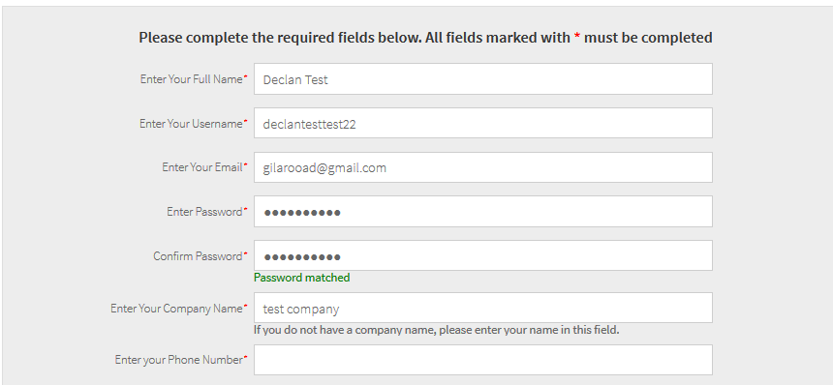

3. Can you also use the above email and send out this email when a new vendor is created via the website admin area within the user management > vendor user section and the activity master > add new activity > new vendor section?

**WDC: 03-12-2015: Fixed**

Dcomments:

1. When you add a new user via the activity master section in the email that goes to the vendor the password is not showing - see below

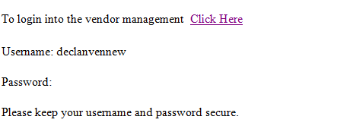

3. If a new vendor is signed up if the user management > vendor user, or activity master > add new vendor or via http://codeigniter-development.com/dec/vendor_user/registration in the email that is generated to the vendor or that is cc'd to the admin when I click on "click here" is brings the user to a blank my account details page see here http://screencast.com/t/VdXmGxzXeZ

If the vendor is not logged in when they click on this link in the email they should be brought to the login page, if a user is logged in when they click on this link the account details page should be populated not blank.

**WDC: 04-12-2015: Fixed**

<http://awesomescreenshot.com/0a15gha72f>

<http://awesomescreenshot.com/0d95gh8u0a>

**Dcomments: I cannot test this until the issue with the vendor email has been fixed in the vendor registration see point 6 above.**

**WDC 8-12-15: Done**

**Vendor Completes Registration**

**6. When the vendor completes all the steps of activity registration for the first time only and clicks on the finish button on step 5, an email to go to declan@activitychief.com with the following message**

Sender ActivityChief.com

From: [newvendoractivity@activitychief.com](mailto:newvendoractivity@activitychief.com)

Subject: {Vendor Name} has completed all registration steps

Body Text

Dear Admin,

{Vendor Name} has completed all the registration steps for {Activity Name}. Please review and approve this activity by clicking here. Note to DevelopersClick Here will bring user to the activity master listing page in the admin.

Thanks

ActivityChief.com

Note to developers, the website admin already gets a new activity email when the vendor completes the step 1, please keep this email, dont make any changes to this email.

**WDC: 02-12-2015: Fixed**

**Dcomments: Vendor name in subject line is using first name, it should be using company name. Vendor name in email is appearing as [[VENDOR_NAME]]. This should show company name.**

**WDC: 03-12-2015: Fixed. We have changed the vendor name to company name.**

**Dcomments: The click here link in this email should bring website admin to the activity master page in the website admin, as present this link goes to** [**http://codeigniter-development.com/dec/vendor_user/activity_listing/**](http://codeigniter-development.com/dec/vendor_user/activity_listing/)

**WDC: 04-12-2015: Fixed**

**Dcomments: This has not been fixed. You are using the wrong url, please reread the instructions above.**

**WDC 8-12-15: Done**

**7. When a vendor adds a new activity and the website admin sets live/activities the activity for the first time via the website admin the vendor should receive the below email.**

sender name ActivityChief.com

from info@activitychief.com

Subject Line. Your Activity Is Now On ActivityChief.com

Body Test

Dear {Name},

Great news, your activity is now listed and live on ActivityChief.com.

To view your activity listing on ActivityChief.com, click here. Note to developers when user clicks on click here they will be brought to their activity profile page on the front end of the website.

Thank-you for listing your activity on ActivityChief.com. We look forward to help you to grow your business.

Regards,

ActivityChief.com

**WDC: 04-12-2015: Fixed**

**Dcomments: This is not fixed. The click here email is not going to the right place. Reread the instructions above.**

**WDC 8-12-15: Done**

10. [**http://codeigniter-development.com/dec/vendor_user/registration**](http://codeigniter-development.com/dec/vendor_user/registration)

When a user completes this step 1 and proceeds to step 2, when they select canada from the country of activity, and then when then select the province of activity dropdown, the country of activity dropdown clears and the user has to select it again.

**WDC-03-12-2015 : Could you please send a video regarding that as we didn't found it on the registration page.**

**Dcomments: See here http://screencast.com/t/NFIUGMTKLk**

**WDC: 04-12-2015: Fixed**

**Dcomments. This not fixed. I tested again we a new activity and same issue exists**

**WDC 8-12-15: Done**

**Dcomments: Please confirm the below tomorrow.**

**10. Google Analytics Tracking**

1. Can you confirm with your Google Analytics guy that the necessary Google Analytics code is on the site to enable ecommerce reporting within Google Analytics

2. Can you confirm with your Google Analytics guy which of the below tracking items he will be setting up and tracking in Google Analytics, I can't remember or last conversation on this.

The below are the buttons/links that I want tracked in Google Analytics to see how many times the buttons or links where clicked on in Google Analytics.

**City Activity Page**

1.How many times the "List" or Grid" buttons have been selected on the activity city for all cities combined and for each city individually

**Activity Profile Page**

**Bookable Products**

1. How many times the "Got A Question About This Activity" button has been selected for each activity and for all activities across the site as a whole.

2. How many times the "Price From x - Book Now" button has been selected for each activity and for all activities across the site as a whole.

3. How many times the "Social Media Share" Buttons button has been selected for each activity and for all activities across the site as a whole.

4. How many times the "Where To Meet" "Click To View Map" link for each activity and for all activities across the site as a whole

**Non Bookable Products**

1. How many times the "Got A Question About This Activity" button has been selected for each activity and for all activities across the site as a whole.

2. How many times the "Price From x - Book Now" button has been selected for each activity and for all activities across the site as a whole.

3. How many times the "Social Media Share" Buttons button has been selected for each activity and for all activities across the site as a whole.

4. How many times the "Where To Meet" "Click To View Map" link for each activity and for all activities across the site as a whole

5. How many times the "Want to book? Click for Contact Info" button has been selected for each activity and for all activities across the site as a whole

**========================================================================**