REFERENCE ARCHITECTURE

Agentic Product Development Lifecycle Framework
  - Solution Architecture, Governing Philosophy and Client Extensibility Model
Document role | Perspective | Status
Reference architecture | Principal AI Architect | Client-neutral / implementation-independent

ARCHITECTURAL THESIS The framework is a governed decision system for software delivery—not an autonomous coding tool. Agents create and execute bounded proposals; deterministic policy, evidence, and accountable human authority govern state transitions.

This document defines the philosophy and structural contracts for an enterprise agentic PDLC framework intended to be adopted across clients with different engineering toolchains, governance regimes and operating models. This revision aligns the architecture with the latest reference implementation: project-scoped context and hydration, replaceable design and test-authoring agents, governed hand-off to client implementation agents, observed QA coverage, reversible test-data handling and promotion-ready evidence bundles.
Audience: enterprise architects, platform engineering leaders, AI governance teams, security architects, SDLC owners, delivery leadership and client implementation teams.

1. Executive architecture position
Software delivery is not a linear sequence of model calls. It is a distributed decision process involving requirements, code, tests, risk, evidence, approvals and operational feedback. An enterprise agentic PDLC must therefore be architected as a governed lifecycle fabric: a durable control plane coordinates work, specialized execution planes perform it inside appropriate trust zones, and a versioned context fabric connects every decision to its source and evidence.
The framework should accelerate judgment-intensive work without allowing probabilistic components to become the final authority for readiness, compliance or release. Its core value is not that an agent can generate an artifact. Its value is that the organization can prove why work was initiated, what was changed, which controls applied, what evidence was produced, who approved the transition and how the outcome informed later decisions.
NORTH-STAR OUTCOME Increase delivery throughput while preserving—or strengthening—traceability, containment, separation of duties, evidence quality and client control over systems of record.

2. Scope and non-goals
The reference architecture covers orchestration across product and software delivery phases, including requirement refinement, design, implementation, verification, security, release and operational learning. A client may adopt one phase or the full lifecycle; every phase uses the same governance contract.
The framework is not:
- A replacement for the client’s issue tracker, source repository, CI/CD platform, test estate or observability platform.
- A universal autonomous agent with unrestricted access to enterprise systems.
- A requirement that every client use the same model, graph database, cloud, workflow engine or developer tool.
- A mechanism for model confidence to substitute for deterministic verification or accountable approval.
- A second system of record that copies all client data into a central platform.

3. Foundational philosophy

3.1 Agents propose; governed mechanisms decide
Generative models are well suited to synthesis, planning, classification, design alternatives, code generation, test ideation and explanation. They are not intrinsically suited to authoritative state transitions. The framework uses agents for bounded cognition and deterministic mechanisms for policy enforcement, schema validation, identity resolution, coverage reconciliation, privilege checks and gate decisions.

3.2 Evidence is the currency of progression
A phase does not complete because an agent says it completed. It completes when required evidence exists, is attributable to the correct inputs and versions, satisfies policy, and is accepted by the configured decision authority. Evidence includes structured artifacts, test results, security findings, approvals, provenance and machine-verifiable relationships.

3.3 Context is federated, not duplicated
Requirements remain in the client’s product system, code remains in source control, test history remains in test infrastructure and operational signals remain in observability platforms. The framework stores stable identities, projections, relationships, decisions and provenance sufficient to coordinate the lifecycle. It resolves source data on demand through adapters.

3.4 Autonomy is bounded by risk
Autonomy is a policy outcome, not a product toggle. Low-risk, reversible and well-observed work may progress automatically; high-impact, ambiguous, security-sensitive or irreversible work requires stronger controls and explicit authority. The same framework supports both modes because decision rights are externalized as policy.

4. Key architectural tenets
Tenet | Architectural implication
Governance before autonomy | Every autonomous action has an explicit scope, policy basis, evidence obligation and accountable owner.
Deterministic core, probabilistic edge | Models reason at bounded edges; lifecycle state, permissions, identity and gate evaluation remain deterministic.
One identity across the lifecycle | A requirement, criterion, change, scenario, execution and release retain durable identities across tools and phases.
Evidence-linked state transitions | No gate advances without evidence bound to the exact repository, artifact, model and policy versions.
Least privilege by phase | Each phase receives only the capabilities and credentials required for its current action.
Separation of proposal, execution and approval | The component that proposes work is not the component that executes privileged actions or approves the result.
Client systems remain authoritative | The framework coordinates systems of record rather than replacing them.
BYO through contracts, not forks | Client-specific behavior enters through versioned ports, policy packs and schemas—not modifications to the governance kernel.
Fail closed on missing trust evidence | Unknown identity, stale context, invalid schema, insufficient graph quality or missing evidence blocks progression.
Replayability and idempotency | Every operation can be correlated, retried safely and reconstructed from durable state and immutable events.
Explainability is operational | Every derived scope, route and gate decision exposes its evidence path and confidence—not merely prose rationale.
Quality is measured continuously | Agents, adapters, impact analysis and policies are evaluated against versioned cases and production outcomes.

5. Logical reference architecture
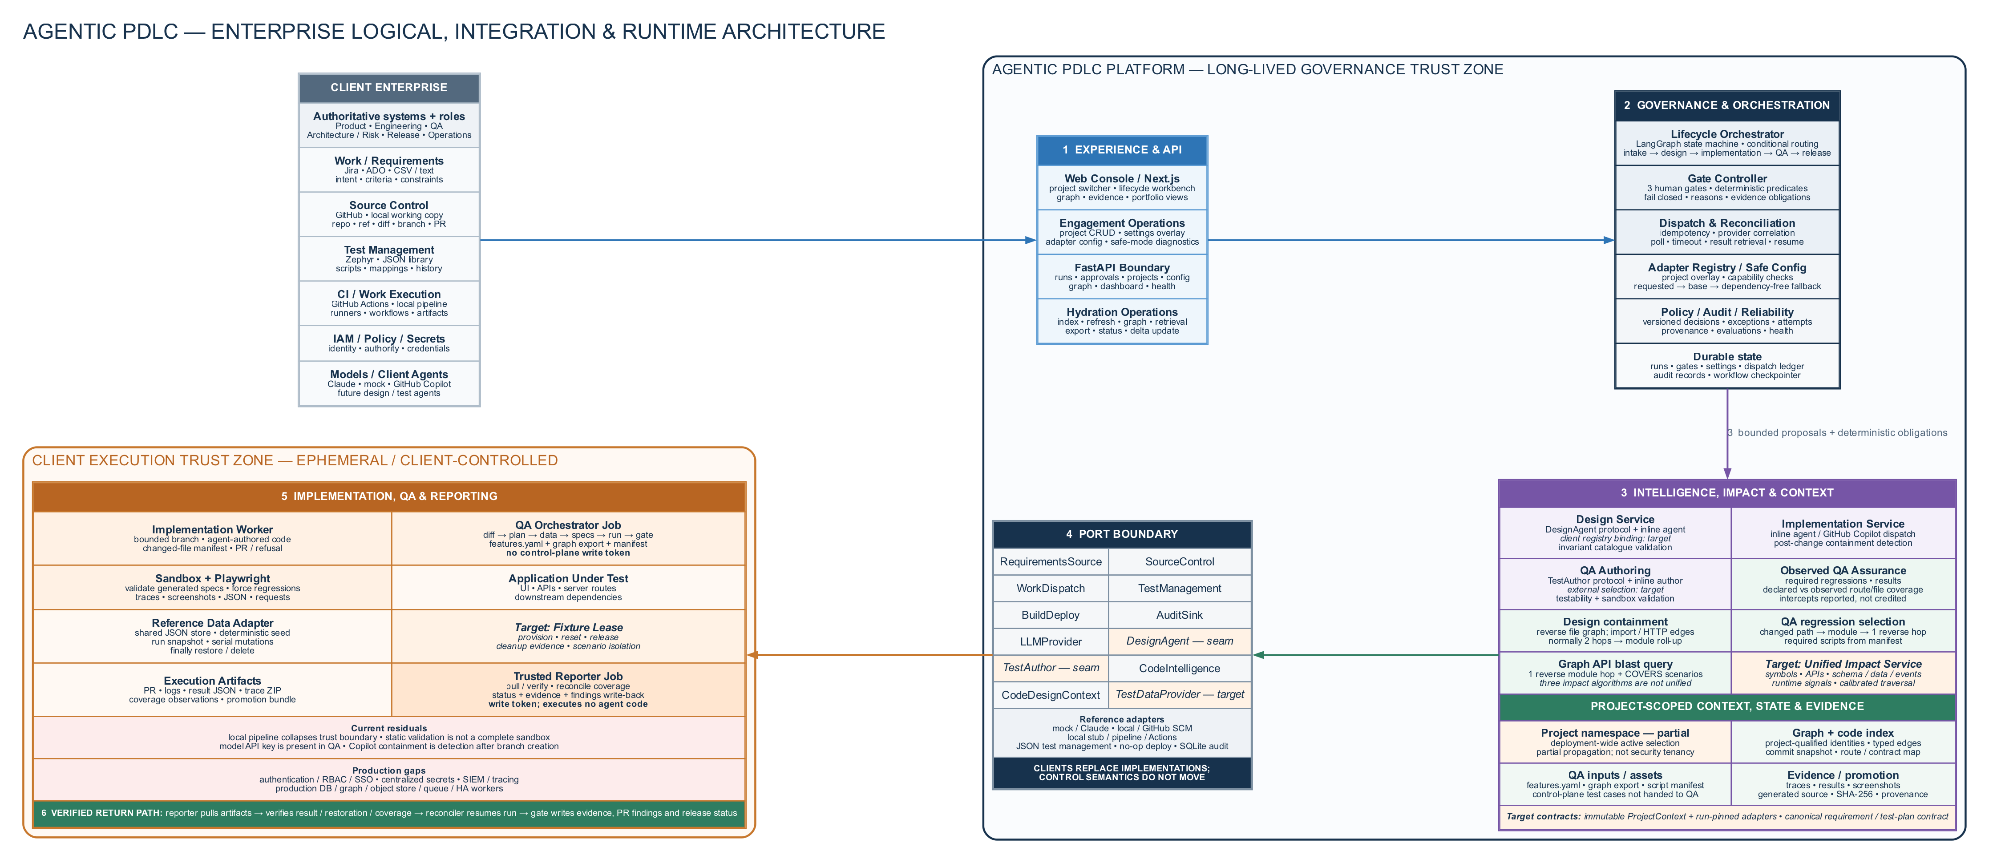
Figure 1. Enterprise logical, integration and runtime architecture
The logical planes remain stable while implementations remain replaceable. The current reference maps project selection and hydration into the experience plane; policy, deterministic gates and evidence into the control plane; DesignAgent, TestAuthor and ModelProvider behind governed ports; project-qualified graph and retrieval stores into the context plane; and client implementation and QA runtimes into the execution plane.
Plane | Primary responsibility | Must remain independent of
Experience plane | Human interaction, review, exception handling, portfolio visibility and explanation | Specific orchestration or model provider
Governance and control plane | Lifecycle state, gates, policy, dispatch, audit, identity, conformance and reconciliation | Client-specific tool APIs and agent implementation details
Intelligence plane | Specialized agents, retrieval, model routing, structured reasoning and evaluation | Authority to self-approve or bypass policy
Execution plane | Runs code, tests, scans, builds and deployments inside client-controlled trust zones | Control-plane write authority and unrelated credentials
Context and evidence fabric | Identity graph, relationship graph, artifact metadata, provenance and evidence pointers | Becoming a duplicate content lake or new source of truth

TRUST BOUNDARY Agent-authored or repository-supplied code executes only in an isolated execution plane. The control plane consumes signed or independently retrieved results; it does not execute untrusted output.

6. The governed phase contract
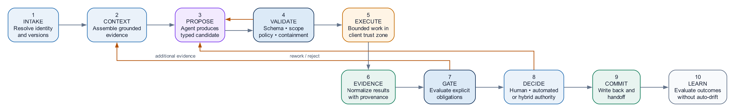
Figure 2. Standard governed phase lifecycle
Every lifecycle phase—requirements, design, implementation, QA, security, release or operations—implements the same conceptual protocol. This consistency is what turns individual agents into a framework.
- Intake: resolve canonical inputs, identities, versions and authorization context.
- Context assembly: retrieve only the evidence needed for the phase, with provenance and freshness metadata.
- Proposal: one or more agents produce typed candidate artifacts or actions.
- Deterministic validation: verify schema, scope, policy, completeness, containment and required relationships.
- Execution: dispatch bounded work into an appropriate execution environment.
- Evidence collection: normalize results without discarding native artifacts or provenance.
- Gate evaluation: compute readiness from explicit policy and evidence obligations.
- Decision: apply configured human, automated or hybrid authority.
- Commit and handoff: update lifecycle state, write back to client systems and emit the next phase contract.
- Learning: record outcomes for evaluation, calibration and policy improvement without silently changing production behavior.

7. BYO and pluggability model
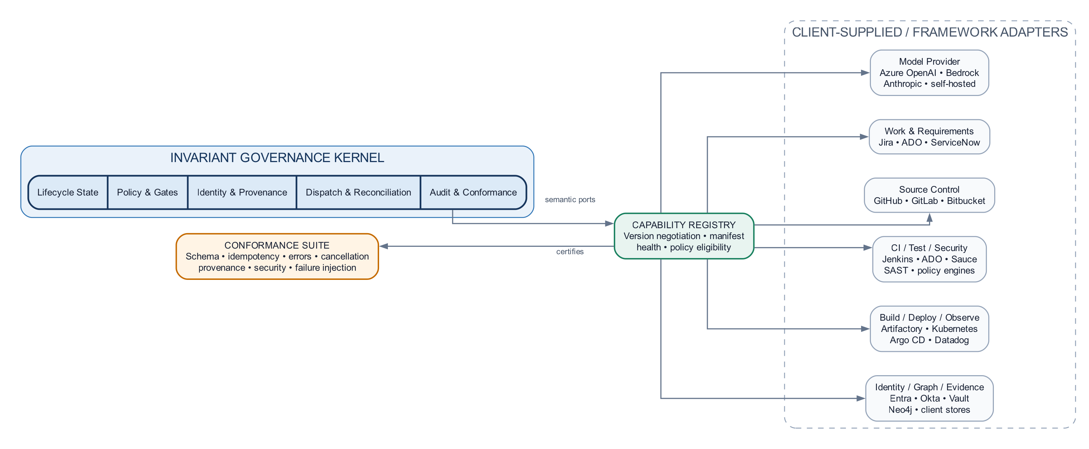
Figure 3. BYO capability architecture: stable kernel, replaceable implementations
Client portability requires a stable governance kernel and replaceable capabilities. The framework uses ports and adapters at every external boundary. A port expresses semantics, invariants, error behavior and evidence obligations. An adapter implements those semantics for a specific client technology.
Extension category | Examples a client may bring | Framework contract
Model and inference | Azure OpenAI, Anthropic, Bedrock, self-hosted models, model gateway | Structured generation, streaming, usage, provenance, safety metadata and error taxonomy
Requirements and work management | Jira, ADO Boards, ServiceNow, Rally, Productboard | Canonical requirement/criterion identity, read/write-back, links, version and authorization
Source control | GitHub, GitLab, Bitbucket, Azure Repos, on-prem Git | Read-at-ref, change proposal, branch/commit identity, review status and webhook provenance
Workflow and CI | GitHub Actions, GitLab CI, Jenkins, ADO Pipelines, Tekton | Idempotent dispatch, correlation, status polling/callback, artifacts, logs and cancellation
Test management and execution | Playwright, Selenium, Appium, Sauce Labs, qTest, Zephyr | Scenario identity, assignment, execution result, evidence and coverage mapping
Security and compliance | SAST, SCA, DAST, secrets, policy engines, GRC tools | Normalized findings, severity, waiver identity, provenance and policy decision input
Build, artifact and deployment | Maven, npm, Artifactory, Docker, Kubernetes, Argo CD, cloud deployment | Immutable artifact identity, promotion, environment, rollout, rollback and attestation
Observability | Datadog, Splunk, Dynatrace, OpenTelemetry, cloud-native monitoring | Release correlation, SLO impact, incident evidence and feedback signals
Identity and authorization | Entra ID, Okta, LDAP, workload identity, Vault | Actor/workload identity, delegated authority, entitlement and credential leasing
Context and graph | Neo4j, Neptune, relational graph, knowledge platform | Typed identity/edge semantics, versioned snapshots, provenance, query and quality metrics

7.1 What is pluggable—and what is not
Pluggability must not weaken governance. Clients may replace implementations, models, systems and policies, but conforming deployments preserve the invariant kernel.
Invariant framework responsibility | Client-configurable implementation
Durable lifecycle state and transition semantics | Workflow/checkpoint persistence technology
Identity, correlation and provenance requirements | Identity resolver and graph/storage provider
Separation of proposal, execution and approval | Client approval hierarchy and segregation-of-duty policy
Evidence obligations before progression | Evidence sources and client-specific thresholds
Least-privilege capability issuance | Enterprise IAM, secrets and workload identity provider
Auditability and replay | Audit sink, retention and regional storage implementation
Adapter conformance and version negotiation | Selected vendor/product adapter

7.2 Adapter conformance contract
An adapter is production-ready only when it satisfies a conformance suite. Interface compatibility alone is insufficient.
- Typed request and response schemas with explicit semantic versions.
- Idempotency keys and deterministic handling of duplicate delivery.
- Stable external identities and correlation across asynchronous operations.
- Canonical error taxonomy: retryable, terminal, unauthorized, invalid, stale and policy-blocked.
- Timeout, cancellation and reconciliation behavior.
- Evidence provenance, content integrity and source timestamps.
- Declared capability manifest, limitations and supported contract versions.
- Security posture: credentials, scopes, data residency, logging and redaction.
- Contract tests, failure-injection tests and operational health signals.

8. Policy and decision architecture
Policy must be external to prompts and executable independently of model behavior. A policy decision evaluates the phase, artifact class, change risk, evidence, client controls and actor authority. It returns an explicit result: allow, deny, require human decision, require additional evidence or route for exception.
Policy layer | Examples
Enterprise baseline | No direct production write, immutable audit, mandatory security evidence, prohibited data movement
Client policy pack | Approved models, regions, tools, approval roles, evidence retention, risk thresholds
Application policy | Critical modules, regulated data, protected branches, mandatory suites, deployment windows
Phase policy | Requirements completeness, design containment, QA coverage, security acceptance, release readiness
Exception policy | Named approver, expiry, rationale, compensating controls and non-reuse by default

Policy decisions should be reproducible against a versioned policy bundle. Prompt text may explain a policy but cannot define or override it.

9. Context, identity and evidence fabric
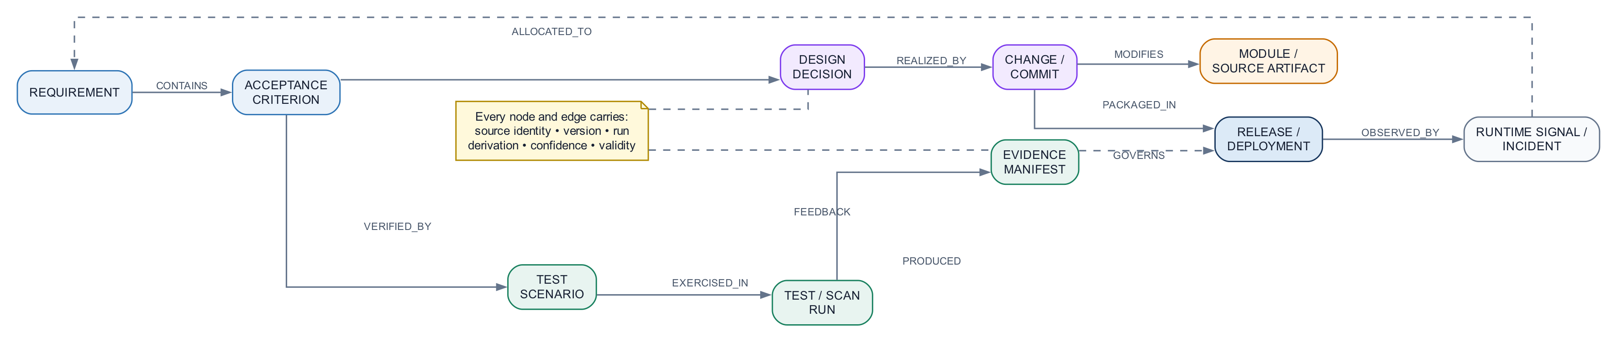
Figure 4. Lifecycle identity, traceability and evidence fabric
The framework requires a lifecycle identity model that bridges client systems without creating a master-data replacement. Each node is anchored by a type, source system and external identity. Relationships are assertions with provenance, validity intervals and the run that established them.
Identity class | Representative relationships
Business intent | Requirement CONTAINS criterion; criterion ALLOCATED_TO design decision
Architecture | Decision AFFECTS component; component DEPENDS_ON component; source artifact BELONGS_TO module
Implementation | Change IMPLEMENTS criterion; commit MODIFIES artifact; artifact IMPORTS artifact
Verification | Scenario VERIFIES criterion; script IMPLEMENTS scenario; run EXERCISES script
Release and operations | Artifact DEPLOYED_AS release; release OBSERVED_BY signal; incident ATTRIBUTED_TO release

Every assertion carries source, confidence, derivation method, graph/index version, observed timestamp and validity. Derived edges never masquerade as authoritative declarations. Runtime-observed, compiler-resolved, manually confirmed and model-inferred relationships remain distinguishable.

10. Impact intelligence as a shared platform capability
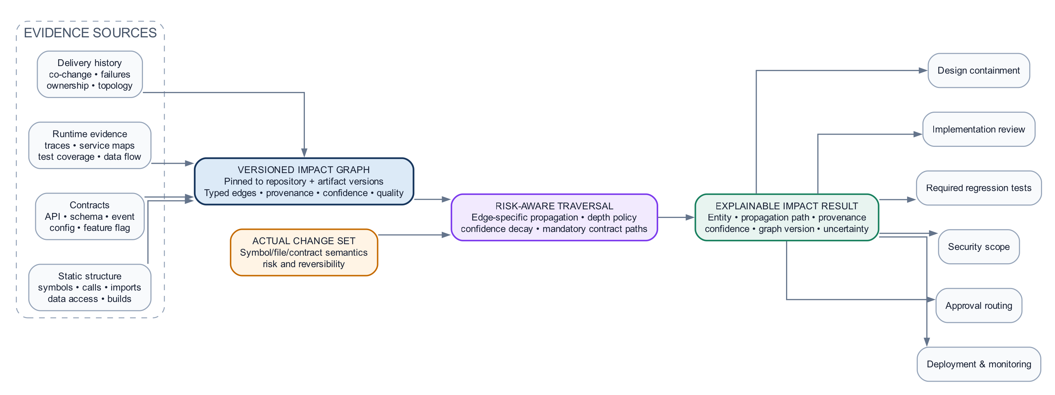
Figure 5. Multi-evidence impact intelligence and deterministic consumption
Blast radius is not a QA utility. It is a cross-lifecycle decision service used by design containment, implementation review, security scope, regression selection, approval routing, deployment strategy and operational monitoring.
DESIGN PRINCIPLE One versioned impact graph and one explanation model must serve every phase. Separate hand-maintained graphs for implementation and QA create contradictory truths and invalidate governance.

The impact service should combine multiple evidence classes:
- Static code structure: symbol references, calls, imports, inheritance, data access and build relationships.
- Contract structure: APIs, schemas, events, configuration, feature flags and infrastructure dependencies.
- Runtime evidence: distributed traces, service maps, test coverage and observed data flows.
- Delivery evidence: historical co-change, prior failures, ownership and deployment topology.
- Declared architecture: bounded contexts, criticality, compliance classifications and approved exceptions.
Impact results are explainable paths rather than unqualified lists. Each result states the changed entity, propagation path, edge provenance, confidence, graph version and policy consequence. Traversal depth is risk- and edge-aware; high-confidence breaking-contract paths may traverse transitively, while weak historical associations may only influence recommendations.

11. Agent architecture
Agents are specialized, replaceable reasoning components—not identities with standing authority. Each agent receives a bounded objective, typed context, allowed capabilities, token/time budget and required output schema. The orchestration layer validates output before it becomes lifecycle state.
Concern | Required architectural control
Prompt injection | Treat repository and external content as untrusted data; isolate instructions; validate tools and outputs
Model variability | Structured schemas, retries with bounded repair, eval thresholds and model/version provenance
Hallucination | Grounded retrieval, identity resolution, evidence references and fail-closed validation
Excessive agency | Capability-scoped tools, allowlisted operations, budgets, approval and execution isolation
Provider dependency | Model-provider port, capability negotiation, portable evals and provider-specific policy
Silent behavior drift | Versioned prompts, models and tools; offline eval gates; production outcome monitoring

12. Security and trust architecture
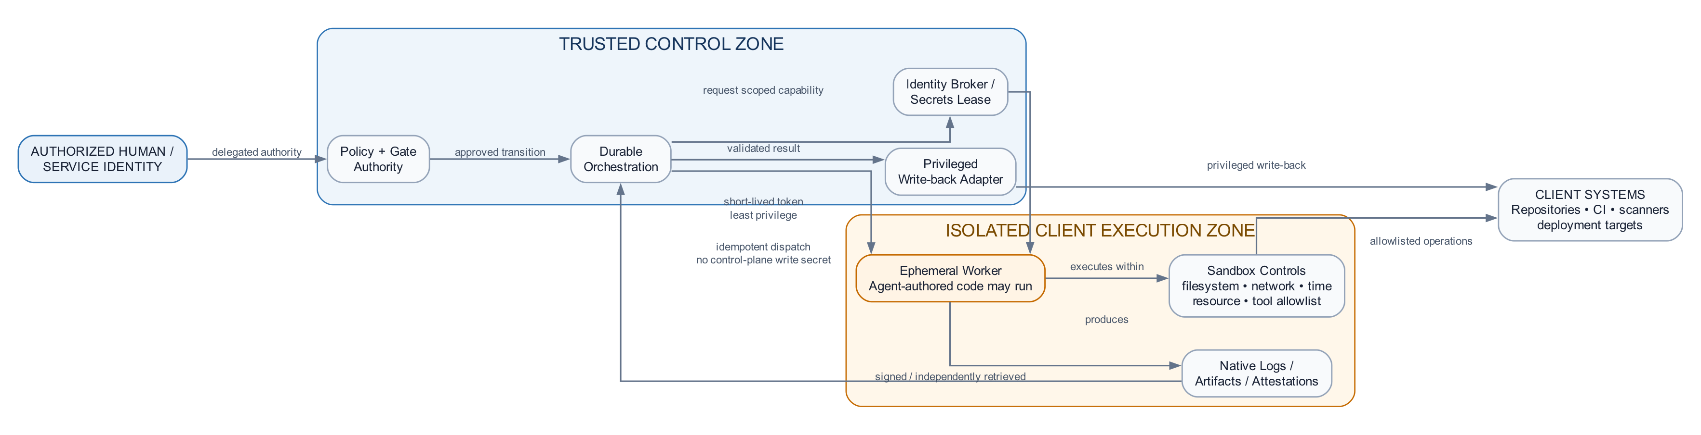
Figure 6. Privilege separation and execution trust boundaries
The architecture assumes that repository content, generated code, external artifacts and even model output may be hostile. Security is expressed through structural boundaries rather than prompt assurances.
- Control plane credentials are never exposed to environments executing agent-authored code.
- Execution workers use short-lived, phase-specific workload identities and egress controls.
- Privileged write-back occurs through a separate trusted reporter or control-plane adapter.
- Every capability invocation is authorized against actor, run, phase, resource and operation.
- Secrets are referenced and leased; they are not placed in prompts, lifecycle state or evidence artifacts.
- Artifacts and result envelopes are signed or independently retrieved from the execution provider.
- Data classification determines model eligibility, region, retention, redaction and retrieval scope.
- Tenant isolation covers compute, state, encryption keys, indexes, telemetry and operator access.

13. Deployment and tenancy patterns
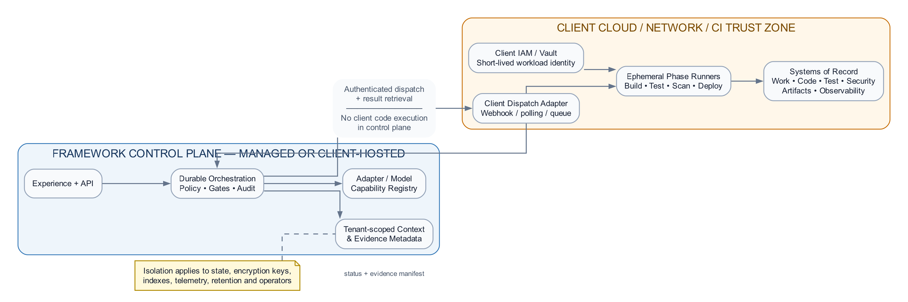
Figure 7. Preferred hybrid deployment: governed control, client-resident execution
The same logical architecture supports multiple physical deployment models. The choice is a client risk and operating-model decision.
Pattern | Best suited to | Key trade-off
Client-hosted | Regulated or sovereignty-sensitive clients | Maximum control; client owns platform operations
Vendor control plane, client execution | Most enterprises | Central lifecycle service with code execution retained in client CI/VPC
Fully managed isolated tenant | Clients accepting managed service with strong isolation | Lower operations burden; stronger vendor assurance required
Hybrid/federated | Large organizations with multiple business units or regions | Local execution and policy domains with enterprise-level portfolio governance

Client execution is the preferred default: code, builds, tests, credentials and deployment actions remain in the environments where existing enterprise controls already apply. The control plane dispatches work and consumes evidence; it does not become a bypass around client CI/CD.

14. Reliability and operational model
Agentic orchestration is asynchronous and failure-prone by nature. Durable execution is a first-class architectural requirement.
- Persist state before external dispatch; persist results before resuming orchestration.
- Use correlation IDs, idempotency keys and monotonic state transitions.
- Separate retryable transport failure from terminal business or policy failure.
- Reconcile external state instead of relying exclusively on callbacks.
- Support timeout, cancellation, compensation and operator repair.
- Make every phase resumable from its last durable boundary without repeating privileged effects.
- Expose platform SLOs for dispatch latency, stuck runs, adapter errors, evidence freshness and gate wait time.

15. Observability, audit and explainability
The framework emits three complementary telemetry streams: operational telemetry for platform health, lifecycle telemetry for delivery flow, and decision telemetry for governance. Audit records are immutable facts; explanations are derived views over those facts.
Telemetry class | Representative measures
Operational | Availability, latency, retries, queue depth, token consumption, adapter health, execution capacity
Lifecycle | Lead time by phase, gate wait, rework, defect escape, release frequency, blocked reasons
Decision | Policy evaluated, evidence used, model/prompt/tool versions, authority, exception and rationale
Intelligence quality | Eval pass rate, impact recall/precision, test-selection recall, grounding failures, drift

16. Evaluation and continuous assurance
No agent, model, impact algorithm or adapter should enter production based on anecdotal demonstrations. The platform maintains versioned evaluation suites at four levels.
Evaluation level | Purpose
Component | Structured-output validity, policy compliance, grounding and task-specific quality
Phase | End-to-end artifact quality, containment, evidence completeness and failure behavior
Lifecycle | Cross-phase traceability, correct routing, recovery and release-readiness decisions
Production outcome | Defect escape, rework, false-positive burden, operator overrides and business impact

Evaluation results become deployment gates for prompts, models, policies and adapters. Production feedback may create candidate improvements, but it never silently modifies production policy or agent behavior.

17. Client implementation blueprint
A client adoption should proceed by stabilizing governance and identity before adding autonomy.
- Establish the client operating model: lifecycle boundaries, decision rights, risk tiers and systems of record.
- Deploy the governance kernel: durable state, audit, policy evaluation, identity and adapter registry.
- Integrate read-only context adapters and build the canonical identity/relationship fabric.
- Select one bounded phase with measurable evidence—typically QA, security triage or requirements quality.
- Implement execution isolation, least privilege, result integrity and operational reconciliation.
- Define deterministic gates and adapter conformance tests before enabling model-generated actions.
- Baseline evals and business/quality metrics; run in recommendation mode against real work.
- Progress through supervised execution, bounded auto-approval and risk-tiered autonomy based on evidence.
- Extend phase by phase while preserving one lifecycle identity model and shared platform services.

18. Architecture governance and ownership
Capability | Accountable owner
Governance kernel and lifecycle contracts | Enterprise platform architecture
Agent quality and model portfolio | AI engineering / responsible AI
Policy packs and decision rights | SDLC governance, risk, security and business owners
Execution adapters and environments | Platform engineering / DevSecOps
Context graph and impact intelligence | Architecture intelligence / developer platform
Client system adapters | Product teams or integration platform owners
Evidence retention and audit | Security, compliance and records management

Changes to invariant contracts require architecture governance and backward-compatibility analysis. Client-specific adapters and policy packs may evolve independently when they remain conformant with supported contract versions.

19. Architectural fitness functions
The architecture should be enforced continuously through executable fitness functions.
- No model SDK imports inside deterministic governance modules.
- No execution environment receives control-plane write credentials.
- Every external dispatch has durable correlation, timeout and reconciliation behavior.
- Every gate decision references a policy version and evidence manifest.
- Every lifecycle artifact resolves to a canonical identity and source version.
- Every adapter passes its semantic conformance and failure-injection suite.
- Every production agent/model/prompt version meets its evaluation threshold.
- Every impact result reports graph version, coverage quality, path provenance and uncertainty.
- Every exception is named, time-bound, attributable and auditable.

20. Reference implementation alignment

20.1 Project and hydration boundary
A project—equivalent to a client engagement—is now a first-class architectural boundary. The active project selects engagement configuration, repository scope, knowledge sources and runtime adapters. Hydration is an operational pipeline rather than a one-time import: indexing, graph construction, retrieval preparation, export and delta refresh all execute within project scope. Graph identities are project-qualified so one engagement cannot overwrite or silently collide with another.

20.2 Replaceable intelligence and execution seams
DesignAgent and TestAuthor are explicit ports. Clients may use the inline reference agents, synchronous client services or dispatched external agents. Implementation work can likewise be delegated through WorkDispatch and SourceControl to a client-provided coding agent. Capability checks, safe administrative selection and fallback behavior protect platform continuity. Replacement never bypasses invariant controls: the framework still owns schema validation, graph-catalogue review, testability checks, policy, evidence normalization and final gate decisions.

20.3 QA scenario, script and test-data lifecycle
QA does not invent a test plan from the diff alone. It assembles change evidence, acceptance criteria, the project-scoped impact graph and the approved test library. TestAuthor proposes scenarios and executable specs; a deterministic gate requires an observable outcome, acceptance-criterion reference and valid data shape. Existing scripts are selected deterministically where possible, generated specs are validated, and mandatory regressions are installed even when an agent omits them.
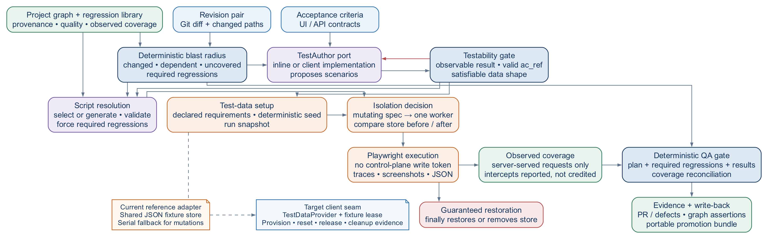
Figure 8. QA authoring, data lifecycle, execution and evidence flow
The implemented reference adapter snapshots the shared JSON store, seeds deterministic data, detects mutating specs, serializes those specs when required, compares state before and after execution, and restores—or deletes—the store in a finally path. This is credible run-level reversibility, but it is not per-scenario isolation. The target contract is a pluggable TestDataProvider that leases isolated fixtures or environments and emits explicit provisioning, reset, release and cleanup evidence.

20.4 Assurance level: what is real, and what remains target state
Capability or assurance claim | Status
Project records, active-project configuration and project-qualified graph identities | Implemented
Operational hydration: index, graph, retrieval, export and delta refresh | Implemented
DesignAgent, TestAuthor and client implementation-agent dispatch seams | Implemented
Scenario traceability, deterministic script installation and required regressions | Implemented
Playwright-observed route/file coverage; fulfilled intercepts reported but not credited | Implemented
Run-level JSON-store snapshot, serial mutation mode and finally-path restoration | Implemented
Portable promotion bundle with generated source, SHA-256 and provenance | Implemented
Per-scenario fixture leases through a TestDataProvider | Target
Branch/statement coverage and deeper semantic side-effect verification | Target
Observed coverage is intentionally described with precision: the reference currently proves route and file reach from server-served requests, not statement, branch or behavioral completeness. Intercepted requests remain visible in the report but receive no coverage credit. A separate reporting job reconciles declared versus observed coverage and writes evidence; execution jobs retain no control-plane write token. Passing generated specs are packaged with source, checksum and provenance for a separate, reviewable promotion decision.

21. Strategic conclusion
A credible agentic PDLC is not defined by the number of agents it contains. It is defined by the quality of its boundaries: what is authoritative, what is inferred, what may act, what must prove, what may be replaced and what must remain invariant.
The proposed framework treats AI as a powerful but non-authoritative participant in a governed lifecycle. It allows clients to bring their own models, tools, clouds, policies and operating practices while retaining a consistent contract for identity, evidence, containment, execution and decision-making. This combination—client sovereignty at the edges and strong governance at the core—is what makes the architecture portable across enterprises without reducing it to either a rigid product or an ungoverned collection of integrations.
PRINCIPAL ARCHITECTURE POSITION Standardize the lifecycle contracts, trust boundaries and evidence semantics. Federate the tools, models, policies and execution environments. Measure the quality of every inference. Never confuse replaceability with optional governance.

Appendix A. Minimum capability contracts
Port | Minimum operations
ModelProvider | complete/stream structured output; usage; model provenance; safety metadata; cancellation
RequirementsSource | resolve, read at version, enumerate criteria, link, write-back with optimistic concurrency
SourceControl | read at ref, compare revisions, propose change, retrieve review status, identify immutable commit
WorkDispatch | claim, trigger idempotently, correlate, check, cancel, retrieve evidence and logs
PolicyDecision | evaluate versioned bundle, explain obligations, return allow/deny/review/additional-evidence
ContextGraph | resolve identity, ingest assertion, query paths, snapshot, expose quality/provenance metrics
EvidenceStore | register immutable manifest, verify integrity, retain pointer, apply residency and retention policy
IdentityAuthority | authenticate actor/workload, authorize capability, issue short-lived credential, record delegation
DesignAgent | propose_design; revise_design; return provenance, assumptions and versioned output
TestAuthor | plan_tests; author_specs; return scenario-to-requirement traceability and source
TestDataProvider (target) | provision_lease; reset_lease; release_lease; emit cleanup and isolation evidence

Appendix B. Required result envelope
Every execution adapter returns a normalized envelope while preserving links to native provider artifacts:
Field | Meaning
run_id / phase / correlation_id | Stable lifecycle and dispatch identity
state | Pending, succeeded, failed, timed out, cancelled or policy-blocked
input_versions | Repository, requirement, graph, policy and artifact versions actually used
outputs | Typed phase-specific payload
evidence_manifest | Immutable artifacts, hashes, locations and retention metadata
assertions | Typed relationships observed by this execution, with provenance
quality | Coverage, completeness, confidence and known limitations
provider | Adapter, capability and contract versions
timestamps | Claimed, started, completed and observed times
errors | Canonical class, native detail, retryability and remediation

Appendix C. Horizontal enterprise architecture sheet
The sheet below separates authoritative client systems, invariant governance, replaceable intelligence, project-scoped state and evidence, versioned ports, and ephemeral client execution. Numbered flows are defined in the ledger beneath the runtime view.

Figure C-1. Horizontal enterprise logical, integration and runtime architecture

