**Problem Statement 1:**

You survey households in your area to find the average rent they are paying. Find the standard deviation from the following data:

$1550, $1700, $900, $850, $1000, $950.

* **Solution 1 -**
* Step 1 – Calculation of Mean – (x1+x2+x3+x4+x5+x6)/n

(1550+1700+900+850+1000+950) / 6 = **1158.33**

* Step 2 – Calculation of Variance –

|  |  |  |
| --- | --- | --- |
| 1550 | 392 | 153403 |
| 1700 | 542 | 293403 |
| 900 | -258 | 66736 |
| 850 | -308 | 95069 |
| 1000 | -158 | 25069 |
| 950 | -208 | 43403 |
| **1158.33** |  | **677083.3** |

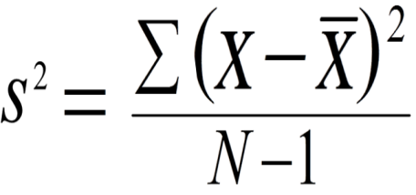

Variance –

677083.3/(6-1) = **135416.7**

* Step 3 – Calculation of Standard Deviation –

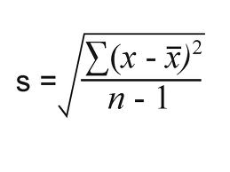

√135416.7= 367.99  
 Therefore, Standard Deviation is **367.99**

**Problem Statement 2:**

Find the variance for the following set of data representing trees in California (heights in feet):

3, 21, 98, 203, 17, 9

* **Solution 2 -**
* Step 1 – Calculation of Mean – (x1+x2+x3+x4+x5+x6)/n

(3+21+98+203+17+9) / 6 = **58.5**

* Step 2 – Calculation of Variance –

|  |  |  |
| --- | --- | --- |
| 3 | -55.5 | 3080.25 |
| 21 | -37.5 | 1406.25 |
| 98 | 39.5 | 1560.25 |
| 203 | 144.5 | 20880.25 |
| 17 | -41.5 | 1722.25 |
| 9 | -49.5 | 2450.25 |
| **58.5** |  | **31099.5** |



Variance –

31099.5/(6-1) = **6219.9**

Therefore, Variance is **6219.9**

* **Task 1 - C:**

In a class on 100 students, 80 students passed in all subjects, 10 failed in one subject, 7 failed in two subjects and 3 failed in three subjects. Find the probability distribution of the variable for number of subjects a student from the given class has failed in.

* **Solution 3 –**
* The probability of failing in 0 subjects, P(X=0) =80/100 =0.8  
  The probability of failing in 1 subjects, P(X=1) =10/100 = 0.1  
  The probability of failing in 2 subjects, P(X=2) =7/100 = 0.07  
  The probability of failing in 3 subjects, P(X=3) = 3/100 = 0.03

The probability distribution can be shown as:

|  |  |  |  |  |
| --- | --- | --- | --- | --- |
| X | 0 | 1 | 2 | 3 |
| P(X) | 0.8 | 0.1 | 0.07 | 0.03 |