### Braintree Payments Gateway

Requirements for Single Transactions

1. Environment-Sandbox / Production.
2. Merchant ID
3. Public Key
4. Private Key

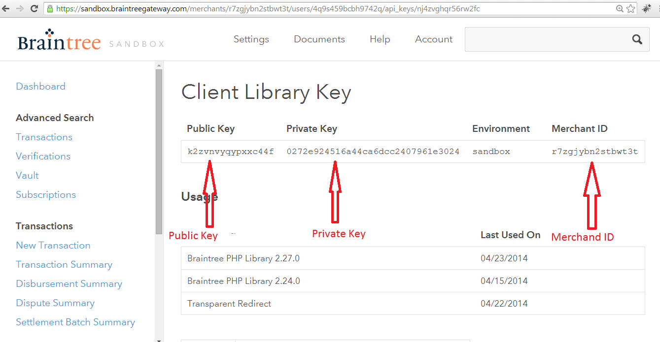

Step to create API Keys

go to https://www.braintreepayments.com/

1. Log in to the **Control Panel**
2. Navigate to **Account** 🡪**My User**
3. Click the blue link titled **API Keys**
4. If no API keys appear, click **Generate New**
5. Click **View** under the **Private Key** column
6. Click **Copy**to copy the API configuration code to the computer's clipboard

For Subscriptions

1. Plan Id
2. Plan Name

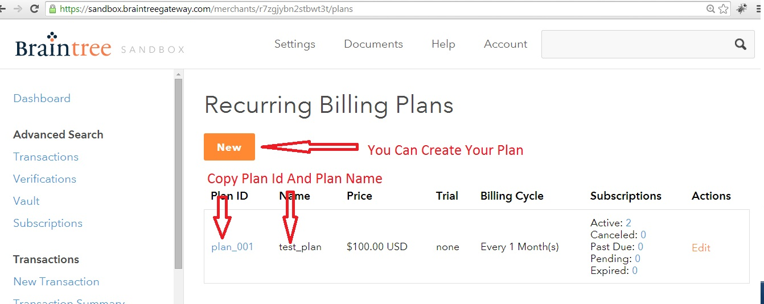

Step to Create Plan for Subscription

go to https://www.braintreepayments.com/

1. Log into the Control Panel
2. Select **Recurring Billing**->**Plans**
3. Click **New**
4. The only fields required to create a plan are the following:

Plan ID

Plan Name

Price (It will be overwrite from your admin panel ,set anything )

1. Once you've filled out all of the necessary information, click **Create**.
2. Take special note of the plan ID that is listed. This is the plan value that is used when creating a subscription.

Set Braintree Payment details in your admin panel

* 1. Log into your admin panel
  2. Select setting🡪 MLUSA Custom Setting🡪

Environment setting- sandbox/production,

Private Key

Public Key

Plan Id

Plan Name

Amount

Subscriptions Period