AppleOrange

STAT380

2023-10-05

# We consider logistric regression for the binary classification.

#### Horea Muresan, Mihai Oltean, Fruit recognition from images using deep learning, Acta Univ. Sapientiae, Informatica Vol. 10, Issue 1, pp. 26-42, 2018.  
#install.packages("OpenImageR")  
library(OpenImageR)

## Warning: package 'OpenImageR' was built under R version 4.0.5

## Functions Used in the Exercise

Extract_col_feature<-function(img){  
 Clr1<-summary(c(img[,, 1]))[-c(1,6)]  
 Clr2<-summary(c(img[,, 2]))[-c(1,6)]  
 Clr3<-summary(c(img[,, 3]))[-c(1,6)]  
 val<-c(Clr1,Clr2, Clr3)   
 #browser()  
 names(val)=paste0("Feature",1:length(val) )  
return(val)  
}

ExtractFeature<-function(FolderName,  
 img_path_dir="/Users/subhadippal/Downloads/Fruit-Images-Dataset-master/Training/",  
 details=TRUE){  
 #browser()  
 #img_path1="/Users/subhadippal/Downloads/Fruit-Images-Dataset-master/Training/Orange/0_100.jpg"  
 files_names<-list.files(paste0(img_path_dir,FolderName))  
 val_color_feature=NULL  
   
 for(FileIndex in 1:length(files_names)){  
 img_path<-paste0(img_path_dir,FolderName,"/" , files_names[FileIndex])  
 #print(img_path)  
 img <- tryCatch(expr = {readImage(img_path)},  
 error = function(e){   
 # (Optional)  
 # Do this if an error is caught...  
 return(NULL)  
 }  
 )  
 #browser()  
 if(!is.null(img)){  
 val_color_feature<-rbind(val_color_feature, c(Extract_col_feature(img)))  
 }  
 if(details){  
 print(paste0("ImageData='",img_path, "' Loaded Succesfully. Feature Extraction complete"))}  
 }  
 Y=rep(x = FolderName, dim(val_color_feature)[1])  
 #val_color_feature  
 return(data.frame(Y,val_color_feature))  
}

Function to Create the Training Dataset

Create_Training_Data<-function(Category1="Apple Braeburn", Category2="Apple Crimson Snow", rand_err=20, details=TRUE){  
#browser()  
Train_cate1<-ExtractFeature(FolderName=Category1, details=details)  
Train_cate2<-ExtractFeature(FolderName=Category2, details=details)  
data=rbind(Train_cate1, Train_cate2)  
Y_var<-ifelse(data$Y==Category1, 1, 0)  
  
vv<-round(runif(rand_err, 1,length(Y_var) ))  
Y_var[vv]= 1- Y_var[vv]  
data$Y= Y_var  
return(data)  
}

### Function to Extract the fearture from testing set.

ExtractFeature_test<-function(FolderNameLoc){  
 #img_path_dir="/Users/subhadippal/Downloads/Fruit-Images-Dataset-master/Training/"  
 #img_path1="/Users/subhadippal/Downloads/Fruit-Images-Dataset-master/Training/Orange/0_100.jpg"  
  
 #img_path_dir  
 img_path<-paste0(FolderNameLoc)  
 #print(img_path)  
 img <- tryCatch(expr = {readImage(img_path)},  
 error = function(e){   
 # (Optional)  
 # Do this if an error is caught...  
 return(NULL)  
 }  
 )  
 #browser()  
 if(!is.null(img)){  
 val_color_feature<- (c(Extract_col_feature(img)))  
 val_color_feature=rbind(val_color_feature,val_color_feature)  
 }  
   
 #Y=rep(x = FolderName, dim(val_color_feature)[1])  
 #val_color_feature  
 return(data.frame(val_color_feature)[1,])  
}

### Sample Images of the objects that we are considering

CategoryLabels=data.frame(Category=c("Apple Braeburn","Apple Crimson Snow" ), ResponseInd=c(1,0)) # Means Apple Braeburn===1, Apple Crimson Snow===0  
img_path=paste0("/Users/subhadippal/Downloads/Fruit-Images-Dataset-master/Training/",CategoryLabels$Category[1],"/1_100.jpg")  
img<-readImage(img_path)  
imageShow(img)

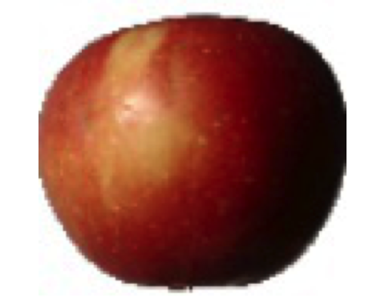

img_path=paste0("/Users/subhadippal/Downloads/Fruit-Images-Dataset-master/Training/",CategoryLabels$Category[2],"/1_100.jpg")  
img<-readImage(img_path)  
imageShow(img)

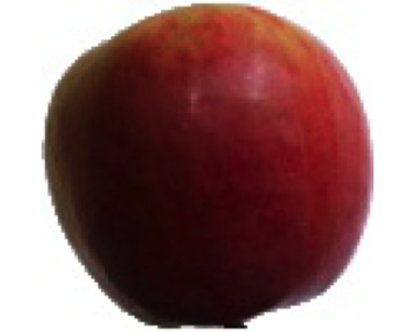

### Creating the Traininig Dataset by extracting the features by reading all the samples/images from the Data folder

#CategoryLabels=data.frame(Category=c("Apple Braeburn","Apple Crimson Snow" ), ResponseInd=c(1,0)) # Means Apple Braeburn===1, Apple Crimson Snow===0  
  
data<-Create_Training_Data(Category1 = CategoryLabels$Category[1], Category2 =CategoryLabels$Category[2], details = FALSE)  
dim(data)

## [1] 936 13

#data<-Create_Train_Data(rand_err = 15, details = FALSE)  
#dim(data)

### Fit a logistic regression with Y=Response

fit<-glm(Y~., data=data, family="binomial")  
#cbind(fit$fitted.values, data$Y)

### Prediction on a data from the testing set: Predict the category of the follwoing object

FolderNameLoc="/Users/subhadippal/Downloads/Fruit-Images-Dataset-master/Test/Apple Crimson Snow/80_100.jpg"  
  
#FolderNameLoc="/Users/subhadippal/Downloads/Fruit-Images-Dataset-master/Test/Apple Braeburn/80_100.jpg"  
img<-readImage(FolderNameLoc);imageShow(img)

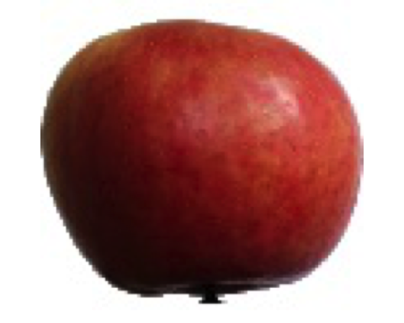

#FolderNameLoc="/Users/subhadippal/Downloads/Fruit-Images-Dataset-master/Test/Apple Golden 1/63_100.jpg"  
  
newData_feature=ExtractFeature_test(FolderNameLoc)  
predictedProb<-predict.glm(fit, newdata=newData_feature, type="response")  
paste0("The predicted probability that the selected image is:",CategoryLabels$Category[1],"( comparing between ", paste0(CategoryLabels$Category, collapse=" and "), ") is ", predictedProb )

## [1] "The predicted probability that the selected image is:Apple Braeburn( comparing between Apple Braeburn and Apple Crimson Snow) is 0.00806555132924715"

predictedProb_1=data.frame(predictedProb, 1-predictedProb)  
colnames(predictedProb_1)=CategoryLabels$Category  
rownames(predictedProb_1)="Predicted Group Probability"  
predictedProb_1

## Apple Braeburn Apple Crimson Snow  
## Predicted Group Probability 0.008065551 0.9919344

## APPLE AND ORNAGE Dataset

### Sample Images of the objects that we are considering

CategoryLabels=data.frame(Category=c("Orange","Apple Braeburn" ), ResponseInd=c(1, 0))  
#Orange===1, and Apple Braeburn===0  
img_path=paste0("/Users/subhadippal/Downloads/Fruit-Images-Dataset-master/Training/",CategoryLabels$Category[1],"/1_100.jpg")  
img<-readImage(img_path)  
imageShow(img)

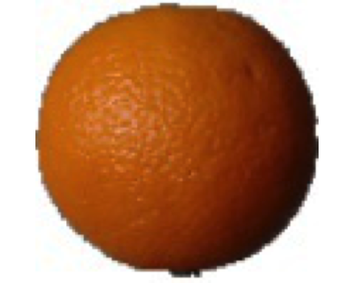

img_path=paste0("/Users/subhadippal/Downloads/Fruit-Images-Dataset-master/Training/",CategoryLabels$Category[2],"/1_100.jpg")  
img<-readImage(img_path)  
imageShow(img)



### Creating the Traininig Dataset by extracting the features by reading all the samples/images from the Data folder

#CategoryLabels=data.frame(Category=c("Orange","Apple Braeburn" ), ResponseInd=c(1, 0))  
#Orange===1, and Apple Braeburn===0  
data_o<-Create_Training_Data(Category1 = CategoryLabels$Category[1], Category2 =CategoryLabels$Category[2], details = FALSE)  
dim(data)

## [1] 936 13

fit_o<-glm(Y~., data=data_o, family="binomial")  
#Estimated_prob<-cbind(fit$fitted.values, data$Y)

### Predict the category of the following object

FolderNameLoc="/Users/subhadippal/Downloads/Fruit-Images-Dataset-master/Test/Apple Braeburn/80_100.jpg"  
img<-readImage(FolderNameLoc);imageShow(img)

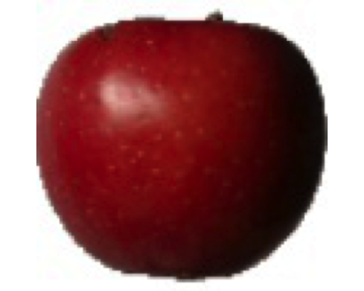

#FolderNameLoc="/Users/subhadippal/Downloads/Fruit-Images-Dataset-master/Test/Orange/6_100.jpg"  
#img<-readImage(FolderNameLoc);imageShow(img)  
  
newData_feature=ExtractFeature_test(FolderNameLoc)  
predictedProb<-predict.glm(fit_o, newdata=newData_feature, type="response")  
paste0("The predicted probability that the selected image is:",CategoryLabels$Category[1],"( comparing between ", paste0(CategoryLabels$Category, collapse=" and "), ") is ", predictedProb )

## [1] "The predicted probability that the selected image is:Orange( comparing between Orange and Apple Braeburn) is 0.0178325574902346"

predictedProb_1=data.frame(predictedProb, 1-predictedProb)  
colnames(predictedProb_1)=CategoryLabels$Category  
rownames(predictedProb_1)="Precicted Group Probability"  
predictedProb_1

## Orange Apple Braeburn  
## Precicted Group Probability 0.01783256 0.9821674

# LDA

library(MASS)  
  
linearLDA_AO <- lda(Y~., data=data_o)  
plot(linearLDA_AO)

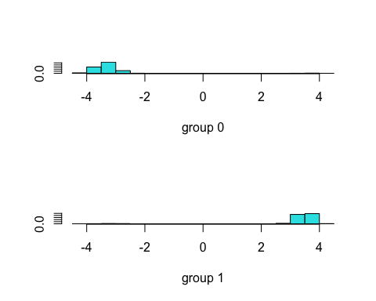

linearLDA_AO$means

## Feature1 Feature2 Feature3 Feature4 Feature5 Feature6 Feature7  
## 0 0.3938512 0.6074363 0.611943 0.9012753 0.08450696 0.2351070 0.3975545  
## 1 0.5337143 0.7025302 0.681959 0.8420987 0.24817555 0.4068126 0.4766850  
## Feature8 Feature9 Feature10 Feature11 Feature12  
## 0 0.8072492 0.04721137 0.14442275 0.3494887 0.7620230  
## 1 0.6020229 0.02421909 0.06724809 0.2889727 0.4403404

### Predict the category of the following object

#FolderNameLoc="/Users/subhadippal/Downloads/Fruit-Images-Dataset-master/Test/Apple Crimson Snow/80_100.jpg"  
  
FolderNameLoc="/Users/subhadippal/Downloads/Fruit-Images-Dataset-master/Test/Apple Braeburn/80_100.jpg"  
  
#FolderNameLoc="/Users/subhadippal/Downloads/Fruit-Images-Dataset-master/Test/Apple Golden 1/63_100.jpg"  
#FolderNameLoc="/Users/subhadippal/Downloads/Fruit-Images-Dataset-master/Test/Orange/6_100.jpg"  
img<-readImage(FolderNameLoc)  
imageShow(img)



newData_feature=ExtractFeature_test(FolderNameLoc)  
pred_LDA_AO<-predict(linearLDA_AO, newdata=newData_feature)  
Pred_prob<-pred_LDA_AO$posterior  
colnames(Pred_prob)=CategoryLabels$Category[c(2,1)]  
rownames(Pred_prob)="Predicted Posterior Probability"  
Pred_prob

## Apple Braeburn Orange  
## Predicted Posterior Probability 1 1.082752e-10

# QDA

#library(MASS)  
Quadratic_QDA_AO <- qda(Y~., data=data_o)

Quadratic_QDA_AO$means

## Feature1 Feature2 Feature3 Feature4 Feature5 Feature6 Feature7  
## 0 0.3938512 0.6074363 0.611943 0.9012753 0.08450696 0.2351070 0.3975545  
## 1 0.5337143 0.7025302 0.681959 0.8420987 0.24817555 0.4068126 0.4766850  
## Feature8 Feature9 Feature10 Feature11 Feature12  
## 0 0.8072492 0.04721137 0.14442275 0.3494887 0.7620230  
## 1 0.6020229 0.02421909 0.06724809 0.2889727 0.4403404

### Precict the Category of the Following Object

#FolderNameLoc="/Users/subhadippal/Downloads/Fruit-Images-Dataset-master/Test/Apple Crimson Snow/80_100.jpg"  
  
FolderNameLoc="/Users/subhadippal/Downloads/Fruit-Images-Dataset-master/Test/Apple Braeburn/80_100.jpg"  
  
#FolderNameLoc="/Users/subhadippal/Downloads/Fruit-Images-Dataset-master/Test/Apple Golden 1/63_100.jpg"  
#FolderNameLoc="/Users/subhadippal/Downloads/Fruit-Images-Dataset-master/Test/Orange/6_100.jpg"  
img<-readImage(FolderNameLoc)  
imageShow(img)



newData_feature=ExtractFeature_test(FolderNameLoc)  
pred_LDA_AO<-predict(Quadratic_QDA_AO, newdata=newData_feature)  
Pred_prob<-pred_LDA_AO$posterior  
colnames(Pred_prob)=CategoryLabels$Category[c(2,1)]  
rownames(Pred_prob)="Predicted Posterior Probability"  
Pred_prob

## Apple Braeburn Orange  
## Predicted Posterior Probability 1 5.116706e-25

#FolderNameLoc="/Users/subhadippal/Downloads/Fruit-Images-Dataset-master/Test/Apple Braeburn/80_100.jpg"  
  
  
FolderNameLoc="/Users/subhadippal/Downloads/Fruit-Images-Dataset-master/Test/Orange/6_100.jpg"  
img<-readImage(FolderNameLoc);imageShow(img)

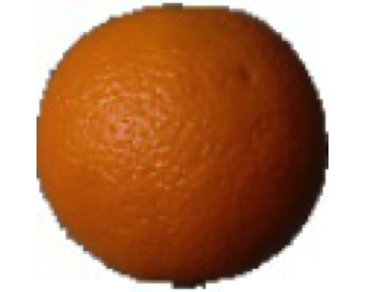

newData_feature=ExtractFeature_test(FolderNameLoc)  
pred_LDA_AO<-predict(Quadratic_QDA_AO, newdata=newData_feature)  
Pred_prob<-pred_LDA_AO$posterior  
colnames(Pred_prob)=CategoryLabels$Category[c(2,1)]  
rownames(Pred_prob)="Predicted Posterior Probability"  
Pred_prob

## Apple Braeburn Orange  
## Predicted Posterior Probability 8.515208e-31 1