LDA_QDA_Example

STAT380

2023-10-12

# Loading the Iris Data

### Example 1: Iris data  
library(MASS)  
library(ggplot2)  
data("iris")  
str(iris)

## 'data.frame': 150 obs. of 5 variables:  
## $ Sepal.Length: num 5.1 4.9 4.7 4.6 5 5.4 4.6 5 4.4 4.9 ...  
## $ Sepal.Width : num 3.5 3 3.2 3.1 3.6 3.9 3.4 3.4 2.9 3.1 ...  
## $ Petal.Length: num 1.4 1.4 1.3 1.5 1.4 1.7 1.4 1.5 1.4 1.5 ...  
## $ Petal.Width : num 0.2 0.2 0.2 0.2 0.2 0.4 0.3 0.2 0.2 0.1 ...  
## $ Species : Factor w/ 3 levels "setosa","versicolor",..: 1 1 1 1 1 1 1 1 1 1 ...

head(iris)

## Sepal.Length Sepal.Width Petal.Length Petal.Width Species  
## 1 5.1 3.5 1.4 0.2 setosa  
## 2 4.9 3.0 1.4 0.2 setosa  
## 3 4.7 3.2 1.3 0.2 setosa  
## 4 4.6 3.1 1.5 0.2 setosa  
## 5 5.0 3.6 1.4 0.2 setosa  
## 6 5.4 3.9 1.7 0.4 setosa

# Basic plots to see the interrelation between the variables

pairs(iris[1:4],  
 gap = 0,  
 bg = c("red", "green", "blue")[iris$Species],  
 pch = 21)

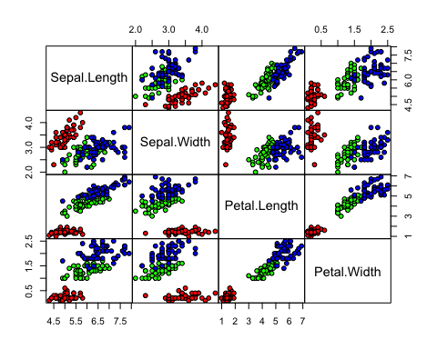

# Splitting the Data in Training and Testing Set

set.seed(134)  
ind = sample(2, nrow(iris), replace = TRUE, prob = c(0.6, 0.4))  
training = iris[ind==1,]  
testing = iris[ind==2,]

# Fitting a Linear Discriminant Analysis

iris_lda = lda(Species~., training)  
iris_lda

## Call:  
## lda(Species ~ ., data = training)  
##   
## Prior probabilities of groups:  
## setosa versicolor virginica   
## 0.3367347 0.3469388 0.3163265   
##   
## Group means:  
## Sepal.Length Sepal.Width Petal.Length Petal.Width  
## setosa 5.006061 3.457576 1.439394 0.2575758  
## versicolor 5.932353 2.735294 4.223529 1.3147059  
## virginica 6.438710 2.935484 5.445161 1.9774194  
##   
## Coefficients of linear discriminants:  
## LD1 LD2  
## Sepal.Length 0.9583651 -0.6656007  
## Sepal.Width 1.1953550 2.4214894  
## Petal.Length -2.6930964 -0.4043851  
## Petal.Width -2.1933913 2.4288629  
##   
## Proportion of trace:  
## LD1 LD2   
## 0.9914 0.0086

attributes(iris_lda); ##or

## $names  
## [1] "prior" "counts" "means" "scaling" "lev" "svd" "N"   
## [8] "call" "terms" "xlevels"  
##   
## $class  
## [1] "lda"

names(iris_lda)

## [1] "prior" "counts" "means" "scaling" "lev" "svd" "N"   
## [8] "call" "terms" "xlevels"

# Predicting the classes (In Training Set) based on the LDA fit

p = predict(iris_lda, training)  
library(klaR) # for the function `partimat'  
partimat(Species~., data = training, method = "lda")

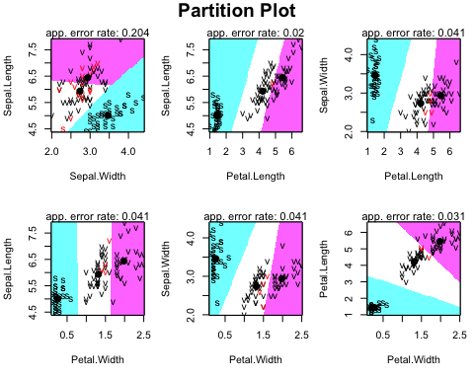

### Confusion matrix and accuracy – training data  
p1 = predict(iris_lda, training)$class  
tab = table(Predicted = p1, Actual = training$Species)  
tab

## Actual  
## Predicted setosa versicolor virginica  
## setosa 33 0 0  
## versicolor 0 34 0  
## virginica 0 0 31

# Predicting the classes (In Testing Set) based on the LDA fit

p2 = predict(iris_lda, testing)$class  
tab1 = table(Predicted = p2, Actual = testing$Species)  
tab1

## Actual  
## Predicted setosa versicolor virginica  
## setosa 17 0 0  
## versicolor 0 14 0  
## virginica 0 2 19

# QDA (Quadratic discriminant analysis on the IRIS Data)

##Everything is not linear – quadratic discriminant analysis  
  
iris_qda=qda(Species~.,data=training)  
iris_qda

## Call:  
## qda(Species ~ ., data = training)  
##   
## Prior probabilities of groups:  
## setosa versicolor virginica   
## 0.3367347 0.3469388 0.3163265   
##   
## Group means:  
## Sepal.Length Sepal.Width Petal.Length Petal.Width  
## setosa 5.006061 3.457576 1.439394 0.2575758  
## versicolor 5.932353 2.735294 4.223529 1.3147059  
## virginica 6.438710 2.935484 5.445161 1.9774194

summary(iris_qda)

## Length Class Mode   
## prior 3 -none- numeric   
## counts 3 -none- numeric   
## means 12 -none- numeric   
## scaling 48 -none- numeric   
## ldet 3 -none- numeric   
## lev 3 -none- character  
## N 1 -none- numeric   
## call 3 -none- call   
## terms 3 terms call   
## xlevels 0 -none- list

#library(klaR)  
partimat(Species~.,data=training,method="lda")



partimat(Species~.,data=training,method="qda")

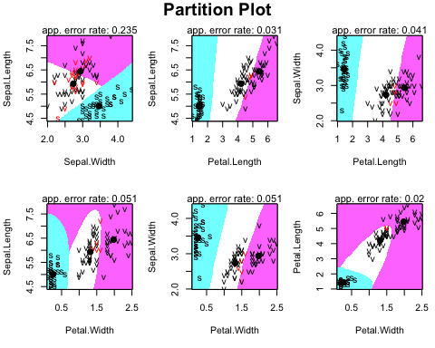

## Check the accuracy of our analysis of QDA in Training Set

#Check the accuracy of our analysis of qda  
Predictions_qda=predict(iris_qda,training)  
table(Predictions_qda$class, training$Species)

##   
## setosa versicolor virginica  
## setosa 33 0 0  
## versicolor 0 34 0  
## virginica 0 0 31

## ## Check the accuracy of our analysis of QDA in Testing Set

#Check the accuracy of our analysis of qda  
Predictions_qda=predict(iris_qda,testing)  
table(Predictions_qda$class, testing$Species)

##   
## setosa versicolor virginica  
## setosa 17 0 0  
## versicolor 0 14 0  
## virginica 0 2 19