Formulae used : -
- price to earning ratio (P/E): RED :

TOTAL CALCULATE

- payout ratio(PR): GREEN EXCEL FILE COMPLETE

investiGATE MULtiple zeros in tata motors
SBI did not declare any dividend for FY 2019–20, even though it earned a profit.

Reason explained clearly (from the Annual Report):
- In FY 2019–20, SBI reported a net profit, but the Board decided not to distribute dividends.
- This decision was mainly due to:
  - COVID-19 uncertainty at the end of FY 2020
  - The need to conserve capital and strengthen reserves
  - Regulatory guidance from RBI, which advised banks to be cautious with dividend payouts during the pandemic

ZEROs mean no profit, or like in sbi, dividends not paid due to covid
- Diluted EPS : GREEN EXCEL FILE COMPLETE
- price to book value (P/B): ORANGE EXCEL FILE COMPLETE

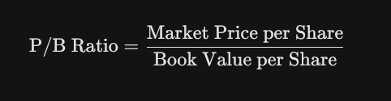market price is fiscal end market price per share, otherwise not matching with moneycontrol
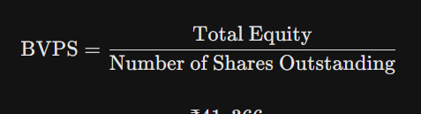

- price to sales ratio (P/S): ORANGE EXCEL FILE COMPLETE

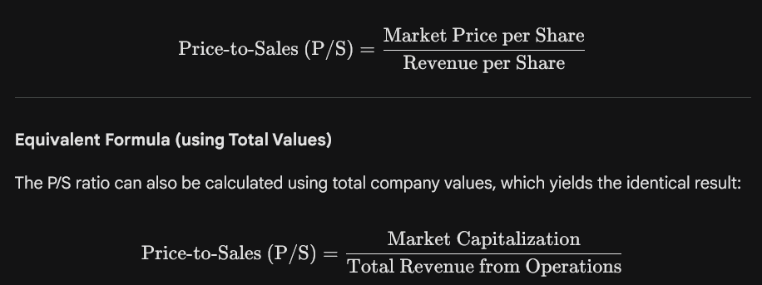

- long term debt to equity ratio (LTDER): GREEN : CALCULATED
LTDER: Will be calculated using Shareholders’ EquityTotal Liabilities​. However, note that banks naturally have extremely high leverage (liabilities) because customer deposits are classified as liabilities. Therefore, the LTDER will be very high and should be compared only against other banks, not industrial companies.
- price to cash flow ratio (P/CF): RED : CALCULATED

TOTAL CALCULATE
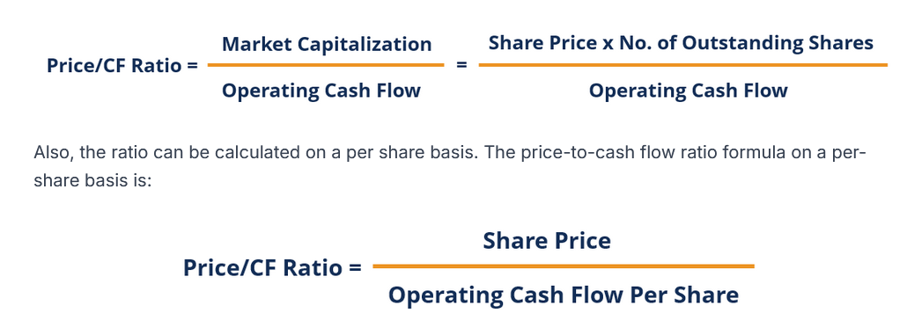

- current ratio (CR): GREEN EXCEL FILE COMPLETE

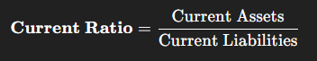

for bank
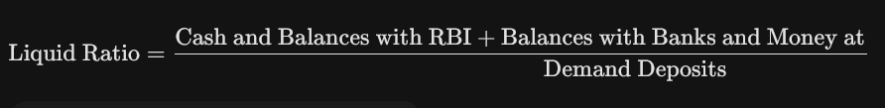
- profit margin(PM) : ORANGE EXCEL FILE COMPLETE
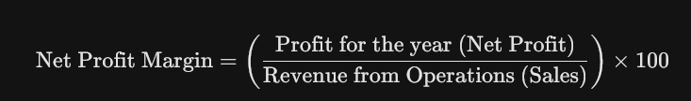
- accounts receivable turnover (ART) : RED : CALCULATED
TOTAL CALCULATE

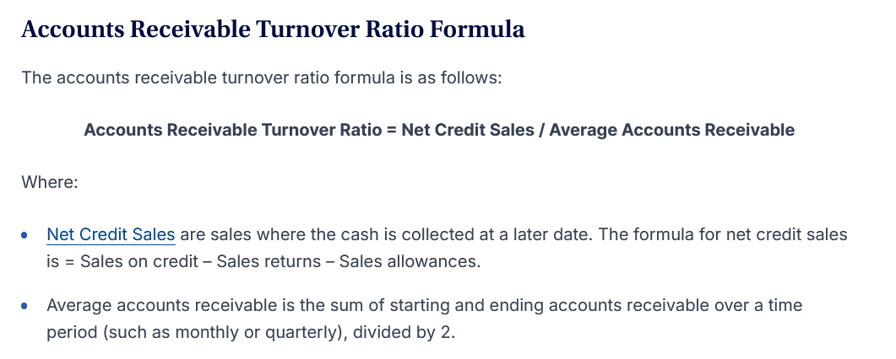
Accounts Receivable Turnover Ratio (A/R Turnover): This ratio is not applicable (N/A) for banks in a meaningful way. Banks do not have "Net Credit Sales" or "Accounts Receivable" from standard commercial sales. Their equivalent is Loans and Advances, but calculating a turnover ratio for this is non-standard and less useful than industry-specific metrics. I will report this ratio as N/A and focus on the other three requested ratios.

GREEN: MATCHED
RED: NOT AT ALL MATCHED
ORANGE: MINUTE ERRORS

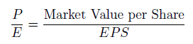
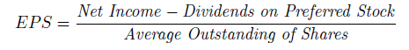
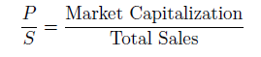
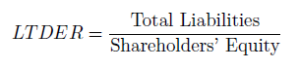

taking another random company, to further classify orange fields

taking hcl 2019 data

