GMR -WEB CENTER -DATABASE-UPGRADE
PIMGM1-DB Upgrade From 11.2.0.4 to 19c

Author : ITC TOWER-C DBA Team
Creation Date : 04-Nov-2024
Last Updated : 04-Nov-2024
Document Control:
Change Record:
 | Date | Author | Version | Change Reference
ReviewersName |  |  |  |  | Position
 |  |  |  |  | Project Manager

- The copy numbers referenced above should be written into the Copy Number space on the cover of each distributed copy. If the document is not controlled, you can delete this table, the Note To Holders, and the Copy Number label from the cover page.

Note To Holders:
If you receive an electronic copy of this document and print it out, please write your name on the equivalent of the cover page, for document control purposes.
If you receive a hard copy of this document, please write your name on the front cover, for document control purposes

INDEX

- PIMGM1 Database Clone Old server to New server.
- Take Cold backup of Source database (Level-0) & 11g O_H Binaries.
- Configure the Target server cloned DIMGM1 instance (clone.pl & Instance configuration)
- Clone database From Source instance to Target instance and (DR) Standby DB BUILD.
- Download and install the 19C Software in Target instance.(.runinstaller)
- Apply July24 PSU patches on 19C Home.
- Stop the Primary database (gmr-chi-pdb02) and Make Standby to Primary database(gmr-chi-pdb03)
- Run Pre-upgrade steps 19C Home
- Validate & Fix the Pre-upgrade recommendation (preupgrade.log)
- Run Preupgrade.sql and validate the Output
- Upgrade 19C database from 11g Database.(./DBUA)
- Run Postupgrade.sql and validate the Output
- Validate 19C version of Time_zone , Compatible, Listener & Database with dba_registry components.
- Set 19c database Env (.bash_profile) & validate system password.
- Rman catalog & Daily backup enable configuration on catalog database
- Sanity checks and share the listener info to Middleware Team.

- PIMGM1 Database Clone Old server to New server

OLD ---PIMGM1 ---gmr-chi-pdb02
NEW ---PIMGM1 ---gmr-chi-pdb03

Clone PIMGM1 Database Old server to New server
Source common /backup mount information --- PIMGM1 ---gmr-chi-pdb02
***************************************
Info to hosting team create share nfs /backup mount point pdb02 to pdb03

[orapcu1@gmr-chi-pdb02 DB_Rman_FULL_BKP]$ df -kh /backup
Filesystem Size Used Avail Use% Mounted on
10.0.198.9:/vol_gmr_chi_NFS_backup_SNMV/qt_gmr-chi-pdb03_Backupnew 200G 191G 9.9G 96% /backup
[orapcu1@gmr-chi-pdb02 DB_Rman_FULL_BKP]$
[orapcu1@gmr-chi-pdb02 backup]$ mkdir -m 777 ORACLE_HOME_BKP
[orapcu1@gmr-chi-pdb02 backup]$ mkdir -m 777 DB_Rman_FULL_BKP
[orapcu1@gmr-chi-pdb02 backup]$

Source Database information --- PIMGM1 ---gmr-chi-pdb02
*****************************
export ORACLE_HOME=/us1101/app/oracle/product/11204
export ORACLE_BASE=/us1101/app/oracle
export PATH=$ORACLE_HOME/bin:$ORACLE_HOME/OPatch:$ORACLE_HOME/perl/bin:$PATH
export LD_LIBRARY_PATH=$ORACLE_HOME/lib
export ORACLE_SID=PIMGM1
export PERL5LIB=$ORACLE_HOME/perl/lib/5.10.0:$ORACLE_HOME/perl/lib/site_perl/5.10.0

Source Database information --- PIMGM1 ---gmr-chi-pdb02
******************************

INSTANCE_NAME TO_CHAR(STARTUP_TIME,'HH HOST_NAME STATUS DATABASE_STATUS ARCHIVE
---------------- ------------------------ -------------------- ---------- ----------------- -------
PIMGM1 05:41 24-AUG-24 gmr-chi-pdb02.gmr.it OPEN ACTIVE STARTED
ciss.com

HOST_NAME INSTANCE_NAME DATABASE_NAME OPEN_MODE DATABASE_ROLE CREATED DBID VERSION
---------------------------------------- ---------------- -------------- -------------------- ---------------- --------- ---------- -----------
BANNER
--------------------------------------------------------------------------------
gmr-chi-pdb02.gmr.itciss.com PIMGM1 PIMGM1 READ WRITE PRIMARY 12-MAR-22 3025155520 11.2.0.4.0
Oracle Database 11g Enterprise Edition Release 11.2.0.4.0 - 64bit Production

Source listener information --- PIMGM1 ---gmr-chi-pdb02
****************************
[orapcu1@gmr-chi-pdb02 backup]$ lsnrctl status LISTENER

LSNRCTL for Linux: Version 11.2.0.4.0 - Production on 05-NOV-2024 23:42:20

Copyright (c) 1991, 2013, Oracle. All rights reserved.

Connecting to (ADDRESS=(PROTOCOL=tcp)(HOST=)(PORT=1521))
STATUS of the LISTENER
------------------------
Alias LISTENER
Version TNSLSNR for Linux: Version 11.2.0.4.0 - Production
Start Date 24-AUG-2024 05:42:01
Uptime 73 days 19 hr. 0 min. 18 sec
Trace Level off
Security ON: Local OS Authentication
SNMP OFF
Listener Parameter File /us1101/app/oracle/product/11204/network/admin/listener.ora
Listener Log File /us1101/app/oracle/diag/tnslsnr/gmr-chi-pdb02/listener/alert/log.xml
Listening Endpoints Summary...
(DESCRIPTION=(ADDRESS=(PROTOCOL=tcp)(HOST=gmr-chi-pdb02.gmr.itciss.com)(PORT=1521)))
Services Summary...
Service "PIMGM1" has 1 instance(s).
Instance "PIMGM1", status READY, has 1 handler(s) for this service...
Service "PIMGM1XDB" has 1 instance(s).
Instance "PIMGM1", status READY, has 1 handler(s) for this service...
The command completed successfully
[orapcu1@gmr-chi-pdb02 backup]$

- Take Cold backup of Source database (Level-0) & 11g O_H Binaries

Source ORACLE_HOME BACKUP from root :* Take $OH --backup location if exist ---- PIMGM1 ---gmr-chi-pdb02
************************************
[root@gmr-chi-pdb02 product]# pwd
/us1101/app/oracle/product
[root@gmr-chi-pdb02 product]# nohup tar cvzf /backup/ORACLE_HOME_BKP/11204_webcenter_DB.tar.gz 11204 >/backup/ORACLE_HOME_BKP/NewO_H03NOV24.log &
[1] 30772
[root@gmr-chi-pdb02 product]#
[orapcu1@gmr-chi-pdb02 ORACLE_HOME_BKP]$ ls -ltrh
total 2.7G
-rwxrwxrwx 1 root root 2.6G Nov 4 20:57 11204_webcenter_DB.tar.gz
-rw-r--r-- 1 root root 2.1M Nov 4 20:57 NewO_H03NOV24.log
[orapcu1@gmr-chi-pdb02 ORACLE_HOME_BKP]$

- Configure the Target server cloned PIMGM1 instance (clone.pl & Instance configuration)
---- PIMGM1 ---gmr-chi-pdb03

ORACLE_HOME tar 11204_webcenter_DB.tar.gz file copy to target node unzip /us1101/app/oracle/product/ and update permission and ownership of the below files.
******************************************************************************************************************************
[orapim1@gmr-chi-pdb03 ORACLE_HOME_BKP]$ cp -r 11204_webcenter_DB.tar.gz /us1101/app/oracle/product/.
[orapim1@gmr-chi-pdb03 ORACLE_HOME_BKP]$ cd /us1101/app/oracle/product/.
[orapim1@gmr-chi-pdb03 product]$ ls -ltrh
total 11G
-rwxr-xr-x 1 orapim1 dba 11G NOV 6 00:12 11204_webcenter_DB.tar.gz
[orapim1@gmr-chi-pdb03 product]$ nohup tar -xvzf 11204_webcenter_DB.tar.gz &
[1] 800712
[orapim1@gmr-chi-pdb03 product]$ nohup: ignoring input and appending output to 'nohup.out'

HI Hosting Team,

Could you please change the permission & owner on below files in gmr-chi-pdb03.gmr.itciss.com.

[orapim1@gmr-chi-pdb03 DB_Rman_FULL_BKP]$ ls -ld /us1101/app/oracle/product/11204/bin/nmb
-rws--x--- 1 root dba 37840 Oct 7 2021 /us1101/app/oracle/product/11204/bin/nmb
[orapim1@gmr-chi-pdb03 DB_Rman_FULL_BKP]$ ls -ld /us1101/app/oracle/product/11204/bin/nmo
-rws--x--- 1 root dba 44720 Oct 7 2021 /us1101/app/oracle/product/11204/bin/nmo
[orapim1@gmr-chi-pdb03 DB_Rman_FULL_BKP]$ ls -ld /us1101/app/oracle/product/11204/bin/nmhs
-rws--x--- 1 root dba 67732 May 18 2015 /us1101/app/oracle/product/11204/bin/nmhs
[orapim1@gmr-chi-pdb03 DB_Rman_FULL_BKP]$

ORACLE_HOME configuration On target node ---- PIMGM1 ---gmr-chi-pdb03
***************************************
Info to hosting team touch the file /etc/oraInst.loc and give full permission on gmr-chi-pdb03.gmr.itciss.com
**************************************************************************************************************
* check ---> cat /etc/oraInst.loc
inventory_loc=/us1101/app/oracle
inst_group=dba
* check ---> cat /etc/oratab
[orapcu1@gmr-chi-pdb02 lib]$ cat /etc/oratab
PIMGM1:/us1101/app/oracle/product/11204:N

[orapim1@gmr-chi-pdb03 ~]$ $ORACLE_HOME/perl/bin/perl $ORACLE_HOME/clone/bin/clone.pl ORACLE_BASE="/us1101/app/oracle/" ORACLE_HOME="$ORACLE_HOME" OSDBA_GROUP=dba OSOPER_GROUP=dba -defaultHomeName
./runInstaller -clone -waitForCompletion "ORACLE_BASE=/us1101/app/oracle/" "ORACLE_HOME=/us1101/app/oracle/product/11204" "oracle_install_OSDBA=dba" "oracle_install_OSOPER=dba" -defaultHomeName -defaultHomeName -silent -noConfig -nowait
Starting Oracle Universal Installer...

Checking swap space: must be greater than 500 MB. Actual 16383 MB Passed
Preparing to launch Oracle Universal Installer from /tmp/OraInstall2024-11-04_10-44-39PM. Please wait ...Oracle Universal Installer, Version 11.2.0.4.0 Production
Copyright (C) 1999, 2013, Oracle. All rights reserved.

You can find the log of this install session at:
/us1101/app/oraInventory/logs/cloneActions2024-11-04_10-44-39PM.log
.................................................................................................... 100% Done.

Installation in progress (Monday, November 4, 2024 10:44:46 PM MST)
.............................................................................. 78% Done.
Install successful

Linking in progress (Monday, November 4, 2024 10:44:49 PM MST)
Link successful

Setup in progress (Monday, November 4, 2024 10:44:55 PM MST)
Setup successful

End of install phases.(Monday, November 4, 2024 10:45:16 PM MST)
WARNING:
The following configuration scripts need to be executed as the "root" user.
/us1101/app/oracle/product/11204/root.sh
To execute the configuration scripts:
1. Open a terminal window
2. Log in as "root"
3. Run the scripts

The cloning of OraHome1 was successful.
Please check '/us1101/app/oraInventory/logs/cloneActions2024-11-04_10-44-39PM.log' for more details.
[orapim1@gmr-chi-pdb03 ~]$

[root@gmr-chi-pdb03 ~]# /us1101/app/oracle/product/11204/root.sh
Check /us1101/app/oracle/product/11204/install/root_gmr-chi-pdb03.gmr.itciss.com_2024-11-04_22-51-43.log for the output of root script
[root@gmr-chi-pdb03 ~]#

set --> .bash_profile ---- PIMGM1 ---gmr-chi-pdb03
*********************
[orapim1@gmr-chi-pdb03 ~]$ cat .bash_profile
# .bash_profile
# Get the aliases and functions
if [ -f ~/.bashrc ]; then
. ~/.bashrc
fi
# User specific environment and startup programs
PATH=$PATH:$HOME/.local/bin:$HOME/bin
export PATH
export ORACLE_HOME=/us1101/app/oracle/product/11204
export ORACLE_BASE=/us1101/app/oracle
export PATH=$ORACLE_HOME/bin:$ORACLE_HOME/OPatch:$ORACLE_HOME/perl/bin:$PATH
export LD_LIBRARY_PATH=$ORACLE_HOME/lib
export ORA_NLS10=/us1101/app/oracle/product/11204/nls/data/9idata
export ORACLE_SID=PIMGM1
export TNS_ADMIN=/us1101/app/oracle/product/11204/network/admin

########
alias sql='sqlplus / as sysdba'
alias lsnr='ps -ef | grep lsnr'
alias TNS="cd $TNS_ADMIN"
alias OH="cd $ORACLE_HOME"
alias dbs="cd $ORACLE_HOME/dbs"
alias pmon='ps -ef | grep pmon | grep -v grep | sort -n'
alias rlogs="cd /nsr/applogs"
alias rscripts="cd /nsr/scripts/oracle"
alias alert="cd /us1101/app/oracle/diag/rdbms/pimgm1/PIMGM1/trace/"

[orapim1@gmr-chi-pdb03 ~]$

logout and login with oracle user orapim1 and connect sqlplus ---- PIMGM1 ---gmr-chi-pdb03
**************************************************************

[orapim1@gmr-chi-pdb03 ~]$ sqlplus / as sysdba
SQL*Plus: Release 11.2.0.4.0 Production on Tus Nov 503:42:48 2024
Copyright (c) 1982, 2013, Oracle. All rights reserved.
Connected to an idle instance.

SYS@PIMGM1 >

create pfile and create directory structure ---- PIMGM1 ---gmr-chi-pdb03
*******************************************

[orapim1@gmr-chi-pdb03 ~]$ cat /home/orapim1/init6nov24PIMGM1.ora
PIMGM1.__db_cache_size=2080374784
PIMGM1.__java_pool_size=16777216
PIMGM1.__large_pool_size=33554432
PIMGM1.__oracle_base='/us1101/app/oracle'#ORACLE_BASE set from environment
PIMGM1.__pga_aggregate_target=2097152000
PIMGM1.__sga_target=4194304000
PIMGM1.__shared_io_pool_size=369098752
PIMGM1.__shared_pool_size=1644167168
PIMGM1.__streams_pool_size=16777216
*.audit_file_dest='/us1101/app/oracle/admin/PIMGM1/adump'
*.audit_trail='db'
*.compatible='11.2.0.4.0'
*.control_files='/un1101/PIMGM1/oradata/control01.ctl','/un1102/PIMGM1/oradata/control02.ctl'
*.db_block_size=8192
*.db_create_file_dest='/ud1101/PIMGM1/oradata/'
*.db_create_online_log_dest_1='/un1101/PIMGM1/oradata'
*.db_create_online_log_dest_2='/un1102/PIMGM1/oradata'
*.db_domain=''
*.db_file_name_convert='/ud1101/PIMAM1/oradata/PIMAM1/datafile/','/ud1101/PIMGM1/oradata/PIMGM1/datafile/'
*.db_name='PIMGM1'#Reset to original value by RMAN
*.diagnostic_dest='/us1101/app/oracle'
*.dispatchers='(PROTOCOL=TCP) (SERVICE=PIMGM1XDB)'
*.log_archive_dest='/ur1101/PIMGM1/ARCHIVES'
*.log_archive_format='PIMGM1_%t_%s_%r.arc'
*.log_file_name_convert='/un1101/PIMAM1/oradata/PIMAM1/onlinelog/','/un1101/PIMGM1/oradata/PIMGM1/onlinelog/','/un1102/PIMAM1/oradata/PIMAM1/onlinelog/','/un1102/PIMGM1/oradata/PIMGM1/onlinelog/'
*.open_cursors=300
*.pga_aggregate_target=2097152000
*.processes=600
*.remote_login_passwordfile='EXCLUSIVE'
*.sessions=1000
*.sga_target=4194304000
*.transactions=1100
*.undo_tablespace='UNDOTBS1'
[orapim1@gmr-chi-pdb03 ~]$

Validated the above all path physical in server, if not present create according to path.

Start nomount target database instance
****************************************
SYS@PIMGM1 > startup nomount;
ORACLE instance started.
Total System Global Area 4175568896 bytes
Fixed Size 2259840 bytes
Variable Size 2298479744 bytes
Database Buffers 1862270976 bytes
Redo Buffers 12558336 bytes
SYS@PIMGM1 >

listener files backup ---and configure to target server: listener files backup ---- PIMGM1 ---gmr-chi-pdb03
************************************************************
[orapim1@gmr-chi-pdb03 ~]$ lsnrctl status LISTENER_PIMGM1
LSNRCTL for Linux: Version 11.2.0.4.0 - Production on 06-NOV-2024 20:32:23
Copyright (c) 1991, 2013, Oracle. All rights reserved.
Connecting to (DESCRIPTION=(ADDRESS=(PROTOCOL=TCP)(HOST=gmr-chi-pdb03.gmr.itciss.com)(PORT=1521)))
STATUS of the LISTENER
------------------------
Alias LISTENER_PIMGM1
Version TNSLSNR for Linux: Version 11.2.0.4.0 - Production
Start Date 06-NOV-2024 08:50:40
Uptime 0 days 11 hr. 41 min. 42 sec
Trace Level off
Security ON: Local OS Authentication
SNMP OFF
Listener Parameter File /us1101/app/oracle/product/11204/network/admin/listener.ora
Listener Log File /us1101/app/oracle/diag/tnslsnr/gmr-chi-pdb03/listener_pimgm1/alert/log.xml
Listening Endpoints Summary...
(DESCRIPTION=(ADDRESS=(PROTOCOL=tcp)(HOST=gmr-chi-pdb03.gmr.itciss.com)(PORT=1521)))
Services Summary...
Service "PIMGM1" has 1 instance(s).
Instance "PIMGM1", status UNKNOWN, has 1 handler(s) for this service...
Service "PIMGM1S" has 1 instance(s).
Instance "PIMGM1", status READY, has 1 handler(s) for this service...
The command completed successfully
[orapim1@gmr-chi-pdb03 ~]$
- Clone database From Source instance to Target instance Standby DB BUILD.

source backup (Rman full backup) --- PIMGM1 ---gmr-chi-pdb02
************************************
Rman full backup
*****************
[orapcu1@gmr-chi-pdb02 DB_Rman_FULL_BKP]$ cat Rman_backup_standby.sh
export NLS_DATE_FORMAT='DD-MON-YYYY HH24:MI'
rman target / LOG=/backup/DB_Rman_FULL_BKP/PRDN_backup_06NOV2024.log <<EOF
RUN
{
ALLOCATE CHANNEL ch00 TYPE disk;
ALLOCATE CHANNEL ch01 TYPE disk;
ALLOCATE CHANNEL ch02 TYPE disk;
ALLOCATE CHANNEL ch03 TYPE disk;
ALLOCATE CHANNEL ch04 TYPE disk;
ALLOCATE CHANNEL ch05 TYPE disk;
ALLOCATE CHANNEL ch06 TYPE disk;
ALLOCATE CHANNEL ch07 TYPE disk;
BACKUP AS COMPRESSED BACKUPSET FULL DATABASE FILESPERSET 10 FORMAT '/backup/DB_Rman_FULL_BKP/full_rman_%d_%M%D%Y_%p_%s.rman';
backup AS COMPRESSED BACKUPSET archivelog all format '/backup/DB_Rman_FULL_BKP/%d_ARCH_%M%D%Y_%p_%s.rman' ;
BACKUP FORMAT '/backup/DB_Rman_FULL_BKP/current_%d_%M_%D_%Y_%t.ctl' CURRENT CONTROLFILE ;
BACKUP CURRENT CONTROLFILE FOR STANDBY FORMAT '/backup/DB_Rman_FULL_BKP/ForStandbyCTRL.bck';
backup spfile format '/backup/DB_Rman_FULL_BKP/spfile_%d.ora';
}
EOF
[orapcu1@gmr-chi-pdb02 DB_Rman_FULL_BKP]$
[oradeb1@gmr-chi-pdb02 DB_Rman_FULL_BKP]$

[orapim1@gmr-chi-pdb03 DB_Rman_FULL_BKP]$ pwd
/backup/DB_Rman_FULL_BKP
[orapim1@gmr-chi-pdb03 DB_Rman_FULL_BKP]$

Copy to rman full backup to Target
***********************************

[orapim1@gmr-chi-pdb03 DB_Rman_FULL_BKP]$ pwd
/backup/DB_Rman_FULL_BKP
[orapim1@gmr-chi-pdb03 DB_Rman_FULL_BKP]$ ls -ltrh
total 179G
-rwxrwxrwx 1 orapim1 dba 878 Nov 5 21:21 Rman_backup_standby.sh
-rw-r----- 1 orapim1 dba 93M Nov 5 21:23 full_rman_PIMGM1_11052024_1_53159.rman
-rw-r----- 1 orapim1 dba 2.8M Nov 5 21:23 full_rman_PIMGM1_11052024_1_53160.rman
-rw-r----- 1 orapim1 dba 96K Nov 5 21:23 full_rman_PIMGM1_11052024_1_53161.rman
-rw-r----- 1 orapim1 dba 10G Nov 5 22:05 full_rman_PIMGM1_11052024_1_53156.rman
-rw-r----- 1 orapim1 dba 20G Nov 5 22:56 full_rman_PIMGM1_11052024_1_53158.rman
-rw-r----- 1 orapim1 dba 21G Nov 5 22:59 full_rman_PIMGM1_11052024_1_53157.rman
-rw-r----- 1 orapim1 dba 21G Nov 5 22:59 full_rman_PIMGM1_11052024_1_53155.rman
-rw-r----- 1 orapim1 dba 32G Nov 5 23:16 full_rman_PIMGM1_11052024_1_53152.rman
-rw-r----- 1 orapim1 dba 33G Nov 5 23:22 full_rman_PIMGM1_11052024_1_53153.rman
-rw-r----- 1 orapim1 dba 37G Nov 5 23:25 full_rman_PIMGM1_11052024_1_53154.rman
-rw-r----- 1 orapim1 dba 788M Nov 5 23:29 PIMGM1_ARCH_11052024_1_53174.rman
-rw-r----- 1 orapim1 dba 890M Nov 5 23:29 PIMGM1_ARCH_11052024_1_53167.rman
-rw-r----- 1 orapim1 dba 890M Nov 5 23:29 PIMGM1_ARCH_11052024_1_53172.rman
-rw-r----- 1 orapim1 dba 909M Nov 5 23:29 PIMGM1_ARCH_11052024_1_53170.rman
-rw-r----- 1 orapim1 dba 907M Nov 5 23:29 PIMGM1_ARCH_11052024_1_53171.rman
-rw-r----- 1 orapim1 dba 894M Nov 5 23:29 PIMGM1_ARCH_11052024_1_53169.rman
-rw-r----- 1 orapim1 dba 900M Nov 5 23:29 PIMGM1_ARCH_11052024_1_53168.rman
-rw-r----- 1 orapim1 dba 55M Nov 5 23:29 PIMGM1_ARCH_11052024_1_53175.rman
-rw-r----- 1 orapim1 dba 1.1G Nov 5 23:30 PIMGM1_ARCH_11052024_1_53173.rman
-rw-r----- 1 orapim1 dba 29M Nov 5 23:30 current_PIMGM1_11_05_2024_1184283004.ctl
-rw-r----- 1 orapim1 dba 29M Nov 5 23:30 ForStandbyCTRL.bck
-rw-r----- 1 orapim1 dba 96K Nov 5 23:30 spfile_PIMGM1.ora
-rw-r--r-- 1 orapim1 dba 48K Nov 5 23:30 PRDN_backup_06NOV2024.log
-rw------- 1 orapim1 dba 64 Nov 5 23:30 nohup.out
[orapim1@gmr-chi-pdb03 DB_Rman_FULL_BKP]$

Building the standby database
*****************************

PROD: Primary--- PIMGM1 ---gmr-chi-pdb02
=========
ALTER SYSTEM SET LOG_ARCHIVE_CONFIG='DG_CONFIG=(PIMGM1,PIMGM1S)' scope=both sid='*';

ALTER SYSTEM SET FAL_SERVER='PIMGM1S' scope=both sid='*';

ALTER SYSTEM SET LOG_ARCHIVE_DEST_2='SERVICE=PIMGM1S NOAFFIRM ASYNC VALID_FOR=(ONLINE_LOGFILES,PRIMARY_ROLE) DB_UNIQUE_NAME=PIMGM1S' scope=both sid='*';

ALTER SYSTEM SET LOG_ARCHIVE_DEST_STATE_2=ENABLE scope=both sid='*'; -----once db restore complete step1

ALTER SYSTEM SET LOG_ARCHIVE_DEST_STATE_2=DEFER scope=both sid='*';

alter system set log_archive_dest_1='/ur1101/PIMGM1/ARCHIVES' scope=both;

alter system set log_archive_dest=' ' scope=both;

alter system set db_recovery_file_dest='/ur1101/PIMGM1/ARCHIVES' scope=both ;

alter system set log_archive_dest_1='LOCATION=USE_DB_RECOVERY_FILE_DEST';

SYS@PIMGM1 > sho parameter LOG_ARCHIVE_CONFIG;

NAME TYPE VALUE
------------------------------------ ----------- ------------------------------
log_archive_config string DG_CONFIG=(PIMGM1,PIMGM1S)
SYS@PIMGM1 > sho parameter FAL_SERVER;

NAME TYPE VALUE
------------------------------------ ----------- ------------------------------
fal_server string PIMGM1S
SYS@PIMGM1 > sho parameter LOG_ARCHIVE_DEST_2;

NAME TYPE VALUE
------------------------------------ ----------- ------------------------------
log_archive_dest_2 string SERVICE=PIMGM1S NOAFFIRM ASYNC
VALID_FOR=(ONLINE_LOGFILES,PR
IMARY_ROLE) DB_UNIQUE_NAME=PIM
GM1S
log_archive_dest_20 string
log_archive_dest_21 string
log_archive_dest_22 string
log_archive_dest_23 string
log_archive_dest_24 string
log_archive_dest_25 string
log_archive_dest_26 string

NAME TYPE VALUE
------------------------------------ ----------- ------------------------------
log_archive_dest_27 string
log_archive_dest_28 string
log_archive_dest_29 string
SYS@PIMGM1 > sho parameter LOG_ARCHIVE_DEST_STATE_2;

NAME TYPE VALUE
------------------------------------ ----------- ------------------------------
log_archive_dest_state_2 string DEFER
log_archive_dest_state_20 string enable
log_archive_dest_state_21 string enable
log_archive_dest_state_22 string enable
log_archive_dest_state_23 string enable
log_archive_dest_state_24 string enable
log_archive_dest_state_25 string enable
log_archive_dest_state_26 string enable
log_archive_dest_state_27 string enable
log_archive_dest_state_28 string enable
log_archive_dest_state_29 string enable
SYS@PIMGM1 > sho parameter log_archive_dest_1;

NAME TYPE VALUE
------------------------------------ ----------- ------------------------------
log_archive_dest_1 string LOCATION=USE_DB_RECOVERY_FILE_
DEST
log_archive_dest_10 string
log_archive_dest_11 string
log_archive_dest_12 string
log_archive_dest_13 string
log_archive_dest_14 string
log_archive_dest_15 string
log_archive_dest_16 string
log_archive_dest_17 string
log_archive_dest_18 string

NAME TYPE VALUE
------------------------------------ ----------- ------------------------------
log_archive_dest_19 string
SYS@PIMGM1 > show parameter db_recovery_file_dest;

NAME TYPE VALUE
------------------------------------ ----------- ------------------------------
db_recovery_file_dest string /ur1101/PIMGM1/ARCHIVES
db_recovery_file_dest_size big integer 50G
SYS@PIMGM1 > sho parameter log_archive_dest;

NAME TYPE VALUE
------------------------------------ ----------- ------------------------------
log_archive_dest string
log_archive_dest_1 string LOCATION=USE_DB_RECOVERY_FILE_ DEST

Added primary db location tnsnames.ora standby information --- PIMGM1 ---gmr-chi-pdb02
***********************************************************
vi tnsnames.ora

PIMGM1S=
(DESCRIPTION=
(ADDRESS=(PROTOCOL=tcp)(HOST=gmr-chi-pdb03.gmr.itciss.com)(PORT=1521))
(CONNECT_DATA=
(SERVICE_NAME=PIMGM1)
(INSTANCE_NAME=PIMGM1)
)
)

Validation --- PIMGM1 ---gmr-chi-pdb02
***********
[orapcu1@gmr-chi-pdb02 admin]$ tnsping PIMGM1S
TNS Ping Utility for Linux: Version 11.2.0.4.0 - Production on 06-NOV-2024 05:17:32
Copyright (c) 1997, 2013, Oracle. All rights reserved.
Used parameter files:
Used TNSNAMES adapter to resolve the alias
Attempting to contact (DESCRIPTION= (ADDRESS=(PROTOCOL=tcp)(HOST=gmr-chi-pdb03.gmr.itciss.com)(PORT=1521)) (CONNECT_DATA= (SERVICE_NAME=PIMGM1) (INSTANCE_NAME=PIMGM1)))
OK (0 msec)
[orapcu1@gmr-chi-pdb02 admin]$

STNDBY: Configuration parameters --- PIMGM1 ---gmr-chi-pdb03
*************************************

SYS@PIMGM1 > alter system set db_unique_name='PIMGM1S' scope=spfile;
System altered.
SYS@PIMGM1 >

stop DB and start database nomount.

ALTER SYSTEM SET LOG_ARCHIVE_CONFIG='DG_CONFIG=(PIMGM1,PIMGM1S)' scope=both sid='*';

ALTER SYSTEM SET FAL_SERVER='PIMGM1' scope=both sid='*';

ALTER SYSTEM SET DB_NAME='PIMGM1' scope=both sid='*';

To Enable MRP process:
ALTER DATABASE RECOVER MANAGED STANDBY DATABASE DISCONNECT FROM SESSION; -----once db restore complete step2

SYS@PIMGM1 > sho parameter db_unique_name;
NAME TYPE VALUE
------------------------------------ ----------- ------------------------------
db_unique_name string PIMGM1S
SYS@PIMGM1 >

SYS@PIMGM1 > sho parameter LOG_ARCHIVE_CONFIG;
NAME TYPE VALUE
------------------------------------ ----------- ------------------------------
log_archive_config string DG_CONFIG=(PIMGM1,PIMGM1S)
SYS@PIMGM1 > sho parameter FAL_SERVER;
NAME TYPE VALUE
------------------------------------ ----------- ------------------------------
fal_server string PIMGM1
SYS@PIMGM1 >

Added standby db location tnsnames.ora primary information --- PIMGM1 ---gmr-chi-pdb03
***********************************************************

[orapim1@gmr-chi-pdb03 admin]$ cat tnsnames.ora
PIMGM1S=
(DESCRIPTION=
(ADDRESS=(PROTOCOL=tcp)(HOST=gmr-chi-pdb03.gmr.itciss.com)(PORT=1521))
(CONNECT_DATA=
(SERVICE_NAME=PIMGM1)
(INSTANCE_NAME=PIMGM1)
)
)

PIMGM1=
(DESCRIPTION=
(ADDRESS=(PROTOCOL=tcp)(HOST=gmr-chi-pdb02.gmr.itciss.com)(PORT=1521))
(CONNECT_DATA=
(SERVICE_NAME=PIMGM1)
(INSTANCE_NAME=PIMGM1)
)
)

validation
**********
[orapim1@gmr-chi-pdb03 admin]$ tnsping PIMGM1
TNS Ping Utility for Linux: Version 11.2.0.4.0 - Production on 06-NOV-2024 06:11:49
Copyright (c) 1997, 2013, Oracle. All rights reserved.
Used parameter files:
Used TNSNAMES adapter to resolve the alias
Attempting to contact (DESCRIPTION= (ADDRESS=(PROTOCOL=tcp)(HOST=gmr-chi-pdb02.gmr.itciss.com)(PORT=1521)) (CONNECT_DATA= (SERVICE_NAME=PIMGM1) (INSTANCE_NAME=PIMGM1)))
OK (0 msec)
[orapim1@gmr-chi-pdb03 admin]$

Restore standby database by using the primary rman full backup ( Location :/backup/DB_Rman_FULL_BKP/ )
********************************************************************************************************
--- PIMGM1 ---gmr-chi-pdb03

[orapim1@gmr-chi-pdb03 DB_Rman_FULL_BKP]$ cat duplicate_standby.sh
rman auxiliary / LOG=rman_PIMGM1_clone_standby_06Nov24.log << EOF
run
{
ALLOCATE auxiliary CHANNEL S1 TYPE DISK;
ALLOCATE auxiliary CHANNEL S2 TYPE DISK;
ALLOCATE auxiliary CHANNEL S3 TYPE DISK;
ALLOCATE auxiliary CHANNEL S4 TYPE DISK;
DUPLICATE TARGET DATABASE FOR STANDBY BACKUP LOCATION '/backup/DB_Rman_FULL_BKP/' NOFILENAMECHECK;
}
EOF
EXIT
[orapim1@gmr-chi-pdb03 DB_Rman_FULL_BKP]$
[orapim1@gmr-chi-pdb03 DB_Rman_FULL_BKP]$
[orapim1@gmr-chi-pdb03 DB_Rman_FULL_BKP]$ chmod -R 777 duplicate_standby.sh

[orapim1@gmr-chi-pdb03 DB_Rman_FULL_BKP]$
[orapim1@gmr-chi-pdb03 DB_Rman_FULL_BKP]$ nohup sh duplicate_standby.sh &
[1] 695924
[orapim1@gmr-chi-pdb03 DB_Rman_FULL_BKP]$ nohup: ignoring input and appending output to 'nohup.out'

[orapim1@gmr-chi-pdb03 DB_Rman_FULL_BKP]$ jobs -l
[1]+ 695924 Running nohup sh duplicate_standby.sh &
[orapim1@gmr-chi-pdb03 DB_Rman_FULL_BKP]$

Validation of standby database and Archive log sync --- PIMGM1 ---gmr-chi-pdb03
**************************************************************

INSTANCE_NAME TO_CHAR(STARTUP_TIME,'HH HOST_NAME STATUS DATABASE_STATUS ARCHIVE
---------------- ------------------------ -------------------- ---------- ----------------- -------
PIMGM1 08:51 06-NOV-24 gmr-chi-pdb03.gmr.it MOUNTED ACTIVE STARTED
ciss.com

SYS@PIMGM1 >

HOST_NAME INSTANCE_NAME DATABASE_NAME OPEN_MODE DATABASE_ROLE CREATED DBID VERSION BANNER
---------------------------------------- ---------------- -------------- -------------------- ---------------- --------- ---------- ----------- --------------------------------------------------------------------------------
gmr-chi-pdb03.gmr.itciss.com PIMGM1 PIMGM1 MOUNTED PHYSICAL STANDBY 12-MAR-22 3025155520 11.2.0.4.0 Oracle Database 11g Enterprise Edition Release 11.2.0.4.0 - 64bit Production

SYS@PIMGM1 >
SYS@PIMGM1 > archive log list;
Database log mode Archive Mode
Automatic archival Enabled
Archive destination /ur1101/PIMGM1/ARCHIVES
Oldest online log sequence 413200
Next log sequence to archive 0
Current log sequence 413201
SYS@PIMGM1 >

thread last sequence received last sequence applied difference
---------- ---------------------- --------------------- ----------
1 413200 413200 0

SYS@PIMGM1 >

- Download and install the 19C Software in Target instance.(.runinstaller)

Unzip the 19c s/w --- PIMGM1 ---gmr-chi-pdb03
***************
[orapim1@gmr-chi-pdb03 19.3.0]$ mkdir /us1101/app/oracle/product/19.3.0
[orapim1@gmr-chi-pdb03 19.3.0]$ unzip /backup/software/LINUX.X64_193000_db_home.zip

Installation of 19c S/w
************************
Open vnc server

[orapim1@gmr-chi-pdb03 ~]$ cat 19C.env
export ORACLE_HOME=/us1101/app/oracle/product/19.3.0
export ORACLE_BASE=/us1101/app/oracle
export PATH=$ORACLE_HOME/bin:$ORACLE_HOME/OPatch:$ORACLE_HOME/perl/bin:$PATH
export ORACLE_SID=PIMGM1
[orapim1@gmr-chi-pdb03 ~]$

[orapim1@gmr-chi-pdb03 ~]$ . ./19C.env
[orapim1@gmr-chi-pdb03 ~]$
[orapim1@gmr-chi-pdb03 ~]$
[orapim1@gmr-chi-pdb03 ~]$ echo $ORACLE_HOME
/us1101/app/oracle/product/19.3.0
[orapim1@gmr-chi-pdb03 ~]$
[orapim1@gmr-chi-pdb03 ~]$ cd /us1101/app/oracle/product/19.3.0
[orapim1@gmr-chi-pdb03 19.3.0]$

[orapim1@gmr-chi-pdb03 19.3.0]$ export CV_ASSUME_DISTID=OEL7.8
[orapim1@gmr-chi-pdb03 19.3.0]$ ./runInstaller
Launching Oracle Database Setup Wizard...

The response file for this session can be found at:
/us1101/app/oracle/product/19.3.0/install/response/db_2024-11-05_09-27-57PM.rsp

You can find the log of this install session at:
/us1101/app/oraInventory/logs/InstallActions2024-11-05_09-27-57PM/installActions2024-11-05_09-27-57PM.log
[orapim1@gmr-chi-pdb03 19.3.0]$
[orapim1@gmr-chi-pdb03 19.3.0]$

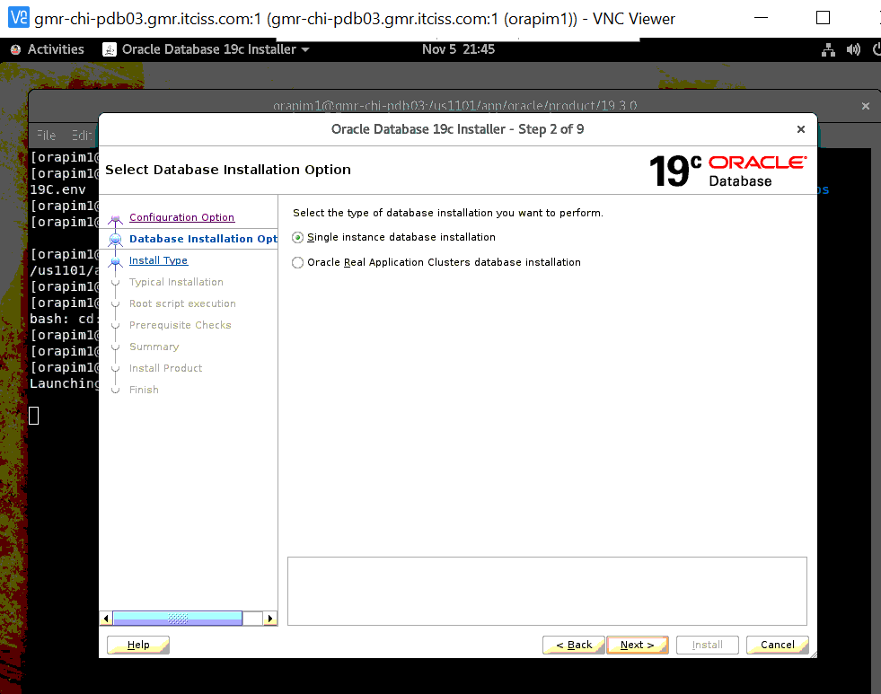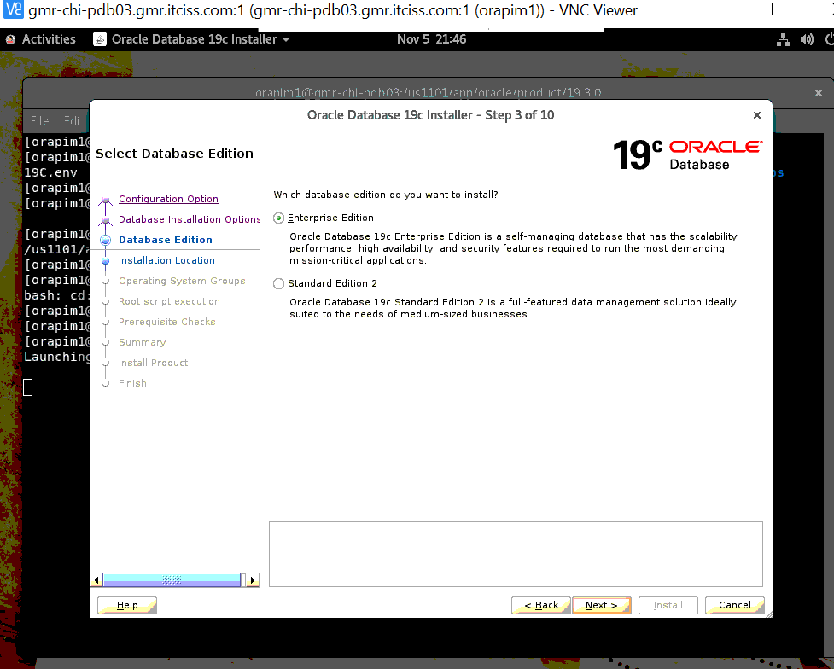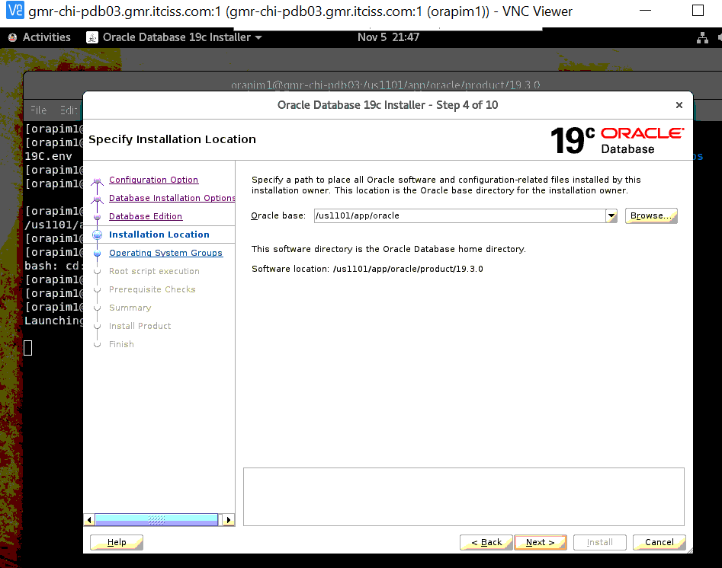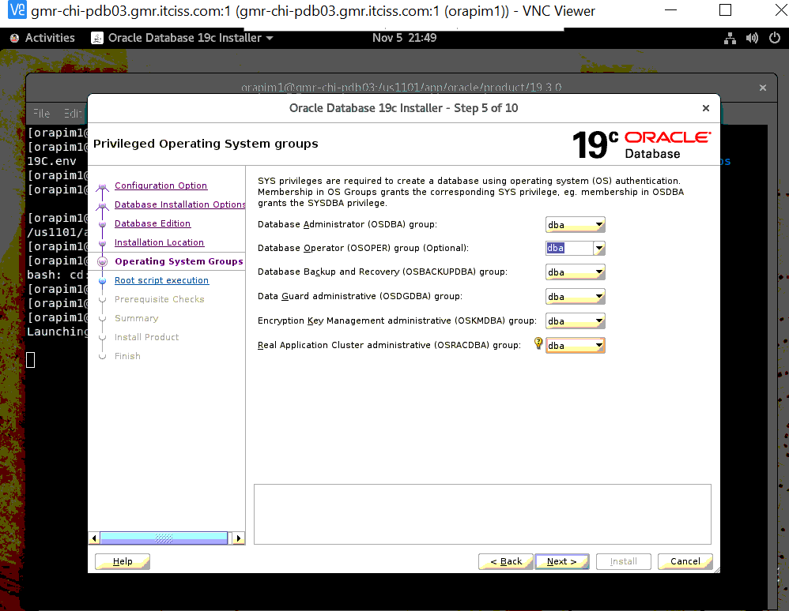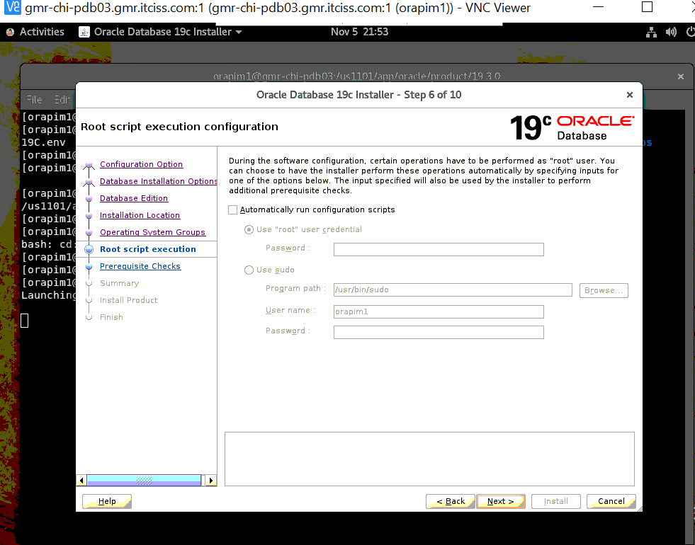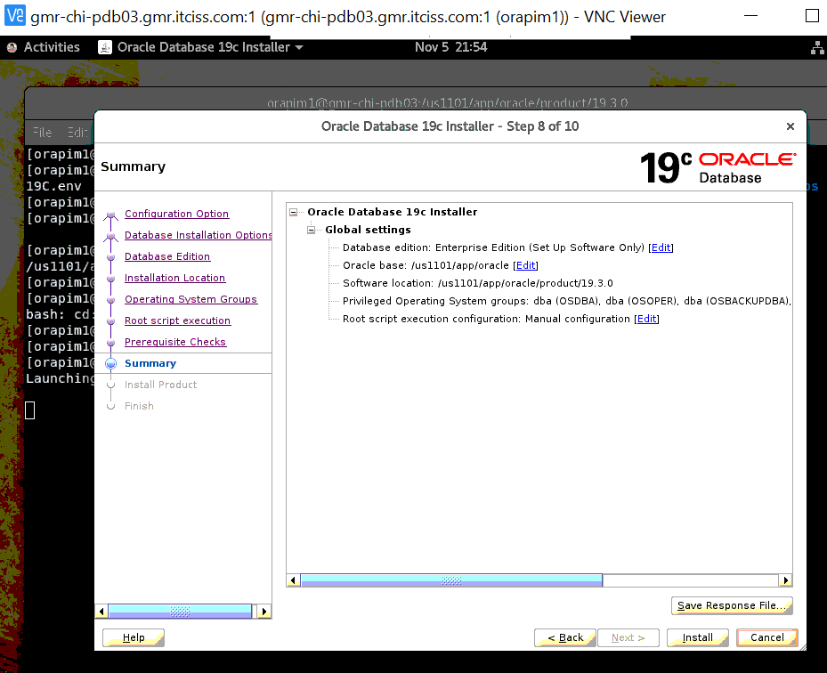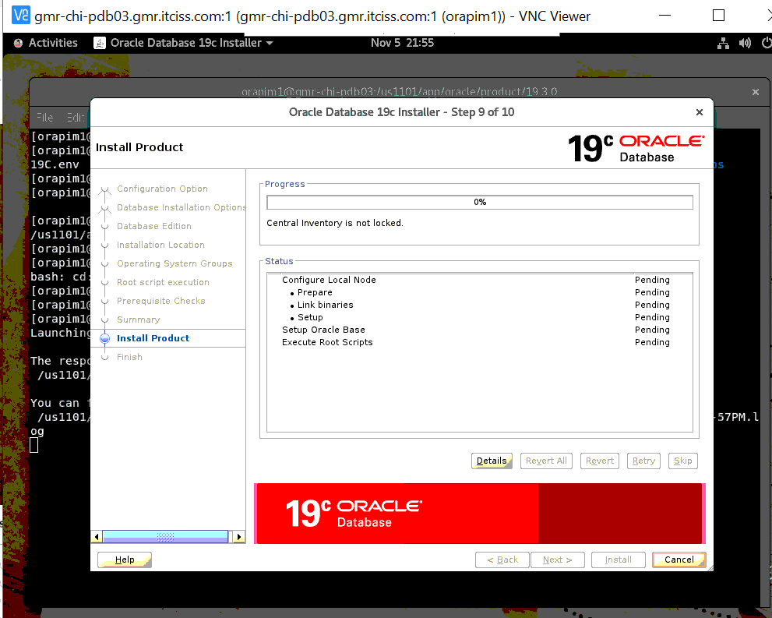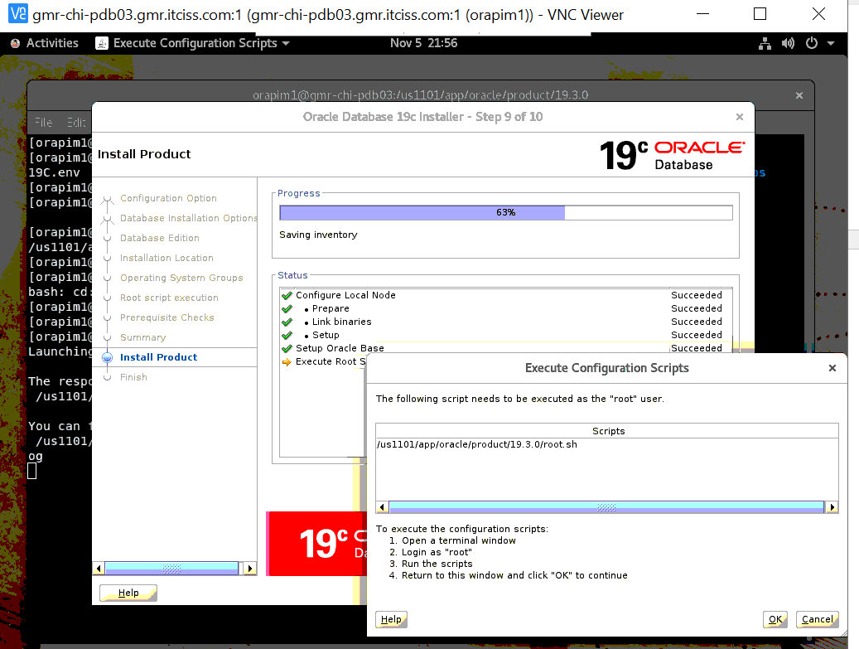
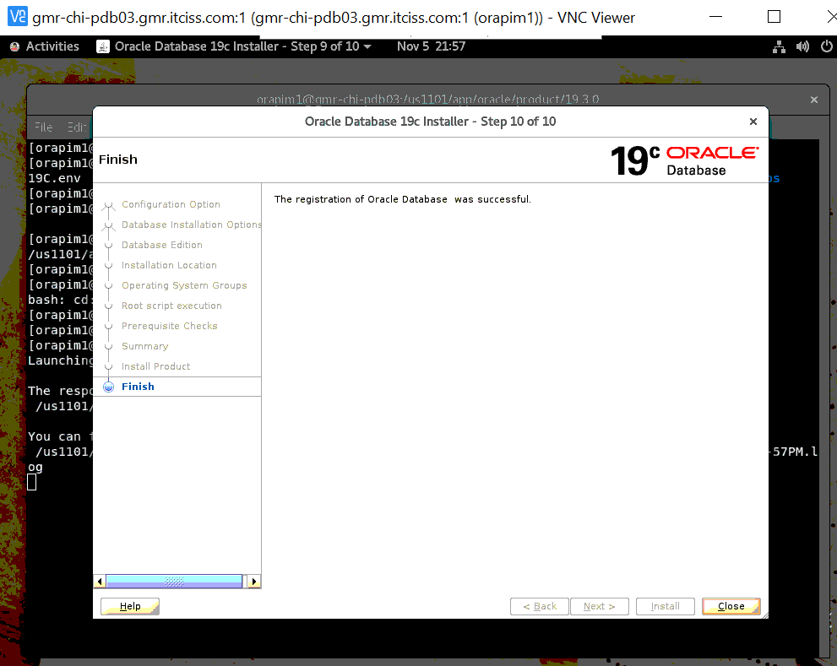

[orapim1@gmr-chi-pdb03 ~]$ sqlplus / as sysdba
SQL*Plus: Release 19.0.0.0.0 - Production on Wed Nov 6 00:15:49 2024
Version 19.24.0.0.0
Copyright (c) 1982, 2024, Oracle. All rights reserved.
Connected to an idle instance.

SQL>

- Apply July24 PSU patches on 19C Home.

July 2024 PSU patching on 19C Home --- PIMGM1 ---gmr-chi-pdb03
**********************************
[orapim1@gmr-chi-pdb03 ~]$ . ./19C.env
[orapim1@gmr-chi-pdb03 ~]$ echo $ORACLE_HOME
/us1101/app/oracle/product/19.3.0
[orapim1@gmr-chi-pdb03 ~]$
Apply latest OPatch version
*****************************
[orapim1@gmr-chi-pdb03 19.3.0]$ cd OPatch
[orapim1@gmr-chi-pdb03 OPatch]$ opatch version
OPatch Version: 12.2.0.1.43

OPatch succeeded.
[orapim1@gmr-chi-pdb03 OPatch]$

Apply Latest PSU patch(36522340 --July2024)
*********************************
[orapim1@gmr-chi-pdb03 OPatch]$ cd /Backup/Software/
[orapim1@gmr-chi-pdb03 Software]$ ls
36522340 OPatch p6880880_190000_Linux-x86-64.zip
LINUX.X64_193000_db_home.zip p36522340_190000_Linux-x86-64.zip PatchSearch.xml
[orapim1@gmr-chi-pdb03 Software]$

[orapim1@gmr-chi-pdb03 36582781]$ pwd
/Backup/Software/36522340/36582781
[orapim1@gmr-chi-pdb03 36582781]$
[orapim1@gmr-chi-pdb03 36522340]$
[orapim1@gmr-chi-pdb03 36522340]$ cd 36582781/
[orapim1@gmr-chi-pdb03 36582781]$
[orapim1@gmr-chi-pdb03 36582781]$ /us1101/app/oracle/product/19.3.0/OPatch/opatch apply
Oracle Interim Patch Installer version 12.2.0.1.43
Copyright (c) 2024, Oracle Corporation. All rights reserved.
Oracle Home : /us1101/app/oracle/product/19.3.0
Central Inventory : /us1101/app/oraInventory
from : /us1101/app/oracle/product/19.3.0/oraInst.loc
OPatch version : 12.2.0.1.43
OUI version : 12.2.0.7.0
Log file location : /us1101/app/oracle/product/19.3.0/cfgtoollogs/opatch/opatch2024-11-05_23-06-13PM_1.log
Verifying environment and performing prerequisite checks...
OPatch continues with these patches: 36582781
Do you want to proceed? [y|n]
y
User Responded with: Y
All checks passed.
Please shutdown Oracle instances running out of this ORACLE_HOME on the local system.
(Oracle Home = '/us1101/app/oracle/product/19.3.0')
Is the local system ready for patching? [y|n]
y
User Responded with: Y
Backing up files...
Applying interim patch '36582781' to OH '/us1101/app/oracle/product/19.3.0'
ApplySession: Optional component(s) [ oracle.network.gsm, 19.0.0.0.0 ] , [ oracle.crypto.rsf, 19.0.0.0.0 ] , [ oracle.pg4appc, 19.0.0.0.0 ] , [ oracle.pg4mq, 19.0.0.0.0 ] , [ oracle.precomp.companion, 19.0.0.0.0 ] , [ oracle.rdbms.ic, 19.0.0.0.0 ] , [ oracle.rdbms.tg4db2, 19.0.0.0.0 ] , [ oracle.tfa, 19.0.0.0.0 ] , [ oracle.net.cman, 19.0.0.0.0 ] , [ oracle.ons.cclient, 19.0.0.0.0 ] , [ oracle.rdbms.tg4ifmx, 19.0.0.0.0 ] , [ oracle.options.olap, 19.0.0.0.0 ] , [ oracle.rdbms.tg4msql, 19.0.0.0.0 ] , [ oracle.sdo.companion, 19.0.0.0.0 ] , [ oracle.ons.eons.bwcompat, 19.0.0.0.0 ] , [ oracle.network.cman, 19.0.0.0.0 ] , [ oracle.rdbms.tg4sybs, 19.0.0.0.0 ] , [ oracle.rdbms.tg4tera, 19.0.0.0.0 ] , [ oracle.xdk.companion, 19.0.0.0.0 ] , [ oracle.options.olap.api, 19.0.0.0.0 ] , [ oracle.oid.client, 19.0.0.0.0 ] , [ oracle.jdk, 1.8.0.191.0 ] not present in the Oracle Home or a higher version is found.
Patching component oracle.rdbms, 19.0.0.0.0...
Patching component oracle.rdbms.util, 19.0.0.0.0...
Patching component oracle.rdbms.rsf, 19.0.0.0.0...
Patching component oracle.assistants.acf, 19.0.0.0.0...
Patching component oracle.assistants.deconfig, 19.0.0.0.0...
Patching component oracle.assistants.server, 19.0.0.0.0...
Patching component oracle.blaslapack, 19.0.0.0.0...
Patching component oracle.buildtools.rsf, 19.0.0.0.0...
Patching component oracle.ctx, 19.0.0.0.0...
Patching component oracle.dbdev, 19.0.0.0.0...
Patching component oracle.dbjava.ic, 19.0.0.0.0...
Patching component oracle.dbjava.jdbc, 19.0.0.0.0...
Patching component oracle.dbjava.ucp, 19.0.0.0.0...
Patching component oracle.duma, 19.0.0.0.0...
Patching component oracle.javavm.client, 19.0.0.0.0...
Patching component oracle.ldap.owm, 19.0.0.0.0...
Patching component oracle.ldap.rsf, 19.0.0.0.0...
Patching component oracle.ldap.security.osdt, 19.0.0.0.0...
Patching component oracle.marvel, 19.0.0.0.0...
Patching component oracle.network.rsf, 19.0.0.0.0...
Patching component oracle.odbc.ic, 19.0.0.0.0...
Patching component oracle.ons, 19.0.0.0.0...
Patching component oracle.ons.ic, 19.0.0.0.0...
Patching component oracle.oracore.rsf, 19.0.0.0.0...
Patching component oracle.perlint, 5.28.1.0.0...
Patching component oracle.precomp.common.core, 19.0.0.0.0...
Patching component oracle.nlsrtl.rsf.core, 19.0.0.0.0...
Patching component oracle.nlsrtl.rsf.ic, 19.0.0.0.0...
Patching component oracle.precomp.rsf, 19.0.0.0.0...
Patching component oracle.rdbms.crs, 19.0.0.0.0...
Patching component oracle.rdbms.dbscripts, 19.0.0.0.0...
Patching component oracle.rdbms.deconfig, 19.0.0.0.0...
Patching component oracle.rdbms.oci, 19.0.0.0.0...
Patching component oracle.rdbms.rsf.ic, 19.0.0.0.0...
Patching component oracle.rdbms.scheduler, 19.0.0.0.0...
Patching component oracle.rhp.db, 19.0.0.0.0...
Patching component oracle.rsf, 19.0.0.0.0...
Patching component oracle.sdo, 19.0.0.0.0...
Patching component oracle.sdo.locator.jrf, 19.0.0.0.0...
Patching component oracle.sqlplus, 19.0.0.0.0...
Patching component oracle.sqlplus.ic, 19.0.0.0.0...
Patching component oracle.wwg.plsql, 19.0.0.0.0...
Patching component oracle.xdk.rsf, 19.0.0.0.0...
Patching component oracle.ovm, 19.0.0.0.0...
Patching component oracle.rdbms.drdaas, 19.0.0.0.0...
Patching component oracle.oraolap, 19.0.0.0.0...
Patching component oracle.rdbms.dv, 19.0.0.0.0...
Patching component oracle.nlsrtl.rsf.lbuilder, 19.0.0.0.0...
Patching component oracle.rdbms.hsodbc, 19.0.0.0.0...
Patching component oracle.rdbms.hs_common, 19.0.0.0.0...
Patching component oracle.rdbms.install.plugins, 19.0.0.0.0...
Patching component oracle.install.deinstalltool, 19.0.0.0.0...
Patching component oracle.oraolap.api, 19.0.0.0.0...
Patching component oracle.xdk.parser.java, 19.0.0.0.0...
Patching component oracle.mgw.common, 19.0.0.0.0...
Patching component oracle.network.listener, 19.0.0.0.0...
Patching component oracle.xdk.xquery, 19.0.0.0.0...
Patching component oracle.ldap.ssl, 19.0.0.0.0...
Patching component oracle.rdbms.rman, 19.0.0.0.0...
Patching component oracle.odbc, 19.0.0.0.0...
Patching component oracle.sdo.locator, 19.0.0.0.0...
Patching component oracle.ldap.client, 19.0.0.0.0...
Patching component oracle.rdbms.install.common, 19.0.0.0.0...
Patching component oracle.ctx.atg, 19.0.0.0.0...
Patching component oracle.rdbms.dm, 19.0.0.0.0...
Patching component oracle.oraolap.dbscripts, 19.0.0.0.0...
Patching component oracle.xdk, 19.0.0.0.0...
Patching component oracle.javavm.server, 19.0.0.0.0...
Patching component oracle.dbtoolslistener, 19.0.0.0.0...
Patching component oracle.rdbms.locator, 19.0.0.0.0...
Patching component oracle.ctx.rsf, 19.0.0.0.0...
Patching component oracle.ldap.rsf.ic, 19.0.0.0.0...
Patching component oracle.network.client, 19.0.0.0.0...
Patching component oracle.rdbms.rat, 19.0.0.0.0...
Patching component oracle.nlsrtl.rsf, 19.0.0.0.0...
Patching component oracle.rdbms.lbac, 19.0.0.0.0...
Patching component oracle.precomp.common, 19.0.0.0.0...
Patching component oracle.precomp.lang, 19.0.0.0.0...
Patching component oracle.jdk, 1.8.0.201.0...
Patch 36582781 successfully applied.
Sub-set patch [29517242] has become inactive due to the application of a super-set patch [36582781].
Please refer to Doc ID 2161861.1 for any possible further required actions.
Log file location: /us1101/app/oracle/product/19.3.0/cfgtoollogs/opatch/opatch2024-11-05_23-06-13PM_1.log
OPatch succeeded.
[orapim1@gmr-chi-pdb03 36582781]$

[orapim1@gmr-chi-pdb03 36582781]$ cd ..
[orapim1@gmr-chi-pdb03 36522340]$ ls
36414915 36582781 PatchSearch.xml README.html
[orapim1@gmr-chi-pdb03 36522340]$ cd 36414915/
[orapim1@gmr-chi-pdb03 36414915]$
[orapim1@gmr-chi-pdb03 36414915]$
[orapim1@gmr-chi-pdb03 36414915]$ /us1101/app/oracle/product/19.3.0/OPatch/opatch apply
Oracle Interim Patch Installer version 12.2.0.1.43
Copyright (c) 2024, Oracle Corporation. All rights reserved.
Oracle Home : /us1101/app/oracle/product/19.3.0
Central Inventory : /us1101/app/oraInventory
from : /us1101/app/oracle/product/19.3.0/oraInst.loc
OPatch version : 12.2.0.1.43
OUI version : 12.2.0.7.0
Log file location : /us1101/app/oracle/product/19.3.0/cfgtoollogs/opatch/opatch2024-11-05_23-16-55PM_1.log
Verifying environment and performing prerequisite checks...
OPatch continues with these patches: 36414915
Do you want to proceed? [y|n]
y
User Responded with: Y
All checks passed.
Please shutdown Oracle instances running out of this ORACLE_HOME on the local system.
(Oracle Home = '/us1101/app/oracle/product/19.3.0')
Is the local system ready for patching? [y|n]
y
User Responded with: Y
Backing up files...
Applying interim patch '36414915' to OH '/us1101/app/oracle/product/19.3.0'
Patching component oracle.javavm.server, 19.0.0.0.0...
Patching component oracle.javavm.server.core, 19.0.0.0.0...
Patching component oracle.rdbms.dbscripts, 19.0.0.0.0...
Patching component oracle.rdbms, 19.0.0.0.0...
Patching component oracle.javavm.client, 19.0.0.0.0...
Patch 36414915 successfully applied.
Log file location: /us1101/app/oracle/product/19.3.0/cfgtoollogs/opatch/opatch2024-11-05_23-16-55PM_1.log
OPatch succeeded.
[orapim1@gmr-chi-pdb03 36414915]$ /us1101/app/oracle/product/19.3.0/OPatch/opatch lsinventory|grep 36414915
Patch 36414915 : applied on Tue Nov 05 23:17:46 MST 2024
Patch description: "OJVM RELEASE UPDATE: 19.24.0.0.240716 (36414915)"
[orapim1@gmr-chi-pdb03 36414915]$ /us1101/app/oracle/product/19.3.0/OPatch/opatch lsinventory|grep 36582781
Patch 36582781 : applied on Tue Nov 05 23:10:45 MST 2024
Patch description: "Database Release Update : 19.24.0.0.240716 (36582781)"
[orapim1@gmr-chi-pdb03 36414915]$

- Take Stop the Primary database (gmr-chi-pdb02) and Make Standby to Primary database(gmr-chi-pdb03)

Primary DATABASE --- PIMGM1 ---gmr-chi-pdb03
**************

SYS@PIMGM1 > select name from v$database;
NAME
---------
PIMGM1

SYS@PIMGM1 > archive log list;
Database log mode Archive Mode
Automatic archival Enabled
Archive destination USE_DB_RECOVERY_FILE_DEST
Oldest online log sequence 415627
Next log sequence to archive 415628
Current log sequence 415628
SYS@PIMGM1 > select thread#,max(sequence#) from v$archived_log where RESETLOGS_CHANGE#=(select RESETLOGS_CHANGE# from v$database) group by thread#;

THREAD# MAX(SEQUENCE#)
---------- --------------
1 415627

SYS@PIMGM1 > alter system switch logfile;

System altered.

SYS@PIMGM1 > /

System altered.

SYS@PIMGM1 > /

System altered.

SYS@PIMGM1 > archive log list;
Database log mode Archive Mode
Automatic archival Enabled
Archive destination USE_DB_RECOVERY_FILE_DEST
Oldest online log sequence 415630
Next log sequence to archive 415631
Current log sequence 415631
SYS@PIMGM1 > select thread#,max(sequence#) from v$archived_log where RESETLOGS_CHANGE#=(select RESETLOGS_CHANGE# from v$database) group by thread#;

THREAD# MAX(SEQUENCE#)
---------- --------------
1 415630

STANDBY --- PIMGM1 ---gmr-chi-pdb03
**********

SYS@PIMGM1 >

thread last sequence received last sequence applied difference
---------- ---------------------- --------------------- ----------
1 415630 415630 0

standby ---PIMGM1S to PIMGM1 ( for upgrade)

alter system set db_unique_name='PIMGM1' scope=spfile;

Primary DATABASE --- PIMGM1 ---gmr-chi-pdb03
**************

SYS@PIMGM1 > sho parameter log_archive_dest_state_2;

NAME TYPE VALUE
------------------------------------ ----------- ------------------------------
log_archive_dest_state_2 string ENABLE

SYS@PIMGM1 > alter system set log_archive_dest_state_2=DEFER scope=both;

System altered.

SYS@PIMGM1 > sho parameter log_archive_dest_state_2;

NAME TYPE VALUE
------------------------------------ ----------- ------------------------------
log_archive_dest_state_2 string DEFER

SYS@PIMGM1 > archive log list;
Database log mode Archive Mode
Automatic archival Enabled
Archive destination USE_DB_RECOVERY_FILE_DEST
Oldest online log sequence 415630
Next log sequence to archive 415631
Current log sequence 415631
SYS@PIMGM1 >
SYS@PIMGM1 >
SYS@PIMGM1 > shut immediate;
Database closed.
Database dismounted.
ORACLE instance shut down.
SYS@PIMGM1 >

STANDBY--- PIMGM1 ---gmr-chi-pdb03
********

Stop MRP ---once archive synce to standby

thread last sequence received last sequence applied difference
---------- ---------------------- --------------------- ----------
1 415630 415630 0

SYS@PIMGM1 > alter database recover managed standby database cancel;

Database altered.

SYS@PIMGM1 >

SYS@PIMGM1 > shut immediate;
ORA-01109: database not open

Database dismounted.
ORACLE instance shut down.
SYS@PIMGM1 >

Convert from standby to physical
*********************************

SYS@PIMGM1 > startup mount;
ORACLE instance started.

Total System Global Area 4175568896 bytes
Fixed Size 2259840 bytes
Variable Size 1040188544 bytes
Database Buffers 3120562176 bytes
Redo Buffers 12558336 bytes
Database mounted.
SYS@PIMGM1 > select name,open_mode,database_role from v$database;

NAME OPEN_MODE DATABASE_ROLE
--------- -------------------- ----------------
PIMGM1 MOUNTED PHYSICAL STANDBY

SYS@PIMGM1 > alter database activate standby database;

Database altered.

SYS@PIMGM1 > select name,open_mode,database_role from v$database;

NAME OPEN_MODE DATABASE_ROLE
--------- -------------------- ----------------
PIMGM1 MOUNTED PRIMARY

SYS@PIMGM1 > shut immediate;
ORA-01109: database not open

Database dismounted.
ORACLE instance shut down.

SYS@PIMGM1 > startup
ORACLE instance started.

Total System Global Area 4175568896 bytes
Fixed Size 2259840 bytes
Variable Size 1040188544 bytes
Database Buffers 3120562176 bytes
Redo Buffers 12558336 bytes
Database mounted.
Database opened.
SYS@PIMGM1 >

INSTANCE_NAME TO_CHAR(STARTUP_TIME,'HH HOST_NAME STATUS DATABASE_STATUS ARCHIVE
---------------- ------------------------ -------------------- ---------- ----------------- -------
PIMGM1 20:25 08-NOV-24 gmr-chi-pdb03.gmr.it OPEN ACTIVE STARTED
ciss.com
Keep database NO archive log
*****************************

SYS@PIMGM1 > archive log list;
Database log mode No Archive Mode
Automatic archival Disabled
Archive destination /ur1101/PIMGM1/ARCHIVES
Oldest online log sequence 1
Current log sequence 1
SYS@PIMGM1 >

INSTANCE_NAME TO_CHAR(STARTUP_TIME,'HH HOST_NAME STATUS DATABASE_STATUS ARCHIVE
---------------- ------------------------ -------------------- ---------- ----------------- -------
PIMGM1 20:26 08-NOV-24 gmr-chi-pdb03.gmr.it OPEN ACTIVE STOPPED
ciss.com

NAME TYPE VALUE
------------------------------------ ----------- ------------------------------
db_name string PIMGM1
db_unique_name string PIMGM1S
global_names boolean FALSE
instance_name string PIMGM1
service_names string PIMGM1S
SYS@PIMGM1 >

SYS@PIMGM1 > alter system set db_unique_name='PIMGM1' scope=spfile;

System altered.

SYS@PIMGM1 >
SYS@PIMGM1 > alter system set service_names='PIMGM1' scope=spfile;

System altered.

SYS@PIMGM1 >

Bounce the Database.
*********************

NAME TYPE VALUE
------------------------------------ ----------- ------------------------------
db_name string PIMGM1
db_unique_name string PIMGM1
global_names boolean FALSE
instance_name string PIMGM1
service_names string PIMGM1
SYS@PIMGM1 >

Listener status before upgrade instance
****************************************

[orapim1@gmr-chi-pdb03 admin]$ lsnrctl status LISTENER_PIMGM1

LSNRCTL for Linux: Version 11.2.0.4.0 - Production on 08-NOV-2024 20:37:05

Copyright (c) 1991, 2013, Oracle. All rights reserved.

Connecting to (DESCRIPTION=(ADDRESS=(PROTOCOL=TCP)(HOST=gmr-chi-pdb03.gmr.itciss.com)(PORT=1521)))
STATUS of the LISTENER
------------------------
Alias LISTENER_PIMGM1
Version TNSLSNR for Linux: Version 11.2.0.4.0 - Production
Start Date 08-NOV-2024 20:33:55
Uptime 0 days 0 hr. 3 min. 10 sec
Trace Level off
Security ON: Local OS Authentication
SNMP OFF
Listener Parameter File /us1101/app/oracle/product/11204/network/admin/listener.ora
Listener Log File /us1101/app/oracle/diag/tnslsnr/gmr-chi-pdb03/listener_pimgm1/alert/log.xml
Listening Endpoints Summary...
(DESCRIPTION=(ADDRESS=(PROTOCOL=tcp)(HOST=gmr-chi-pdb03.gmr.itciss.com)(PORT=1521)))
Services Summary...
Service "PIMGM1" has 2 instance(s).
Instance "PIMGM1", status UNKNOWN, has 1 handler(s) for this service...
Instance "PIMGM1", status READY, has 1 handler(s) for this service...
Service "PIMGM1XDB" has 1 instance(s).
Instance "PIMGM1", status READY, has 1 handler(s) for this service...
The command completed successfully
[orapim1@gmr-chi-pdb03 admin]$
- Run Preupgrade steps 19C Home

Pre upgrade step of 19c
************************
Step 1: preupgrade.jar

/us1101/app/oracle/product/11203/jdk/bin/java -jar /us1101/app/oracle/product/19.3.0/rdbms/admin/preupgrade.jar FILE DIR /Backup/Pre19clog

[orapim1@gmr-chi-pdb03 Pre19clog]$ /us1101/app/oracle/product/11203/jdk/bin/java -jar /us1101/app/oracle/product/19.3.0/rdbms/admin/preupgrade.jar FILE DIR /Backup/Pre19clog
==================
PREUPGRADE SUMMARY
==================
/Backup/Pre19clog/preupgrade.log
/Backup/Pre19clog/preupgrade_fixups.sql
/Backup/Pre19clog/postupgrade_fixups.sql

Execute fixup scripts as indicated below:

Before upgrade:

Log into the database and execute the preupgrade fixups
@/Backup/Pre19clog/preupgrade_fixups.sql

After the upgrade:

Log into the database and execute the postupgrade fixups
@/Backup/Pre19clog/postupgrade_fixups.sql

Preupgrade complete: 2024-08-19T10:28:23
[orapim1@gmr-chi-pdb03 Pre19clog]$

- Validate & Fix the Preupgrade recommendation (preupgrade.log)

step 2: validate the preupgrade.log logfile validation and run recommanded

Step 3: system tabel space minmum

Before preupgrade_fix from validation of preupgrade log file
**************************************************************
Auto Min Size
Tablespace Size Extend For Upgrade Action
---------- ---------- -------- ----------- --------
TEMP 29 MB DISABLED 150 MB Extend
WCI_SOAINFRA 25 GB ENABLED 21 GB Adjust
datafile
MAXBYTES
WCI_SOAINFRA
*************
TABLESPACE_NAME PERCENTAGE_USED SPACE_ALLOCATED SPACE_USED SPACE_FREE DATAFILES
------------------------------ --------------- --------------- ---------- ---------- ----------
WCI_SOAINFRA 91.43 220464 201580.75 18883.25 8

ADDED size WCI_SOAINFRA
************************
SYS@PIMGM1 > ALTER DATABASE DATAFILE '/ud1101/PIMGM1/oradata/PIMGM1/datafile/o2_mf_wci_soai_g9bhs2m0_.dbf' resize 30G;
Database altered.
SYS@PIMGM1 > ALTER DATABASE DATAFILE '/ud1102/PIMGM1/oradata/PIMGM1/datafile/o8_mf_wci_soai_g9bhs2m0_.dbf' resize 30G;
Database altered.
SYS@PIMGM1 >

TABLESPACE_NAME PERCENTAGE_USED SPACE_ALLOCATED SPACE_USED SPACE_FREE DATAFILES
------------------------------ --------------- --------------- ---------- ---------- ----------
WCI_SOAINFRA 80.91 249136 201580.75 47555.25 8

TEMP tablespace
****************
Status Name Type ExtManag Size (M) Used (M) Used %
--------- -------------------- --------- ---------- --------------- ----------------------------- -------
ONLINE TEMP TEMPORARY LOCAL 239.000 4.000/ 239.000 1.67

SYS@PIMGM1 > alter tablespace TEMP add tempfile '/ut1101/PIMGM1/oradata/temp02.dbf' size 5G;
Tablespace altered.
SYS@PIMGM1 >
Status Name Type ExtManag Size (M) Used (M) Used %
--------- -------------------- --------- ---------- --------------- ----------------------------- -------
ONLINE TEMP TEMPORARY LOCAL 5,359.000 4.000/ 5,359.000 0.07

SYSTEM
*******
Min Size
Tablespace Size For Upgrade
-------------------- -----------
SYSTEM 4550 MB 4981 MB

TABLESPACE_NAME PERCENTAGE_USED SPACE_ALLOCATED SPACE_USED SPACE_FREE DATAFILES
------------------------------ --------------- --------------- ---------- ---------- ----------
SYSTEM 70.41 8096 5700.69 2395.31 2

Current system
**************
TABLESPACE_NAME FILE_NAME BYTES/1024/1024 MAXBYTES/1024/1024 STATUS AUT
------------------------------ -------------------------------------------------------------------------------- --------------- ------------------ ---------- ---
SYSTEM /ud1101/PIMGM1/oradata/PIMGM1S/datafile/o1_mf_system_mlq46co6_.dbf 4000 0 AVAILABLE NO
SYSTEM /ud1102/PIMGM1/oradata/PIMGM1/datafile/o2_mf_system_g9bhs2jy_.dbf 4096 0 AVAILABLE NO

ADDED system
**************
SYS@PIMGM1 > ALTER TABLESPACE SYSTEM ADD DATAFILE '/ud1102/PIMGM1/oradata/PIMGM1/datafile/system02.dbf' SIZE 5G;
Tablespace altered.
SYS@PIMGM1 >

TABLESPACE_NAME PERCENTAGE_USED SPACE_ALLOCATED SPACE_USED SPACE_FREE DATAFILES
------------------------------ --------------- --------------- ---------- ---------- ----------
SYSTEM 43.14 13216 5701.69 7514.31 3

Make sure SYSAUX , SYSTEM ,UNDOTBS1 ----Autoextend Yes
******************************************************

SYS@PIMGM1 > select FILE_NAME,TABLESPACE_NAME,BYTES/1024/1024/1024,MAXBYTES,AUTOEXTENSIBLE from dba_data_files where tablespace_name='SYSTEM';

FILE_NAME TABLESPACE_NAME BYTES/1024/1024/1024 MAXBYTES AUT
-------------------------------------------------------------------------------- ------------------------------ -------------------- ---------- ---
/ud1101/PIMGM1/oradata/PIMGM1S/datafile/o1_mf_system_mlq46co6_.dbf SYSTEM 3.90625 0 NO
/ud1102/PIMGM1/oradata/PIMGM1/datafile/o2_mf_system_g9bhs2jy_.dbf SYSTEM 4 0 NO
/ud1102/PIMGM1/oradata/PIMGM1/datafile/system02.dbf SYSTEM 5 0 NO

SYS@PIMGM1 > select FILE_NAME,TABLESPACE_NAME,BYTES/1024/1024/1024,MAXBYTES,AUTOEXTENSIBLE from dba_data_files where tablespace_name='UNDOTBS1'
2 ;

FILE_NAME TABLESPACE_NAME BYTES/1024/1024/1024 MAXBYTES AUT
-------------------------------------------------------------------------------- ------------------------------ -------------------- ---------- ---
/ud1101/PIMGM1/oradata/PIMGM1S/datafile/o1_mf_undotbs1_mlq46cor_.dbf UNDOTBS1 2.44140625 0 NO

SYS@PIMGM1 > select FILE_NAME,TABLESPACE_NAME,BYTES/1024/1024/1024,MAXBYTES,AUTOEXTENSIBLE from dba_data_files where tablespace_name='SYSAUX';

FILE_NAME TABLESPACE_NAME BYTES/1024/1024/1024 MAXBYTES AUT
-------------------------------------------------------------------------------- ------------------------------ -------------------- ---------- ---
/ud1101/PIMGM1/oradata/PIMGM1S/datafile/o1_mf_sysaux_mlq46cp0_.dbf SYSAUX 1.46484375 0 NO
/ud1102/PIMGM1/oradata/PIMGM1/datafile/sysaux02.dbf SYSAUX 5 0 NO

SYS@PIMGM1 >

Pre upgrade checks or validation steps
***************************************

- Run Preupgrade.sql and validate the Output

step 7: run ( preupgrade_fixups.sql)

SYS@PIMGM1 > @/backup/19CupgradeInfo/Pre19clog_prod/preupgrade_fixups.sql
Executing Oracle PRE-Upgrade Fixup Script

Auto-Generated by: Oracle Preupgrade Script
Version: 19.0.0.0.0 Build: 13
Generated on: 2024-11-08 20:41:06

For Source Database: PIMGM1
Source Database Version: 11.2.0.4.0
For Upgrade to Version: 19.0.0.0.0

Preup Preupgrade
Action Issue Is
Number Preupgrade Check Name Remedied Further DBA Action
------ ------------------------ ---------- -------------------------------
1. purge_recyclebin YES None.
2. em_present NO Manual fixup recommended.
3. invalid_objects_exist NO Manual fixup recommended.
4. amd_exists YES None.
5. network_acl_priv NO Manual fixup recommended.
6. apex_manual_upgrade NO Manual fixup recommended.
7. mv_refresh NO Manual fixup recommended.
8. dictionary_stats YES None.
9. trgowner_no_admndbtrg YES None.
10. component_info NO Informational only.
Further action is optional.
11. exf_rul_exists NO Informational only.
Further action is optional.
12. rman_recovery_version NO Informational only.
Further action is optional.
13. invalid_all_obj_info NO Informational only.
Further action is optional.

The fixup scripts have been run and resolved what they can. However,
there are still issues originally identified by the preupgrade that
have not been remedied and are still present in the database.
Depending on the severity of the specific issue, and the nature of
the issue itself, that could mean that your database is not ready
for upgrade. To resolve the outstanding issues, start by reviewing
the preupgrade_fixups.sql and searching it for the name of
the failed CHECK NAME or Preupgrade Action Number listed above.
There you will find the original corresponding diagnostic message
from the preupgrade which explains in more detail what still needs
to be done.

PL/SQL procedure successfully completed.

SYS@PIMGM1 > spool off;
[orapim1@gmr-chi-pdb03 Pre19clog_prod]$

- Upgrade 19C database from 11g Database.(./DBUA)

step 13: ./dbua
open vncserver
source the 11g database environment
Go to 19c oracle_home
[orapim1@gmr-chi-pdb03 dbs]$ cd /us1101/app/oracle/product/19.3.0/bin
[orapim1@gmr-chi-pdb03 dbs]$ ./dbua

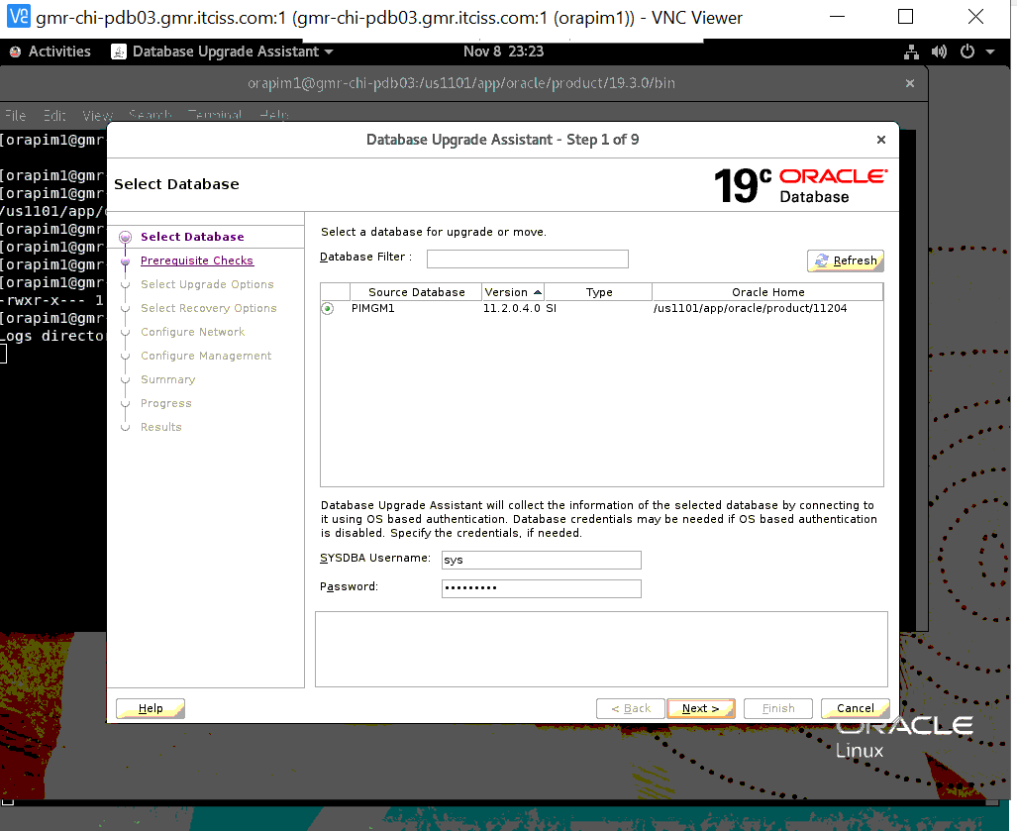
passwd-----oracle123 (check source sys password)
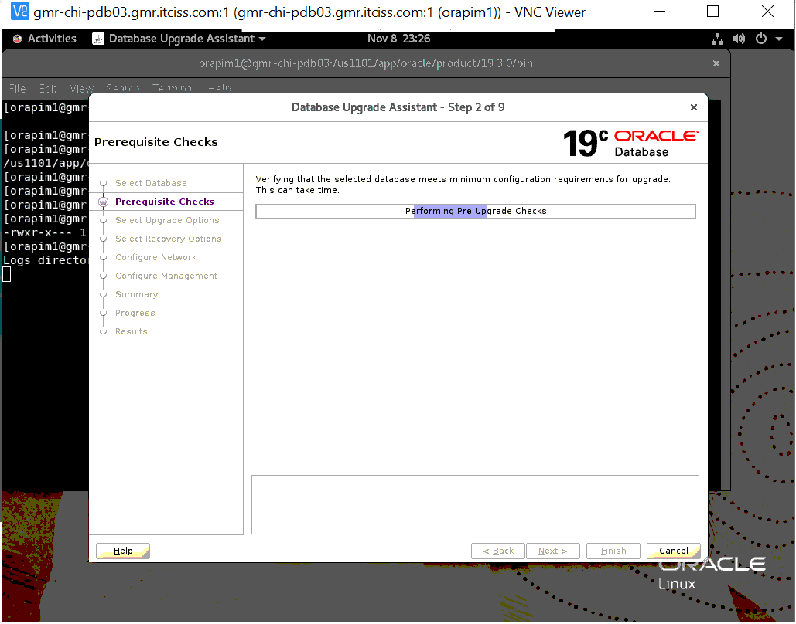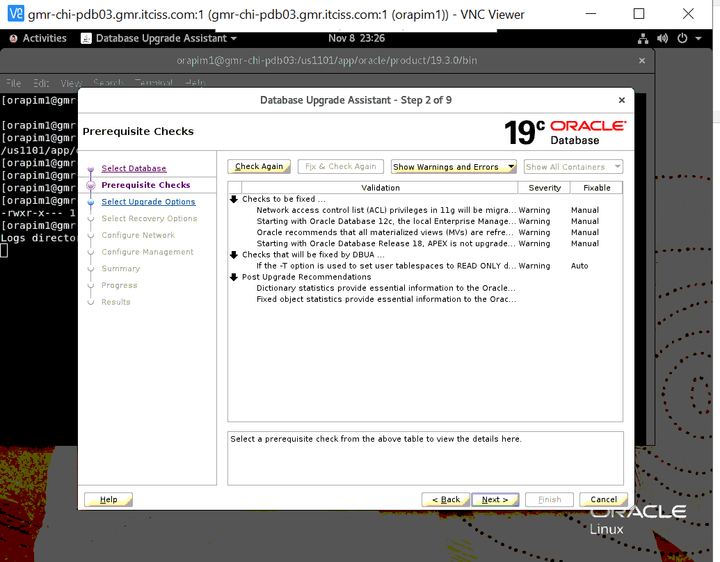
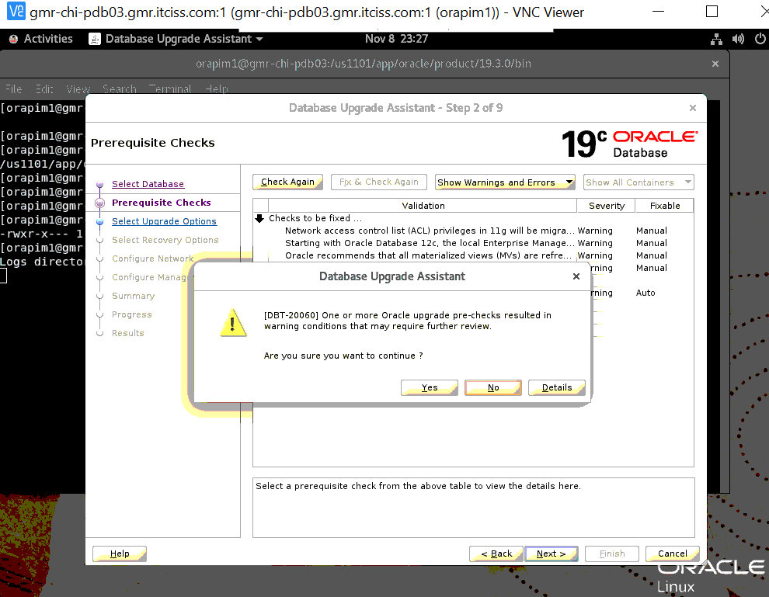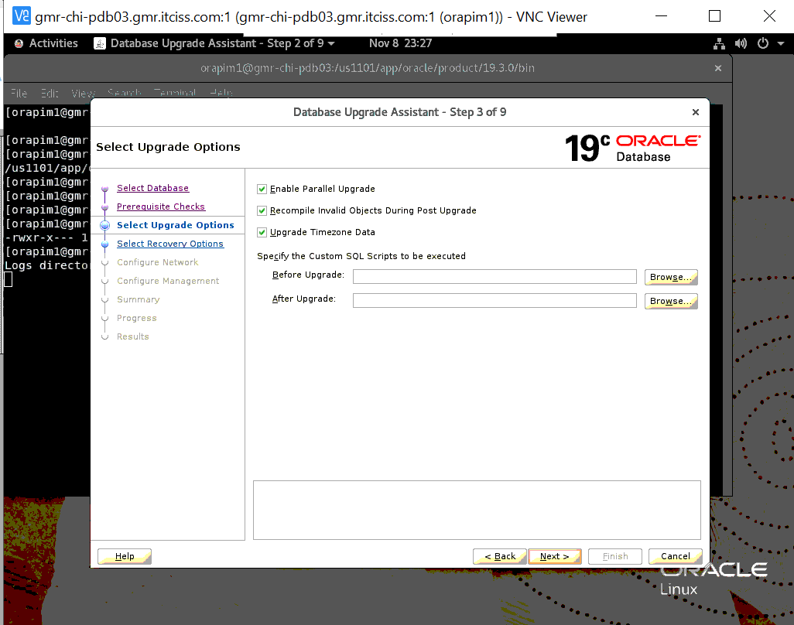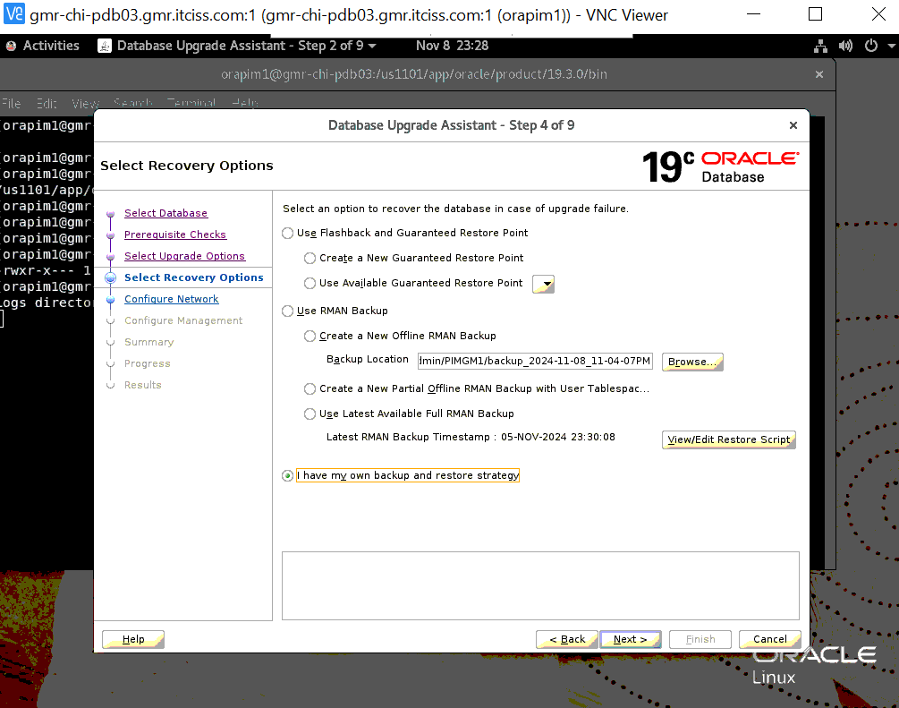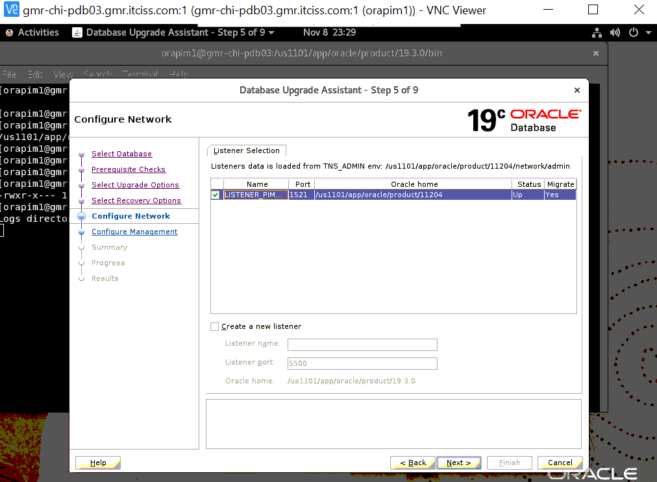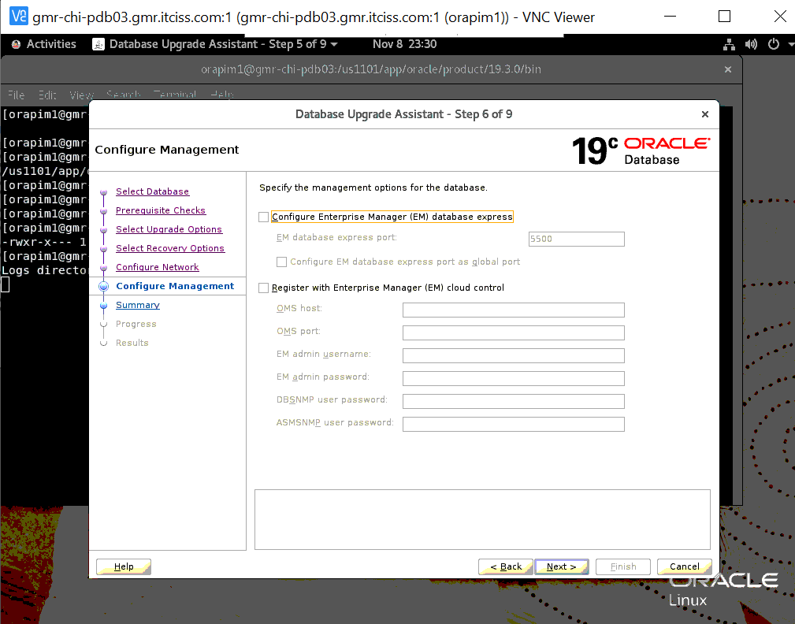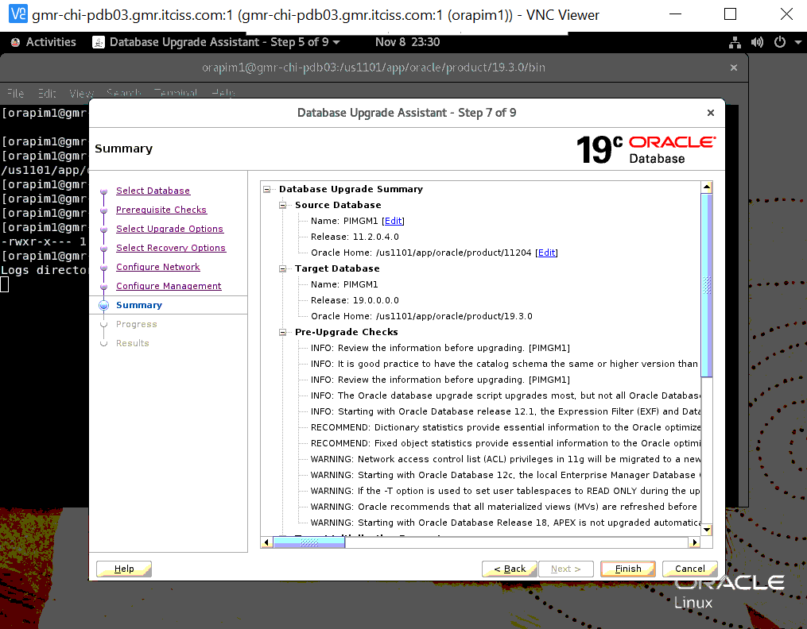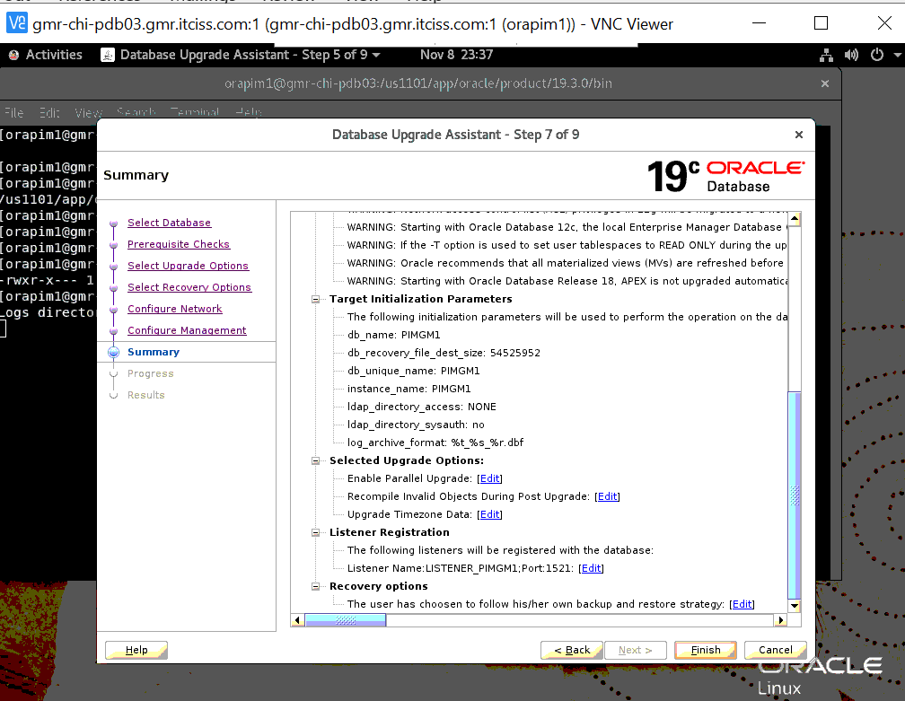
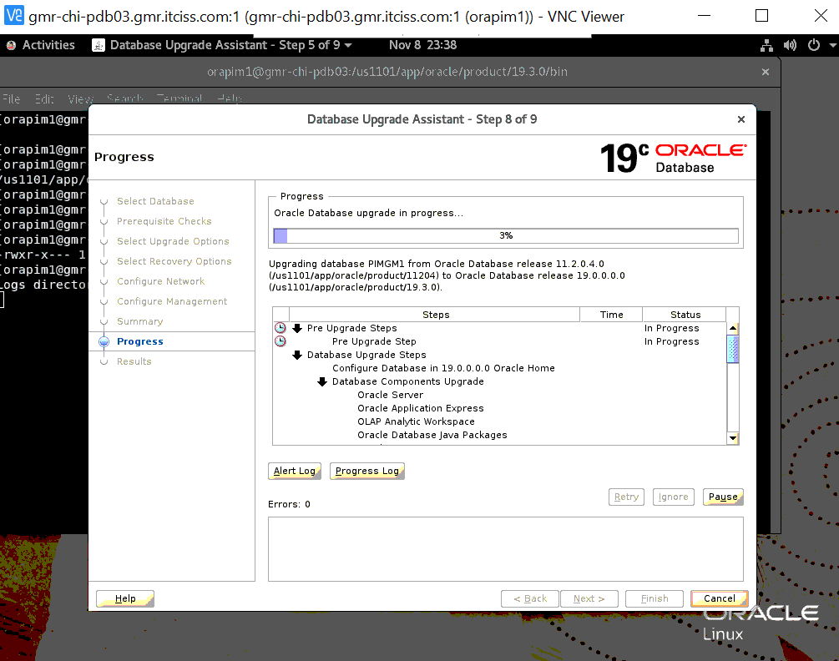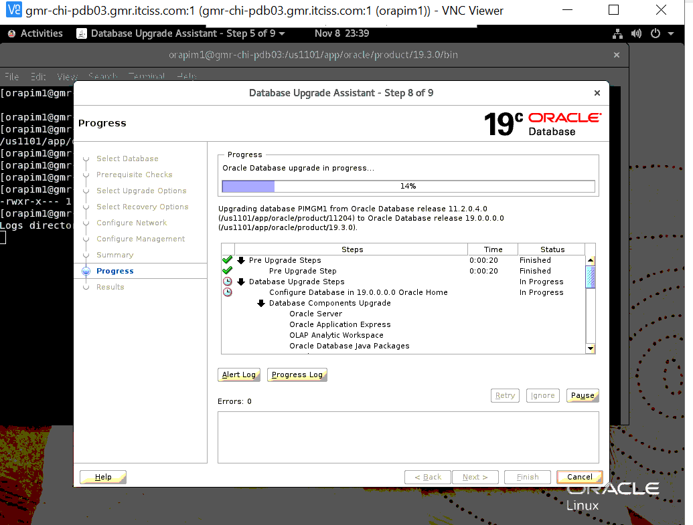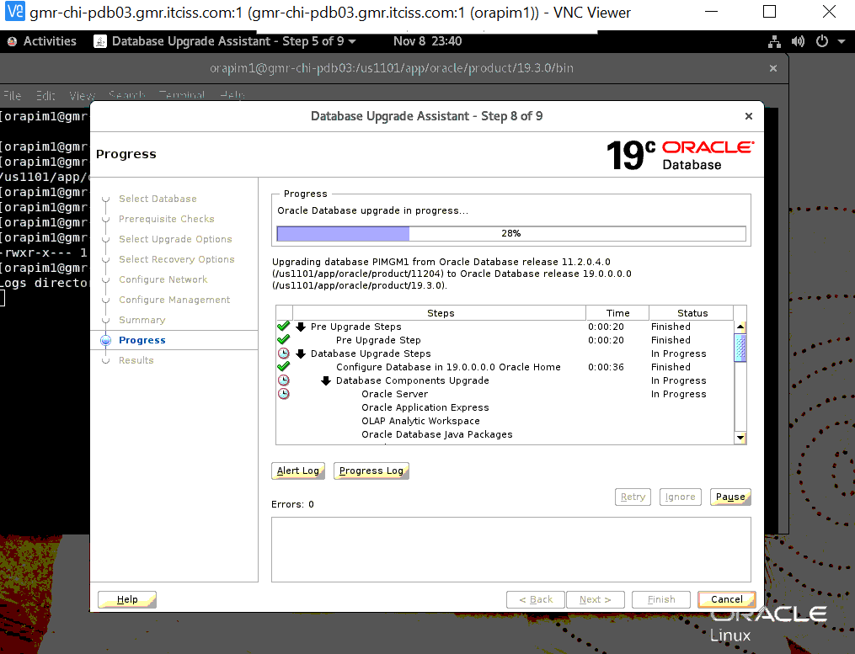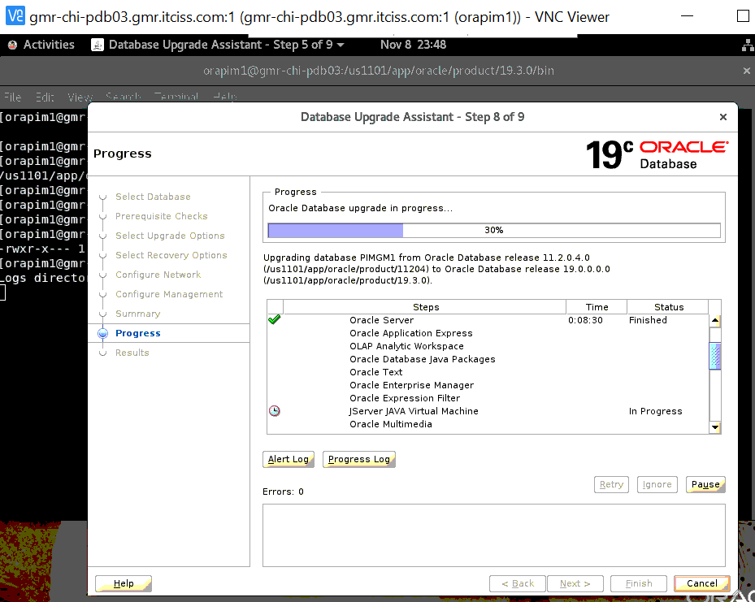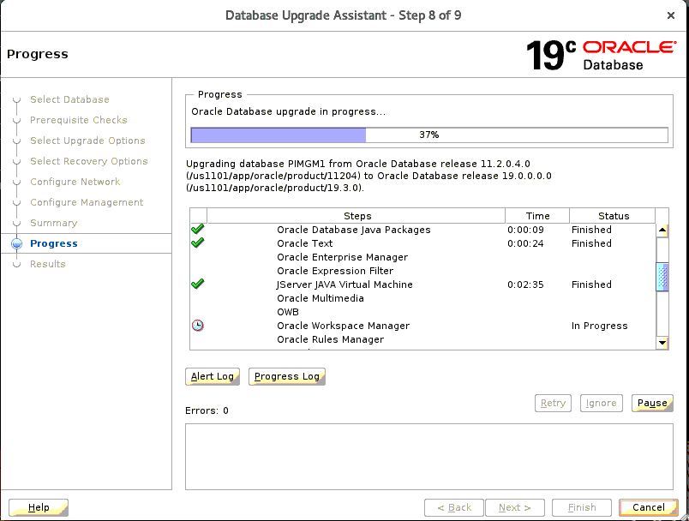

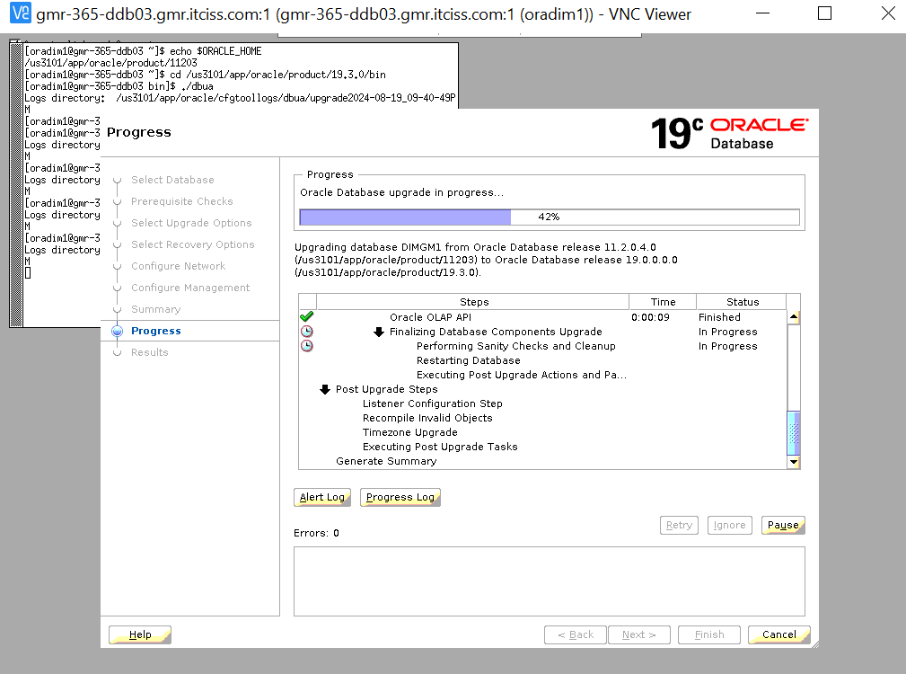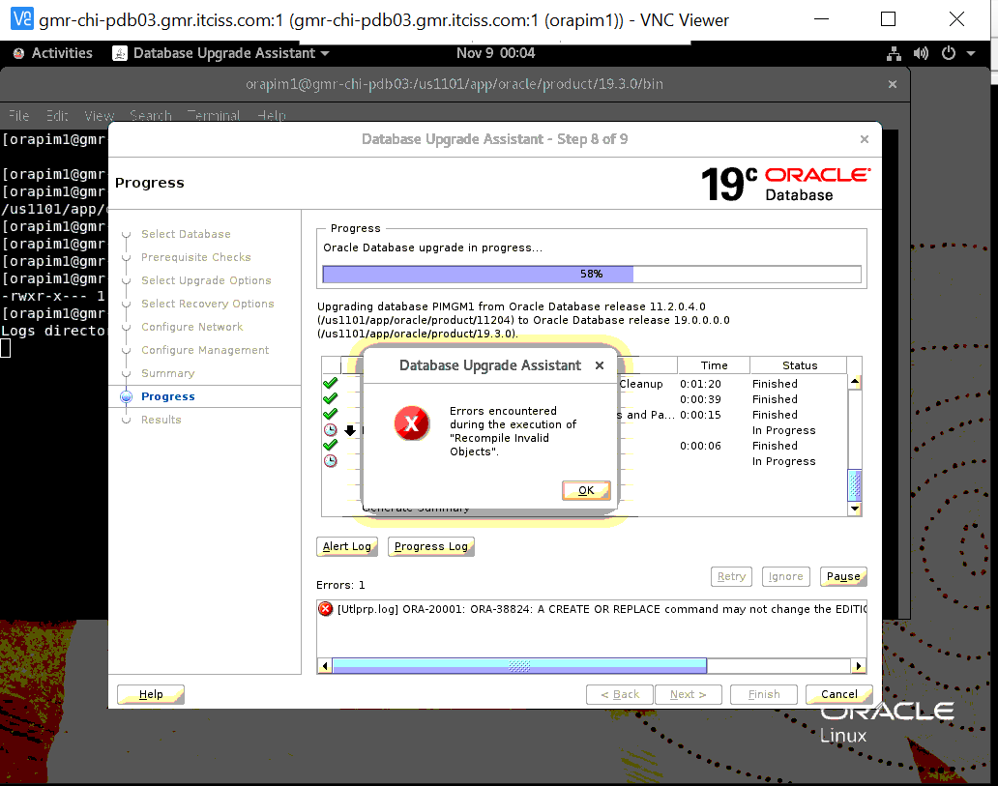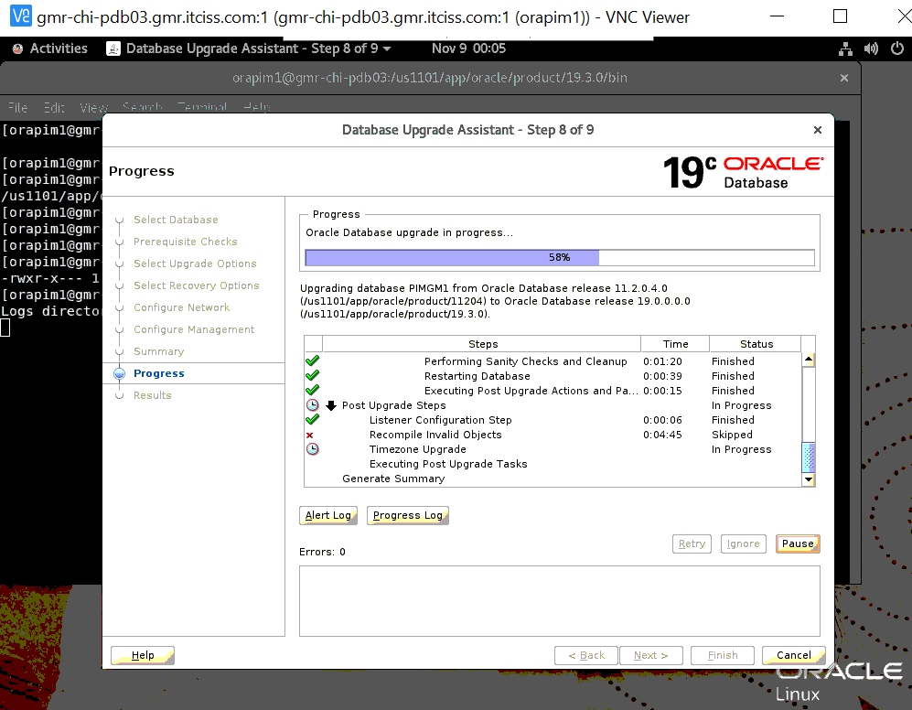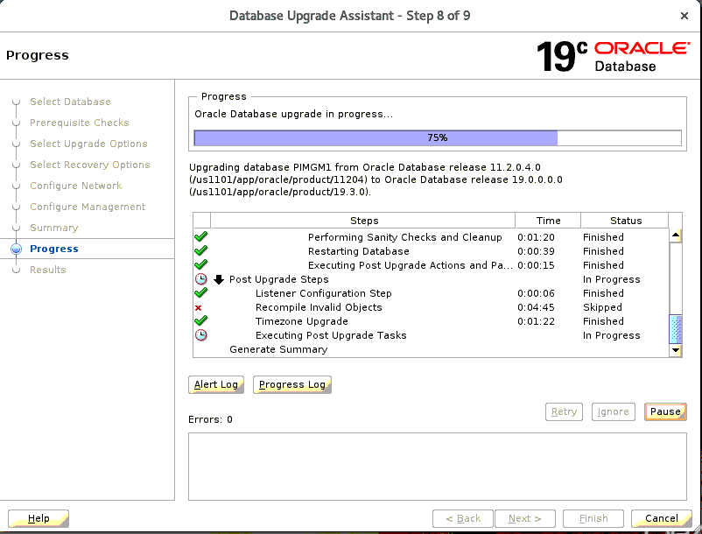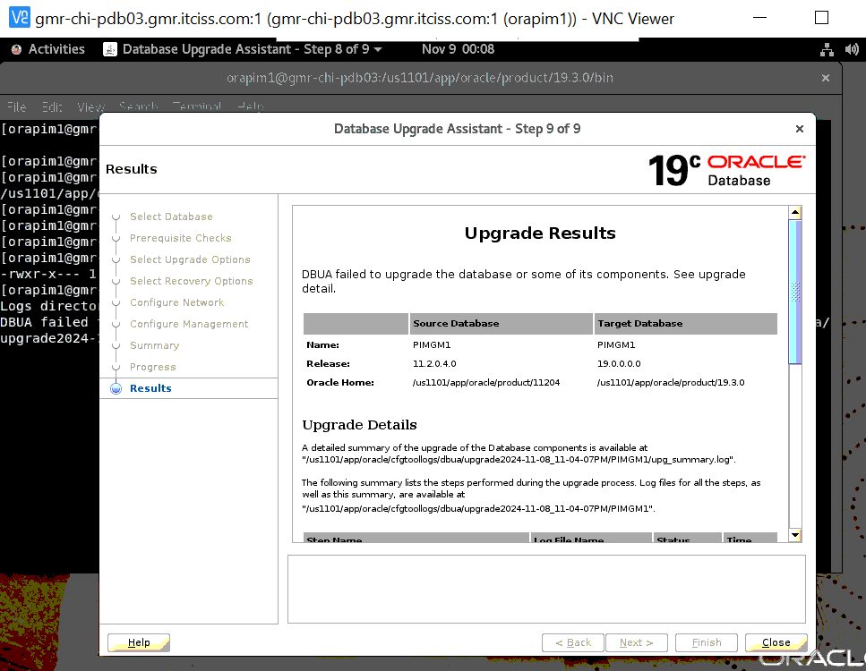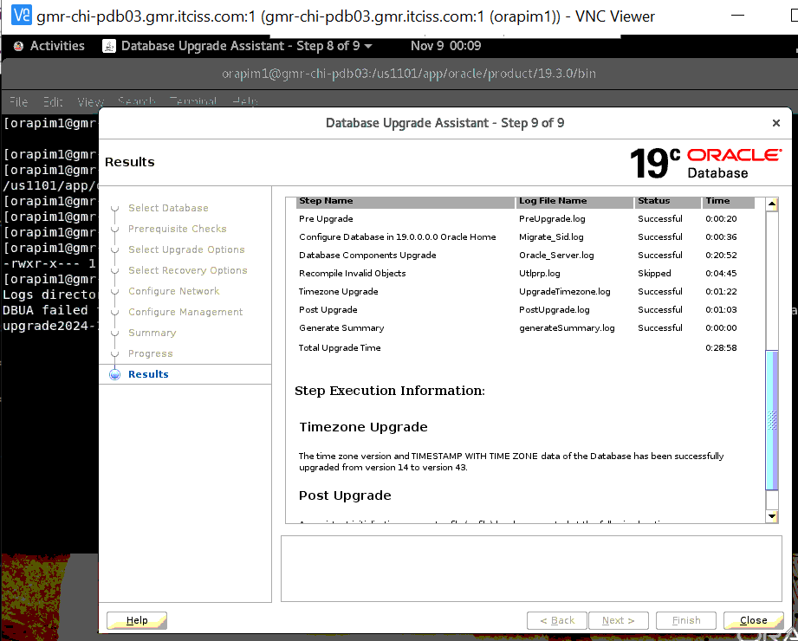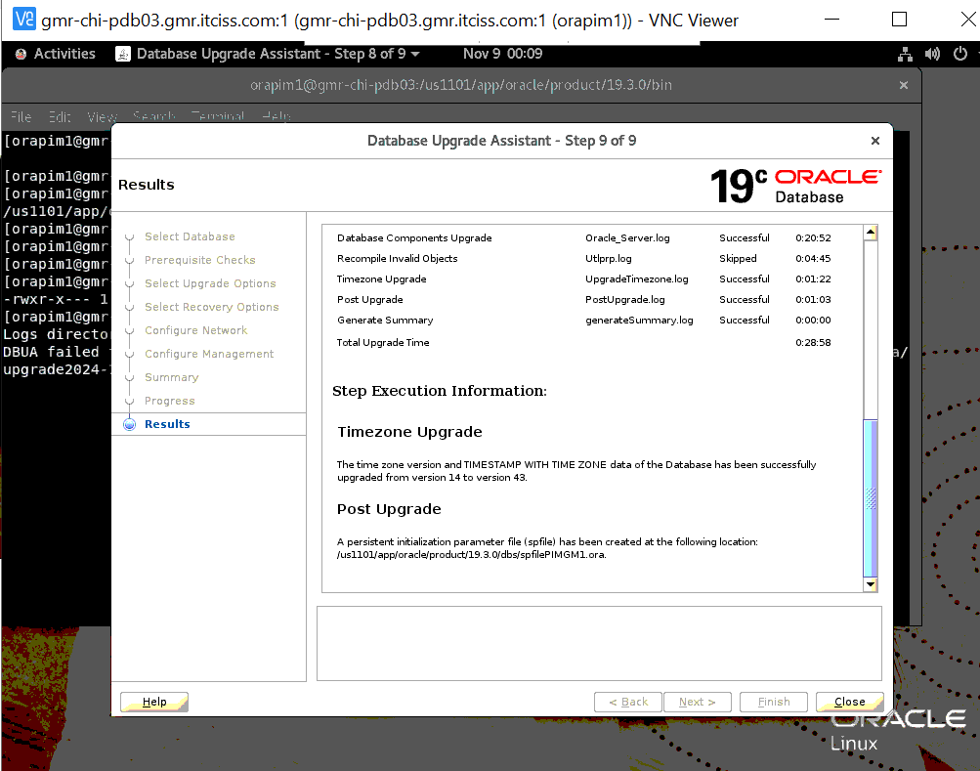

- Run Postupgrade.sql and validate the Output

Post upgrade:-
*****************
Gather stale data dictionary statistics
****************************************
SYS@PIMGM1 > EXECUTE DBMS_STATS.GATHER_DICTIONARY_STATS;
PL/SQL procedure successfully completed.
SYS@PIMGM1 >

Gather statistics on fixed objects prior to the upgrade
*******************************************************
SYS@PIMGM1 > EXECUTE DBMS_STATS.GATHER_FIXED_OBJECTS_STATS;
PL/SQL procedure successfully completed.
SYS@PIMGM1 >

Postupgrade_fixups.sql :-
**************************
SYS@PIMGM1 > @postupgrade_fixups.sql
Session altered.
PL/SQL procedure successfully completed.
PL/SQL procedure successfully completed.
PL/SQL procedure successfully completed.
Package created.
No errors.
Package body created.
PL/SQL procedure successfully completed.
No errors.
Package created.
No errors.
Package body created.
No errors.
Executing Oracle POST-Upgrade Fixup Script
Auto-Generated by: Oracle Preupgrade Script
Version: 19.0.0.0.0 Build: 13
Generated on: 2024-11-08 20:41:09
For Source Database: PIMGM1
Source Database Version: 11.2.0.4.0
For Upgrade to Version: 19.0.0.0.0
Preup Preupgrade
Action Issue Is
Number Preupgrade Check Name Remedied Further DBA Action
------ ------------------------ ---------- --------------------------------
14. depend_usr_tables YES None.
15. old_time_zones_exist YES None.
16. post_dictionary YES None.
17. post_fixed_objects NO Informational only.
Further action is optional.
18. upg_by_std_upgrd YES None.

The fixup scripts have been run and resolved what they can. However,
there are still issues originally identified by the preupgrade that
have not been remedied and are still present in the database.
Depending on the severity of the specific issue, and the nature of
the issue itself, that could mean that your database upgrade is not
fully complete. To resolve the outstanding issues, start by reviewing
the postupgrade_fixups.sql and searching it for the name of
the failed CHECK NAME or Preupgrade Action Number listed above.
There you will find the original corresponding diagnostic message
from the preupgrade which explains in more detail what still needs
to be done.

PL/SQL procedure successfully completed.

Session altered.

SQL>
- Validate 19C Validate 19C version of Time_zone , Compatible, Listener & Database with dba_registry components.
Validation queries:--
*********************

Validatation queries:-
*********************
INSTANCE_NAME TO_CHAR(STARTUP_TIME,'HH HOST_NAME STATUS DATABASE_STATUS ARCHIVE
---------------- ------------------------ -------------------- ---------- ----------------- -------
PIMGM1 00:07 09-NOV-24 gmr-chi-pdb03.gmr.it OPEN ACTIVE STOPPED
ciss.com

HOST_NAME INSTANCE_NAME DATABASE_NAME OPEN_MODE DATABASE_ROLE CREATED DBID VERSION
---------------------------------------- ---------------- -------------- -------------------- ---------------- --------- ---------- -----------
BANNER
--------------------------------------------------------------------------------
gmr-chi-pdb03.gmr.itciss.com PIMGM1 PIMGM1 READ WRITE PRIMARY 12-MAR-22 3025155520 19.0.0.0.0
Oracle Database 19c Enterprise Edition Release 19.0.0.0.0 - Production

ACTION_TIME PATCH_TYPE ACTION STATUS DESCRIPTION SOURCE_VERSION TARGET_VERSION PATCH_ID
--------------------- ---------- ----------- ----------- ------------------------------------------------------- --------------- --------------- ----------
08-NOV-2024 23:57:53 INTERIM APPLY SUCCESS OJVM RELEASE UPDATE: 19.24.0.0.240716 (36414915) 19.1.0.0.0 19.24.0.0.0 36414915
08-NOV-2024 23:57:53 RU APPLY SUCCESS Database Release Update : 19.24.0.0.240716 (36582781) 19.1.0.0.0 19.24.0.0.0 36582781

19C Listener
************
[orapim1@gmr-chi-pdb03 ~]$ lsnrctl status LISTENER_PIMGM1
LSNRCTL for Linux: Version 19.0.0.0.0 - Production on 09-NOV-2024 00:40:20
Copyright (c) 1991, 2024, Oracle. All rights reserved.
Connecting to (DESCRIPTION=(ADDRESS=(PROTOCOL=TCP)(HOST=gmr-chi-pdb03.gmr.itciss.com)(PORT=1521)))
STATUS of the LISTENER
------------------------
Alias LISTENER_PIMGM1
Version TNSLSNR for Linux: Version 19.0.0.0.0 - Production
Start Date 09-NOV-2024 00:40:05
Uptime 0 days 0 hr. 0 min. 15 sec
Trace Level off
Security ON: Local OS Authentication
SNMP OFF
Listener Parameter File /us1101/app/oracle/product/19.3.0/network/admin/listener.ora
Listener Log File /us1101/app/oracle/diag/tnslsnr/gmr-chi-pdb03/listener_pimgm1/alert/log.xml
Listening Endpoints Summary...
(DESCRIPTION=(ADDRESS=(PROTOCOL=tcp)(HOST=gmr-chi-pdb03.gmr.itciss.com)(PORT=1521)))
(DESCRIPTION=(ADDRESS=(PROTOCOL=ipc)(KEY=EXTPROC1521)))
Services Summary...
Service "PIMGM1" has 2 instance(s).
Instance "PIMGM1", status UNKNOWN, has 1 handler(s) for this service...
Instance "PIMGM1", status READY, has 1 handler(s) for this service...
Service "PIMGM1XDB" has 1 instance(s).
Instance "PIMGM1", status READY, has 1 handler(s) for this service...
The command completed successfully
[orapim1@gmr-chi-pdb03 ~]$

Database Registry components
****************************
col VERSION for a15;
set lines 180
set pages 999
col COMP_NAME for a60;
select COMP_ID,COMP_NAME,VERSION,STATUS from dba_registry;
select TZ_VERSION from registry$database;

COMP_ID COMP_NAME VERSION STATUS
------------------------------ ---------------------------------------------------------------------- --------------- --------------------------------------------
CATALOG Oracle Database Catalog Views 19.0.0.0.0 VALID
CATPROC Oracle Database Packages and Types 19.0.0.0.0 VALID
JAVAVM JServer JAVA Virtual Machine 19.0.0.0.0 VALID
XML Oracle XDK 19.0.0.0.0 VALID
CATJAVA Oracle Database Java Packages 19.0.0.0.0 VALID
APS OLAP Analytic Workspace 19.0.0.0.0 VALID
RAC Oracle Real Application Clusters 19.0.0.0.0 OPTION OFF
OWM Oracle Workspace Manager 19.0.0.0.0 VALID
CONTEXT Oracle Text 19.0.0.0.0 VALID
XDB Oracle XML Database 19.0.0.0.0 VALID
ORDIM Oracle Multimedia 19.0.0.0.0 VALID
SDO Spatial 19.0.0.0.0 VALID
XOQ Oracle OLAP API 19.0.0.0.0 VALID
APEX Oracle Application Express 18.1.0.00.45 INVALID

14 rows selected.

SYS@PIMGM1 >

Time_zone validation:-
*********************
SYS@PIMGM1 > SELECT version FROM v$timezone_file;

VERSION
----------
43

SQL> select count(1) from dba_objects where status='INVALID';

COUNT(1)
----------
0

SQL>

- Set 19c database Env (.bash_profile) & validate system password.

Environment set
*****************

[orapim1@gmr-chi-pdb03 ~]$ cat .bash_profile
# .bash_profile

# Get the aliases and functions
if [ -f ~/.bashrc ]; then
. ~/.bashrc
fi

# User specific environment and startup programs
export ORACLE_HOME=/us1101/app/oracle/product/19.3.0
export ORACLE_BASE=/us1101/app/oracle
export PATH=$ORACLE_HOME/bin:$ORACLE_HOME/OPatch:$ORACLE_HOME/perl/bin:$PATH
export LD_LIBRARY_PATH=$ORACLE_HOME/lib
export ORACLE_SID=PIMGM1
export PERL5LIB=$ORACLE_HOME/perl/lib/5.38.2:$ORACLE_HOME/perl/lib/site_perl/5.38.2

########
alias sql='sqlplus / as sysdba'
alias lsnr='ps -ef | grep lsnr'
alias TNS="cd $TNS_ADMIN"
alias OH="cd $ORACLE_HOME"
alias dbs="cd $ORACLE_HOME/dbs"
alias pmon='ps -ef | grep pmon | grep -v grep | sort -n'
alias rlogs="cd /nsr/applogs"
alias rscripts="cd /nsr/scripts/oracle"
alias alert="cd /us1101/app/oracle/diag/rdbms/pimgm1/PIMGM1/trace/"

[orapim1@gmr-chi-pdb03 ~]$

SYS@PIMGM1 > select name from v$database;

NAME
---------
PIMGM1

SYS@PIMGM1 >
SYS@PIMGM1 > alter user sys identified by se4h4wks;

User altered.

SYS@PIMGM1 >

19c PIMGM1 Parameter files:
*****************************
[orapim1@gmr-chi-pdb03 ~]$ cd /us1101/app/oracle/product/19.3.0/dbs
[orapim1@gmr-chi-pdb03 dbs]$ ls -ltrh
total 28K
-rw-r--r-- 1 orapim1 dba 3.1K May 14 2015 init.ora
-rw-r----- 1 orapim1 dba 24 Nov 8 23:39 lkPIMGM1
-rw-rw---- 1 orapim1 dba 1.6K Nov 9 00:07 hc_PIMGM1.dat
-rw-r----- 1 orapim1 dba 4.5K Nov 9 00:07 spfilePIMGM1.ora
-rw-r----- 1 orapim1 dba 4.5K Nov 9 00:46 orapwPIMGM1
[orapim1@gmr-chi-pdb03 dbs]$ date
Sat Nov 9 00:46:49 MST 2024
[orapim1@gmr-chi-pdb03 dbs]$ pwd
/us1101/app/oracle/product/19.3.0/dbs
[orapim1@gmr-chi-pdb03 dbs]$

Compatible & Archive log Enable
********************************
[orapim1@gmr-chi-pdb03 dbs]$ sqlplus sys/se4h4wks@PIMGM1 as sysdba

SQL*Plus: Release 19.0.0.0.0 - Production on Sat Nov 9 00:47:45 2024
Version 19.24.0.0.0
Copyright (c) 1982, 2024, Oracle. All rights reserved.
Connected to:
Oracle Database 19c Enterprise Edition Release 19.0.0.0.0 - Production
Version 19.24.0.0.0

SYS@PIMGM1 > sho user;
USER is "SYS"

SYS@PIMGM1 >

SYS@PIMGM1 > sho parameter comp

NAME TYPE VALUE
------------------------------------ ----------- ------------------------------
cell_offload_compaction string ADAPTIVE
compatible string 11.2.0.4.0
db_index_compression_inheritance string NONE
inmemory_prefer_xmem_memcompress string
nls_comp string BINARY
noncdb_compatible boolean FALSE
plsql_v2_compatibility boolean FALSE
SYS@PIMGM1 >
SYS@PIMGM1 >
SYS@PIMGM1 >
SYS@PIMGM1 > alter system set compatible='19.0.0' scope=spfile;

System altered.

SYS@PIMGM1 > shut immediate;
Database closed.
Database dismounted.
ORACLE instance shut down.
SYS@PIMGM1 >

[ldhipulla@gmr-chi-pdb03 ~]$ sudo su - orapim1
Last login: Sat Nov 9 00:39:39 MST 2024 on pts/11
[orapim1@gmr-chi-pdb03 ~]$ sqlplus / as sysdba

SQL*Plus: Release 19.0.0.0.0 - Production on Sat Nov 9 00:50:13 2024
Version 19.24.0.0.0

Copyright (c) 1982, 2024, Oracle. All rights reserved.

Connected to an idle instance.

SYS@PIMGM1 > startup
ORACLE instance started.

Total System Global Area 4194301784 bytes
Fixed Size 8947544 bytes
Variable Size 788529152 bytes
Database Buffers 3388997632 bytes
Redo Buffers 7827456 bytes
Database mounted.
Database opened.
SYS@PIMGM1 > show parameter compatible;

NAME TYPE VALUE
------------------------------------ ----------- ------------------------------
compatible string 19.0.0
noncdb_compatible boolean FALSE
SQL>

SYS@PIMGM1 > startup mount;
ORACLE instance started.

Total System Global Area 4194301784 bytes
Fixed Size 8947544 bytes
Variable Size 788529152 bytes
Database Buffers 3388997632 bytes
Redo Buffers 7827456 bytes
Database mounted.
SYS@PIMGM1 >
SYS@PIMGM1 >
SYS@PIMGM1 > archive log list;
Database log mode Archive Mode
Automatic archival Enabled
Archive destination /ur1101/PIMGM1/ARCHIVES
Oldest online log sequence 109
Next log sequence to archive 110
Current log sequence 110
SYS@PIMGM1 >

- Rman catalog & Daily backup enable configuration on catalog database

*********************************************************************
Rman catalog & Daily backup enable configuration on catalog database
*********************************************************************

[REPRMAN oracle@iss-chi-rman04 ~]$ hostname -f
iss-chi-rman04.itciss.com
[REPRMAN oracle@iss-chi-rman04 ~]$ id;pwd
uid=501(oracle) gid=400(dba) groups=400(dba),501(oinstall)
/home/oracle
[REPRMAN oracle@iss-chi-rman04 ~]$

SYS@REPRMAN > create tablespace GMR_GMR_CHI_PDB03_PIMGM1 datafile '/ud1002/REPRMAN/GMR_GMR_CHI_PDB03_PIMGM1_01.dbf' size 500m;

Tablespace created.

SYS@REPRMAN > CREATE USER GMR_GMR_CHI_PDB03_PIMGM1 IDENTIFIED BY GMR_GMR_CHI_PDB03_PIMGM1 DEFAULT TABLESPACE GMR_GMR_CHI_PDB03_PIMGM1 TEMPORARY TABLESPACE TEMP;

User created.

SYS@REPRMAN > GRANT CONNECT TO GMR_GMR_CHI_PDB03_PIMGM1;
GRANT RESOURCE TO GMR_GMR_CHI_PDB03_PIMGM1;
GRANT RECOVERY_CATALOG_OWNER TO GMR_GMR_CHI_PDB03_PIMGM1;
GRANT UNLIMITED TABLESPACE TO GMR_GMR_CHI_PDB03_PIMGM1;
Grant succeeded.

SYS@REPRMAN >
Grant succeeded.

SYS@REPRMAN >
Grant succeeded.

SYS@REPRMAN >

Grant succeeded.

SYS@REPRMAN >
SYS@REPRMAN >

[PIMGM1 orapim1@gmr-chi-pdb03 ~]$

SYS@PIMGM1 > select username,account_status from dba_users where username='DBRMAN';

USERNAME
--------------------------------------------------------------------------------
ACCOUNT_STATUS
--------------------------------
DBRMAN
OPEN

[orapcu1@gmr-chi-pdb02 oracle]$ cat arch_PIMGM1_nmda.sh
connect target dbrman/dbrman123@PIMGM1_RBKP;
connect catalog GMR_GMR_CHI_PDB03_PIMGM1/GMR_GMR_CHI_PDB03_PIMGM1@REPRMAN;
RUN {
ALLOCATE CHANNEL CH1 TYPE SBT_TAPE;
ALLOCATE CHANNEL CH2 TYPE SBT_TAPE;
ALLOCATE CHANNEL CH3 TYPE SBT_TAPE;
ALLOCATE CHANNEL CH4 TYPE SBT_TAPE;
CROSSCHECK archivelog all;
backup archivelog all not backed up 1 times format 'AL_%d_%U';
delete force noprompt archivelog all backed up 1 times to device type sbt completed before 'sysdate-1/2';
RELEASE CHANNEL CH1;
RELEASE CHANNEL CH2;
RELEASE CHANNEL CH3;
RELEASE CHANNEL CH4;
}
[orapcu1@gmr-chi-pdb02 oracle]$

Note : Rman catalog database inform add in tnsnames.ora in target database (gmr-chi-pdb03)
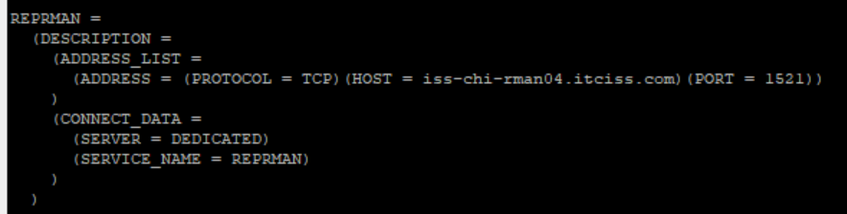

[PIMGM1 orapim1@gmr-chi-pdb03 nsr]$ rman
Recovery Manager: Release 19.0.0.0.0 - Production on Sat Nov 9 01:32:27 2024
Version 19.24.0.0.0
Copyright (c) 1982, 2019, Oracle and/or its affiliates. All rights reserved.

RMAN> connect target dbrman/dbrman123@PIMGM1_RBKP;
connected to target database: PIMGM1 (DBID=3025155520)
RMAN> connect catalog GMR_GMR_CHI_PDB03_PIMGM1/GMR_GMR_CHI_PDB03_PIMGM1@REPRMAN;
connected to recovery catalog database

RMAN> register database;

RMAN-00571: ===========================================================
RMAN-00569: =============== ERROR MESSAGE STACK FOLLOWS ===============
RMAN-00571: ===========================================================
RMAN-03002: failure of register command at 11/09/2024 01:33:09
RMAN-06428: recovery catalog is not installed

RMAN> create catalog;

recovery catalog created

RMAN> register database;

database registered in recovery catalog
starting full resync of recovery catalog
full resync complete

RMAN> BACKUP CURRENT CONTROLFILE FORMAT '/backup/DB_Rman_FULL_BKP/Postupg_CTRL.bck';

Starting backup at 09-NOV-24
allocated channel: ORA_DISK_1
channel ORA_DISK_1: SID=515 device type=DISK
channel ORA_DISK_1: starting full datafile backup set
channel ORA_DISK_1: specifying datafile(s) in backup set
including current control file in backup set
channel ORA_DISK_1: starting piece 1 at 09-NOV-24
channel ORA_DISK_1: finished piece 1 at 09-NOV-24
piece handle=/backup/DB_Rman_FULL_BKP/Postupg_CTRL.bck tag=TAG20241109T013627 comment=NONE
channel ORA_DISK_1: backup set complete, elapsed time: 00:00:01
Finished backup at 09-NOV-24

Starting Control File and SPFILE Autobackup at 09-NOV-24
piece handle=/us1101/app/oracle/product/19.3.0/dbs/c-3025155520-20241109-00 comment=NONE
Finished Control File and SPFILE Autobackup at 09-NOV-24
RMAN> exit

Recovery Manager complete.
[PIMGM1 orapim1@gmr-chi-pdb03 nsr]$ ls -ld /backup/DB_Rman_FULL_BKP/Postupg_CTRL.bck
-rw-r----- 1 orapim1 dba 30801920 Nov 9 01:36 /backup/DB_Rman_FULL_BKP/Postupg_CTRL.bck
[PIMGM1 orapim1@gmr-chi-pdb03 nsr]$

- Sanity checks and share the listener info to Middleware Team.

INSTANCE_NAME TO_CHAR(STARTUP_TIME,'HH HOST_NAME STATUS DATABASE_STATUS ARCHIVE
---------------- ------------------------ -------------------- ---------- ----------------- -------
PIMGM1 01:17 09-NOV-24 gmr-chi-pdb03.gmr.it OPEN ACTIVE STARTED
ciss.com

[orapim1@gmr-chi-pdb03 ~]$ lsnrctl status LISTENER_PIMGM1

LSNRCTL for Linux: Version 19.0.0.0.0 - Production on 09-NOV-2024 00:40:20

Copyright (c) 1991, 2024, Oracle. All rights reserved.

Connecting to (DESCRIPTION=(ADDRESS=(PROTOCOL=TCP)(HOST=gmr-chi-pdb03.gmr.itciss.com)(PORT=1521)))
STATUS of the LISTENER
------------------------
Alias LISTENER_PIMGM1
Version TNSLSNR for Linux: Version 19.0.0.0.0 - Production
Start Date 09-NOV-2024 00:40:05
Uptime 0 days 0 hr. 0 min. 15 sec
Trace Level off
Security ON: Local OS Authentication
SNMP OFF
Listener Parameter File /us1101/app/oracle/product/19.3.0/network/admin/listener.ora
Listener Log File /us1101/app/oracle/diag/tnslsnr/gmr-chi-pdb03/listener_pimgm1/alert/log.xml
Listening Endpoints Summary...
(DESCRIPTION=(ADDRESS=(PROTOCOL=tcp)(HOST=gmr-chi-pdb03.gmr.itciss.com)(PORT=1521)))
(DESCRIPTION=(ADDRESS=(PROTOCOL=ipc)(KEY=EXTPROC1521)))
Services Summary...
Service "PIMGM1" has 2 instance(s).
Instance "PIMGM1", status UNKNOWN, has 1 handler(s) for this service...
Instance "PIMGM1", status READY, has 1 handler(s) for this service...
Service "PIMGM1XDB" has 1 instance(s).
Instance "PIMGM1", status READY, has 1 handler(s) for this service...
The command completed successfully
[orapim1@gmr-chi-pdb03 ~]$

Share the below TNS info to middle ware team
***********************************************

(DESCRIPTION=(ADDRESS=(PROTOCOL=tcp)(HOST=gmr-chi-pdb03.gmr.itciss.com)(PORT=1521))(CONNECT_DATA=(SERVICE_NAME=PIMGM1)(INSTANCE_NAME=PIMGM1)))

************************************************&&&&&&&&&&&&&&&&**************************************************************

Document Reference:
********************

https://oracle-base.com/articles/19c/upgrading-to-19c
https://www.oracle.com/a/tech/docs/twp-upgrade-oracle-database-19c.pdf
How to Download and Run Oracle's Database Pre-Upgrade Utility (Doc ID 884522.1)
Patching fails during relink , with error code 102 :: Fatal error: Command failed for target `javavm_refresh' (Doc ID 2002334.1)

