QUANTCAST PROD EBS 12.2.9 Upgrade DBA Playbook

Document Control

Change Record

Date | Author | Version | Change Reference

Reviewers

Name | Position

- The copy numbers referenced above should be written into the Copy Number space on the cover of each distributed copy. If the document is not controlled, you can delete this table, the Note To Holders, and the Copy Number label from the cover page.

Note To Holders:
If you receive an electronic copy of this document and print it out, please write your name on the equivalent of the cover page, for document control purposes.
If you receive a hard copy of this document, please write your name on the front cover, for document control purposes

Table of Contents
PRE-CUTOVER 3
PC1 – Take a backup of DB and RDBMS Home. 3
PC2 - Apply October 2020 PSU patch and ETCC patches 3
PC3 - Run ETCC on DB Tier 4
PC4 - Create staging as EBSPROD user 4
PC5 - Install 12.2 file system 5
PC6 - Install ETCC MT Patches 12
PC7 Update EBS 12.2 Parameters 13
MS1 - Milestone Backup 1 14
BACKUP 14
CB0 - Cold backup 14
CUTOVER 15
CU0 - Update DB parameters 15
CU1 - Apply AD CUP Patches 15
CU2 - Apply Pre-Install Patches 15
CU3 - Merge Upgrade Driver 15
CU4 - Disable Custom Triggers and Custom Jobs 16
CU5 - Apply 1220 Upgrade Driver 17
CU6 - Configure EBS 12.2 Filesystem 18
MS2 - Milestone Backup 2 19
ONLINE ENABLEMENT 20
OLE1 - Apply Online Patching Readiness and GSCC Report patches 20
OLE2 - Register Custom Schemas 20
OLE3 - Perform fix for AD_ZD_PREP invalid object 20
OLE4 - Ensure there are no AD_ZD invalid objects 20
OLE5 - Apply the Online Patching Enablement patch 21
OLE6 - Run ETCC 21
AD & TXK PATCHES 21
AT1 - Run adgrants.sql 21
AT2 - Start Weblogic Admin Server 21
AT3 - Drop ADX_PRE_AUTOCONFIG Table 21
AT4 - Apply AD.12 Patch 22
AT5 - Apply TXK.12 Merge patches 22
AT6 - Stop Weblogic Admin Server 22
AT7 - Migrate Latest Code to both the RAC nodes 22
AT8 - Build Context File on both the DB node 23
AT9 - Run Autoconfig on DB node 23
AT10 - Run Autoconfig on Apps Tier 23
MILESTONE BACKUP 3 23
12.2.9 UPGRADE 23
RUP1 - Apply 12.2.9 Upgrade Patch in Downtime Mode and Interactive Mode 23
RUP2 - Apply 1220 Online Help Patch 24
RUP3 - Apply 1229 Online Help Patch 24
RUP4 - Apply OA Framework (FWK) Release 12.2.9 Bundle 7 Patch 24
RUP5 - Apply EBS JAN 2021 CPU Patch 24
RUP6 - Apply Post patches 24
MILESTONE BACKUP 4 24
JDK UPGRADE 25
JDK1 - Main JDK Upgrade 25
JDK2 - Update JDK Configuration 25
JDK3 - Run autoconfig 25
JDK4 - WebTier JDK Upgrade - 64 Bit 25
JDK5 - 1012 Home JDK Upgrade-32 bit 25
JDK6 - Relink Forms 25
JDK7 - Relink Reports 25
JDK8 - Allow Unrestricted access for JSPs 26
JRE UPGRADE 26
JRE1 - Apply the JRE Interoperability Patch 26
JRE2 - Copy Latest JRE 26
JRE3 - Update JRE Configuration 26
Post Upgrade Steps 26
PUG1A - Update Context File for below parameters 26
PUG1 - Copy Custom tops from 1213 27
PUG2 - Prepare Custom Env File 27
PUG4 - Run Autoconfig 27
PUG5 - Upload Patch Context File to DB 28
PUG6 - Copy Logo Files 28
PUG7 - XDO Configuration 28
PUG8 - Perform ADADMIN Activities 28
PUG9 - Re-enable the Custom triggers 29
PUG9.1 - Custom JAR deployment – Not done in EBSPROD yet 30
PUG10 - Bring up Apps Services 31
PUG11 - Perform Sanity Tests 31
PUG12 - Run FS_CLONE 31
PUG13 - Run adpreclone on both Run and Patch FS 31
PUG14 - Take Full Instance Backup 31
HA Node Addition 32
NA01 - Start AdminServer on both Run and Patch FS 32
NA02 - Enable Passwordless SSH 32
NA03 - Enable Shared file system on primary node 32
NA04 - Prepare pairs file for second and third nodes 32
NA05 - Run adclonectx.pl on the uap52 and uap53 33
NA10 - Stop Admin Server (on run and patch) 33
NA13 - Run autoconfig in following sequence 34
NA14 - Bring up Services on both APP nodes 34
NA17 - Restart the services. 34
NA19 - Run fs_clone with all 3 APP nodes in place 34
NA20 - Run adpreclone.pl on both Run and Patch FS 34
NA21 - Compile Invalids 34
MS6 - Final Milestone Backup 34

EBS 12.2.9 Upgrade Steps

PRE-Upgrade

GOLD Backup– Take a backup of DB and RDBMS Home.

Take OH backup as below

[oraprd@ebsprod 19c]$ pwd
/u03/prd/prddb/19c/
nohup tar -cvzf /stage/DB_APPS_BKP/PRD/OH_BKP/OH_BEFORE_UPG_GOLD.tgz dbhome_1>/stage/DB_APPS_BKP/PRD/OH_BKP/PRD_BEFORE_UPG_GOLD_OHBKP.log &

STARTUP MOUNT

[oraprd@ebsprod DB_APPS_BKP]$ pwd
/stage/DB_APPS_BKP

Execute RMAN BACKUP as below

[oraprd@ebsprod DB_APPS_BKP_P3]$ nohup sh rman_bkp_PC1.sh >/stage/DB_APPS_BKP/PRD/DB/rman_full_bkp_PU1_FINAL_nh.log &

[oraprd@ebsprod DB_APPS_BKP_P3]$ cat rman_bkp_final.sh
echo "Backup start time is `date` " >> /stage/DB_APPS_BKP/PRD/rman_full_bkp_PU1_ PC1.log
rman target / > /stage/DB_APPS_BKP/PRD/rman_full_bkp_PU1_FINAL.log << EOF
run {
allocate channel ch1 type disk format '/stage/DB_APPS_BKP/GOLD/DB/dbfull_incr0_%d_t%t_s%s_p%p';
allocate channel ch2 type disk format '/stage/DB_APPS_BKP/GOLD/DB/dbfull_incr0_%d_t%t_s%s_p%p';
allocate channel ch3 type disk format '/stage/DB_APPS_BKP/GOLD/DB/dbfull_incr0_%d_t%t_s%s_p%p';
allocate channel ch4 type disk format '/stage/DB_APPS_BKP/GOLD /DB/dbfull_incr0_%d_t%t_s%s_p%p';
allocate channel ch5 type disk format '/stage/DB_APPS_BKP/GOLD /DB/dbfull_incr0_%d_t%t_s%s_p%p';
allocate channel ch6 type disk format '/stage/DB_APPS_BKP/GOLD /DB/dbfull_incr0_%d_t%t_s%s_p%p';
allocate channel ch7 type disk format '/stage/DB_APPS_BKP/GOLD /DB/dbfull_incr0_%d_t%t_s%s_p%p';
allocate channel ch8 type disk format '/stage/DB_APPS_BKP/GOLD /DB/dbfull_incr0_%d_t%t_s%s_p%p';
allocate channel ch9 type disk format '/stage/DB_APPS_BKP/GOLD /DB/dbfull_incr0_%d_t%t_s%s_p%p';
allocate channel ch10 type disk format '/stage/DB_APPS_BKP/GOLD /DB/dbfull_incr0_%d_t%t_s%s_p%p';
backup incremental level 0 section size 10G database
filesperset 5
include current controlfile;
backup current controlfile FORMAT '/stage/DB_APPS_BKP/PRD/DB/cffull_PU1_d%d_t%t_s%s_p%p';
}
EOF
echo "Backup end time is `date` " >> /stage/DB_APPS_BKP/PRD/DB/rman_full_bkp_PU1_PC1.log

IMP : During Rman backup if u see anything taking control backup,
[oraprd@ebsprod DB]$ cp -rp /u03/prd/prddb/19c/dbhome_1/dbs/c-2456528033-20210706-00 .

Take Application folder tar backup as below

[appprd@ebsprod PRD]$ pwd
/u01
nohup tar -cvzf /stage/DB_APPS_BKP/PRD/APP/PRD_BEFORE_UPG_GOLD.tgz crp > /stage/DB_APPS_BKP/PRD/PRD_BEFORE_UPG_GOLD.log

PU2 - Apply JAN 2021 PSU patch and ETCC patches

Known Issue:
===========
CDB:
=====
create or replace directory DATA_PUMP_DIR as '/u03/prd/prddb/19c/dbhome_1/rdbms/log';

PDB:
create or replace directory DATA_PUMP_DIR as '/u03/prd/prddb/19c/dbhome_1/rdbms/log/AF26919F6E9F4EB8E053160AB80AA39A';

DB JAN CPU21:
=============
/stage/Jan_CPU21/DB/32126828/32218454

[oraprd@ebsprod 32218454]$ opatch prereq CheckConflictAgainstOHWithDetail -ph ./|grep -i conflict

Summary of Conflict Analysis:
Following patches have conflicts. Please contact Oracle Support and get the merged patch of the patches :
Conflicts/Supersets for each patch are:
Conflict with 28318139
Conflict details:
Conflict with 29867728
Conflict details:

[oraprd@ebsprod 32218454]$ opatch rollback -id 28318139

[oraprd@ebsprod 32218454]$ opatch rollback -id 29867728

**************
oraprd@ebsprod 32218454]$ cp -pR /u03/prd/prddb/19c/dbhome_1/Opatch /u03/prd/prddb/19c/dbhome_1/OPatch_b4_janpsu21

[oraprd@ebsprod Jan_CPU21]$ cd $ORACLE_HOME
[oraprd@ebsprod dbhome_1]$ unzip -o /stage/Jan_CPU21/p6880880_190000_Linux-x86-64.zip

[oraprd@ebsprod dbhome_1]$ cd /stage/Jan_CPU21/DB/32126828/32218454
[oraprd@ebsprod 32218454]$ opatch apply

[oraprd@ebsprod 32126828]$ cd 32067171
[oraprd@ebsprod 32067171]$ opatch apply

ETCC Recommended DB PATCHES:
============================
[oraprd@ebsprod patches]$ pwd
/stage/ETCC/patches
[oraprd@ebsprod patches]$ mkdir PRD_ETCC
-rwxr-x--- 1 oraprd dba 41K Jun 25 13:16 p32288423_R12_GENERIC.zip
drwxr-x--- 2 oraprd dba 6.0K Jun 25 13:17 PRD_ETCC
[oraprd@ebsprod patches]$ chmod -R 777 PRD_ETCC/

cd /stage/ETCC/consolidated_DB_FIXES/etcc-bundle/LINUX_X86-64/database/19.10.0.0.210119DBRU/
[oraprd@EBSPROD 19.10.0.0.210119DBRU]$ ls -lrth
total 2.7M
-r--r--r-- 1 oraprd dba 1020K Dec 18 05:40 p31424070_1910000DBRU_Generic.zip
-r--r--r-- 1 oraprd dba 209K Dec 19 11:01 p31405300_1910000DBRU_Linux-x86-64.zip
-r--r--r-- 1 oraprd dba 1.1M Dec 19 16:15 p28318139_1910000DBRU_Generic.zip
-r--r--r-- 1 oraprd dba 371K Jan 11 01:00 p29867728_1910000DBRU_Linux-x86-64.zip
[oraprd@EBSPROD 19.10.0.0.210119DBRU]$ unzip p31424070_1910000DBRU_Generic.zip

[oraprd@EBSPROD 19.10.0.0.210119DBRU]$unzip p31405300_1910000DBRU_Linux-x86-64.zip

cd 31424070
$ORACLE_HOME/OPatch/opatch apply

cd ../ 31405300
$ORACLE_HOME/OPatch/opatch apply

$ORACLE_HOME/OPatch/opatch lspatches

Run Datapatch:
===============

SQL> connect /as sysdba
Connected to an idle instance.

SQL> startup upgrade;
ORA-32004: obsolete or deprecated parameter(s) specified for RDBMS instance
ORACLE instance started.

Total System Global Area 5083495768 bytes
Fixed Size 9149784 bytes
Variable Size 3120562176 bytes
Database Buffers 1929379840 bytes
Redo Buffers 24403968 bytes
Database mounted.
Database opened.
SQL>

SQL> show pdbs

CON_ID CON_NAME OPEN MODE RESTRICTED
---------- ------------------------------ ---------- ----------
2 PDB$SEED MIGRATE YES
3 PRD MOUNTED

SQL> alter pluggable database prd open upgrade;

Pluggable database altered.

SQL> show pdbs

CON_ID CON_NAME OPEN MODE RESTRICTED
---------- ------------------------------ ---------- ----------
2 PDB$SEED MIGRATE YES
3 PRD MIGRATE YES

Note : Before running Datapatch , PDB and PDB$SEED should be restricted = YES.

[oraprd@ebsprod OPatch]$ cd $ORACLE_HOME/Opatch

[oraprd@ebsprod OPatch]$ ./datapatch –verbose

PC3 - Run ETCC on DB Tier

cd /stage/ETCC/patches/PRD_ETCC/

./checkDBpatch.sh contextfile=/u03/prd/prddb/19c/dbhome_1/appsutil/PRD_ebsprod.xml

PC4 - Create staging as EBSPROD user

[appprd@ebsprod build]$ unzip p22066363_R12_GENERIC.zip ==> StartCD
[appprd@ebsprod build]$ pwd
/stage/build

[appprd@ebsprod build]$ cd startCD/Disk1/rapidwiz/bin
[appprd@ebsprod bin]$ ./buildStage.sh

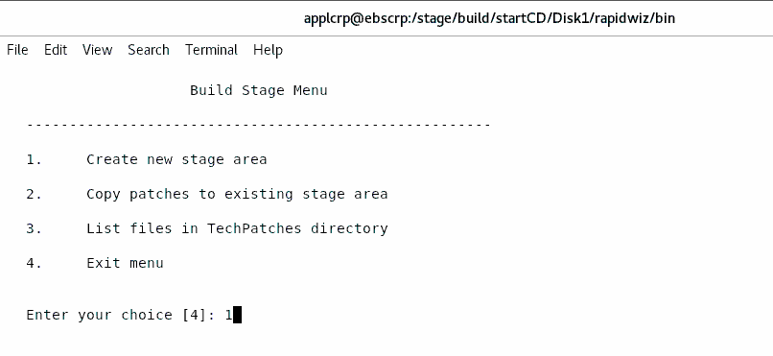

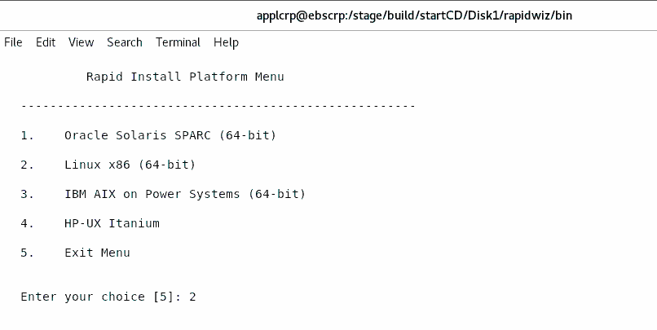

Specify the directory containing the zipped installation media:
/stage/build

[appprd@ebsprod 25525148]$ sh patchRIStage.sh
Patch directory is /stage/build/25525148

Enter the location of the Rapid Install Stage area:/stage/build

Completed patching of the Rapid Install Stage area /stage/build
[appprd@ebsprod 25525148]$

[appprd@ebsprod build]$ cd 31033613/
[appprd@ebsprod 31033613]$

[appprd@ebsprod 31033613]$ sh patchRIStage.sh
Patch directory is /stage/build/31033613

Enter the location of the Rapid Install Stage area:/stage/build
[appprd@ebsprod 31033613]$

PC5 - Install 12.2 file system
echo $DISPLAY

sudo su - appprd
[appprd@ebsprod ~]$ cd /stage/build/startCD/Disk1/rapidwiz/
[appprd@ebsprod rapidwiz]$ ./rapidwiz

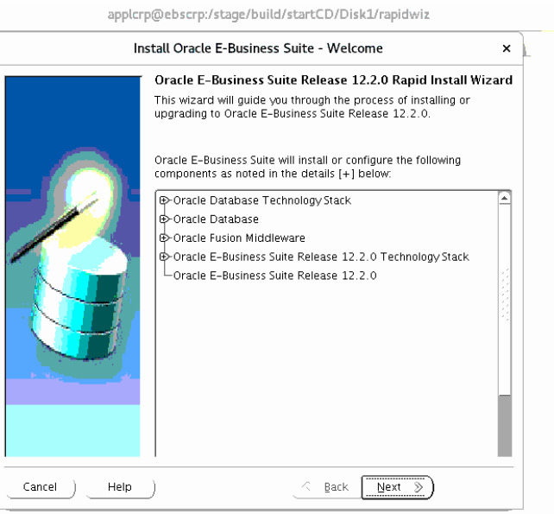

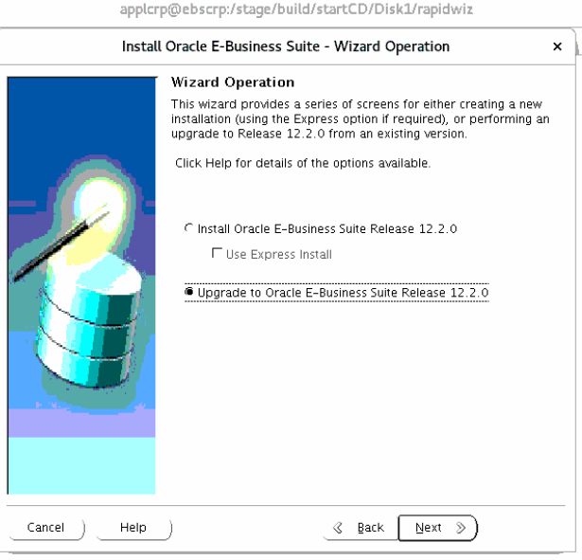

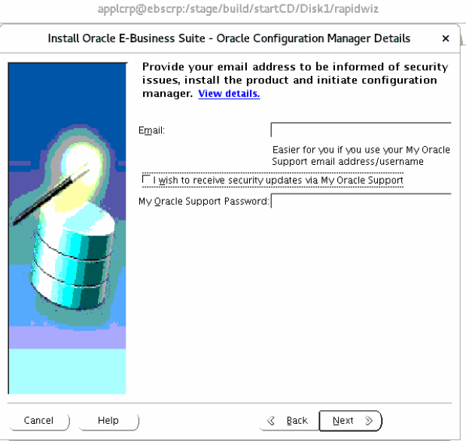

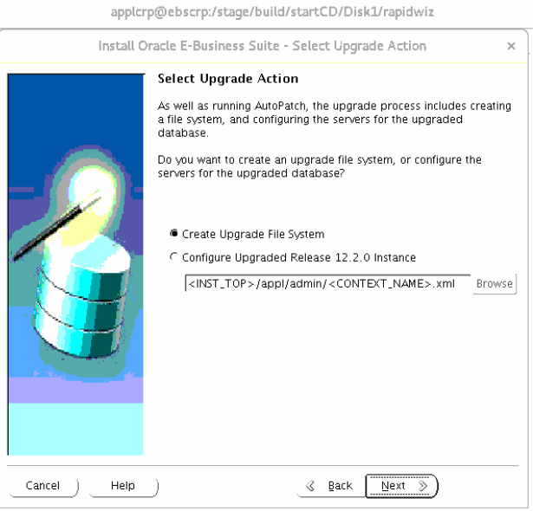

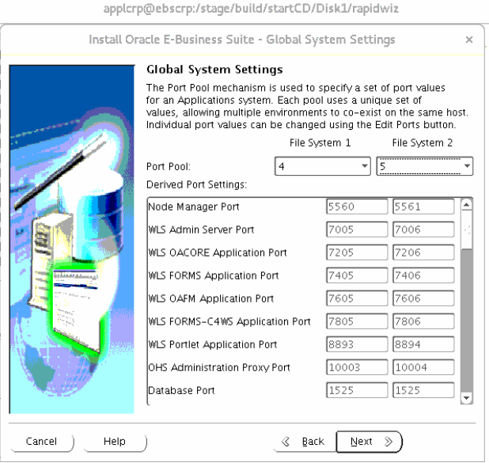

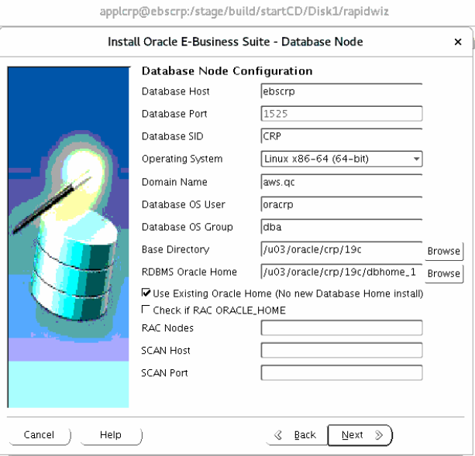

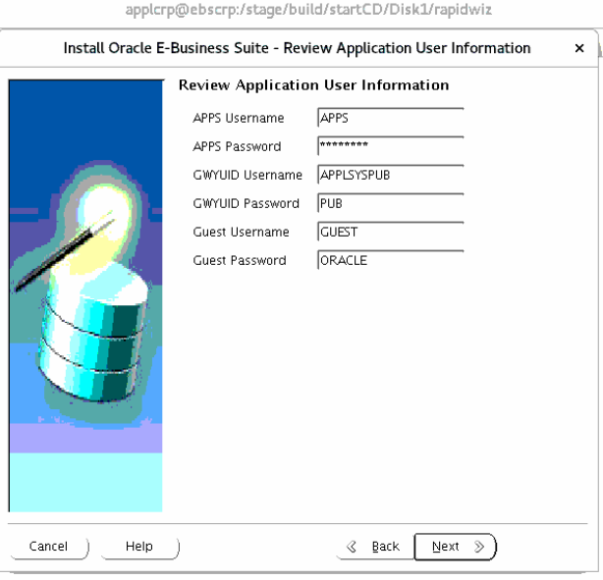

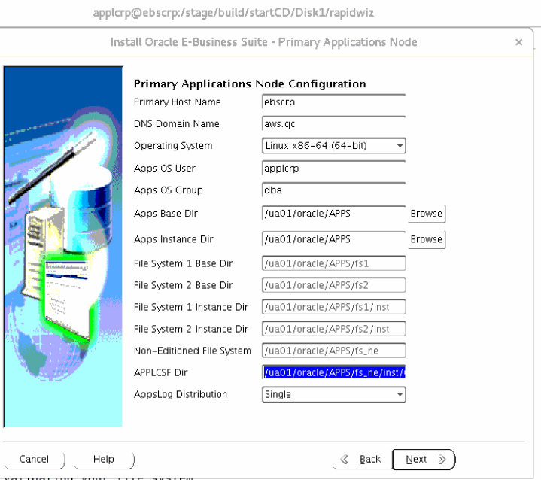

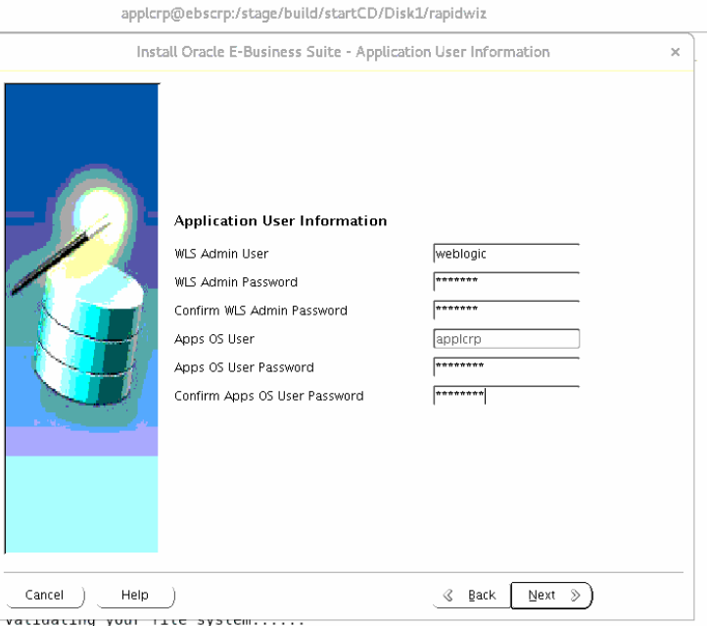

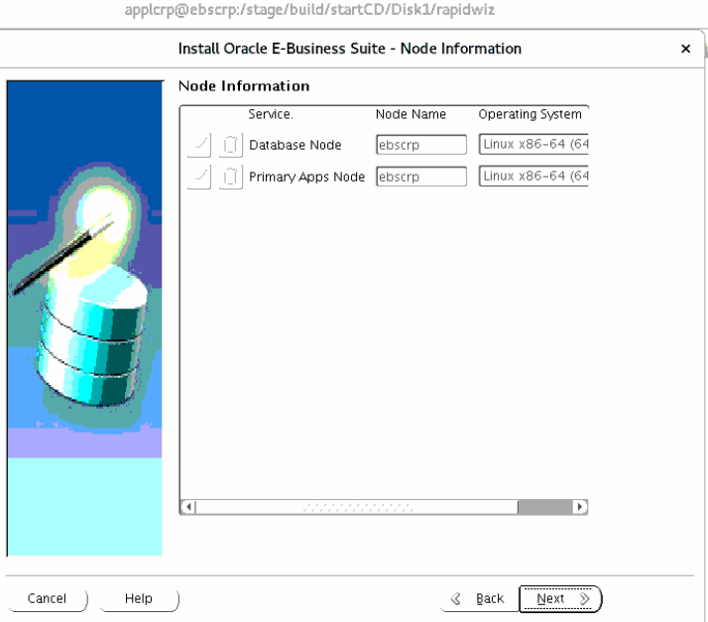

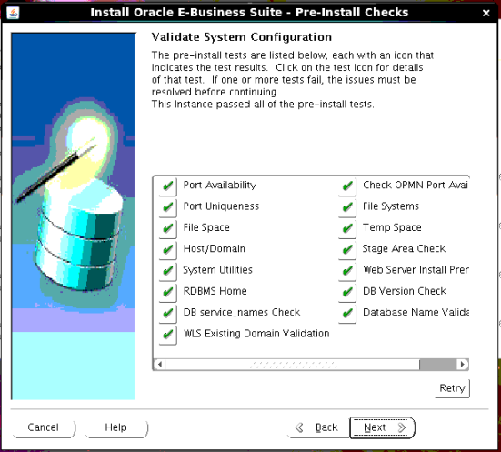

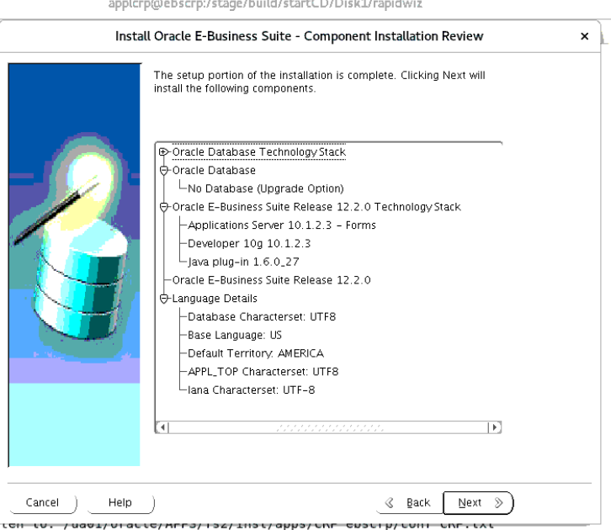

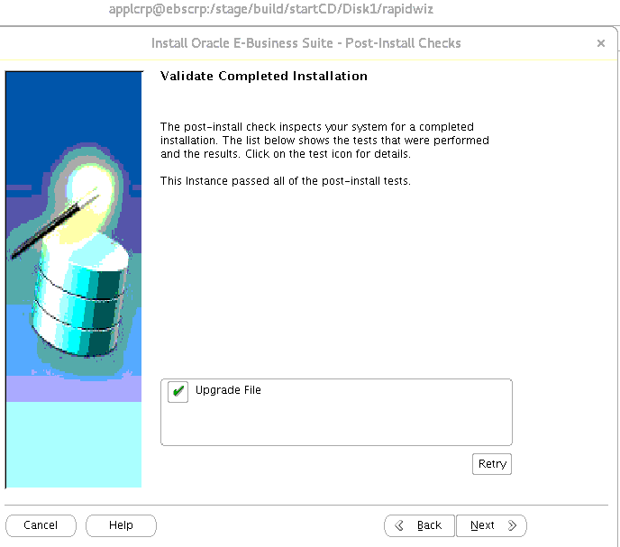

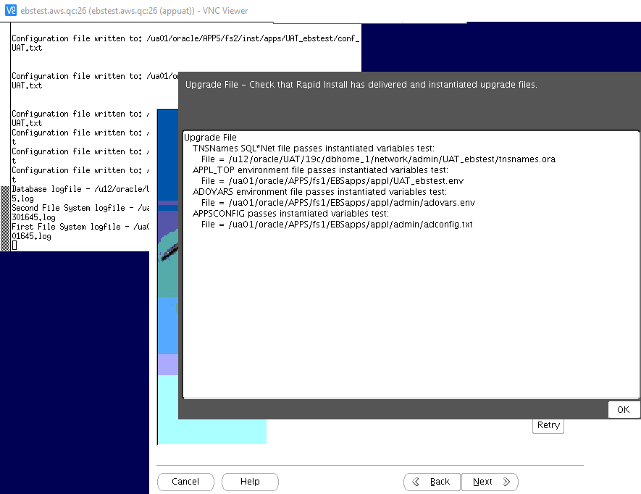

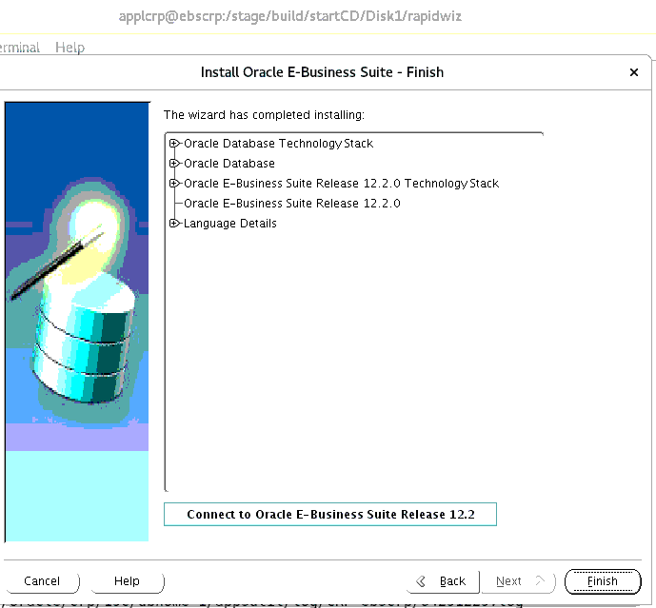

PC6 - Install ETCC MT Patches
cd /stage/ETCC/consolidated_12.2_JAN21

Forms Patching
cd /stage/ETCC/consolidated_12.2_JAN21/etcc-bundle/LINUX_X86-64/forms/10.1.2.3.0/26825525
$ORACLE_HOME/OPatch/opatch apply

cd ../25342269
$ORACLE_HOME/OPatch/opatch apply

cd ../27491934
$ORACLE_HOME/OPatch/opatch apply

FMW Web Tier patching

export ORACLE_HOME=/ua01/oracle/APPS/fs1/FMW_Home/webtier
export PATH=$ORACLE_HOME/OPatch:$PATH

cd /stage/ETCC/consolidated_12.2_JAN21/etcc-bundle/LINUX_X86-64/webtier/11.1.1.9.0/22288381
$ORACLE_HOME/OPatch/opatch apply

cd /stage/ETCC/consolidated_12.2_JAN21/etcc-bundle/LINUX_X86-64/webtier/11.1.1.9.0/31047338
$ORACLE_HOME/OPatch/opatch apply

cd /stage/ETCC/consolidated_12.2_JAN21/etcc-bundle/LINUX_X86-64/webtier/11.1.1.9.0/31304503
$ORACLE_HOME/OPatch/opatch apply

cd /stage/ETCC/consolidated_12.2_JAN21/etcc-bundle/LINUX_X86-64/webtier/11.1.1.9.0/23716938
$ORACLE_HOME/OPatch/opatch apply

RSF within FMW Web tier Patching

cd /stage/ETCC/consolidated_12.2_JAN21/etcc-bundle/LINUX_X86-64/webtier/11.1.0.7.0/22290164
$ORACLE_HOME/OPatch/opatch apply

ORACLE_COMMON Patching

export ORACLE_HOME=/ua01/oracle/APPS/fs1/FMW_Home/oracle_common
export PATH=$ORACLE_HOME/OPatch:$PATH

cd /stage/ETCC/consolidated_12.2_JAN21/etcc-bundle/LINUX_X86-64/oracle_common/11.1.1.9.0/9905685/oui
$ORACLE_HOME/OPatch/opatch apply

cd /stage/ETCC/consolidated_12.2_JAN21/etcc-bundle/LINUX_X86-64/oracle_common/11.1.1.9.0/17428617
$ORACLE_HOME/OPatch/opatch apply

cd /stage/ETCC/consolidated_12.2_JAN21/etcc-bundle/LINUX_X86-64/oracle_common/11.1.1.9.0/21366277
$ORACLE_HOME/OPatch/opatch apply

cd /stage/ETCC/consolidated_12.2_JAN21/etcc-bundle/LINUX_X86-64/oracle_common/11.1.1.9.0/21628307
$ORACLE_HOME/OPatch/opatch apply

cd ../24606362
$ORACLE_HOME/OPatch/opatch apply

cd ../24843064/oui
$ORACLE_HOME/OPatch/opatch apply

cd ../../13544814
$ORACLE_HOME/OPatch/opatch apply

cd ../16089637
$ORACLE_HOME/OPatch/opatch apply

cd ../20141119
$ORACLE_HOME/OPatch/opatch apply

cd ../30368663/oui
$ORACLE_HOME/OPatch/opatch apply

cd ../../27212806
$ORACLE_HOME/OPatch/opatch apply

cd ../28708563
$ORACLE_HOME/OPatch/opatch apply

WLS Patching
cd $FMW_HOME/utils/bsu
unzip /stage/ETCC/consolidated_12.2_JAN21/etcc-bundle/LINUX_X86-64/WLS_JAN2021_PSU/p31136426_1036_Generic.zip
chmod 755 bsu_update.sh
./bsu_update.sh install

cp bsu.sh bsu.sh_bkp
vi bsu.sh
Update MEM_ARGS to below value:
MEM_ARGS="-Xms4098m -Xmx4098m -XX:-UseGCOverheadLimit"

cd $FMW_HOME/utils/bsu/cache_dir

unzip /stage/ETCC/consolidated_12.2_JAN21/etcc-bundle/LINUX_X86-64/WLS_JAN2021_PSU/p32052267_1036_Generic.zip

cd $FMW_HOME/utils/bsu/

./bsu.sh -remove -patchlist=1LRI,2GYW,CW9T,VKXF,BLTG -prod_dir=/ua01/oracle/APPS/fs1/FMW_Home/wlserver_10.3 -log=Wlsremb4jan21psu_1YWL_1.log
./bsu.sh -remove -patchlist=YHJK,FCX7,Y5AP -prod_dir=/ua01/oracle/APPS/fs1/FMW_Home/wlserver_10.3 -log=Wlsremb4jan21psu_1YWL_2.log
./bsu.sh -install -patch_download_dir=/ua01/oracle/APPS/fs1/FMW_Home/utils/bsu/cache_dir -patchlist=1YWL -prod_dir=/ua01/oracle/APPS/fs1/FMW_Home/wlserver_10.3 -log=wlsjan21psu_1YWL.log

unzip -o /stage/ETCC/consolidated_12.2_JAN21/etcc-bundle/LINUX_X86-64/wls/10.3.6.0.210119/p13845626_10360210119_Generic.zip
unzip -o /stage/ETCC/consolidated_12.2_JAN21/etcc-bundle/LINUX_X86-64/wls/10.3.6.0.210119/p22323006_1036_Generic.zip
unzip -o /stage/ETCC/consolidated_12.2_JAN21/etcc-bundle/LINUX_X86-64/wls/10.3.6.0.210119/p26795917_1036_Generic.zip

cd $FMW_HOME/utils/bsu/

./bsu.sh -prod_dir=$FMW_HOME/wlserver_10.3 -patchlist=CIH8 -remove -log=postjan21psuconflicts_postpatches.log
./bsu.sh -install -patch_download_dir=/ua01/oracle/APPS/fs1/FMW_Home/utils/bsu/cache_dir -patchlist=HJT5,DI8E,DN1F -prod_dir=/ua01/oracle/APPS/fs1/FMW_Home/wlserver_10.3 -log=wlsjan21psuoverlay_etcc_rcmd.log

Apply WLS ADR Patch

cd $FMW_HOME/utils/bsu/cache_dir
unzip -o /stage/ETCC/WLS_ADR_JULY2020/p31241365_1036_Linux-x86-64.zip

cd $FMW_HOME/utils/bsu/
./bsu.sh -install -patch_download_dir=/ua01/oracle/APPS/fs1/FMW_Home/utils/bsu/cache_dir -prod_dir=$FMW_HOME/wlserver_10.3 -patchlist=CW7X -log=adr_patch_july2020_rcmd.log

PC7 Update EBS 12.2 Context Parameters

Update .bash_profile in App server

. /ua01/oracle/APPS/fs1/EBSapps/appl/APPSPRD_ebsprod.env

Change the APPLPTMP,DBHOST and DBPORT to below in CONTEXT_FILE

[appprd@ebsprod ~]$ cp /ua01/oracle/APPS/fs1/inst/apps/PRD_ebsprod/appl/admin/PRD_ebsprod.xml /ua01/oracle/APPS/fs1/inst/apps/PRD_ebsprod/appl/admin/PRD_ebsprod.xml_02July2021

[appprd@ebsprod ~]$ grep -i s_applptmp $CONTEXT_FILE
<APPLPTMP oa_var="s_applptmp" osd="UNIX">/usr/tmp</APPLPTMP>

Changed as below in CONTEXT FILE
=====================================
[appprd@ebsprod ~]$ grep -i s_applptmp $CONTEXT_FILE
<APPLPTMP oa_var="s_applptmp" osd="UNIX">/oratmp/PRD</APPLPTMP>

Update the ADJRIOPTS in the below files to -mx512m and NLS_LANG to American_America.AL32UTF8 ⇒ Already having 2GB. NO action Required

cd $INST_TOP/appl/admin
cp -pr adovars_PU1_ebsprod.env adovars_PU1_ebsprod.env_bkp_2jul21

< ADJRIOPTS="-mx512m"

vi $CONTEXT_FILE
<ADJRIOPTS oa_var="s_adjriopts" osd="LINUX_X86-64">-mx512m</ADJRIOPTS>

Update TNS IFILE

cd $TNS_ADMIN
vi PRD_ebsprod_ifile.ora

PRD = (DESCRIPTION=
(ADDRESS=(PROTOCOL=tcp)(HOST=ebsprod)(PORT=1521))
(CONNECT_DATA=(SID=PRD))
)

Check Custom triggers

SQL> select 'alter trigger '|| owner||'.'||trigger_name||' disable;' from dba_triggers where trigger_name like 'XX%' ;

'ALTERTRIGGER'||OWNER||'.'||TRIGGER_NAME||'DISABLE;'
--------------------------------------------------------------------------------
alter trigger APPS.XXQC_AR_BILLING_STG_T disable;

Check tablespace sizes and ensure free space of 5GB- APPS_TS_SEED and 25GB- SYSTEM

SQL> alter tablespace APPS_TS_SEED add datafile '/u14/oracle/PRD/PRDdata/a_ref05.dbf' size 5G;
Tablespace altered.
SQL> alter tablespace APPS_TS_SUMMARY add datafile '/u14/oracle/PRD/PRDdata/a_summ02.dbf' size 2G;
Tablespace altered.
SQL> alter tablespace APPS_TS_TX_DATA add datafile '/u14/oracle/PRD/PRDdata/a_txn_data07.dbf' size 10G;
Tablespace altered.
SQL> alter tablespace APPS_TS_TX_IDX add datafile '/u14/oracle/PRD/PRDdata/a_txn_ind09.dbf' size 10G;
Tablespace altered.
SQL> alter tablespace APPS_TS_TX_IDX add datafile '/u14/oracle/PRD/PRDdata/a_txn_ind10.dbf' size 10G;
Tablespace altered.
SQL> alter tablespace SYSAUX add datafile '/u14/oracle/PRD/PRDdata/sysaux07.dbf' size 20G;
Tablespace altered.
SQL> alter tablespace SYSTEM add datafile '/u14/oracle/PRD/PRDdata/system15.dbf' size 10G;
Tablespace altered.
SQL> alter tablespace XXQC_DATA add datafile '/u14/oracle/PRD/PRDdata/xxqc_data02.dbf' size 5G;
Tablespace altered.

MS1 - Milestone Backup 1
*** Stop all the application
*** Take the milestone backup

STARTUP MOUNT

[oraprd@ebsprod MS1]$cat rman_bkp_ms1_PRD.sh
echo "Backup start time is `date` " >> /stage/DB_APPS_BKP/MS1/DB/rman_full_bkp_PU1_20210702_MS1.log
rman target / > /stage/DB_APPS_BKP/MS1/DB/rman_full_bkp_PU1_20210702_MS1.log << EOF
run {
allocate channel ch1 type disk format '/stage/DB_APPS_BKP/MS1/DB/dbfull_incr0_20210702_%d_t%t_s%s_p%p';
allocate channel ch2 type disk format '/stage/DB_APPS_BKP/MS1/DB/dbfull_incr0_20210702_%d_t%t_s%s_p%p';
allocate channel ch3 type disk format '/stage/DB_APPS_BKP/MS1/DB/dbfull_incr0_20210702_%d_t%t_s%s_p%p';
allocate channel ch4 type disk format '/stage/DB_APPS_BKP/MS1/DB/dbfull_incr0_20210702_%d_t%t_s%s_p%p';
allocate channel ch5 type disk format '/stage/DB_APPS_BKP/MS1/DB/dbfull_incr0_20210702_%d_t%t_s%s_p%p';
allocate channel ch6 type disk format '/stage/DB_APPS_BKP/MS1/DB/dbfull_incr0_20210702_%d_t%t_s%s_p%p';
allocate channel ch7 type disk format '/stage/DB_APPS_BKP/MS1/DB/dbfull_incr0_20210702_%d_t%t_s%s_p%p';
allocate channel ch8 type disk format '/stage/DB_APPS_BKP/MS1/DB/dbfull_incr0_20210702_%d_t%t_s%s_p%p';
allocate channel ch9 type disk format '/stage/DB_APPS_BKP/MS1/DB/dbfull_incr0_20210702_%d_t%t_s%s_p%p';
allocate channel ch10 type disk format '/stage/DB_APPS_BKP/MS1/DB/dbfull_incr0_20210702_%d_t%t_s%s_p%p';
backup incremental level 0 section size 10G database
filesperset 5
include current controlfile;
backup current controlfile FORMAT '/stage/DB_APPS_BKP/MS1/DB/cffull_PU1_20210702_d%d_t%t_s%s_p%p';
}
EOF
echo "Backup end time is `date` " >> /stage/DB_APPS_BKP/MS1/DB/rman_full_bkp_PU1_20210702_MS1.log

OH:
====
[oraprd@ebsprod MS1]$ cat backup_oh_ms1.sh
cd /u03/prd/prddb/19c/
nohup tar -czvf /stage/DB_APPS_BKP/MS1/OH/PRD_OH_ms1.tar.gz dbhome_1 >/stage/DB_APPS_BKP/MS1/OH/PRD_OH_ms1_bkp.log &

cd /ua01/oracle/APPS/
nohup tar -czvf /stage/DB_APPS_BKP/MS1/APPS/PRD_fs1_ms1.tar.gz fs1 >/stage/DB_APPS_BKP/MS1/APPS/PRD_fs1_ms1_bkp.log &
nohup tar -czvf /stage/DB_APPS_BKP/MS1/APPS/PRD_fs2_ms1.tar.gz fs2 >/stage/DB_APPS_BKP/MS1/APPS/PRD_fs2_ms1_bkp.log &
nohup tar -czvf /stage/DB_APPS_BKP/MS1/APPS/PRD_fsne_ms1.tar.gz fs_ne >/stage/DB_APPS_BKP/MS1/APPS/PRD_fs_ne_ms1_bkp.log &

cd /u03/oracle/
nohup tar -czvf /stage/DB_APPS_BKP/MS1/APPS/APPSoraInventory_ms1.tar.gz oraInventory >/stage/DB_APPS_BKP/MS1/APPS/PRD_oraInventory_ms1_bkp.log &

CUTOVER

CU0 - Update DB parameters

alter system set recyclebin=off deferred;
alter system set optimizer_adaptive_features=false;
alter system set "_disable_actualization_for_grant"=true;
ALTER SYSTEM SET max_dump_file_size = unlimited scope=spfile;
ALTER SYSTEM SET "_system_trig_enabled"=TRUE;
alter system set service_names='EBSPROD','ebs_patch';
alter system set job_queue_processes=16 ;

ALTER PROFILE DEFAULT LIMIT FAILED_LOGIN_ATTEMPTS UNLIMITED;
ALTER PROFILE AD_PATCH_MONITOR_PROFILE LIMIT FAILED_LOGIN_ATTEMPTS UNLIMITED;
ALTER PROFILE EM_OAM_MONITOR_PROFILE LIMIT FAILED_LOGIN_ATTEMPTS UNLIMITED;
ALTER PROFILE GSM_PROF LIMIT FAILED_LOGIN_ATTEMPTS UNLIMITED;
ALTER PROFILE ORA_STIG_PROFILE LIMIT FAILED_LOGIN_ATTEMPTS UNLIMITED;

=====

CU1 - Apply AD CUP Patches

create table SYSTEM.invalids_CU1 as (select * from dba_invalid_objects);

Enable Maintenance mode

sqa @$AD_TOP/patch/115/sql/adsetmmd.sql ENABLE

[oraprd@ebsprod DB]$ export ORACLE_PDB_SID=PRD
[oraprd@ebsprod DB]$ sqlplus /nolog

SQL> @/stage/ad_grants_v/adgrants.sql_delta12 APPS
Connected.

PL/SQL procedure successfully completed.

EBSPROD> @?/rdbms/admin/utlrp

Grant execute on dbms_redefinition to APPS;
cp /stage/ebs_patches/ADZDDTFIX/17268684/admin/ADZDDTFIX.sql /u03/prd/prddb/19c/dbhome_1/appsutil/admin/

@ADZDDTFIX.sql

No Data :
[oraprd@ebsprod admin]$ cat adzddtfix.out
[oraprd@ebsprod admin]$

Execute the Generated SQL procedures as sysdba
###############################################
[appprd@ebsprod AD_source]$ pwd
/stage/ebs_patches/AD_source

[appprd@ebsprod AD_source]$ unzip "*.zip"
[appprd@ebsprod AD_source]$ mkdir -p /stage/ebs_patches/10117518_CUP11
admrgpch -s /stage/ebs_patches/AD_source -d /stage/ebs_patches/10117518_CUP11 -merge_name 10117518_CUP11 -admode

time adpatch logfile=10117518_cup11.log patchtop=/stage/ebs_patches/10117518_CUP11 driver=u_10117518_CUP11.drv workers=8

Time taken : 35 MINS

POST STEP:
=========
Adadmin
Run adadmin -> Compile/Reload Applications Database Entities menu ->
Compile APPS schema.
2. Type "No" when prompt for Run Invoker Rights processing in incremental mode [No] ?

CU2 - Apply Pre-Install Patches

cd /stage/ebs_patches/Preinstall/30399970
time adpatch driver=u30399970.drv logfile=u30399970.log preinstall=y

cd ../ 31219447
time adpatch driver=u31219447.drv logfile=u31219447.log preinstall=y

cd ../31745734
time adpatch driver=u31745734.drv logfile=u31745734.log preinstall=y

CU3 - Merge Upgrade Driver

cd $AU_TOP/patch/115/driver
admrgpch -d . -preinstall -master u10124646.drv

CU4 - Disable Custom Triggers and Custom Jobs

Triggers:

select 'alter trigger '|| owner||'.'||trigger_name||' disable;' from dba_triggers where trigger_name like 'XX%' ;

sqa

SQL> select 'alter trigger '|| owner||'.'||trigger_name||' disable;' from dba_triggers where trigger_name like 'XX%' ;

'ALTERTRIGGER'||OWNER||'.'||TRIGGER_NAME||'DISABLE;'
--------------------------------------------------------------------------------
alter trigger APPS.XXQC_AR_BILLING_STG_T disable;

select job_name, owner, enabled from dba_scheduler_jobs where ENABLED='TRUE';

Jobs:

exec dbms_scheduler.disable('PURGE_LOG',TRUE);
exec dbms_scheduler.disable('GATHER_SYS_STATS_JOB',TRUE);
exec dbms_scheduler.disable('ORA$AUTOTASK_CLEAN',TRUE);
exec dbms_scheduler.disable('DRA_REEVALPRDE_OPEN_FAILURES',TRUE);
exec dbms_scheduler.disable('BSLN_MAINTAIN_STATS_JOB',TRUE);
exec dbms_scheduler.disable('RSE$CLEAN_RECOVERABLE_SCRIPT',TRUE);
exec dbms_scheduler.disable('SM$CLEAN_AUTO_SPLIT_MERGE',TRUE);
exec dbms_scheduler.disable('CLEANUP_NON_EXIST_OBJ',TRUE);
exec dbms_scheduler.disable('PMO_DEFERRED_GIDX_MAINT_JOB',TRUE);
exec dbms_scheduler.disable('CLEANUP_ONLINE_IND_BUILD',TRUE);
exec dbms_scheduler.disable('CLEANUP_TAB_IOT_PMO',TRUE);
exec dbms_scheduler.disable('CLEANUP_TRANSIENT_TYPE',TRUE);
exec dbms_scheduler.disable('CLEANUP_TRANSIENT_PKG',TRUE);
exec dbms_scheduler.disable('CLEANUP_ONLINE_PMO',TRUE);
exec dbms_scheduler.disable('FILE_SIZE_UPD',TRUE);
exec dbms_scheduler.disable('DRA_REEVALUATE_OPEN_FAILURES',TRUE);
exec dbms_job.broken(104,TRUE);
exec dbms_job.broken(225,TRUE);

APPS User:

BEGIN
FOR J IN (SELECT * FROM user_jobs)
LOOP
dbms_job.broken( J.job, TRUE);
END LOOP;
END;
/

select schema_user, 'exec dbms_job.broken('||job||',TRUE);' from dba_jobs where BROKEN='N' order by schema_user;

CU5 - Apply 1220 Upgrade Driver

In Screen or Vnc:

cd $AU_TOP/patch/115/driver
time adpatch driver=u_merged.drv logfile=1220_upg_EBSPROD.log options=nocopyportion,nogenerateportion workers=8

batchsize: 5000

TIME TAKEN : 207 Mins
KNOWN ISSUE:
=============
/stage/.scripts/known_issues_bef_122_merge.sql

CU6 - Configure EBS 12.2 Filesystem

vi $CONTEXT_FILE on both RunFS and PatchFS

<dbhost oa_var="s_dbhost">ebsprod</dbhost>
<cmanhost oa_var="s_cmanhost">ebsprod</cmanhost>
<dbport oa_var="s_dbport" oa_type="EXT_PORT" base="1521" step="1" range="-1" label="Database Port">1521</dbport>

echo $DISPLAY

cd /stage/build/startCD/Disk1/rapidwiz
./rapidwiz

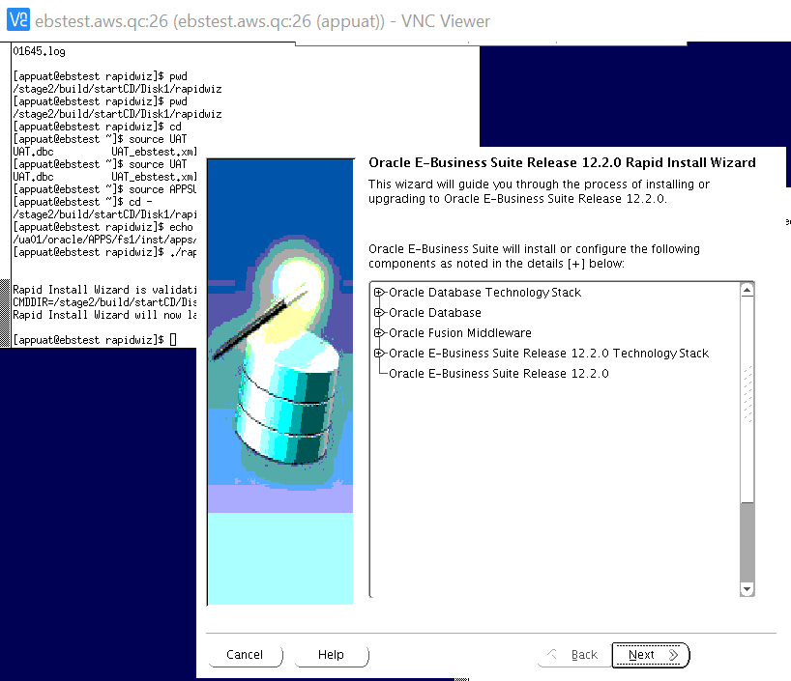
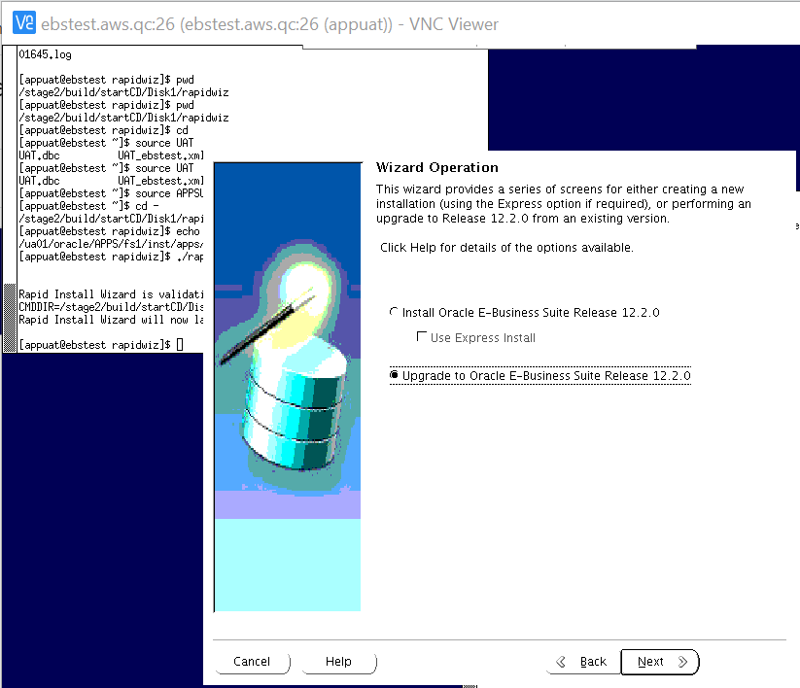
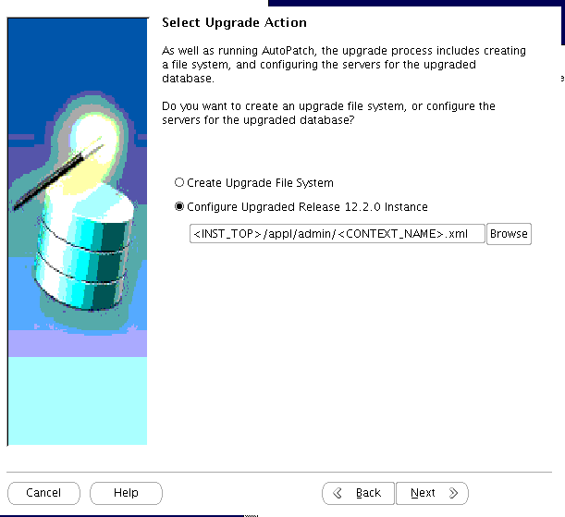
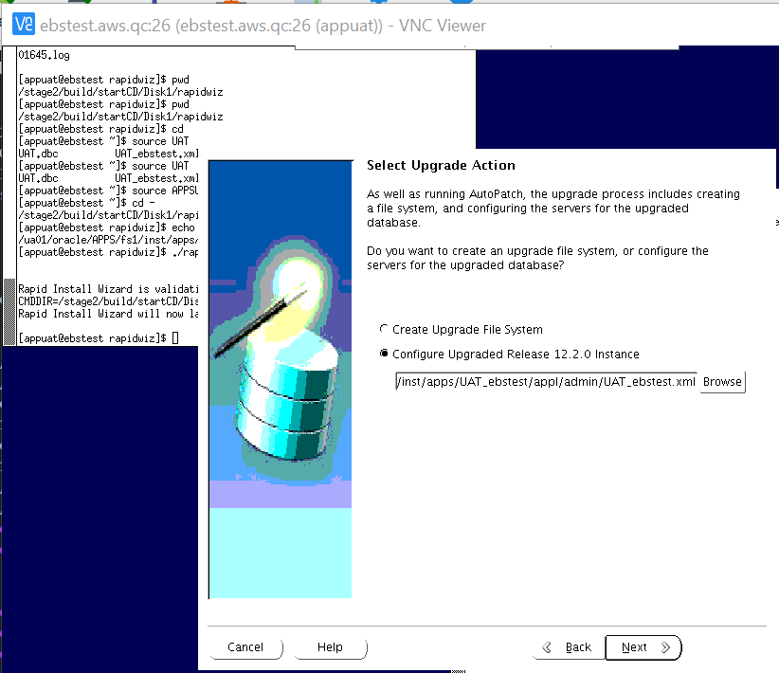
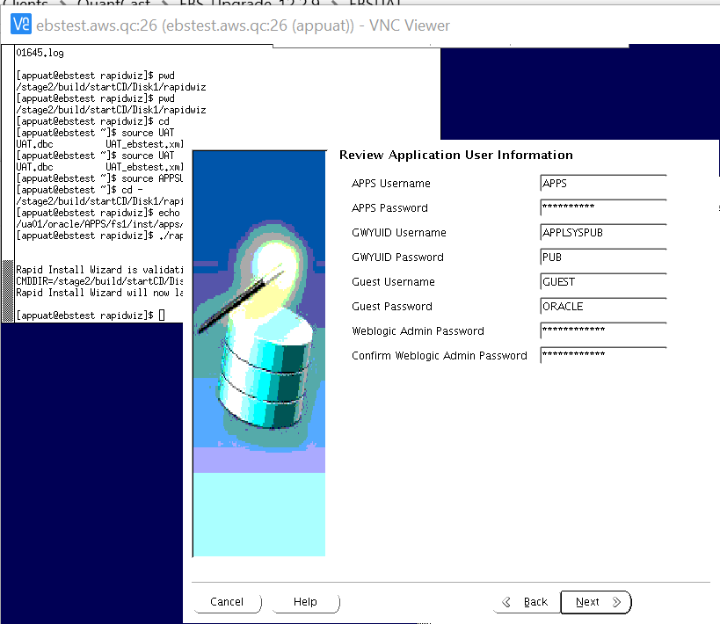
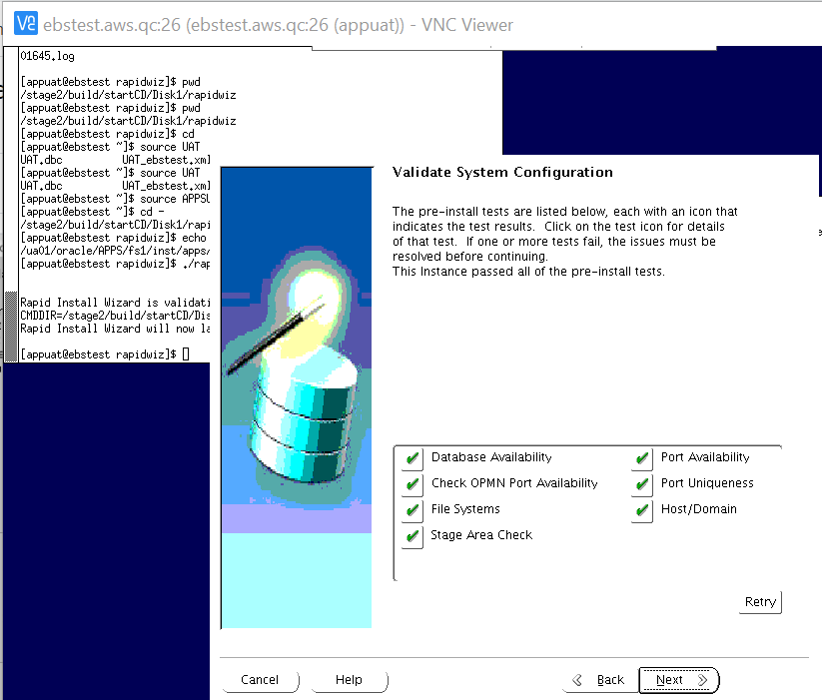
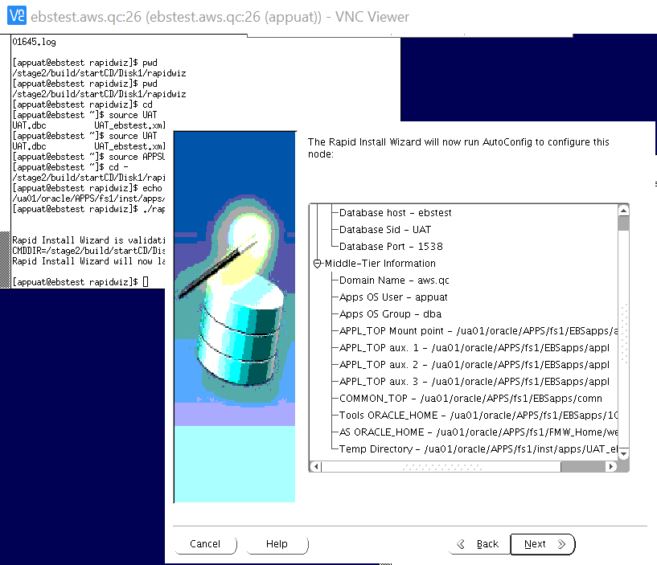
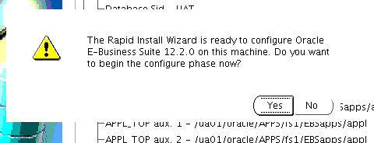
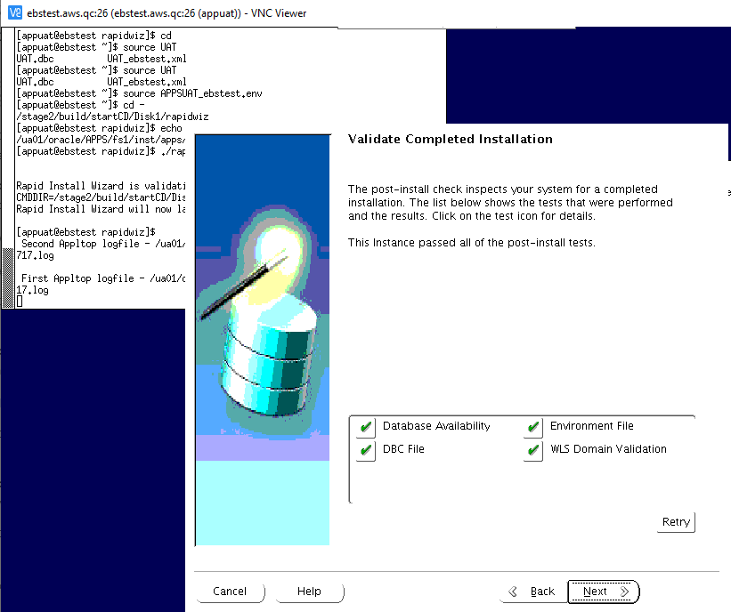
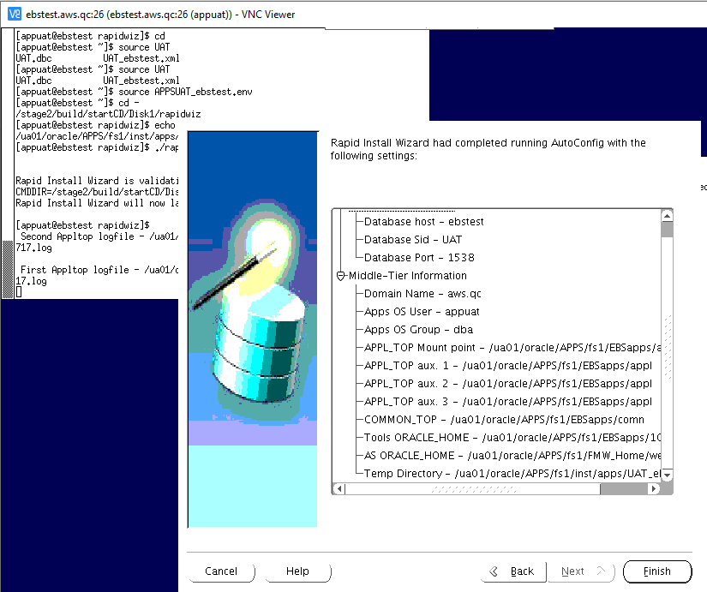

Log Locations:
Second File System logfile - /ua01/oracle/APPS/fs2/inst/apps/PRD_ebsprod/logs/
First File System logfile - /ua01/oracle/APPS/fs1/inst/apps/PRD_ebsprod/logs/
MS2 - Milestone Backup 2

STOP Applications.
Putting DB in Mount State.

cd /ua01/oracle/APPS/
nohup tar -czvf /stage/DB_APPS_BKP/MS2/APPS/PRD_fs1_ms2.tar.gz fs1 >/stage/DB_APPS_BKP/MS2/APPS/PRD_fs1_ms2_bkp.log &
nohup tar -czvf /stage/DB_APPS_BKP/MS2/APPS/PRD_fs2_ms2.tar.gz fs2 >/stage/DB_APPS_BKP/MS2/APPS/PRD_fs2_ms2_bkp.log &
nohup tar -czvf /stage/DB_APPS_BKP/MS2/APPS/PRD_fsne_ms2.tar.gz fs_ne >/stage/DB_APPS_BKP/MS2/APPS/PRD_fs_ne_ms2_bkp.log &

cd /u03/oracle/
nohup tar -czvf /stage/DB_APPS_BKP/MS2/APPS/APPSoraInventory_ms2.tar.gz oraInventory >/stage/DB_APPS_BKP/MS2/APPS/PRD_oraInventory_ms2_bkp.log &

cd /u03/prd/prddb/19c/
nohup tar -czvf /stage/DB_APPS_BKP/MS2/OH/PRD_OH_ms2.tar.gz dbhome_1 >/stage/DB_APPS_BKP/MS2/OH/PRD_OH_ms2_bkp.log &
echo "Backup start time is `date` " >> /stage/DB_APPS_BKP/MS2/DB/rman_full_bkp_PU1_MS2.log
rman target / > /stage/DB_APPS_BKP/MS2/DB/rman_full_bkp_PU1_MS2.log << EOF
run {
allocate channel ch1 type disk format '/stage/DB_APPS_BKP/MS2/DB/dbfull_incr0_%d_t%t_s%s_p%p';
allocate channel ch2 type disk format '/stage/DB_APPS_BKP/MS2/DB/dbfull_incr0_%d_t%t_s%s_p%p';
allocate channel ch3 type disk format '/stage/DB_APPS_BKP/MS2/DB/dbfull_incr0_%d_t%t_s%s_p%p';
allocate channel ch4 type disk format '/stage/DB_APPS_BKP/MS2/DB/dbfull_incr0_%d_t%t_s%s_p%p';
allocate channel ch5 type disk format '/stage/DB_APPS_BKP/MS2/DB/dbfull_incr0_%d_t%t_s%s_p%p';
allocate channel ch6 type disk format '/stage/DB_APPS_BKP/MS2/DB/dbfull_incr0_%d_t%t_s%s_p%p';
allocate channel ch7 type disk format '/stage/DB_APPS_BKP/MS2/DB/dbfull_incr0_%d_t%t_s%s_p%p';
allocate channel ch8 type disk format '/stage/DB_APPS_BKP/MS2/DB/dbfull_incr0_%d_t%t_s%s_p%p';
allocate channel ch9 type disk format '/stage/DB_APPS_BKP/MS2/DB/dbfull_incr0_%d_t%t_s%s_p%p';
allocate channel ch10 type disk format '/stage/DB_APPS_BKP/MS2/DB/dbfull_incr0_%d_t%t_s%s_p%p';
backup incremental level 0 section size 10G database
filesperset 5
include current controlfile;
backup current controlfile FORMAT '/stage/DB_APPS_BKP/MS2/DB/cffull_PU1_d%d_t%t_s%s_p%p';
}
EOF
echo "Backup end time is `date` " >> /stage/DB_APPS_BKP/MS2/DB/rman_full_bkp_PU1_MS2.log

ONLINE ENABLEMENT

OLE1 - Apply Online Patching Readiness and GSCC Report patches

Run adgrant.sql_69 from patch /stage/ebs_patches/OLE/31026891/admin/adgrants.sql

adpatch options=hotpatch,noprereq,nocompilejsp patchtop=/stage/ebs_patches/OLE/31026891 logfile=u31026891.log driver=u31026891.drv workers=8
adpatch options=hotpatch,noprereq,nocompilejsp patchtop=/stage/ebs_patches/OLE/30611142 logfile=u30611142.log driver=u30611142.drv workers=8

**************
mkdir -p $LOG_HOME/appl/op
cd $LOG_HOME/appl/op
sqs @$AD_TOP/sql/ADZDPSUM.sql
sqs @$AD_TOP/sql/ADZDPMAN.sql
sqs @$AD_TOP/sql/ADZDPAUT.sql
sqa @$AD_TOP/sql/ADZDDBCC.sql
sqa @$AD_TOP/sql/ADZDEXRPT.sql

mv adzdpsum.txt adzdpsum_pre.txt
mv adzdpman.txt adzdpman_pre.txt
mv adzdpaut.txt adzdpaut_pre.txt
mv adzddbcc.lst adzddbcc_pre.lst
mv adzdexrpt.txt adzdexrpt_pre.txt

***************

OLE2 - Register Custom Schemas

sqa
exec fnd_oracle_user_pkg.load_row('XXX_MTG_INSIGHT','CUSTOM','INVALID',NULL,'N','B');
exec fnd_oracle_user_pkg.load_row('XXQC_DW','CUSTOM','INVALID',NULL,'N','B');
exec fnd_oracle_user_pkg.load_row('XXQC_HYP','CUSTOM','INVALID',NULL,'N','B');
exec fnd_oracle_user_pkg.load_row('APPSREAD','CUSTOM','INVALID',NULL,'N','B');
exec fnd_oracle_user_pkg.load_row('XXQC_RO','CUSTOM','INVALID',NULL,'N','B');
exec fnd_oracle_user_pkg.load_row('XXQC_TB','CUSTOM','INVALID',NULL,'N','B');
exec fnd_oracle_user_pkg.load_row('PORTAL30_SSO','CUSTOM','INVALID',NULL,'N','B');
exec fnd_oracle_user_pkg.load_row('PORTAL30','CUSTOM','INVALID',NULL,'N','B');

Commit;

OLE3 - Perform fix for AD_ZD_PREP invalid object
export ORACLE_PDB_SID=PRD;
sqlplus / as sysdba

@?/rdbms/admin/dbmsxdbschmig.sql
@?/rdbms/admin/prvtxdbschmig.plb

sqlplus /nolog
@/stage/ad_grants_v/adgrants.sql_ole APPS

sqlplus / as sysdba
GRANT SELECT, UPDATE, DELETE, INSERT on sys.xdb$moveSchemaTab to apps;
grant execute on SYS.XDB_MIGRATESCHEMA to apps;

sqa

alter package AD_ZD_PREP compile body;
alter package AD_ZD_TABLE compile body;

OLE4 - Ensure there are no AD_ZD invalid objects
select owner,object_name,object_type,status from dba_objects where status='INVALID' and object_name like 'AD_ZD%';

OLE5 - Apply the Online Patching Enablement patch
create table SYSTEM.invalids_OLE5 as (select * from dba_invalid_objects);

adpatch options=hotpatch,noprereq,nocompilejsp patchtop=/stage/ebs_patches/OLE logfile=u13543062.log driver=u13543062.drv workers=8

OLE6 - Run ETCC
update ORACLE_HOME details in .bashrc_EBSPROD

Run ETCC on both Db nodes and APP node

EBSPROD
sh /stage/ETCC/patches/PRD_ETCC/checkDBpatch.sh

sh /stage/ETCC/patches/etcc_1229/checkMTpatch.sh

Run datapatch

sysdba
startup upgrade

cd $ORACLE_HOME/OPatch
./datapatch

SQL> Shut immediate;
SQL> startup

AD & TXK PATCHES

AT1 - Run adgrants.sql
[oraprd@ebsprod ~]$ export ORACLE_PDB_SID=PRD;
[oraprd@ebsprod ~]$ sqlplus /nolog

SQL*Plus: Release 19.0.0.0.0 - Production on Sun Aug 29 08:31:06 2021
Version 19.10.0.0.0

Copyright (c) 1982, 2020, Oracle. All rights reserved.

SQL> @/stage/ad_grants_v/adgrants.sql_delta12 APPS

AT2 - Start Weblogic Admin Server
{ echo weblogic4crp ; echo apps4crp ; }|adadminsrvctl.sh start

AT3 - Drop ADX_PRE_AUTOCONFIG Table
sqa @$AD_TOP/patch/115/sql/txkDropAdxPreAutoConfig.sql

AT4 - Apply AD.12 Patch
create table SYSTEM.invalids_AT5 as (select * from dba_invalid_objects);

Delete entries of Source APP node/s from FND_NODES
SQL> exec fnd_conc_clone.setup_clean();

PL/SQL procedure successfully completed.

SQL> commit;

Commit complete.

oraprd@EBSPROD.aws.qc:EBSPROD > pwd
/u03/prd/prddb/19c/dbhome_1/appsutil

oraprd@EBSPROD.aws.qc:EBSPROD > ./scripts/EBSPROD_EBSPROD/adautocfg.sh

[appprd@ebsprod ~]$ adautocfg.sh

APPLY AD.12 Patch
{ echo apps4crp; echo SYSPRD1UPG; echo weblogic4crp ; } |adop phase=apply patches=30628681 hotpatch=yes patchtop=/stage/ebs_patches/DELTA12

AT5 - Apply TXK.12 Merge patches
{ echo apps4crp; echo SYSPRD1UPG; echo weblogic4crp ; } | time adop phase=apply patches=30735865,31904550 hotpatch=yes merge=yes patchtop=/stage/ebs_patches/DELTA12

AT6 - Stop Weblogic Admin Server
{ echo weblogic4crp ; echo apps4crp ;}|adadminsrvctl.sh stop
{ echo weblogic4crp ;} | adnodemgrctl.sh stop

AT7 - Migrate Latest Code to DB node
. /ua01/oracle/APPS/EBSapps.env run
perl $AD_TOP/bin/admkappsutil.pl
cp /ua01/oracle/APPS/fs1/inst/apps/PRD_ebsprod/admin/out/appsutil.zip /stage/tools/appsutil.zip_uat_at7

sqa

create table fnd_nodes_bkp1_a7 as select * from fnd_nodes;
create table fnd_oam_context_files_bkp1_a7 as select * from fnd_oam_context_files;
exec fnd_conc_clone.setup_clean();
commit;

On the Database Tier (as the ORACLE user):
Copy or SCP the appsutil.zip file to $ORACLE_HOME on all the RAC nodes

cd $ORACLE_HOME
mv appsutil appsutil_at9
unzip -o /stage/scripts/appsutil.zip

AT8 - Build Context File on DB node
[oraprd@ebsprod bin]$ . $ORACLE_HOME/PRD_ebsprod.env
[oraprd@ebsprod bin]$ perl adbldxml.pl jtop=$ORACLE_HOME/jdk

Starting context file generation for db tier..
Using JVM from /u03/prd/prddb/19c/dbhome_1/jdk/bin/java to execute java programs..
APPS Password:

The log file for this adbldxml session is located at:
/u03/prd/prddb/19c/dbhome_1/appsutil/log/adbldxml_08291000.log
s_pluggable_database : true
s_pdb_name : PRD

Enter the database listener name:EBSPCDB
Enter the value for Display Variable: ebsprod:4

AT9 - Run Autoconfig on DB node
Source PRD_ebsprod.env
cd $ORACLE_HOME/appsutil/bin
./adconfig.sh contextfile=/u03/prd/prddb/19c/dbhome_1/appsutil/PRD_ebsprod.xml

AT10 - Run Autoconfig on Apps Tier
[appprd@ebsprod scripts]$ ./adautocfg.sh -appspass=apps4crp

MILESTONE BACKUP 3
[oraprd@ebsprod MS3]$ cat backup_oh_ms3.sh
cd /ua01/oracle/APPS/
nohup tar -czvf /stage/DB_APPS_BKP/MS3/APPS/PRD_fs1_ms3.tar.gz fs1 >/stage/DB_APPS_BKP/MS3/APPS/PRD_fs1_ms3_bkp.log &
nohup tar -czvf /stage/DB_APPS_BKP/MS3/APPS/PRD_fs2_ms3.tar.gz fs2 >/stage/DB_APPS_BKP/MS3/APPS/PRD_fs2_ms3_bkp.log &
nohup tar -czvf /stage/DB_APPS_BKP/MS3/APPS/PRD_fsne_ms3.tar.gz fs_ne >/stage/DB_APPS_BKP/MS3/APPS/PRD_fs_ne_ms3_bkp.log &

cd /u03/oracle/
nohup tar -czvf /stage/DB_APPS_BKP/MS3/APPS/APPSoraInventory_ms3.tar.gz oraInventory >/stage/DB_APPS_BKP/MS3/APPS/PRD_oraInventory_ms3_bkp.log &

cd /u03/prd/prddb/19c/
nohup tar -czvf /stage/DB_APPS_BKP/MS3/OH/PRD_OH_ms3.tar.gz dbhome_1 >/stage/DB_APPS_BKP/MS3/OH/PRD_OH_ms3_bkp.log &
echo "Backup start time is `date` " >> /stage/DB_APPS_BKP/MS3/DB/rman_full_bkp_PU1_MS3.log
rman target / > /stage/DB_APPS_BKP/MS3/DB/rman_full_bkp_PU1_MS3.log << EOF
run {
allocate channel ch1 type disk format '/stage/DB_APPS_BKP/MS3/DB/dbfull_incr0_%d_t%t_s%s_p%p';
allocate channel ch2 type disk format '/stage/DB_APPS_BKP/MS3/DB/dbfull_incr0_%d_t%t_s%s_p%p';
allocate channel ch3 type disk format '/stage/DB_APPS_BKP/MS3/DB/dbfull_incr0_%d_t%t_s%s_p%p';
allocate channel ch4 type disk format '/stage/DB_APPS_BKP/MS3/DB/dbfull_incr0_%d_t%t_s%s_p%p';
allocate channel ch5 type disk format '/stage/DB_APPS_BKP/MS3/DB/dbfull_incr0_%d_t%t_s%s_p%p';
allocate channel ch6 type disk format '/stage/DB_APPS_BKP/MS3/DB/dbfull_incr0_%d_t%t_s%s_p%p';
allocate channel ch7 type disk format '/stage/DB_APPS_BKP/MS3/DB/dbfull_incr0_%d_t%t_s%s_p%p';
allocate channel ch8 type disk format '/stage/DB_APPS_BKP/MS3/DB/dbfull_incr0_%d_t%t_s%s_p%p';
allocate channel ch9 type disk format '/stage/DB_APPS_BKP/MS3/DB/dbfull_incr0_%d_t%t_s%s_p%p';
allocate channel ch10 type disk format '/stage/DB_APPS_BKP/MS3/DB/dbfull_incr0_%d_t%t_s%s_p%p';
backup incremental level 0 section size 10G database
filesperset 5
include current controlfile;
backup current controlfile FORMAT '/stage/DB_APPS_BKP/MS3/DB/cffull_PU1_d%d_t%t_s%s_p%p';
}
EOF
echo "Backup end time is `date` " >> /stage/DB_APPS_BKP/MS3/DB/rman_full_bkp_PU1_MS3.log

12.2.9 UPGRADE

RUP1 - Apply 12.2.9 Upgrade Patch in Downtime Mode and Interactive Mode

create table SYSTEM.invalids_rup1 as (select * from dba_invalid_objects);

Use Below Command only to apply the patch:
cd /stage/ebs_patches/1229/28840850
time adop phase=apply apply_mode=downtime wait_on_failed_job=yes workers=10

Applying patch interactively.

Enter command line parameters followed by <Return>, or just <Return> for default processing:

Filename [adpatch.log] : u28840850.log

Num Workers = 10
Options = "hotpatch".

You can be notified by email if a failure occurs.
Do you wish to activate this feature [No] ?

Please enter the batchsize [1000] : 5000

The default directory is [/stage/1229/28840850] :

Please enter the name of your AutoPatch driver file : u28840850.drv

Do you wish to apply this patch now [No] ? Yes

RUP2 - Apply 1220 Online Help Patch -- 56 mins in PRD
create table SYSTEM.invalids_RUP2 as (select * from dba_invalid_objects);

{ echo apps4crp; echo SYSPRD1UPG; echo weblogic4crp; } | time adop phase=apply patchtop=$AU_TOP/patch/115 patches=driver:u10201000.drv options=nocopyportion,nogenerateportion,forceapply hotpatch=yes workers=16

RUP3 - Apply 1229 Online Help Patch --
{ echo apps4crp; echo SYSPRD1UPG; echo weblogic4crp; } | time adop phase=apply patches=28840900 hotpatch=yes patchtop=/stage/ebs_patches/1229 workers=16

RUP4 - Apply OA Framework (FWK) Release 12.2.9 Bundle 7 Patch

{ echo apps4crp; echo SYSPRD1UPG; echo weblogic4crp; } | adop phase=apply patches=32308701 apply_mode=downtime patchtop=/stage/ebs_patches/OA_FWK workers=16

Note : 32130874 This Patch has been Superseded. Reason Implicitly Superseded when its Replacement bug was released 32308701

RUP5 - Apply EBS JAN 2021 CPU Patch

export ORACLE_PDB_SID=PRD
sqlplus /nolog
@/stage/ad_grants_v/adgrants.sql_delta12 APPS

JAN 2021 CPU Patch

{ echo apps4crp; echo SYSPRD1UPG; echo weblogic4crp; } | adop phase=apply patches=32071646 apply_mode=downtime patchtop=/stage/ebs_patches/CPU_EBS workers=16

Post CPU Patches

{ echo apps4crp; echo SYSPRD1UPG; echo weblogic4crp; } | adop phase=apply patches=32117360,32004048 apply_mode=downtime patchtop=/stage/ebs_patches/CPU_EBS workers=16

{ echo apps4crp; echo SYSPRD1UPG; echo weblogic4crp; } | adop phase=apply patches=31745969,31206584,30980446,30367367,25229413,26282050,29662975 apply_mode=downtime merge=yes patchtop=/stage/ebs_patches/CPU_EBS workers=16

RUP6 - Apply Post patches

create table SYSTEM.invalids_RUP6 as (select * from dba_invalid_objects);

time adop phase=apply apply_mode=downtime wait_on_failed_job=yes workers=16

MILESTONE BACKUP 4

cd /ua01/oracle/APPS/
nohup tar -cvf /stage/PRD/backup/ua01_EBSPROD_fs1_ms4.tar.gz fs1 &

cd /ua4002/oracle/EBSPROD/
nohup tar -cvf /stage/PRD/backup/fininst_EBSPROD_fs1_ms4.tar.gz fs1 &

cd /ua01/
nohup tar -cvf /stage/PRD/backup/oraInventory_ms4.tar.gz oraInventory &

JDK UPGRADE

JDK1 - Main JDK Upgrade
create table SYSTEM.invalids_JDK1 as (select * from dba_invalid_objects);

cd $COMMON_TOP/util
mv jdk32 jdk32_old
mv jdk64 jdk64_old
tar -xvf /stage/ebs_patches/JDK_JRE/jdk-7u291-linux-i586.tar.gz
mv jdk1.7.0_291 jdk32
tar -xvf /stage/ebs_patches/JDK_JRE/jdk-7u291-linux-x64.tar.gz
mv jdk1.7.0_291 jdk64

JDK2 - Update JDK Configuration
Bring up Weblogic Admin Server
adadminsrvctl.sh start
$FND_TOP/bin/txkrun.pl –script =SetJDKCfg

Enter the full path of new 64-bit JDK: /ua01/oracle/APPS/fs1/EBSapps/comn/util/jdk64
Enter the full path of new 32-bit JDK: /ua01/oracle/APPS/fs1/EBSapps/comn/util/jdk32

JDK3 - Run autoconfig
Bring down Admin Server and node manager.

adadminsrvctl.sh stop
adnodemgrctl.sh stop

adautocfg.sh

JDK4 - WebTier JDK Upgrade - 64 Bit
cd $FMW_HOME/webtier

mv jdk jdk_old
tar -xvf /stage/ebs_patches/JDK_JRE/jdk-7u291-linux-x64.tar.gz
mv jdk1.7.0_291 jdk

JDK5 - 1012 Home JDK Upgrade-32 bit
cd $ORACLE_HOME
mv jdk jdk_old
tar -xvf /stage/ebs_patches/JDK_JRE/jdk-7u291-linux-i586.tar.gz
mv jdk1.7.0_291 jdk

JDK6 - Relink Forms

cd $ORACLE_HOME/forms/lib
make -f ins_forms.mk sharedlib install

JDK7 - Relink Reports

cd $ORACLE_HOME/reports/lib
make -f ins_reports.mk install

JDK8 - Allow Unrestricted access for JSPs
sqa

SET SERVEROUTPUT ON
DECLARE
stat BOOLEAN;
BEGIN
DBMS_OUTPUT.DISABLE;
DBMS_OUTPUT.ENABLE (100000);
stat := fnd_profile.SAVE ('FND_SEC_ALLOW_JSP_UNRESTRICTED_ACCESS', 'Yes' , 'SITE');
IF stat
THEN
DBMS_OUTPUT.put_line ('Stat = TRUE - profile FND_SEC_ALLOW_JSP_UNRESTRICTED_ACCESS updated');
ELSE
DBMS_OUTPUT.put_line ('Stat = FALSE - profile FND_SEC_ALLOW_JSP_UNRESTRICTED_ACCESS NOT updated');
END IF;
COMMIT;
END;
/

JRE UPGRADE

JRE1 - Apply the JRE Interoperability Patch

{ echo apps4crp ; echo SYSPRD1UPG ; echo weblogic4crp ; } | adop phase=apply patches=26100397 apply_mode=downtime patchtop=/stage/ebs_patches/JDK_JRE workers=16

JRE2 - Copy Latest JRE

cd $COMMON_TOP/webapps/oacore/util/javaplugin/

cp /stage/ebs_patches/JDK_JRE/jre- -windows-i586.exe .
mv jre-8u281-windows-i586.exe j2se18281.exe

JRE3 - Update JRE Configuration
$FND_TOP/bin/txkSetPlugin.sh 18281
Verify JRE Version:
grep -i plugin $CONTEXT_FILE

Post Upgrade Steps

PUG1A - Update Context File for below parameters

Update below values in Context File:

JWS:

<config_option type="techstack" oa_var="s_forms_launch_method">jws</config_option>

Shared File system:

<shared_file_system oa_var="s_shared_file_system">true</shared_file_system>

WF Mailer:

<hostname oa_var="s_javamailer_imaphost" customized="yes">imap</hostname>
<domain oa_var="s_javamailer_imapdomainname" customized="yes">gmail.com</domain>
<username oa_var="s_wf_admin_role">SYSADMIN</username
<username oa_var="s_javamailer_reply_to" customized="yes">wfmaileruat@quantcast.com</username>
<username oa_var="s_javamailer_imap_user" customized="yes">wfmaileruat@quantcast.com</username>

Login URL:

<activewebport oa_var="s_active_webport" oa_type="DUP_PORT" base="8000" step="1" range="-1" label="Active Web Port">80</activewebport>
<externURL oa_var="s_external_url">http://EBSPROD.aws.qc</externURL>
<webentryhost oa_var="s_webentryhost">EBSPROD</webentryhost>
<login_page oa_var="s_login_page">http://EBSPROD.aws.qc/OA_HTML/AppsLogin</login_page>

Server Admin

<ohs_serveradmin oa_var="s_ohs_serveradmin"> ohs_admin@aws.qc </ohs_serveradmin>

APPLPTMP

<APPLPTMP oa_var="s_applptmp" osd="UNIX">/oratmp/</APPLPTMP>

PUG1 - Copy Custom tops from 1213

cd $AU_TOP/resource
cp -Rp /stage/backups/ua01/oracle/EBSPROD_1213/apps/apps_st/appl/au/12.0.0/resource/XX* .
cp -Rp /stage/backups/ua01/oracle/EBSPROD_1213/apps/apps_st/appl/au/12.0.0/resource/CUSTOM* .

cd $APPL_TOP
cp -Rp /stage/backups/ua01/oracle/EBSPROD_1213/apps/apps_st/appl/xbol .
cp -Rp /stage/backups/ua01/oracle/EBSPROD_1213/apps/apps_st/appl/xxcao .

cd $JAVA_TOP
cp -Rp /stage/backups/ua01/oracle/EBSPROD_1213/apps/apps_st/comn/java/classes/com .
cp -Rp /stage/backups/ua01/oracle/EBSPROD_1213/apps/apps_st/comn/java/classes/COM .
cp -Rp /stage/backups/ua01/oracle/EBSPROD_1213/apps/apps_st/comn/java/classes/crysec .
cp -Rp /stage/backups/ua01/oracle/EBSPROD_1213/apps/apps_st/comn/java/classes/EDU .
cp -Rp /stage/backups/ua01/oracle/EBSPROD_1213/apps/apps_st/comn/java/classes/ewttdg .
cp -Rp /stage/backups/ua01/oracle/EBSPROD_1213/apps/apps_st/comn/java/classes/javax .
cp -Rp /stage/backups/ua01/oracle/EBSPROD_1213/apps/apps_st/comn/java/classes/jndi .
cp -Rp /stage/backups/ua01/oracle/EBSPROD_1213/apps/apps_st/comn/java/classes/junit .
cp -Rp /stage/backups/ua01/oracle/EBSPROD_1213/apps/apps_st/comn/java/classes/model .
cp -Rp /stage/backups/ua01/oracle/EBSPROD_1213/apps/apps_st/comn/java/classes/netcharts .
cp -Rp /stage/backups/ua01/oracle/EBSPROD_1213/apps/apps_st/comn/java/classes/netscape .
cp -Rp /stage/backups/ua01/oracle/EBSPROD_1213/apps/apps_st/comn/java/classes/org .
cp -Rp /stage/backups/ua01/oracle/EBSPROD_1213/apps/apps_st/comn/java/classes/sun .
cp -Rp /stage/backups/ua01/oracle/EBSPROD_1213/apps/apps_st/comn/java/classes/tdg .
cp -Rp /stage/backups/ua01/oracle/EBSPROD_1213/apps/apps_st/comn/java/classes/tomsawyer .
cp -Rp /stage/backups/ua01/oracle/EBSPROD_1213/apps/apps_st/comn/java/classes/unittest .
cp -Rp /stage/backups/ua01/oracle/EBSPROD_1213/apps/apps_st/comn/java/classes/view .
cp -Rp /stage/backups/ua01/oracle/EBSPROD_1213/apps/apps_st/comn/java/classes/watt .
cp -Rp /stage/backups/ua01/oracle/EBSPROD_1213/apps/apps_st/comn/java/classes/xbol .

PUG2 - Prepare Custom Env File
[appprd@ebsprod admin]$ cd /stage/.scripts/PRD_ADSPLICE_FILES/
[appprd@ebsprod PRD_ADSPLICE_FILES]$ ls -lrth
total 16K
-rwxrwxrwx 1 appprd dba 347 May 18 21:41 newprods.txt
-rwxrwxrwx 1 appprd dba 4.8K May 18 21:42 xxqcprod.txt
-rwxrwxrwx 1 appprd dba 2.8K May 18 22:00 xxqcterr.txt

[appprd@ebsprod PRD_ADSPLICE_FILES]$ cp -rf * /ua01/oracle/APPS/fs1/EBSapps/appl/admin/
[appprd@ebsprod PRD_ADSPLICE_FILES]$ cd /ua01/oracle/APPS/fs1/EBSapps/appl/admin
Do you wish to regenerate your environment file [Yes] ?

Checking if AutoConfig is enabled....

Running AutoConfig on : All products ...

The log file is located at:
/ua01/oracle/APPS/fs1/EBSapps/appl/admin/PRD/log/autoconfig_1.log

Please check the log file for more details about the run of AutoConfig.

If you added new products, use FNDCPASS to change their default passwords.

AD Splicer is complete.

Errors and warnings are listed in the log file
/ua01/oracle/APPS/fs1/EBSapps/appl/admin/PRD/log/adsplice_cust_xxqc_30AUG2021.log

and in other log files in the same directory.

PUG4 - Run Autoconfig

perl $AD_TOP/bin/admkappsutil.pl

cp /ua01/oracle/APPS/fs1/inst/apps/PRD_ebsprod/admin/out/appsutil.zip /stage/.scripts/appsutil_30AUG2021.zip

EBSPROD

. .bash_profile
cd $ORACLE_HOME
tar -czvf appsutil_b4_pug4.tar.gz appsutil/
cp /stage/.scripts/appsutil_30AUG2021.zip $ORACLE_HOME
cd $ORACLE_HOME
unzip -o /stage/.scripts/appsutil_30AUG2021.zip
EBSPROD

$ORACLE_HOME/appsutil/bin/adconfig.sh contextfile=$ORACLE_HOME/appsutil/EBSPROD1_EBSPROD.xml -appspass=apps4crp
ebsprod

adautocfg.sh

Remove the *deny* entry from $EBS_DOMAIN_HOME/config/config.xml

PUG5 - Upload Patch Context File to DB
UPDATE THE JDBC URL in the patch context file and upload as below:
BEFORE :

[appprd@ebsprod resource]$ vi /ua01/oracle/APPS/fs2/inst/apps/PRD_ebsprod/appl/admin/PRD_ebsprod.xml
[appprd@ebsprod resource]$ grep -i jdbc_url $CONTEXT_FILE
<jdbc_url oa_var="s_apps_jdbc_connect_descriptor">jdbc:oracle:thin:@(DESCRIPTION=(LOAD_BALANCE=YES)(FAILOVER=YES)(ADDRESS_LIST=(ADDRESS=(PROTO COL=tcp)(HOST=ebsprod)(PORT=1525)))(CONNECT_DATA=(SID=PRD)))</jdbc_url>
<jdbc_url_generation_check oa_var="s_jdbc_connect_descriptor_generation">true</jdbc_url_generation_check>
<patch_jdbc_url oa_var="s_apps_jdbc_patch_connect_descriptor"/>

AFTER:
[appprd@ebsprod resource]$ grep -i jdbc_url $CONTEXT_FILE
<jdbc_url oa_var="s_apps_jdbc_connect_descriptor">jdbc:oracle:thin:@(DESCRIPTION=(LOAD_BALANCE=YES)(FAILOVER=YES)(ADDRESS_LIST=(ADDRESS=(PROTOCOL=tcp)(HOST=ebsprod)(PORT=1525)))(CONNECT_DATA=(SID=PRD)))</jdbc_url>
<jdbc_url_generation_check oa_var="s_jdbc_connect_descriptor_generation">true</jdbc_url_generation_check>
<patch_jdbc_url oa_var="s_apps_jdbc_patch_connect_descriptor">jdbc:oracle:thin:@(DESCRIPTION=(ADDRESS=(PROTOCOL=tcp)(HOST=ebsprod.aws.qc)(PORT=1525))(CONNECT_DATA=(SERVICE_NAME=PRD_ebs_patch)(INSTANCE_NAME=EBSPCDB)))</patch_jdbc_url>

$ADJVAPRG oracle.apps.ad.autoconfig.oam.CtxSynchronizer action=upload contextfile=/ua01/oracle/APPS/fs2/inst/apps/PRD_ebsprod/appl/admin/PRD_ebsprod.xml logfile=/stage/tools/EBSPROD_patchctxupload_30AUG2021.log

PUG6 - Copy Logo Files
Copy Logo Files to $OA_MEDIA

cd $OA_MEDIA

cp -Rp /stage/backups/ua01/oracle/EBSPROD_1213/apps/apps_st/comn/java/classes/oracle/apps/media/xx* .

PUG8 - Perform ADADMIN Activities

Compile invalid objects

EXECUTE SYS.UTL_RECOMP.RECOMP_PARALLEL;

Force Generate Jar files from ADADMIN
Reload Jar files to Database from ADADMIN

perl $FND_TOP/patch/115/bin/ojspCompile.pl --compile --flush -p 10

Generate all Messages
Generate forms
Generate reports,
Re-Create Grants and Synonyms,
Compile Flexfields
Compile Apps Schema

create table system.invalids_pug9x as select * from dba_invalid_objects;

PUG9 - Re-enable the Custom triggers
sqa
alter trigger APPS.XXQC_AR_BILLING_STG_T enable;

-- SYS jobs
exec dbms_scheduler.enable('PURGE_LOG');
exec dbms_scheduler.enable('GATHER_SYS_STATS_JOB');
exec dbms_scheduler.enable('ORA$AUTOTASK_CLEAN');
exec dbms_scheduler.enable('DRA_REEVALPRDE_OPEN_FAILURES');
exec dbms_scheduler.enable('BSLN_MAINTAIN_STATS_JOB');
exec dbms_scheduler.enable('RSE$CLEAN_RECOVERABLE_SCRIPT');
exec dbms_scheduler.enable('SM$CLEAN_AUTO_SPLIT_MERGE');
exec dbms_scheduler.enable('CLEANUP_NON_EXIST_OBJ');
exec dbms_scheduler.enable('PMO_DEFERRED_GIDX_MAINT_JOB');
exec dbms_scheduler.enable('CLEANUP_ONLINE_IND_BUILD');
exec dbms_scheduler.enable('CLEANUP_TAB_IOT_PMO');
exec dbms_scheduler.enable('CLEANUP_TRANSIENT_TYPE');
exec dbms_scheduler.enable('CLEANUP_TRANSIENT_PKG');
exec dbms_scheduler.enable('CLEANUP_ONLINE_PMO');
exec dbms_scheduler.enable('FILE_SIZE_UPD');

APPS user jobs:

SQL> BEGIN
FOR J IN (SELECT * FROM user_jobs)
LOOP
dbms_job.broken( J.job, FALSE);
END LOOP;
END;
/

select schema_user, 'exec dbms_job.broken('||job||',FALSE);' from dba_jobs where BROKEN='Y' order by schema_user;

PUG9.1 - Custom JAR deployment
cd $JAVA_TOP
zip -r customall.zip xxqc oracle/apps/ben/selfservice/cwb/webui/xx*
adjava oracle.apps.ad.jri.adjmx -areas customall.zip -outputFile customall.jar -jar ebsjarsign 1 CUST jarsigner -storePass puneet -keyPass myxuan

PUG9.2 – Update WF Mailer status and startup mode ⇒ Not Applicable for PRD
============
UPDATE fnd_svc_components
SET
component_status = 'DEACTIVATED_SYSTEM'
WHERE
component_id = (
SELECT
component_id
FROM
fnd_svc_components
WHERE
component_name = 'Workflow Notification Mailer'
);
============
UPDATE fnd_svc_components fsc
SET
fsc.startup_mode = 'MANUAL'
WHERE
fsc.component_name = 'Workflow Notification Mailer';
COMMIT;

PUG10 - Bring up Apps Services
create table SYSTEM.invalids_PUG10_New as (select * from dba_invalid_objects);
{ echo apps ; echo apps4crp ; echo weblogic4crp; } | sh $ADMIN_SCRIPTS_HOME/adstrtal.sh -nopromptmsg

PUG11 - Perform Sanity Tests
Check Login,
Forms access
Concurrent Request Log and Out files are opening Fine.

PUG12 - Run FS_CLONE ⇒ COMPLETED on QC EBSPROD in 60 mins

{ echo apps ; echo apps4crp ; echo weblogic4crp ; } | sh $ADMIN_SCRIPTS_HOME/adstrtal.sh -nopromptmsg

{ echo apps4crp ; echo SYSPRD1UPG ; echo weblogic4crp ; } |time adop phase=fs_clone

[ERROR] [CLEANUP 1:1 ddl_id=5287] ORA-04020: deadlock detected while trying to lock object SYS.DBMS_SYS_SQL SQL: begin sys.ad_grants.cleanup; end;
Refer : Doc ID 2424333.1

PUG13 - Run adpreclone on both Run and Patch FS
cd $ADMIN_SCRIPTS_HOME
adadminsrvctl.sh start
cd $ADMIN_SCRIPTS_HOME/
perl adpreclone.pl appsTier
. /ua01/oracle/APPS/EBSapps.env patch
adadminsrvctl.sh start forcepatchfs
cd $ADMIN_SCRIPTS_HOME/
perl adpreclone.pl appsTier

MS5 - Take Full Instance Backup
create restore point ms5 guarantee flashback database;
cd /ua01/
nohup tar -cvf /stage/PRD/backup/EBSPROD_ua01_ms5.tar.gz EBSPROD &
cd /fininst/
nohup tar -cvf /stage/PRD/backup/EBSPROD_fininst_ms5.tar.gz EBSPROD &
cd /ua01/
nohup tar -cvf /stage/PRD/backup/EBSPROD_oraInventory_ms5.tar.gz oraInventory &

TLS - Enable Steps
Update Context File for TLS Connectivity
Autoconfig
AFTER TLS perform FS_CLONE
AFTER TLS perform adadmin activities
Perform Basic Sanity
Compile Invalids, Run GSS, Release On-Hold Jobs

Blitz Reports Upgrade
[appprd@ebsprod blitz_report_r12_v3_1_10]$ sh install.sh
APPS password for environment PRD [apps] : ********

APPS user does not have the SELECT ANY DICTIONARY privilege granted.
This privilege is required to run the DBA% performance analysis Blitz reports (www.enginatics.com/installation-guide/#Prerequisites).
Please provide the SYSTEM password to grant the SELECT ANY DICTIONARY privilege
SYSTEM password for environment PRD : **********
Granting SELECT ANY DICTIONARY privilege

NA20 - Run adpreclone.pl on both Run and Patch FS
cd $ADMIN_SCRIPTS_HOME/
perl adpreclone.pl appsTier

NA21 - Compile Invalids
Compile invalid objects

EXECUTE SYS.UTL_RECOMP.RECOMP_PARALLEL;

MS6 - Final Milestone Backup
cd /ua01/
nohup tar -cvf /stage/PRD/backup/EBSPROD_ua01_ms6.tar.gz EBSPROD &
cd /fininst/
nohup tar -cvf /stage/PRD/backup/EBSPROD_fininst_ms6.tar.gz EBSPROD &
cd /ua01/
nohup tar -cvf /stage/PRD/backup/EBSPROD_oraInventory_ms6.tar.gz oraInventory &

