CYBER SECURITY TRAINING REPORT
WEEK 3 – PASSWORD CRACKING PROJECT
John the Ripper & NetworkWalks Password Cracking Modules
Name | V Subhaharini (Subha)
Batch | B083E
Programme | B.Sc. Computer Science with Cyber Security
Training Provider | NetworkWalks Academy
Report | Week 3 – Password Cracking Project

1. Project Overview
Week 3 focused on practical password-cracking techniques in an authorized cybersecurity training environment provided by NetworkWalks Academy. The two mandatory modules were Password Cracking with John the Ripper (JTR) and Password Cracking with NetworkWalks Tools.

2. Objectives
- Understand the basic workflow of password cracking.
- Extract a crackable hash from a password-protected PDF.
- Use a wordlist to test candidate passwords.
- Perform password recovery with John the Ripper.
- Use the NetworkWalks hash calculator and password-cracking module.
- Verify successful matches and capture training completion evidence.

3. Tools and Technologies
- Kali Linux
- John the Ripper (JTR)
- RockYou wordlist
- NetworkWalks Hash Calculator
- NetworkWalks Password Cracker
- Password-protected PDF test files (My-Locked-PDF1.pdf, My-Locked-PDF2.pdf)

4. Module 1 – Password Cracking with JTR
First, the password-protected PDF test files were converted/extracted into a crackable PDF hash format using the NetworkWalks Hash Calculator. The RockYou wordlist available in Kali Linux was then used with John the Ripper. JTR tested candidate passwords from the wordlist until a matching password was found for each hash.

4.1 Hash Extraction
Each locked PDF was uploaded to the NetworkWalks Hash Calculator, which produced a crackable hash in pdf2john/hashcat-compatible format.
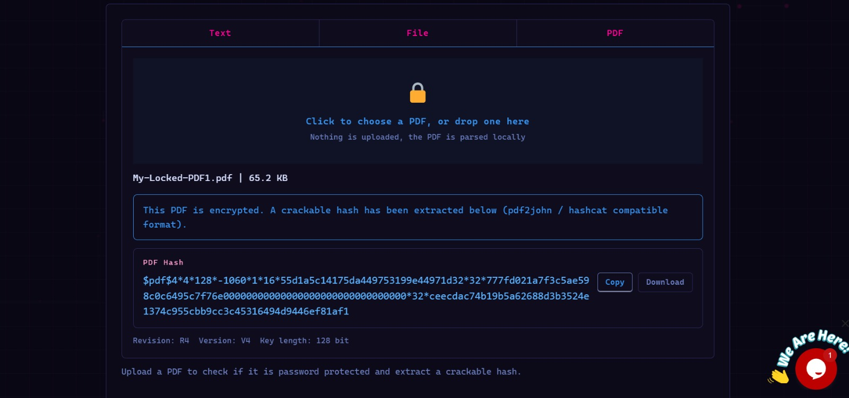
Figure 1 – PDF hash extracted from My-Locked-PDF1.pdf using the NetworkWalks Hash Calculator.

4.2 Wordlist Preparation
The RockYou wordlist was prepared in the Kali Linux wordlists directory (/usr/share/wordlists/) and used as the candidate-password source:
sudo gzip -d /usr/share/wordlists/rockyou.txt.gz

4.3 JTR Result
John the Ripper was run against each extracted hash using:
john --format=pdf --wordlist=/usr/share/wordlists/rockyou.txt <hashfile>
JTR completed the wordlist-based cracking process and reported successful matches for all three supplied training hashes.
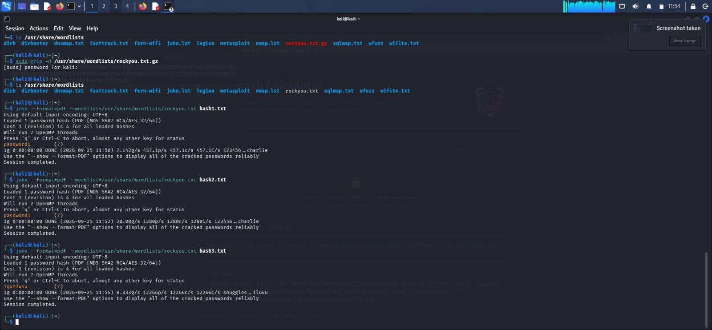
Figure 2 – John the Ripper terminal workflow: hash1.txt and hash2.txt cracked to “password1”; hash3.txt cracked to “1qaz2wsx”.

5. Module 2 – Password Cracking with NetworkWalks Tools
The second module used the NetworkWalks training tools. Each password-protected PDF was loaded into the hash calculator, which extracted a crackable PDF hash. The generated hash was then used with the NetworkWalks Password Cracker workflow.
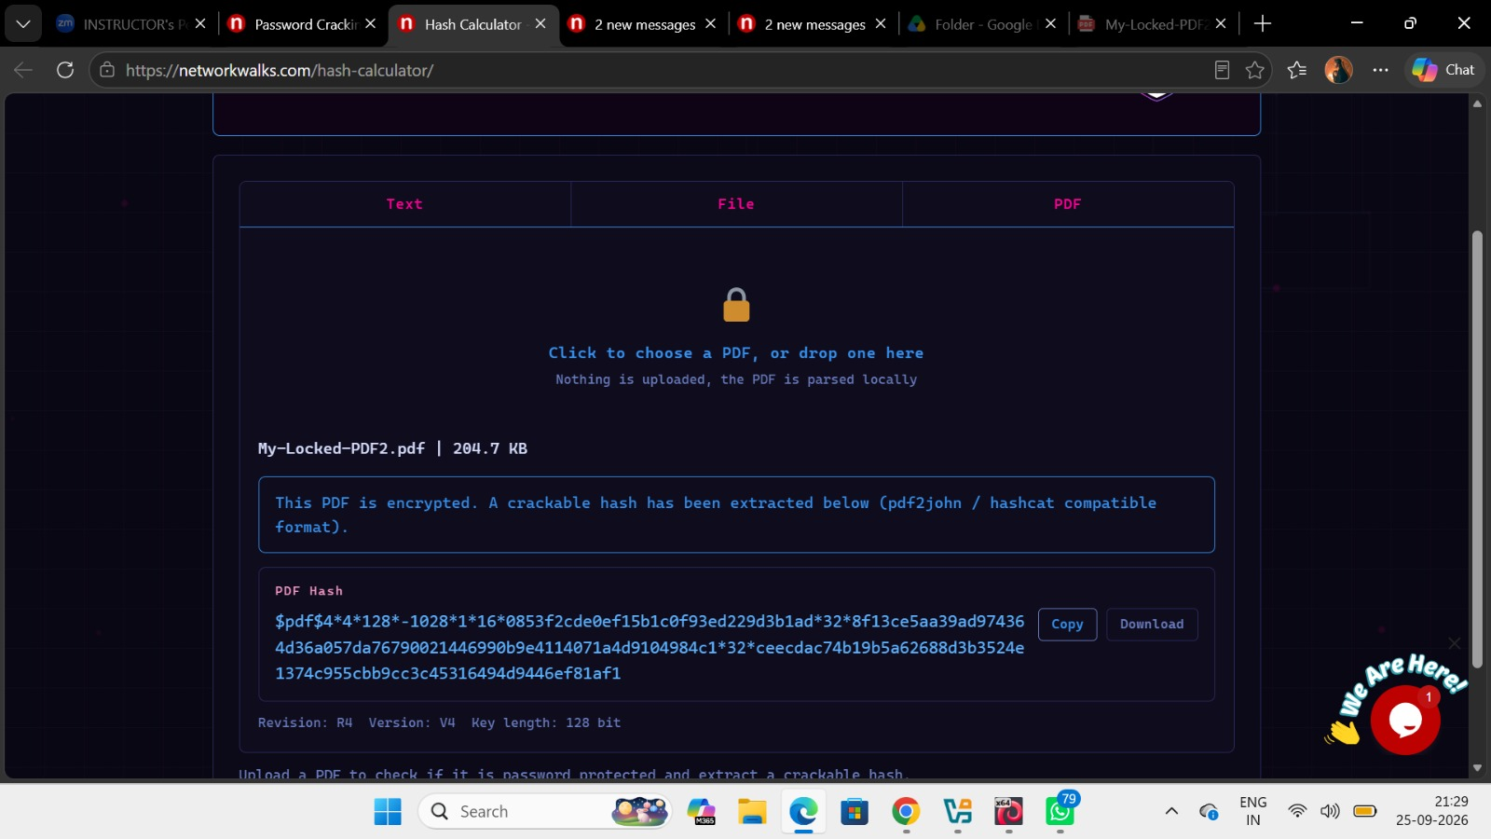
Figure 3 – PDF hash extracted from My-Locked-PDF2.pdf.
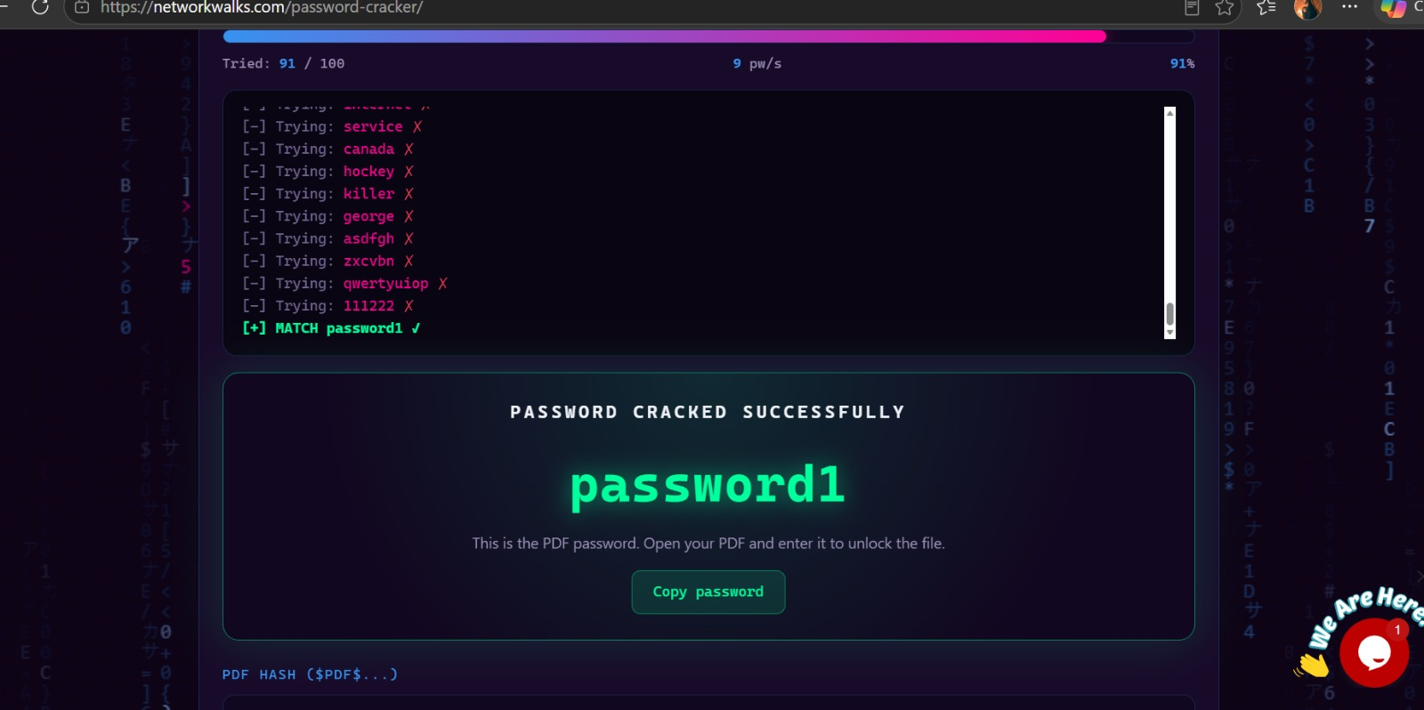
Figure 4 – Successful password recovery: “password1” recovered after 91 of 100 attempts.
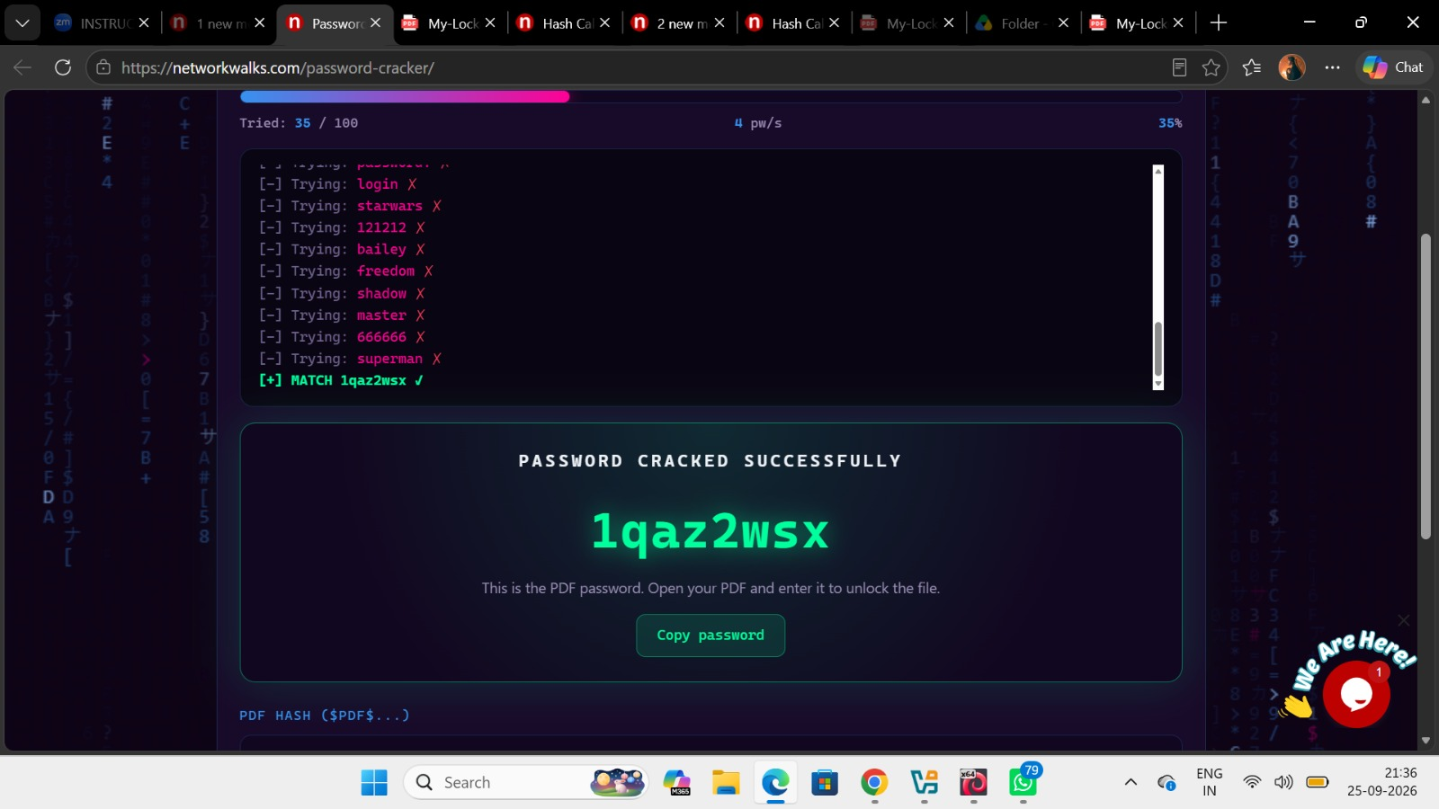
Figure 5 – Successful password recovery: “1qaz2wsx” recovered after 35 of 100 attempts.

6. Training Flags / Completion Evidence
The training platform displayed completion flags after each successful task, confirming the modules were completed correctly.
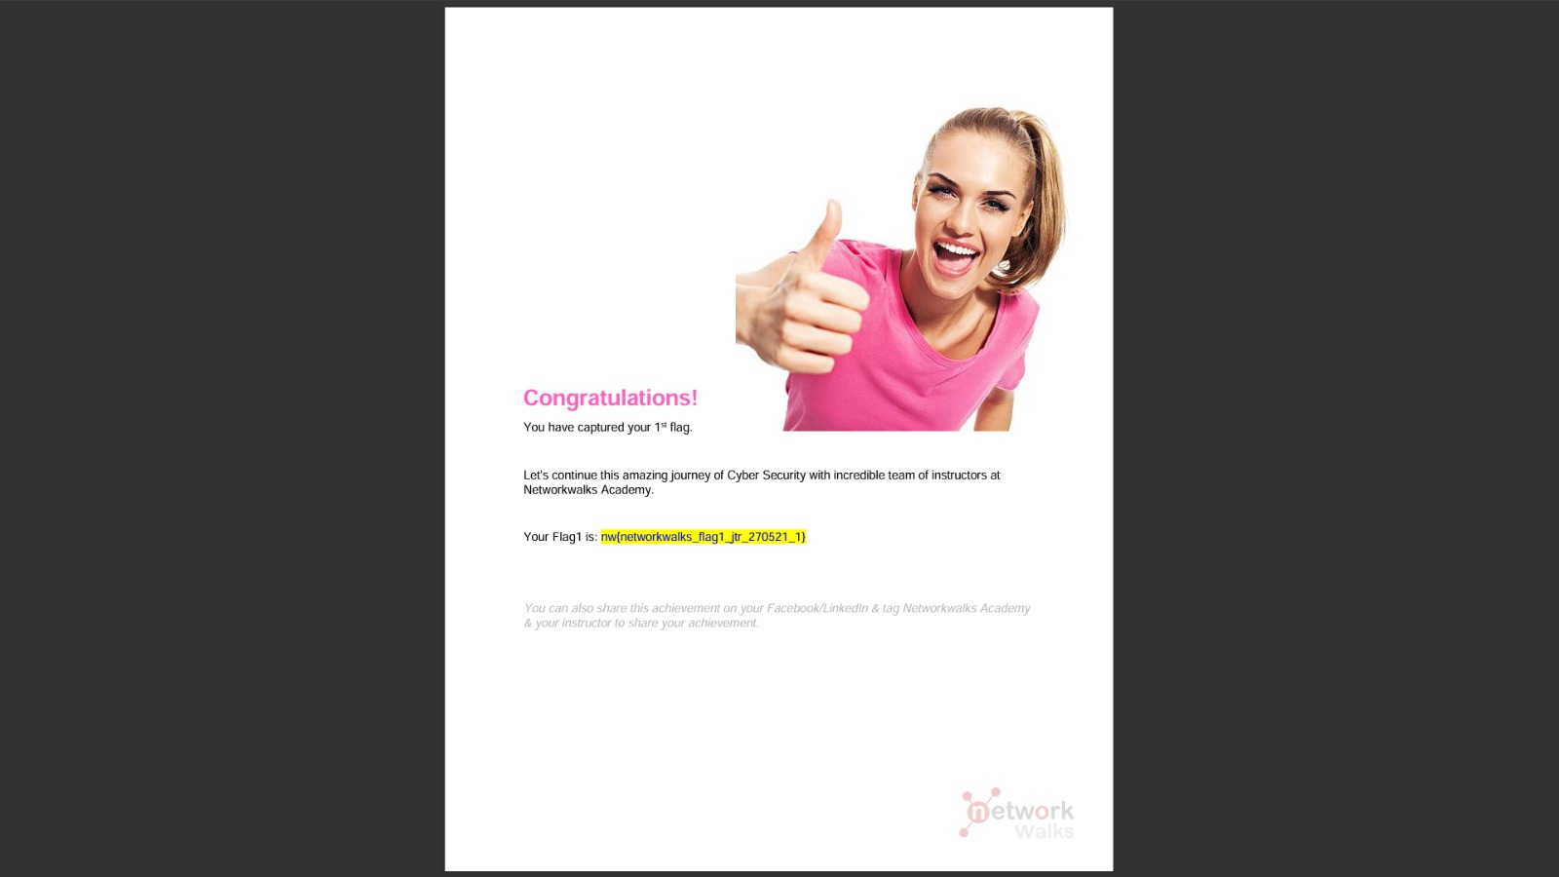
Figure 6 – Training completion evidence: nw{networkwalks_flag1_jtr_270521_1}

Figure 7 – Additional completion evidence: nw{networkwalks_persistence_jtr_270521_1}
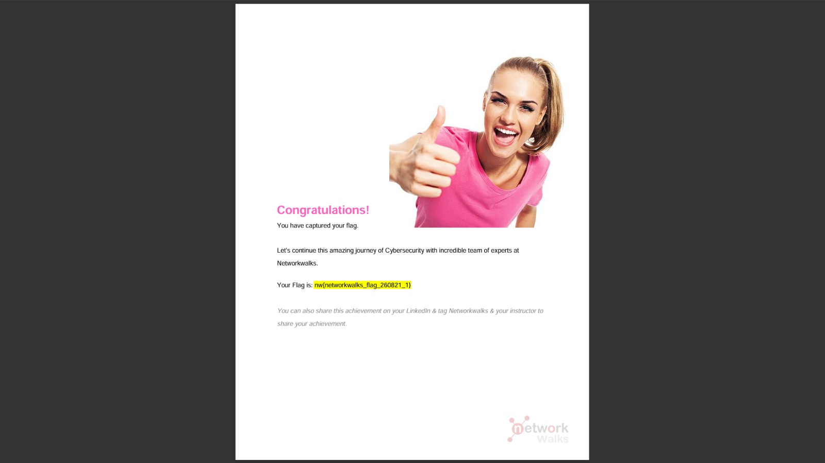
Figure 8 – Completion evidence for the NetworkWalks Tools module: nw{networkwalks_flag_260821_1}

7. Results
- W3-PM1 (Password Cracking with JTR): Completed successfully.
- W3-PM2 (Password Cracking with NetworkWalks Tools): Completed successfully.
- PDF hashes were successfully extracted for the supplied lab files.
- Wordlist-based password recovery was successfully demonstrated (passwords recovered: password1, password1, 1qaz2wsx).
- Training completion evidence (flags) was captured for both modules.

8. Learning Outcomes
- Understood the relationship between a protected file, its hash, and password recovery.
- Gained hands-on familiarity with John the Ripper.
- Learned how a wordlist such as RockYou is used during password cracking.
- Practiced reading cracking progress, attempts, and successful matches.
- Learned a second workflow using a web-based cybersecurity training tool.
- Improved practical documentation and evidence collection skills.

9. Security and Ethical Considerations
Password cracking must only be performed against systems and files for which explicit authorization has been provided. This project used intentionally supplied training material within the NetworkWalks Academy lab environment. Real credentials, private hashes, or unauthorized targets must not be tested.

10. Conclusion
Week 3 provided practical experience with password-cracking workflows using both John the Ripper and NetworkWalks tools. The required modules were completed in the authorized training environment, and the workflow was documented above with full supporting evidence.

