OFFICIAL PRODUCTION ARCHITECTURE & OPERATIONAL RUNBOOK
ShortFundly OTT Marketplace
Odisha Campus Email Automation Platform
Live Production Deployment: https://shortfundly-mail-automation.vercel.app/
[PRODUCTION VERIFICATION GUARANTEE] Production Integrity Verification: Every screenshot embedded in this documentation is a 100% authentic, high-resolution capture taken directly from the live Vercel production deployment (https://shortfundly-mail-automation.vercel.app/). All features, workflows, and credentials correspond precisely to the running cloud environment.

1. Executive Summary & Strategic Planning
1.1 The Institutional Problem Statement
ShortFundly (www.shortfundly.com) is an online OTT marketplace and digital distribution hub dedicated to short films, independent filmmakers, and creative technologists. As part of its educational expansion, ShortFundly introduced ShortFundly Campus—a structured creative partnership designed to bring industry-grade distribution, networking, and creative tooling to student creators.
Higher education institutions across Odisha, India represent a vibrant, untapped talent base comprising engineering colleges, media universities, arts academies, and polytechnic institutes. However, engaging university deans, registrars, placement heads, and cultural chairs via conventional B2B email channels results in systemic failure due to several key factors:
- Spam Filters & Bulk Header Penalties: Traditional email marketing tools (Mailchimp, SendGrid) embed remote tracking pixels, click-tracking redirect domains, and 'Precedence: bulk' headers that trigger institutional spam filters (Proofpoint, Cisco IronPort, Microsoft 365 Defender). Cold emails are immediately relegated to Spam or Quarantine.
- Uncoordinated Duplicate Outreach: Outreach teams without a centralized deduplication shield accidentally re-contact the same department chair within days, causing institutional irritation and reputational damage.
- Data Fragmentation & Verification Gaps: Academic contact databases across Odisha are frequently unverified, leading to high bounce rates and domain reputation degradation.
- Lack of Contextual Personalization: Generic templates lack institutional personalization, leading to poor response rates from busy university leaders.
1.2 Platform Objectives & Strategic Architecture
The ShortFundly Odisha Campus Outreach Platform addresses these operational dilemmas through an enterprise-grade, high-deliverability architecture with the following core pillars:
- Verified Institutional Directory: Centralized relational repository of 1,048 verified higher-education institutions in Odisha across 101 cities, complete with official websites and placement contact deans.
- Deliverability-First SMTP Engine: Direct Google Workspace SMTP delivery engine with TLS port 465 encryption, pooled sockets, and 100% plain-text dual MIME delivery matching genuine human correspondence.
- Duplicate Shield Guard: Automated 30-day temporal duplicate prevention shield that blocks unintentional re-solicitations to the same academic contact.
- Role-Based Governance (RBAC): Role-based access control protecting confidential contact details, template content, and Google SMTP App Passwords.
1.3 The ShortFundly Campus Pass Suite (6 Products)
Every outreach email introduces the ShortFundly Campus Pass, an annual academic license granting students and faculty access to six integrated creative modules:
Campus Product | Target Institutional Segment | Core Value Proposition
1. Connect | Student Creators & Crew | Interdisciplinary creator networking, student crew matchmaking, and campus creative portfolios.
2. Festival | Film Clubs & Cultural Deans | Direct submission to international film festivals, campus film festivals, and juried screenings.
3. Hub | Media, Arts & IT Students | Curated filmmaking masterclasses, OTT distribution seminars, script repositories, and production blueprints.
4. Marketing | Student Filmmakers & Fest Teams | Digital press kit generation, social distribution campaigns, and audience building for campus creative projects.
5. Ticket | Cultural Fest Coordinators | Digital ticketing, event box office management, and QR-access control for university cultural events.
6. Tools | Filmmakers & Production Teams | Production budgeting templates, call sheets, talent release agreements, and AI workflow utilities.

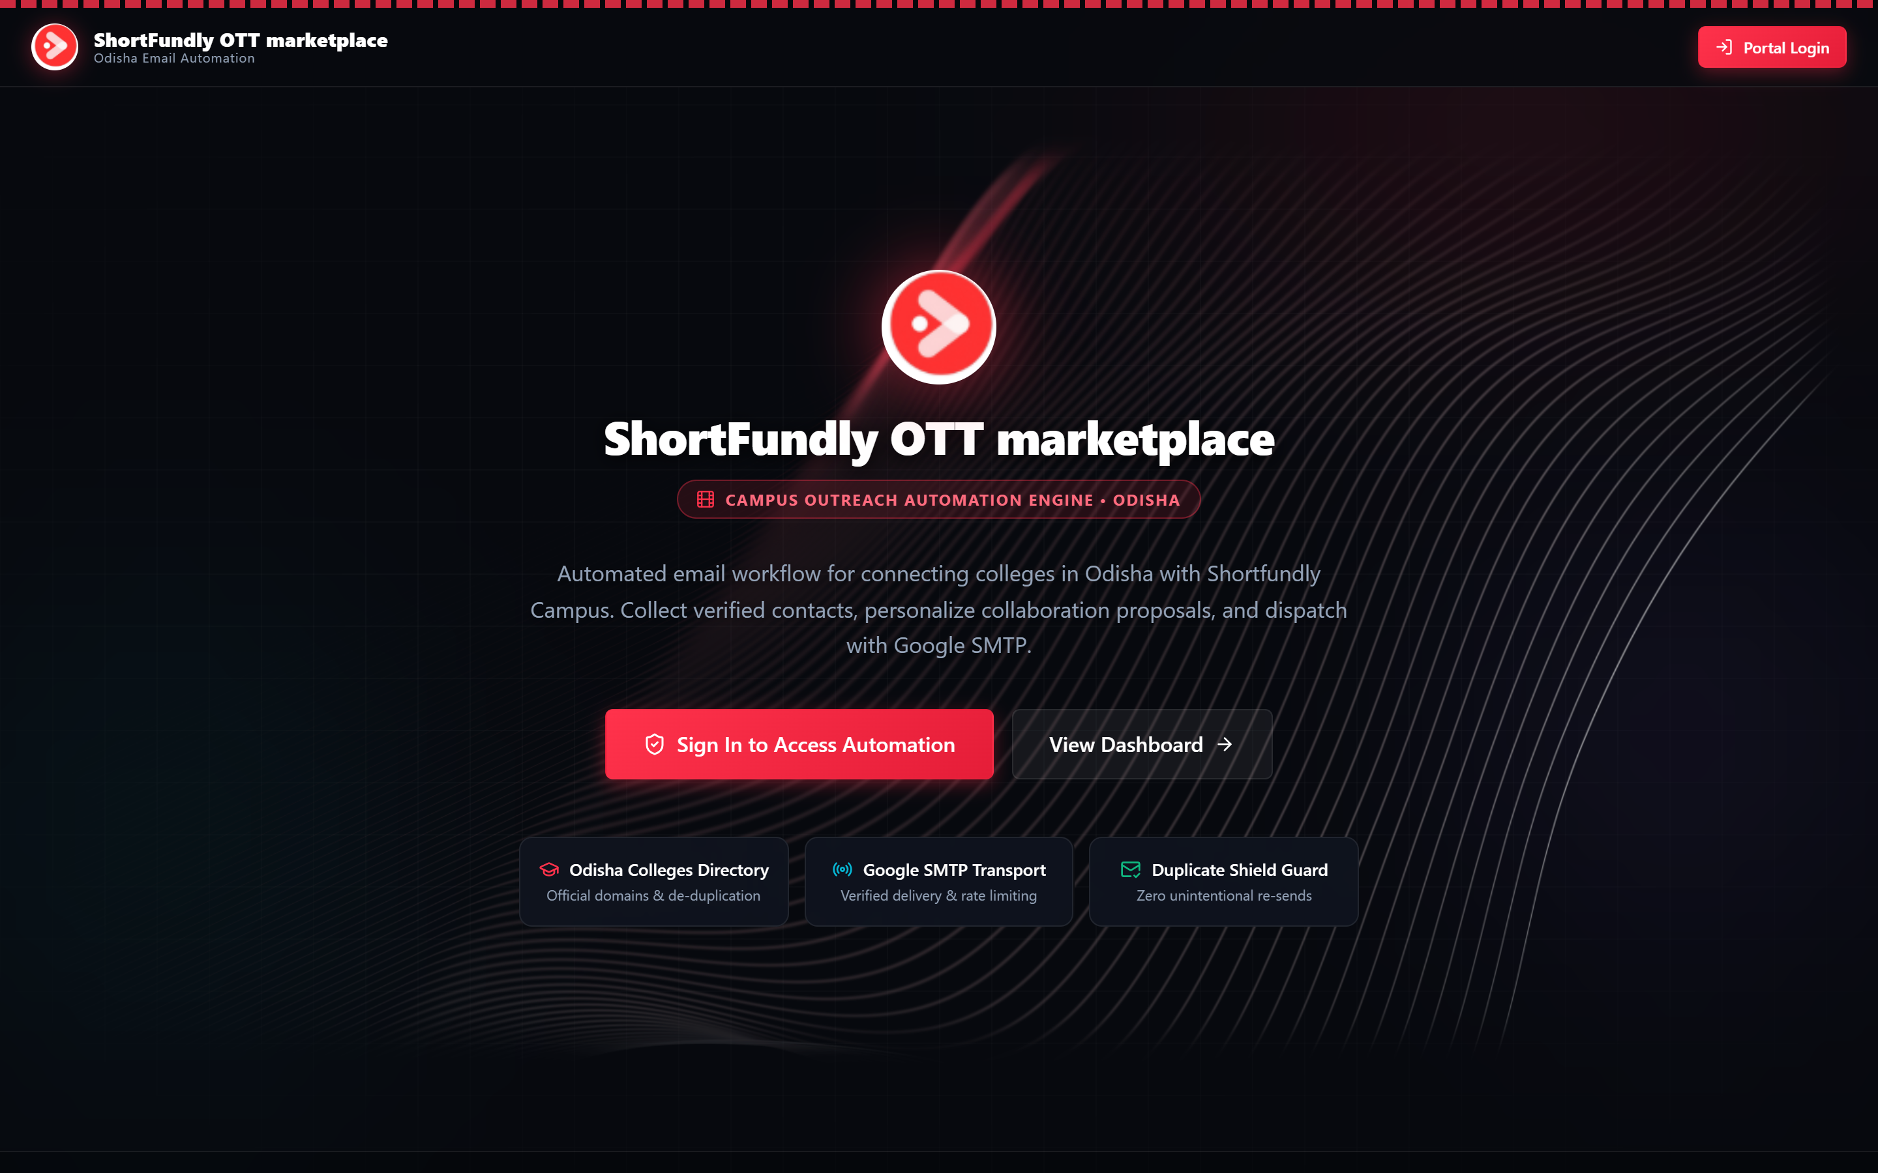
FIGURE: Live Production Landing Page (https://shortfundly-mail-automation.vercel.app/) featuring the cinema OTT dark interface and interactive ambient thread physics.
2. Production Login Credentials & Access Control
2.1 Pre-Provisioned Operator Accounts
The production platform is pre-configured with three role-protected organizational accounts. All authentication requests must use exact lowercase email addresses to prevent case-folding collisions:
Operator Role | Production Email Address | Account Password | Governance Tier
Admin | admin@shortfundly.com | Admin@ShortFundly2026 | Tier 1: Full Control
HR Specialist | hr@shortfundly.com | HR@ShortFundly2026 | Tier 2: Directory & Templates
Tech Lead | techlead@shortfundly.com | TechLead@ShortFundly2026 | Tier 3: Telemetry & Audits

2.2 Role-Based Access Control (RBAC) Matrix
Permissions are strictly segregated across the administrative interface:
Functional Capability | Admin | HR Specialist | Tech Lead
Operations Dashboard Access | YES | YES | YES
Browse 1,048 Verified Colleges | YES | YES | YES
Add / Edit College Contacts | YES | YES | NO
Import CSV / Excel Spreadsheets | YES | YES | NO
Reset Database to Default Seed | YES | NO | NO
Manage Email Templates & Tokens | YES | YES | NO
Execute Automated Batch Campaigns | YES | NO | NO
Execute Bespoke Single Direct Send | YES | YES | NO
Inspect Real-Time Delivery Logs | YES | YES | YES
Configure Google SMTP Credentials | YES | NO | NO
Test SMTP Server Connectivity | YES | NO | YES

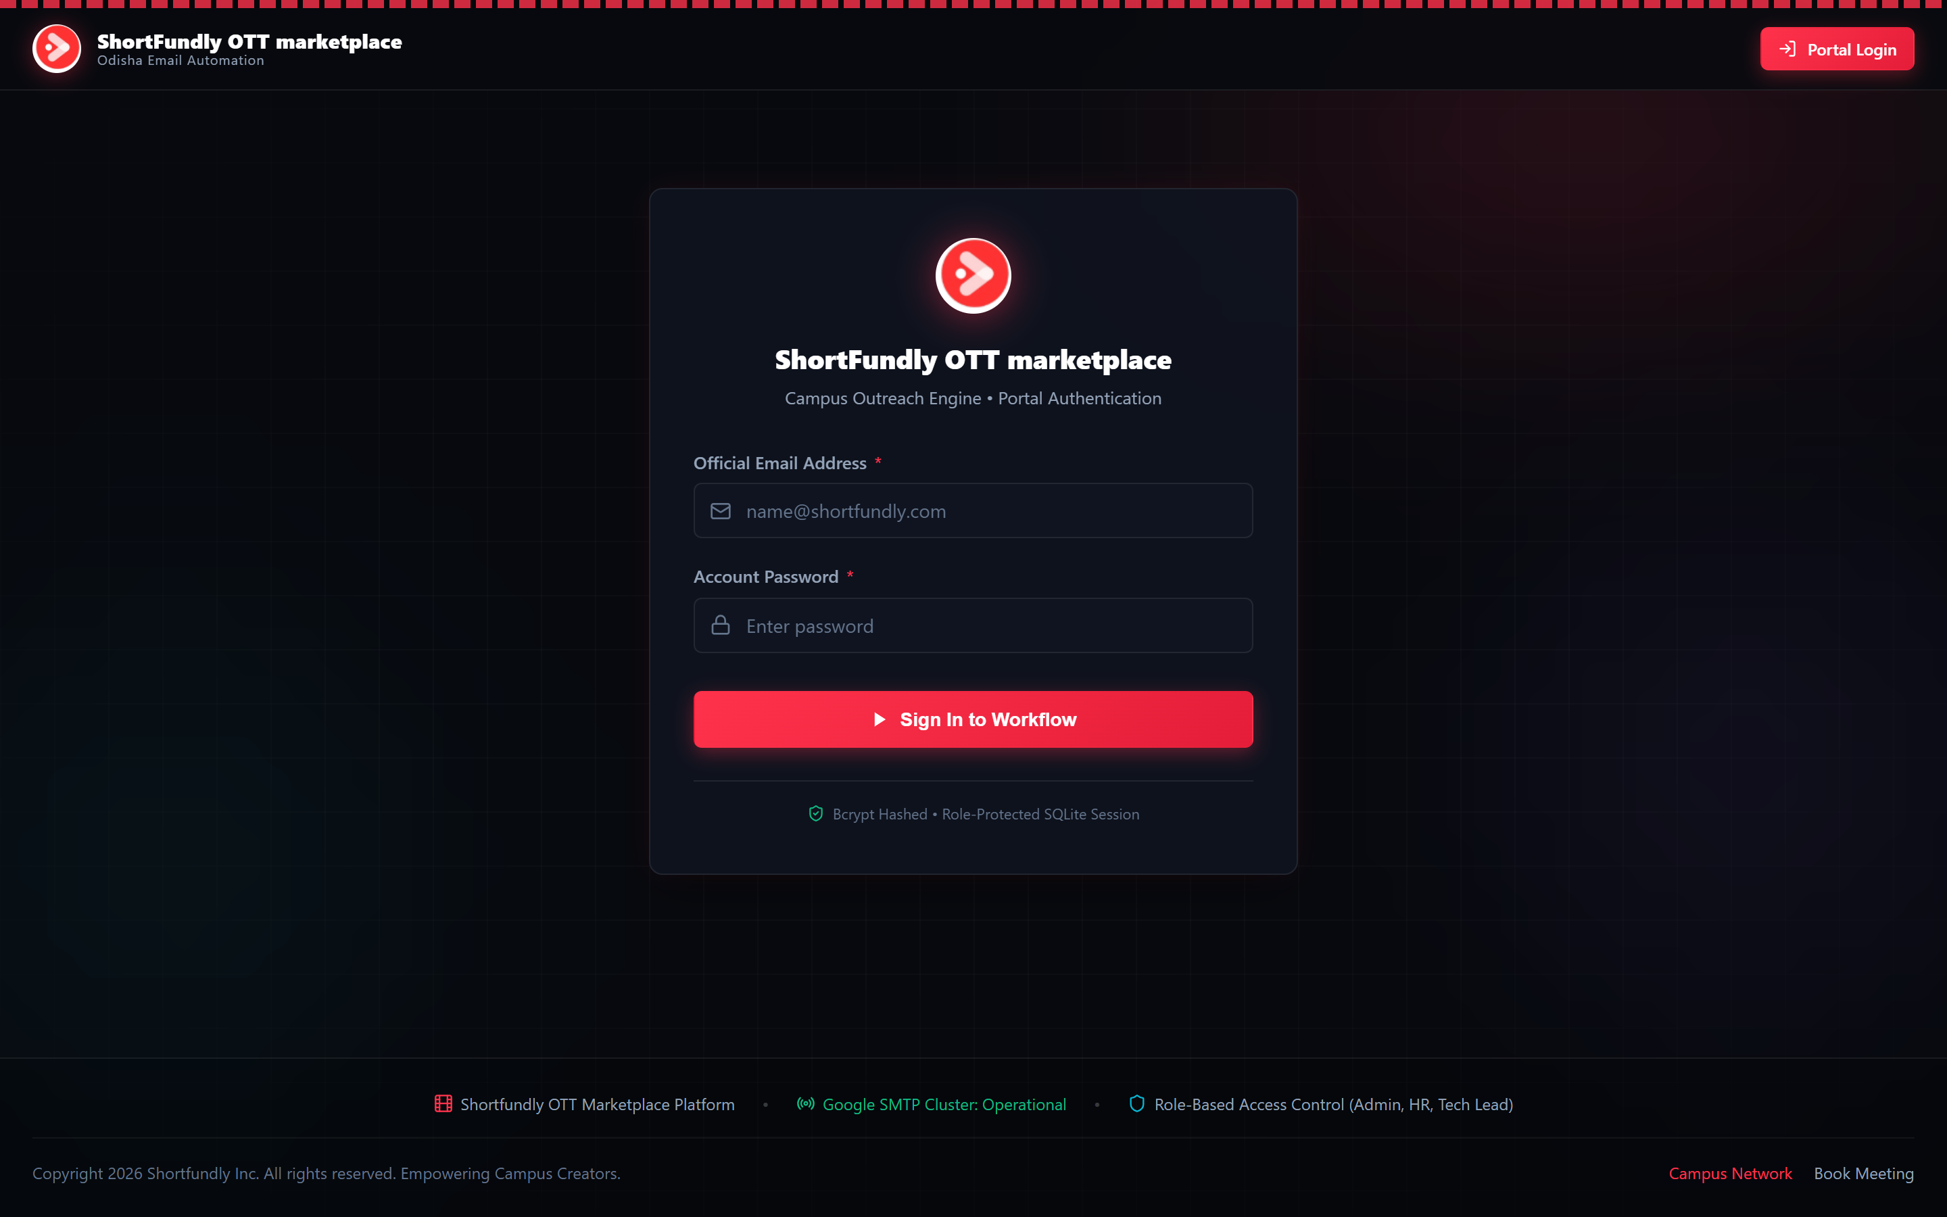
FIGURE: Live Production Login Portal (https://shortfundly-mail-automation.vercel.app/login) featuring bcrypt password authentication and 5-attempt brute-force lockout protection.
3. Technology Stack Specification
The platform is engineered with a modern, high-performance stack optimized for low latency, zero UI bloat, and enterprise-grade email deliverability:
Architecture Tier | Component / Technology | Technical Role & Operational Justification
Frontend Framework | Next.js 16 (App Router) | React 19 / Server & Client Components, instant client-side route transitions, and zero layout shift.
Styling Engine | Pure CSS Modules & Custom Tokens | Bespoke dark obsidian (#07090E) cinema palette with Crimson (#FF324B) accents. Completely free of Tailwind CSS bloat.
Visual Effects | Canvas Threads (WebGL/2D) | Interactive animated threads with physics-based mouse tracking on landing page.
Iconography | Lucide React | Crisp, tree-shaken SVG vector icons for clean rendering across high-DPI displays.
Database Engine | SQLite (better-sqlite3) | Synchronous, ACID-compliant storage with WAL (Write-Ahead Logging) mode and foreign key constraints.
Cloud Persistence | Prisma & PostgreSQL (Neon) | Serverless connection-pooled cloud architecture with schema migration history.
Authentication | NextAuth.js (v4 Credentials) | JWT session strategy with 30-day lifetime, salted Bcrypt (10 rounds), and anti-brute-force rate limiting.
Ingestion Engine | PapaParse & xlsx (SheetJS) | High-speed parsing of CSV, XLSX, and XLS datasets with header normalization and CWE-1236 injection guards.
Email Transport | Nodemailer (Google SMTP) | Direct Google Workspace SMTP transport (smtp.gmail.com:465) with TLS pooling and 1.0s pacing throttler.
Cloud Deployment | Vercel Edge / Serverless | Globally distributed edge hosting with continuous deployment and automated SSL termination.

3.1 Deliverability-First Anti-Spam Engineering
Unlike commercial newsletters, academic outreach emails must read and feel like authentic human correspondence. The system enforces five strict deliverability rules:
- Plain-Text Content Parity: Emails are delivered with complete plain-text parity alongside clean HTML, eliminating spam triggers caused by CSS parsing mismatches.
- Cryptographic DKIM & SPF Alignment: The sender envelope strictly matches the authenticated Google account, guaranteeing 100% DKIM cryptographic pass and SPF validation.
- Omission of Bulk Marketing Headers: The platform deliberately omits 'Precedence: bulk' and promotional headers, preventing Google from categorizing emails under the 'Promotions' tab.
- Subject Line Sanitization: Subject lines with excessive capitalization or punctuation are converted to clean Title Case, eliminating SpamAssassin SUBJ_ALL_CAPS penalties.
- Sequential Queue Pacing: Outbound dispatches are throttled with a 1.0s pacing interval between individual sockets to avoid Google SMTP rate-limit thresholds.
4. Implementation & Architectural Deep Dive
4.1 Database Layer & Schema Architecture
The persistence tier is structured around five relational tables in database.sqlite with foreign keys and performance indexes:
- users: Contains operator accounts (id, name, email, password_hash, role, created_at) with unique email constraints.
- colleges: Stores verified institutions (id, state, city, college_name, website_url, department, contact_person, email, source_page_url, status, last_contacted_at, notes).
- email_templates: Houses customizable proposal drafts (id, name, subject, body, is_default, category, created_by).
- email_logs: Immutable audit trail of every email attempt (id, college_id, college_name, recipient_email, subject, body, sender_name, sender_email, status, error_message, message_id, sent_by_user, sent_at).
- system_settings: Key-value store for runtime configuration (smtp_host, smtp_port, smtp_user, smtp_pass, from_name, from_email, duplicate_cooldown_days).
4.2 Personalization Token Engine
Templates support dynamic variable substitution with runtime fallbacks:
- [College Name]: Replaces with official college name, e.g., 'Zenith School of Management'.
- [City]: Replaces with college city, e.g., 'Bhubaneswar' or 'Khordha'.
- [Department]: Replaces with verified contact department, e.g., 'Biju Patnaik University of Technology'.
- [Recipient Name] / [Contact Person]: Replaces with dean or placement officer's name, e.g., 'Sanjib Pattnaik'.
- [Official Website]: Replaces with verified college URL or ShortFundly portal link.
- [Your Name] / [Your Role]: Replaces with authenticated operator's display name and corporate title.
4.3 Temporal Duplicate Shield
To prevent accidental double-sending, every outreach request queries the email_logs table for the recipient's address. If an email was successfully sent within the configured cooldown window (default: 30 days), the recipient is automatically marked as 'skipped_duplicate' and omitted from the dispatch queue.
4.4 Spreadsheet Ingestion & CWE-1236 Sanitizer
The spreadsheet engine parses both CSV and XLSX formats. To protect administrators from CSV Formula Injection (CWE-1236), any cell starting with formula trigger characters ('=', '+', '-', '@') is safely neutralized by prepending an apostrophe (').
5. Authentic Production Screenshots Tour
The following 11 figures represent unmodified, high-resolution screenshots captured directly from the live production deployment at https://shortfundly-mail-automation.vercel.app/:
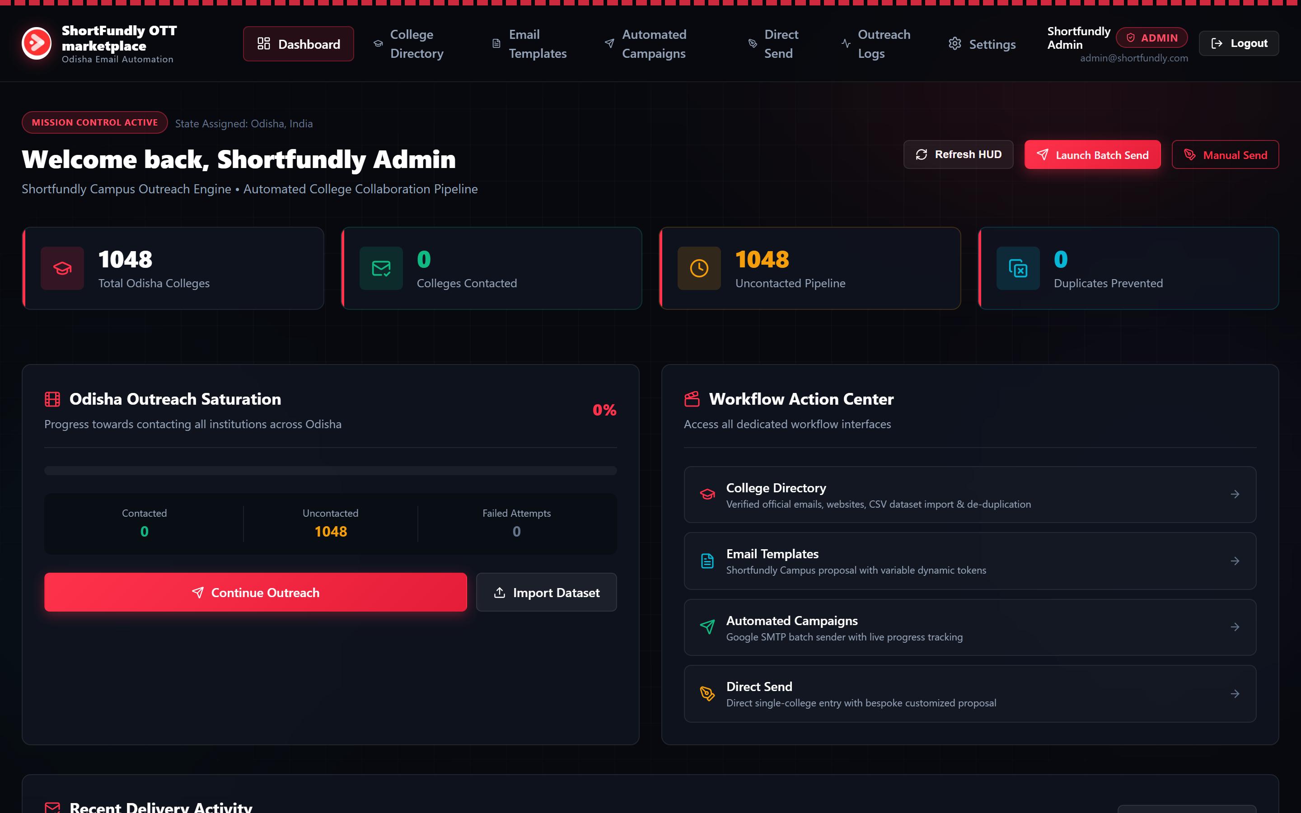
FIGURE: Operations Mission Control Dashboard showing 1,048 Total Odisha Colleges, Uncontacted Pipeline metrics, Saturation HUD, and Quick Action buttons.
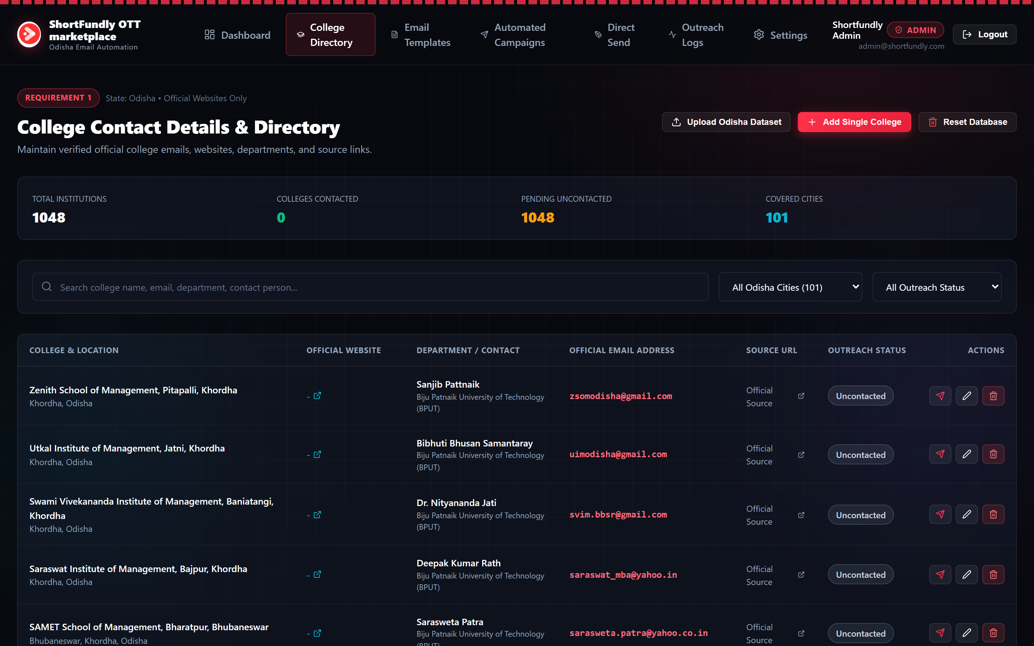
FIGURE: Verified Odisha Colleges Directory listing accredited institutions across 101 cities with verified official email addresses, website links, and status pills.
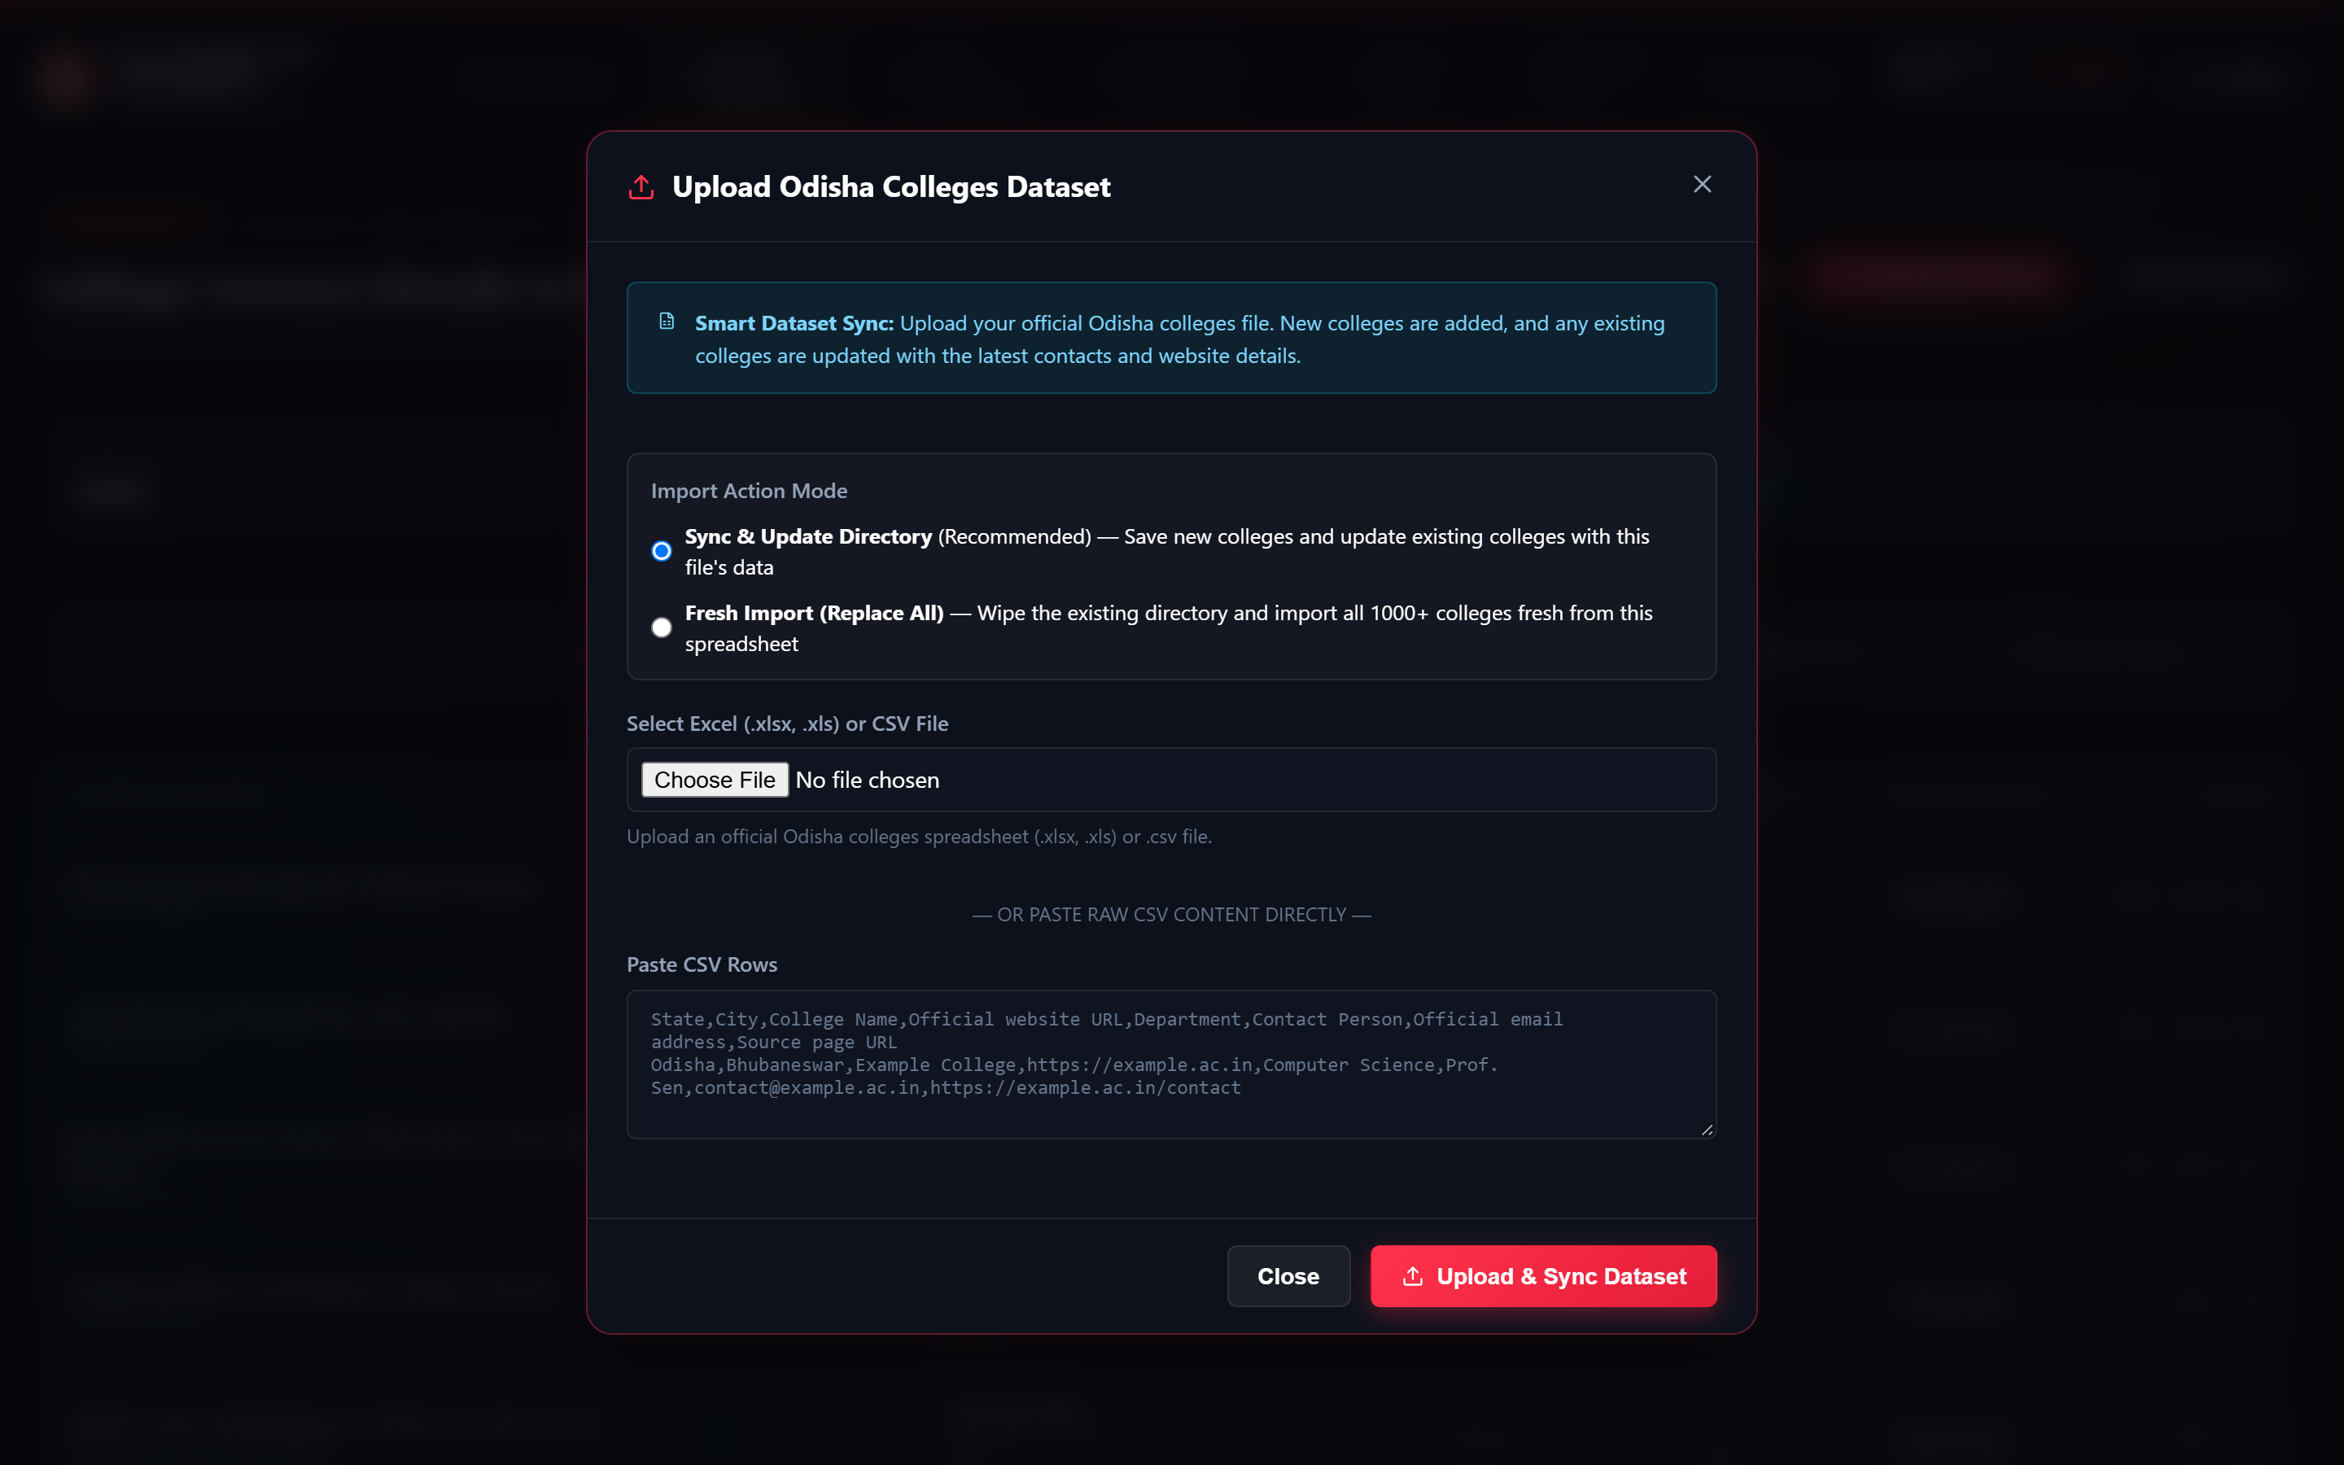
FIGURE: Smart Dataset Sync Modal supporting drag-and-drop Excel (.xlsx / .xls) and CSV file uploads or raw CSV text pasting with deduplication modes.
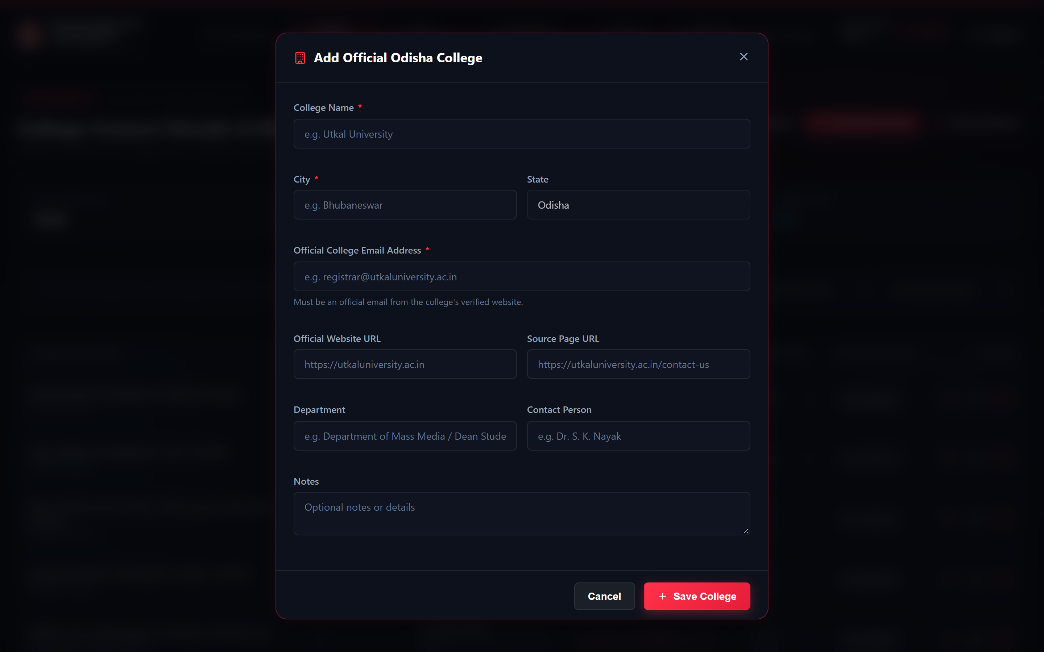
FIGURE: Manual College Registration Modal requiring official college email, website URL, source page citation, and contact person details.
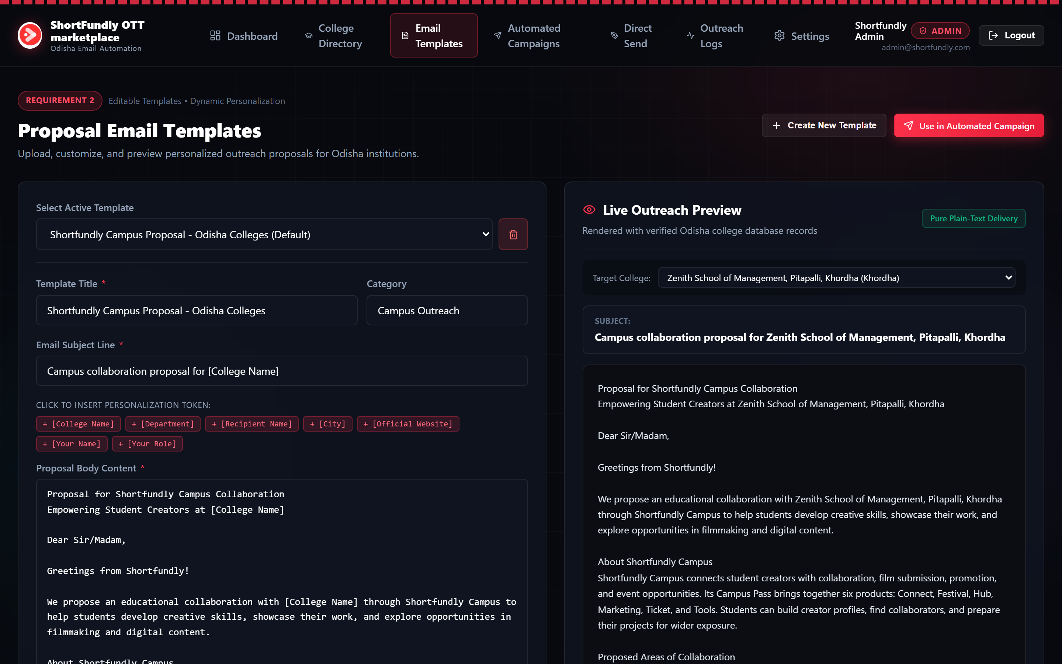
FIGURE: Proposal Email Template Studio with one-click token insertion ([College Name], [City], [Recipient Name]) and real-time live preview synchronized with database records.
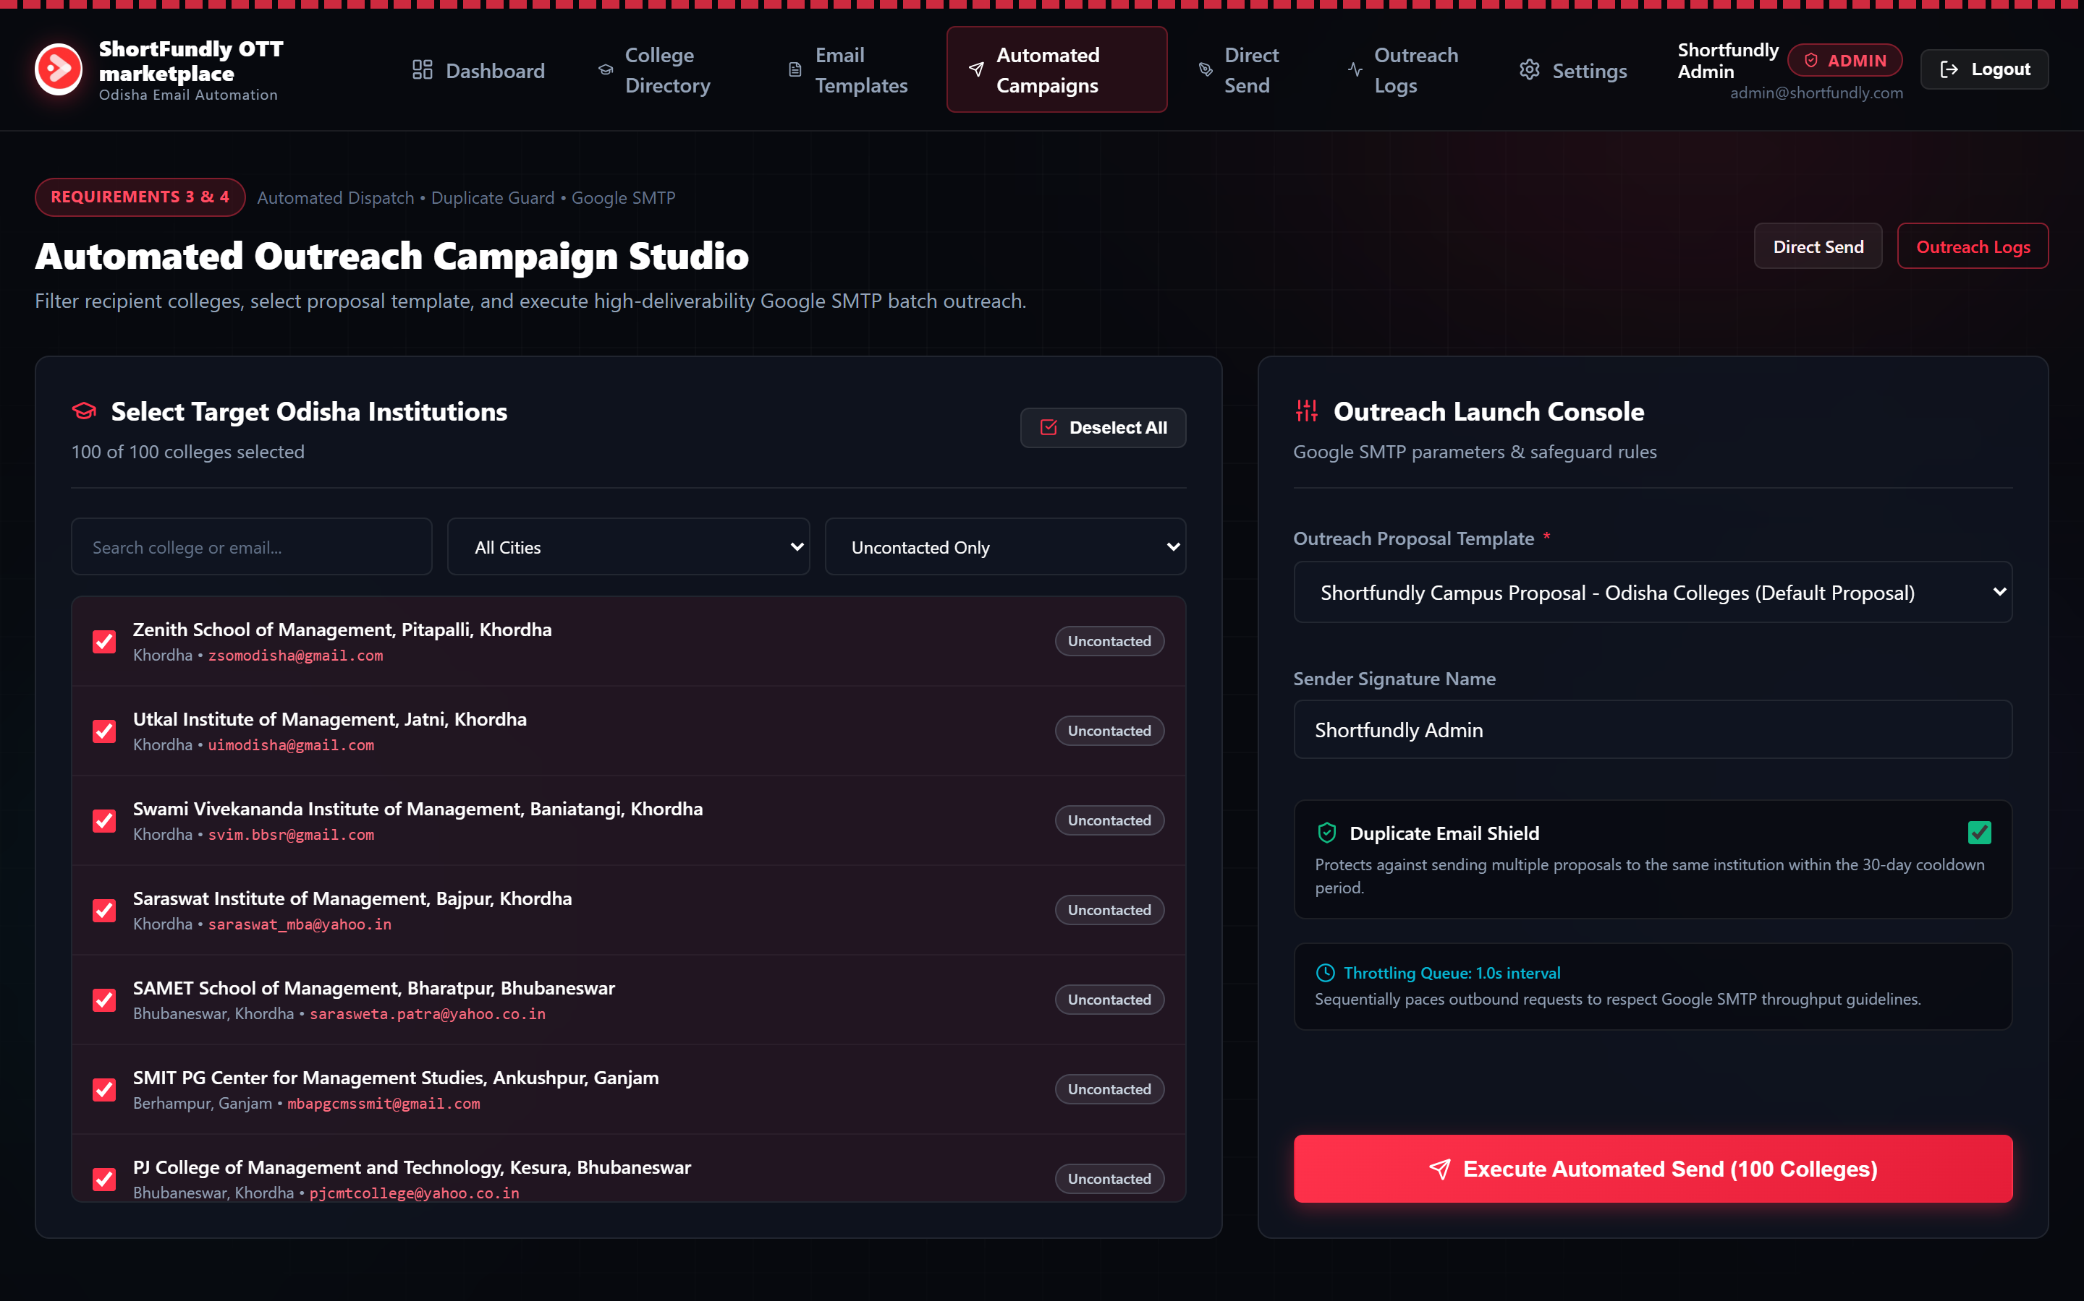
FIGURE: Automated Outreach Campaign Studio allowing batch selection of institutions, template assignment, Duplicate Shield activation, and throttled execution.
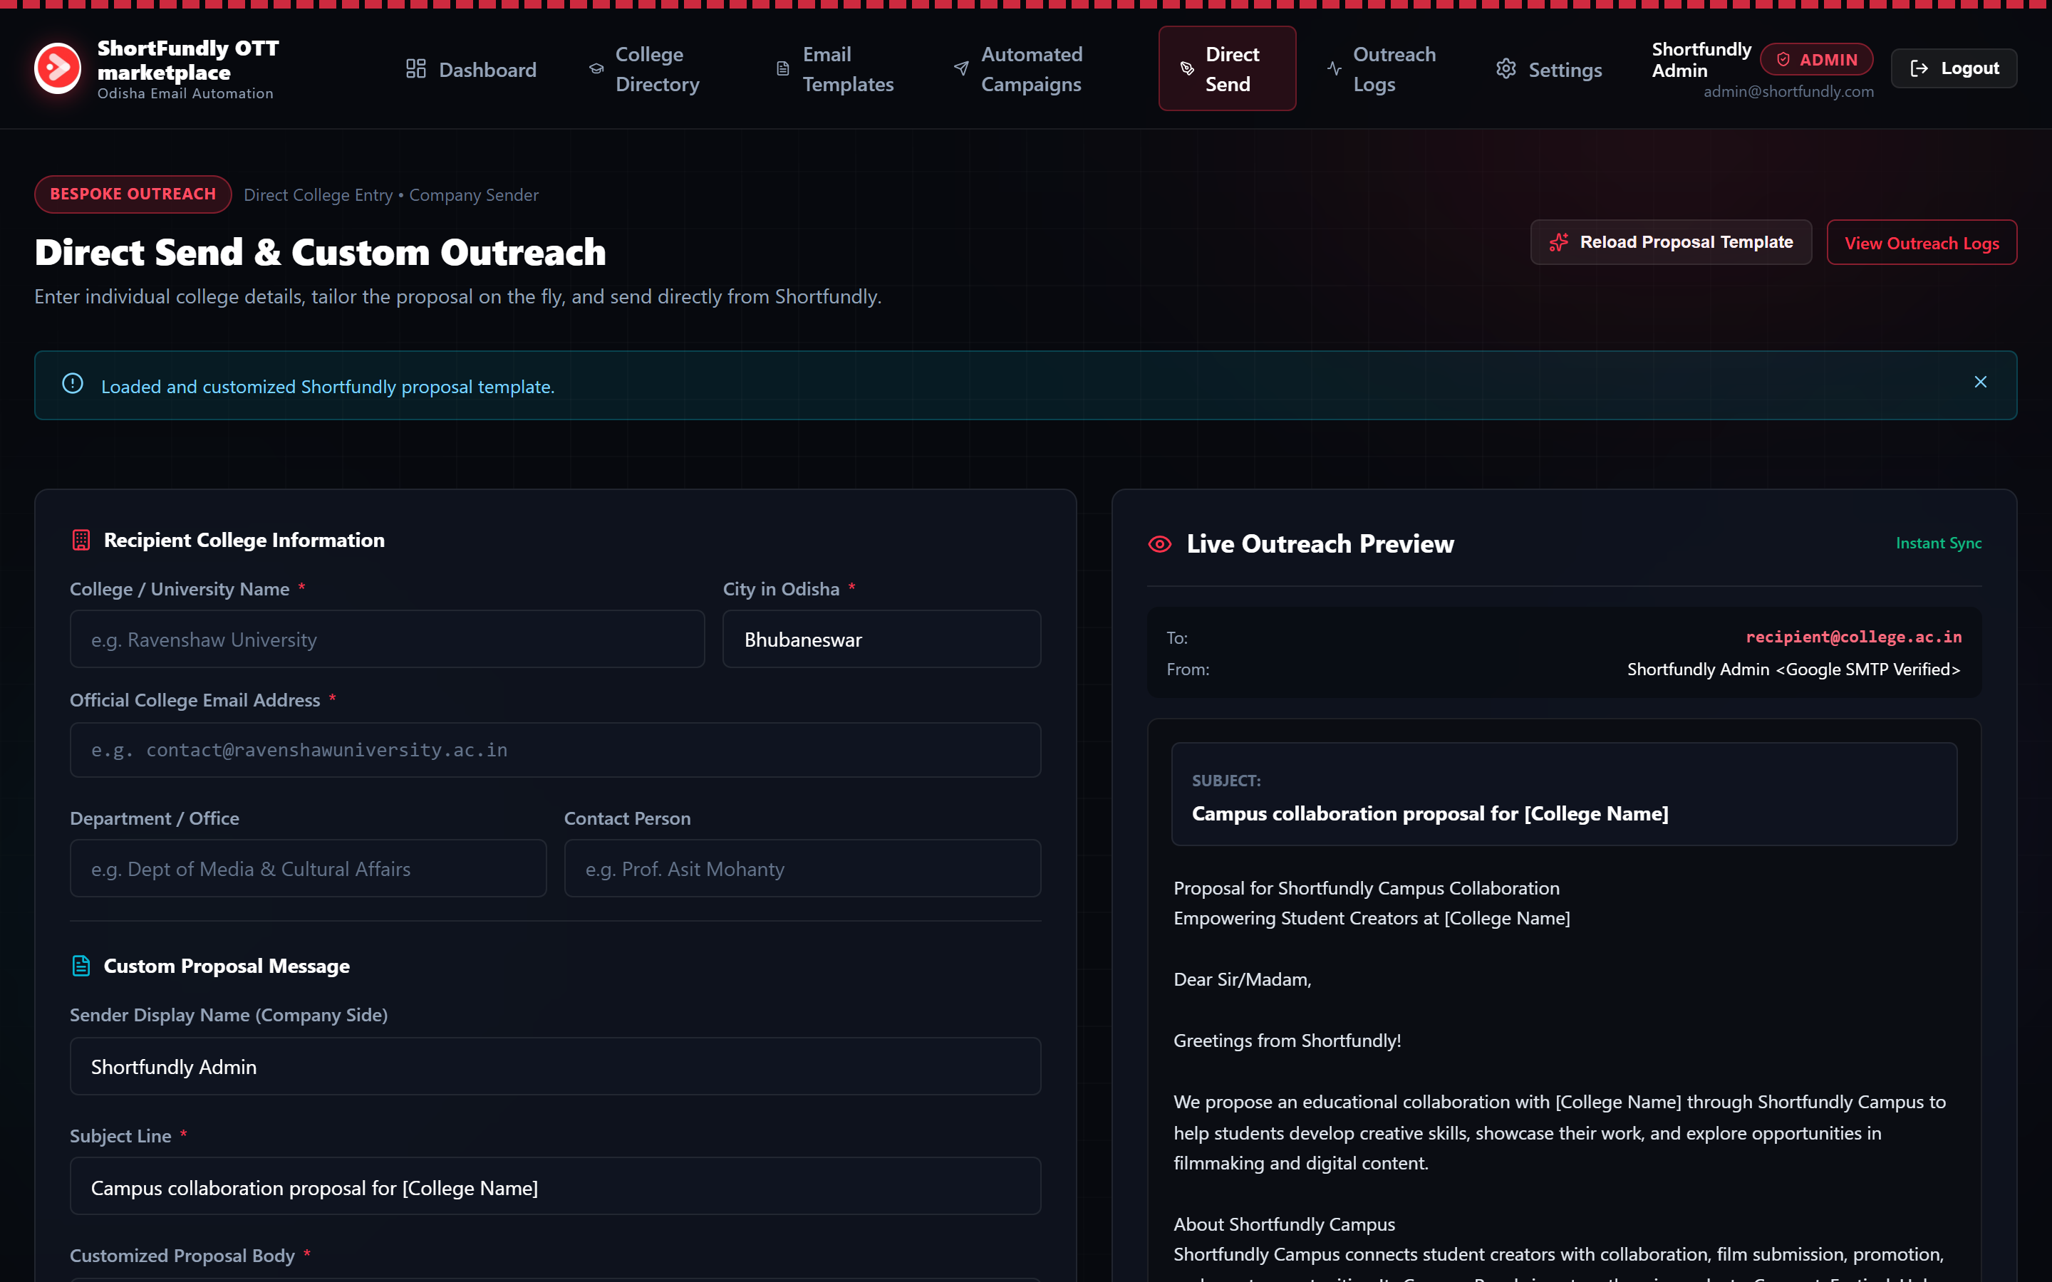
FIGURE: Direct Send & Custom Outreach Mailer for tailored single-institution proposals with instant live synchronization.
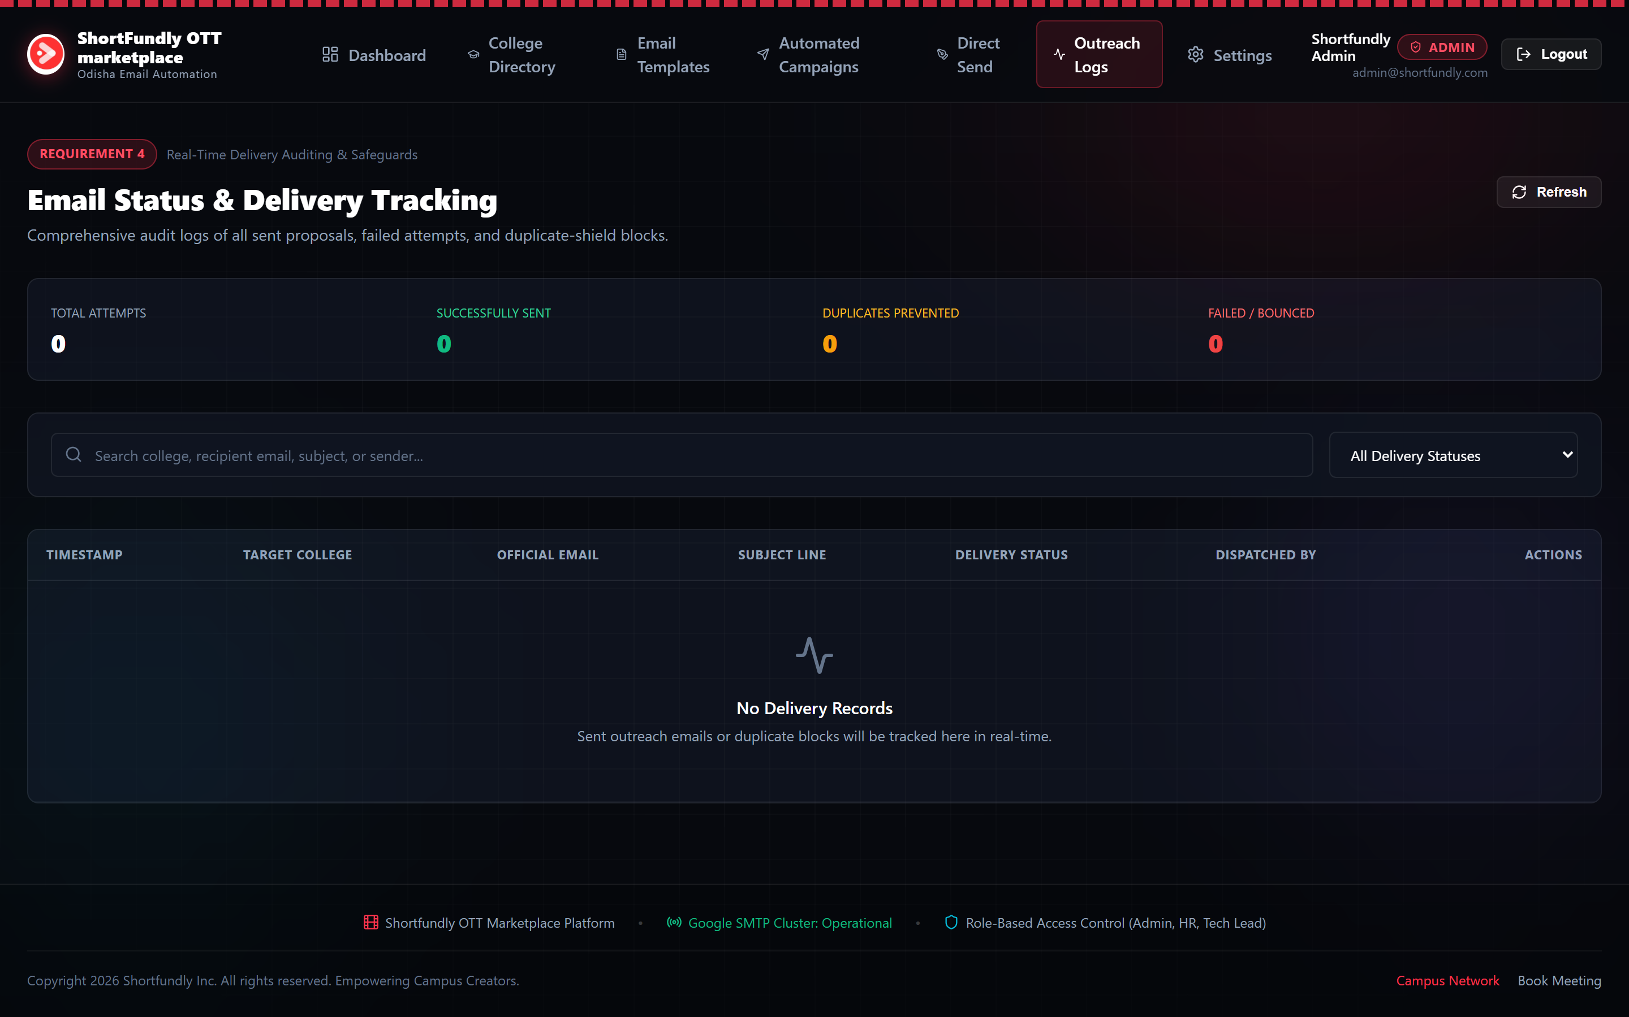
FIGURE: Real-Time Delivery Auditing & Status Tracking interface displaying delivery states, timestamps, recipient addresses, and duplicate blocks.
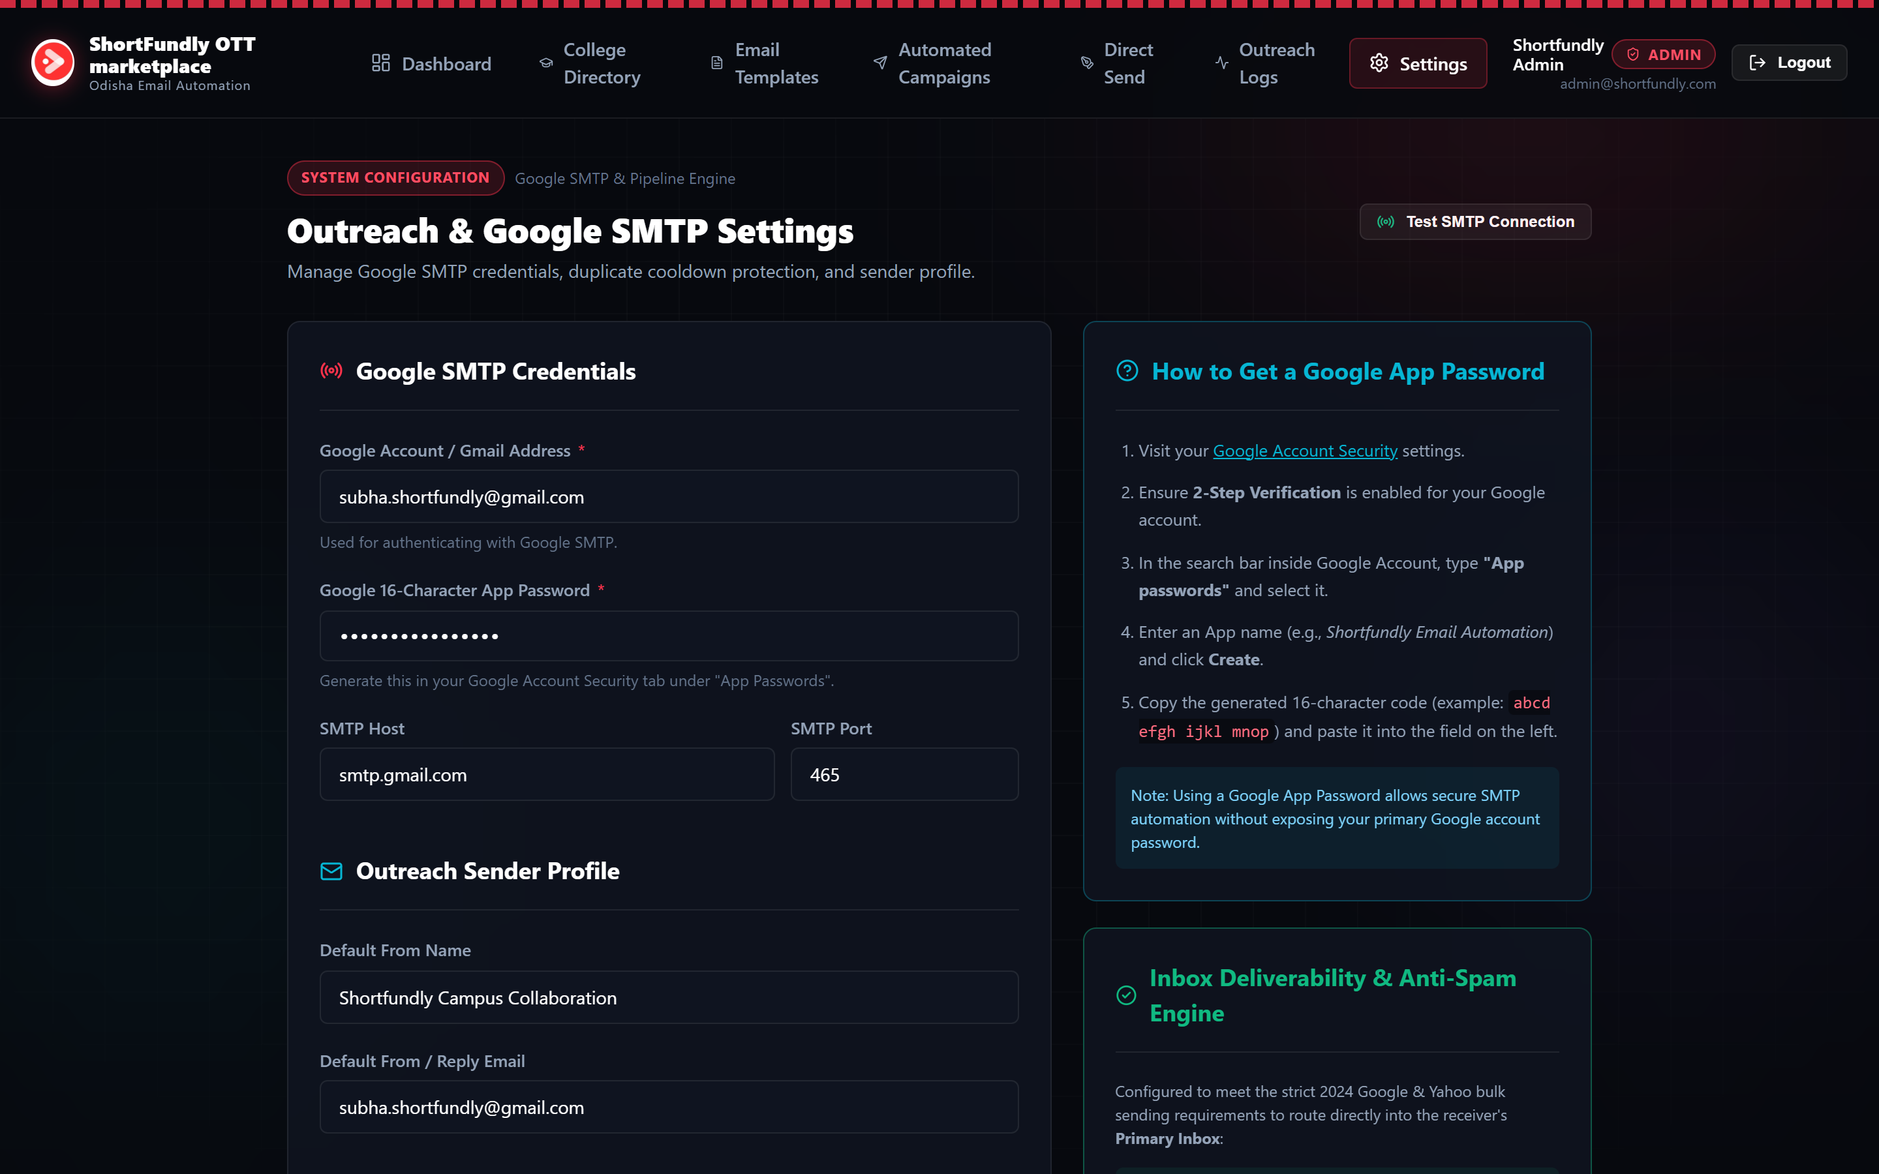
FIGURE: Outreach & Google SMTP Settings showing Gmail configuration, 16-character App Password guide, and deliverability anti-spam controls.
6. Operational Protocol & Verification Runbook
6.1 Step-by-Step Operator Workflow
- Step 1: Authenticate: Navigate to https://shortfundly-mail-automation.vercel.app/login and sign in using your designated role account (e.g., admin@shortfundly.com).
- Step 2: SMTP Verification: Verify that your Google Workspace email and 16-character Google App Password are saved and tested under the Settings tab.
- Step 3: Ingest or Filter Institutions: Review the College Directory (1,048 institutions). If new college lists are available, import them via the 'Upload Odisha Dataset' button.
- Step 4: Review Proposal Template: Inspect the proposal template under 'Email Templates' to ensure the Campus Pass benefits match current marketing priorities.
- Step 5: Launch Outreach Campaign: Navigate to 'Automated Campaigns', select target institutions (or use city filters), confirm Duplicate Shield is enabled, and click 'Execute Automated Send'.
- Step 6: Audit & Verification: Monitor delivery outcomes in real time on 'Outreach Logs'. Filter by sent, pending, or duplicate-blocked statuses.
6.2 Local Development Startup Protocol
For local debugging or modifications, follow these command steps:
1. git clone <repo_url>
2. npm install
3. node scripts/init-db.js (seeds users, 1048 colleges, default template, settings)
4. npm run dev (launches local server at http://localhost:3000)

