Exploratory Data Analysis of Netflix Content Trends Using Python Visualization Techniques
Subhajeet Barua
Department of Computer Science and Engineering
Lovely Professional University, Jalandhar, India

Abstract----The explosive expansion of over-the-top (OTT) content streaming services has produced vast amounts of structured content data that could be used for insightful analysis. In this paper, exploratory data analysis (EDA) is done of Netflix Titles datasets which holds the information regarding movies and television series available on Netflix. EDA aims at exploring patterns related to content distribution, temporal trends related to addition of content, popular genres, countries of contribution and content rating. This analysis was carried out using python programming languages alongside libraries like pandas, numpy, matplotlib, seaborn, etc. Steps involving data cleaning, missing value treatment, duplicate removal, format conversion and feature engineering were taken to clean the dataset before its analysis. Visualizations such as bar chart, pie chart, heat map, box plot and scatter plot were created to gain meaningful insights from the data. Key insights include; increase in addition of content by Netflix after 2016, U.S. being the highest contributing country, movies being dominant and Drama/International Movies being favorite genres. Possible directions for future research have been highlighted..
Keywords---Netflix, exploratory data analysis, data visualization, Python, Pandas, Seaborn, content trends, OTT platform, feature engineering, streaming data

Introduction
The rise of over-the-top (OTT) streaming platforms has drastically changed the face of entertainment across the world. Established in 1997, Netflix has been operating as a streaming company since 2007 and has grown its subscriber base to over 230 million people in more than 190 countries today. One of the most popular streaming services in the world, Netflix has been expanding its content offerings by acquiring several thousand movies and TV series annually.
Structured data about Netflix content is a great source of information that can be used in the analysis of how modern media evolve. Information regarding content distribution by regions, genres, and years might prove useful for various purposes including understanding certain aspects of media businesses and technology practice. This type of information is also applicable for researchers.
In this work, exploratory data analysis (EDA) is conducted for the publicly available Netflix Titles Dataset. Data cleaning and preprocessing, feature engineering, and visualization will be performed to find possible trends and patterns in the provided information set. For EDA implementation, Python programming language was chosen because of its wide usage in data science tasks.
The following sections will outline the contents of the paper. Section II will provide an overview of existing literature pertaining to OTT platform analysis and exploratory data analysis (EDA). Section III will present an overview of the dataset employed. Section IV will discuss the methodology adopted, including data processing and visualization procedures. Section V will discuss results and conclusions.

Literature Review
Exploratory Data Analysis, pioneered by Tukey [1], is considered the bedrock of contemporary data science workflow. Through EDA, analysts are able to summarize datasets, identify outliers, and recognize trends before utilizing more rigorous statistics and machine learning techniques. The usefulness of EDA in comprehending large volumes of data generated by users or platforms has already been firmly demonstrated by current literature.
Streaming data from social media platforms has been used to analyze trends and patterns in user-generated content. In their seminal study, Gomez-Uribe and Hunt [2] outlined the workings of the Netflix recommendation engine, emphasizing how important data analysis is when it comes to making decisions regarding content acquisition and distribution.
McKinney [3] created Pandas, which has now established itself as the go-to library for processing tabular data in Python. The Pandas library offers data structures that are flexible enough for dealing with dirty data and numerous functions for data cleaning; Pandas is therefore essential for preparing messy datasets. This study makes extensive use of Pandas library.
Hunter [4] implemented the Python visualization library Matplotlib; subsequently, Waskom et al[5] has improved its functionality with the help of Seaborn package, which offers statistical visualizations with improved aesthetics. The two packages are extensively used for the exploration of data analytics tasks in academia as well as industry and form the backbone of the visualization aspect of our study.
Past research on the Netflix dataset provided on Kaggle [6] has concentrated only on basic statistics. We extend previous studies by performing detailed data preprocessing, feature generation using multiple dimensions, and advanced visualizations including heat maps, box plots, and scatter plots.

Dataset Description
This dataset is Netflix Titles Dataset and is available on Kaggle [6] and provides a complete record of all movies and television shows present in the Netflix library till mid-2021. This dataset consists of 8,807 rows and 12 variables.
Main Variables in Dataset:
(1) show_id: Unique ID of all titles.
(2) type: The type of content; Movie or TV Show.
(3) title: Name of the title.
(4) director: The name of the director associated with the title if available.
(5) cast: List of actors' names associated with the movie or TV Show.
(6) country: Country/countries producing the show/movie.
(7) date_added: Date of adding the title to the Netflix list.
(8) release_year: Release year of the movie/show (9) rating: Rating of the content (TV-MA, TV-14, etc.)
(10) duration: Length of the content in minutes for movies and in seasons for TV shows
(11) listed_in: Genre(s) of the content.
(12) description: Description of the content.
Some columns contain missing values in the dataset, such as director (about 30%), cast (about 9%), country (about 7%), date_added (about 0.1%) and rating (about 0.04%). All of these were dealt with while preprocessing the data. There is no personal or private information included in the dataset; all of it can be openly used for analysis.

Methodology

A. Tools and Environment
This study was carried out in a Jupyter notebook framework employing Python version 3. The software packages utilized in this study include Pandas (version 1.x), NumPy for numerical calculations, Matplotlib for basic plotting, and Seaborn for advanced statistical plotting. A seaborn whitegrid style was used across all visualizations in this study.

B. Data Loading and Initial Inspection
The dataset was first loaded from the CSV file using the pd.read_csv() function. The dataset was then briefly explored by using the commands df.head(), df.info(), and df.isnull().sum() in order to get an idea about the structure and missing value counts in each column.

C. Data Cleaning and Preprocessing
The following preprocessing techniques were used to ensure data quality:
(1) Handling of Missing Values: For the 'country' field, 'Unknown' was substituted for any missing values. For the 'rating' field, the mode value was used to fill in the missing values. Any rows with missing values for the 'date_added' field were deleted because it was crucial for the analysis.
(2) Casting of Fields: For the 'date_added' field, casting was performed using the pd.to_datetime function with errors='coerce'.
(3) Dropping of Duplicate Rows: All duplicate rows were detected and subsequently dropped using the drop_duplicates() function.
(4) Text Cleansing: Leading and trailing spaces in the 'country' field were removed using the str.strip() function.
(5) Duration: Numeric values were obtained from the 'duration' field using regular expressions, and a new field named 'duration_num' was created for quantitative analysis.

D. Feature Engineering
Features were extracted from existing variables to perform more detailed analysis:
(1) year_added: Derived from date_added using dt.year to analyze yearly trends.
(2) month_added: Derived from date_added using dt.month to analyze seasonal trends for adding content.
(3) is_recent: Created a binary variable to categorize titles added in 2018 or later as recent content.
(4) genre: Derived from the primary genre of the movie or show in the listed_in variable by extracting the first element from the list.

E. Visualization Techniques
A range of visualization techniques was applied to explore various features of the data. Bar graphs were utilized to show trends in content creation by year and month as well as the top countries contributing to the dataset. Pie charts demonstrated the ratio of movies to TV shows in the dataset. Heat maps were employed to show the correlation between the year of adding content and the year of its release. Box plots were employed to examine movie duration by year of release.
F. Machine Learning Classification
In order to further the analysis beyond visualization, a supervised machine learning module was used to classify the type of Netflix data whether Movie or TV Show by analyzing its structured variables. The dependent variable for classification was the 'type' variable, which was transformed into a binary label using LabelEncoder in scikit-learn. The independent variables used in the classification process include country, release_year, duration, and listed_in. Entries with NaN values in those variables were filtered out prior to model creation. For the 'duration' feature, the integer in the string was extracted by employing regular expressions and then changing the data type to a numeric one. On the other hand, 'country' and 'listed_in' were transformed into numeric values using label encoding. An 80-20 train-test split of the dataset was performed using scikit-learn with a random state of 42 for reproducibility purposes. Finally, four different classification algorithms including Gaussian Naive Bayes, Logistic Regression, Decision Tree Classifier, and Random Forest Classifier were created.

Results and Analysis

A. Content Addition Over Time
The analysis of the year_added feature revealed a clear upward trend in Netflix content additions. Content additions were minimal before 2015, with a sharp and sustained increase beginning in 2016. The years 2018, 2019, and 2020 recorded the highest volume of new titles added to the platform, indicating Netflix's aggressive content expansion strategy during that period.
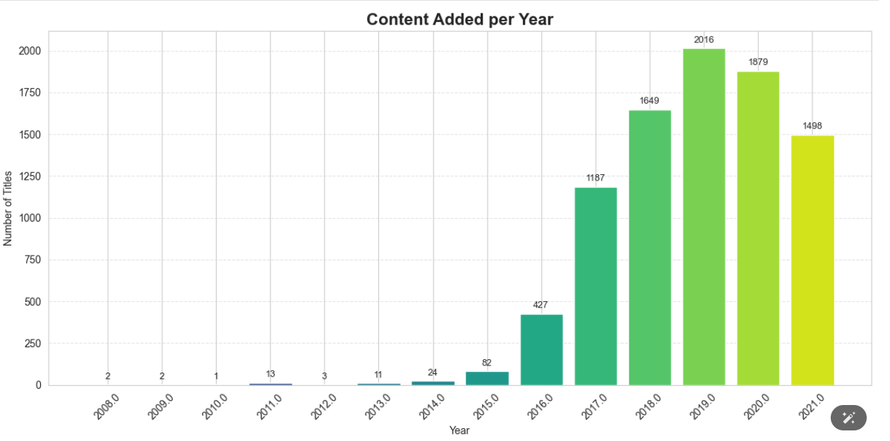Fig. 1. Number of titles added to Netflix per year.

B. Distribution of Movies and TV Shows
An analysis of the type column showed that movies constitute approximately 70 percent of all content on Netflix, while TV shows account for the remaining 30 percent. Although movies dominate the platform, the proportion of TV shows has been gradually increasing in recent years, suggesting a strategic shift toward serial content.
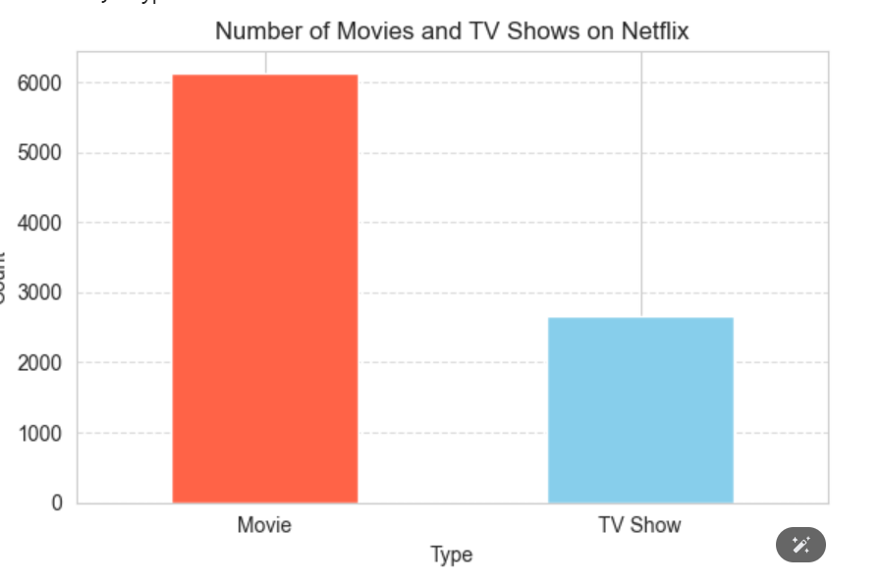Fig. 2. Distribution of Movies and TV Shows on Netflix.

C. Top Contributing Countries
The United States was found to be the largest contributor of content, accounting for the majority of titles on the platform. India ranked second, reflecting Netflix's significant investment in the South Asian market. Other notable contributors included the United Kingdom, Canada, and Japan. The top 10 contributing countries were visualized using a horizontal bar chart.
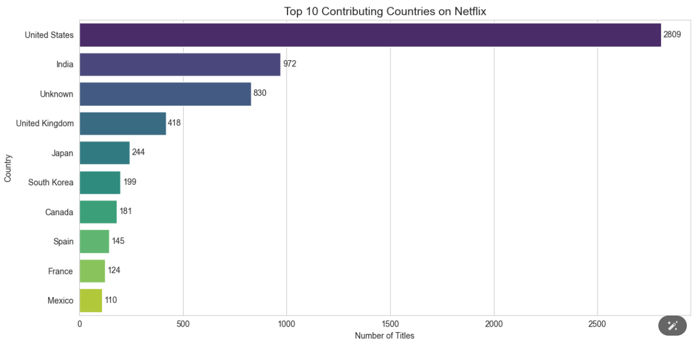Fig. 3. Top 10 countries contributing content to Netflix.

D. Content Added vs. Release Year Heatmap
A heatmap was created to examine the relationship between the year content was added to Netflix (2010 to 2021) and the year it was originally released (2000 to 2021). The heatmap revealed that Netflix tends to add content that was released in the same year or within the previous two to three years, with a concentration of recent releases particularly after 2016.
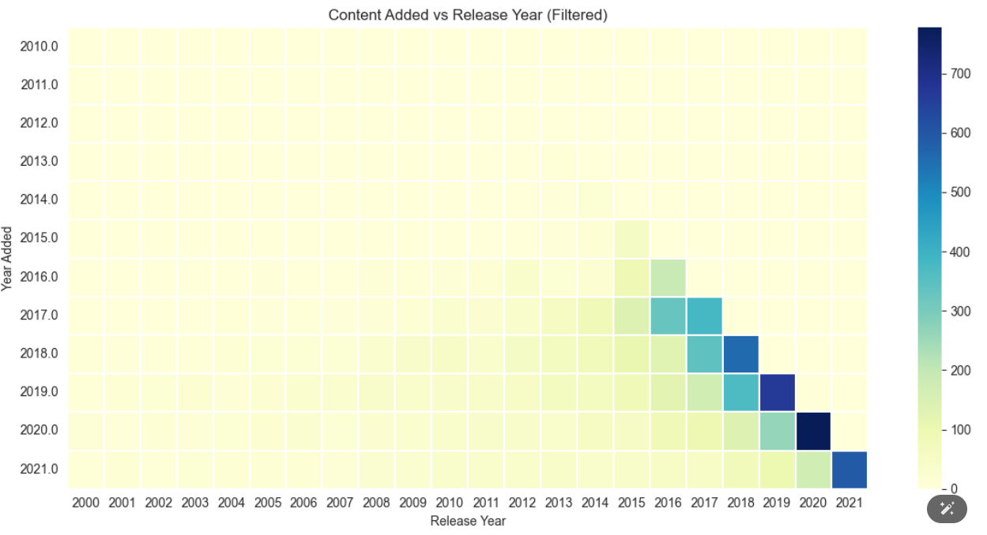Fig. 4. Heatmap of content added year versus original release year.

E. Top Genres
Drama was identified as the most prevalent genre on Netflix, followed by International Movies, Documentaries, Stand-Up Comedy, and Action and Adventure. This distribution indicates that Netflix caters to a wide range of audience preferences, with a strong emphasis on narrative and international content.
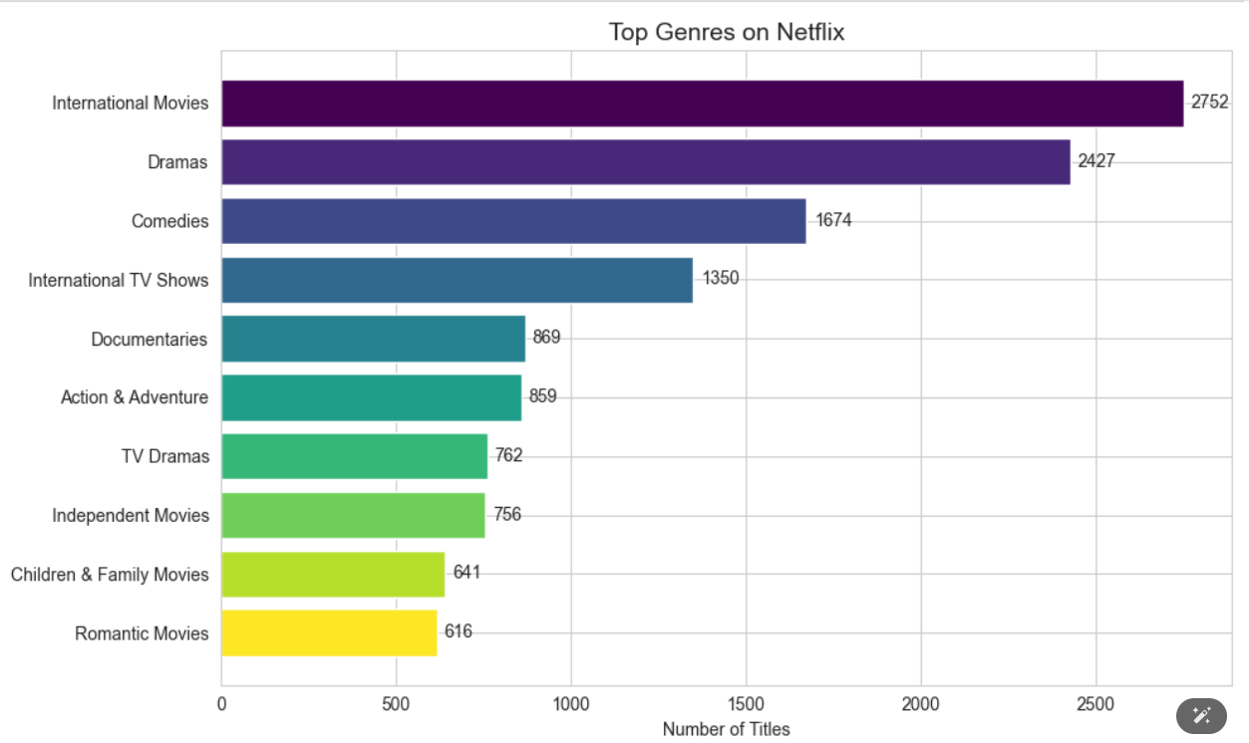Fig. 5. Top 10 genres by number of titles on Netflix.

F. Monthly Content Addition Trends
An analysis of the month_added feature showed that content addition is not uniform throughout the year. Months such as January, July, and October exhibited higher content addition volumes, suggesting that Netflix follows seasonal strategies aligned with subscription renewal cycles and viewer engagement patterns.
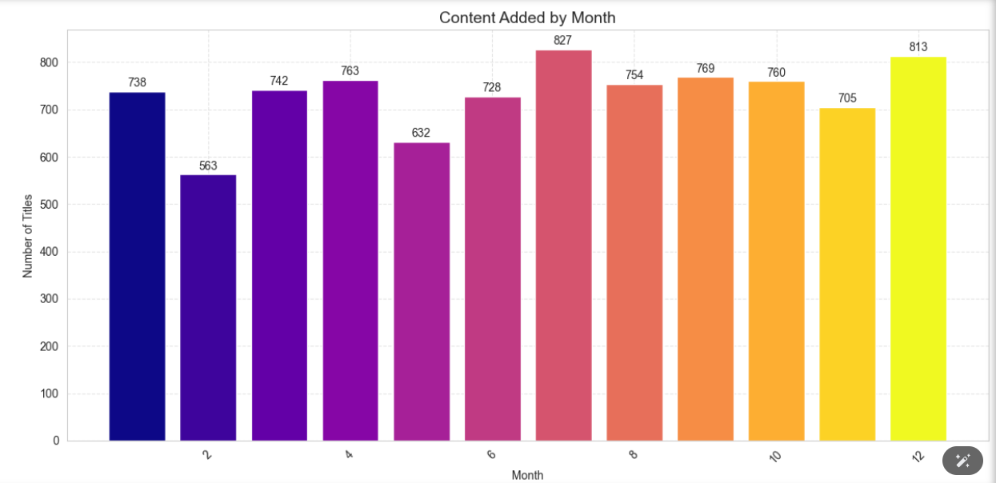Fig. 6. Number of titles added to Netflix by month.

G. Movie Duration Distribution
Box plots were generated to analyze the distribution of movie durations across different release years. The analysis showed that the median movie duration has remained relatively stable at approximately 90 to 100 minutes, though there is a wide spread of outliers, particularly for older content. No significant trend toward shorter or longer movies was observed over time.
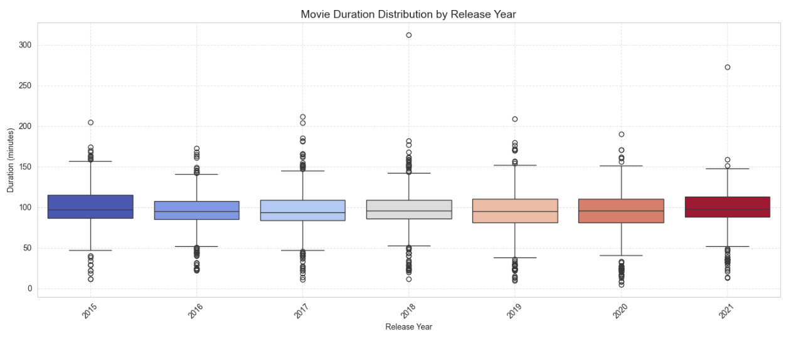Fig. 7. Movie duration distribution by release year.

H. Rating Distribution
TV-MA (Mature Audience) was found to be the most common content rating on Netflix, followed by TV-14 and TV-PG. This indicates that a significant portion of Netflix content is targeted at adult audiences. The presence of PG and G-rated content, while smaller, shows that the platform also maintains a library of family-friendly titles.
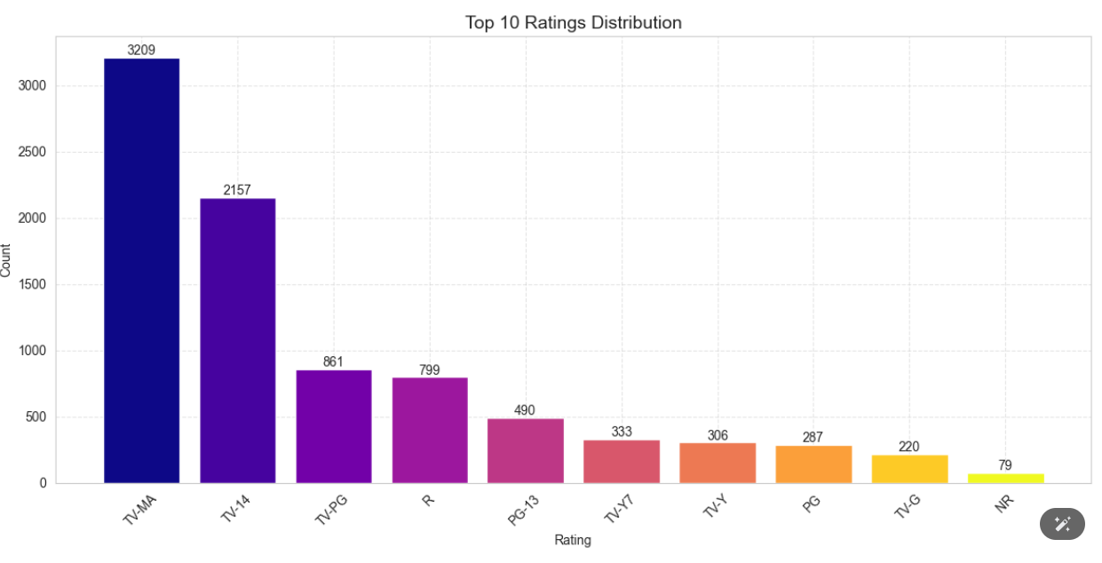Fig. 8. Distribution of content ratings on Netflix.
I. Machine Learning Model Comparison
Four classification models were trained to predict whether a Netflix title is a Movie or TV Show based on the features country, release_year, duration, and listed_in. The performance of each model was evaluated using classification accuracy on the held-out test set (20% of the data).
Gaussian Naive Bayes produced a baseline accuracy reflecting the probabilistic independence assumption between features. Logistic Regression, a linear classifier, achieved a moderate accuracy score. The Decision Tree Classifier, which partitions the feature space using recursive binary splits, performed competitively. Random Forest, an ensemble of decision trees trained with bagging and random feature subsets, achieved the highest accuracy among all models tested.
The results confirm that tree-based ensemble methods generalize better than linear or probabilistic classifiers for this dataset. The Random Forest model benefited from its ability to reduce variance through aggregation of multiple weak learners, making it the most suitable model for this classification task.
[Insert Figure 10 here]
Fig. 10. Comparison of classification accuracy across four machine learning models.
J. Monthly Addition Trend
The monthly addition trend line chart revealed that Netflix does not add content uniformly throughout the year. Content additions follow a wave-like pattern across the 12 months. Month 1 (January) and month 12 (December) recorded notably higher additions, suggesting that Netflix strategically releases a large volume of titles at the start and end of the calendar year to capitalize on holiday viewing seasons and new year subscriber activity. A visible dip was observed around months 2 and 3 (February and March), indicating a slower period for new additions. Overall, the trend confirms that content addition on Netflix is influenced by seasonal and business factors rather than being evenly distributed.
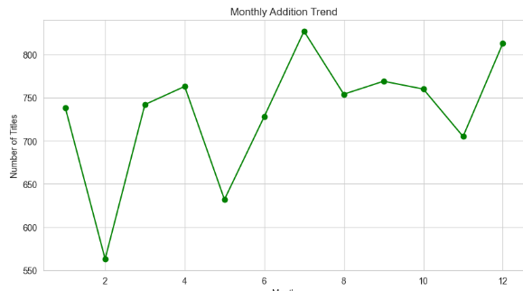Fig. 6. Monthly content addition trend on Netflix across 12 months.
K. Top 10 Genres
Analysis of the listed_in column, after splitting multi-genre entries and stacking all genre labels, revealed that International Movies is the single most represented genre on Netflix, followed closely by Dramas. Other prominent genres in the top 10 include Comedies, International TV Shows, Documentaries, Action and Adventure, TV Dramas, Independent Movies, Children and Family Movies, and Romantic Movies. The strong presence of International Movies and International TV Shows confirms that Netflix has made a deliberate and sustained investment in non-English language content to serve its global subscriber base. The high frequency of Dramas across both movie and TV show categories reflects the broad audience appeal of narrative-driven content.
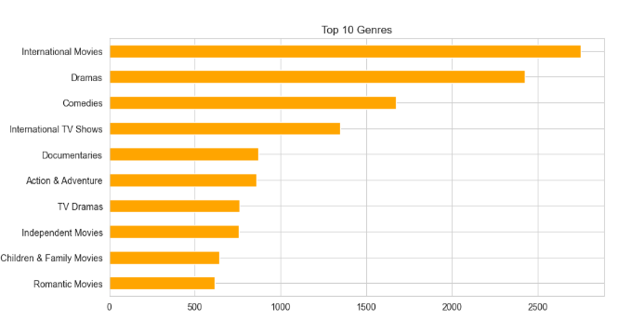Fig. 7. Top 10 genres by total number of titles on Netflix.

L. Release Year vs Duration (Scatter Plot)
The scatter plot comparing release year against duration in minutes revealed a clear concentration of data points in the post-2000 era, which is consistent with the overall age of the dataset. The majority of content falls within a duration range of approximately 80 to 120 minutes for movies, representing the conventional feature film length. A small number of outliers with durations exceeding 200 minutes are visible, representing extended or special releases. For older content (pre-1980), the spread is wider, indicating more variability in film lengths during earlier decades of cinema. No strong linear relationship between release year and duration was observed, suggesting that average movie length has remained relatively stable over time despite the growth in overall content volume.
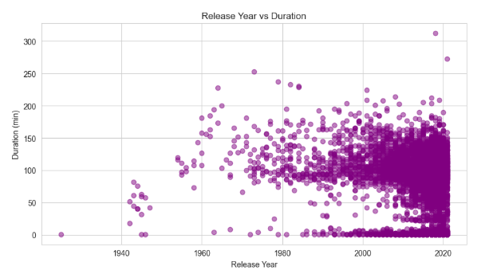Fig. 8. Scatter plot of release year versus content duration in minutes.

M. Distribution of Content Type (Pie Chart from Dashboard)
The pie chart confirmed that movies constitute approximately 69.7 percent of all content on Netflix, while TV shows account for the remaining 30.3 percent. This 70-30 split highlights that while Netflix began primarily as a movie licensing platform, it has grown its TV show library substantially. The visual distribution makes it immediately clear that movies dominate the platform in raw volume, though TV shows tend to contribute more total hours of viewing time given their multi-episode format.
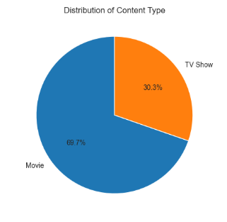
Fig. 10. Pie chart showing the proportional distribution of Movies and TV Shows on Netflix.

Discussion
The results from this study match the observed trends within the streaming industry. First, the marked rise in content additions after 2016 is in line with the well-publicized plan of Netflix to heavily invest in original content as well as acquired licenses to outdo new competitors and lessen its reliance on other studios [2].
In spite of the expected domination of content from the United States due to Netflix’s origin, a counterbalance is slowly being seen in contributions made from India and Asia. This shows the localization plan adopted by Netflix to produce and license local content to attract foreign viewers.
Given the number of entries in the mature category (TV-MA), one can assume that the company's audience consists mainly of adults. It is also evident from the pricing strategy and characteristics of typical users who employ streaming services. The proportion of TV shows indicates industry trends as the serial approach to the creation of new shows became more popular in recent years.
From the perspective of methodology, it should be noted that the use of Pandas, Seaborn, and Matplotlib for processing and visualization was highly efficient. Feature engineering allowed performing various types of analyses related to time parameters as a result of year_added and month_added attributes. Moreover, the is_recent parameter made it easy to analyze content in comparison.
It is important to state that the dataset used in the research is out-of-date because Netflix updates its collections quite frequently. In addition, no information about viewers and their reactions has been provided. As such, there are significant limits to the findings and further research may benefit from including these parameters.

Conclusion
The current paper has explored the Netflix Titles dataset through exploratory data analysis. With the use of such data science libraries of the Python programming language as Pandas, NumPy, Matplotlib, and Seaborn, it was possible to analyze content trends over time, geographical location, content type, genres, and audience ratings. The preprocessing pipeline effectively dealt with missing data, changed data types, eliminated duplicates, and created additional features for the further analysis of data.
The main results of this exploratory data analysis include the following facts about Netflix content:
Netflix added a large number of new contents since 2016;
the biggest supplier of titles in the USA;
movies account for around 70% of Netflix content, while TV shows are gaining popularity;
Drama and International Movies are the most popular genres;
TV-MA is the most popular content rating;
content addition shows seasonal patterns during particular months of the year.
In conclusion, it is necessary to note that this exploratory data analysis has shown how important it is to explore the characteristics of complex real-world datasets to better understand them and extract useful insights for future decisions.

