PROJECT:3

**INSERT ITEM INTO DYNAMODB FROM S3 USING AWS LAMBDA**

In this project we will use aws lambda to initialize a trigger which will get datas from amazon s3 and store it into dynamodb.

For this we will use IAM,DYNAMODB,S3 AND AWS LAMBDA

**STEPS :-**

1.Creation of s3 bucket

2.Creation of dynamodb table

3.Creation of policy for IAM role for AWS LAMBDA

4.Creation and configuration of a lambda function

5.Configure the s3 bucket to trigger the lambda function

6.Test the project by uploading a .csv file yo your bucket

7.Delete the files and the services

STEP1-CREATION OF S3 BUCKET:

* First login to your AWS console and go to s3 service.
* Create a bucket with an unique name

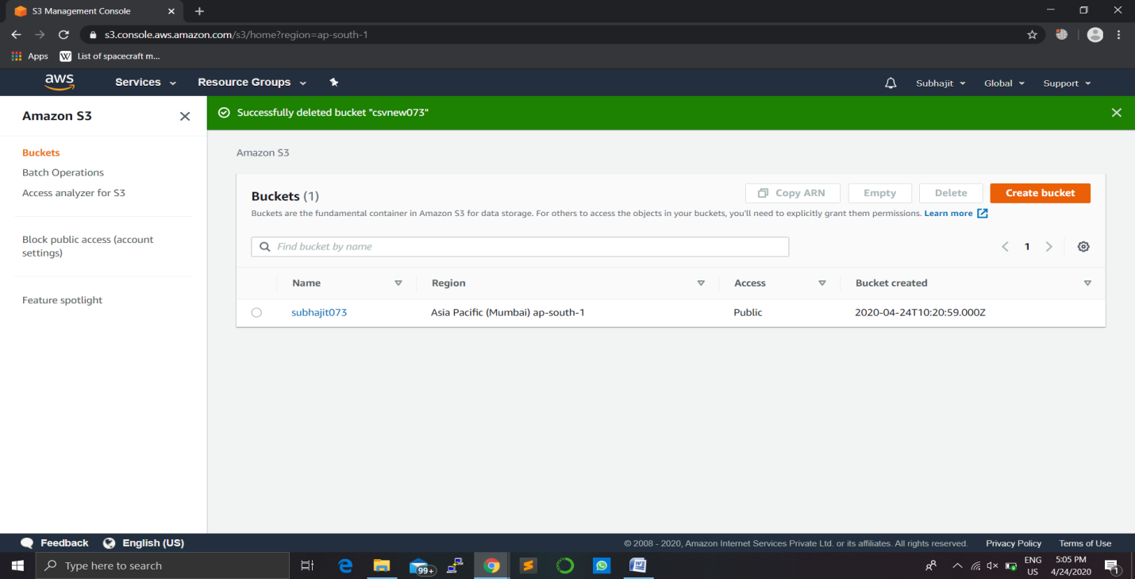

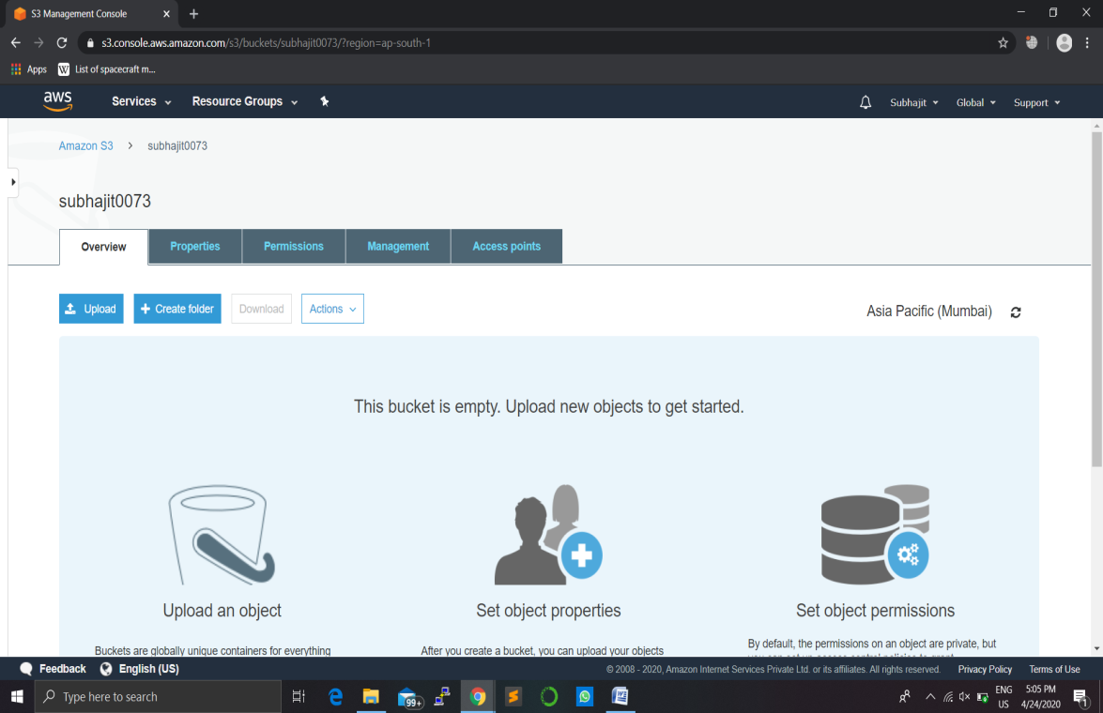

STEP2-CREATION OF DYNAMODB TABLE:

* In this step go to dynamodb service and then create a table to store datas.

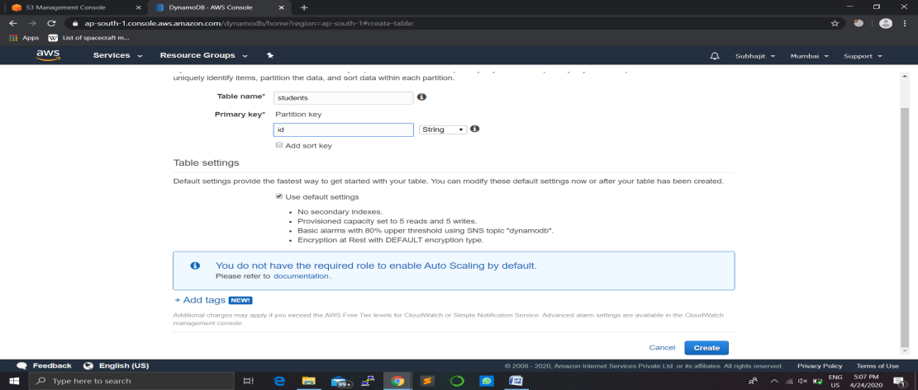

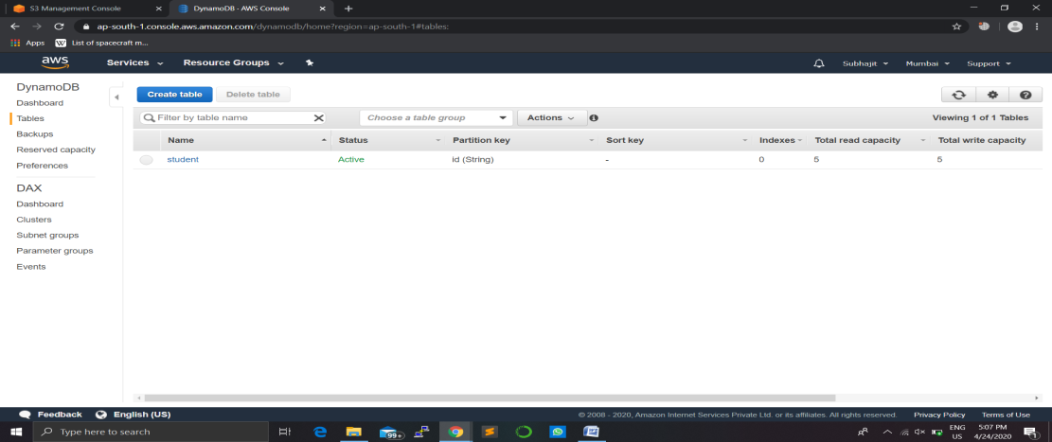

STEP3-CREATION OF POLICY FOR IAM ROLE FOR AWS LAMBDA:

* In this step we will create a policy including permissions for lambda function to acess all

The services like s3,dynamodb,cloudwatch.

* Then we will create a role for aws lamdbda and attach the above policy to it.

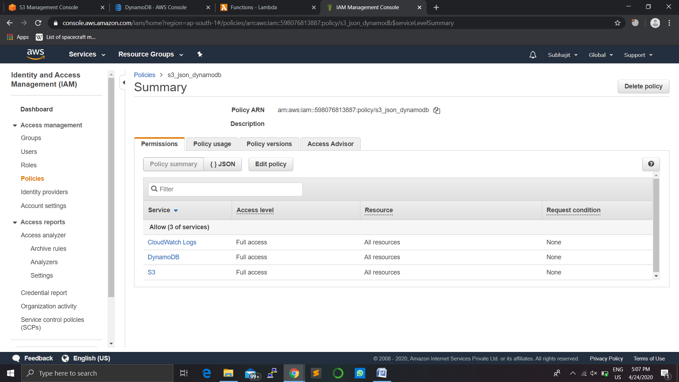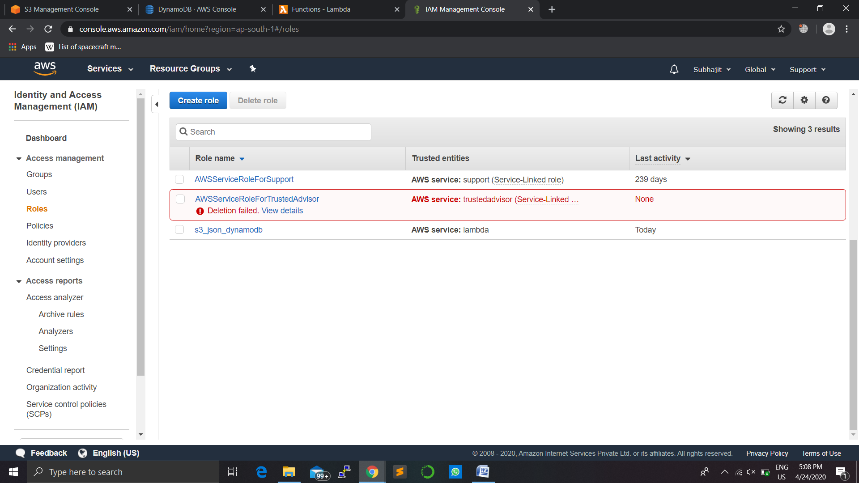

STEP4.CREATION AND CONFIGURATION OF A LAMBDA FUNCTION:

* In this step we will be creating a lambda function and then configure it to access s3 and the get the datas from the bucket and store it into dynamodb.
* We will also add a trigger so that when ever a .csv file is added to s3 it will invoke the lambda function and then read the items in it.

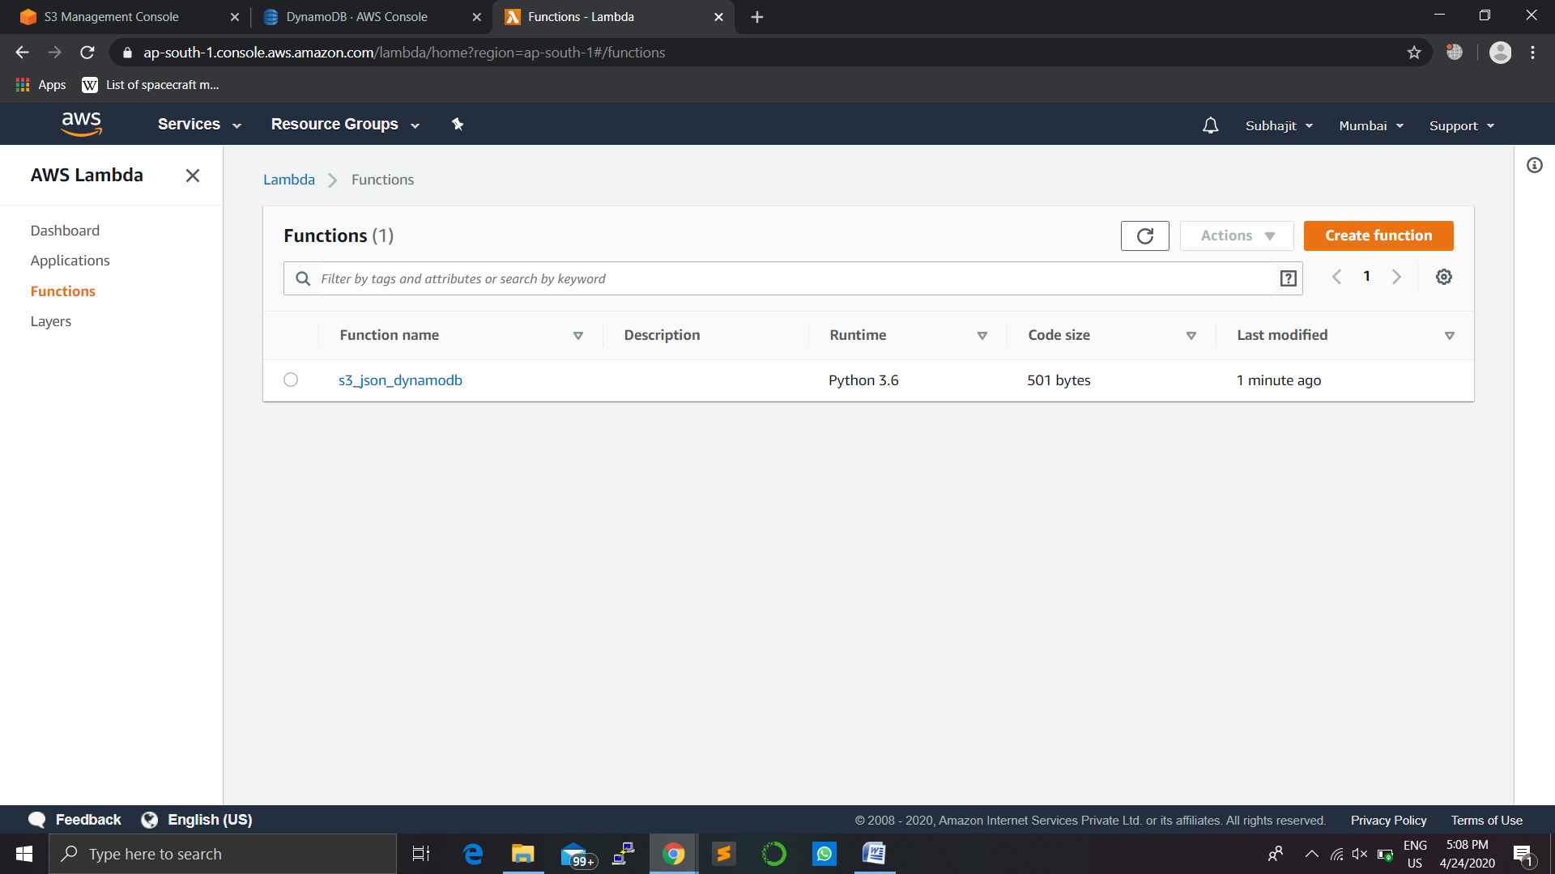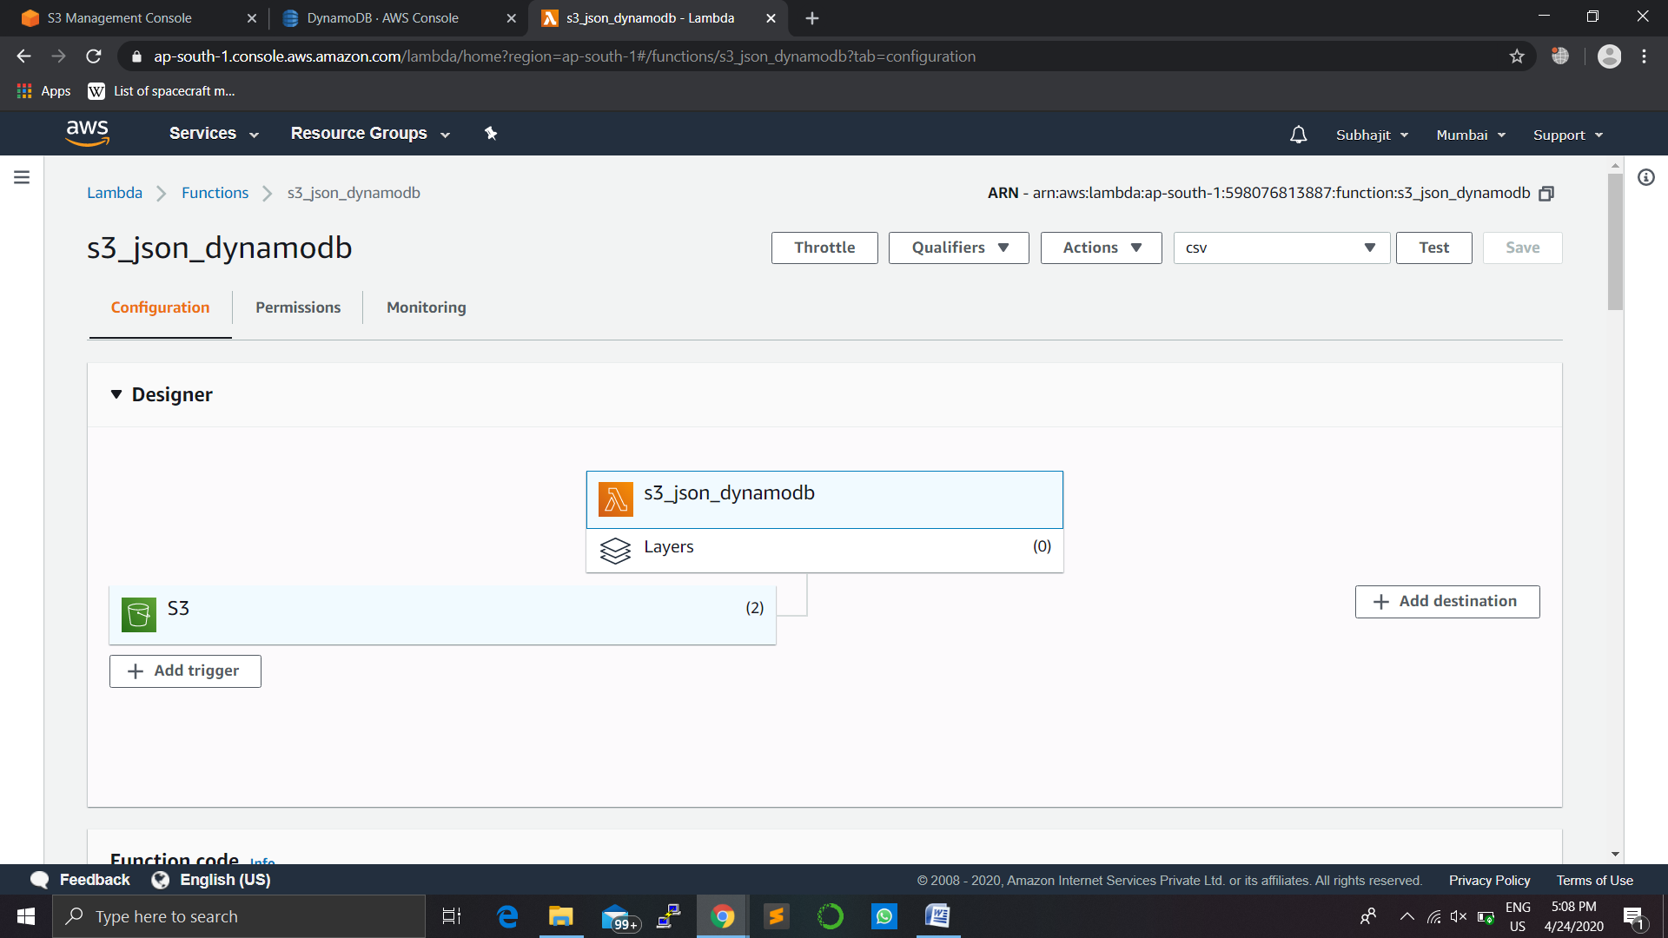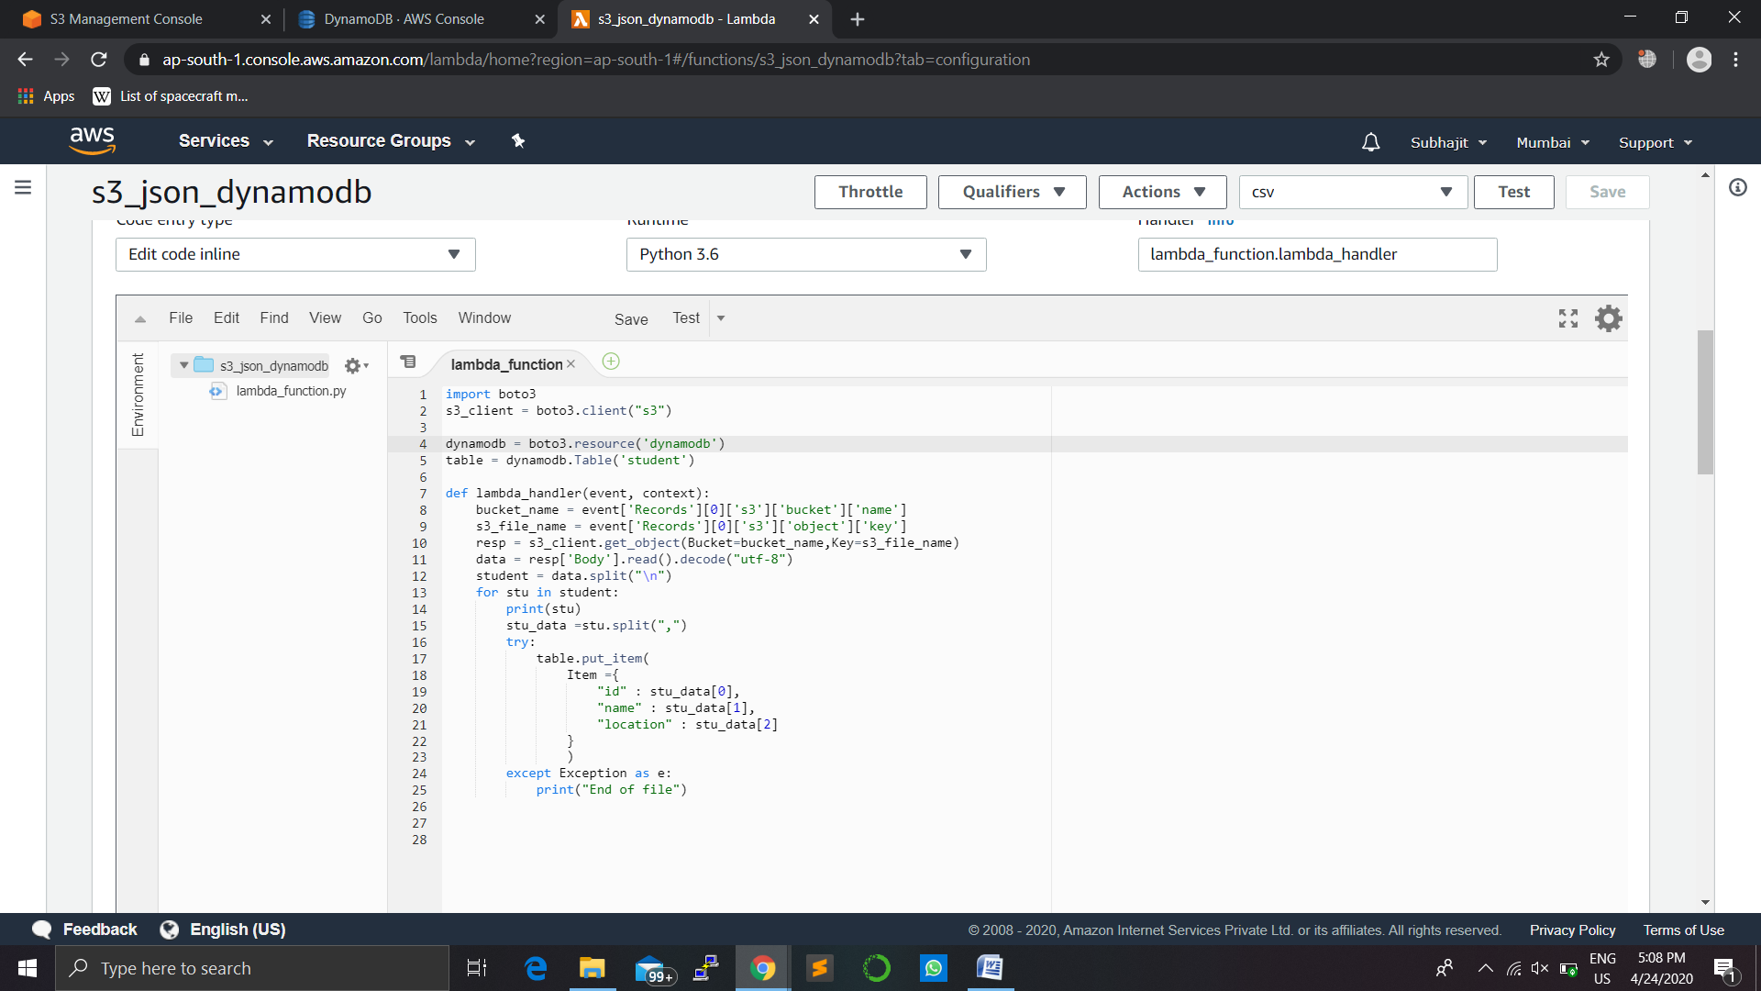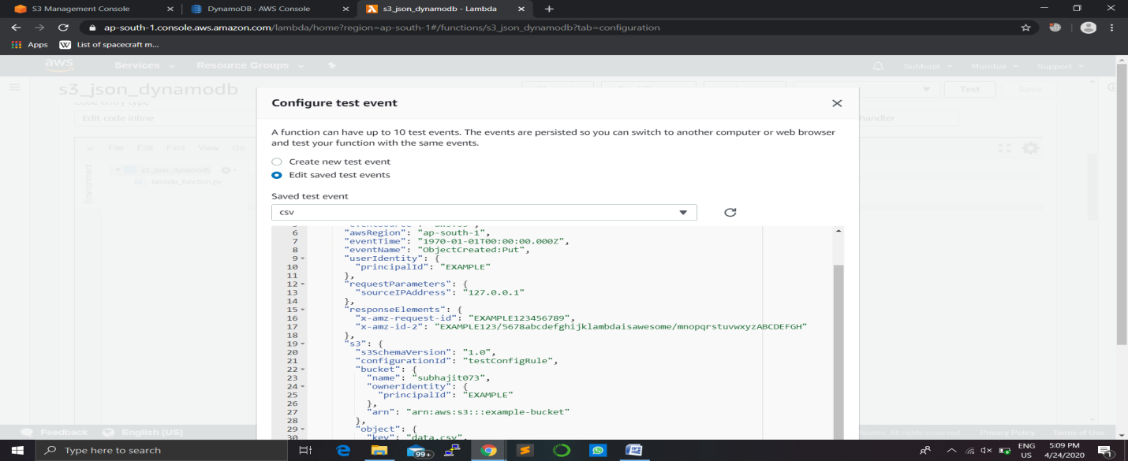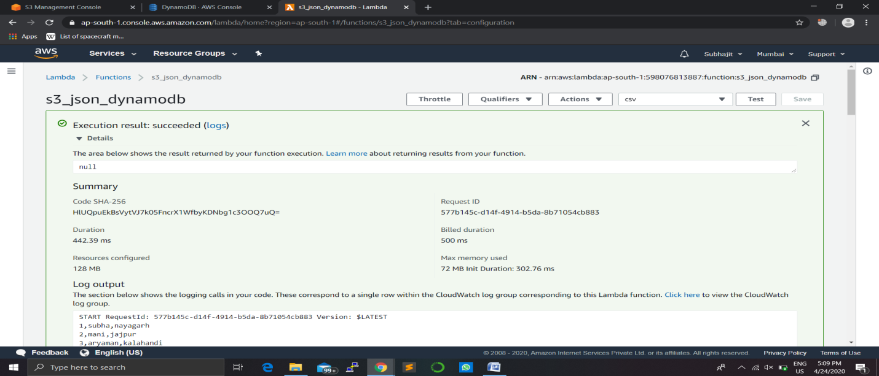

STEP5-CONFIGURE THE S3 BUCKET TO TRIGGER THE LAMBDA FUNCTION:

* Configure the s3 bucket to create an trigger when ever a .csv file is uploaded.

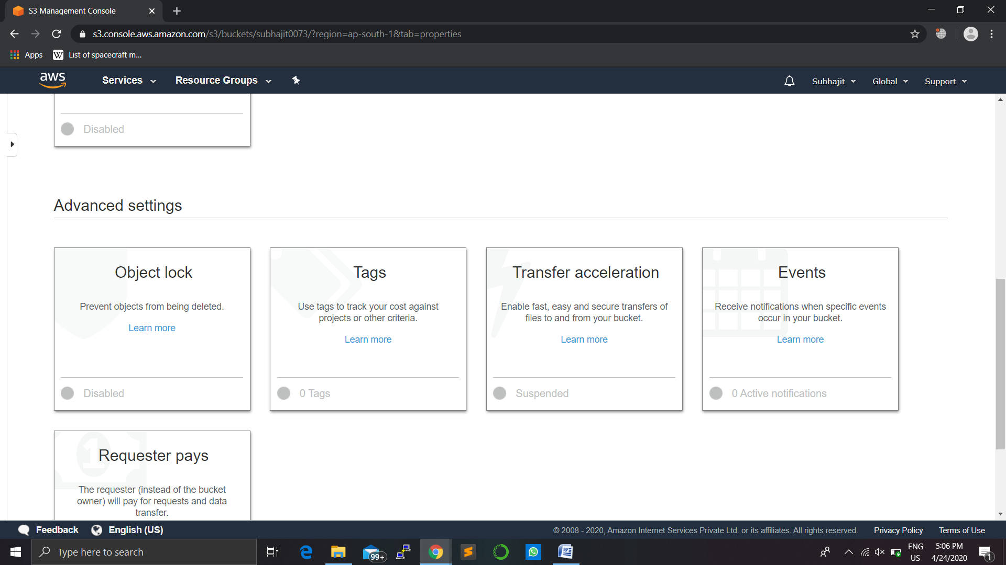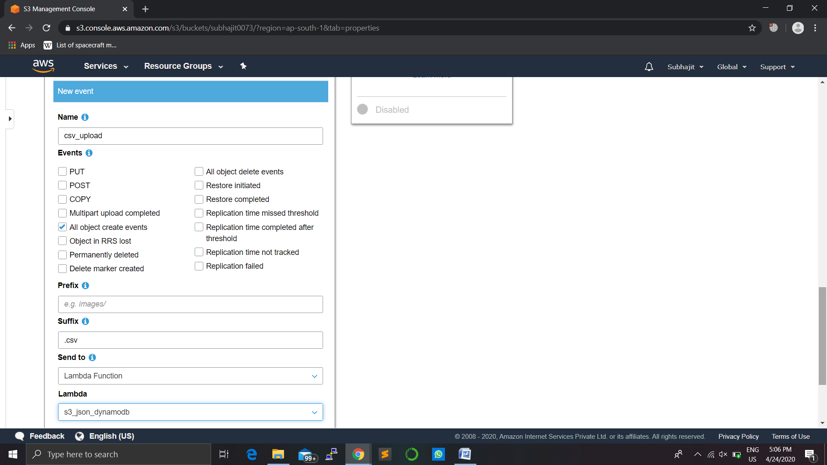

STEP6-TEST THE PROJECT BY UPLOADING A .CSV FILE YO YOUR BUCKET:

* In this step we will test the project

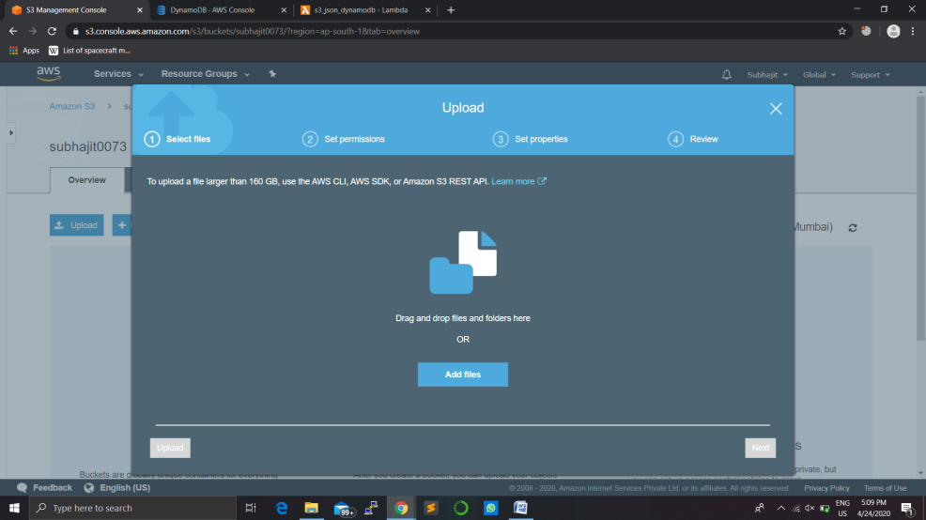

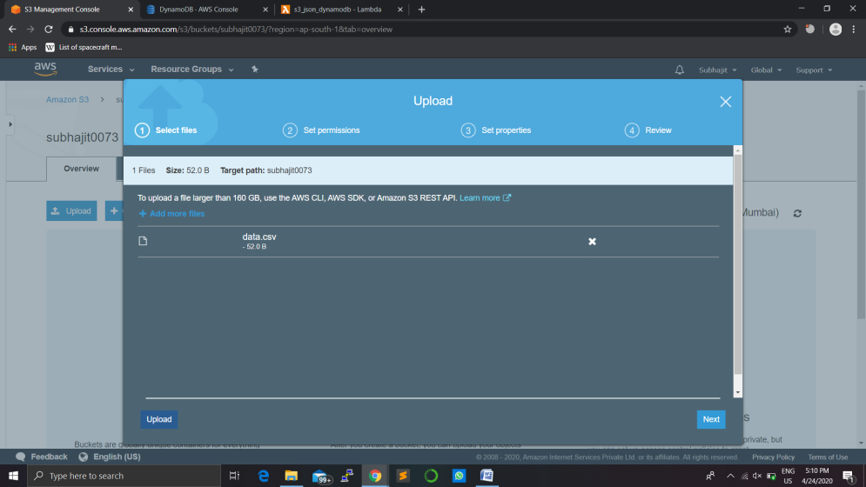

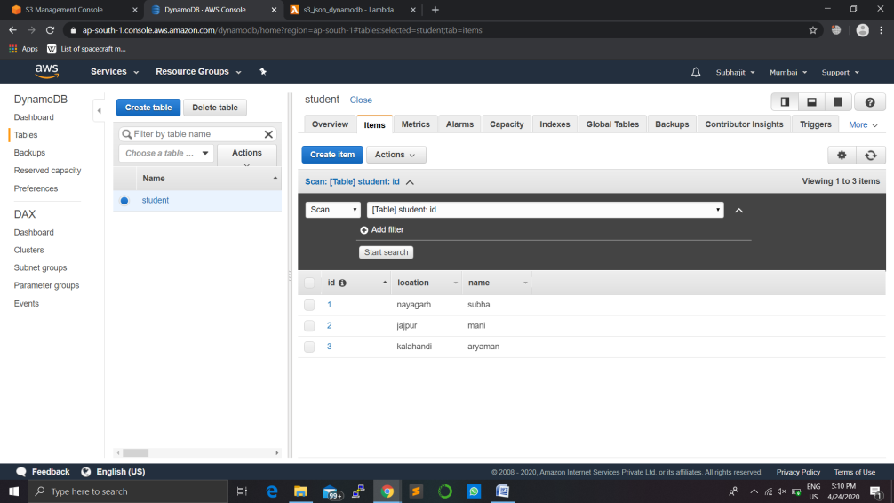

STEP7-DELETE THE FILES AND THE SERVICES:

* After the testing you can delete all the above files and functions so that you won’t have to pay extra fees.

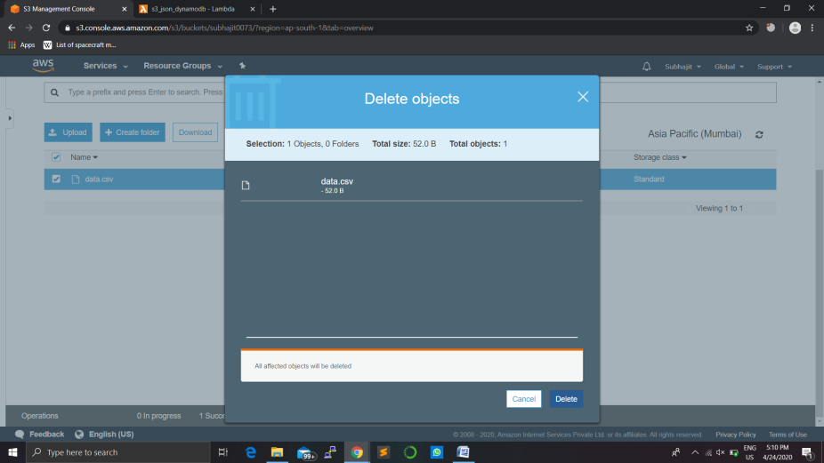

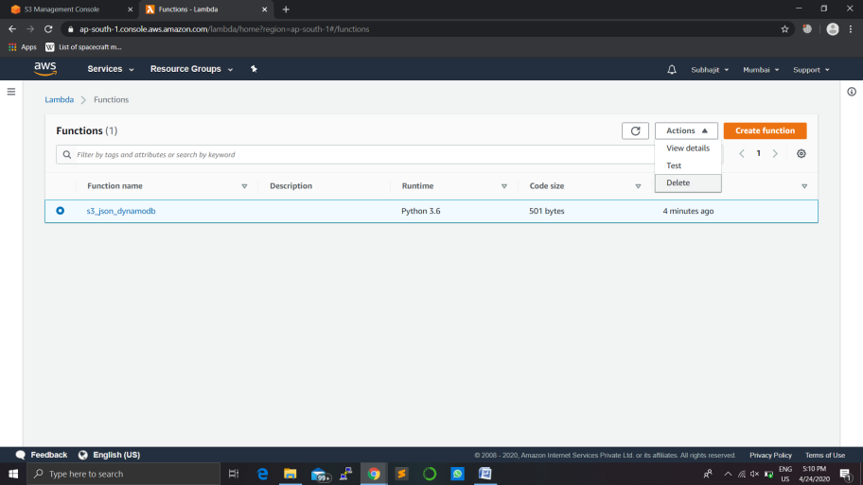

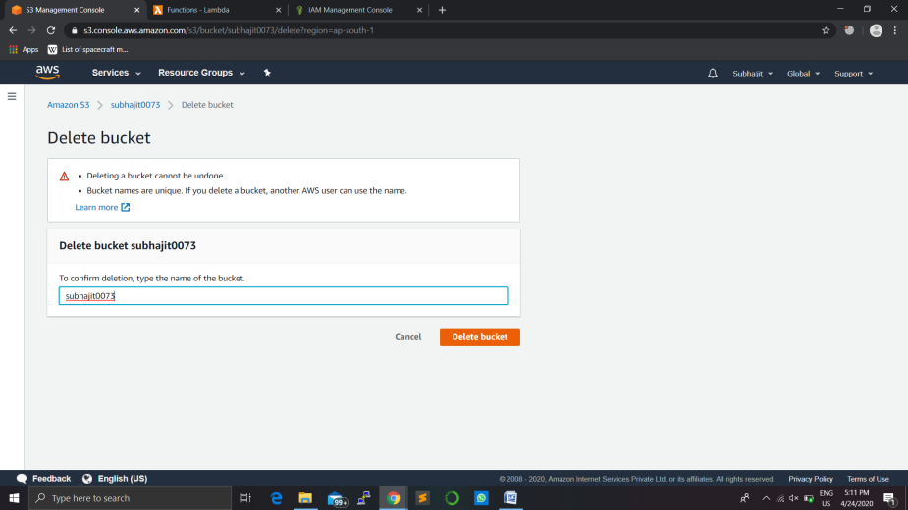

-------------------FINISH--------------------