**Project-3**

**Send Fanout Event Notifications**

**With Amazon Simple Queue Service (SQS) and Amazon Simple Notification Service (SNS)**

This project covers how to use the Amazon Simple Notification (SNS) service to create a Fanout pattern. We will create a single SNS topic and have multiple [SQS queues](https://funnelgarden.com/amazon-simple-queue-service-sqs-intro/) subscribe to it, along with an SMS and email notification.

SNS is a AWS publish-subscribe messaging service that allows a multiple subscribers to be notified about a specific event. It decouples events from the processing of those events and allows for parallel processing of events by each subscriber.

**STEPS TO IMPLEMENT THE PROJECT**

## **Step 1. Enter the Amazon SNS Console**

When you [click here](https://console.aws.amazon.com/console/home" \t "_blank), the AWS Management Console will open in a new browser window, so you can keep this step-by-step guide open. When the screen loads, enter your user name and password to get started. Then type *notification*in the search bar and select **Simple Notification Service** to open the service console.

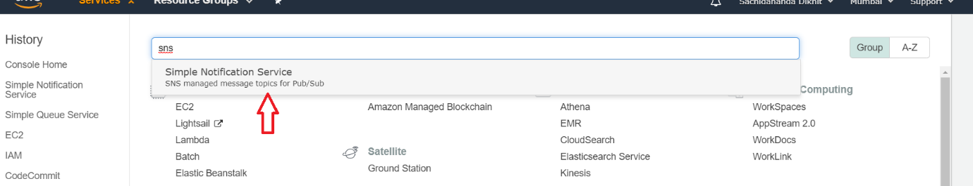

**Figure 1. (SNS Console)**

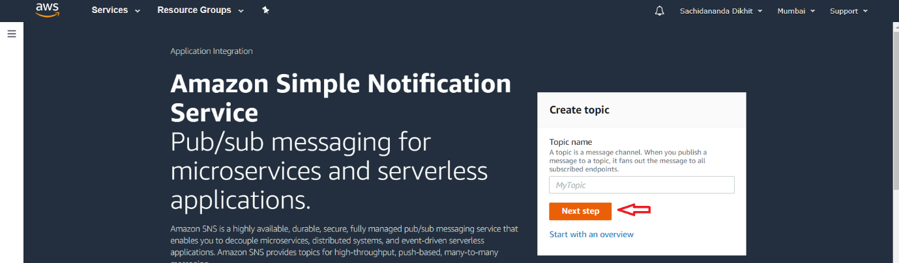If the SNS console landing page appears, click **Next step**.

**Figure 2. (Landing Page of SNS)**

## **Step 2. Create an Amazon SNS Topic**

In this step, you will create an Amazon SNS topic. A topic is a communication channel to send messages and subscribe to notifications. In this example, a sample ecommerce application will push a message to an Amazon SNS topic whenever a new order is placed on the online store.

1. In the Create topic page, type ***New-Orders***, in the topic name box, then click **Create topic.**

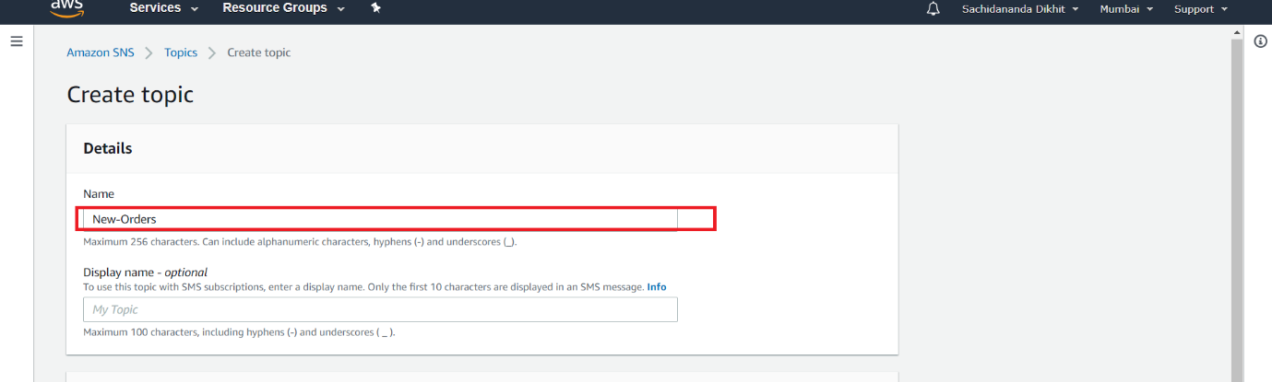

**Figure 3. (Creation of Topic)**

1. The Topic details page confirms the topic is successfully created.

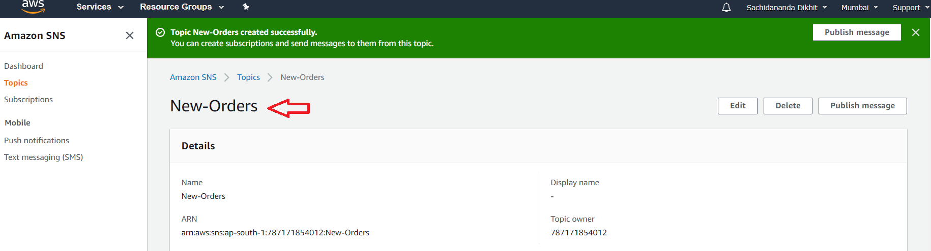

**Figure 4. (Confirmation of Topic Creation)**

## **Step 3: Create the Amazon SQS Queues**

Now that you have created the topic with Amazon SNS, you will create Amazon SQS queues that will subscribe to the topic.

When you subscribe multiple queues to a topic, each queue receives identical notifications every time a message is pushed to the topic. Services attached to those queues can then process the orders asynchronously and in parallel.  
  
For example, an Amazon EC2 server instance attached to one of the queues could handle the processing or fulfillment of the order, while the other server instance could be attached to a data warehouse for analysis of all orders received.

1. [Click here](https://console.aws.amazon.com/sqs" \t "_blank) to open the Amazon SQS console in a new browser window. If the SQS landing page appears, click **Get Started Now**. Otherwise, proceed to the next step.

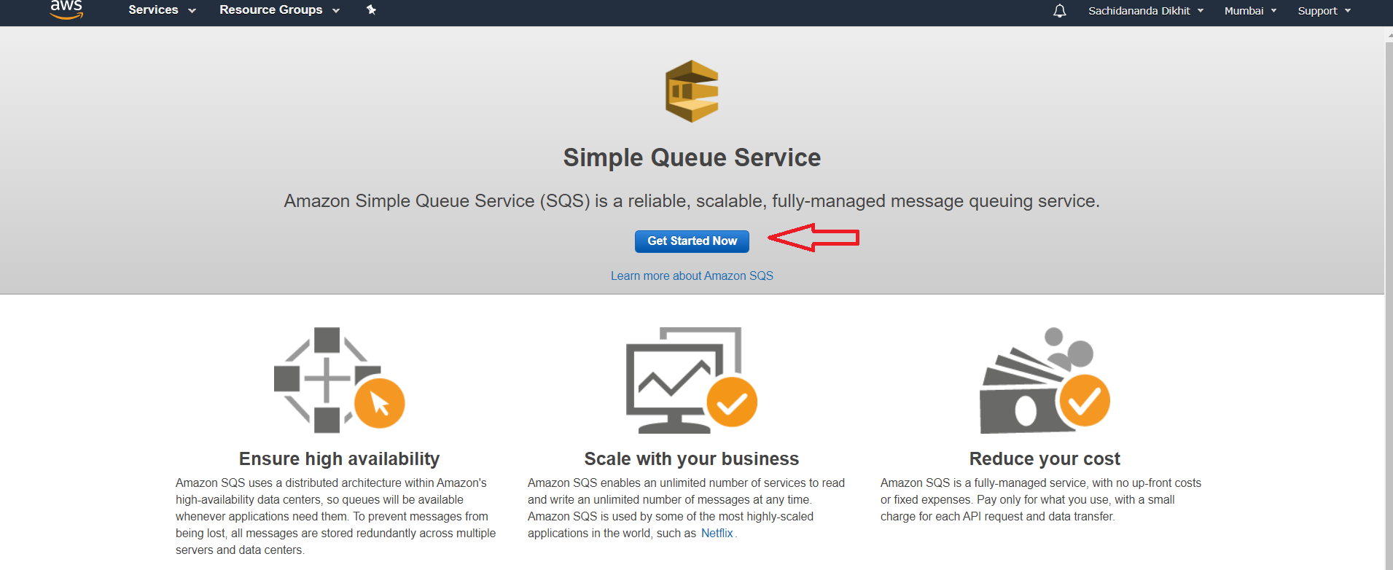

**Figure 5.(Console page of SQS)**

b. Our first queue will store orders for a fictional Inventory Service that keeps track of products, adding and deleting them as needed from inventory with each order.

On the **Create New Queue** page, enter *Orders-for-Inventory* in the **Queue Name** field. Leave **Standard Queue** selected and click **Quick-Create Queue**.

**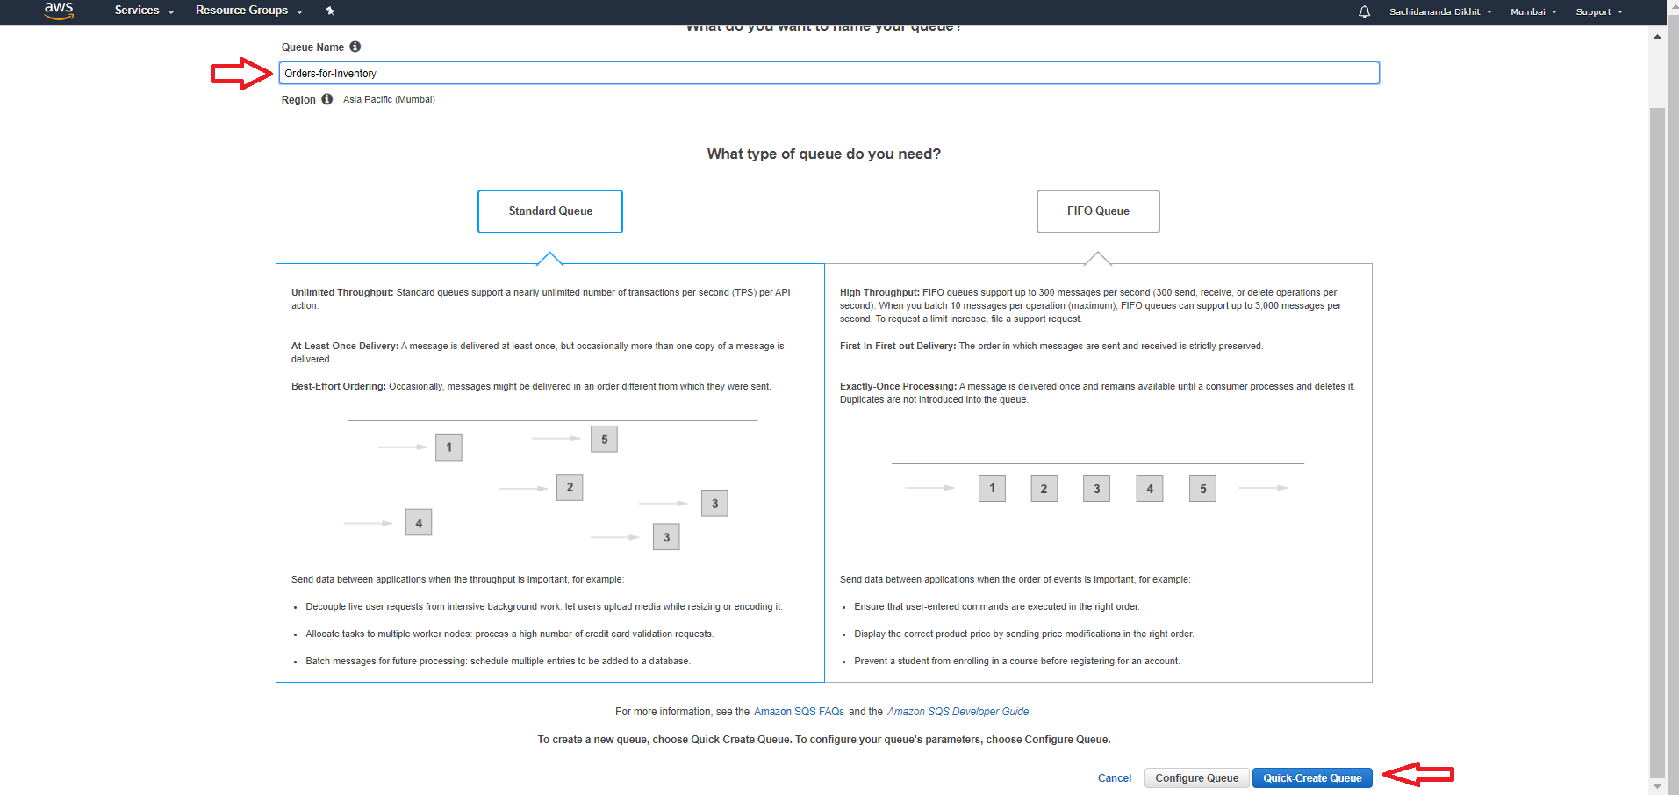Figure 6. (Creation of Queue)**

c. Your new queue is created and selected in the queue list. Next, you’ll create a second queue to handle order analytics.

Click **Create New Queue** to create another queue to store orders for the Analytics Service.

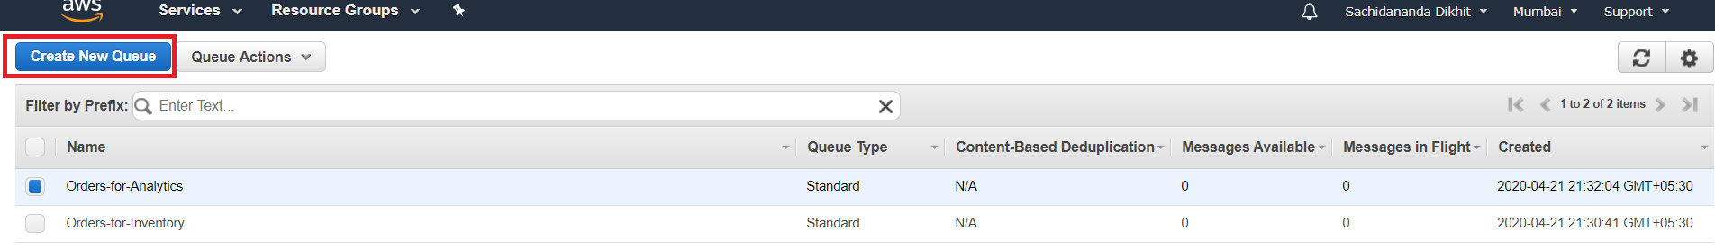

**Figure 7. (Creation of New Queue)**

d.Enter *Orders-for-Analytics* in the **Queue Name** field, and click **Quick-Create Queue**.

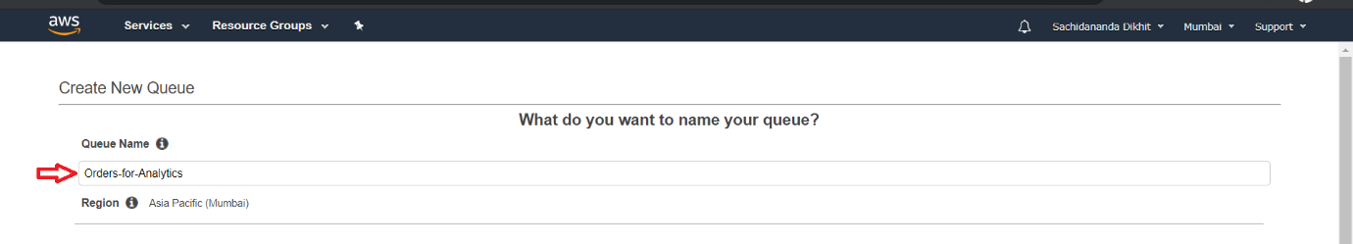

**Figure 8. (Naming & Creation of Queue)**

e.The new queue now appears in the queue list.

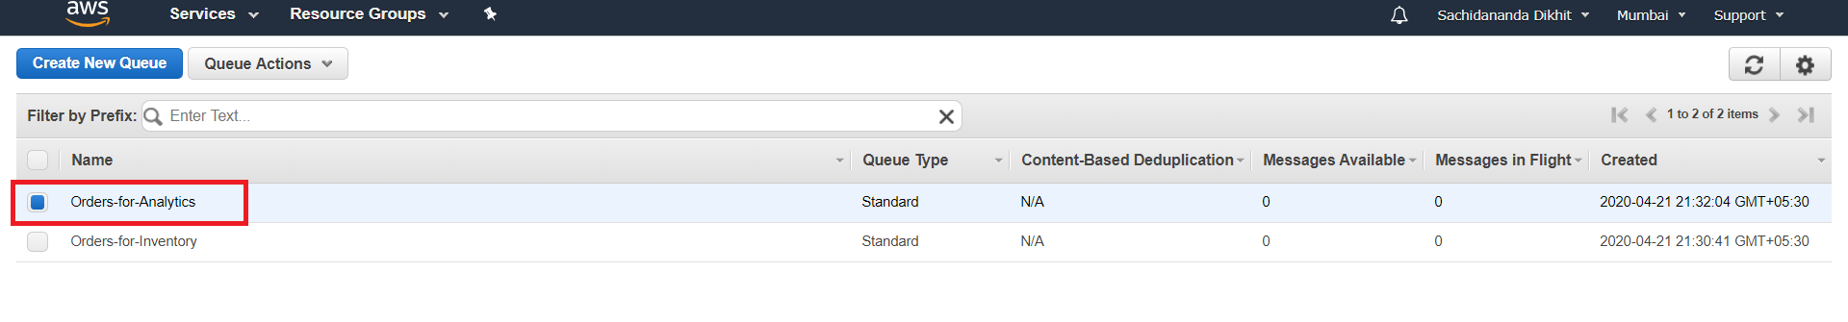

**Figure 9. (Dashboard of the Queues)**

## **Step 4: Subscribe the Queues to the Topic**

Now that you have created your two Amazon SQS queues, you need to subscribe them to the Amazon SNS topic that broadcasts notifications of new orders.

a. From the list of queues, select the *Orders-for-Inventory* and *Orders-for-Analytics* queues. From **Queue Actions**, select **Subscribe Queues to SNS Topic**.

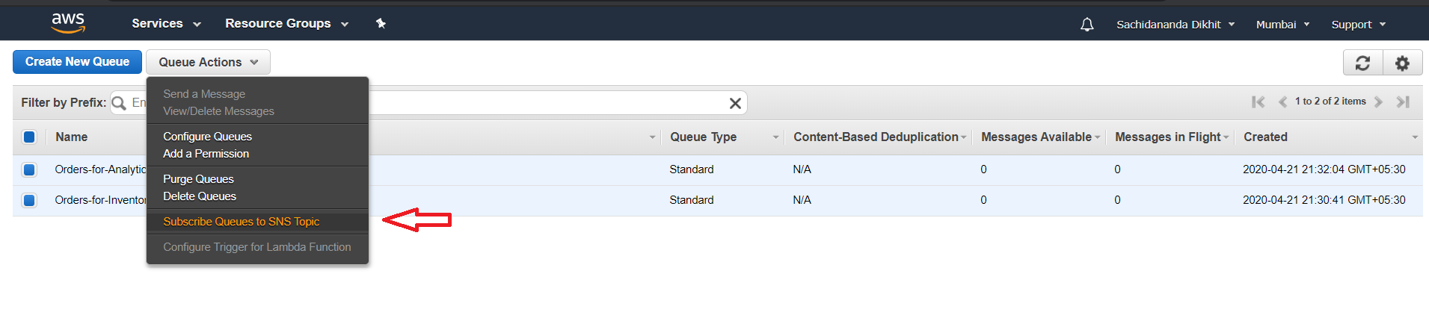

**Figure 10. (Subscribe to SNS Topic))**

b. The **Subscribe to a Topic** dialog box is displayed. From the **Choose a Topic** drop-down list, select your *New-Orders* Amazon SNS topic.

Your SNS topic appears in the list because you created it from the same account that you used to create your Amazon SQS queues. If the SNS topic was made by another account, you could subscribe to it by using the Topic ARN. For more details, see the [Amazon SNS documentation](http://docs.aws.amazon.com/sns/latest/dg/SubscribeTopic.html" \t "_blank).

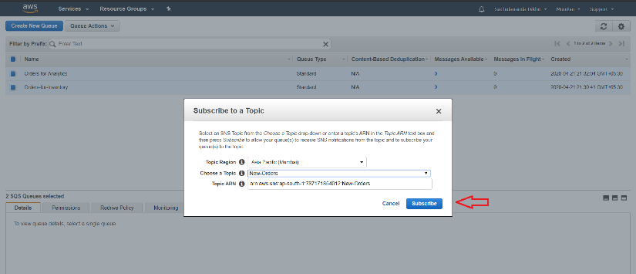Leave the **Topic Region** unchanged, and click **Subscribe**.

**Figure 11. (Subscription of the Topic)**

c. The Topic Subscription Result dialog box is displayed. Click **OK**.

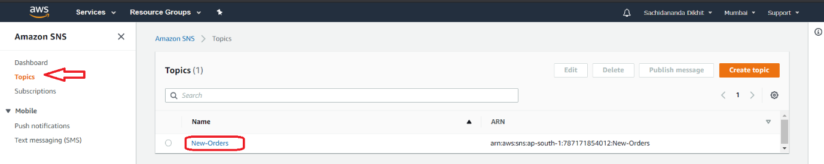

**Figure 12. (Dashboard of SNS)**

## **Step 5: Publish a Message to the Topic**

Your queues are now subscribed to the topic. In this step, you will simulate a new order by having the fictional ecommerce application push a message to the topic with the order details.

1. In the Amazon SNS console *New Orders* topic details page, click **Publish message**.

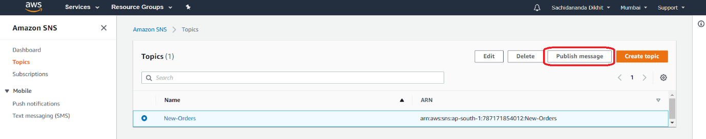

**Figure 13. (Publishing of Message)**

b. **Publish Message to topic** page appears. In the Subject box, type Order 123-4567890-1234567. In the Message field, enter the following text to represent a sample order:

*1 x Widget @ $29.99 USD*

*2 x Widget Cables @ $4.99*

Click Publish Message. A confirmation dialog box will appear.

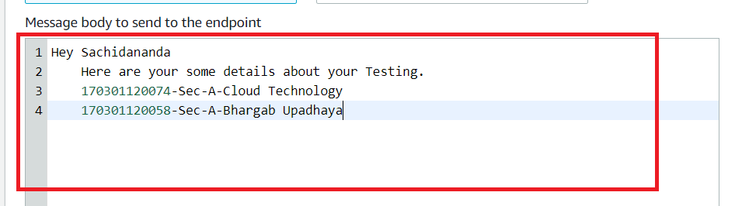

**Figure 14. (Publishing the Message)**

## **Step 6: Verify the Subscription**

Once a new message is published, Amazon SNS will deliver that message to every endpoint that is subscribed to the topic. In a fanout scenario like this one, the Amazon SQS queues are the endpoints.

In this step, you will confirm that the queues received the new order notification by viewing the message that the topic sent to the queues.

1. In the Amazon SQS console, check the box for the *Orders-for-Inventory* queue from the queue list. From the **Queue Action** drop-down, select **View/Delete Messages**.

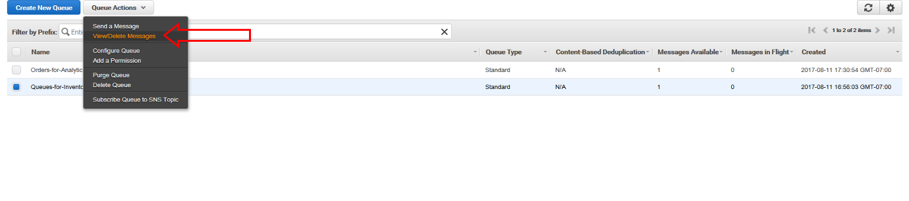

**Figure 15. (Verification of the Subscription)**

1. Click **Start Polling for Messages**.

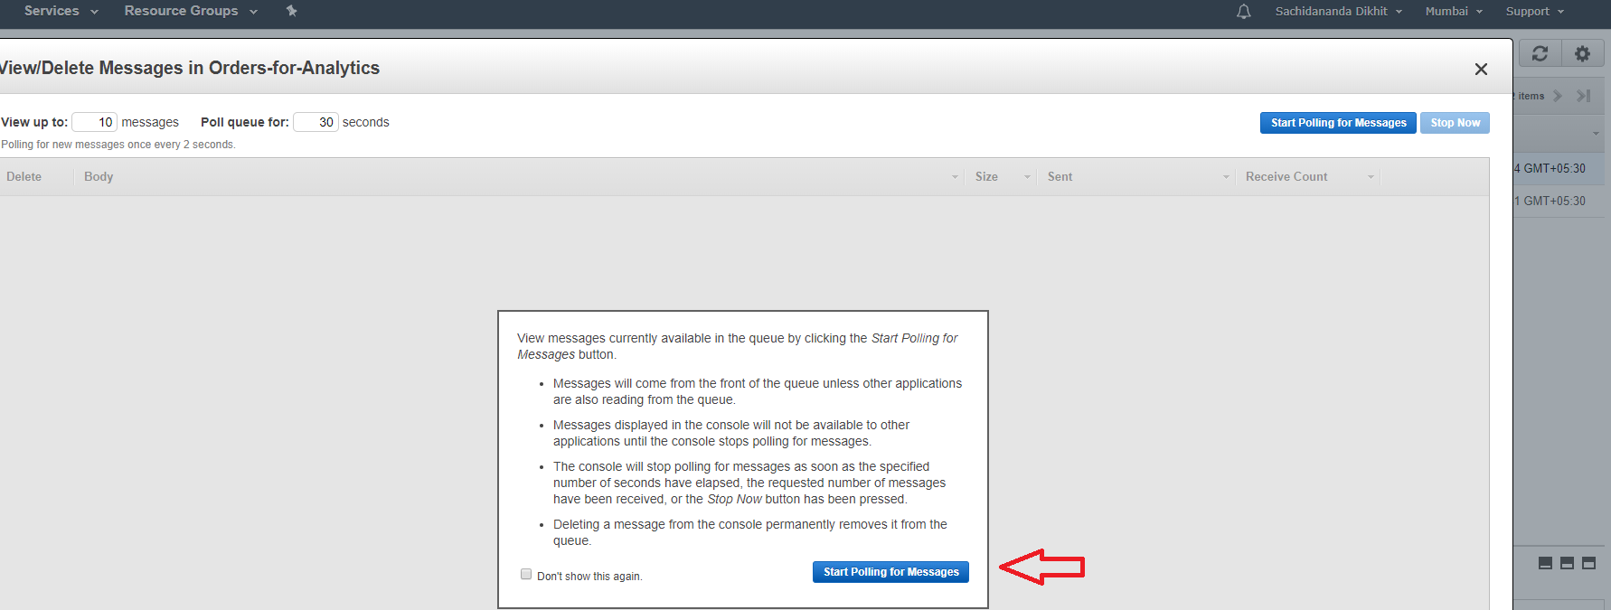

**Figure 16. (Message Polling)**

1. The **View/Delete Messages in Orders-for-Inventory** dialog box appears.

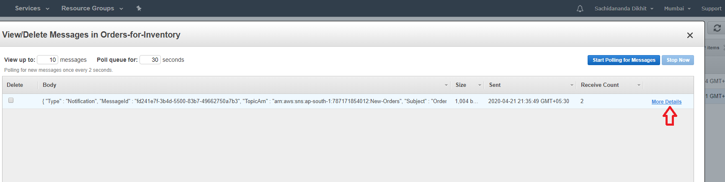

**Figure 17. (Details of the Message Dialog box)**

d. In the Body column, click **More Details**. The **Message Details** box contains a JSON document that contains the subject and message that you published to the topic.

You have confirmed that the *Orders-for-Inventory*queue received the notification of the new order from the *New-Orders*topic.

Click **Close**.

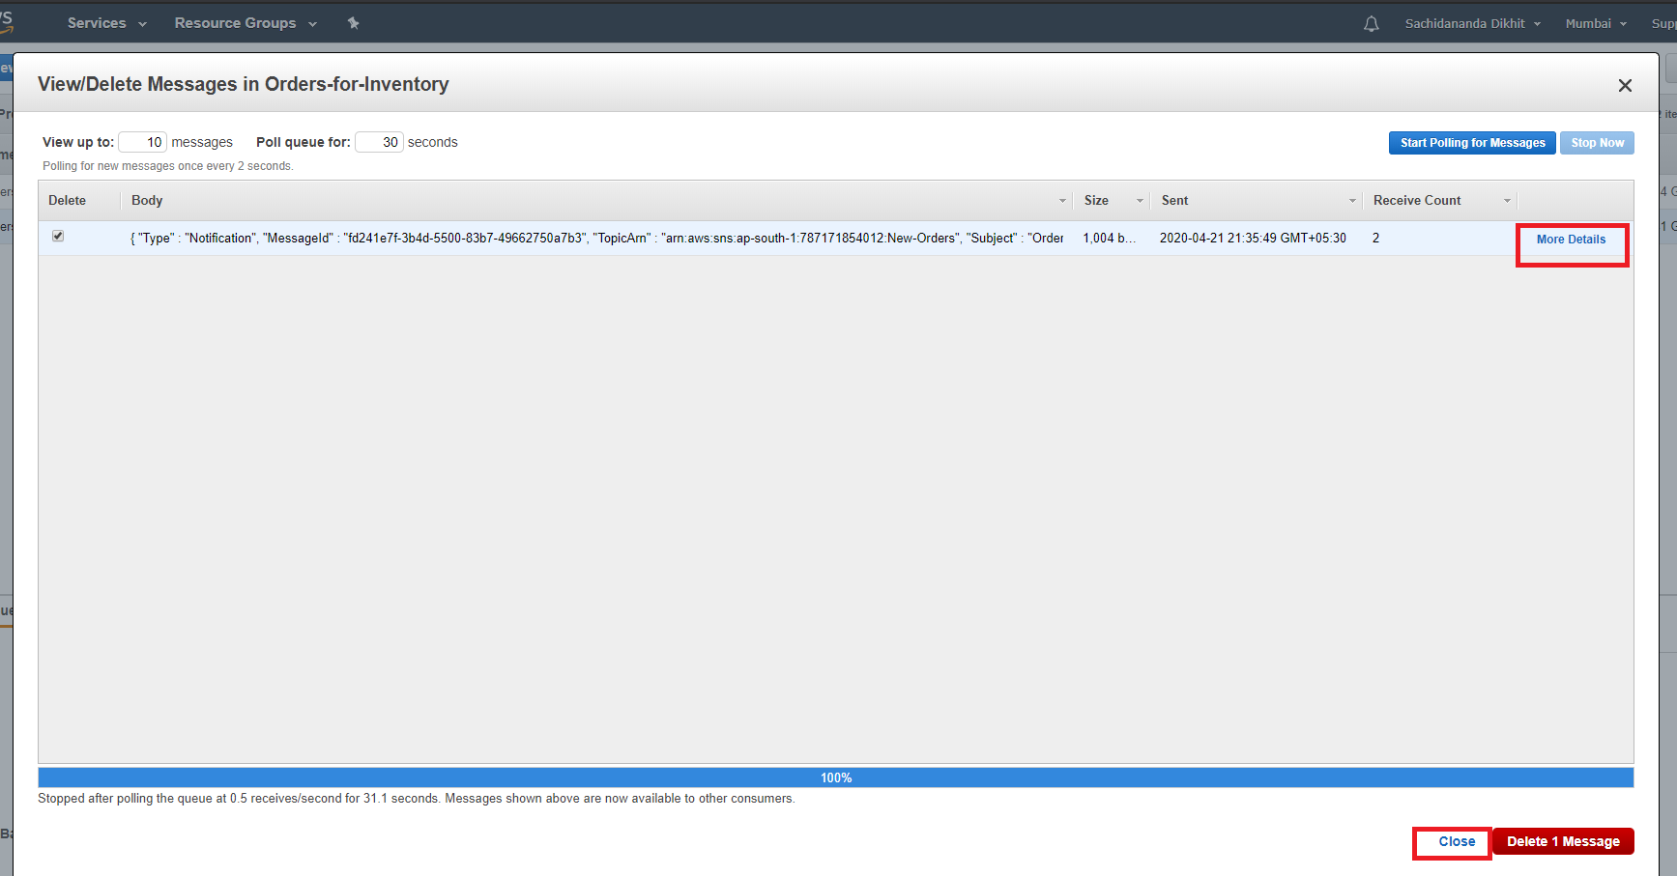

**Figure 18. (Closing the Dialog box)**

e. We'll assume that our fictional Inventory Service has finished processing this message, and that we can now safely delete the message from the queue.

Click **Delete 1 Message**. To confirm, click **Yes, Delete Checked Messages**. Then click **Close**.

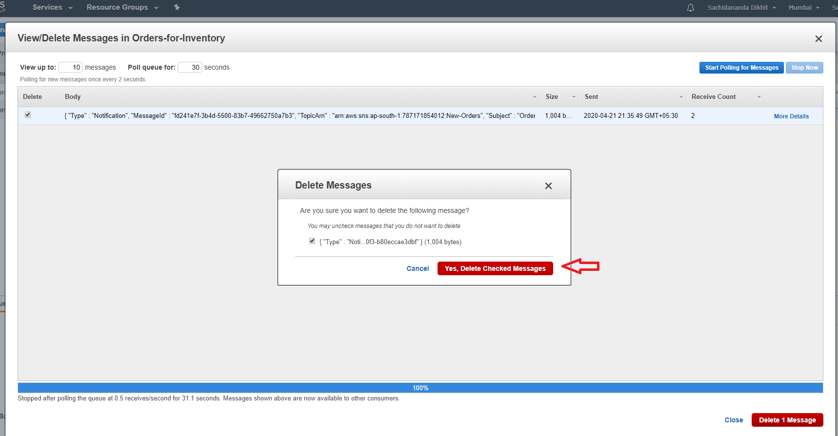

**Figure 19. (Deletion of Mesaage)**

f. Repeat steps 6a through 6e to confirm that the *Orders-for-Analytics* queue also received the notification of the new order.

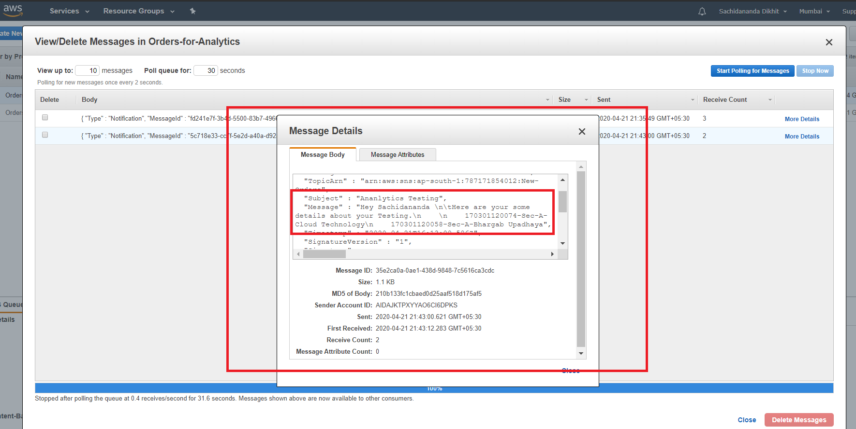

**Figure 20. (View of the Published Message)**

## **Step 7: Delete your Resources**

In this step, you will delete the resources you have created for this tutorial, which include the Topic Subscriptions, Topics, and Queues. It is a best practice to delete resources you are no longer using so you don’t incur charges.

a.Open the Amazon SNS console and click **Topics** in the left navigation pane.

Select the *New-Orders* topic.

Click **Delete** to delete topics.

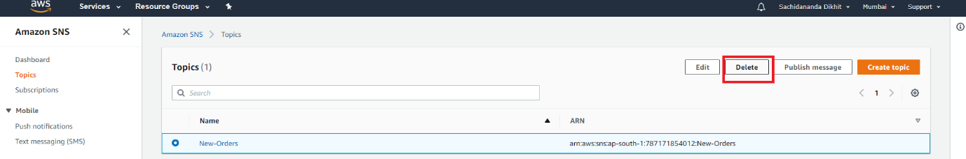

**Figure 21. (Deletion of Topic)**

1. The **Delete** confirmation dialog box appears. Type *delete me* in the dialog box and click ***Delete.*** The topic, and its subscriptions, are deleted. You can now close the SNS browser window (but don't sign out, as you still need to delete the queues in the SQS console).

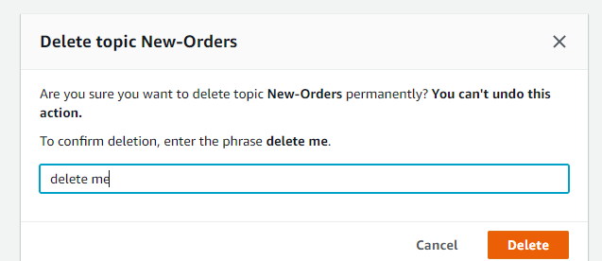

**Figure 22. (Deletion of Topic)**

1. In the Amazon SQS console, select the ***Orders-for-Inventory*** and ***Orders-for-Analytics*** queues. From **Queue Actions**, select **Delete Queues**.

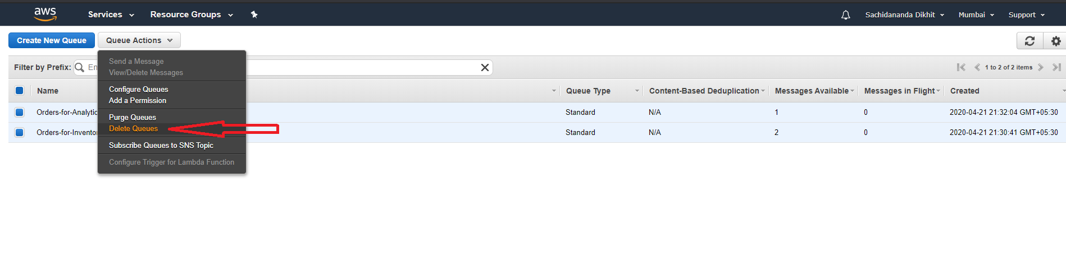

**Figure 23. (Deletion of Queues)**

d. The **Delete Queues** dialog box is displayed. Click **Yes, Delete 2 Queues**. The queues are deleted.

You can now sign out of the Amazon SQS console.

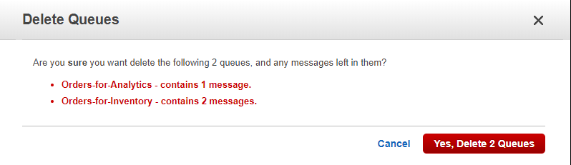

**Figure 24. (Deletion of Queues)**

**Sachidananda Dikhit**

**170301120074**