Architecture Design

# HR Analytics

|  |  |
| --- | --- |
| **Written By** | Subhajit Ghosh |
| **Document Version** | 0.1 |
| **Last Revised Date** | 14-08-2023 |

**DOCUMENT CONTROL**

## Change Record:

|  |  |  |  |
| --- | --- | --- | --- |
| **VERSION** | **DATE** | **AUTHOR** | **COMMENTS** |
| 0.1 | 14-08-2023 | Subhajit Ghosh | Introduction and architecture defined |
| 0.1 | 14-08-2023 | Subhajit Ghosh | Architecture & Architecture description appended and  updated. |
| 0.1 | 14-08-2023 | Subhajit Ghosh | Tableau Architecture |
| 0.1 | 14-08-2023 | Subhajit Ghosh | Deployment |

**Reviews:**

|  |  |  |  |
| --- | --- | --- | --- |
| **VERSION** | **DATE** | **REVIEWER** | **COMMENTS** |
|  |  |  |  |

**Approval Status:**

|  |  |  |  |  |  |
| --- | --- | --- | --- | --- | --- |
| **VERSION** | **REVIEW**  **DATE** | **REVIEWED BY** |  | **APPROVED BY** | **COMMENTS** |
|  |  |  |  |  |  |

**Contents**

1. Introduction 04
   1. What is Architecture Design Document? 04
   2. Scope 04
2. Architecture 05
   1. Power BI Architecture 05
   2. Power BI Architecture 05
   3. Gateway/Load Balancer 06
   4. Application Server 06
   5. VIZQL Server 07
   6. Data Engine 07
   7. Backgrounder 07
   8. Data Server 07
   9. Power BI Communication Flow 07
3. Deployment 08
   1. Deployment Options in Tableau 09
   2. Single Node Architecture 10
   3. Node Architecture 11

# Introduction

## What is Architecture design document?

Software architectural design is a pivotal phase in software development, encapsulating the blueprint for a computer system's construction. According to IEEE, it entails the formulation of a cohesive assemblage of both hardware and software elements, along with their interfaces. This serves as the foundation upon which the computer system will be fashioned.

The software crafted for computer-based systems can adopt diverse architectures, each offering a distinct system classification. Within each architecture, key elements manifest:

* **Components**: These encompass various building blocks, such as databases and computational modules, pivotal for fulfilling the system's intended functions.
* **Connectors**: These play a vital role in facilitating harmonious interactions by enabling coordination, communication, and cooperation amongst the components.
* **Integration Guidelines**: These define how the components can be melded harmoniously to shape the entirety of the system.
* **Semantic Models:** These conceptual frameworks furnish designers with insights into the system's comprehensive attributes, aiding their comprehension of its holistic nature.

In essence, software architectural design guides the structure and organization of computer-based systems, and its various architectural styles delineate how the components, connectors, integration, and overarching semantics coalesce into a cohesive whole.

## Scope

Architecture Design Document (ADD) is an architecture design process that follows a step-by-step refinement process. The process can be used for designing data structures, required software architecture, source code and ultimately, performance algorithms. Overall, the design principles may be defined during requirement analysis and then refined during architectural design work.

# Architecture

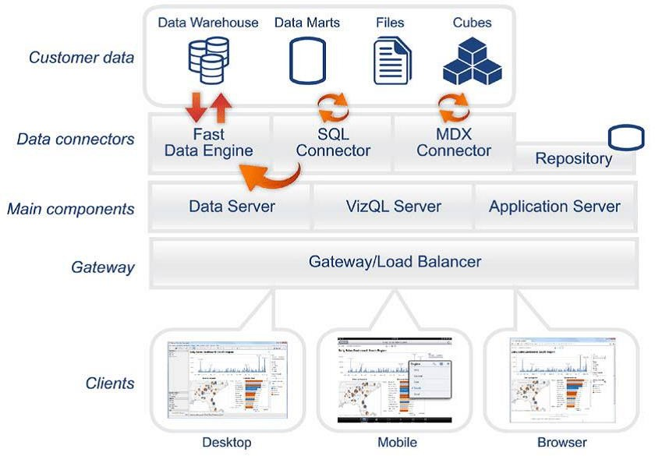

**Tableau Server Architecture**

Power BI Server, now known as Power BI Report Server, is an on-premises solution provided by Microsoft that allows organizations to host, manage, and distribute Power BI reports within their own network environment. The architecture of Power BI Report Server involves several components that work together to deliver Power BI reports to end-users.

### Shape Description automatically generated with low confidenceARCHITECTURE DESIGN

**6**

Here's an overview of its architecture:

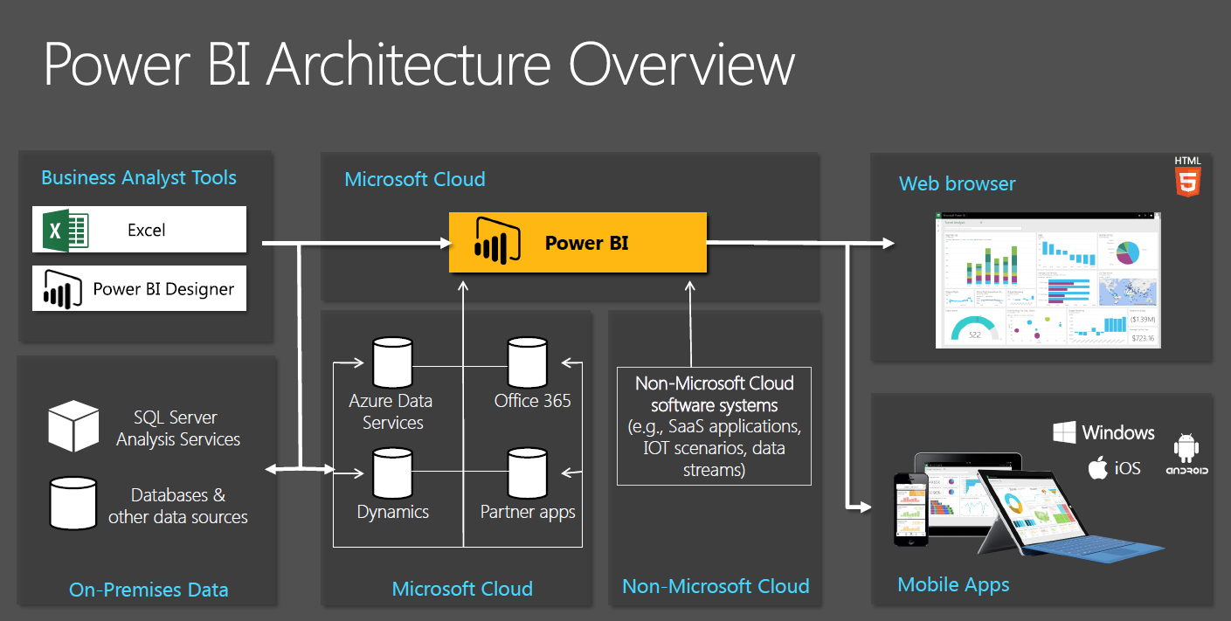

Power BI Report Server is internally managed by the multiple server processes.

**1.Web Portal**:

The primary interface for end-users to access and interact with Power BI reports is through the web portal. Users can view, filter, and interact with reports using a web browser. The web portal provides a user-friendly interface for report navigation and exploration.

**2.Report Server:**

The heart of the Power BI Report Server architecture is the Report Server itself. This component manages report storage, processing, rendering, and distribution. It is responsible for handling user requests, retrieving data, rendering visualizations, and delivering the reports to users via the web portal.

**3.Report Builder:**

Power BI Report Server includes a client tool called Report Builder. This tool allows report authors to create and design Power BI reports using a desktop application. Once created, these reports can be published to the Report Server for distribution.

**4.Data Sources:**

Power BI reports hosted on the Report Server can connect to various data sources, including databases, Excel files, Analysis Services models, and more. Data sources are defined within the reports and are used to fetch the necessary data for visualizations.

**5.Data Models:**

Power BI reports can include data models that enable more complex analysis by combining and transforming data from different sources. These data models are typically created using Power Query and Power Pivot, and they help provide a performant experience by pre-aggregating and optimizing data.

**6.Security and Authentication:**

The Power BI Report Server supports different methods of authentication, including Windows Authentication and custom forms-based authentication. It integrates with existing organizational security systems to control user access to reports and data.

**7.Extensions:**

Power BI Report Server supports custom extensions, allowing developers to add custom functionality or integrate with other systems. These extensions can include custom data visualizations, data connectors, and more.

**8.Subscription and Alerts:**

Users can subscribe to reports and receive scheduled updates via email. Alerts can be set up to notify users when specific conditions are met within the data.

**9.Mobile Access:**

Power BI mobile apps can be used to access reports hosted on the Power BI Report Server. Users can view reports and dashboards on their mobile devices while connected to the organization's network.

## 8) Tableau Communication Flow

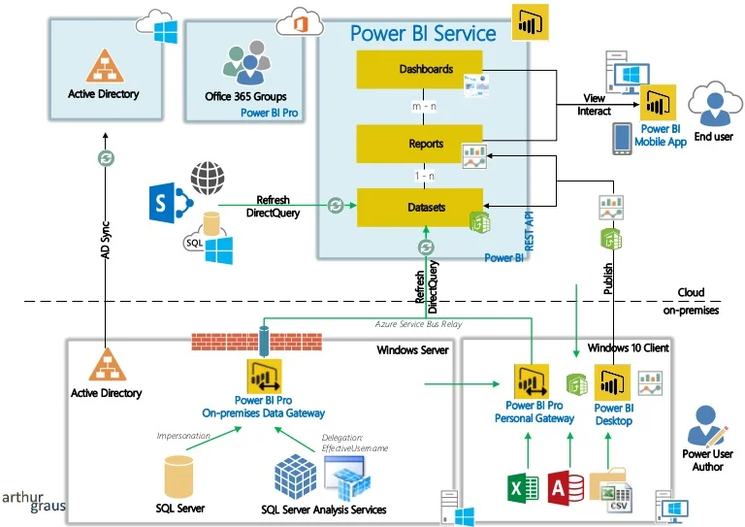

1. **Deployment Description**

## Deployment options in Power BI

Power BI offers multiple deployment options to cater to various organizational needs and preferences:

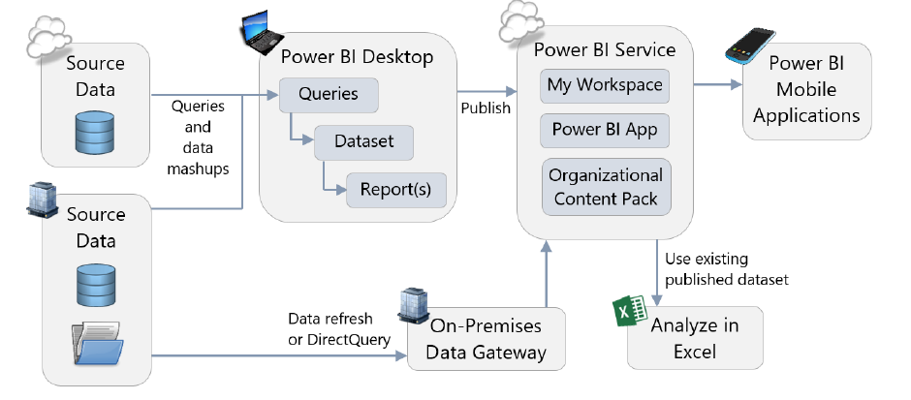

**Power BI Service (Cloud):** This is the cloud-based deployment where you create, publish, and share reports and dashboards on the Power BI cloud platform. It's ideal for organizations that want a fully managed solution without managing on-premises infrastructure.

**Power BI Report Server (On-Premises):** This deployment allows you to host and manage Power BI reports within your own network environment. It's suitable for organizations with data security and compliance concerns that prefer to keep their data on-premises.

## Single Node Architecture

In the context of Power BI, a single-node architecture typically refers to a standalone deployment of Power BI Report Server or Power BI Service. Here's a brief overview:

**Single Node for Power BI Report Server:** In this architecture, a single server hosts the Power BI Report Server component. It handles report storage, processing, rendering, and distribution. Users access reports through the web portal hosted on this server.

**Single Node for Power BI Service:** This refers to using the Power BI cloud service without complex scaling or distribution across multiple nodes. Reports and dashboards are created and managed within the Power BI cloud platform, and users access them through their browsers or Power BI apps.

## Node Architecture

Node architecture in Power BI typically refers to a more distributed setup, commonly seen in larger and more complex deployments:

**Multi-Node Power BI Report Server:** In larger organizations, where more processing power and redundancy are required, you can set up a multi-node Power BI Report Server environment. This involves multiple report server nodes working together to handle the load and provide failover support.

**Gateway Nodes for Power BI Service:** In the context of Power BI Service, nodes often refer to gateway nodes. These are used to establish secure connections between on-premises data sources and the Power BI cloud service. Multiple gateway nodes can be set up to manage connections for different departments or data sources.

**Clustered Nodes for High Availability:** For both Power BI Report Server and Power BI Service, clustering can be used to ensure high availability. In a clustered environment, multiple nodes work together to provide failover support and minimize downtime.

It's worth noting that the specific architectures and terms might vary based on the deployment option you choose (cloud or on-premises), the scale of your organization, and your infrastructure preferences. These descriptions provide a general overview of the concepts related to deployment and architecture in Power BI.