**HR Analytics**

Wireframe Documentation

Author: Subhajit Ghosh

**HOME PAGE**

**Card**

**Slicer**

**Stacked Bar Chart**

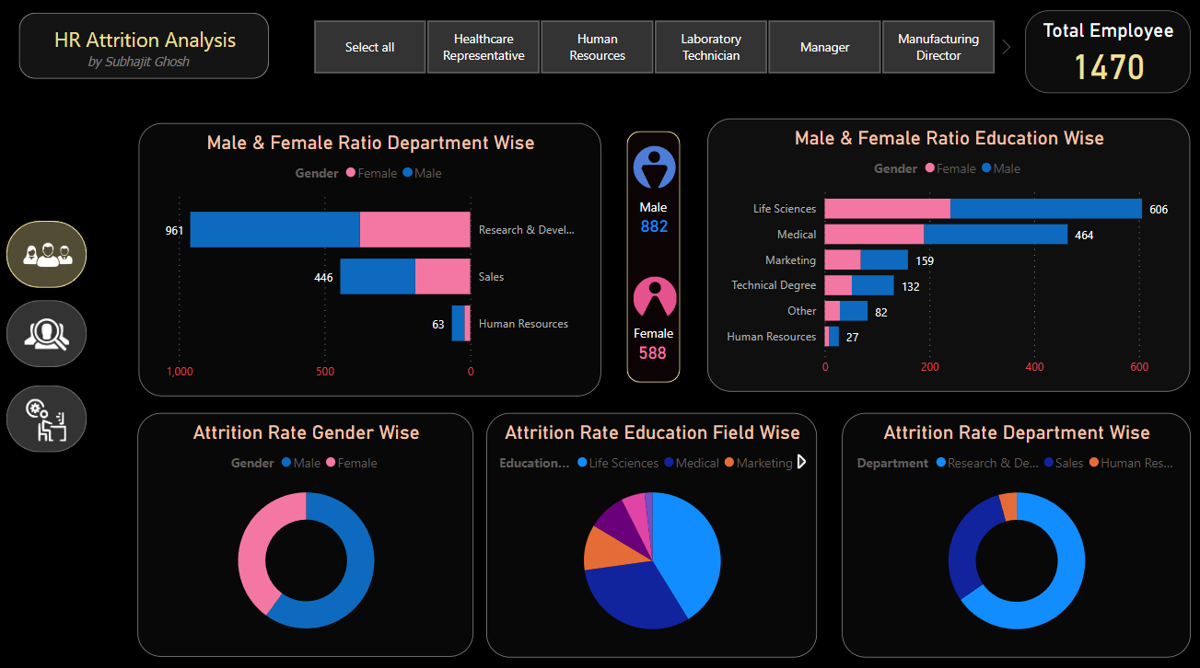

**PIE Chart**

**Donut chart**

**MONETARY FACILITY AND WORK CULTURE**

