**Upstox:**

* Process for installing the libraries:

1. Open command prompt (start menu --> type cmd)

2. pip install upstox-python-sdk

3. pip install flask

4. pip install pandas

5. pip install protobuf

6. pip install flask

7. pip install pandas_ta

8. pip install ta

9. pip install requests

10. pip install websockets --upgrade

**Upstox Login and Access Token**

1. Go to <https://account.upstox.com/developer/apps>
2. Do login
3. Create new app
4. Add appname = upstoxApp, redirect url = <https://www.google.com> . Keep postback url and description empty.
5. Copy API key and API secret

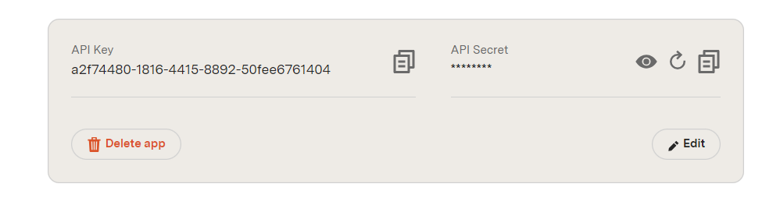

1. In upstox_login.py file, put client_id as the api key. Client_secret as API secret and redirect_url as <https://www.google.com>

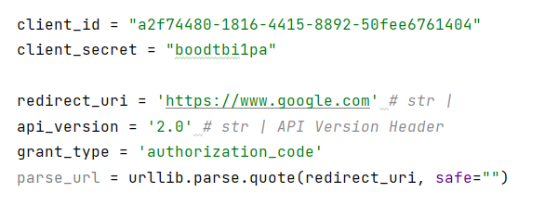

1. Make step = 1 and run the file. There will be a link in the terminal. Click that link and login to that link. After login see the url.

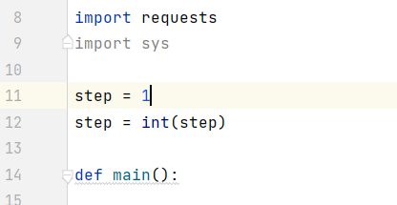

1. Copy the code from the url

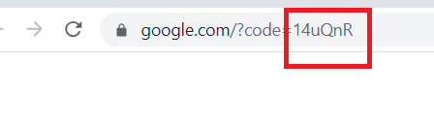

1. Make 2 changes in the code. Make step = 2 (at the top) and then update the “code” value to this code which we got from the url.

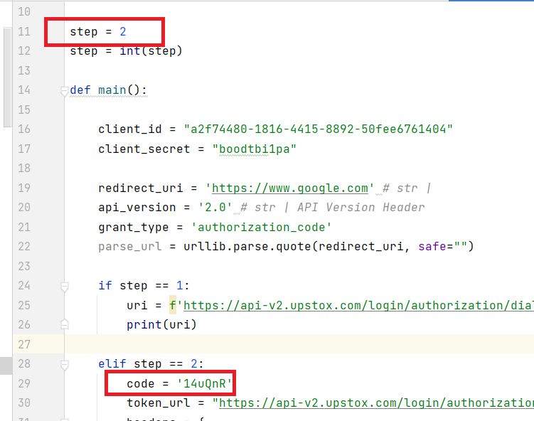

1. Run the code and get the access token

