**Landing Page**

**GIG Title :-** build a professional landing page with style, responsive

**Category :-** Programming and Tech => Website Development

**Service type:-** Custom Website

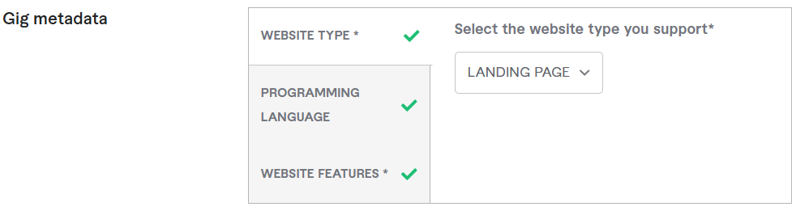

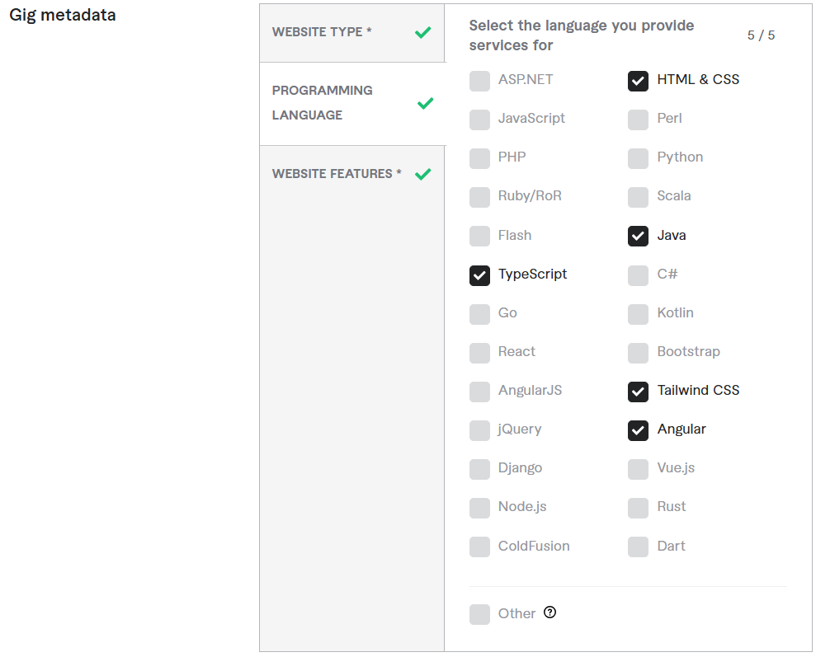

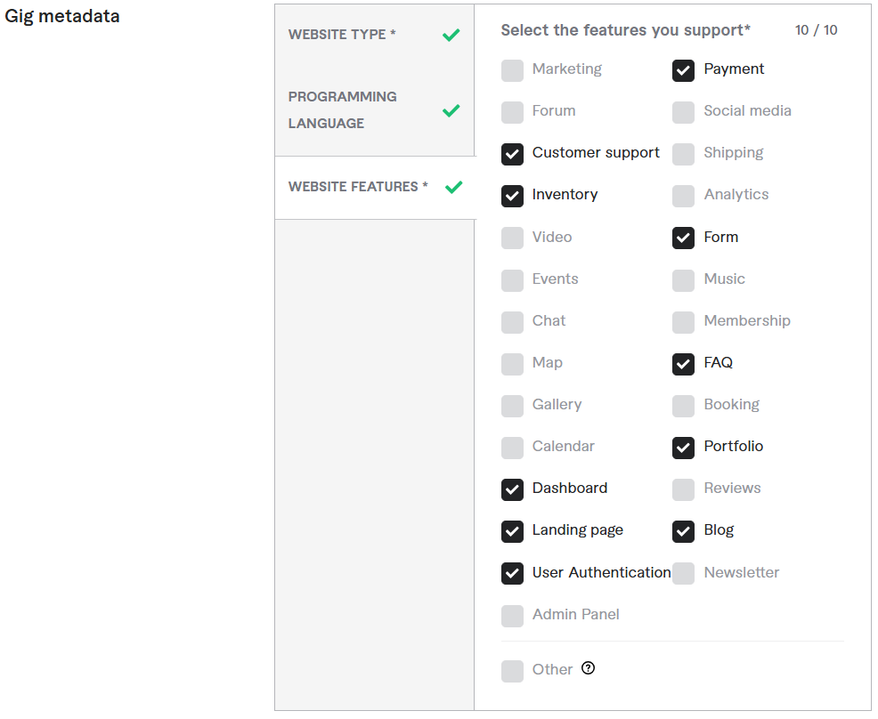

**Search tags:-** Landing Page, Small Business, Responsive Web, FreeStyle

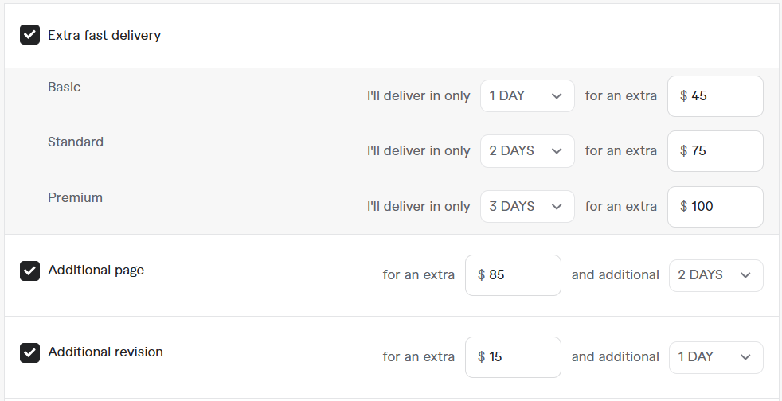

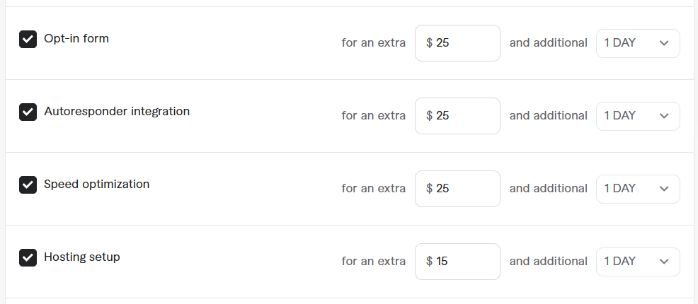

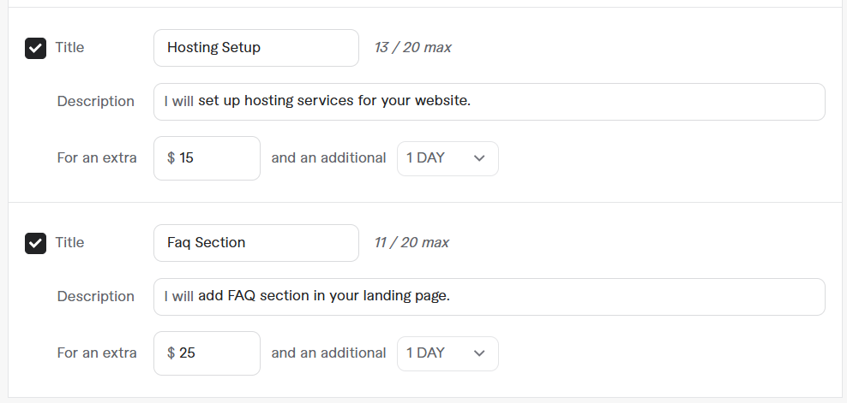

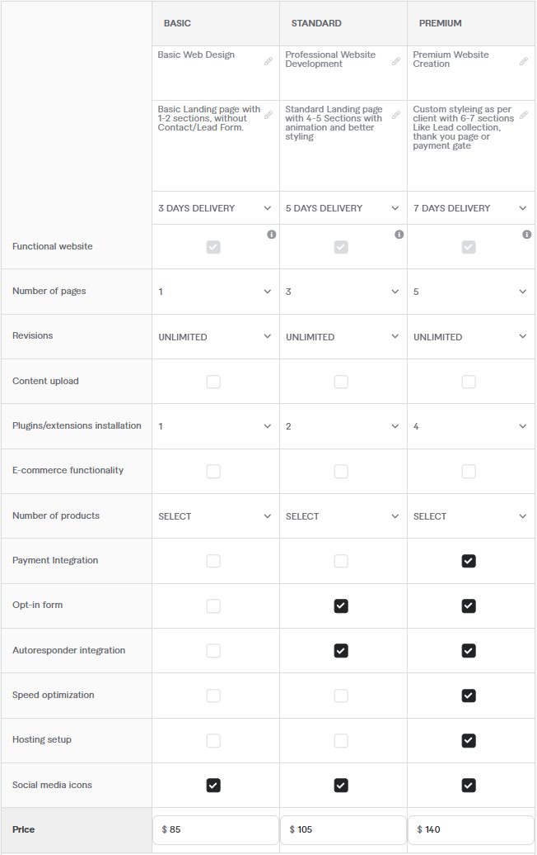

**Briefly Describe Your Gig:-**

**=== Package prices are Not-Fixed. The cost varies depending on the Requirements ===**

**Are you looking for a High-Converting Landing Page that boosts leads and sales?**

I specialize in designing **custom, responsive landing pages** optimized for **maximum conversions**. Whether you need a **Sales Funnel, Squeeze Page, or Lead Generation Page**, I've got you covered!

I will design a high-converting landing page for any business, including **Real Estate, Digital Products, E-books, Credit Repair, Law Firms, Medical Services, E-commerce Stores, Gyms, Photography, Agencies, Online Services, and more.**

**What You Get:**

* **Custom landing page design**
* Optimized for **fast loading speed & mobile responsiveness**
* **SEO-friendly** for better Google Ads performance
* High-converting **CTA (Call-to-Action) buttons**
* **Lead Capture form integration** for email marketing
* 100% Satisfaction Guaranteed

**Why Choose Me?**

* **8+ years of experience in landing page development**
* **2000+ successful projects** on Fiverr
* Quick delivery & unlimited revisions

**Let's build a High-Converting Landing Page to grow your business! Order now**

**Requirement Questions:-**

* **Describe the kind of landing page you have in your mind ?**