DevOps Foundations: Version Control and CI/CD with Jenkins

Course-End Project 1: Insured Assurance

Objective

To create a GitHub Actions CI/CD pipeline workflow for invoking the deployment of a Java application as a Jenkins job using Tomcat Apache

Real-time scenario:

Insured Assurance, a leading global insurance provider based in the US, offers a range of products including home, health, car, and life insurance. The company is transitioning to a DevOps architecture and aims to automate code builds and deployments across various environments. To meet this need, it has adopted GitHub Actions for code checkout, building, and testing automation and Jenkins for continuous deployment. As a DevOps engineer at Insured Assurance, you are tasked with implementing a CI/CD pipeline using GitHub Actions and Jenkins.

Tasks

The following tasks outline the process of implementing CI/CD using GitHub Actions and Jenkins:

1. Create a code repository on GitHub

2. Create a GitHub Actions pipeline to perform continuous integration

3. Configure Tomcat Apache for automated code deployment

4. Integrate the GitHub Actions pipeline to invoke the Jenkins pipeline

5. Invoke pipeline to validate automated deployment

Solution

Task 1: Create a code repository on GitHub Forking repository from

<https://github.com/demo1orgtoday/MavenBuild-SL.git>

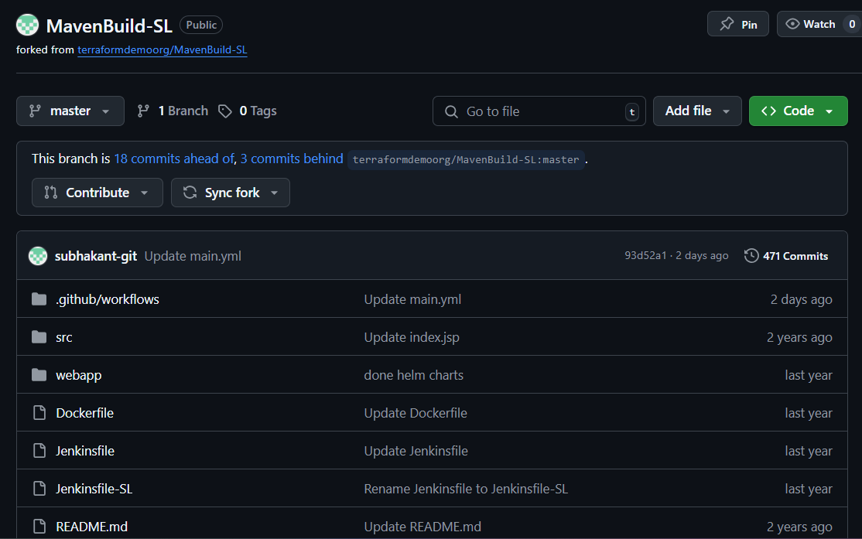

Task 2: Create a GitHub Actions workflow to perform continuous integration

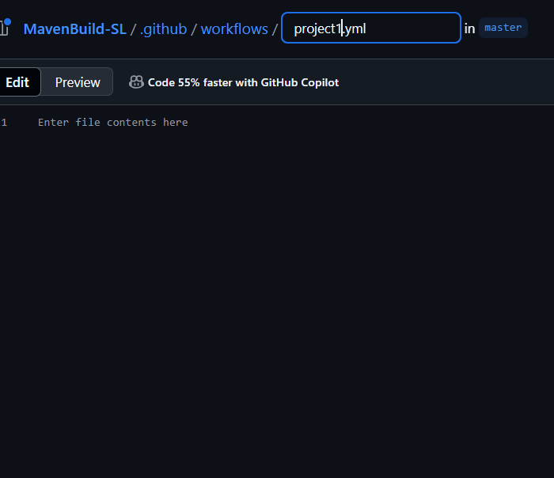

Initial GitHub Action Code:

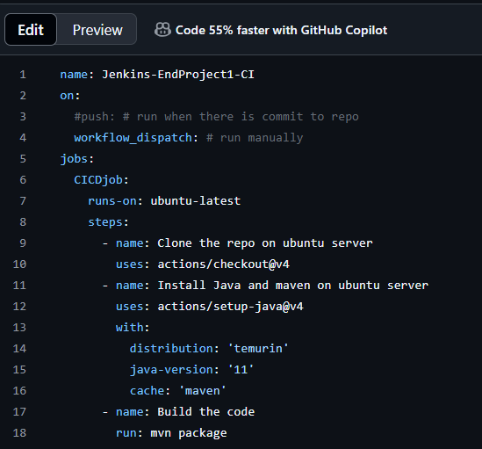

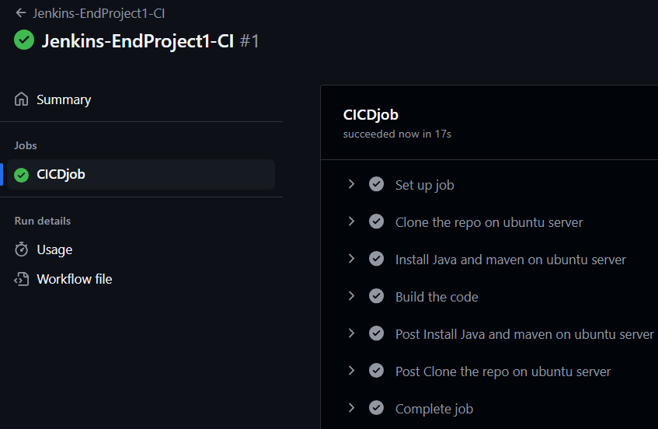

Task 3: Configure Tomcat Apache for automated code deployment

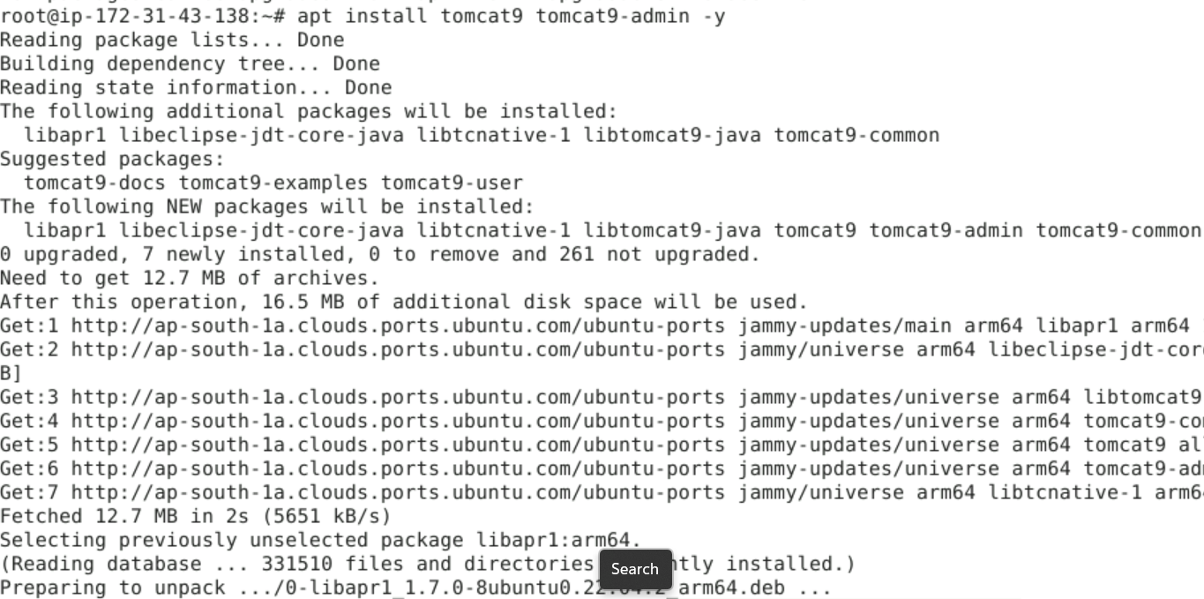

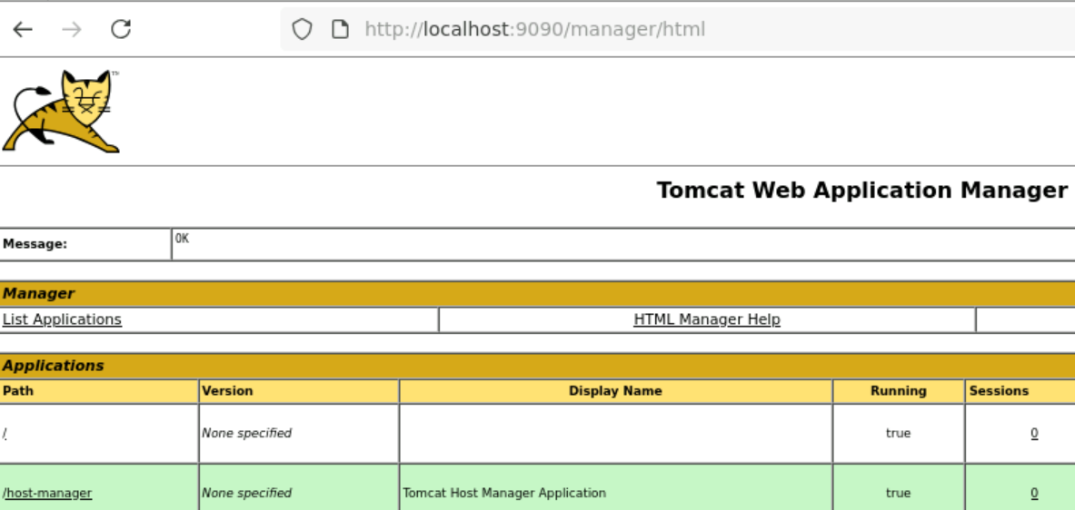

Added Deploy to container Jenkins plugin

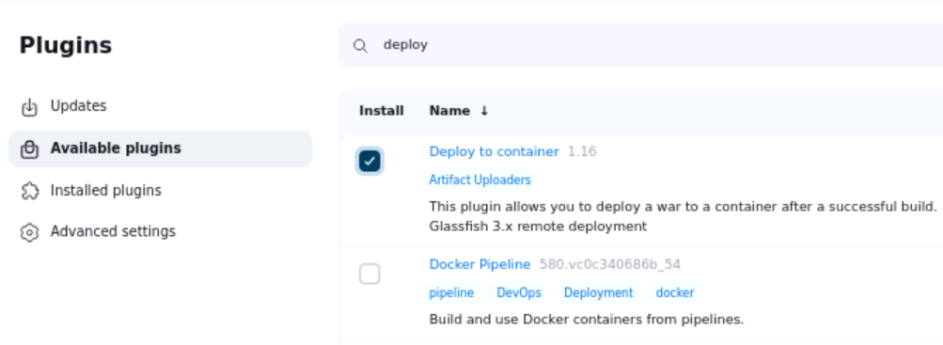

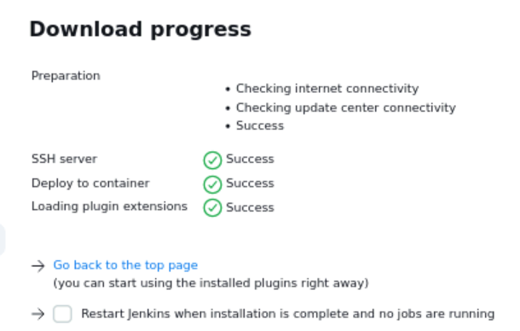

Added tomcat user

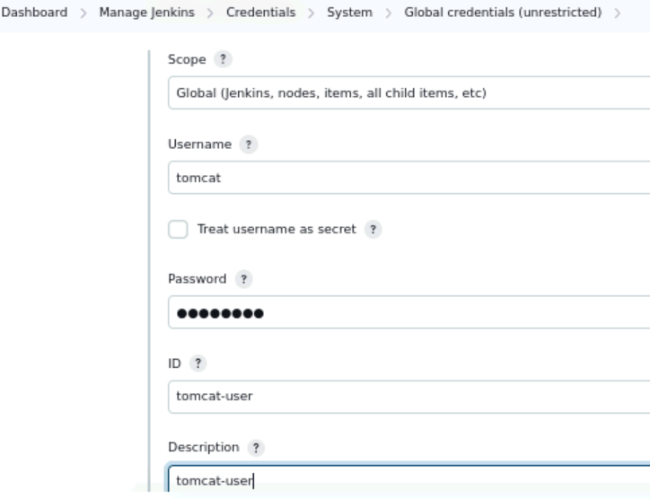

Task 4: Integrate the GitHub Actions pipeline to invoke the Jenkins pipeline

Added secrets for lab connection

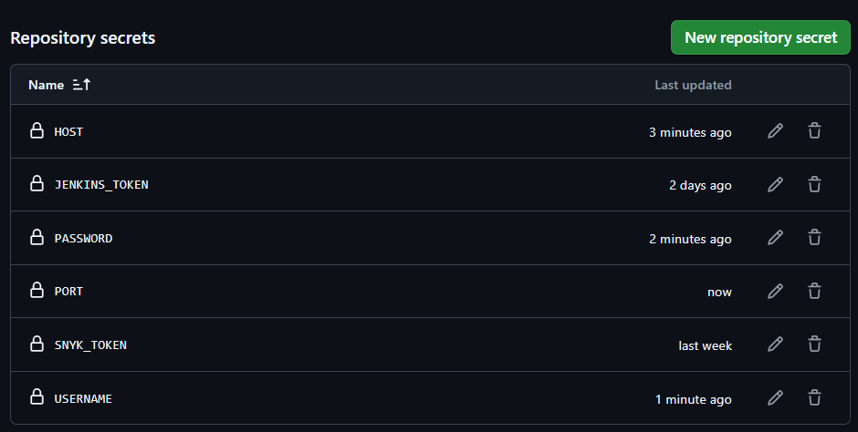

Updated action with .war copy and trigger for Jenkins job

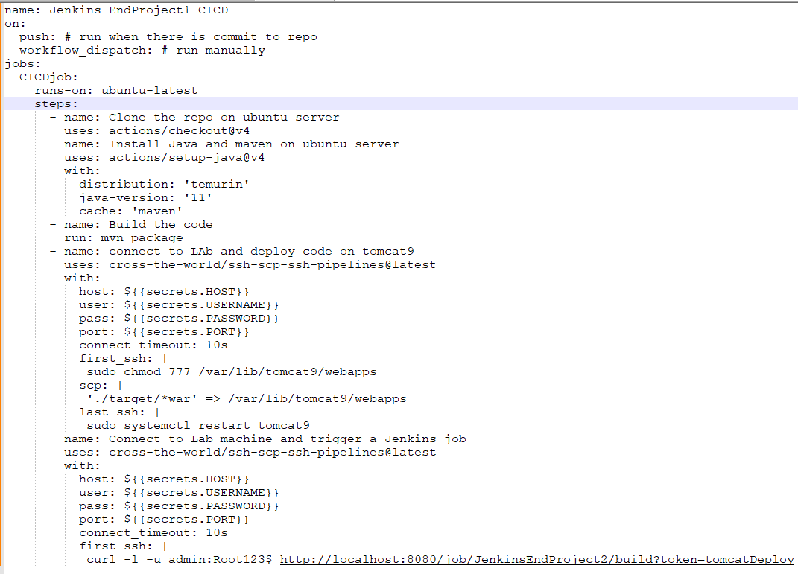

Added maven tool in Jenkins

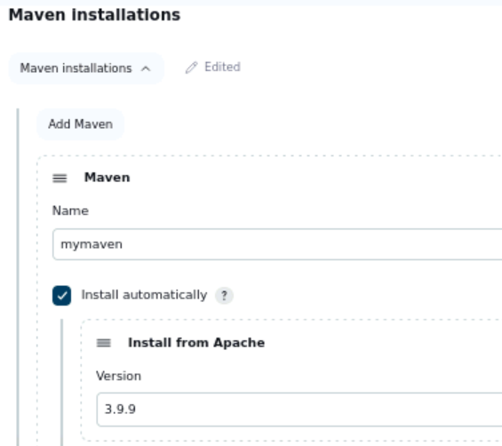

Creating Jenkins pipeline job

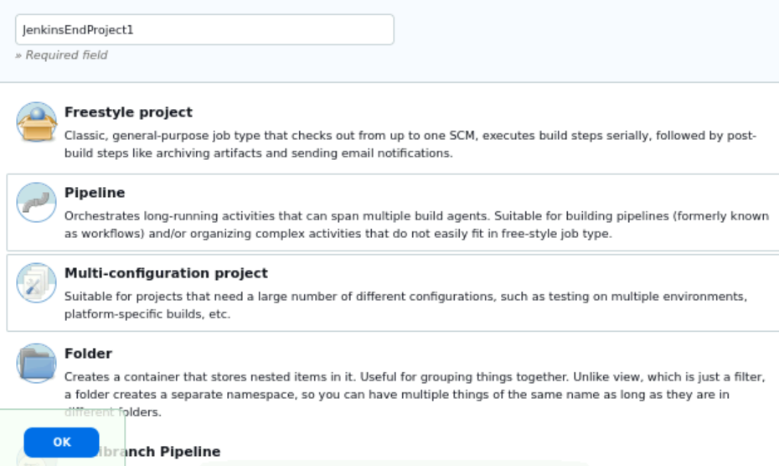

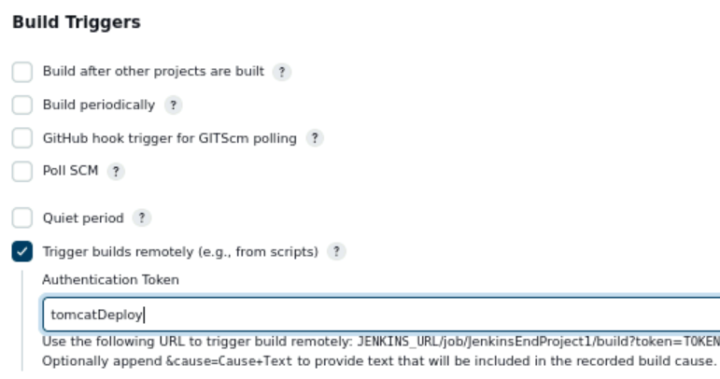

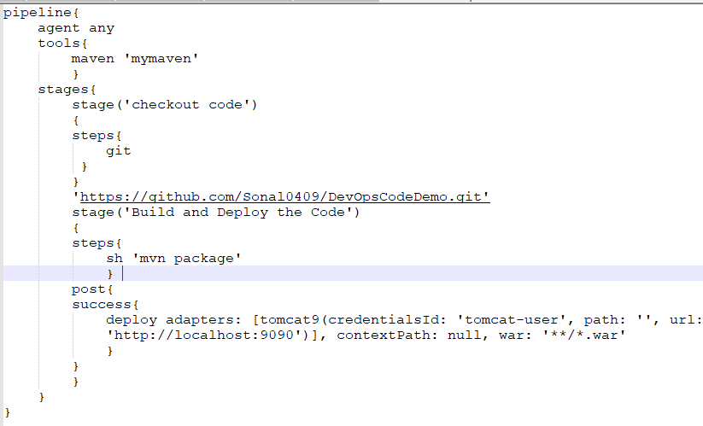

Task 5: Invoke pipeline to validate automated deployment

