**Assigment 1 - Import Acadgild VM into Oracle virtual box**

**1. VM Snapshot**

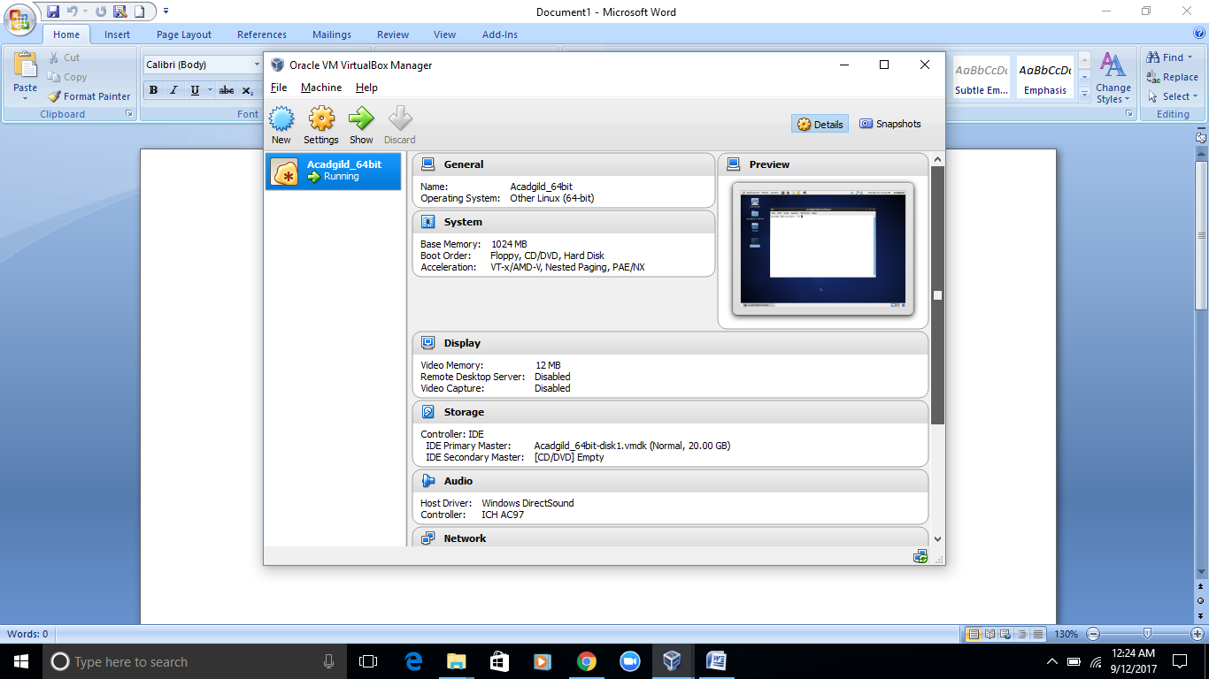

**2.** **JPS** - ***jps*** command is used to check all the Hadoop daemons like NameNode, DataNode, ResourceManager, NodeManager etc. which are running on the machine.

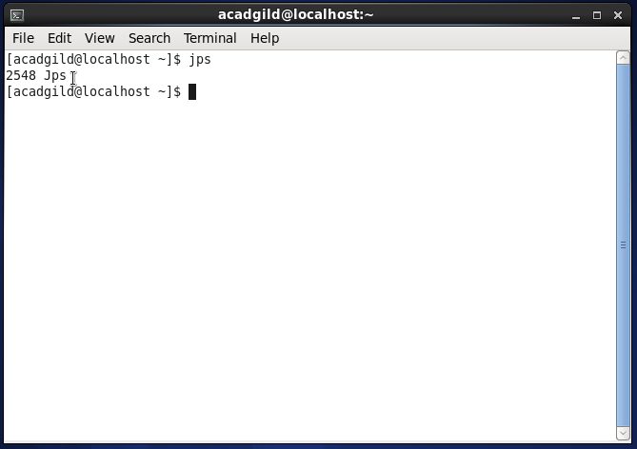

**3. Start ssh service**

**cmd** # sudo service sshd start

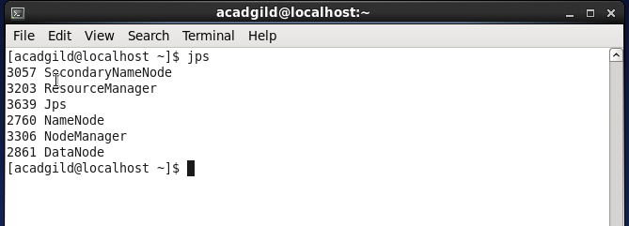

**4. Start History server**

**cmd** # mr-jobhistory-daemon.sh start historyserver

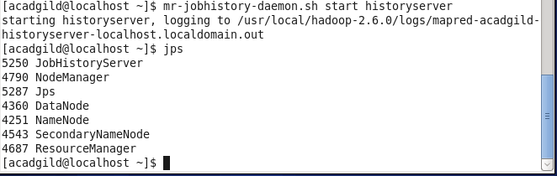

**5. Start pig in hdfs mode**

**cmd** # pig

