**Assigment 2 - Linux Commands**

1. pwd - Show current working directory



2. vi <filename> - Command line text editor

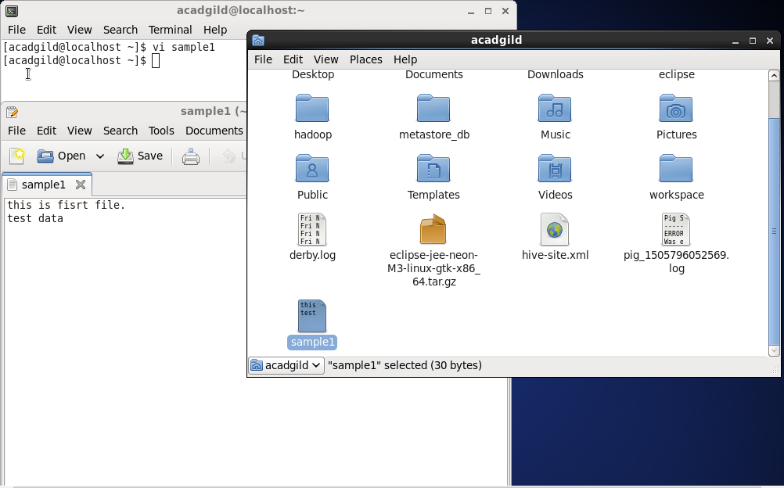

3. touch <filename> - Create / Update file

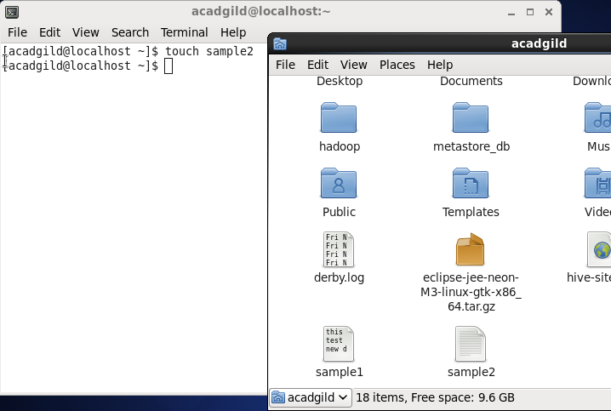

4. mkdir <directory name> - To create directory

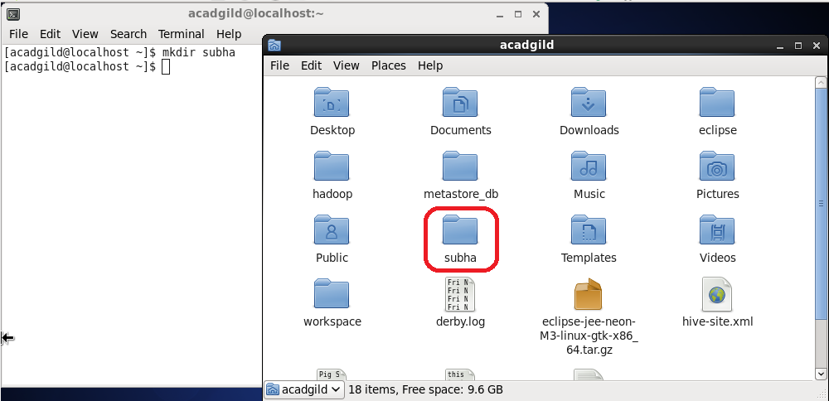

5. rm - Remove file/directory

Create files and directories

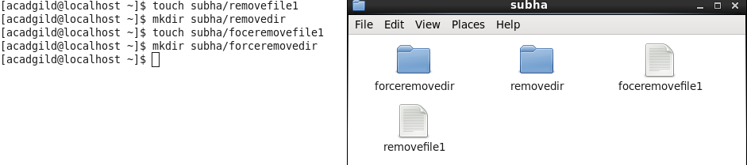

* rm <file> - Remove file
* rm -r <dir> - Remove directory
* rm -f <file> - force remove file
* rm -rf <dir> - force remove directory

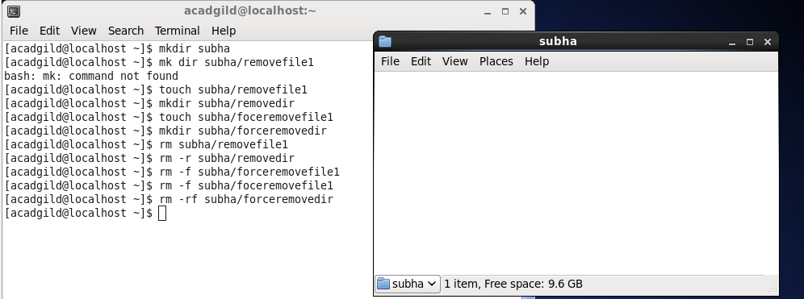

6. ls - Directory Listing

* ls # Directory listing
* ls -al # Formatted listing with hidden files
* ls -lt # Sorting the Formatted listing by time modification

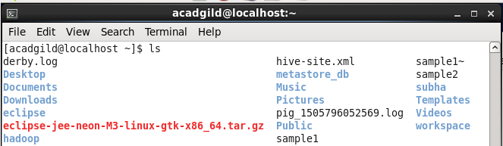

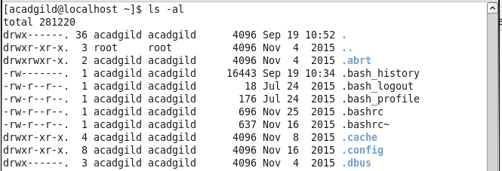

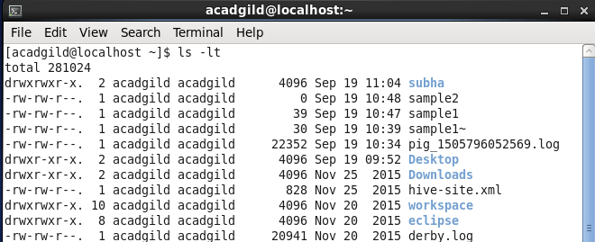

7. echo - to display line of text / string in scripting lang

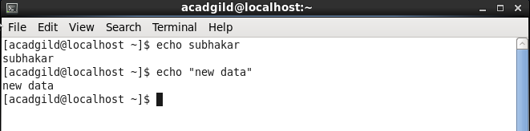

8. cat - Diaplay contents of the file

* cat sample1 - Display data in the file
* cat >sample3 - Create file and enter the test

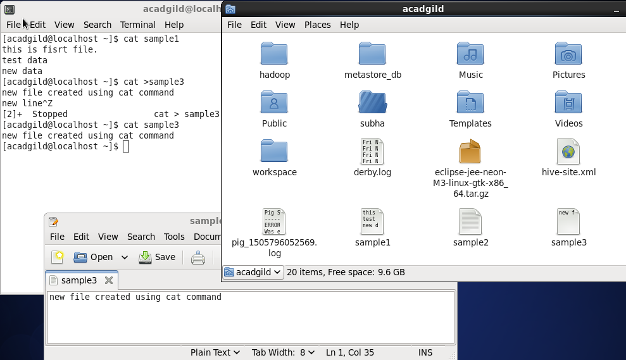

9. who - list of logged in users

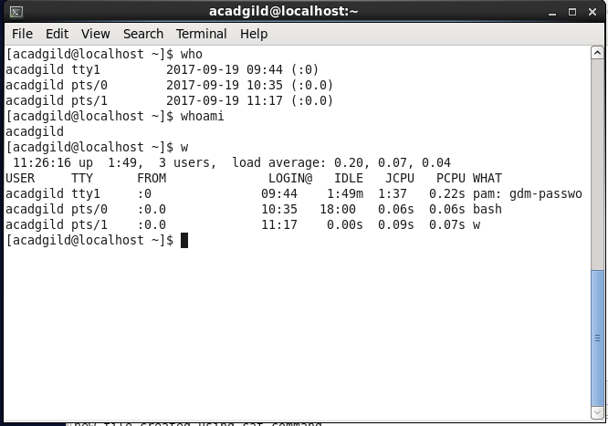

10. cd - Change directory

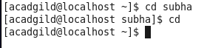

11. date - To display current date and time



12. cal - To display current month calender

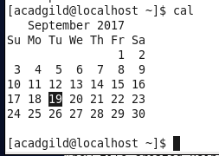

13. mv - Rename file

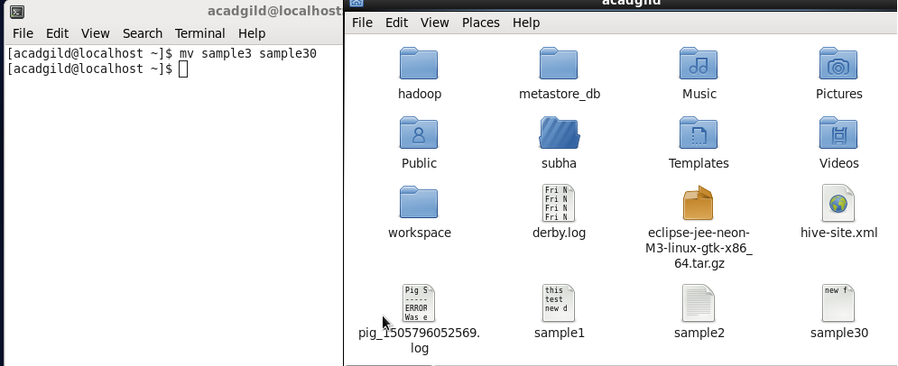

14. cp - Copy file / directory

* cp <file1> <file2> - Copy file
* cp -r <dir1> <dir2> - Copy directory

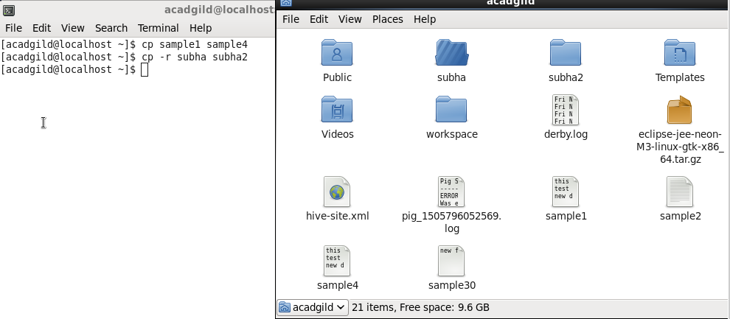

15 . which - Locate the [executable file](https://www.computerhope.com/jargon/e/execfile.htm) associated with a given [command](https://www.computerhope.com/jargon/c/command.htm)

