No route to host
After esw upgrade, server will show an error as “No route to host” while checking the server status in stack.
Here are the steps to clear the issue.
- Login the BMC WEB UI
- Launch KVM
- Once KVM launched, perform power cycle. While loading the server press “DEL” key and enter boot options.
- Go to Boot Change Boot mode from UEFI to LEGACY.
- Set Boot Option :1 to Hard disk
- Set Boot Option :2 to Network and remaining boot options need to be disabled
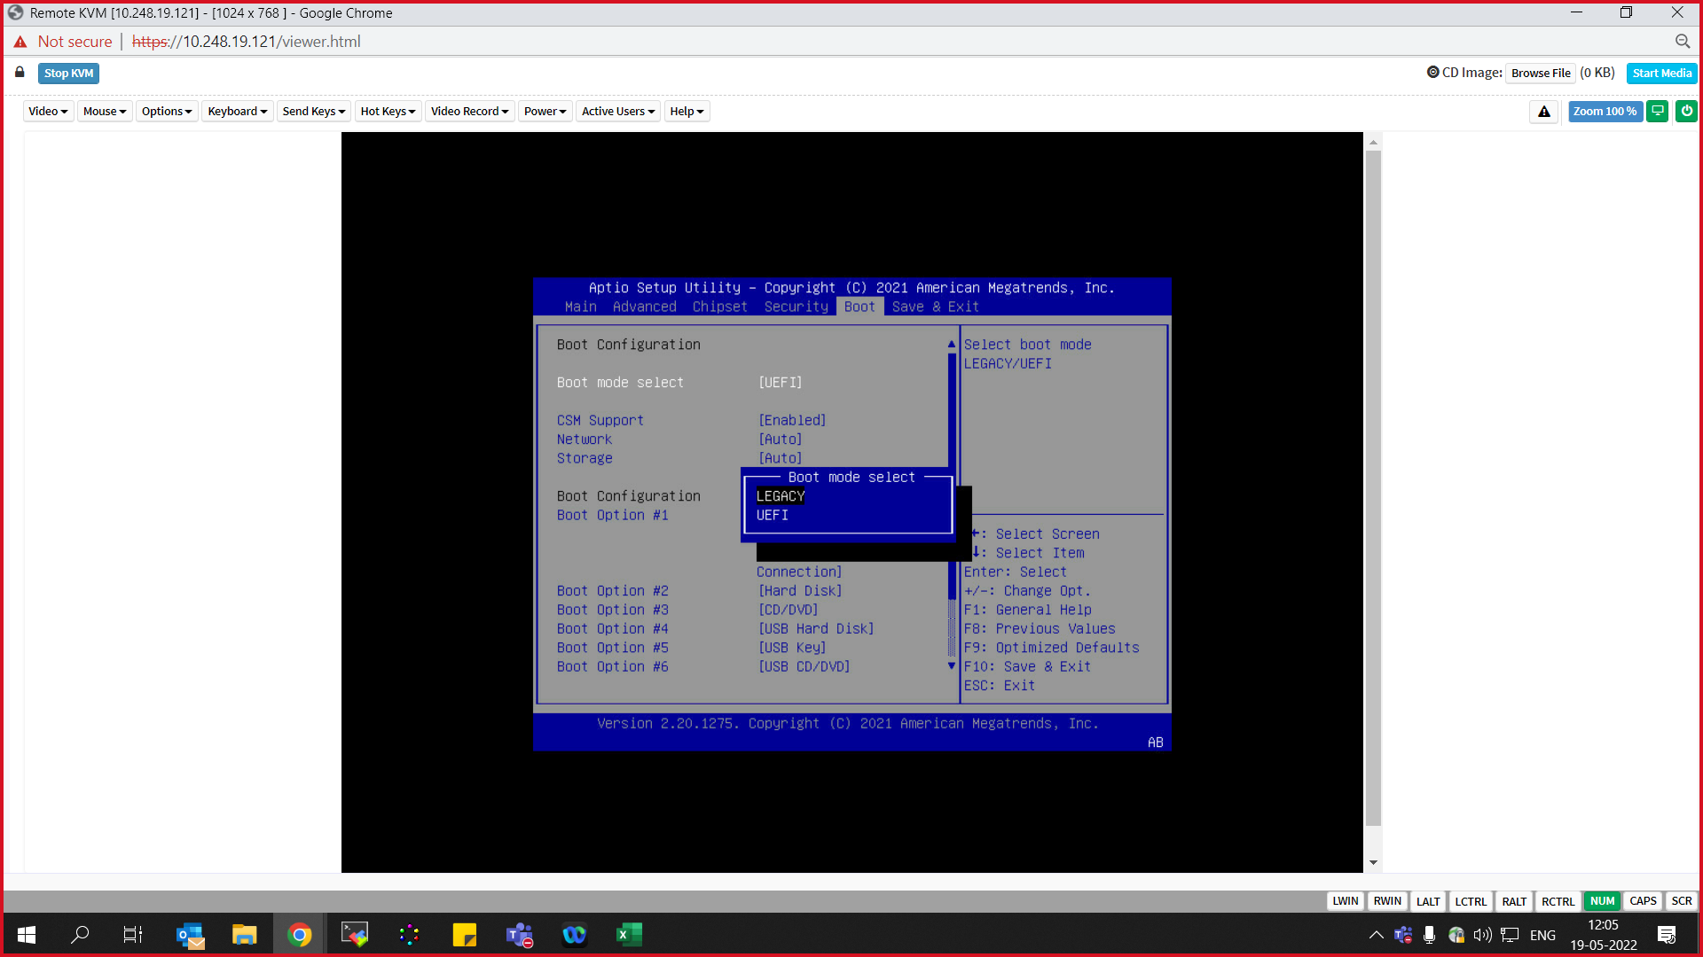

Deploy to SSH
After esw upgrade, server will show an error as “Deploy to SSH” while checking the server status.
Here are the steps to clear the issue.
- Login the BMC WEB UI
- Launch KVM
- Once KVM launched, perform power cycle. While loading the server press “DEL” key and enter into boot options
- Go to Boot Change Boot mode from UEFI to LEGACY.
- Set Boot Option :1 to Hard disk
- Set Boot Option :2 to Network and remaining boot options need to be disabled

Ping is available & No connection in NADCM
Before or after upgrade, sometimes IP ping will be available, but it will show as No Connection in NADCM. Please follow below procedures to clear the issue.
- Perform corresponding server BMC cold restart (sudo ipmitool mc reset cold)
- Once server got restored, perform password reset for user 2 (sudo ipmitool user set password 2)
- Do above step and Set 3 or 4 different passwords in stack
Or
- login BMC and go to SettingsUser Management Select Admin Change to existing password (as per customer)



