IN-SILICO GENOME CHARACTERIZATION
AND FUNCTIONAL ANNOTATION
A comparative analysis of Bacillus subtilis 168 and
Bacillus licheniformis DSM 13
PROJECT REPORT
Prepared by: Subhalaxmi Sahoo
Programme: M.Sc. Bioinformatics
Institution: Centre For Post Graduate Studies, OUAT
Academic year: 2026

Contents
- 1. Abstract
- 2. Introduction
- 3. Aim and Objectives
- 4. Data Sources and Bioinformatics Tools
- 5. Materials and Methods
- 6. Results
- 7. Overall Discussion
- 8. Conclusion
- 9. Limitations
- 10. Project Organization and Reproducibility
- 11. References

1. Abstract
This project presents an in-silico characterization and comparative analysis of the reference genomes of Bacillus subtilis strain 168 and Bacillus licheniformis strain DSM 13. Genome sequences were retrieved from NCBI and analysed using Biopython to determine genome length and nucleotide composition. Prokka was used for genome annotation, followed by Python-based summaries of coding sequences, functional descriptions, hypothetical proteins, gene assignments, COG assignments and EC-number annotations. COG identifiers were mapped using COG2024 reference definitions. A local nucleotide database was prepared from the B. licheniformis genome and the B. subtilis genome was compared against it using BLASTn. Both genomes were approximately 4.2 Mb. B. licheniformis had a slightly larger genome and higher GC content. Prokka predicted 4,214 CDS in B. subtilis and 4,308 CDS in B. licheniformis. BLASTn yielded 782 local alignments, with 23.28% query coverage and 22.81% reference coverage. The project demonstrates an integrated computational workflow for bacterial genome statistics, annotation, functional classification and local sequence comparison.

Keywords
Bacterial genomics; Bacillus subtilis; Bacillus licheniformis; Biopython; Prokka; COG2024; enzyme annotation; BLASTn.

2. Introduction
Bacterial genome characterization uses computational methods to examine genome size, nucleotide composition, predicted genes and functional features. Genome annotation identifies coding sequences and other genomic elements, while functional annotation assigns putative biological roles to predicted proteins. Comparative genomics helps identify similarities and differences between organisms by examining their sequences and predicted genomic features.
Bacillus subtilis 168 is a well-studied model bacterium. Bacillus licheniformis DSM 13 is another member of the genus Bacillus and provides a useful comparative reference. This project analyses both reference genomes using publicly available sequence data and commonly used bioinformatics tools.
The work combines sequence retrieval, genome statistics, gene annotation, functional summaries, COG classification, enzyme annotation and local nucleotide sequence comparison. All results are computational predictions or database-supported annotations and should be interpreted accordingly.

3. Aim and Objectives
Aim: To characterize and compare the genomic features and predicted functional annotations of B. subtilis 168 and B. licheniformis DSM 13 using computational bioinformatics tools.

3.1 Objectives
- Retrieve reference genome sequences and accession information from NCBI.
- Calculate genome length and nucleotide composition, including GC and AT content.
- Annotate both bacterial genomes using Prokka.
- Summarize CDS, described CDS, hypothetical proteins, gene assignments, COG assignments and EC-number annotations.
- Map COG identifiers to functional categories using COG2024 reference definitions.
- Compare CDS carrying EC-number annotations and distinct EC-number assignments.
- Perform local BLASTn comparison and summarize alignment identity, length and genomic coverage.
- Generate comparative tables and graphical representations.

4. Data Sources and Bioinformatics Tools
Resource / tool | Application
NCBI Genome | Retrieval of reference genome sequences and accession information.
Python and Biopython | FASTA reading and nucleotide composition analysis.
Prokka | Prokaryotic genome annotation and prediction of CDS and RNA features.
COG2024 reference data | Mapping COG identifiers to functional descriptions and categories.
BLASTn / makeblastdb | Local nucleotide database construction and sequence alignment.
Pandas | Tabulation and processing of annotation results.
Matplotlib | Generation of comparative graphs.
Conda | Management of bioinformatics software environments.

5. Materials and Methods

5.1 Genome sequence retrieval
Reference genome sequences were retrieved from NCBI in FASTA format. The B. subtilis 168 reference genome accession was NC_000964.3, and the B. licheniformis DSM 13 reference genome accession was CP000002.1. The FASTA files were stored in the project directory for downstream analysis.

5.2 Genome statistics using Biopython
The FASTA files were read using the SeqIO module of Biopython. The total sequence length and counts of adenine (A), thymine (T), guanine (G) and cytosine (C) were calculated. GC content was calculated as (G + C) / genome length × 100, and AT content as (A + T) / genome length × 100.

5.3 Genome annotation using Prokka
Both genomes were annotated using Prokka. The annotation outputs were examined to obtain the number of contigs, coding sequences (CDS), transfer RNA (tRNA), ribosomal RNA (rRNA) and transfer-messenger RNA (tmRNA) features. Prokka tabular annotation files were used for downstream functional annotation summaries.

5.4 Functional annotation and COG classification
Python scripts processed the Prokka annotation tables to summarize described CDS, hypothetical proteins, uncharacterized proteins, gene assignments, COG assignments and EC-number annotations. COG identifiers were mapped to functional descriptions and categories using the COG2024 definition file (cog-24.def.tab). The B. subtilis COG mapping output reported 2,021 COG-assigned CDS, all 2,021 matched to COG2024 definitions, with zero unmatched identifiers.

5.5 Enzyme annotation analysis
EC-number annotations were extracted from the Prokka output tables. For each genome, the number of CDS carrying EC-number annotations and the number of distinct EC-number strings were counted. These values represent predicted annotation assignments and are not measurements of enzyme activity.

5.6 Local nucleotide comparison using BLASTn
A local nucleotide database was created from the B. licheniformis DSM 13 genome using makeblastdb. The B. subtilis 168 genome was used as the query in a BLASTn search against this database. The database metadata identified a nucleotide database containing 4,222,336 letters. Tabular BLASTn output was processed using Python to summarize alignment count, percentage identity, alignment length and genomic interval coverage. Coverage was calculated from the union of aligned intervals on each genome.

5.7 Data visualization
Comparative tables and graphs were generated using Python libraries, including Pandas and Matplotlib.

6. Results

6.1 Comparative genome statistics
Feature | B. subtilis 168 | B. licheniformis DSM 13
Genome length (bp) | 4,215,606 | 4,222,336
A | 1,188,073 | 1,133,427
T | 1,193,137 | 1,138,368
G | 915,112 | 975,438
C | 919,284 | 975,103
GC content (%) | 43.51 | 46.20
AT content (%) | 56.49 | 53.80

B. licheniformis DSM 13 had a genome 6,730 bp larger than B. subtilis 168. Its GC content was higher (46.20%) than that of B. subtilis (43.51%). Conversely, B. subtilis had a higher AT content (56.49%) than B. licheniformis (53.80%).
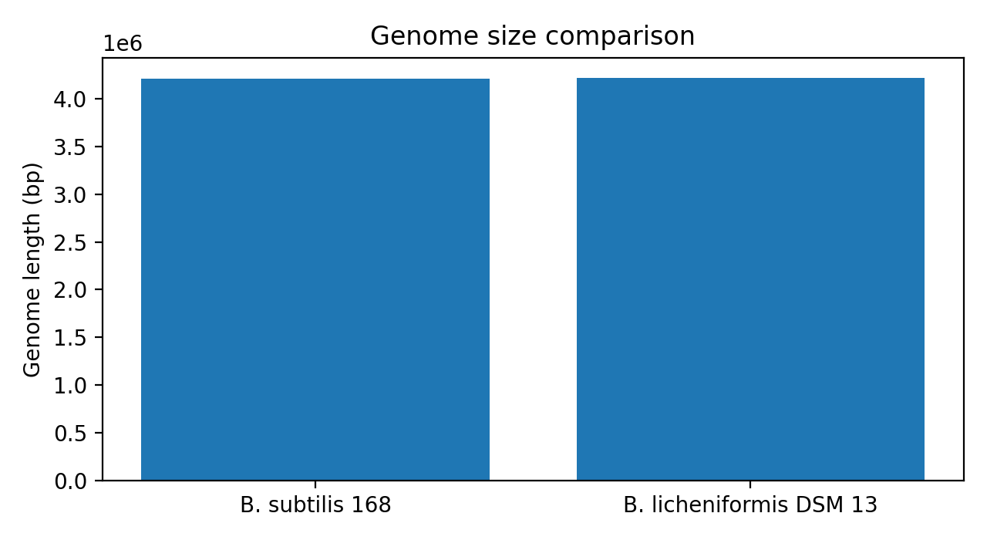
Figure 1. Genome size comparison of the two bacterial reference genomes.
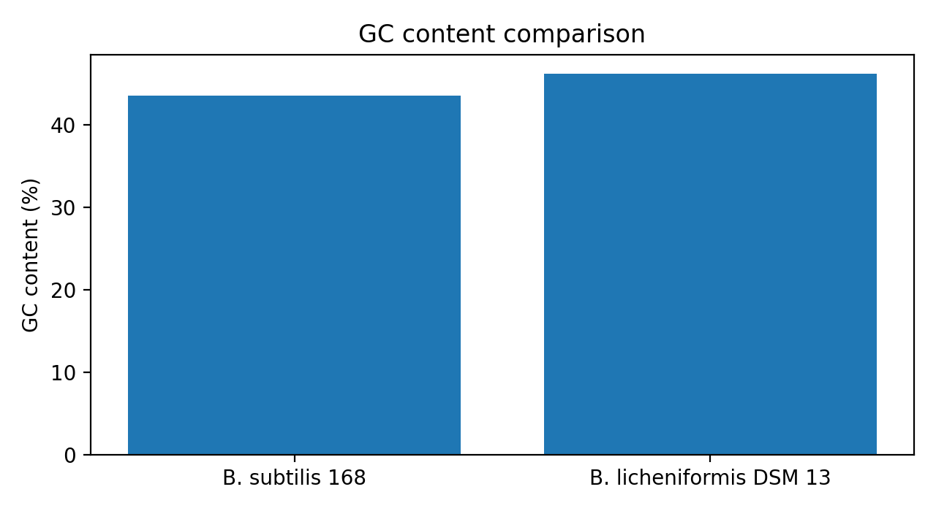
Figure 2. GC content comparison of the two bacterial reference genomes.

6.2 Genome annotation using Prokka
Feature | B. subtilis 168 | B. licheniformis DSM 13
Contigs | 1 | 1
Genome bases | 4,215,606 | 4,222,336
CDS | 4,214 | 4,308
tRNA | 87 | 71
rRNA | 30 | 21
tmRNA | 1 | 1

Both reference sequences were represented by one contig. Prokka predicted 4,214 CDS in B. subtilis and 4,308 CDS in B. licheniformis. B. subtilis had more predicted tRNA and rRNA features, while both annotations contained one tmRNA feature.
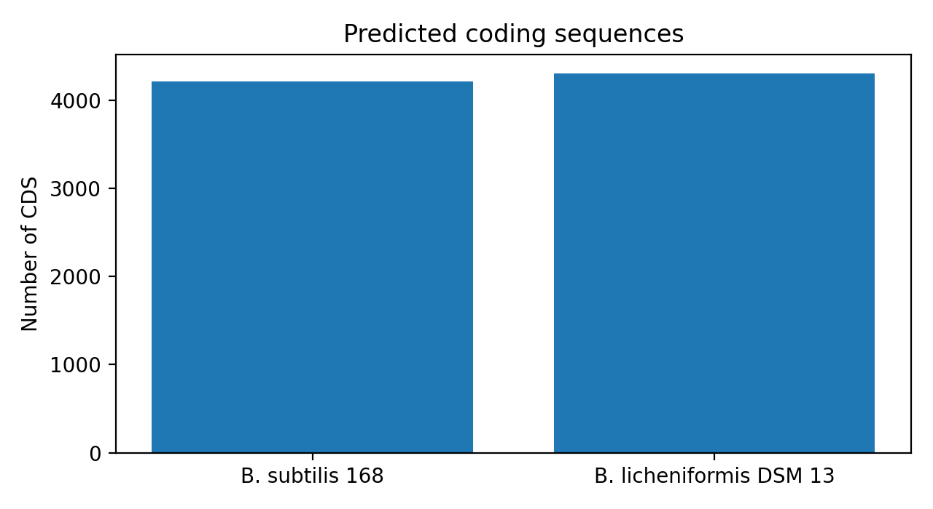
Figure 3. Predicted coding sequence counts obtained from Prokka annotation.

6.3 Comparative functional annotation
Feature | B. subtilis 168 | B. licheniformis DSM 13
Total CDS | 4,214 | 4,308
Described CDS | 2,821 (66.94%) | 2,726 (63.23%)
Hypothetical proteins | 1,387 (32.91%) | 1,582 (36.72%)
Uncharacterized proteins | 6 | 0
Gene assignments | 2,734 | 2,606
COG assignments | 2,021 | 1,961
CDS with EC numbers | 1,425 | 1,419

B. subtilis had more described CDS (2,821) than B. licheniformis (2,726), along with more gene assignments and COG assignments. In contrast, B. licheniformis had more predicted CDS overall and more hypothetical proteins. The reported described and hypothetical categories are retained as recorded in the project summaries.

6.4 COG functional classification
COG classification was performed for 2,021 CDS in B. subtilis and 1,961 CDS in B. licheniformis. For the B. subtilis COG2024 mapping run, all 2,021 identifiers matched the reference definitions, with zero unmatched identifiers. The following category-wise values were available in the consolidated project output:
COG category | B. subtilis count
A – RNA processing and modification | 3
B – Chromatin structure and dynamics | 6
C – Energy production and conversion | 120
D – Cell cycle control, cell division and chromosome partitioning | 59
E – Amino acid transport and metabolism | 254
F – Nucleotide transport and metabolism | 78
G – Carbohydrate transport and metabolism | 205
H – Coenzyme transport and metabolism | 150

This is a partial list of categories available in the recorded summary, not a complete category distribution. The full category-wise comparative table and graph should be taken from the saved COG output files if a complete category-by-category presentation is required. COG categories may overlap because a protein can be associated with more than one functional category.

6.5 Comparative enzyme annotation
Feature | B. subtilis 168 | B. licheniformis DSM 13
Total CDS | 4,214 | 4,308
CDS with EC numbers | 1,425 | 1,419
Distinct EC-number strings | 795 | 798

The number of CDS with EC-number annotations was similar in the two genomes. B. subtilis had six more CDS with EC-number annotations, whereas B. licheniformis had three more distinct EC-number strings. EC-number assignments are computational annotations and do not demonstrate experimentally measured enzyme activity.
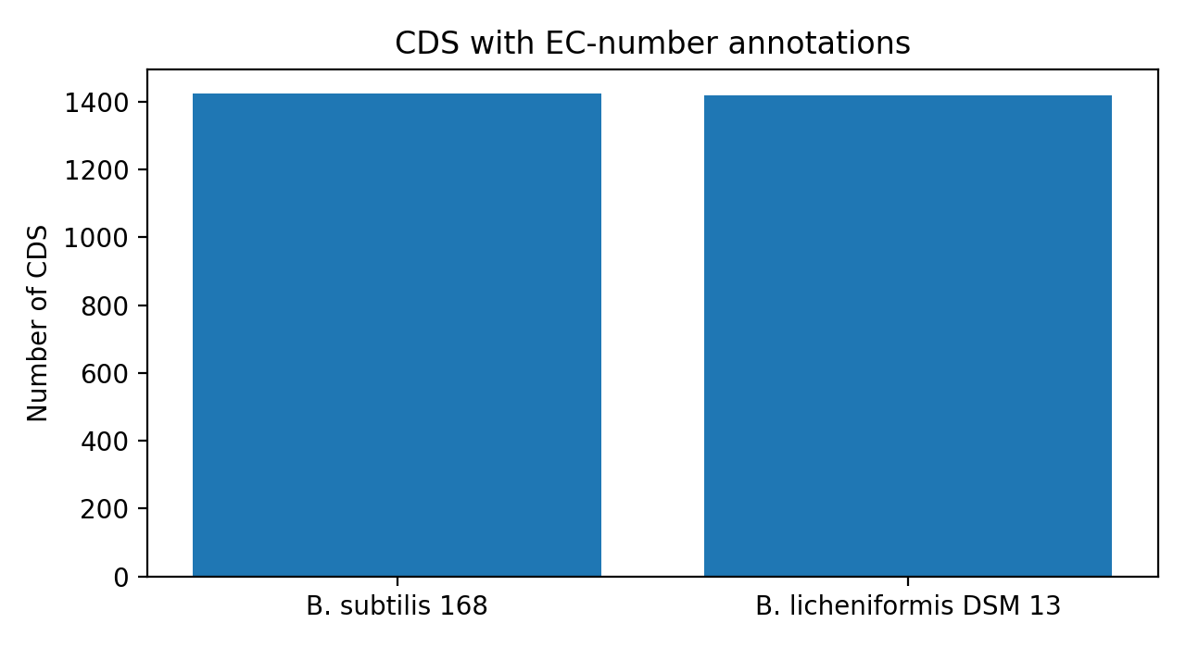
Figure 4. Number of CDS associated with EC-number annotations.

6.6 Whole-genome BLASTn comparative analysis
BLASTn result | Value
Query genome | B. subtilis 168
Reference / database genome | B. licheniformis DSM 13
Database type | Nucleotide
Database sequence length | 4,222,336 letters
Total local alignments | 782
Average alignment identity | 86.55%
Highest alignment identity | 100%
Lowest alignment identity | 69.76%
Average alignment length | 1,674.85 bp
Longest alignment | 19,915 bp
Length-weighted alignment identity | 83.10%
Query genome coverage | 23.28% (981,530 bp)
Reference genome coverage | 22.81% (963,161 bp)

BLASTn identified 782 local nucleotide alignments between the genomes. Average alignment identity was 86.55%, with values ranging from 69.76% to 100%. The average alignment length was 1,674.85 bp, and the longest alignment was 19,915 bp. The union of aligned intervals covered 23.28% of the B. subtilis query genome (981,530 bp) and 22.81% of the B. licheniformis reference genome (963,161 bp). These results describe local sequence matches only and must not be interpreted as complete genome-wide identity, one-to-one orthology or conserved genome organization.

7. Overall Discussion
The two Bacillus reference genomes were similar in overall size, with both measuring approximately 4.2 Mb. B. licheniformis was slightly larger by 6,730 bp and had a higher GC content. These differences indicate variation in nucleotide composition between the two reference genomes.
Prokka predicted a greater number of CDS in B. licheniformis, but B. subtilis had more described CDS, gene assignments and COG assignments in the functional summary. B. licheniformis also had more hypothetical proteins, indicating that a greater proportion of its predicted proteins remained without a specific functional description in the annotation output.
The enzyme annotation summaries were broadly similar: 1,425 CDS in B. subtilis and 1,419 CDS in B. licheniformis carried EC-number annotations. The numbers of distinct EC-number strings were also close (795 and 798, respectively). These counts reflect annotation records and do not establish biochemical activity.
The BLASTn comparison identified local regions of nucleotide similarity, but aligned intervals covered only about one quarter of either genome. The alignment statistics therefore describe detected local matches and cannot be generalized to the entirety of the two genomes. Overall, the project demonstrates how sequence statistics, annotation, functional classification and local sequence alignment can be integrated into a bacterial comparative genomics workflow.

8. Conclusion
This project characterized and compared the reference genomes of Bacillus subtilis 168 and Bacillus licheniformis DSM 13 using computational bioinformatics tools. Biopython was used to calculate genome length and nucleotide composition, Prokka was used for genome annotation, Python scripts were used for functional and enzyme annotation summaries, COG2024 data supported functional category mapping, and BLASTn was used to identify local nucleotide similarities. The genomes were close in size but differed in GC content and annotation summaries. B. subtilis had more described CDS, gene assignments and COG assignments, whereas B. licheniformis had more CDS overall and more hypothetical proteins. BLASTn detected 782 local alignments with partial genome coverage. The project provided practical experience in bacterial genome retrieval, sequence analysis, annotation, functional classification, comparative analysis and visualization.

9. Limitations
- The analyses are computational and depend on the quality and scope of reference sequences, annotation databases and software.
- Hypothetical proteins remain functionally unresolved in the annotation output.
- COG and EC-number assignments are database-supported predictions, not experimental validation.
- COG functional categories can overlap; category counts should not automatically be interpreted as mutually exclusive groups.
- BLASTn is a local alignment method. Reported identity and coverage values describe detected local alignments, not complete genome-wide similarity.
- The complete category-wise comparative COG table was not available in the consolidated summary; only the recorded category values are reproduced.

10. Project Organization and Reproducibility

10.1 Main project directory
The project was organized in the directory named Bacterial_Genome_Project. under the user's Documents directory (the folder name includes a trailing period).

10.2 Main folders and files
Folder / file group | Contents / purpose
01_Genome_Sequences | B. subtilis 168 genome FASTA and Comparison_Genome containing the B. licheniformis DSM 13 FASTA.
03_Genome_Annotation/Prokka_Output_Final | Final Prokka outputs, including protein FASTA (.faa), nucleotide FASTA (.ffn and .fna), feature table (.tsv), GenBank (.gbk), sequence report (.fsa) and log/error output (.err).
04_Functional_Analysis | Python scripts and generated summaries for functional annotation, COG classification, enzyme annotation and comparative analysis; includes COG_Reference with cog-24.def.tab.
07_Comparative_Genome_Analysis | Comparative sequence analysis outputs, including BLASTn database and alignment-related files and summaries.

10.3 Key computational outputs
- Genome composition summaries for both FASTA files.
- Final Prokka annotations for B. subtilis 168 and B. licheniformis DSM 13.
- Functional annotation summaries for described CDS, hypothetical proteins, gene assignments, COG assignments and EC annotations.
- B. subtilis COG2024 mapping: 2,021 matched identifiers and zero unmatched identifiers.
- Comparative enzyme annotation: 1,425 versus 1,419 CDS with EC numbers, and 795 versus 798 distinct EC-number strings.
- BLASTn summary: 782 alignments, 86.55% average identity, 83.10% length-weighted identity, 23.28% query coverage and 22.81% reference coverage.
For reproducibility, retain the original FASTA files, Prokka output directories, Python analysis scripts, COG2024 definition file, BLAST database files, BLAST tabular output and generated CSV/PNG figures together in the project folder. Check the report tables against the saved output files before formal submission.

10.4 Interpretation notes
The values in this report reproduce the numerical summaries recorded during the project. The Prokka functional summary lists described CDS, hypothetical proteins and uncharacterized proteins as separate annotation classes; these categories are retained as reported. The COG category table contains only the category values available in the consolidated output summary. No ANI analysis or ANI result is included.

11. References
1. Seemann, T. (2014). Prokka: rapid prokaryotic genome annotation. Bioinformatics, 30(14), 2068–2069. https://doi.org/10.1093/bioinformatics/btu153
2. Altschul, S. F., Gish, W., Miller, W., Myers, E. W., & Lipman, D. J. (1990). Basic local alignment search tool. Journal of Molecular Biology, 215(3), 403–410. https://doi.org/10.1016/S0022-2836(05)80360-2
3. NCBI Genome. National Center for Biotechnology Information. https://www.ncbi.nlm.nih.gov/datasets/genome/
4. NCBI COG Database. https://www.ncbi.nlm.nih.gov/research/cog/
5. Biopython documentation. https://biopython.org/wiki/Documentation
6. Matplotlib documentation. https://matplotlib.org/stable/
7. Python documentation. https://docs.python.org/3/

