COMPARATIVE ANALYSIS OF GUT MICROBIOME COMPOSITION
Comparative metagenomic analysis of gut microbiome in IBD and non-IBD groups

Study: Human Gut Metagenome and Metatranscriptome in Inflammatory Bowel Disease (iHMP/HMP2)
MGnify Study Accession: MGYS00002301
NCBI SRA Accession: SRP115812
NCBI BioProject Accession: PRJNA389280

PROJECT REPORT
Prepared by: Subhalaxmi Sahoo
Programme: M.Sc. Bioinformatics
Institution: Centre For Post Graduate Studies, OUAT
Academic year: 2026

ABSTRACT
The human gut microbiome consists of diverse microorganisms that contribute to digestion, metabolism and immune system regulation. Alterations in gut microbial composition have been associated with inflammatory bowel disease (IBD), which includes Crohn’s disease (CD) and ulcerative colitis (UC).
The present project aimed to compare gut microbiome composition among Crohn’s disease, ulcerative colitis and non-IBD groups using publicly available processed metagenomic taxonomic abundance data. Processed SSU taxonomic abundance data were obtained from MGnify. Clinical metadata and sequencing run information were obtained from the Integrative Human Microbiome Project (iHMP/HMP2) and NCBI Sequence Read Archive (SRA).
A total of 362 sequencing runs were successfully matched with clinical information, representing 117 unique participants. Phylum-level relative abundance was calculated for each sample. Repeated sequencing runs were averaged at the participant level. Statistical comparison was performed using the Kruskal–Wallis test followed by Benjamini–Hochberg false discovery rate (FDR) correction.
None of the eight selected taxonomic categories showed a statistically significant difference among the three disease groups after FDR correction. The project demonstrates the use of bioinformatics methods for metadata matching, taxonomic abundance analysis, visualization and statistical comparison of public metagenomic data.

Keywords
Gut microbiome; inflammatory bowel disease; Crohn’s disease; ulcerative colitis; metagenomics; taxonomic abundance; relative abundance; Kruskal–Wallis test; bioinformatics.

1. INTRODUCTION

1.1 Human Gut Microbiome
The human gastrointestinal tract contains a complex community of microorganisms, including bacteria, archaea, viruses and fungi. This microbial community is collectively known as the gut microbiome. It performs important biological functions, including digestion of dietary components, production of vitamins, regulation of metabolism and maintenance of intestinal health.
Gut microorganisms also interact with the host immune system and help maintain intestinal homeostasis. Changes in microbial composition may influence normal physiological functions and contribute to disease development.

1.2 Inflammatory Bowel Disease
Inflammatory bowel disease (IBD) is a group of chronic inflammatory disorders affecting the gastrointestinal tract. The two major forms are Crohn’s disease and ulcerative colitis.
Crohn’s disease can affect different parts of the gastrointestinal tract and may involve multiple layers of the intestinal wall. Ulcerative colitis mainly affects the colon and rectum and generally involves inflammation of the inner lining of the large intestine.

1.3 Gut Microbiome and IBD
Alterations in gut microbial composition have been reported in individuals with IBD. Changes in the abundance of bacterial groups may be associated with intestinal inflammation and changes in microbial community structure. Comparative microbiome analysis helps investigate differences in microbial composition between disease groups and participants classified as non-IBD.

1.4 Importance of Bioinformatics in Microbiome Analysis
Bioinformatics supports the analysis of large sequencing datasets. Computational methods can be used to inspect taxonomic abundance tables, connect sequencing information with clinical metadata, calculate relative abundance, visualize microbial community composition and perform statistical comparisons. In this project, publicly available processed taxonomic abundance data were analysed using Python.

2. AIM AND OBJECTIVES

2.1 Aim
To perform a comparative analysis of gut microbiome composition among Crohn’s disease, ulcerative colitis and non-IBD groups using publicly available processed metagenomic taxonomic abundance data.

2.2 Objectives
- To obtain processed gut microbiome taxonomic abundance data from MGnify.
- To inspect the structure of the downloaded datasets.
- To collect sequencing run information from NCBI SRA.
- To match sequencing runs with clinical participant information.
- To classify participants into CD, UC and non-IBD groups.
- To calculate phylum-level relative abundance.
- To compare microbial composition across the three disease groups.
- To visualize microbial abundance patterns.
- To perform statistical analysis using the Kruskal–Wallis test and FDR correction.

3. DATASET AND DATA SOURCES

3.1 Selected Study
The data were obtained from the Integrative Human Microbiome Project (iHMP), which investigates relationships between the human microbiome and inflammatory bowel disease. The selected study is associated with the human gut metagenome and metatranscriptome in inflammatory bowel disease.

3.2 Data Sources
Database / Resource | Accession / File | Purpose
MGnify | MGYS00002301 | Processed taxonomic abundance data
NCBI SRA | SRP115812 | Sequencing run metadata
NCBI BioProject | PRJNA389280 | Study information
IBDMDB / iHMP | hmp2_metadata_2018-08-20.csv | Clinical metadata

3.3 Downloaded Data Files
- taxonomy_abundances_SSU_v4.1.tsv
- phylum_taxonomy_abundances_SSU_v4.1.tsv
- hmp2_metadata_2018-08-20.csv
- SraRunInfo.csv
The phylum-level abundance file contained taxonomic categories and abundance values corresponding to individual sequencing runs. Clinical metadata contained participant identifiers and diagnosis information. NCBI SRA metadata provided sequencing run accessions and participant-related identifiers.

3.4 Dataset Characteristics
Parameter | Observed value
Phylum abundance table | 57 rows × 364 columns
Full taxonomy table | 1,367 rows × 363 columns
MGnify sequencing runs | 362
NCBI SRA sequencing runs | 378
Clinical metadata records | 5,533
Clinical metadata columns | 490
Clinical participants in metadata | 130

4. METHODOLOGY
The project followed a computational workflow involving data collection, data inspection, metadata matching, relative abundance calculation, visualization and statistical analysis.

4.1 Data Collection
Processed taxonomic abundance data were obtained from MGnify. Both the full taxonomic abundance table and the phylum-level abundance table were used. Clinical metadata were obtained from the IBDMDB data resource, and sequencing run information was obtained from NCBI SRA Run Selector using study accession SRP115812.

4.2 Data Inspection
Python and the Pandas library were used to inspect the downloaded files, including their row and column counts, sample identifiers, taxonomic fields, sequencing run accessions and clinical diagnosis categories. Clinical metadata contained multiple data types; metagenomics records were selected for the present analysis.

4.3 Matching Sequencing Runs
Sequencing run identifiers from the MGnify abundance table were compared with the Run column in NCBI SRA metadata. The host_subject_id field was used to derive participant identifiers, which were then matched with the Participant ID field in the clinical metadata. All 362 MGnify sequencing runs were matched with clinical participant information.

4.4 Classification of Disease Groups
Matched sequencing runs were classified according to the diagnosis field into Crohn’s disease (CD), ulcerative colitis (UC) and non-IBD groups.
Disease group | Sequencing runs | Unique participants
CD | 187 | 59
UC | 101 | 34
nonIBD | 74 | 24
Total | 362 | 117

4.5 Phylum-Level Relative Abundance Calculation
Bacterial taxonomic rows were selected from the phylum-level abundance table. Relative abundance was calculated separately for each sequencing run using the following formula:
Relative abundance (%) = (Abundance of individual phylum / Total selected bacterial phylum abundance in that sample) × 100
The denominator represents the sum of the selected bacterial phylum rows in the abundance table. Therefore, the resulting values represent proportional abundance within that selected bacterial phylum-table total, rather than absolute microbial load.

4.6 Participant-Level Data Preparation
Some participants contributed repeated or longitudinal sequencing runs. To reduce the influence of treating repeated runs as independent participants, sample-level relative abundance values were averaged for each participant and taxonomic category. The resulting participant-level dataset was used for group-level summaries and statistical testing.

4.7 Data Visualization
Python libraries, including Pandas and Matplotlib, were used to summarize and visualize the abundance data. A grouped bar chart compared the ten most abundant taxonomic-table categories across the three groups. A statistical comparison graph was also generated to display participant-level abundance distributions.

4.8 Statistical Analysis
The Kruskal–Wallis test was used to compare participant-level abundance distributions across CD, UC and nonIBD groups. This non-parametric test compares three or more independent groups. Benjamini–Hochberg false discovery rate correction was applied to adjust p-values for multiple testing. An adjusted p-value below 0.05 was considered statistically significant.

5. RESULTS

5.1 Sequencing Run Matching
Parameter | Number
MGnify sequencing runs | 362
NCBI SRA sequencing runs | 378
Matched sequencing runs | 362
MGnify runs not found in NCBI | 0
NCBI runs not represented in MGnify abundance table | 16

All 362 sequencing runs represented in the MGnify abundance table were identified in the NCBI SRA metadata.

5.2 Participant Matching
All 362 sequencing runs were successfully connected with clinical participant information. The clinical metadata contained 130 participants overall, of whom 117 were represented in the matched abundance dataset.

5.3 Disease Group Distribution
Disease group | Sequencing runs | Unique participants
CD | 187 | 59
UC | 101 | 34
nonIBD | 74 | 24
Total | 362 | 117

Crohn’s disease contributed the largest number of sequencing runs and unique participants in the final dataset.

5.4 Phylum-Level Relative Abundance
Relative abundance was calculated for each selected bacterial phylum category in every sample. Participant-level abundance values were then summarized by disease group. For example, the mean participant-level relative abundance of Bacteroidetes in the CD group was approximately 41.42%.
The analysis generated the following result files:
- sample_level_phylum_relative_abundance.csv
- participant_level_phylum_abundance.csv
- disease_group_phylum_summary.csv

5.5 Graphical Comparison of Taxonomic Categories
A grouped bar chart was generated to compare the ten most abundant taxonomic-table categories across CD, UC and nonIBD groups. The graph provides a visual summary of mean relative abundance patterns.
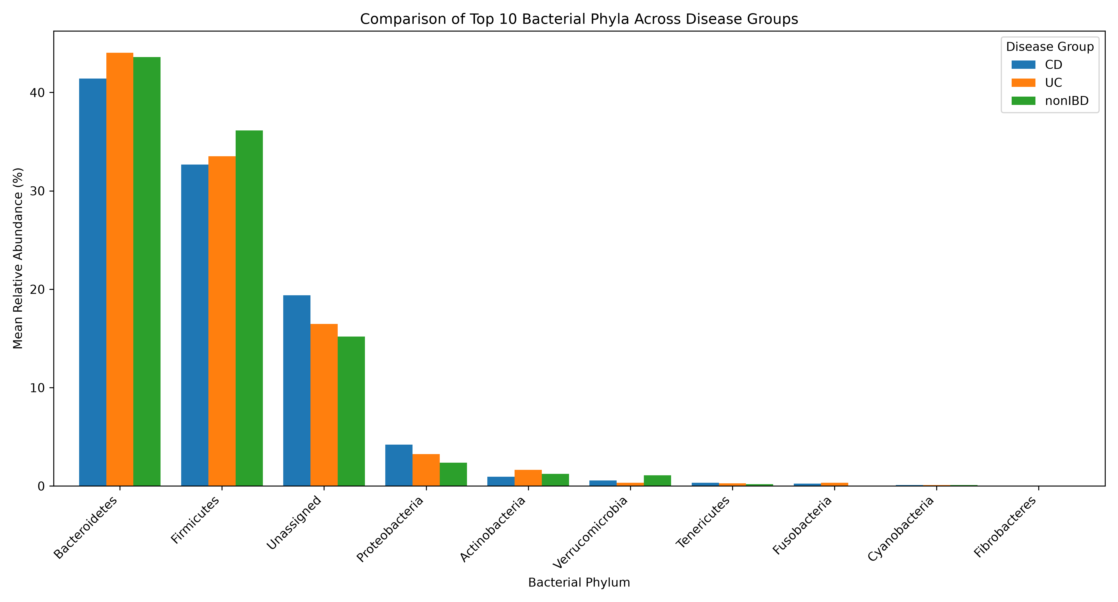
Figure 1. Comparison of the top ten taxonomic-table categories across CD, UC and nonIBD groups.

5.6 Statistical Comparison
The Kruskal–Wallis test was applied to eight selected taxonomic categories. Benjamini–Hochberg correction was used to adjust the p-values.
Category | Kruskal–Wallis H | Raw p-value | FDR-adjusted p-value | Significant (FDR < 0.05)
Bacteroidetes | 0.296354 | 0.862279 | 0.873413 | No
Firmicutes | 1.379872 | 0.501608 | 0.772906 | No
Unassigned | 6.340126 | 0.042001 | 0.336008 | No
Proteobacteria | 1.090561 | 0.579679 | 0.772906 | No
Actinobacteria | 2.296018 | 0.317268 | 0.772906 | No
Verrucomicrobia | 1.899150 | 0.386906 | 0.772906 | No
Tenericutes | 0.270693 | 0.873413 | 0.873413 | No
Fusobacteria | 3.664015 | 0.160092 | 0.640368 | No

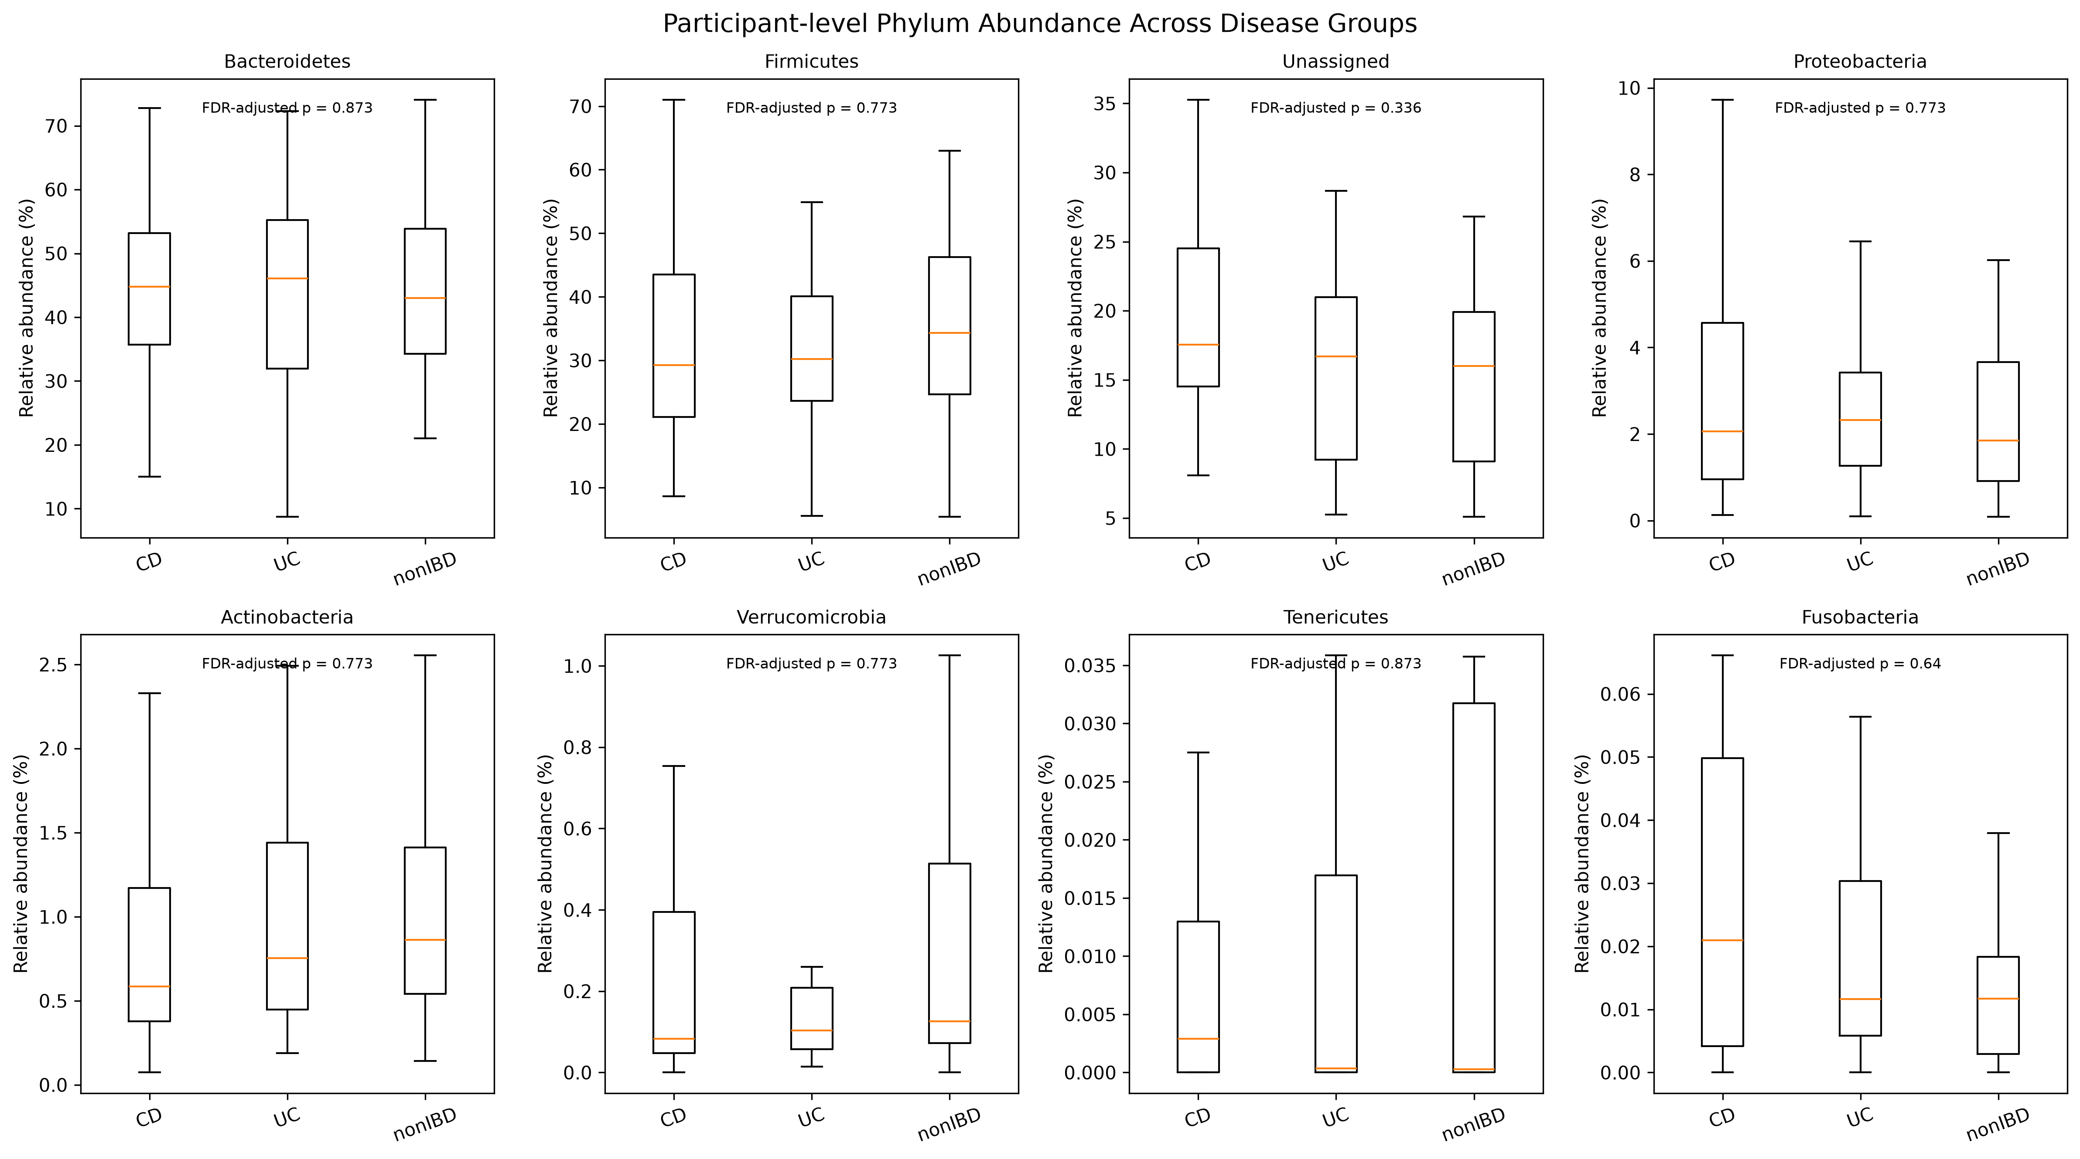
Figure 2. Statistical comparison of participant-level relative abundance across the three groups.

5.7 Interpretation of Statistical Results
None of the eight tested categories showed a statistically significant difference among CD, UC and nonIBD groups after FDR correction. The Unassigned category had a raw p-value of 0.042001, but its FDR-adjusted p-value was 0.336008 and therefore was not significant after correction. Unassigned is a table category and should not be interpreted as a formal bacterial phylum.
The results indicate that this analysis did not detect statistically significant differences in the selected categories. A non-significant result does not prove that the groups are identical.

6. DISCUSSION
This project compared gut microbiome composition among Crohn’s disease, ulcerative colitis and non-IBD groups using processed metagenomic taxonomic abundance data. The final dataset included 362 sequencing runs from 117 unique participants. Matching the run identifiers with clinical information allowed the abundance data to be grouped according to diagnosis.
The relative abundance analysis provided an overview of bacterial phylum-level composition. Bacteroidetes was an abundant component of the profiles, with a mean participant-level relative abundance of approximately 41.42% in the CD group. This value alone does not establish that Bacteroidetes was higher or lower in CD than in the other groups; that interpretation requires comparison with the corresponding group values and statistical evidence.
The Kruskal–Wallis tests followed by FDR correction did not identify statistically significant differences for any of the eight tested categories. The raw p-value for Unassigned was below 0.05, but this finding did not remain significant after multiple-testing correction. These findings should be interpreted as a failure to detect significant differences in the selected categories, not as proof that the microbial communities are identical.
Differences may occur at lower taxonomic levels or may be associated with clinical and environmental variables not included in the current analysis. The project demonstrates a reproducible computational workflow for analysing public microbiome abundance data.

7. LIMITATIONS
- The analysis was restricted to phylum-level taxonomic abundance data; genus-, species- and strain-level differences were not investigated.
- The number of participants was unequal across the three disease groups.
- Repeated or longitudinal sample values were averaged at the participant level, which reduces repeated-run pseudoreplication but removes temporal information.
- Clinical factors such as medication, diet, age, disease activity and sequencing batch were not included as covariates in the statistical model.
- Relative abundance is compositional and does not directly measure absolute microbial load.
- Statistical testing was limited to eight selected taxonomic categories.
- The nonIBD label reflects the study metadata classification and should not automatically be treated as a universally healthy control designation.

8. CONCLUSION
The present project performed a comparative analysis of gut microbiome composition among Crohn’s disease, ulcerative colitis and non-IBD groups using publicly available processed metagenomic taxonomic abundance data. A total of 362 sequencing runs representing 117 unique participants were matched with clinical metadata.
Phylum-level relative abundance was calculated, and participant-level profiles were generated to account for repeated sequencing runs. Graphical summaries and statistical comparisons were performed using Python. The Kruskal–Wallis test followed by Benjamini–Hochberg correction showed that none of the eight selected categories had statistically significant differences among the three groups.
The project demonstrates the application of bioinformatics methods for data inspection, metadata matching, taxonomic abundance analysis, visualization and statistical testing. It provides a foundation for further microbiome research involving finer taxonomic resolution, functional profiling and adjustment for clinical covariates.

9. SOFTWARE AND TOOLS USED
Tool / Software | Application
Python | Data analysis and processing
Pandas | Data handling and manipulation
Matplotlib | Data visualization
SciPy | Statistical analysis
Visual Studio Code | Python script development
MGnify | Taxonomic abundance data source
NCBI SRA | Sequencing run metadata source
IBDMDB / iHMP | Clinical metadata source

10. PROJECT OUTPUT FILES

10.1 Analysis Scripts (02_Analysis)
- inspect_data.py
- inspect_metadata.py
- check_metadata_categories.py
- inspect_sra_metadata.py
- match_sequencing_runs.py
- check_participant_matching.py
- analyze_phylum_abundance.py
- plot_phylum_comparison.py
- statistical_phylum_analysis.py

10.2 Result Files (03_Results)
- matched_sequencing_runs.csv (if retained under this name)
- runs_with_disease_groups.csv
- sample_level_phylum_relative_abundance.csv
- participant_level_phylum_abundance.csv
- disease_group_phylum_summary.csv
- phylum_statistical_tests.csv

10.3 Graph Files (04_Graphs)
- top_10_phylum_comparison.png
- statistical_phylum_comparison.png

11. REFERENCES AND DATA RESOURCES
- MGnify. European Bioinformatics Institute. Study accession MGYS00002301. https://www.ebi.ac.uk/metagenomics/
- NCBI Sequence Read Archive (SRA). Study accession SRP115812. https://www.ncbi.nlm.nih.gov/sra/
- NCBI BioProject. Accession PRJNA389280. https://www.ncbi.nlm.nih.gov/bioproject/PRJNA389280
- Integrative Human Microbiome Project / IBDMDB. https://ibdmdb.org/
- Kruskal, W. H., & Wallis, W. A. (1952). Use of ranks in one-criterion variance analysis. Journal of the American Statistical Association, 47(260), 583–621.
- Benjamini, Y., & Hochberg, Y. (1995). Controlling the false discovery rate: A practical and powerful approach to multiple testing. Journal of the Royal Statistical Society: Series B, 57(1), 289–300.

